Greg Spahlinger

11/17/20

Use Patterns and Auspicious Use Practices of Kickstarter

Kickstarter is a website with an admirable and useful goal: to connect people who want to donate money, with those who have interesting project ideas they lack the capital to realize. This type of service, known as crowdfunding, has become increasingly widespread during the 2010s, and continues into the present day, and Kickstarter has several competitors in the field, including GoFundMe and IndieGoGo providing similar service models. While crowdfunding can be a tempting idea for tech savvy artists and inventors, it should go without saying that not every sharp idea that has come to the platform has been counted among its success stories.

In order to better understand what makes Kickstarter tick, and what separates a successful project from a failure I have explored a data set collected from 4114 campaigns that ran on Kickstarter between the years of 2009 and 2017. The goal of this report is to identify some trends in the data for where Kickstarter is most used, what categories of campaigns are most successful, how the use has evolved with time, how the size of the campaign’s goal affects the likelihood of success, and how backer count predicts success or failure.

Findings – Geographical Usage of Kickstarter

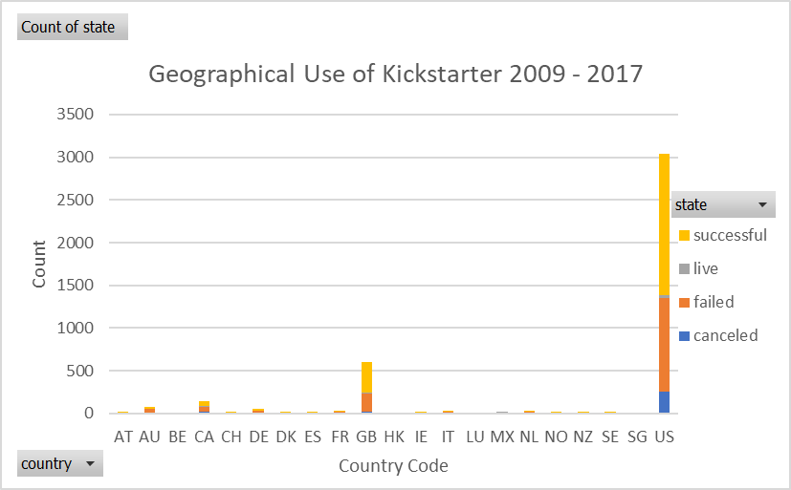

Fig. 1 – The US and UK Dominate Kickstarter Use

The first and most striking finding of this analysis was the distribution of Kickstarter use by geography. As is evident in figure 1, the US shows hegemonic dominance over the platform, launching around 74% of all campaigns. The UK (country code GB) shows up at a distant second place with 15% of the remaining campaigns. Because of the dominance of the US, the categorical analysis will focus exclusively on performance within the US. This is because the high representation of American campaigns will lead to a more robust analysis than any other country.

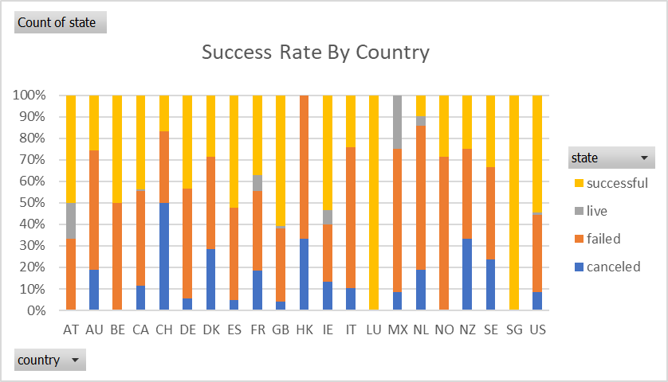

Fig. 2 Campaign Success Rate by Country

Before moving on to that, it is worth noting that the success rate of campaigns varies widely by country, but that in the two top players, the rates are similar and favorable. Both the US and the UK launch successful campaigns at a rate between 50 and 65%, with the US having a slightly lower success rate than the UK. Only two countries had significantly higher success rates than this: Luxembourg and Singapore, which both have a 100% success rate. This impressive fact is somewhat tempered by the fact that the countries have launched a combined total of 3 campaigns.

Findings – Categorical Use of Kickstarter within the US

One striking and helpful finding that emerges from the data is that not only are different types of projects launched at different rates, but they also have very different chances of success. Of the different categories of use within the US, theatre (912), music (636), and film and video (422) projects were the most often launched in that order. These were also some of the most successful categories. Music, with a 77% success rate was the most successful category overall.

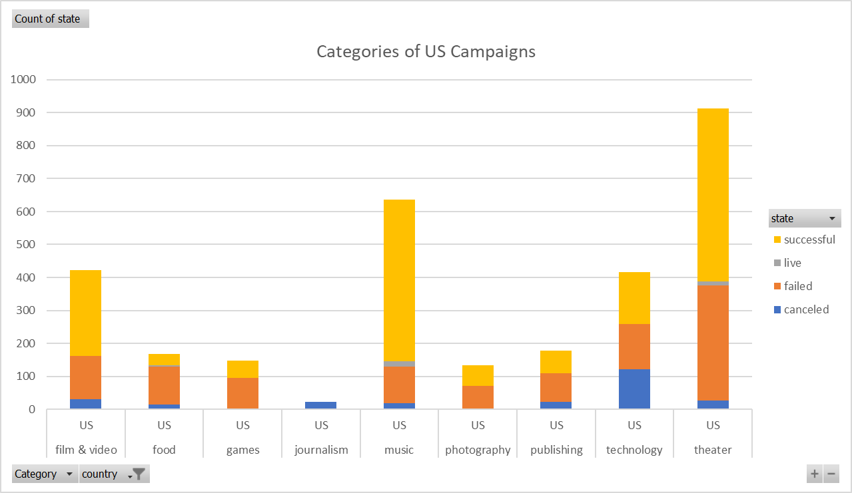

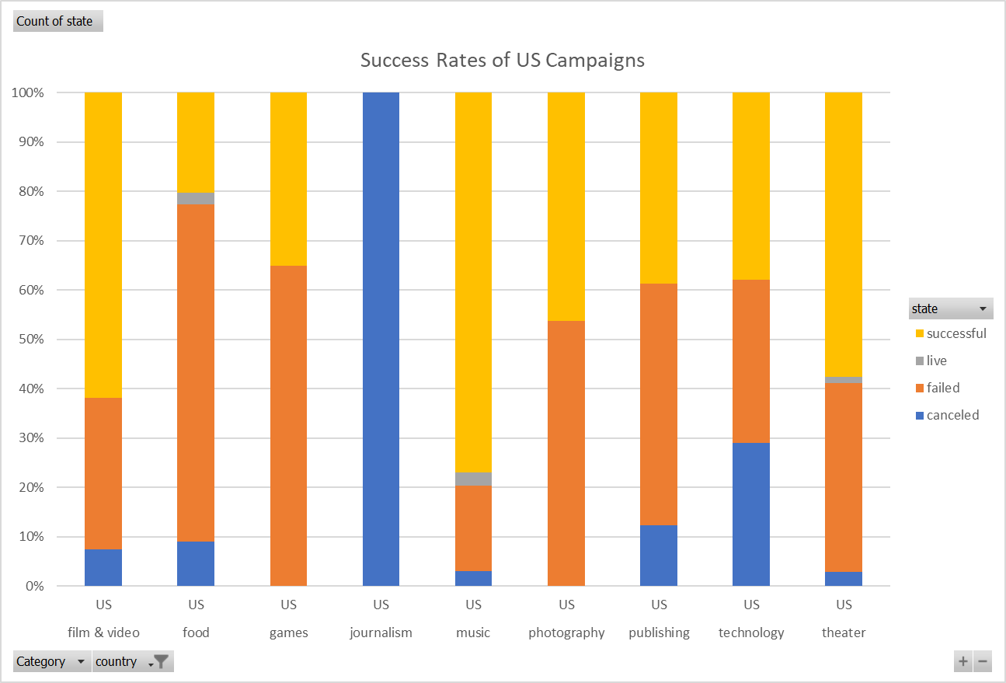

Fig. 3 – Categories and Success rates of US launched Kickstarter Campaigns.

Findings – Subcategory and Temporal Trends

The category stats make it apparent which spaces are launching the most campaigns successfully, but a closer look at the data yields some surprising insights. It might be tempting to look at the analysis so far and conclude that launching a musical campaign in the US is a relatively safe bet. This could be somewhat misleading, though, because a look at the timing and musical genre data yields some additional nuance. A closer look at music campaigns, makes it apparent that the genre you launch your campaign in is strongly correlated to its chance of success. To date none of the campaigns in World Music have made it to a conclusion, and none of the Jazz projects and few of the Faith projects have succeeded as of the end of this data set (note: a few of the Faith projects categorized as “live” have met their funding goal).

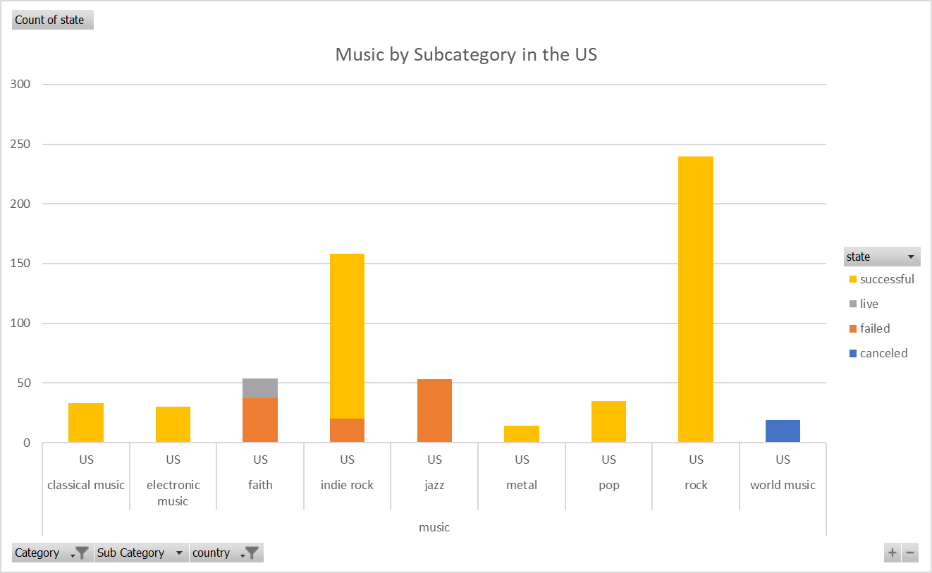

Fig. 4 – In the US, Music Campaigns Fail by Genre

The data suggests that Kickstarter music campaigns are relatively dominated by rock and indie rock music, which are the first and second most popular genres in which to launch campaigns. This is curious and may spell trouble, as the overall popularity of rock music has been declining since the 2000s. This might predict that the success of musical campaigns would diminish over time, and in fact this is observed. Globally, the number of successful music projects in this data set peaked in 2012, when 136 successful campaigns were launched, and has slowly been trending downward since. In the last full year that this data set covers (2016) only 52 successful music campaigns were launched.

Are there any areas where the success is growing over time? As it turns out, yes. When you look at numbers for games on Kickstarter overall, they do not look overly auspicious, but a closer look yields some interesting insight. Globally, the number of campaigns devoted to games is growing over time, and the proportion of successful campaigns is also growing. This growth is seen until 2017, which should be ignored, because it does not represent a full year.

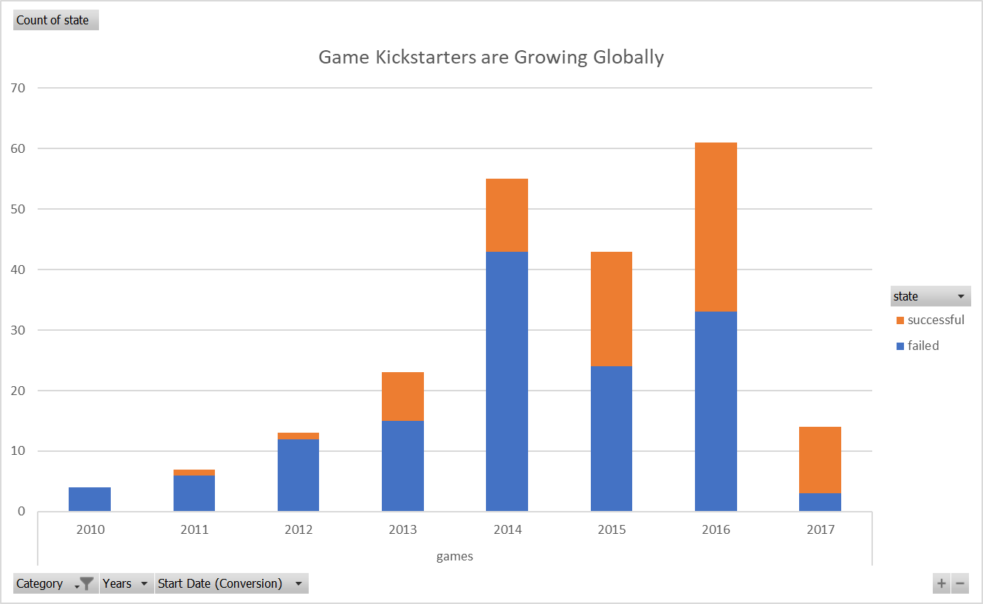

Fig. 5 – Game Campaigns are Increasing in Number, and Getting more Successful Over Time.

The failure rate shown in Fig. 5 is still relatively high, but there is an important insight which will predict which games will be successful, and which will fail. Surprisingly, in our current data set, the success of game campaigns perfectly correlates with the subcategory of game. In the present data only boardgames have been successful, while mobile and video game campaigns have always failed. This suggests that Kickstarter has a healthy boardgame scene, which is growing over time, and that the platform is currently an excellent place to pitch new boardgame ideas.

Findings – Goal Size, and a Post Mortem for Unsuccessful Campaigns.

In thinking about how a user can make the best use of Kickstarter, the amount of funding one is trying to secure might seem relevant. Kickstarter goals can vary widely from hundreds to tens of thousands of dollars. In order to capture this range, Kickstarter goals were separated into bins of 5000 currency units, with goals of less than 1000 or more than 50,000 being made into categories of their own at the end of the spectrum. The number of campaigns in each bin were plotted by state in figure 6.



Fig. 6 – More Ambitious Goals Succeed Less Often.

It can be seen from the figure, that there are three behaviors in the lines for success and failure, which mirror each other. Between >1000 and 15000 the success rate comes down from 70% to just under 50%. This stays relatively constant until the goals reach 45000, at which point the success rate drops steeply to just under 20% for goals of 50000 or more. At the same time, the cancellation rate starts very low (4%) and increases steadily to just over 5 times its starting rate. In summary, the more money you are looking for, the less likely you are to succeed on Kickstarter. This trend is most noticeable for projects on the extremes, though, and holds less for projects with middling levels of ambition.

Some additional statistics on Kickstarter backers can help to shine a light on why projects fail on Kickstarter. Successful campaigns on Kickstarter have a median of 62 backers, a mean of 194 and a range of about 26,000. This suggests that while there are some outlier campaigns that garner massive attention and support, the average campaign needs on the order of tens of backers to succeed. The same analysis found that failed and cancelled campaigns have a median of 4 and 2 backers respectively. Which is to say, half of the campaigns that failed or were cancelled had fewer than 2 to 4 backers – or effectively no support. The maximum values for failed and cancelled campaigns were 1293 and 1501 backers respectively. This tells you that not every campaign that fails or is cancelled does so because no one is interested, but may reflect the fact that ambitious goals become increasingly difficult to accomplish.

Future Directions and Limitations of the Data

The data used in this study were provided as is, and the author was not involved in the acquisition and curation of them. While it’s usually a fair assumption that such data have been randomly sampled, some of the findings raise questions. I found it startling, for instance, that no campaigns appeared in the Rap, R&B or Hip Hop genres of music – all of which are extremely popular domestically and worldwide. While this might mean that no projects in these genres are actually being launched on Kickstarter, it could also mean that the data has been curated around some specific areas of interest or is otherwise biased, and is therefore not fully representative of what is going on in the platform as a whole. Along the same lines, the data presented here is confined to Kickstarter alone, and as previously mentioned, several other platforms exist for crowdfunding, such as GoFundMe and IndieGoGo. While some of the insights presented here might be relevant to other platforms, there is no guarantee that this is the case – especially when we are talking about analyses by category or geography. It could well be that the reason Jazz projects are failing on Kickstarter is because Jazz fans are more inclined to use IndieGoGo.

Finally, the data set used in this report is several years old, and contains partial data for 2017. While I attempted to make statements about how music and games are trending in the data, it’s worth noting that we do not know how these trends have progressed into the present. To assume persistence is an extrapolation.

My goal for this report has been to provide some insights to the prospective user of Kickstarter, and to that end, I have focused on the largest markets and some general trends of use. This analysis is not comprehensive, and there are a few things that could still be extracted from the data. First, I have chosen to focus mostly on the US market, but the UK market is also substantial, and a category analysis could be conducted, to see if the same trends there are the same. Second, this analysis has shown that at least half of failed and cancelled Kickstarter campaigns “die on the vine”, having received little to no attention or support. It would be interesting to look at how the “spotlight” and “staff pick” methods of promotion affect a campaign’s chance of success.