**Stoppage and Electrical consumption label and display changes**

Following changes are recommended for the “Production Run Fixed Asset” page and “Adding Stoppage and Electrical Consumption” page.

In this screen following changes are made

* Routing Task Grid label changed to show Routing label
* Routing Task Name added to the Grid
* Separate Grids to display Stoppages and Electricity Consumed
* Necessary label changes relevant to Stoppages and Electricity

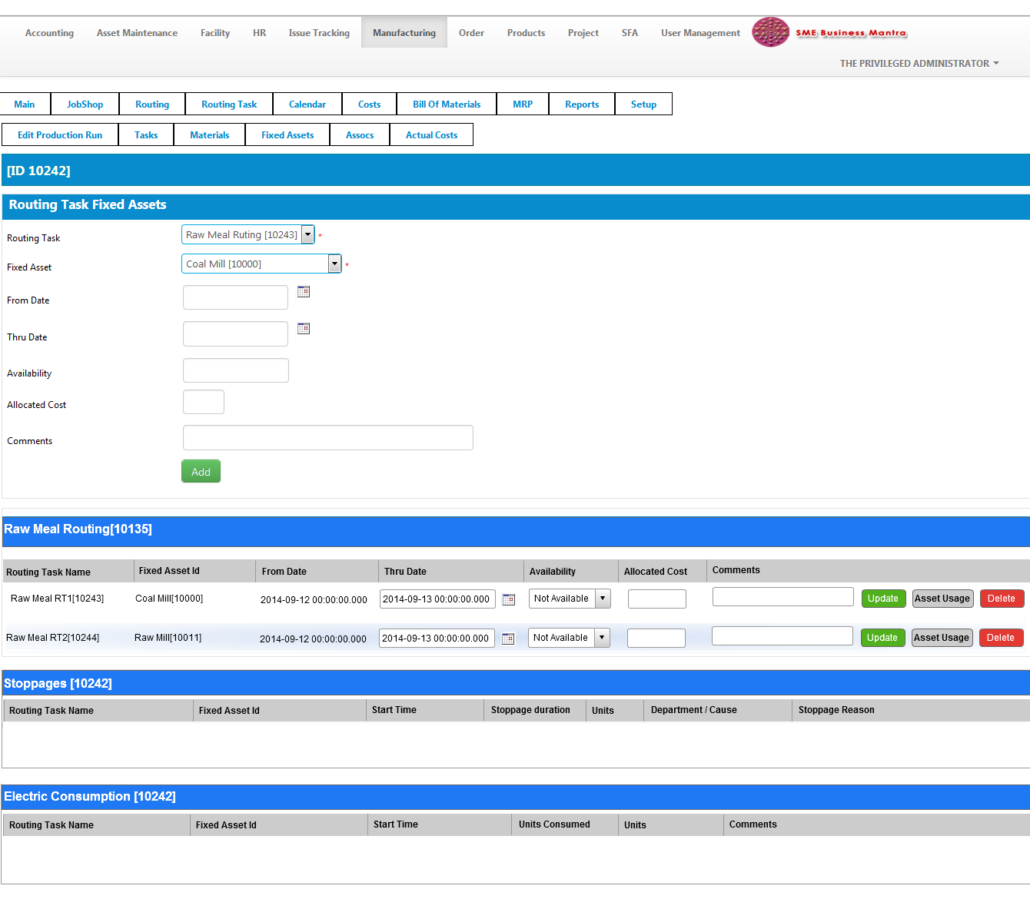

1. Adding a stoppage

While selecting the “Product Meter Type Id as Stoppages” then the labels should change as:

1. Start time
2. Stoppage Duration ( Instead of Stoppage Time)
3. Units
4. Department /Cause Drop down
5. Stoppage Reason

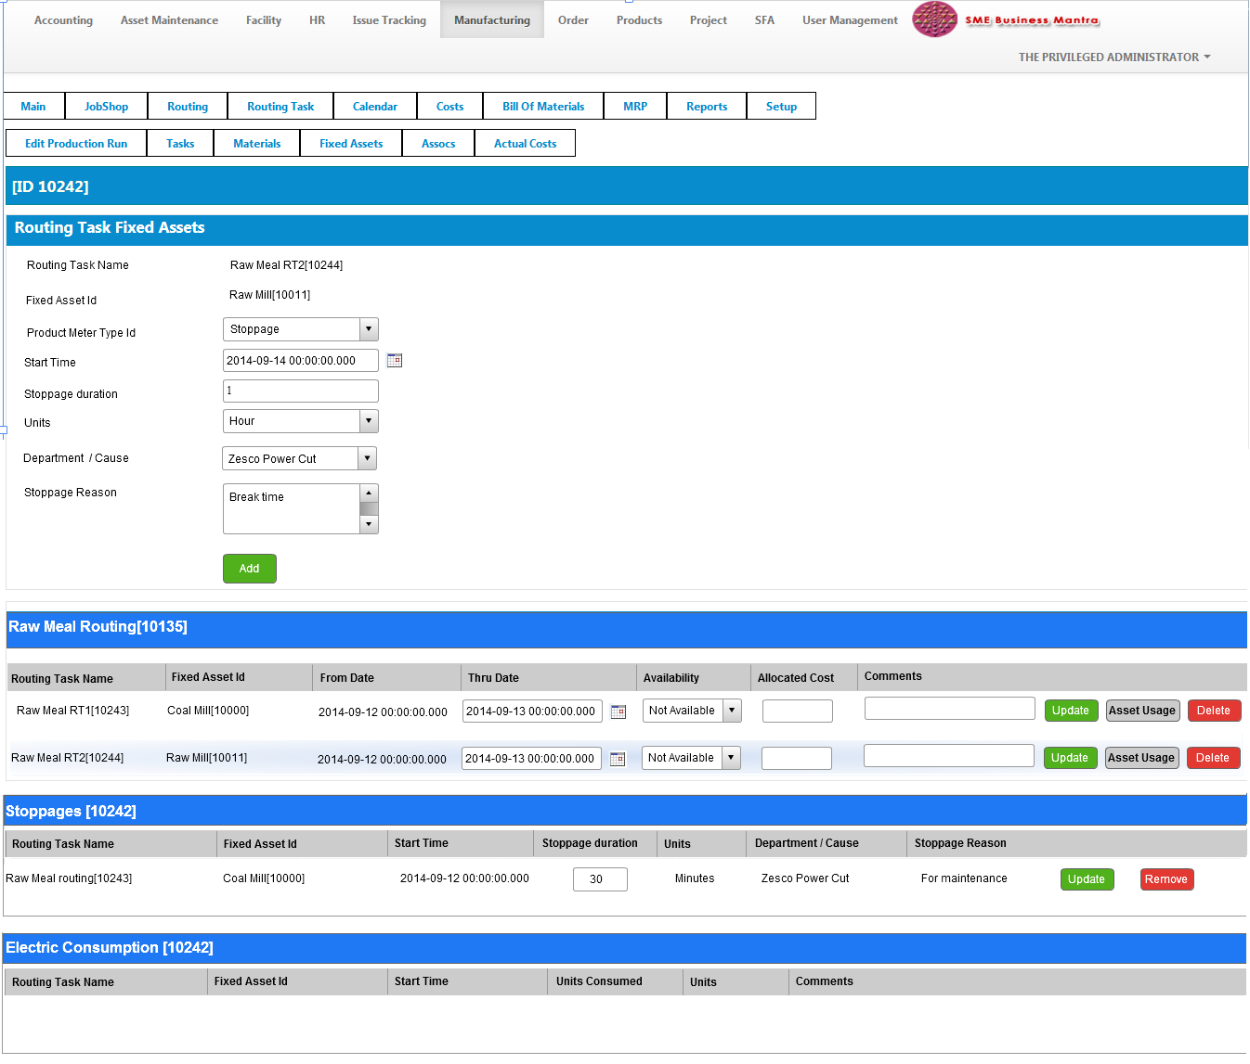

1. Adding Electrical consumption

While selecting the “Product Meter Type Id” as Electrical Consumption then the labels should change as:

1. Start time
2. Units Consumed
3. Units
4. Comments

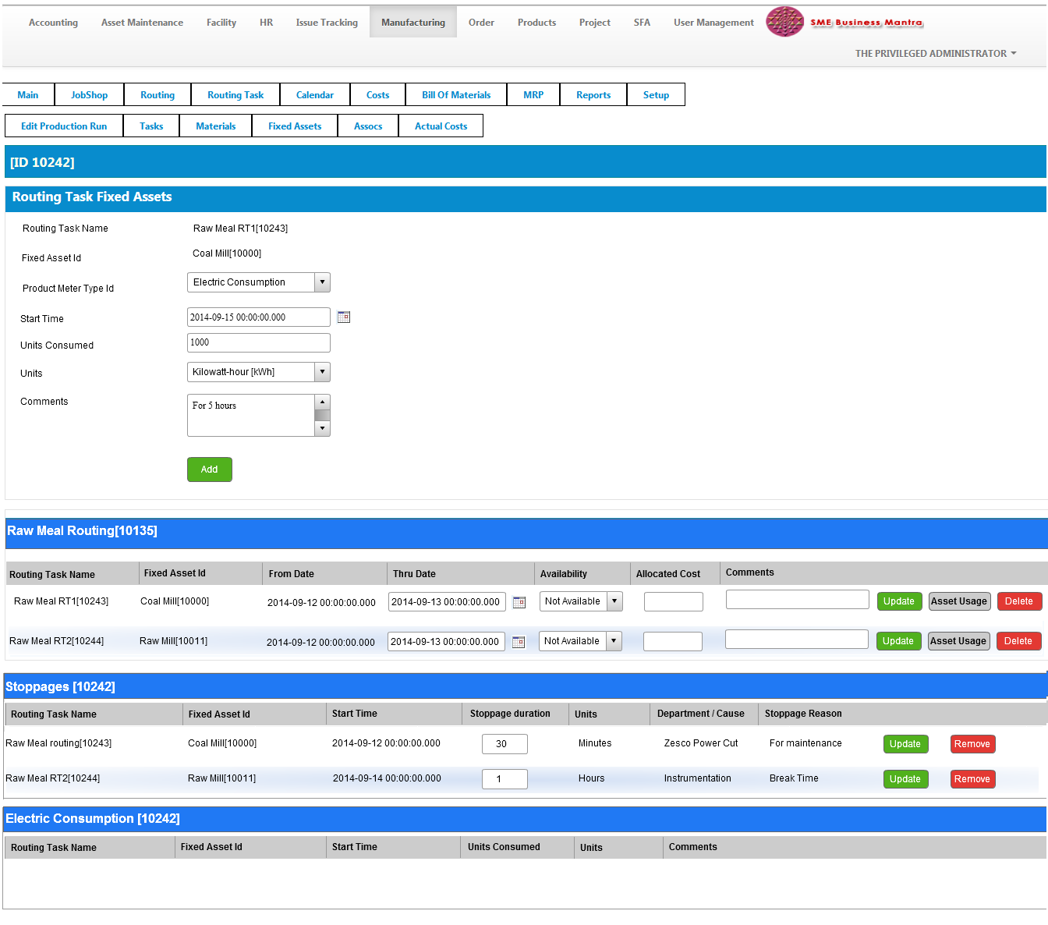

1. Final Screen

