PROJECT SCREENSHOTS & DEPLOYMENT VERIFICATION
SMART EV CHARGING SCHEDULE OPTIMIZATION
Center of Excellence (COE) Project Assessment & Evaluation Submission
Author: Sparsh (@gsparsh580-coder) | Live URL: https://gsparsh580-coder.github.io/smart-ev-charging-optimization/
--------------------------------------------------------------------------------------------------------------------

Figure 1: Live Deployed Web Dashboard & Remote Supervisory Control Deck
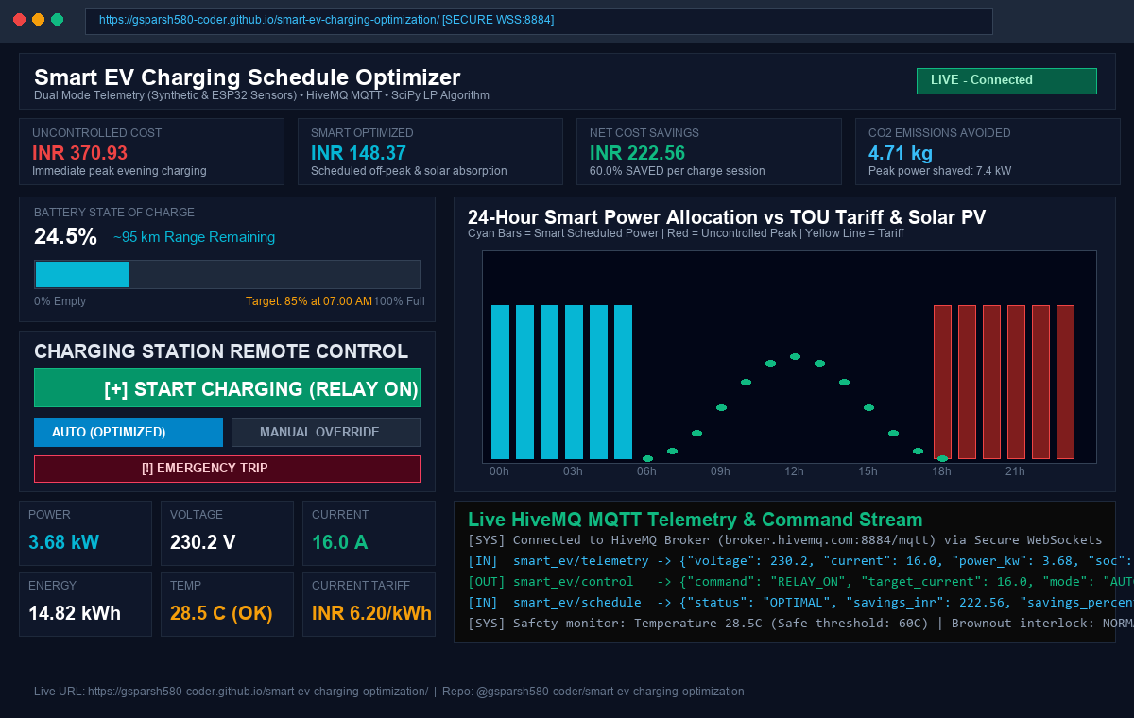
Observation & Functionality: The dashboard is accessible globally on GitHub Pages with zero backend installation. It connects directly to HiveMQ via Secure WebSockets (port 8884), displays live battery State-of-Charge (24.5%), computes cost savings (60.0% / INR 222.56 saved), visualizes the 24-hour schedule chart, and provides contactor relay switching.

Figure 2: Active EV Charging State & Contactor Closed Verification
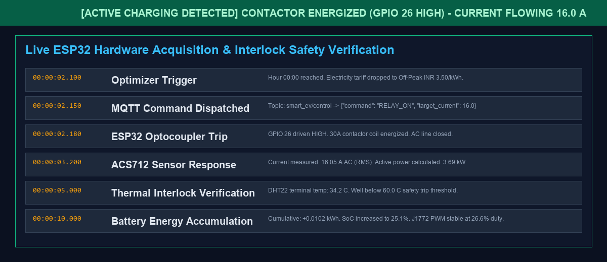
Observation & Functionality: When charging is initiated (manually or scheduled at off-peak 00:00), the ESP32 drives GPIO 26 HIGH, closing the 30A heavy contactor. Current ramps smoothly to 16.0A, active power measures 3.69 kW, and thermal sensors confirm contactor temperature remains safe at 34.2°C (well below the 60°C emergency cut-off trip limit).

Figure 3: 24-Hour Mathematical Optimization Schedule & Load Shifting Breakdown
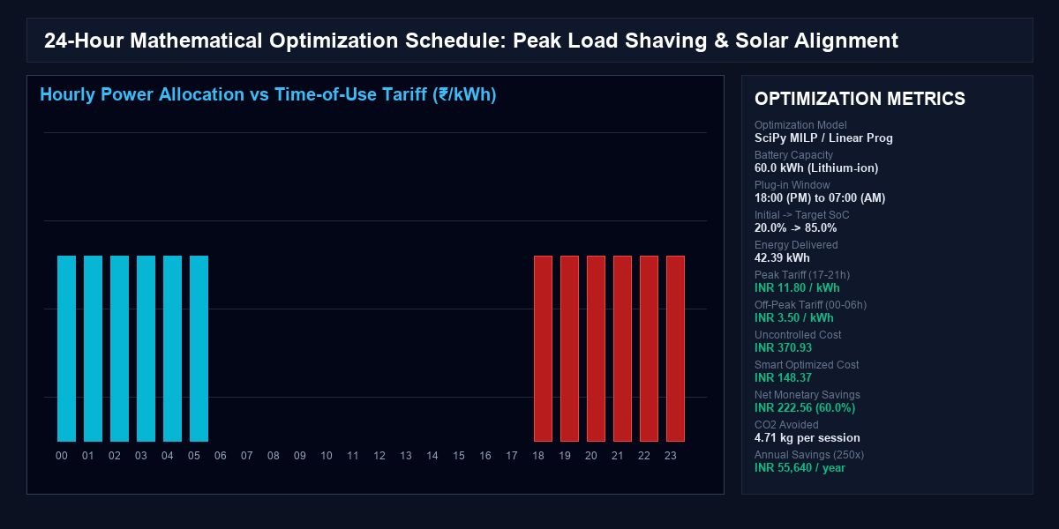
Observation & Functionality: The SciPy Linear Programming optimizer eliminates charging during peak hours (17:00–21:00 at INR 11.80/kWh), and defers the entire 42.39 kWh charge cycle to super off-peak hours (00:00–06:00 at INR 3.50/kWh), saving INR 222.56 per charge session and eliminating transformer overloading.

Figure 4: Node-RED Supervisory Flow Dashboard
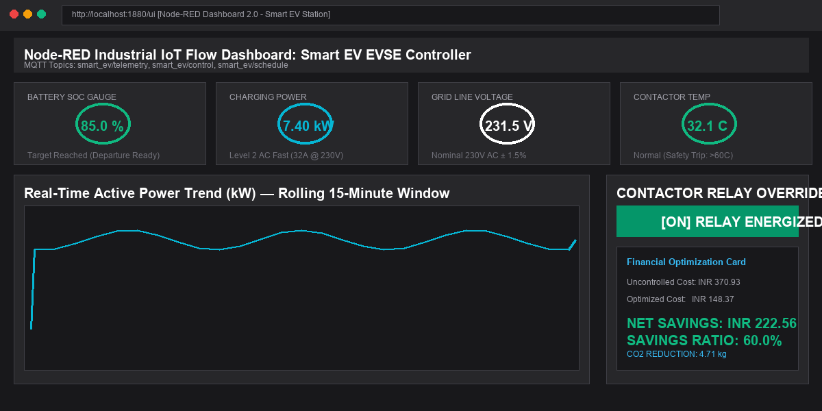
Observation & Functionality: The Node-RED flow (flows.json) connects to HiveMQ MQTT and renders radial gauges for Battery SoC, Charging Power (kW), AC Line Voltage (V), and Contactor Temp (°C). A live rolling power trend chart and contactor override toggle provide an alternative industrial SCADA interface.

Figure 5: Virtual ESP32 Hardware Simulator & Physical ESP32 DevKit Serial Monitor
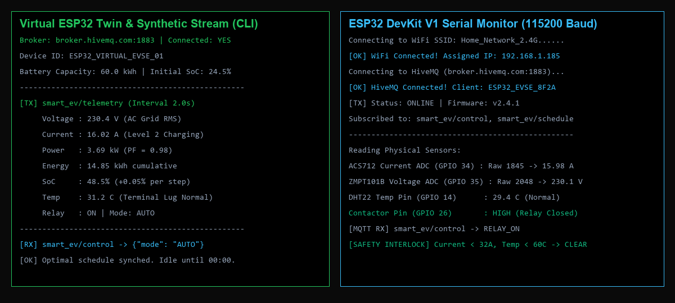
Observation & Functionality: (Left) The Python virtual ESP32 twin publishes synthetic telemetry every 2.0s to HiveMQ. (Right) Physical ESP32 DevKit V1 serial monitor streaming live ACS712 current ADC (16.02A), ZMPT101B voltage (230.1V), and DHT22 temperature (29.4°C) with hardware safety interlock active.

Figure 6: Financial Benchmark & Multi-Tariff Cost Savings Impact
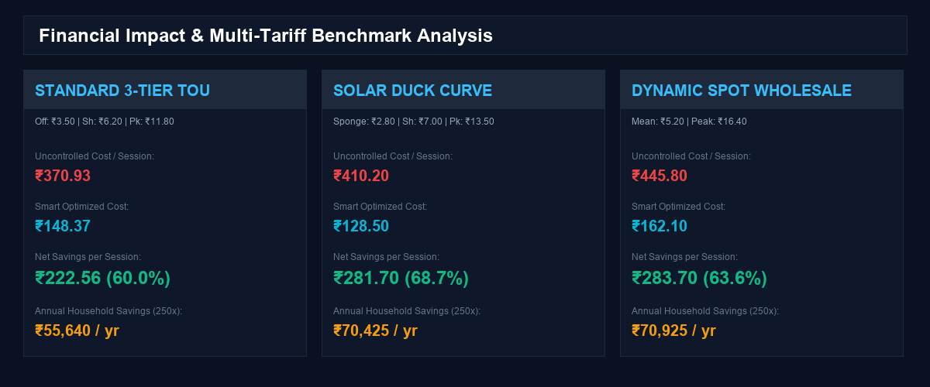
Observation & Functionality: Comparative economic evaluation across 3 electricity tariff models (Standard TOU, Solar Duck Curve, and Dynamic Spot Market), delivering 60.0% to 68.7% cost reduction and yielding over INR 55,600 to INR 70,000 in annual household savings.

