Date of Issue:

05 June 2015

**SAFETY DATA SHEET**

|  |
| --- |
| **1. Substance and Source Identification** |

**Product Identifier**

**RM Number:** 8466

**RM Name:** γ‑Hexachlorocyclohexane (Lindane)

**Other Means of Identification:** Not applicable.

**Recommended Use of This Material and Restrictions of Use**

This Reference Material (RM) is intended for use in the evaluation of procedures used in the measurement of lindane in environmental samples and for the preparation and evaluation of daily working standards used in the procedures listed in the Report of Investigation. RM 8466 is provided as a primary reference compound of measured purity for γ‑hexachlorocyclohexane (lindane). A unit of RM 8466 consists of one vial containing approximately 100 mg of lindane.

**Company Information**

|  |  |
| --- | --- |
| National Institute of Standards and Technology |  |
| Standard Reference Materials Program |  |
| 100 Bureau Drive, Stop 2300 |  |
| Gaithersburg, Maryland 20899-2300 |  |
|  |  |
| Telephone: 301-975-2200 | Emergency Telephone ChemTrec: |
| FAX: 301-948-3730 | 1-800-424-9300 (North America) |
| E-mail: [SRMMSDS@nist.gov](mailto:SRMMSDS@nist.gov) | +1-703-527-3887 (International) |
| Website: <http://www.nist.gov/srm> |  |

|  |
| --- |
| **2. HAZARDS IDENTIFICATION** |

**Classification**

**Physical Hazard:** Not classified.

**Health Hazard:** Acute Toxicity, Oral Category 3

Acute Toxicity, Dermal Category 3

Acute Toxicity, Inhalation Category 4

Carcinogen Category 2

STOT, Repeated Exposure Category 2

Reproductive Toxicity: Lactation

**Label Elements**

**Symbol**

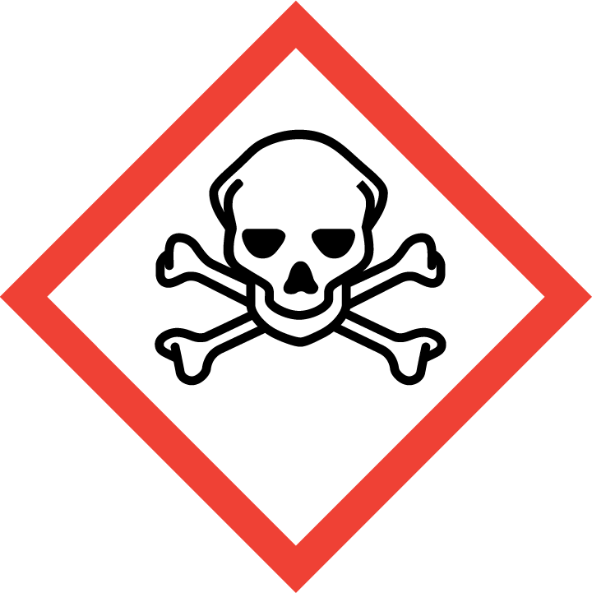 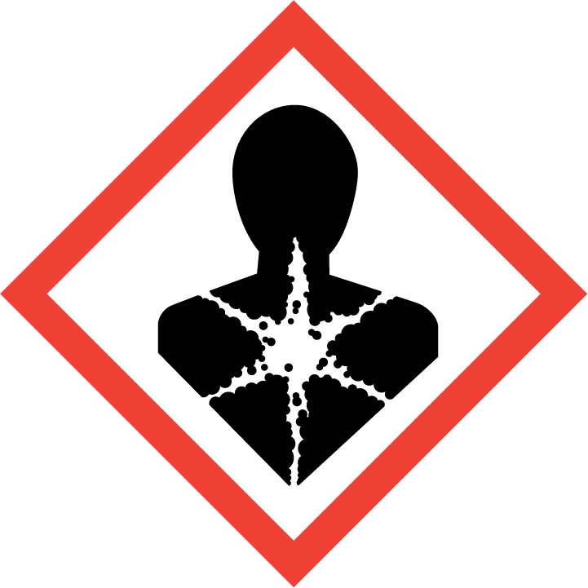

**Signal Word**

DANGER

**Hazard Statement(s):**

H301 Toxic if swallowed.

H311 Toxic in contact with skin.

H332 Harmful if inhaled.

H351 Suspected of causing cancer.

H362 May cause harm to breast-fed children.

H373 May cause damage to organs through prolonged or repeated exposure.

**Precautionary Statement(s):**

P201 Obtain special instructions before use.

P202 Do not handle until all safety precautions have been read and understood.

P260 Do not breathe dust or mist.

P263 Avoid contact during pregnancy and while nursing.

P264 Wash hands thoroughly after handling.

P270 Do not eat, drink or smoke when using this product.

P271 Use only outdoors or in a well-ventilated area.

P280 Wear protective gloves, protective clothing, and eye protection.

P301 + P310 If swallowed: Immediately call a call a doctor.

P330 Rinse mouth.

P302 + P352 If on skin: Wash with plenty of soap and water.

P304 + P340 If inhaled: Remove victim to fresh air and keep at rest in a position comfortable for breathing.

P308 + P313 If exposed or concerned: Get medical attention.

P361 + 364 Take off immediately all contaminated clothing and wash it before reuse.

P405 Store locked up.

P501 Dispose of contents and container according to local regulations.

**Hazards Not Otherwise Classified:** Not applicable.

**Ingredients(s) with Unknown Acute Toxicity:** Not applicable.

|  |
| --- |
| **3. COMPOSITION AND INFORMATION ON HAZARDOUS INGREDIENTS** |

**Substance:** Lindane

**Other Designations:** γ‑HCH; γ‑benzenehexachloride (γ‑BHC); 1,2,3,4,5,6-hexachlorocyclohexane; γ‑1,2,3,4,5,6‑hexachlorocyclohexane; RCA U129; C14H8Cl6.

Components listed below comply with OSHA’s 29 CFR 1910.1200.

|  |  |  |  |
| --- | --- | --- | --- |
| **Component(s)** | **CAS Number** | **EC Number**  **(EINECS)** | **Nominal Mass Concentration (%)** |
| Lindane | 58-89-9 | 200-401-2 | 99.9 |

|  |
| --- |
| **4. FIRST AID MEASURES** |

**Description of First Aid Measures:**

**Inhalation:** If adverse effects occur, remove to uncontaminated area. Give artificial respiration if not breathing. Get immediate medical attention.

**Skin Contact:** Wash skin with soap and water for at least 15 minutes while removing contaminated clothing and shoes. Get medical attention, if needed. Thoroughly clean and dry contaminated clothing and shoes before reuse.

**Eye Contact:** Flush eyes with water for at least 15 minutes. Then get immediate medical attention.

**Ingestion:** Contact local poison control center or physician immediately. Never make an unconscious person vomit or drink fluids. When vomiting occurs, keep head lower than hips to help prevent aspiration. If person is unconscious, turn head to side. Get medical attention immediately.

**Most Important Symptoms/Effects, Acute and Delayed:** Organochlorine pesticides cause liver and kidney damage.

**Indication of any immediate medical attention and special treatment needed, if necessary:** If any of the above symptoms are present, seek medical attention if needed.

|  |
| --- |
| **5. FIRE FIGHTING MEASURES** |

**Fire and Explosion Hazards:** Slight fire hazard. Dust/air mixtures may ignite or explode. See Section 9, “Physical and Chemical Properties” for flammability properties.

**Extinguishing Media:**

Suitable: Regular dry chemical, carbon dioxide, water, and regular foam.

Unsuitable: None listed.

**Specific Hazards Arising from the Chemical:** None listed.

**Special Protective Equipment and Precautions for Fire-Fighters:** Avoid inhalation of material or combustion byproducts. Wear full protective clothing and NIOSH approved self-contained breathing apparatus (SCBA).

**NFPA Ratings** (0 = Minimal; 1 = Slight; 2 = Moderate; 3 = Serious; 4 = Severe)

Health = 3 Fire = 1 Reactivity = 0

|  |
| --- |
| **6. ACCIDENTAL RELEASE MEASURES** |

**Personal Precautions, Protective Equipment and Emergency Procedures:** Any accumulated material on surfaces should be removed and properly disposed of. Use suitable protective equipment; see Section 8, “Exposure Controls and Personal Protection”.

**Methods and Materials for Containment and Clean up:** Do not touch spilled material. Notify safety personnel of spills. Absorb with sand or other non-combustible material. Collect spilled material in appropriate container for disposal. Isolate hazard area and deny entry. Subject to California Safe Drinking Water and Toxic Enforcement Act of 1986 (Proposition 65). Keep out of water supplies and sewers.

|  |
| --- |
| **7. HANDLING AND STORAGE** |

**Safe Handling Precautions:** Minimize dust generation and accumulation on surfaces. Routine housekeeping should be instituted to ensure that dusts do not accumulate on surfaces. See Section 8, “Exposure Controls and Personal Protection”.

**Storage:** Store and handle in accordance with all current regulations and standards. Keep separated from incompatible substances (See Section 10, “Stability and Reactivity”).

|  |
| --- |
| **8. EXPOSURE CONTROLS AND PERSONAL PROTECTION** |

**Exposure Limits:**

OSHA (PEL): 0.5 mg/m3 TWA.

Prevent or reduce skin absorption.

ACGIH (TLV): 0.5 mg/m3 TWA

Skin – potential significant contribution to overall exposure by the cutaneous route.

NIOSH (REL): 0.5 mg/m3 TWA

50 mg/m3 IDLH

Skin – potential for dermal absorption.

**Engineering Controls:** Provide local exhaust or process enclosure ventilation system. Ensure compliance with applicable exposure limits.

**Personal Protection:** In accordance with OSHA 29 CFR 1910.132, subpart I, wear appropriate Personal Protective Equipment (PPE) to minimize exposure to this material.

**Respiratory Protection:** If workplace conditions warrant a respirator, a respiratory protection program that meets OSHA 29CFR 1910.134 must be followed. Refer to NIOSH 42 CFR 84 for applicable certified respirators.

**Eye/Face Protection:** Wear splash resistant safety goggles with a face shield. An eye wash station should be readily available near areas of use.

**Skin and Body Protection:** Personal protective equipment for the body should be selected based on the task being performed and the risks involved and should be approved by a specialist before handling this product. Chemical-resistant gloves should be worn at all times when handling chemicals.

|  |
| --- |
| **9**. **Physical and Chemical Properties** |

| **Descriptive Properties:** | **Lindane** |
| --- | --- |
| **Appearance  (physical state, color, etc.):** | white or yellow crystalline solid |
| **Molecular Formula:** | C6H6Cl6 |
| **Molar Mass (g/mol):** | 290.83 |
| **Odor:** | damp, moldy odor |
| **Odor threshold:** | not available |
| **pH:** | not available |
| **Evaporation rate:** | not applicable |
| **Melting point/freezing point (ºC):** | 112 to 113  (233 to 235 °F) |
| **Specific Gravity (water=1):** | 1.89 |
| **Vapor Pressure (mmHg):** | 9.4 x 10–6 at 20 ºC |
| **Vapor Density (air = 1):** | not applicable |
| **Viscosity (cP):** | not applicable |
| **Solubility(ies):** | slightly soluble in water (0.10 ppm at 20 °C),  soluble in acetone, benzene, chloroform, cyclohexanone, ether, xylene, fats, and oils |
| **Partition coefficient (n-octanol/water):** | not available |
| **Particle Size:** | not available |
|  |  |
| **Thermal Stability Properties:** |  |
| **Autoignition Temperature (ºC):** | not available |
| **Thermal Decomposition (ºC):** | not available |
| **Initial boiling point and boiling range (ºC):** | 323 (613 ºF) |
| **Explosive Limits, LEL (Volume %):** | not available |
| **Explosive Limits, UEL (Volume %):** | not available |
| **Flash Point (ºC):** | not available |
| **Flammability (solid, gas):** | not available |

|  |
| --- |
| **10. Stability and Reactivity** |

**Reactivity:** Stable at normal temperatures and pressure.

|  |  |  |  |  |
| --- | --- | --- | --- | --- |
| **Stability:** | X | Stable |  | Unstable |

**Possible Hazardous Reactions:** None listed.

**Conditions to Avoid:** Avoid heat, flames, sparks and other sources of ignition. Keep out of water supplies and sewers.

**Incompatible Materials:** Bases, combustible materials, and metals.

**Fire/Explosion Information:** See Section 5, “Fire Fighting Measures”.

**Hazardous Decomposition:** Thermal decomposition will produce oxides of carbon, phosgene, and halogenated compounds.

|  |  |  |  |  |
| --- | --- | --- | --- | --- |
| **Hazardous Polymerization:** |  | Will Occur | X | Will Not Occur |

|  |
| --- |
| **11. TOXICOLOGICAL INFORMATION** |

|  |  |  |  |  |  |  |
| --- | --- | --- | --- | --- | --- | --- |
| **Route of Exposure:** | X | Inhalation | X | Skin | X | Ingestion |

**Symptoms Related to the Physical, Chemical and Toxicological Characteristics:** Nausea, vomiting, diarrhea, stomach pain, and headache.

**Potential Health Effects (Acute, Chronic and Delayed):**

**Inhalation:** Lindane may be absorbed through the lungs and may produce central nervous system effects including muscle twitching, myoclonic jerking, and convulsive seizures with periods of unconsciousness. Other symptoms of poisoning may be headache, nausea, vomiting, malaise, and dizziness. Chronic exposure may produce symptoms of depression, sleeplessness, headache, vomiting, asthenia, sleeplessness and neurological effects.

**Skin Contact:** Same symptoms as in inhalation and ingestion if sufficient amounts are absorbed through the skin. Chronic exposure may cause dermatitis and urticarial.

**Eye Contact:** May cause irritation. Prolonged or repeated exposure may cause conjunctivitis.

**Ingestion:** Ingestion of food is the primary source of exposure for the general population. Acute and chronic ingestion may cause malaise, faintness, nausea, vomiting, muscle spasms, dizziness, ataxia, tremor, restlessness, cyanosis, kidney damage, liver damage, convulsions, unconsciousness, respiratory failure, and death. Lindane may cross the placenta and can be excreted in breast milk.

**Numerical Measures of Toxicity:**

**Acute Toxicity:**

Category 3, Rat, Oral LD50: 76 mg/kg

Category 4, Rat, Inhalation LC50: 1.6 mg/L (4 h)

Category 3, Rabbit, Dermal LD50: 900 mg/kg

**Skin Corrosion/Irritation:** Not classified; no data available.

**Serious Eye Damage/Eye Irritation:** Not classified; no data available.

**Respiratory Sensitization:** Not classified; no data available.

**Skin Sensitization:** Not classified; no data available.

**Germ Cell Mutagenicity:** Not classified; no data available.

**Carcinogenicity:** Category 2

|  |  |  |  |  |
| --- | --- | --- | --- | --- |
| **Listed as a Carcinogen/Potential Carcinogen** | X | Yes |  | No |

Lindane is listed by IARC as Group 2B (possibly carcinogenic to humans), and NTP as *reasonably anticipated to be a human carcinogen*. It is not listed by OSHA as a carcinogen/potential carcinogen.

Tumorigenic effects: Mouse, Oral TD: 25 g/kg (73 weeks)

Mutagenic effects: Hamster, 200 mg/L

**Reproductive Toxicity:**

Lactation: May be excreted in breast milk.

**Specific Target Organ Toxicity, Single Exposure:** Not classified; no data available.

**Specific Target Organ Toxicity, Repeated Exposure:** Category 2.

**Aspiration Hazard:** Not classified; no data available.

|  |
| --- |
| **12. ECOLOGICAL INFORMATION** |

**Ecotoxicity Data:**

Fish Toxicity: Rainbow trout (*Oncorhynchus mykiss*) LC50 [static]: 16 to 19 µg/L (96 h)

Bluegill (*Lepomis macrochirus*) LC50 [static]: 23 to 28 µg/L (96 h)

Invertebrate Toxicity: Water flea (*Daphnia magna*) EC50 [static]: 0.48 to 0.551 mg/L (48 h)

**Persistence and Degradability:** No data available.

**Bioaccumulative Potential:** BCF value 168.66 (1400 fish species).

**Mobility in Soil:** No data available.

**Other Adverse effects:** No data available.

|  |
| --- |
| **13. DISPOSAL CONSIDERATIONS** |

**Waste Disposal:** Dispose of waste in accordance with all applicable federal, state, and local regulations. Subject to disposal regulations: US EPA 40 CFR 262. Hazardous Waste Numbers: U129; D013 for concentrations at or above 0.4 mg/L.

|  |
| --- |
| **14. TRANSPORTATION INFORMATION** |

**U.S. DOT and IATA:** UN2761, Organochlorine pesticide, solid, toxic (lindane), 6.1, PG II, E4.

|  |
| --- |
| **15. REGULATORY INFORMATION** |

**U.S. Regulations:**

CERCLA Sections 102a/103 (40 CFR 302.4): 1 lb (0.454 kg) final RQ

SARA Title III Section 302 (40 CFR 355.30): 1000 lb lower TPQ; 10 000 lb upper TPQ.

SARA Title III Section 304 (40 CFR 355.40): 1 lb EPCRA RQ.

SARA Title III Section 313 (40 CFR 372.65): 0.1 % de minimis concentration.

OSHA Process Safety (29 CFR 1910.119): Not regulated.

SARA Title III Sections 311/312 Hazardous Categories (40 CFR 370.21):

ACUTE HEALTH: Yes.

CHRONIC HEALTH: Yes.

FIRE: No.

REACTIVE: No.

PRESSURE: No.

**State Regulations:**

California Proposition 65: WARNING! This product contains a chemical (lindane) known to the state of California to cause cancer.

**U.S. TSCA Inventory:** Listed.

**TSCA 12(b), Export Notification:** Lindane is listed.

**Canadian Regulations:**

WHMIS Information: Not provided for this material.

|  |
| --- |
| **16. OTHER INFORMATION** |

**Issue Date:** 05 June 2015

**Sources:** ChemADVISOR, Inc., SDS *Lindane*, 20 March 2015.

Hazardous Substances Data Bank (HSDB), National Library of Medicine's TOXNET system, *Lindane CAS No.* 58-89-9; available at <http://toxnet.nlm.nih.gov> (accessed Jun 2015).

U.S. Environmental Protection Agency (EPA), Technology Transfer Network Air Toxics Web Site,

Lindane (Gamma-Hexachlorocyclohexane); available at <http://www.epa.gov/ttn/atw/hlthef/lindane.html> (accessed Jun 2015).

**Key of Acronyms:**

|  |  |  |  |
| --- | --- | --- | --- |
| ACGIH | American Conference of Governmental Industrial Hygienists | NRC | Nuclear Regulatory Commission |
| ALI | Annual Limit on Intake | NTP | National Toxicology Program |
| CAS | Chemical Abstracts Service | OSHA | Occupational Safety and Health Administration |
| CERCLA | Comprehensive Environmental Response, Compensation, and Liability Act | PEL | Permissible Exposure Limit |
| CFR | Code of Federal Regulations | RCRA | Resource Conservation and Recovery Act |
| DOT | Department of Transportation | REL | Recommended Exposure Limit |
| EC50 | Effective Concentration, 50 % | RM | Reference Material |
| EINECS | European Inventory of Existing Commercial Chemical Substances | RQ | Reportable Quantity |
| EPCRA | Emergency Planning and Community Right-to-Know Act | RTECS | Registry of Toxic Effects of Chemical Substances |
| IARC | International Agency for Research on Cancer | SARA | Superfund Amendments and Reauthorization Act |
| IATA | International Air Transportation Agency | SCBA | Self‑Contained Breathing Apparatus |
| IDLH | Immediately Dangerous to Life and Health | SRM | Standard Reference Material |
| LC50 | Lethal Concentration, 50 % | STEL | Short Term Exposure Limit |
| LD50 | Lethal Dose, 50 % | TLV | Threshold Limit Value |
| LEL | Lower Explosive Limit | TPQ | Threshold Planning Quantity |
| MSDS | Material Safety Data Sheet | TSCA | Toxic Substances Control Act |
| NFPA | National Fire Protection Association | TWA | Time Weighted Average |
| NIOSH | National Institute for Occupational Safety and Health | UEL | Upper Explosive Limit |
| NIST | National Institute of Standards and Technology | WHMIS | Workplace Hazardous Materials Information System |

**Disclaimer:** Physical and chemical data contained in this SDS are provided only for use in assessing the hazardous nature of the material. The SDS was prepared carefully, using current references; however, NIST does not certify the data in the SDS. The reference values for this material are given in the NIST Report of Investigation.

Users of this RM should ensure that the SDS in their possession is current. This can be accomplished by contacting the SRM Program: telephone (301) 975-2200; fax (301) 948-3730; e-mail srmmsds@nist.gov; or via the Internet at http://www.nist.gov/srm.