**MAIN.PY** → The main program used to parse documents

**KEYWORDS.PY** → Gets a list of keywords for each SRM

**Run main.py :**

* In Terminal, cd to C:\programs\NLP\NLPParser (or wherever the NLPParser program is located on a given computer)
* Type python3 main.py
* Hit enter.
* Follow the prompts.

**To convert pdf/word files to .txt form:**

* 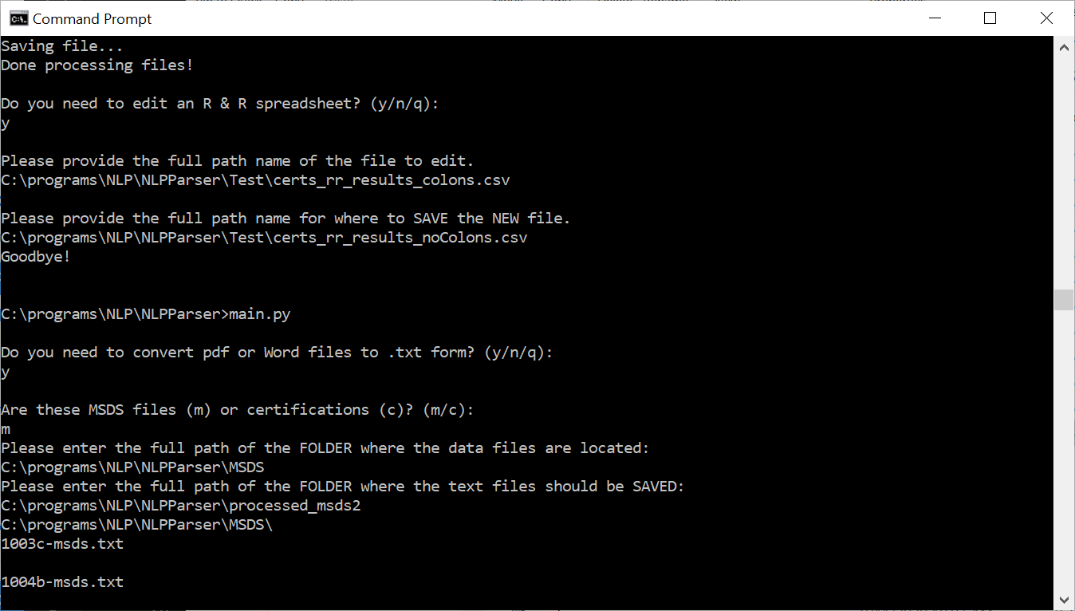
* NOTE: The **MSDS** folder and the **CERTS** folder contain the pdf/docx files.
  + The results go in C:\programs\NLP\NLPParser\processed_msds OR C:\programs\NLP\NLPParser\processed_certs
* You can just drag and drop the folders into the Terminal.
* The program should display files/SRM’s being processed.

To parse the data into an RandR-readable spreadsheet:

* 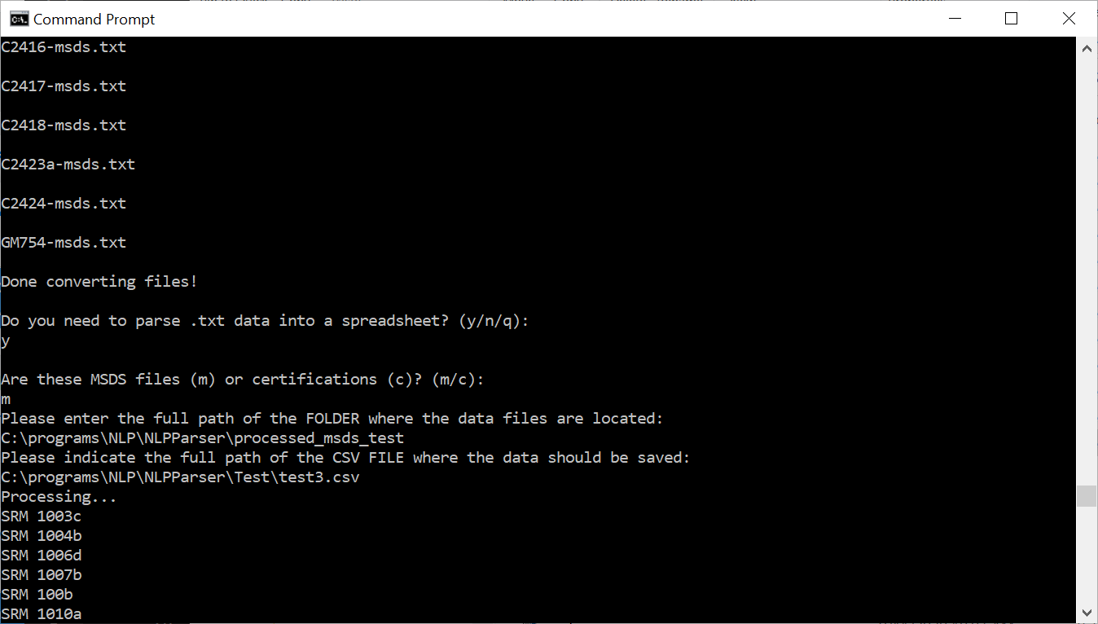
* The program will create the .csv. You just need to provide what you want the file name to be (full path).
* You can just drag and drop the folders into the command prompt.
* The program should display files/SRM’s being processed.

At this point, the results must be run through RandR (NIST’s NLP Program).

**Run keywords.py :**

* Cd to C:\programs\NLP\NLPParser
* Type python3 keywords.py
* Hit enter.
* Follow the prompts:
* 