Short intro to Python: <http://do1.dr-chuck.com/pythonlearn/EN_us/pythonlearn.pdf>

**SET UP**

[**Download**](https://www.python.org/downloads/) **Python 3.9.2:**

* Double-click on python-3.9.2-macosx10.9.pkg and follow the steps in the installer, accepting default parameters (unless otherwise desired).

**Install packages from Terminal:**

* Pip install packages that will be used in the program:
  + pip3 install pandas
  + pip3 install ocrmypdf
  + pip3 install --pre tesseract
  + pip3 install ghostscript
  + pip3 install pngquant
  + pip3 install tika
  + pip3 install docx2txt
  + If you get a ModuleNotFoundError for anything when you run the program, simply type ‘pip3 install [moduleName]’ into Terminal to install whatever is missing

**Download** [**VS Code**](https://code.visualstudio.com/download) **or another text editor/IDE that will run Python**

* Double-click on the download and install.
* Add Python and Code Runner Extensions to VS Code
  + 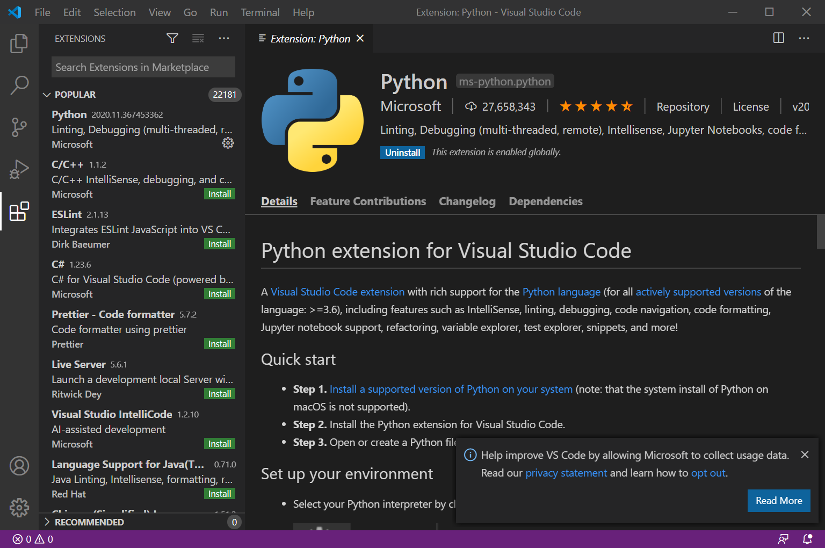
* Click on the VS Code option to select Python interpreter. Select version 3.9.
  + 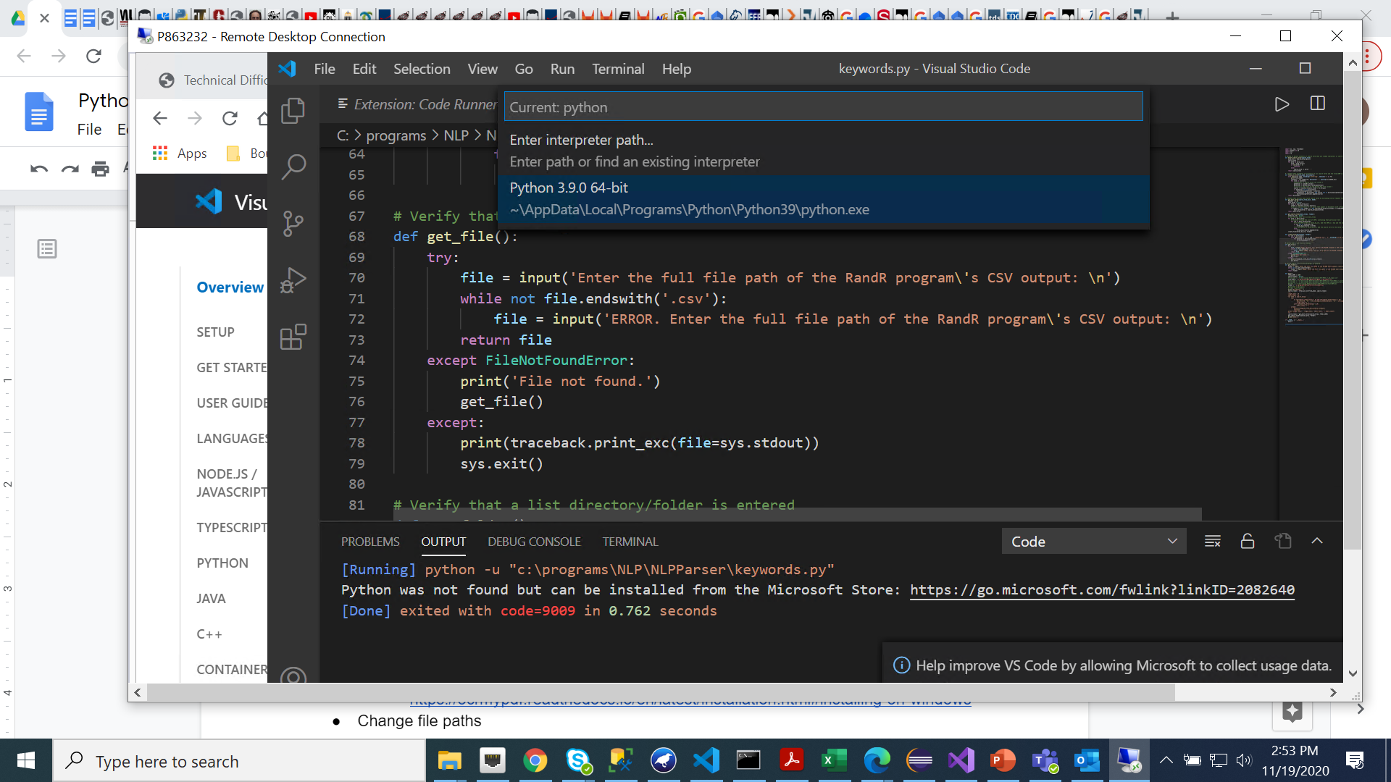
* You should then be prompted to install Linter pylint. Click install.

**To run NLPParser Program, see Google Doc called “Run R&R Parser”. It explains how to:**

* Convert PDF’s & .DOCX files to .TXT
* Parse TXT files
* Edit RandR output to prepare it to be entered into the database
* Run Keywords program that generates lists of keywords for each SRM