National Institute of Standards & Technology



Report of Investigation

Reference Material 8394

Tissue Engineering Reference Scaffolds for Cell Culture

This Reference Material (RM) is intended to provide a common source tissue‑engineering scaffold for measurement comparisons of cell adhesion and proliferation. A unit of RM 8394 consists of 24 free‑form fabricated [1] poly(ε‑caprolactone) (PCL) scaffolds in a 96‑well plate. Each plate contains 24 scaffolds and is packaged in a heat‑sealed plastic pouch and then boxed. The scaffolds have six layers of struts and each scaffold is approximately 5.3 mm in diameter, 1.6 mm in height, with 300 µm strut diameter, 500 µm strut spacing, and 60 % porosity.

**Reference Values:** Reference values for strut diameter, strut spacing and porosity are provided in Table 1 (see Figure 1 for schematic of structural parameters). Stereomicroscope images and 3D tomographs of the scaffolds are provided in Figure 2. Figure 3 shows the structure of the scaffolds in the scanning electron microscope. Figure 4 shows the morphology, adhesion and proliferation of osteoblasts on the scaffolds after 1 d or 7 d culture. Quantitative reference data for cell number on scaffolds after 1 d and 7 d culture as measured by a DNA assay is given in Figure 5. Reference values are noncertified values that are the best estimate of the true value; however, the values do not meet the NIST criteria for certification [2]. The scaffolds shapes and sizes may differ from unit to unit. The uncertainties given provide a gauge of the size of this variation.

**Expiration of Value Assignment:** **RM 8394** is valid, within the measurement uncertainty specified, until **31 December 2022**, provided that the RM is handled and stored in accordance with the instructions given in this report (see “Instructions for Handling, Storage, and Use”). This report is nullified if the RM is damaged, contaminated, or otherwise modified.

**Maintenance of RM:** NIST will monitor this RM over the period of its validity. If substantive technical changes occur that affect the reference values before expiration, NIST will notify the purchaser. Registration (see attached sheet) will facilitate notification.

Overall direction and coordination of the analyses was performed C.G. Simon, Jr., of the NIST Biosystems and Biomaterials Division.

Statistical consultation for the analysis of data was provided by W. Liggett, H‑K. Liu, and A. Possolo of the NIST Statistical Engineering Division.

Support aspects involved in the issuance of this RM were coordinated through the NIST Office of Reference Materials.

Anne L. Plant, Chief

Biosystems and Biomaterials Division

Gaithersburg, MD 20899 Robert L. Watters, Jr., Director

Report Issue Date: 24 April 2013 Office of Reference Materials

**INSTRUCTIONS FOR HANDLING, STORAGE, AND USE**

**Handling:** Opening and processing RM 8394 should be performed under a laminar flow hood to maintain sterility, wear dust‑free gloves, and only handle the scaffold with clean, sterile forceps.

**Storage:** The scaffolds should be stored at room temperature and protected from exposure to ultraviolet radiation and moisture.

**Use:** If scaffolds are to be used for cell culture, do not pick them up directly, even with gloves. They should only be handled with clean, sterile forceps.

*Sterilization of Scaffolds:* Scaffolds were sterilized by gamma irradiation prior to shipping to NIST and should remain sterile indefinitely if the heat-sealed plastic pouch remains unopened. We do not recommend additional gamma irradiation for sterilization as this could change the surface properties of the scaffolds. It has been reported, however, that gamma irradiation does not affect cell adhesion to PCL films [3]. Scaffolds can be re‑sterilized with a bench-top ethylene oxide sterilizer. After ethylene oxide sterilization, scaffolds should be degassed under a house vacuum for 3 d and incubated in phosphate buffered saline (PBS) for 3 d to remove potential ethylene oxide residuals, which can be toxic to cells. Scaffolds may also be disinfected by incubating for 10 min in 70 % (by mass) ethanol in water solution, followed by several rinses in PBS.

# PREPARATION AND ANALYSIS([1])

Scaffolds were purchased from 3D‑Biotek, LLC. Scaffolds were made by a freeform fabrication process (precision extrusion deposition) [1] in a 0°/90° lay‑down pattern using a research‑grade PCL polymer. The number averaged relative molecular mass (*M*n), was 52 855 g/mol, the mass averaged relative molecular mass (*M*w), was 84 889 g/mol and the polydispersity (*M*w/*M*n) was 1.61, as determined by gas phase chromatography.

**Scaffold Structural Analysis**

Two scaffolds were selected from five different plates (five different units) for a total of ten scaffolds. These same ten scaffolds were used for all the structural measurements and are shown in Figure 2.

*Stereomicroscopy Scaffold Strut Diameter and Strut Spacing*: A stereomicroscope was used to measure the strut spacing and the strut diameter at 3 locations in the 10 scaffolds.

*Gravimetry Scaffold Porosity*: The porosity of the scaffolds was determined by gravimetric analysis. Calipers were used to determine the height and diameter of the scaffolds. Scaffolds have a slightly tapered profile where they are wider on one face than the other as shown in Figure 2b. Thus, when diameter was measured with calipers, the diameter measured was the diameter of the top face. Two caliper measurements of the height were made and averaged. Four caliper measurements of diameter were made and averaged. The scaffolds were weighed to determine mass. Two mass measurements were made and averaged. The density of the PCL is 1.145 g/mL. The following formula was used to determine porosity:

where  = 3.14, *r* is scaffold radius (in centimeters), *h* is scaffold height (in centimeters), *m* is scaffold mass (in grams) and *d* is PCL density (in grams per cubic centimeters).

*X‑Ray Microcomputed Tomography* (μCT) *Strut Diameter, Strut Spacing, and Porosity*: Scaffolds were imaged by using a Scanco μCT 40 (55 kVp, 145 μA, 6 µm voxel size, threshold 33, sigma 1.2, support 2). A Threshold value of 33 was chosen based on scaffold voxel intensity histograms which showed that 33 was the minimum between the background peak and the scaffold peak. For porosity calculations, the region of interest was defined just inside the edges of the scaffold to reduce edge effects in the analysis. 3D image analysis tools were used to calculate both the strut diameter and the strut spacing in both the *xy*‑plane and in the *z*‑axis. The strut diameters and strut spacings were measured at two locations in each 3D tomograph.

*Scanning Electron Microscopy (SEM)*: Scaffolds were sputter‑coated with gold and imaged (15 kV, Hitachi S‑4700‑II FE‑SEM).

**Reference Values:** Table 1 lists the average mass, diameter, height, porosity, strut diameter, and strut spacing, measured as described below.

Table 1. Reference Values for Scaffolds

|  |  |  |  |
| --- | --- | --- | --- |
| Measurand | Reference Value(a) | Units | Standard Deviation(b) |
| Mass | 13.4 ± 2.0 | mg | 0.84 |
| Diameter | 5.3 ± 0.2 | mm | 0.10 |
| Height (thickness) | 1.61 ± 0.08 | mm | 0.033 |
|  |  |  |  |
| Porosity (gravimetry)(c) | 66.8 ± 5.2 | % air | 2.2 |
| Porosity (µCT)(c) | 60.4 ± 6.2 | % air | 2.6 |
|  |  |  |  |
| Strut Diameter (microscopy, *xy*‑plane) | 306 ± 45 | μm | 19 |
| Strut Diameter (µCT, *xy*‑plane) | 316 ± 40 | μm | 17 |
| Strut Diameter (µCT, *z*‑axis) | 313 ± 40 | μm | 17 |
| Strut Spacing (microscopy, *xy*‑plane) | 472 ± 64 | μm | 27 |
| Strut Spacing (µCT, *xy*‑plane) | 477 ± 74 | μm | 31 |
| Strut Spacing (µCT, *z*‑axis) | 198 ± 64 | μm | 27 |

(a) The range, reference value  expanded uncertainty, are 95 % prediction intervals. The expanded uncertainty, *U*, is calculated as *U = ku*c, where *u*c is the sample standard deviation of the analyte, and the coverage factor, *k*, is determined to be 2.37. These intervals are expected to include a future NIST measurement result of the analyte mean for a randomly drawn unit of RM 8394 with approximately a 95 % level of confidence [4].

(b) The standard deviation obtained from the 10 scaffolds measured [4].

(c) The discrepancy between porosity measured by gravimetry versus μCT can be explained in terms of edge effects. The edges of the scaffolds are irregular and not perfectly uniform (see Figure 2). These irregularities on scaffold edges result in void areas contributing to the porosity as calculated by gravimetry since calipers will detect the outermost strut as the edge of the scaffold (resulting in inflated porosity values). For the μCT calculation, the “volume for analysis” was chosen such that it was completely inside the scaffold perimeter and excluded the scaffold edges. Thus, the μCT value for porosity (60.4 %) was for an idealized scaffold that did not have irregular edges.

**Cell Culture and DNA Analysis**

*Cell Culture and Medium*:The MC3T3‑E1 murine calvarial osteoblast cell line (Riken Cell Bank, Japan) was used as it is a well‑characterized in vitro model for osteoblasts [5,6]. Cells were cultured in media prepared from α‑modification of Eagle’s minimum essential medium, supplemented with 10 % volume fraction of fetal bovine serum and 0.06 mg/mL of kanamycin sulfate, as described [7]. Cells were cultured in a 5 % CO2 atmosphere (by volume) at 37 °C. Cells were passaged with 0.25 % mass fraction trypsin containing 1 mmol/L EDTA (ethylenediaminetetraacetic acid). Passage 4 cells at 80 % confluency were used for all experiments. Cells were counted with a haemocytometer.

*Seeding Cells on Scaffolds*: The scaffolds were placed in the 96‑well plates with the tapered side down (Figure 2b). Scaffolds were used as received without further sterilization. Medium (200 μL) was added to each well. The scaffolds were exposed to medium with serum for a total of 30 min to 1 h prior to seeding with cells. During the exposure to medium, a house vacuum was applied to the plates for 30 s, released and reapplied for another 30 s. The vacuum helps the scaffold pores to wet thoroughly with the medium. Medium (100 μL) was removed from each well and replaced with 100 μL of the medium containing the 20 000 MC3T3‑E1 osteoblasts in suspension. Note that time of scaffold exposure to medium with serum can affect cell adhesion to scaffolds due to protein adsorption effects.

*Cell Culture on Scaffolds*: The plates with cells were cultured for one day. For the cells incubated for seven days, the scaffolds were moved to a new well on day two using sterile forceps and fresh media (200 μL). Moving of the scaffolds to a new well removes the cells on the scaffolds from cells adherent on the bottoms of the wells to minimize paracrine signals from cells not on the scaffolds. The medium was changed on day three.

*Assay Initiation*: Assays were initiated at 24 h ± 1 h for the one‑day time point or 168 h ± 2 h for the seven‑day time point.

*Fluorescence Microscopy:* Cell‑laden scaffolds were removed from medium, immediately placed in 3.7 % (by mass) formaldehyde in 0.1 mol/L phosphate buffered saline (PBS) for 1 h at 37 °C, permeabilized in 0.2 % (by mass) Triton X‑100 for 5 min at 37 °C and stained with 1 μmol/L Sytox green and 33 nm Alexa fluor 546 phalloidin in PBS for 1 h at 37 °C. Scaffolds were rinsed with PBS (0.1 mol/L), rinsed with deionized water and air‑dried. Cells were imaged using an inverted epifluorescence microscope. Images were collected on red and green channels and were merged to yield two channel nuclei‑actin images as shown in Figure 4.

*DNA Assay for Cell Number*: A DNA quantitation kit (Picogreen assay, Invitrogen, Grand Island, NY) was used to determine the amount of DNA on the scaffolds as a measure of the number of cells at 1 d and 7 d after seeding. The scaffolds were removed from medium, rinsed in PBS, incubated in 0.2 mL lysis solution [0.02 % by mass sodium dodecyl sulfate and 0.2 mg/mL Proteinase K in TE (Tris‑EDTA) buffer] for 24 h at 37 °C in 96‑well plates. TE buffer is 10 mmol/L Tris‑HCl [tris(hydroxymethyl)aminomethane] and 1 mmol/L EDTA at pH 7.5. Cell lysate (0.05 mL) from scaffolds was transferred to a fresh 96‑well plate and diluted 1:1 (by volume) with 0.05 mL of Picogreen DNA reagent. Fluorescence intensity was measured by a microplate reader using excitation wavelength 488 nm and emission wavelength 525 nm. A calibration plot prepared from serial dilutions of a supplier‑provided DNA solution was used to calibrate readings. The DNA fluorescence measurements of experimental samples must fall within the dynamic range of the DNA calibration plot. Note that cells on scaffolds can be stored frozen if the DNA assay must be postponed [rinse scaffolds in PBS (0.1 mol/L) prior to freezing].

*Replicates*: This entire experiment was repeated three separate times, using a fresh vial of cells for each experiment with start times separated by one week for each experiment. Six scaffolds were evaluated for each time point, for each week.



Figure 1. Diagram of scaffold with definitions of strut structural parameters identified.

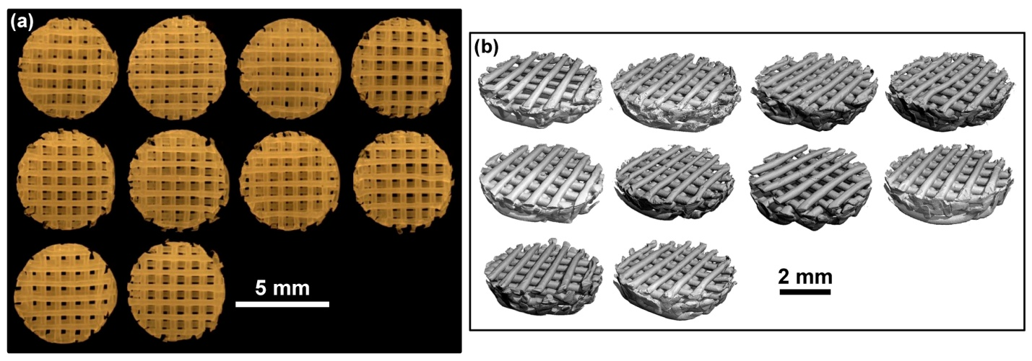

Figure 2. Stereomicrographs (a) and X‑ray microcomputed 3D tomographs (b) of the 10 scaffolds used for structural characterization.

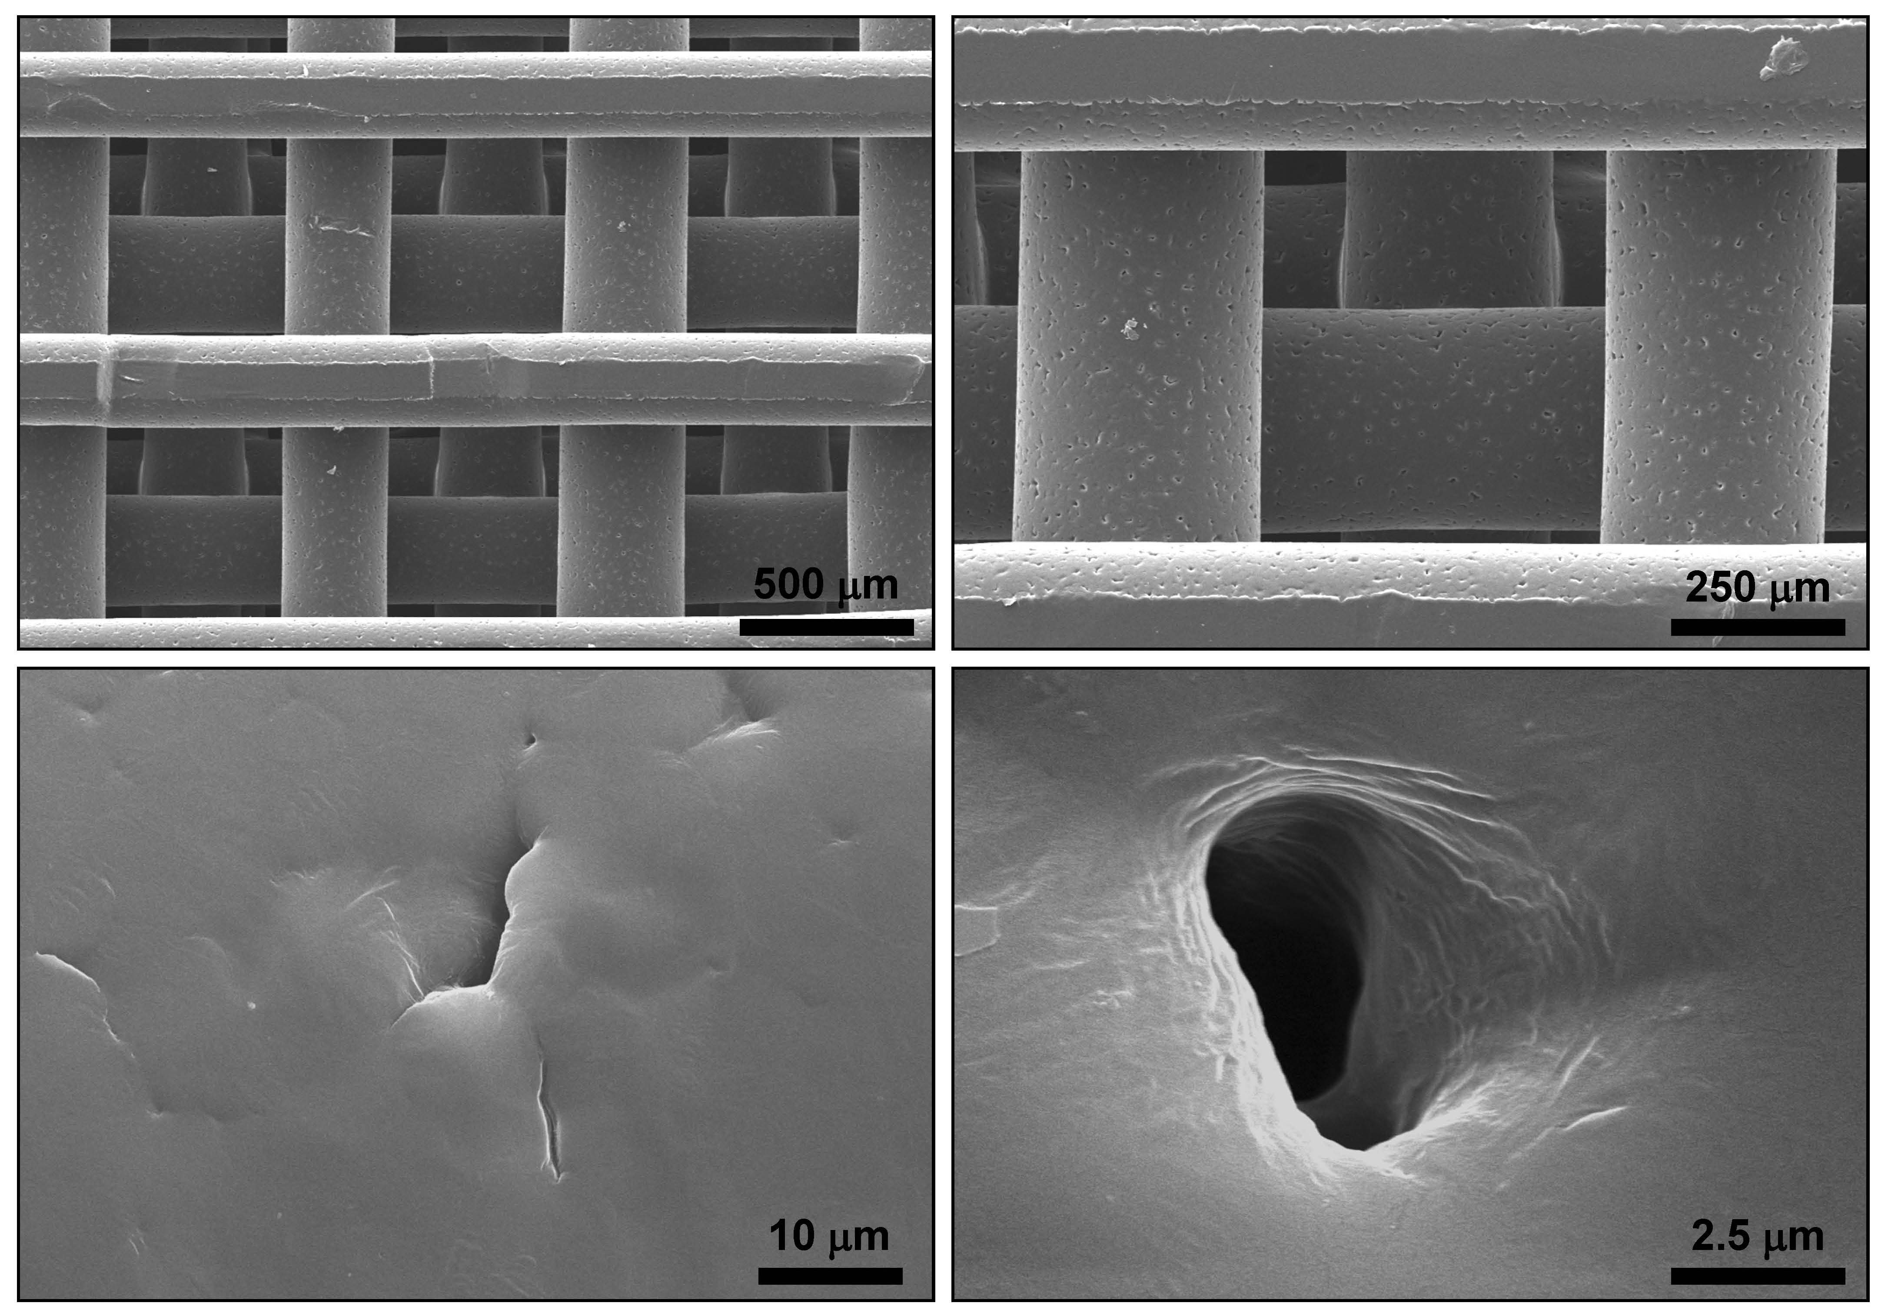

Figure 3. Scanning electron micrographs of a reference scaffold at various magnifications:  
500 μm – top left; 50 μm – top right; 10 μm – bottom left; 2.5 μm – bottom right.

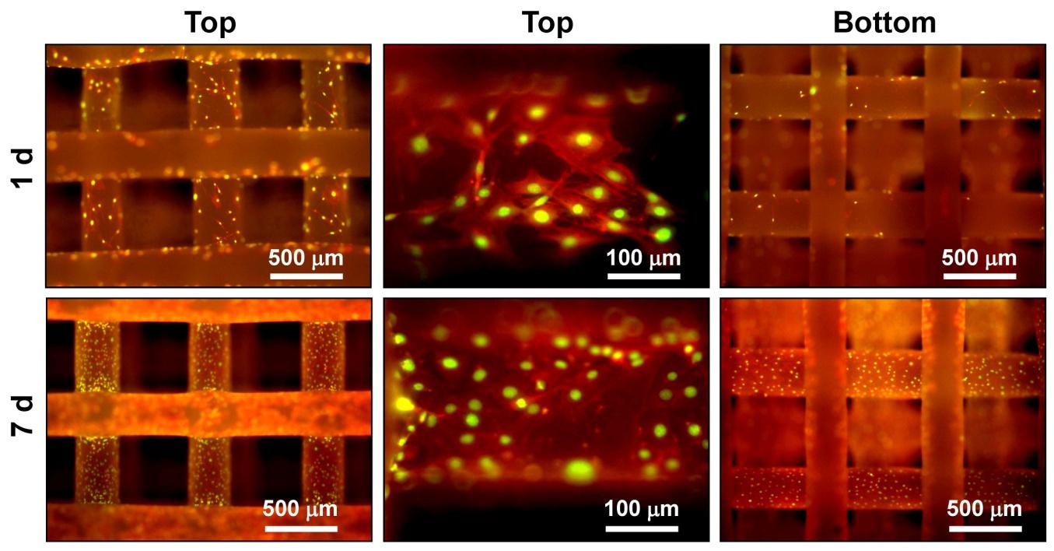

Figure 4. Fluorescence micrographs of MC3T3‑E1 osteoblasts cultured for 1 d (top row) or for 7 d (bottom row) on reference scaffolds. The left column shows that osteoblasts proliferated on the scaffolds from 1 d to 7 d. The center column shows that cells have a well spread morphology on the top of the struts at 1 d and 7 d. The right column contains images of the bottom of the scaffolds; not many osteoblasts were present on the bottom of the struts at 1 d but the osteoblasts had proliferated and migrated to the bottom of the struts by 7 d.

Red = actin = Alexa fluor 546 phalloidin; Green = nuclei = Sytox green.

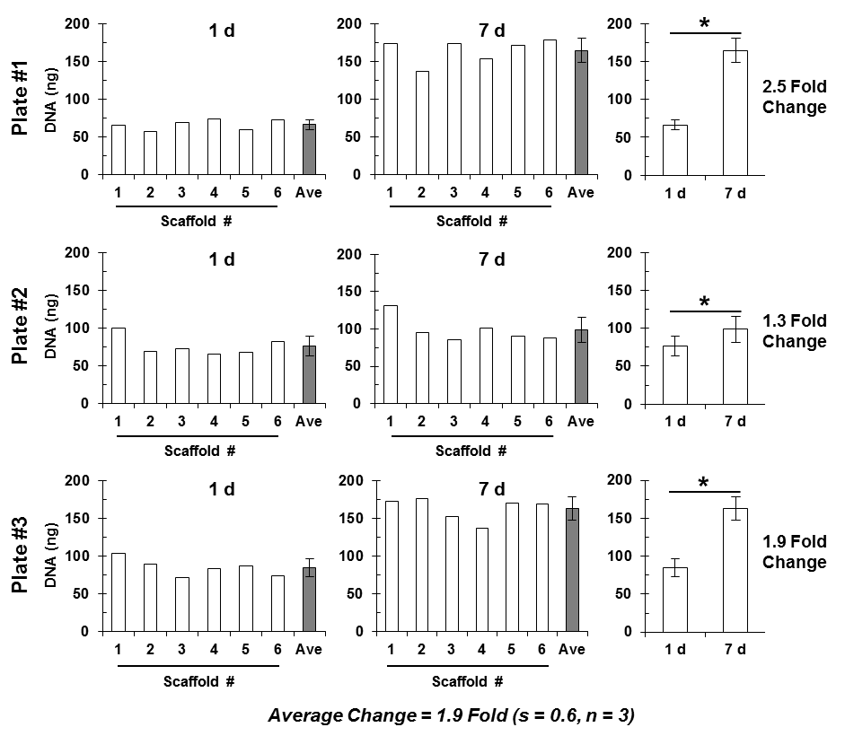

Figure 5. The Picogreen DNA assay was used to measure osteoblast number on reference scaffolds at 1 d for adhesion (left column) and 7 d for proliferation (middle column). The experiment was performed three separate times on different weeks represented by plates #1 to #3. Six scaffolds were used for each time point. The results of the six scaffolds are presented as the open bars in left and middle columns. The grey bars represent the means where the standard deviation (s) (n = 6) is indicated by the error bracket. The plots in the right column are the mean values for 1 d and 7 d (same as grey bars in the left and middle columns). The significant differences are indicated by the asterisks (t‑test, p < 0.05). The fold change was calculated by dividing the 7 d value by the 1 d value.

The data in Figure 5 gives an example of the variability experienced when the DNA assay was run three times by the same operator in the span of one month. On average, the amount of DNA roughly doubled from 1 d to 7 d culture for MC3T3‑E1 mouse osteoblasts on PCL freeform fabricated scaffolds (1.9‑fold average increase, s = 0.6, n = 3). When using the RM 8394 reference scaffolds with adherent cells that proliferate, users should expect to see a statistically significant increase in DNA from 1 d to 7 d culture. RM 8394 reference scaffolds should be used to control for variability in 3D scaffold material properties during in vitro testing of cell adhesion and proliferation.

The magnitudes of the DNA assay values are highly variable for many reasons: microplate reader variability, batch‑to‑batch variability in Picogreen reagent, manufacturer differences in 96‑well plate properties used for fluorescence readings, pipetting errors, operator variability in performing cell seeding and culture, batch‑to‑batch variability in serum composition, fluctuations in incubator CO2/temperature, variability in cell proliferation rate, etc. This variability is acceptable as long as the DNA fluorescence values fall within the dynamic range of the DNA calibration plot.

REFERENCES

[1] Darling, A.L.; Sun, W.; *3D Microtomographic Characterization of Precision Extruded Poly‑‑caprolactone Scaffolds*; J. Biomed. Mater. Res., Part B, Vol. 70B: pp. 311–317 (2004).

[2] May, W.; Parris, R.; Beck, C.; Fassett, J.; Greenberg, R.; Guenther, F.; Kramer, G.; Wise, S.; Gills, T.; Colbert, J.; Gettings, R.; MacDonald, B.; *Definitions of Terms and Modes Used at NIST for Value‑Assignment of Reference Materials for Chemical Measurements*;NIST Special Publication 260‑136; U.S. Government Printing Office: Washington, DC (2000); available at <http://www.nist.gov/srm/publications.cfm> (accessed Apr 2013)

[3] Cottam, E.; Hukins, D.W.L.; Lee, K.; Hewitt, C.; Jenkins, M.J.; *Effect of Sterilisation By Gamma Irradiation on the Ability of Polycaprolactone (PCL) to Act as a Scaffold Material*; Medical Engineering and Physics, Vol. 31, pp. 221–226 (2009).

[4] JCGM 100:2008; *Evaluation of Measurement Data —* *Guide to the Expression of Uncertainty in Measurement* (GUM 1995 with Minor Corrections); Joint Committee for Guides in Metrology (2008); available at <http://www.bipm.org/utils/common/documents/jcgm/JCGM_100_2008_E.pdf> (accessed Apr 2013); see also Taylor, B.N.; Kuyatt, C.E.; *Guidelines for Evaluating and Expressing the Uncertainty of NIST Measurement Results*; NIST Technical Note 1297; U.S. Government Printing Office: Washington, DC (1994); available at <http://www.nist.gov/pml/pubs/tn1297/index.cfm> (accessed Apr 2013).

[5] Sudo, H.; Kodama, H.; Amagai, Y.; Yamamoto, S.; Kasai, S.; *In Vitro Differentiation and Calcification in a New Clonal Osteogenic Cell Line Derived From Newborn Mouse Calvaria*; J. Cell Biol., Vol. 96, Issue 1, pp. 191‑198 (1983).

[6] Powell, K.; Leslie, M.; *Dishing Up Bone Formation*; J. Cell Biol., Vol. 171: p. 409 (2005).

[7] Yang, Y.; Bolikal, D.; Becker, M.L.; Kohn, J.; Zeiger, D.; Simon, Jr., C.G.; *Combinatorial Polymer Scaffold Libraries for Screening Cell‑Biomaterial Interactions in 3D*; Advanced Materials, Vol. 20, Issue 11, pp. 2037–2043 (2008).

*Users of this RM should ensure that the Report of Investigation in their possession is current. This can be accomplished by contacting the SRM Program: telephone (301) 975‑2200; fax (301) 948‑3730; e‑mail*[*srminfo@nist.gov*](mailto:srminfo@nsit.gov)*; or via the Internet at* [*http://www.nist.gov/srm*](http://www.nist.gov/srm)*.*

1. () Certain commercial equipment, instruments, or materials are identified in this report to adequately specify the experimental procedure. Such identification does not imply recommendation or endorsement by NIST, nor does it imply that the materials or equipment identified are necessarily the best available for the purpose.