Date of Issue:

19 May 2015

**SAFETY DATA SHEET**

|  |
| --- |
| **1. Substance and Source Identification** |

**Product Identifier**

**SRM Number:** 2265

**SRM Name:** Nitrated Aromatic Hydrocarbons in Methylene Chloride II

**Other Means of Identification:** Not applicable.

**Recommended Use of This Material and Restrictions of Use**

This Standard Reference Material (SRM) is a solution of 16 nitrated polycyclic aromatic hydrocarbons (nitro‑PAHs) from nitrophenanthrenes to nitrobenzopyrenes in methylene chloride. This SRM is intended primarily for use in the calibration of chromatographic instrumentation used for the determination of nitro-PAHs. SRM 2265 is part of a suite of SRMs containing nitro PAHs in various solvents. A unit of SRM 2265 consists of five 2-mL ampoules, each containing approximately 1.2 mL of solution

**Company Information**

|  |  |
| --- | --- |
| National Institute of Standards and Technology |  |
| Standard Reference Materials Program |  |
| 100 Bureau Drive, Stop 2300 |  |
| Gaithersburg, Maryland 20899‑2300 |  |
|  |  |
| Telephone: 301‑975‑2200 | Emergency Telephone ChemTrec: |
| FAX: 301‑948‑3730 | 1‑800‑424‑9300 (North America) |
| E‑mail: [SRMMSDS@nist.gov](mailto:SRMMSDS@nist.gov) | +1‑703‑527‑3887 (International) |
| Website: <http://www.nist.gov/srm> |  |

|  |  |
| --- | --- |
| **2. Hazards Identification** |  |

**Classification**

**Physical Hazard:** Not classified.

**Health Hazard:** Corrosive/Skin Irritant Category 2

Eye Damage/Irritant Category 2A

Carcinogenic Category 1B

STOT Single Exposure Category 3

**Label Elements**

**Symbol**

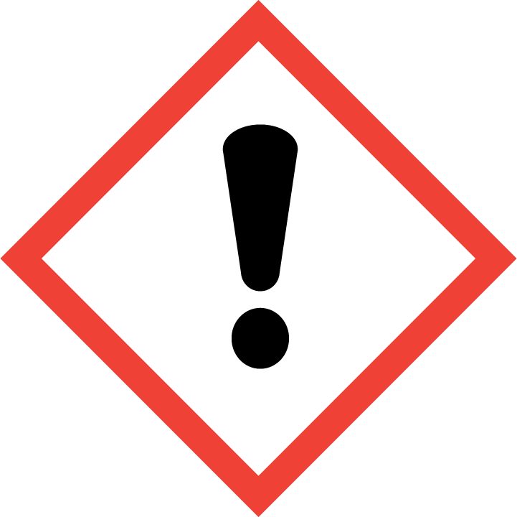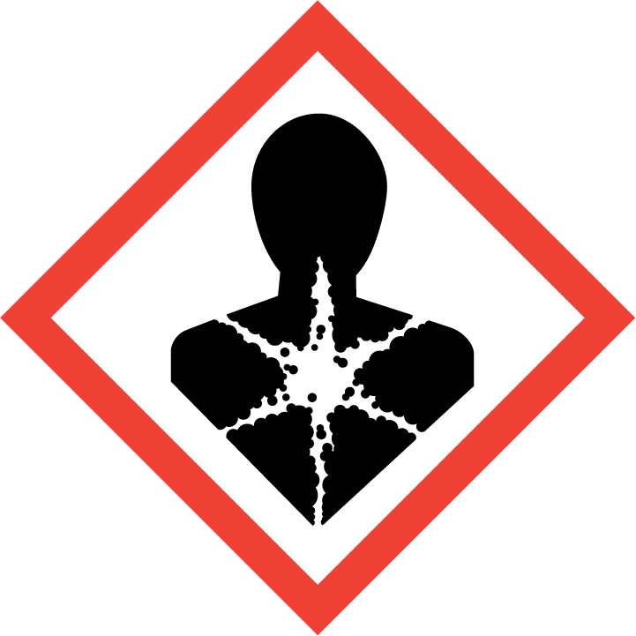

**Signal Word**

DANGER

**Hazard Statement(s)**

H315 Causes skin irritation.

H319 Causes serious eye irritation.

H350 May cause cancer.

H336 May cause drowsiness or dizziness.

**Precautionary Statement(s)**

P201 Obtain special instructions before use.

P202 Do not handle until all safety precautions have been read and understood.

P261 Avoid breathing fumes, mist, vapors, or spray.

P264 Wash hands thoroughly after handling.

P271 Use only outdoors or in a well-ventilated area.

P280 Wear protective gloves, eye protection, and protective clothing.

P304+P340 If inhaled: Remove person to fresh air and keep comfortable for breathing.

P312 Call a doctor if you feel unwell.

P302+P352 If on skin: Wash with plenty of water.

P332+P313 If skin irritation occurs: Get medical attention.

P305+P351+P338 If in eyes: Rinse eyes cautiously with water for several minutes. Remove contact lenses, if present and easy to do. Continue rinsing.

P337+P313 If eye irritation persists: Get medical attention.

P362+P364 Take off contaminated clothing and wash it before reuse.

P308+P313 If exposed or concerned: Get medical attention.

P403+P233 Store in a well-ventilated place. Keep container tightly closed.

P405 Store locked up.

P501 Dispose of contents and container according to local regulations.

**Hazards Not Otherwise Classified:** None.

**Ingredients(s) with Unknown Acute Toxicity:** None.

|  |
| --- |
| **3. Composition and Information on Hazardous Ingredients** |

**Substance:** Methylene chloride

**Other Designations:** Dichloromethane; methylene dichloride; DCM; CH2Cl2

**Note:**  This material contains trace amounts of nitrated aromatic hydrocarbons. The concentrations are below the reportable limit for hazardous components (1 % or greater) and carcinogens (0.1 % or greater), required by OSHA, 29 CFR 1910.1200 (g)(2)(i)(C)(1), for SDS information. For actual concentrations, see the NIST Certificate of Analysis.

| **Hazardous Component(s)** | **CAS Number** | **EC Number (EINECS)** | **Nominal Mass Concentration (%)** |
| --- | --- | --- | --- |
| Methylene Chloride | 75-09-2 | 200-838-9 | >99 |

|  |
| --- |
| **4. First Aid Measures** |

**Description of First Aid Measures**

**Inhalation:** If adverse effects occur, remove to well‑ventilated (uncontaminated) area. Give artificial respiration if not breathing. Get immediate medical attention.

**Skin Contact:** Wash skin with soap and water for at least 15 minutes while removing contaminated clothing and shoes. Thoroughly clean and dry before reuse. Get medical attention, if needed.

**Eye Contact:** Flush eyes with plenty of water for at least 15 minutes. Then get immediate medical attention.

**Ingestion:** If a large amount is swallowed, seek medical attention.

**Most Important Symptoms/Effects, Acute and Delayed:** May cause eye and skin irritation, central nervous system depression, cancer; releases CO during detoxification.

**Indication of any immediate medical attention and special treatment needed, if necessary:** If any of the above symptoms are present, seek immediate medical attention.

|  |
| --- |
| **5. Fire Fighting Measures** |

**Fire and Explosion Hazards:** Slight fire hazard. See Section 9, “Physical and Chemical Properties” for flammability properties.

**Extinguishing Media**

Suitable: Regular dry chemical, carbon dioxide, water, or alcohol‑resistant foam.

Unsuitable: None listed.

**Specific Hazards Arising from the Chemical**: Not applicable.

**Special Protective Equipment and Precautions for Fire‑Fighters:** Move container from fire area if it can be done without personal risk. Avoid inhalation of material or combustion by‑products. Wear full protective clothing and NIOSH‑approved self‑contained breathing apparatus (SCBA).

**NFPA Ratings** (0 = Minimal; 1 = Slight; 2 = Moderate; 3 = Serious; 4 = Severe)

Health = 2 Fire = 1 Reactivity = 0

|  |
| --- |
| **6. Accidental Release Measures** |

**Personal Precautions, Protective Equipment and Emergency Procedures:** Use suitable protective equipment; see Section 8, “Exposure Controls and Personal Protection”. Keep out of waters supplies and sewers.

**Methods and Materials for Containment and Clean up:** Stop leak if possible without personal risk, with water spray to reduce vapors. Absorb spilled material with sand or non‑combustible material and collect in appropriate container for disposal.

|  |
| --- |
| **7. Handling and Storage** |

**Safe Handling Precautions:** See Section 8, “Exposure Controls and Personal Protection”.

**Storage and Incompatible Materials:** Store in a well‑ventilated area. Keep separated from incompatible substances (see Section 10, “Stability and Reactivity”).

|  |
| --- |
| **8. Exposure Controls and Personal Protection** |

**Exposure Limits**

OSHA (PEL): 25 ppm TWA

125 ppm STEL 15 min

12.5 ppm Action Level

see 29 CFR 1910.1052

NIOSH (REL): 2300 ppm IDLH

ACGIH (TLV): 50 ppm TWA

**Engineering Controls:** Provide local exhaust or process enclosure ventilation system. Ensure compliance with applicable exposure limits.

**Personal Protection Measures:** In accordance with OSHA 29 CFR 1910.132, subpart I, wear appropriate Personal Protective Equipment (PPE) to minimize exposure to this material.

**Respiratory Protection:** If workplace conditions warrant a respirator, a respiratory protection program that meets OSHA 29CFR 1910.134 must be followed. Refer to NIOSH 42 CFR 84 for applicable certified respirators.

**Eye Protection:** Splash resistant safety goggles and emergency eyewash are recommended.

**Skin and Body Protection:** Chemical resistant clothing and gloves are recommended.

|  |
| --- |
| **9. Physical and Chemical Properties** |

| **Descriptive Properties** |  |
| --- | --- |
| **Molar Mass (g/mol)** | 84.93 |
| **Molecular Formula** | CH2Cl2 |
| **Appearance (physical state, color, etc.)** | clear, colorless liquid |
| **Odor** | chloroform-like odor |
| **Odor threshold** | 25 ppm to 50 ppm |
| **pH** | not available |
| **Evaporation rate** (butyl acetate = 1) | 27.5 |
| **Melting point/freezing point** | –95 °C (–139 °F) |
| **Relative Density** (water = 1) | 1.3266 |
| **Density** | not available |
| **Vapor Pressure** | 400 mmHg at 24 °C |
| **Vapor Density** (air = 1) | 2.9 |
| **Viscosity** | 0.441 cP at 20 °C |
| **Solubilities** | water: 1.32 % at 20 °C;  miscible with alcohols, ether, dimethylformamide, phenols, aldehydes, ketones, acetic acid, triethyl phosphate, acetoacetic acid, cyclohexylamine, chlorinated solvents |
| **Partition coefficient** (n‑octanol/water) | not available |

|  |  |
| --- | --- |
| **Thermal Stability Properties** |  |
| **Autoignition Temperature** | 556 °C (1033 °F) |
| **Thermal Decomposition** | not available |
| **Initial boiling point and boiling range** | 40 °C (104 °F) |
| **Explosive Limits, LEL** (Volume %) | 13 |
| **Explosive Limits, UEL** (Volume %) | 23 |
| **Flash Point** | not flammable |
| **Flammability** (solid, gas) | not available |

|  |
| --- |
| **10. Stability and Reactivity** |

**Reactivity:** Stable at normal temperatures and pressure.

|  |  |  |  |  |
| --- | --- | --- | --- | --- |
| **Stability:** | X | Stable |  | Unstable |

**Possible Hazardous Reactions:** Not applicable.

**Conditions to Avoid:** Avoid heat, flames, sparks, and other sources of ignition. Minimize contact with material. Avoid inhalation of material or combustion by‑products. Keep out of water supplies and sewers.

**Incompatible Materials:** Oxidizing materials, combustible materials, metals, and bases.

**Hazardous Decomposition:** Oxides halogenated compounds, oxides of carbon, phosgene.

|  |  |  |  |  |
| --- | --- | --- | --- | --- |
| **Hazardous Polymerization:** |  | Will Occur | X | Will Not Occur |

|  |
| --- |
| **11. Toxicological Information** |

|  |  |  |  |  |  |  |
| --- | --- | --- | --- | --- | --- | --- |
| **Route of Exposure:** | X | Inhalation | X | Skin | X | Ingestion |

**Symptoms Related to the Physical, Chemical and Toxicological Characteristics:** Skin irritation, eye irritation, central nervous system depression, and cancer.

**Potential Health Effects (Acute, Chronic, and Delayed)**

**Inhalation:** Short‑term exposure may result in irritation, changes in body temperature, nausea, vomiting, chest pain, irregular heartbeat, headache, drowsiness, dizziness, disorientation, tingling sensation, loss of coordination, lung congestion, and blood disorders. Long‑term exposure may also include hallucinations, changes in blood pressure, liver damage, reproductive effects, effects on the brain, and cancer.

**Skin Contact:** Irritation (possibly severe), absorption may occur which may result in effects listed for short‑term inhalation exposure. Long‑term exposure may result in skin disorders.

**Eye Contact:** Irritation.

**Ingestion:** Same effects listed for inhalation and including diarrhea, stomach pain, difficulty breathing, pain in extremities, internal bleeding, kidney disorders, convulsions, and unconsciousness.

**Numerical Measures of Toxicity**

**Acute Toxicity:** Not classified.

Rat, oral, LD50: 3000 mg/kg

Rat, inhalation, LC50: 76 000 mg/m3 (4 h)

**Skin Corrosion/Irritation:** Category 2

Rabbit, skin 100 mg (24 h) – moderate

Rabbit, skin 810 mg (24 h) – severe

**Serious Eye Damage/Eye Irritation:** Category 2A

Rabbit, eye 500 mg (24 h) – mild

Rabbit, eye 162 mg – moderate

Rabbit, eye 10 mg – produced keratitis, iritis, increased corneal thickness, and inflammation of the conjunctiva with effects lasting up to 2 weeks.

**Respiratory Sensitization:** Not classified; no data available.

**Skin Sensitization:** Not classified; no data available.

**Germ Cell Mutagenicity:** Not classified.

Rat 1275 mg/kg, 30 µmol/L; Escherichia coli 8250 µg/well

**Carcinogenicity:** Category 1B

|  |  |  |  |  |
| --- | --- | --- | --- | --- |
| **Listed as a Carcinogen/Potential Carcinogen** | X | Yes |  | No |

Methylene chloride is currently listed by IARC as Group 2B, *possibly carcinogenic to humans*; by NTP as *reasonably anticipated to be a human carcinogen* and is present on OSHA’s list of carcinogens.

Tumorigenic: Rat, inhalation, TCLo: 3500 ppm (6 h)

**Reproductive Toxicity:** Not classified; no data available.

Rat, inhalation TCLo: 1250 ppm (7 h, pregnant 6 d to 15 d)

**STOT, Single Exposure:** Category 3, has shown to be a central nervous system depressant.

**STOT, Repeated Exposure:** Not classified; no data available.

**Aspiration Hazard:** Not classified.

|  |
| --- |
| **12. Ecological Information** |

**Ecotoxicity Data**

Fish: Fathead minnow, *Pimephales promelas*, LC50: 140.8 to 277.8 mg/L [flow-through] (96 h)

Fathead minnow, *Pimephales promelas*, LC50: 262 to 855 mg/L [static] (96 h)

Algae: *Pseudokirchneriella subcapitata* EC50: >500 mg/L (96 h)

Invertebrate: Water flea, *Daphnia magna*, EC50: 1532 to 1847 mg/L [static] (48 h)

**Persistence and Degradability:** No data available.

**Bioaccumulative Potential:** Bioconcentration factor (BCF) 6.4 to 40 (method: OECD 305C)

**Mobility in Soil:** No data available.

**Other Adverse effects:** No data available.

|  |
| --- |
| **13. Disposal Considerations** |

**Waste Disposal:** Dispose in accordance with all applicable federal, state, and local regulations. Subject to hazardous waste regulations US EPA 40 CFR 262: Hazardous waste number U080.

|  |
| --- |
| **14. Transportation Information** |

**U.S. DOT and IATA:** UN1593, *Dichloromethane*, Hazard Class 6.1, Packing Group III.

|  |
| --- |
| **15. Regulatory Information** |

**U.S. Regulations**

CERCLA Sections 102a/103 (40 CFR 302.4): 1000 lbs (454 kg) final RQ.

SARA Title III Section 302 (40 CFR 355.30): Not regulated.

SARA Title III Section 304 (40 CFR 355.40): Not regulated.

SARA Title III Section 313 (40 CFR 372.65): 0.1 % de minimis concentration.

OSHA Process Safety (29 CFR 1910.119): Not regulated.

SARA Title III Sections 311/312 Hazardous Categories (40 CFR 370.21):

ACUTE HEALTH: Yes

CHRONIC HEALTH: Yes

FIRE: No

REACTIVE: No

PRESSURE: No

**State Regulations**

California Proposition 65: Warning! This product contains a chemical (methylene chloride) known to the state of California to cause cancer.

**U.S. TSCA Inventory:** Methylene chloride is listed.

T**SCA 12(b), Export Notification:** Not listed.

**Canadian Regulations:** WHMIS Information is not provided for this material.

|  |
| --- |
| **16. Other Information** |

**Issue Date:** 19 May 2015

**Sources:** ChemADVISOR, Inc., SDS, *Dichloromethane*, 20 March 2015.

Hazardous Substance Data Bank, National Library of Medicine’s Toxnet system, *Methylene Chloride*, *CAS # 75-09-2*, available at: <http://toxnet.nlm.nih.gov/> (accessed May 2015).

OSHA 1910.1052 App A, *Safety Data Sheet and Technical Guidelines for Methylene Chloride*, available at: <https://www.osha.gov/pls/oshaweb/owadisp.show_document?p_table=STANDARDS&p_id=10095> (accessed May 2015).

**Key of Acronyms:**

|  |  |  |  |
| --- | --- | --- | --- |
| ACGIH | American Conference of Governmental Industrial Hygienists | NTP | National Toxicology Program |
| CAS | Chemical Abstracts Service | OSHA | Occupational Safety and Health Administration |
| CERCLA | Comprehensive Environmental Response, Compensation, and Liability Act | PEL | Permissible Exposure Limit |
| CFR | Code of Federal Regulations | RCRA | Resource Conservation and Recovery Act |
| DOT | Department of Transportation | REL | Recommended Exposure Limit |
| EINECS | European Inventory of Existing Commercial Chemical Substances | RQ | Reportable Quantity |
| EPCRA | Emergency Planning and Community Right‑to‑Know Act | RTECS | Registry of Toxic Effects of Chemical Substances |
| IARC | International Agency for Research on Cancer | SARA | Superfund Amendments and Reauthorization Act |
| IATA | International Air Transportation Agency | SCBA | Self‑Contained Breathing Apparatus |
| IDLH | Immediately Dangerous to Life and Health | SRM | Standard Reference Material |
| LC50 | Lethal Concentration | STEL | Short Term Exposure Limit |
| LD50 | Median Lethal Dose or Lethal Dose, 50 % | STOT | Specific Target Organ Toxicity |
| LEL | Lower Explosive Limit | TLV | Threshold Limit Value |
| MSDS | Material Safety Data Sheet | TPQ | Threshold Planning Quantity |
| NFPA | National Fire Protection Association | TSCA | Toxic Substances Control Act |
| NIOSH | National Institute for Occupational Safety and Health | TWA | Time Weighted Average |
| NIST | National Institute of Standards and Technology | UEL | Upper Explosive Limit |
| n.o.s. | Not Otherwise Specified | WHMIS | Workplace Hazardous Materials Information System |

**Disclaimer:** Physical and chemical data contained in this SDS are provided only for use in assessing the hazardous nature of the material. The SDS was prepared carefully, using current references; however, NIST does not certify the data in the SDS. The values for this material are given in the NIST Certificate of Analysis.

Users of this SRM should ensure that the SDS in their possession is current. This can be accomplished by contacting the SRM Program: telephone (301) 975‑2200; fax (301) 948‑3730; e‑mail srmmsds@nist.gov; or via the Internet at <http://www.nist.gov/srm>.