Date of Issue:

20 December 2013

**SAFETY DATA SHEET**

|  |
| --- |
| **1. Substance and Source Identification** |

**Product Identifier**

**SRM Number:** 3002

**SRM Name:** Ethylbenzene in Methanol

**Other Means of Identification:** Not applicable.

**Recommended Use of This Material and Restrictions of Use**

This Standard Reference Material (SRM) is a gravimetrically prepared single‑compound solution (ethylbenzene) in methanol intended primarily for the calibration of instrumentation and validation of methods for volatile organic compound (VOC) determinations. Because of its miscibility with water, this SRM can also be used to fortify samples with known amounts of the VOC. A unit of SRM 3002 consists of two 5 mL sealed borosilicate glass ampoules of a gravimetrically prepared solution of ethylbenzene in methanol. Approximately 2.5 mL of this SRM mixture is supplied in each 5 mL glass ampoule.

**Company Information**

|  |  |
| --- | --- |
| National Institute of Standards and Technology |  |
| Standard Reference Materials Program |  |
| 100 Bureau Drive, Stop 2300 |  |
| Gaithersburg, Maryland 20899-2300 |  |
|  |  |
| Telephone: 301-975-2200 | Emergency Telephone ChemTrec: |
| FAX: 301-948-3730 | 1-800-424-9300 (North America) |
| E-mail: [SRMMSDS@nist.gov](mailto:SRMMSDS@nist.gov) | +1-703-527-3887 (International) |
| Website: <http://www.nist.gov/srm> |  |

|  |
| --- |
| **2. HAZARDS IDENTIFICATION** |

**Classification**

**Physical Hazard:** Flammable Liquid, Category 2

**Health Hazard:** Acute Toxicity, Oral, Category 3

Acute Toxicity, Inhalation, Category 3

Acute Toxicity, Dermal, Category 3

Carcinogen, Category 2

Specific Target Organ Toxicity ‑ Single Exposure, Category 1

**Label Elements**

**Symbol**

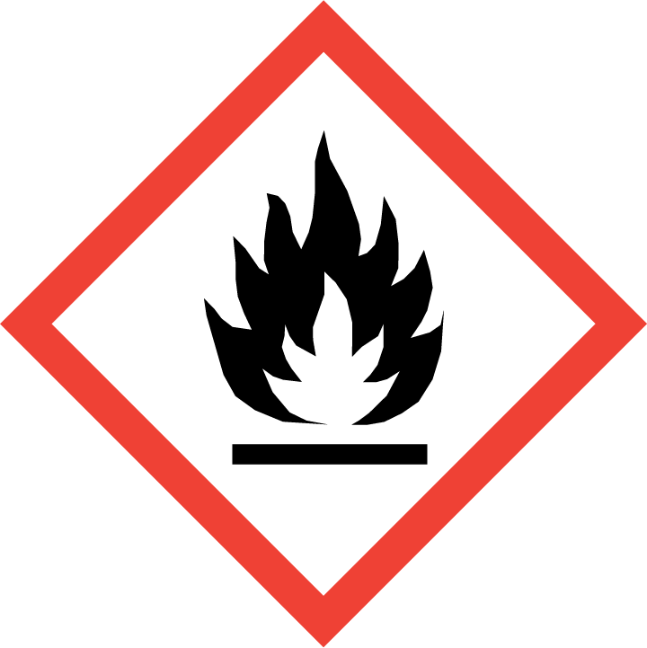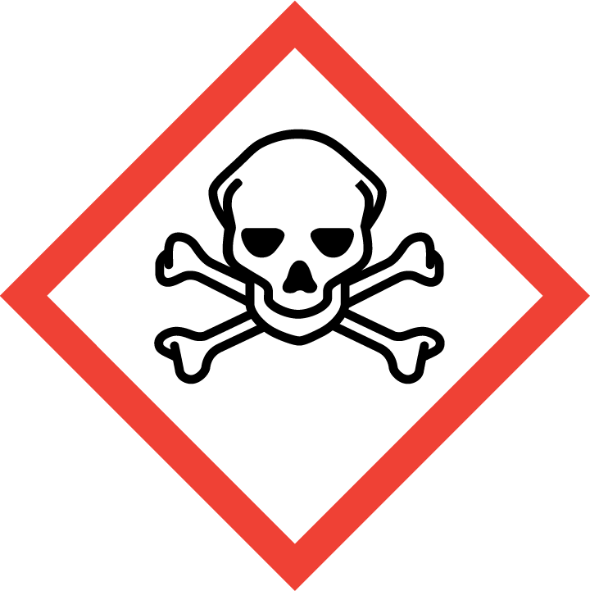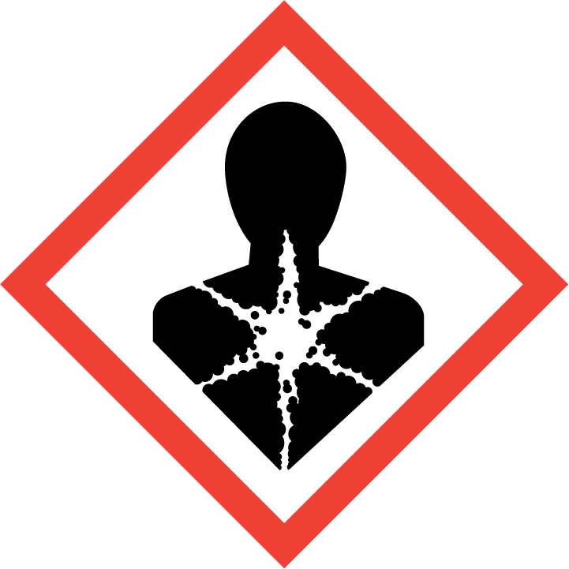

**Signal Word**

Danger

**Hazard Statement(s)**

H225 Highly flammable liquid and vapor.

H301+H311+H331 Toxic if swallowed, in contact with skin or if inhaled.

H351 Suspected of causing cancer (inhalation).

H370 Causes damage to organs.

**Precautionary Statement(s)**

Prevention

P201 Obtain special instrucitons before use.

P202 Do not handle until alal safety precautions have been read and understood.

P210 Keep away from heat/sparks/open flames/hot surfaces. — No smoking.

P233 Keep container tightly closed.

P241 Use explosion-proof electrical/ventilating/lighting equipment.

P242 Use only non-sparking tools.

P243 Take precautionary measures against static discharge.

P260 Do not breathe fume/gas/mist/vapors/spray.

P264 Wash hands thoroughly after handling.

P280 Wear protective gloves/eye protection/protective clothing.

Response

P301+P310 IF SWALLOWED: Immediately call a POISON CENTER or doctor/physician.

P308+P311 IF exposed or concerned: Call a POISON CENTER or doctor/physician.

P330 Rinse mouth.

P303+P361+P353 If on skin (or hair): take off immediately all contaminated clothing. Rinse skin with water/shower.

P370+P378 In case of fire: use regular dry chemical, carbon dioxide, water, or alcohol‑resistant foam.

Storage

P403+P235 Store in a well-ventilated place. Keep cool.

P405 Store locked up.

Dispose

P501 Dispose of contents in accordance with applicable programs.

**Hazards Not Otherwise Classified:** None.

**Ingredients(s) with Unknown Acute Toxicity:** None.

|  |
| --- |
| **3. COMPOSITION AND INFORMATION ON HAZARDOUS INGREDIENTS** |

**Substance:** Ethylbenzene/Methanol solution

**Other Designations:** Methanol (Wood alcohol; wood spirit; methyl hydroxide; methyl alcohol);   
 Ethylbenzene (phenylethane; ethyl benzene; ethylbenzol; alpha methyltoluene)..

Hazardous components 1 % or greater; carcinogens 0.1 % or greater are listed in compliance with OSHA 29 CFR 1910.1200. The actual values for this material are given in the NIST Certificate of Analysis.

|  |  |  |  |
| --- | --- | --- | --- |
| **Hazardous Component(s)** | **CAS Number** | **EC Number** **(EINECS)** | **Nominal Mass Concentration  (%)** |
| Methanol | 67-56-1 | 200-659-6 | 99 |
| Ethylbenzene | 100-41-4 | 202-849-4 | 1 |

|  |
| --- |
| **4. FIRST AID MEASURES** |

**Description of First Aid Measures**

**Inhalation:** If adverse effects occur, remove to well‑ventilated (uncontaminated) area. If breathing is difficult, qualified personnel may administer oxygen. If not breathing, qualified personnel should give artificial respiration. Seek immediate medical attention.

**Skin Contact:** Rinse affected skin with water for at least 15 minutes, then wash thoroughly with soap or mild detergent and water. If skin irritation persists, seek medical aid and bring the container or label.

**Eye Contact:** Immediately flush eyes, including under the eyelids, with copious amounts of water for at least 15 minutes. Seek immediate medical attention.

**Ingestion:** If ingested, seek medical attention.

**Most Important Symptoms/Effects, Acute and Delayed**

**Inhalation:** Irritation, dizziness, tingling sensation, pain in extremities, tremors, loss of coordination, difficulty breathing, irregular heartbeat, visual disturbances, blindness, bluish skin color, convulsions, unconsciousness, and coma.

**Skin Contact:** Irritation.

**Eye Contact:** Irritation.

**Ingestion:** Same as most important symptoms/effects listed under inhalation.

**Indication of any immediate medical attention and special treatment needed, if necessary:** If any of the above symptoms are present, seek immediate medical attention.

|  |
| --- |
| **5. FIRE FIGHTING MEASURES** |

**Fire and Explosion Hazards:** Severe fire hazard. Vapor/air mixtures are explosive above the flash point. Vapors or gases may ignite at distant ignition sources and flash back. See Section 9, “Physical and Chemical Properties” for flammability properties.

**Extinguishing Media**

Suitable: Regular dry chemical, carbon dioxide, water, or alcohol‑resistant foam.

Unsuitable: None listed.

**Specific Hazards Arising from the Chemical:** Not applicable.

**Special Protective Equipment and Precautions for Fire-Fighters:** Move container from fire area if it can be done without personal risk. Avoid inhalation of material or combustion by‑products. Wear full protective clothing and NIOSH‑approved self‑contained breathing apparatus (SCBA).

**NFPA Ratings** (0 = Minimal; 1 = Slight; 2 = Moderate; 3 = Serious; 4 = Severe)

Health = 2 Fire = 3 Reactivity = 0

|  |
| --- |
| **6. ACCIDENTAL RELEASE MEASURES** |

**Personal Precautions, Protective Equipment and Emergency Procedures:** Use suitable protective equipment; see Section 8, “Exposure Controls and Personal Protection”. Keep out of waters supplies and sewers.

**Methods and Materials for Containment and Clean up:** Avoid heat, flames, sparks and other sources of ignition. Stop leak if possible without personal risk, with water spray to reduce vapors. Absorb spilled material with sand or non‑combustible material and collect in appropriate container for disposal.

|  |
| --- |
| **7. HANDLING AND STORAGE** |

**Safe Handling Precautions:** See Section 8, “Exposure Controls and Personal Protection”.

**Storage and Incompatible Materials:** Store in a well‑ventilated area. Keep separated from incompatible substances (halo carbons, combustible materials, metals, oxidizing materials, halogens, metal carbide, bases, acids, and amines).

|  |
| --- |
| **8. EXPOSURE CONTROLS AND PERSONAL PROTECTION** |

**Exposure Limits**

Methanol

OSHA (PEL): 260 mg/m3; 200 ppm TWA

ACGIH (TLV): 200 ppm TWA

250 ppm STEL

Skin – potential significant contribution to overall exposure by the cutaneous route.

NIOSH (REL): 260 mg/m3; 200 ppm TWA

325 mg/m3; 250 ppm STEL

6000 ppm IDLH

Potential for dermal absorption.

Ethylbenzene

OSHA (PEL): 435 mg/m3; 100 ppm TWA

ACGIH (TLV): 20 ppm TWA

NIOSH (REL): 435 mg/m3; 100 ppm TWA

545 mg/m3; 125 ppm STEL

800 ppm IDLH (10 % LEL)

**Engineering Controls:** Provide local exhaust or process enclosure ventilation system. Ensure compliance with applicable exposure limits.

**Personal Protection Measures:** In accordance with OSHA 29 CFR 1910.132, subpart I, wear appropriate Personal Protective Equipment (PPE) to minimize exposure to this material.

**Respiratory Protection:** If workplace conditions warrant a respirator, a respiratory protection program that meets OSHA 29CFR 1910.134 must be followed. Refer to NIOSH 42 CFR 84 for applicable certified respirators.

**Eye Protection:** Splash resistant safety goggles and emergency eyewash are recommended.

**Skin and Body Protection:** Chemical resistant clothing and gloves are recommended.

|  |
| --- |
| **9. PHYSICAL AND CHEMICAL PROPERTIES** |

**NOTE:** The physical and chemical data provided are for the pure components. No physical or chemical data are available for this solution.

| **Properties** | **Methanol 99 %** | **Ethylbenzene**  **1 %** |
| --- | --- | --- |
| **Molar Mass (g/mol)** | 32.04 | 106.17 |
| **Molecular Formula** | CH3OH | C8H10 |
| **Appearance (physical state, color, etc.)** | clear, colorless liquid | clear, colorless liquid |
| **Odor** | alcohol odor | distinct odor |
| **Odor threshold** | 100 ppm | 140 ppm |
| **pH** | not available | not available |
| **Evaporation rate (butyl acetate = 1)** | 4.6 | not available |
| **Melting point/freezing point** | –94 °C (–137 °F) | –95 °C (–139 °F) |
| **Relative Density** asSpecific Gravity (water = 1) | 0.7914 | 0.8670 |
| **Density** | not available | not available |
| **Vapor Pressure** | 97.25 mmHg at 20 °C | 7.1 mmHg at 20 °C |
| **Vapor Density (air = 1)** | 1.11 | 3.7 |
| **Viscosity** | 0.59 cP at 20 °C | 0.64 cP at 25 °C |
| **Solubilities** | soluble in water  solvent: ether, benzene, acetone, chloroform, ethanol, ketones, organic solvents | soluble in water 0.015 % solvent: alcohol, ether, benzene, sulfur dioxide, carbon tetrachloride;  insoluble in ammonia |
| **Partition coefficient (n‑octanol/water)** | not available | not available |
| **Thermal Stability Properties** |  |  |
| **Autoignition Temperature** | 385 °C (725 °F) | 432 °C (809.6 °F) |
| **Thermal Decomposition** | not available | not available |
| **Initial boiling point and boiling range** | 65 °C (149 °F) | 136 °C (277 °F) |
| **Explosive Limits, LEL (Volume %)** | 6 % | 0.8 % |
| **Explosive Limits, UEL (Volume %)** | 36 % | 6.7 % |
| **Flash Point (Closed Cup)** | 11 °C (51.8 °F) | 15 °C (59 °F) |
| **Flammability (solid, gas)** | not applicable | not applicable |

|  |
| --- |
| **10. STABILITY AND REACTIVITY** |

**Reactivity:** This material is not reactive at normal temperatures and pressure.

|  |  |  |  |  |
| --- | --- | --- | --- | --- |
| **Stability:** | X | Stable |  | Unstable |

**Possible Hazardous Reactions:** Not applicable.

**Conditions to Avoid:** Avoid heat, flames, sparks, and other sources of ignition. Minimize contact with material. Avoid inhalation of material or combustion by-products. Keep out of water supplies and sewers.

**Incompatible Materials:** Halo carbons, combustible materials, metals, oxidizing materials, halogens, metal carbide, bases, acids, and amines.

**Hazardous Decomposition:** Oxides of carbon.

|  |  |  |  |  |
| --- | --- | --- | --- | --- |
| **Hazardous Polymerization:** |  | Will Occur | X | Will Not Occur |

|  |
| --- |
| **11. TOXICOLOGICAL INFORMATION** |

|  |  |  |  |  |  |  |
| --- | --- | --- | --- | --- | --- | --- |
| **Route of Exposure:** | X | Inhalation | X | Skin | X | Ingestion |

**Symptoms Related to the Physical, Chemical and Toxicological Characteristics:** Skin irritation, eye irritation, central nervous system depression, and nerve damage; may cause blindness.

**Potential Health Effects (Acute, Chronic, and Delayed)**

**Inhalation:** Acute and chronic exposure to methanol may cause irritation, cough, ringing in the ears, constipation, headache, drowsiness, dizziness, tingling sensation, pain in extremities, tremors, loss of coordination, blood disorders, and nerve damage. Chronic exposure may also cause sensitivity to light, changes in blood pressure, digestive issues, difficulty breathing, irregular heartbeat, visual disturbances, blindness, bluish skin color, lung congestion, heart damage, kidney damage, liver damage, reproductive effects, effects on the brain, convulsions, unconsciousness, and coma. The ethylbenzene in this solution may contribute to the effects of exposure listed above.

**Skin Contact:** Acute and chronic exposure to methanol may result in irritation, absorption may occur, headache, drowsiness, loss of coordination, blood disorders, and nerve damage. The ethylbenzene in this solution may contribute to the effects of exposure listed above.

**Eye Contact:** Acute and chronic exposure to methanol may cause irritation; acute may cause eye damage. The ethylbenzene in this solution may contribute to the effects of exposure listed above.

**Ingestion:** Acute and chronic exposure may cause the same effects as listed for inhalation.

**Numerical Measures of Toxicity**

**Acute toxicity:**

Methanol: Category 3 for oral, inhalation, and dermal.

Human, Oral, LDLo: 143 mg/kg

Rat, Oral, LD50: 5628 mg/kg

Rat, Inhalation, LC50: 83.2 mg/L (4 h); 145 000 ppm (1 h); 64 000 ppm (4 h)

Rabbit, Dermal, LD50: 15 800 mg/kg

Ethylbenzene:

Rat, Oral, LD50: 3500 mg/kg

Rat, Inhalation, LC50: 17.2 mg/L (4 h)

Rabbit, Dermal, LD50: 15 354 mg/kg

**Skin corrosion/irritation:** Not classified.

Methanol: Rabbit, skin: 20 mg (24 h) moderate

Ethylbenzene: Rabbit, skin: 15 mg (24 h) mild

**Serious eye damage/eye irritation:** Not classified.

Methanol: Rabbit, eyes: 100 mg (24 h) moderate; 40 mg moderate

Ethylbenzene: Rabbit, eyes: 500 mg severe

**Respiratory sensitization:** No data available.

**Skin sensitization:** No data available.

**Germ Cell Mutagenicity:** No data available.

**Carcinogenicity:** Carcinogen 2, methanol/ethylbenzene solution.

|  |  |  |  |  |
| --- | --- | --- | --- | --- |
| **Listed as a Carcinogen/Potential Carcinogen** | **X** | **Yes** |  | **No** |

Methanol is not listed by IARC, NTP, or OSHA as a carcinogen.

Ethylbenzene is listed by IARC as Group 2B (possibly carcinogenic to humans).

**Tumorigenic**:

Methanol: Rat, Inhalation, TCLo: 1000 ppm (2 years)

Ethylbenzene: Rat, Inhalation, TCLo: 750 ppm (6 h)

**Mutagenic:**

Methanol: Mouse, Oral TD: 1 g/kg (cytogenetic analysis)

Rat, Oral TD: 10 μmol/kg (DNA damage)

Human, lymphocyte TC: 300 mmol/L (DNA inhibition)

Ethylbenzene: Mouse, lymphocyte: 80 mg/L

**Reproductive Toxicity:** No data available.

**Specific target organ toxicity, single exposure:** Category 1, Damage to organs, eyes, kidney, liver, heart, central nervous system.

**Specific target organ toxicity, repeated exposure:** Not classified.

**Aspiration hazard:** Not applicable.

|  |
| --- |
| **12. ECOLOGICAL INFORMATION** |

**Ecotoxicity Data**

Methanol

Fish, Bluegill (*Lepomis macrochirus*), LC50: 13 500 mg/L to 17 600 mg/L (96 h) flow‑through

Fish, Fathead minnow (*Pimephales promelas*), LC50: 28 200 mg/ L (96 h) flow‑through

Fish, Fathead minnow (*Pimephales promelas*), LC50: >100 mg/L (96 h) static

Ethylbenzene

Fish, Bluegill (*Lepomis macrochirus*), LC50: 32 mg/L (96 h) static

Fish, Fathead minnow (*Pimephales promelas*), LC50: 7.55 to 11 mg/ L (96 h) flow‑through

Fish, Fathead minnow (*Pimephales promelas*), LC50: 9.1 to 15.6 mg/L (96 h) static

**Persistence and Degradability:** No data available.

**Bioaccumulative Potential:**

Methanol: <10 species (fish.)

Ethylbenzene: 15 species (fish)

**Mobility in Soil:** No data available.

**Other Adverse effects:** No data available.

|  |
| --- |
| **13. DISPOSAL CONSIDERATIONS** |

**Waste Disposal:** Dispose in accordance with all applicable federal, state, and local regulations.

|  |
| --- |
| **14. TRANSPORTATION INFORMATION** |

**U.S. DOT and IATA:** UN1230, Methanol solution, Hazard Class 3, 6.1, Packing Group II.

|  |
| --- |
| **15. REGULATORY INFORMATION** |

**U.S. Regulations**

CERCLA Sections 102a/103 (40 CFR 302.4): Methanol: 5000 lb (2270 kg) final RQ;

Ethylbenzene: 1000 lb (454 kg) final RQ.

SARA Title III Section 302 (40 CFR 355.30): Not regulated.

SARA Title III Section 304 (40 CFR 355.40): Not regulated.

SARA Title III Section 313 (40 CFR 372.65): Methanol: 1.0 % de minimis concentrations.

Ethylbenzene: 0.1 % de minimis concentrations.

OSHA Process Safety (29 CFR 1910.119): Not regulated.

SARA Title III Sections 311/312 Hazardous Categories (40 CFR 370.21):

ACUTE HEALTH: Yes

CHRONIC HEALTH: Yes

FIRE: Yes

REACTIVE: No

PRESSURE: No

**State Regulations:** California Proposition 65: WARNING! This product contains a chemical (methanol) known to the state of California to cause reproductive/developmental effects. WARNING! This product contains a chemical (ethylbenzene) known to the state of California to cause cancer.

**U.S. TSCA Inventory:** Methanol and ethylbenzene are listed.

**TSCA 12(b), Export Notification:** Not listed.

**Canadian Regulations:** WHMIS Information: Not provided for this material.

|  |
| --- |
| **16. OTHER INFORMATION** |

**Issue Date:** 20 December 2013

**Sources:** ChemADVISOR, Inc., MSDS *Methyl Alcohol*, 11 September 2013.

ChemADVISOR, Inc., MSDS *Ethyl Benzene*, 11 September 2013

CDC, NIOSH, *Methanol, RTECS# PC1400000, CAS No. 67-56-1*; available at <http://www.cdc.gov/niosh-rtecs/PC155CC0.html> (accessed Dec 2013).

CDC NIOSH, *Ethylbenzene, RTECS# DA0700000, CAS No. 100‑41‑4*; available at <http://www.cdc.gov/niosh-rtecs/daaae60.html> (accessed Dec 2013).

**Key of Acronyms:**

|  |  |  |  |
| --- | --- | --- | --- |
| ACGIH | American Conference of Governmental Industrial Hygienists | NTP | National Toxicology Program |
| CAS | Chemical Abstracts Service | OSHA | Occupational Safety and Health Administration |
| CERCLA | Comprehensive Environmental Response, Compensation, and Liability Act | PEL | Permissible Exposure Limit |
| CFR | Code of Federal Regulations | RCRA | Resource Conservation and Recovery Act |
| DOT | Department of Transportation | REL | Recommended Exposure Limit |
| EINECS | European Inventory of Existing Commercial Chemical Substances | RQ | Reportable Quantity |
| EPCRA | Emergency Planning and Community Right-to-Know Act | RTECS | Registry of Toxic Effects of Chemical Substances |
| IARC | International Agency for Research on Cancer | SARA | Superfund Amendments and Reauthorization Act |
| IATA | International Air Transportation Agency | SCBA | Self‑Contained Breathing Apparatus |
| IDLH | Immediately Dangerous to Life and Health | SRM | Standard Reference Material |
| LC50 | Lethal Concentration | STEL | Short Term Exposure Limit |
| LD50 | Median Lethal Dose or Lethal Dose, 50 % | TLV | Threshold Limit Value |
| LEL | Lower Explosive Limit | TPQ | Threshold Planning Quantity |
| MSDS | Material Safety Data Sheet | TSCA | Toxic Substances Control Act |
| NFPA | National Fire Protection Association | TWA | Time Weighted Average |
| NIOSH | National Institute for Occupational Safety and Health | UEL | Upper Explosive Limit |
| NIST | National Institute of Standards and Technology | WHMIS | Workplace Hazardous Materials Information System |
| n.o.s. | Not Otherwise Specified |  |  |

**Disclaimer:** Physical and chemical data contained in this SDS are provided only for use in assessing the hazardous nature of the material. The SDS was prepared carefully, using current references; however, NIST does not certify the data in the SDS. The values for this material are given in the NIST Certificate of Analysis.

Users of this SRM should ensure that the SDS in their possession is current. This can be accomplished by contacting the SRM Program: telephone (301) 975-2200; fax (301) 948-3730; e-mail srmmsds@nist.gov; or via the Internet at <http://www.nist.gov/srm>.