Date of Issue:

20 July 2015

**SAFETY DATA SHEET**

|  |
| --- |
| **1. Substance and Source Identification** |

**Product Identifier**

**SRM Number:** 4947c

**SRM Name:** Tritiated Toluene Radioactivity Standard for Liquid Scintillation Counting

**Other Means of Identification:** Not applicable.

**Recommended Use of This Material and Restrictions of Use**

This Standard Reference Material (SRM) is intended primarily for the calibration of instruments that are used to measure radioactivity by liquid scintillation counting and for the monitoring of radiochemical procedures. A unit of SRM 4947c consists of 4 mL of tritiated-toluene in flame sealed borosilicate glass ampoule.

**Company Information**

|  |  |
| --- | --- |
| National Institute of Standards and Technology |  |
| Standard Reference Materials Program |  |
| 100 Bureau Drive, Stop 2300 |  |
| Gaithersburg, Maryland 20899-2300 |  |
|  |  |
| Telephone: 301-975-2200 | Emergency Telephone ChemTrec: |
| FAX: 301-948-3730 | 1-800-424-9300 (North America) |
| E-mail: [SRMMSDS@nist.gov](mailto:SRMMSDS@nist.gov) | +1-703-527-3887 (International) |
| Website: <http://www.nist.gov/srm> |  |

|  |
| --- |
| **2. HAZARDS IDENTIFICATION** |

**Radiological Hazard**

**Warning: THIS MATERIAL SHOULD ONLY BE USED BY PERSONS QUALIFIED TO HANDLE RADIOACTIVE MATERIAL!**

This product contains licensed radioactive material and is therefore subject to the requirements of 10 CFR Part 20 (e.g., public and occupational exposure limits, waste disposal).  At a minimum, the basic radiation safety principles of time, distance, and shielding, and appropriate radiation contamination control should be practiced to avoid/minimize any external and/or internal exposure.  Consult with your Radiation Safety office for your facility’s radiation safety requirements/precautions specific to the radionuclide(s) (including its activity and chemical/physical form) in this Radioactive SRM.

**SRM 4947c is a radioactive material, Hydrogen-3-toluene, with a massic activity of approximately  
308 kBq•g-1. Hydrogen‑3‑toluene decays by beta‑particle emission. During the decay process no photons are emitted.**

**Classification**

**Physical Hazard:** Flammable liquid Category 2

**Health Hazard:** Acute Toxicity, Inhalation Category 4

Skin Corrosion/Irritation Category 2

Serious Eye Damage/Eye Irritation Category 2B

Reproductive Toxicity Category 2

STOT, Single Exposure Category 3

STOT, Repeated Exposure Category 2

Aspiration Hazard Category 1

**Label Elements**

**Symbol**

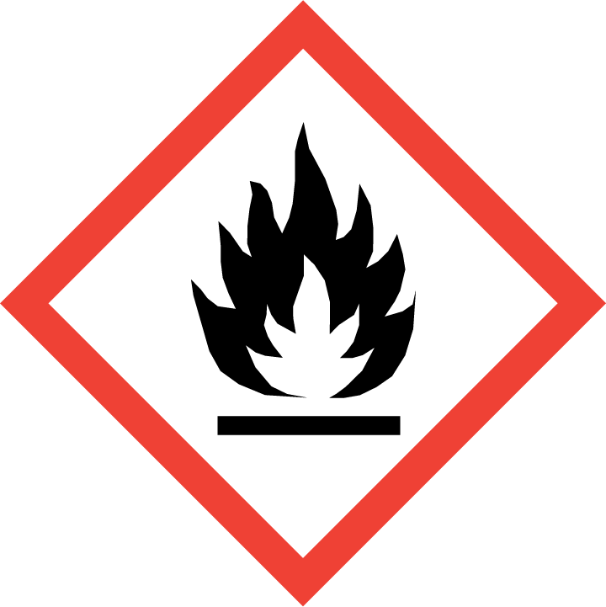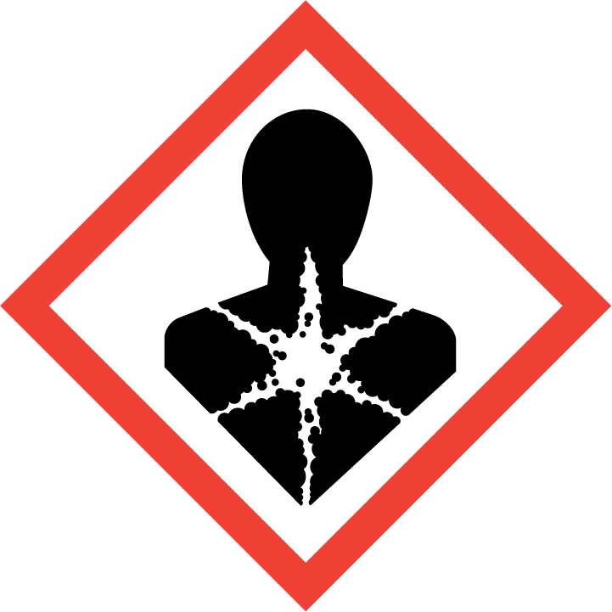

**Signal Word**

DANGER

**Hazard Statement(s)**

H225 Highly flammable liquid and vapor.

H304 May be fatal if swallowed and enters airways.

H315+H320 Causes skin and eye irritation.

H332 Harmful if inhaled.

H336 May cause drowsiness or dizziness.

H361 Suspected of damaging fertility or the unborn child.

H373 May cause damage to organs (eyes, skin, respiratory system, central nervous system, liver, kidneys) through prolong or repeated exposure (inhalation, ingestion, skin contact).

**Precautionary Statement(s)**

P201 Obtain special instructions before use.

P202 Do not handle until all safety precautions have been read and understood.

P210 Keep away from heat, sparks, open flames, and hot surfaces. No smoking.

P241 Use explosion-proof electrical, ventilating, and lighting equipment.

P242 Use only non-sparking tools.

P243 Take precautionary measures against static discharge.

P260 Do not breathe fumes, gas, mist, vapors, or spray.

P264 Wash hands thoroughly after handling.

P271 Use only in a well‑ventilated area.

P280 Wear protective gloves, clothing, and eye protection.

P301+P310 If swallowed: Immediately call a doctor.

P303+P361+P353 If on skin (or hair): Take off immediately all contaminated clothing. Rinse skin with water.

P304+P340 If inhaled: Remove victim to fresh air and keep at rest in a position comfortable for breathing.

P305+P351+P338 If in eyes: Rinse cautiously with water for several minutes. Remove contact lenses, if present and easy to do. Continue rinsing.

P308+P313 If exposed or concerned: Get medical attention.

P331 Do NOT induce vomiting.

P362+P364 Take off contaminated clothing and wash it before reuse.

P403+P233 Store in a well‑ventilated place. Keep container tightly closed.

P405 Store locked up.

P501 Dispose of contents and container according to local regulations.

**Hazards Not Otherwise Classified:** Not applicable.

**Ingredients(s) with Unknown Acute Toxicity:** Not applicable.

|  |
| --- |
| **3. COMPOSITION AND INFORMATION ON HAZARDOUS INGREDIENTS** |

**Substance:** Tritiated-toluene

**Other Designations:**

**Toluene:** Methylbenzene; toluol; 1-methylbenzene; methylbenzol; phenylmethane; methyl benzene

**Hydrogen-3 toluene:** Not applicable.

Components are listed in compliance with OSHA’s 29 CFR 1910.1200; for the actual values see the NIST Certificate.

|  |  |  |  |
| --- | --- | --- | --- |
| **Hazardous Component(s)** | **CAS Number** | **EC Number**  **(EINECS)** | **Nominal Mass Concentration (%)** |
| Toluene | 108-88-3 | 203-625-9 | >99.9 |
| Hydrogen-3 toluene | not applicable | not applicable | 0.000 000 09 |

|  |
| --- |
| **4. FIRST AID MEASURES** |

**Description of First Aid Measures:**

**Inhalation:** If adverse effects occur, remove to uncontaminated area. If not breathing, give artificial respiration or oxygen by qualified personnel. Seek immediate medical attention.

**Skin Contact:** Rinse affected area with copious amounts of water followed by washing with soap and water for at least 15 minutes while removing contaminated clothing. Seek medical attention, if needed.

**Eye Contact:** Immediately flush eyes, including under the eyelids with copious amounts of water for at least 30 minutes. Seek immediate medical attention.

**Ingestion:** Contact a poison control center immediately for instructions. Wash out mouth with water, but do not induce vomiting. Seek medical aid at once, and bring the container or label.

**Most Important Symptoms/Effects, Acute and Delayed:** Respiratory tract, skin, and eye irritation; aspiration hazard, nervous system depression, and nerve damage.

**Indication of any immediate medical attention and special treatment needed, if necessary:** If any of the above symptoms are present, seek immediate medical attention.

|  |
| --- |
| **5. FIRE FIGHTING MEASURES** |

**Fire and Explosion Hazards:** Severe fire hazard. The vapor is heavier than air. Vapors or gases may ignite at distant ignition sources and flash back. Vapor/air mixtures are explosive. Electrostatic discharges may be generated by flow or agitation resulting in ignition or explosion. See Section 9, “Physical and Chemical Properties” for flammability properties.

**Extinguishing Media:**

Suitable: Regular dry chemical, carbon dioxide, water, regular foam.

Unsuitable: None listed.

**Specific Hazards Arising from the Chemical:** Thermal decomposition products: oxides of carbon, hydrocarbons.

**Special Protective Equipment and Precautions for Fire-Fighters:** Avoid inhalation of material or combustion byproducts. Wear full protective clothing and NIOSH approved self-contained breathing apparatus (SCBA).

**NFPA Ratings:**  (0 = Minimal; 1 = Slight; 2 = Moderate; 3 = Serious; 4 = Severe)

Health = 3 Fire = 0 Reactivity = 0

|  |
| --- |
| **6. ACCIDENTAL RELEASE MEASURES** |

**This material is radioactive. DO NOT touch spilled material. Immediately notify safety personnel of a spill.**

**Personal Precautions, Protective Equipment, Methods and Materials for Containment and Clean up:**

**Radiological Emergency Procedures:**

*The following is a guide for first responders. The following actions, including remediation, should be carried out by qualified individuals. In cases where a life-threatening injury occurs concurrent with personal contamination, treat the injury* ***first.***

Do not touch damaged packages or spilled material. Handle as a radioactive material spill. In addition to those actions described below, the guidelines in the Emergency Response Guidebook (ERG) provide more specific measures that should be followed.

**Spill and Leak Control:**

Alert and clear everyone from the area affected by the spill.

Take actions to limit the spread of contamination.

Summon aid.

**Damage to the Radioactive Source:**

Evacuate the immediate vicinity around the source.

Place a barrier at a safe distance from the source.

Identify area as a radiation hazard.

**Suggested Emergency Protective Equipment:**

Gloves

Footwear Covers

Outer layer or easily removed protective clothing (as situation requires)

|  |
| --- |
| **7. HANDLING AND STORAGE** |

**Safe Handling Precautions and Storage: This material is radioactive.** Store and handle in accordance with all current regulations and standards. See NRC 10 CFR 20 or state regulations. See Section 8, “Exposure Controls and Personal Protection”.

|  |
| --- |
| **8. EXPOSURE CONTROLS AND PERSONAL PROTECTION** |

**Exposure Limits:**

**Hydrogen-3:**

ALIinh: 8000 μCi or 296 MBq (See NRC 10 CFR 20 Appendix B)

ALIing: 8000 μCi or 296 MBq

OSHA: See OSHA 29 CFR and NRC 10 CFR 20.

ACGIH: See International Commission on Radiological Protection guidelines.

**Toluene:**

NIOSH (REL): 375 mg/m3; 100 ppm (TWA)

560 mg/m3; 150 ppm (STEL)

1885 mg/m3; 500 ppm (IDLH)

ACGIH (TLV): 75 mg/m3; 20 ppm (TWA)

OSHA (PEL): 750 mg/m3; 200 ppm (TWA)

1130 mg/m3; 300 ppm (Ceiling)

**Engineering Controls:** Provide local exhaust or process enclosure ventilation system. Ensure compliance with applicable exposure limits.

**Personal Protection:** In accordance with OSHA 29 CFR 1910.132, subpart I, wear appropriate Personal Protective Equipment (PPE) to minimize exposure to this material.

**Respiratory Protection:** If workplace conditions warrant a respirator, a respiratory protection program that meets OSHA 29CFR 1910.134 must be followed. Refer to NIOSH 42 CFR 84 for applicable certified respirators.

**Eye/Face Protection:** Wear splash resistant safety goggles with a face shield. An eye wash station should be readily available near areas of use.

**Skin and Body Protection:** Wear protective clothing to prevent contact with skin. Wear appropriate gloves.

|  |
| --- |
| **9**. **Physical and Chemical Properties** |

|  |  |
| --- | --- |
| **Descriptive Properties:** | **Toluene** |
| **Appearance (physical state, color, etc.):** | clear, colorless liquid |
| **Molecular Formula:** | C7H8 |
| **Molar Mass (g/mol):** | 92.14 |
| **Odor:** | distinct odor |
| **Odor threshold:** | 10 ppm to 15 ppm |
| **pH:** | not available |
| **Evaporation rate** (butyl acetate = 1): | 2.24 |
| **Melting point/freezing point (ºC):** | –95 (–139 ºF) |
| **Sublimation Point (ºC):** | not applicable |
| **Decomposition (ºC):** | not applicable |
| **Relative Density** as specific gravity (water = 1): | 0.8669 |
| **Vapor Pressure:** | 22 mmHg at 20 ºC |
| **Vapor Density (air = 1):** | 3.14 |
| **Viscosity (cP):** | 0.560 cP at 25 °C |
| **Solubility(ies):** | water solubility: 0.05 % at 20 °C; soluble in alcohol, ether, benzene, chloroform, ligroin, acetic acid, carbon disulfide, acetone |
| **Partition coefficient (n-octanol/water):** | log Kow = 2.73 |
| **Thermal Stability Properties:** |  |
| **Autoignition Temperature (ºC):** | 480 (896 ºF) |
| **Thermal Decomposition (ºC):** | not applicable |
| **Initial boiling point and boiling range (ºC):** | 111 (232 ºF) |
| **Explosive Limits, LEL (Volume %):** | 1.2 |
| **Explosive Limits, UEL (Volume %):** | 7.1 |
| **Flash Point (Closed Cup):** | 4 ºC (39.2 ºF) |
| **Flammability (solid, gas):** | not applicable |

|  |
| --- |
| **10. Stability and Reactivity** |

**Reactivity:** Stable at normal temperatures and pressure.

|  |  |  |  |  |
| --- | --- | --- | --- | --- |
| **Stability:** | X | Stable |  | Unstable |

**Possible Hazardous Reactions:** No data available.

**Conditions to Avoid:** Avoid heat, flames, sparks and other sources of ignition. Ampoules may rupture or explode if exposed to heat. Keep out of water supplies and sewers.

**Incompatible Materials:** Oxidizing materials, halogens, combustible materials, acids, metal salts.

**Fire/Explosion Information:** See Section 5, “Fire Fighting Measures”.

**Hazardous Decomposition:** Thermal decomposition will produce oxides of carbon, hydrocarbons.

|  |  |  |  |  |
| --- | --- | --- | --- | --- |
| **Hazardous Polymerization:** |  | Will Occur | X | Will Not Occur |

|  |
| --- |
| **11. TOXICOLOGICAL INFORMATION** |

|  |  |  |  |  |  |  |
| --- | --- | --- | --- | --- | --- | --- |
| **Route of Exposure:** | X | Inhalation | X | Skin | X | Ingestion |

**Symptoms Related to the Physical, Chemical and Toxicological Characteristics:** Respiratory tract, skin, and eye irritation; aspiration hazard, nervous system depression, and nerve damage.

**Potential Health Effects (Acute, Chronic and Delayed):**

**Inhalation:** Exposure to 100 ppm may cause irritation. Levels of 200 ppm to 600 ppm for up to 8 h caused fatigue, weakness, confusion, headache, nausea, impaired coordination and reaction time, paresthesias of the skin, euphoria, dizziness, and dilated pupils. Exposure to 800 ppm caused rapid irritation, nasal mucous secretion, metallic taste, drowsiness, and impaired balance. After effects including nervousness, muscular fatigue, and insomnia lasted for several days.

**Skin Contact:** Contact with liquid may cause irritation and dermatitis due to defatting.

**Eye Contact:** Irritation with redness and pain and conjunctivitis.

**Ingestion:** Aspiration hazard; ingestion of toluene can cause lung damage and death.

**Numerical Measures of Toxicity:**

**Acute Toxicity:** Category 4, inhalation.

Toluene: Rat, Oral LD50: 636 mg/kg

Rat, Dermal LD50: 8390 mg/kg

Rat, Inhalation LC50: 12.5 mg/L(4 h)

**Skin Corrosion/Irritation:** Category 2

Toluene: Rabbit, Dermal: 435 mg (mild); 500 mg (moderate); 20 mg (moderate, 24 h)

**Serious Eye Damage/Irritation:** Category 2B

Toluene: Rabbit, Eye: 870 µg (mild); 100 mg/30 s rinse (mild); 2 mg (severe, 24 h)

**Respiratory Sensitization:** No data available.

**Skin Sensitization:** No data available.

**Germ Cell Mutagenicity:** Not classified.

Toluene: Human, Inhalation: 252 µg/L (19 years)

**Carcinogenicity:** Not classified.

|  |  |  |  |  |
| --- | --- | --- | --- | --- |
| **Listed as a Carcinogen/Potential Carcinogen** |  | Yes | X | No |

Toluene is not listed by NTP or OSHA as a carcinogen; IARC lists toluene as Group 3, not classifiable.

**Radiological Hazard**: Hydrogen-3-toluene

Ionizing radiation is a known carcinogen.

**Reproductive Toxicity:** Category 2B

Toluene: Endpoints listed for reproductive effects on embryo or fetus

Rat, Oral, TDLo: 7280 mg/kg (pregnant 6 d to 19 d),

fetotoxicity (except death, e.g., stunted fetus)

Mouse, Oral, TDLo: 9 g/kg (pregnant 6 d to 15 d), fetal death

**Specific Target Organ Toxicity, Single Exposure:** Category 3 (narcotic effects)

See health effects listed in “Potential Health Effects (Acute, Chronic and Delayed)”.

**Specific Target Organ Toxicity, Repeated Exposure:** Category 2

Prolonged or repeated exposure may cause mucous membrane irritation, vomiting, insomnia, nosebleeds, chest pains, euphoria, headache, vertigo, nausea, anorexia, momentary loss of memory, loss of coordination and impairment of reaction time, tinnitus, impaired speech, vision, and/or hearing, alcohol intolerance, and petechiae and abnormal bleeding. Volunteers exposed to 200 ppm for 6 hours/day for 2 days showed a significant increase in heart rate. Cardiac sensitization may occur and may result in cardiac arrest due to ventricular fibrillation. Repeated inhalation to the point of euphoria has caused irreversible encephalopathy with cerebellar ataxia, rhythmic limb movements, disequilibrium, bizarre behavior, emotional lability, optic atrophy, and diffuse cerebral atrophy.

**Aspiration Hazard:** Category 1

Toluene is reported as an aspiration hazard.

|  |
| --- |
| **12. ECOLOGICAL INFORMATION** |

**Ecotoxicity Data:**

Fish Toxicity: Rainbow trout (*Oncorhynchus mykiss*) LC50 (flow‑through): 5.9 mg/L to 7.8 mg/L (96 h)

Invertebrate: Freshwater water flea (*Daphnia magna*) EC50 (static): 5.5 mg/L to 9.8 mg/L (48 h)

**Persistence and Degradability:** No data available.

**Bioaccumulative Potential:** No data available.

**Mobility in Soil:** No data available

**Other Adverse effects:** No data available.

|  |
| --- |
| **13. DISPOSAL CONSIDERATIONS** |

**Waste Disposal: This material is radioactive.** Dispose in accordance with all applicable federal, state, and local regulations for **RADIOACTIVE** materials. See NRC 10 CFR 20 subpart K.

|  |
| --- |
| **14. TRANSPORTATION INFORMATION** |

**U.S. DOT and IATA:**

**Primary Risk**: UN1294, Toluene, Hazard Class 3, Packing Group II, Excepted Quantity E2.

**Subsidiary Risk:** Not radioactive for shipping purposes.

|  |
| --- |
| **15. REGULATORY INFORMATION** |

**U.S. Regulations:**

CERCLA Sections 102a/103 (40 CFR 302.4): Toluene, 1000 lbs; 454 kg RQ.

SARA Title III Section 302 (40 CFR 355.30): Not regulated.

SARA Title III Section 304 (40 CFR 355.40): Not regulated.

SARA Title III Section 313 (40 CFR 372.65): Toluene, 1.0 % de minimis concentrations.

OSHA Process Safety (29 CFR 1910.119): Not regulated.

SARA Title III Sections 311/312 Hazardous Categories (40 CFR 370.21):

ACUTE HEALTH: Yes.

CHRONIC HEALTH: Yes.

FIRE: Yes.

REACTIVE: No.

PRESSURE: No.

**State Regulations:**

California Proposition 65: Warning! This product contains a chemical known to the state of California to cause reproductive/developmental effects.

**U.S. TSCA Inventory:** Toluene is listed.

**TSCA 12(b), Export Notification:** No components are listed.

**Canadian Regulations:** WHMIS Information is not provided for this material.

|  |
| --- |
| **16. OTHER INFORMATION** |

**Issue Date:** 20 July 2015

**Sources:** ChemAdvisor, Inc., SDS *Toluene,* 20 March 2015.

Hazardous Substances Data Bank, National Library of Medicine, *Toluene CAS 108-88-3*, Full Record, available at <http://toxnet.nlm.nih.gov/cgi-bin/sis/htmlgen?HSDB> (accessed July 2015).

NIOSH Pocket Guide to Chemical Hazards, *Toluene CAS 108-88-3*, (04 April 2011),available at <http://www.cdc.gov/niosh/npg/npgd0619.html> (accessed July 2015); also see *RTECS #: XS5250000*, (May 2009); at <http://www.cdc.gov/niosh-rtecs/XS501BD0.html> (accessed July 2015).

OSHA 29 CFR, Subpart Z, Ionizing radiation, 1910.1096.

NRC 10 CFR 20, Standards for Protection Against Radiation.

DOT 49 CFR 173, Shippers General Requirements for Shipments and Packages.

**Key of Acronyms:**

|  |  |  |  |
| --- | --- | --- | --- |
| ACGIH | American Conference of Governmental Industrial Hygienists | NIOSH | National Institute for Occupational Safety and Health |
| ALI | Annual Limit on Intake | NIST | National Institute of Standards and Technology |
| CAS | Chemical Abstracts Service | NRC | Nuclear Regulatory Commission |
| CEN | European Committee for Standardization | NTP | National Toxicology Program |
| CERCLA | Comprehensive Environmental Response, Compensation, and Liability Act | OSHA | Occupational Safety and Health Administration |
| CFR | Code of Federal Regulations | PEL | Permissible Exposure Limit |
| CPSU | Coal Mine Dust Personal Sample Unit | RCRA | Resource Conservation and Recovery Act |
| DOT | Department of Transportation | REL | Recommended Exposure Limit |
| EC50 | Effective Concentration, 50 % | RM | Reference Material |
| EINECS | European Inventory of Existing Commercial Chemical Substances | RQ | Reportable Quantity |
| EPCRA | Emergency Planning and Community Right-to-Know Act | RTECS | Registry of Toxic Effects of Chemical Substances |
| IARC | International Agency for Research on Cancer | SARA | Superfund Amendments and Reauthorization Act |
| IATA | International Air Transportation Agency | SCBA | Self‑Contained Breathing Apparatus |
| IDLH | Immediately Dangerous to Life and Health | SRM | Standard Reference Material |
| ISO | International Organization for Standardization | STEL | Short Term Exposure Limit |
| LC50 | Lethal Concentration, 50 % | TDLo | Toxic Dose Low |
| LD50 | Lethal Dose, 50 % | TLV | Threshold Limit Value |
| LEL | Lower Explosive Limit | TPQ | Threshold Planning Quantity |
| MSDS | Material Safety Data Sheet | TSCA | Toxic Substances Control Act |
| NFPA | National Fire Protection Association | TWA | Time Weighted Average |
| MSHA | Mine Safety and Health Administration | UEL | Upper Explosive Limit |
|  |  | WHMIS | Workplace Hazardous Materials Information System |

**Disclaimer:** Physical and chemical data contained in this SDS are provided only for use in assessing the hazardous nature of this material. The SDS was prepared carefully, using current references; however, NIST does not certify the data in the SDS. The certified values for this material are given in the NIST Certificate.

Users of this SRM should ensure that the SDS in their possession is current. This can be accomplished by contacting the SRM Program: telephone (301) 975-2200; fax (301) 948-3730; e-mail srmmsds@nist.gov; or via the Internet at http://www.nist.gov/srm.