Date of Issue:

19 August 2015

**SAFETY DATA SHEET**

|  |
| --- |
| **1. Substance and Source Identification** |

**Product Identifier**

**RM Number:** 8107

**RM Name:** Additives in Smokeless Powder

**Other Means of Identification:** Not applicable.

**Recommended Use of This Material and Restrictions of Use**

This Reference Material (RM) is intended to support analytical measurements of nitroglycerin, diphenylamine, *N*‑nitroso‑diphenylamine, and ethyl centralite, including qualitative additive identification and quantitative compositional measurements. RM 8107 is a smokeless powder of the type used as the propellant in small arms ammunition. A unit of RM 8107 consists of one bottle containing 5 g of smokeless powder.

**Company Information**

|  |  |
| --- | --- |
| National Institute of Standards and Technology |  |
| Standard Reference Materials Program |  |
| 100 Bureau Drive, Stop 2300 |  |
| Gaithersburg, Maryland 20899-2300 |  |
|  |  |
| Telephone: 301-975-2200 | Emergency Telephone ChemTrec: |
| FAX: 301-948-3730 | 1-800-424-9300 (North America) |
| E-mail: [SRMMSDS@nist.gov](mailto:SRMMSDS@nist.gov) | +1-703-527-3887 (International) |
| Website: <http://www.nist.gov/srm> |  |

|  |
| --- |
| **2. HAZARDS IDENTIFICATION** |

**Classification**

**Physical Hazard:** Explosives Division 1.3

**Health Hazard:** Acute Toxicity, Oral Category 4

Eye Damage/Irritation Category 2A

Skin Sensitization Category 1A

Reproductive Toxicity Category 1B

STOT, Repeated Exposure Category 2

**Label Elements**

**Symbol**

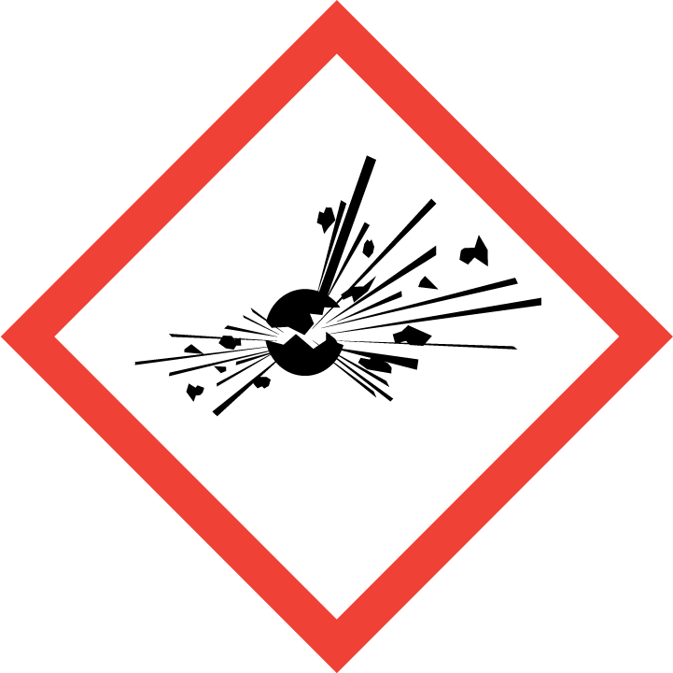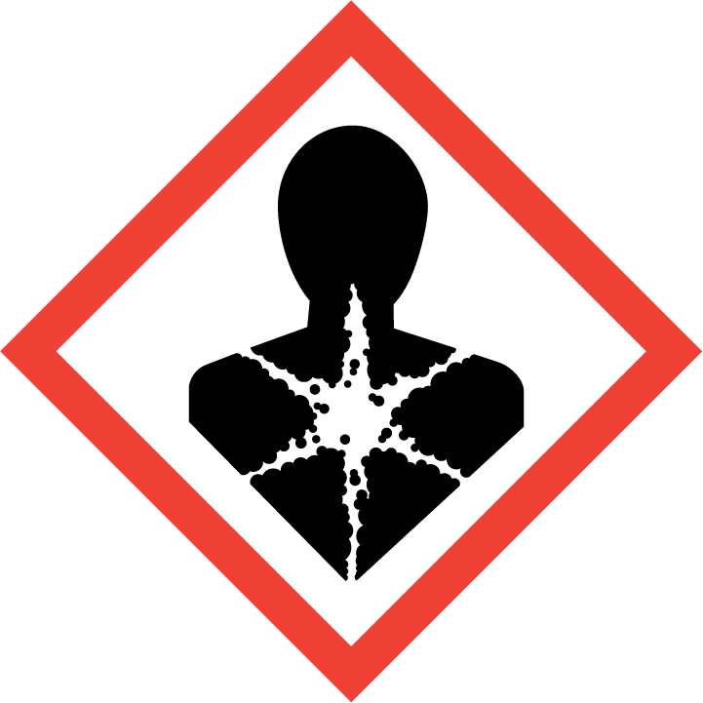

**Signal Word**

DANGER

**Hazard Statement(s)**

H203 Explosive; fire, blast or projection hazard.

H302 Harmful if swallowed.

H319 Causes serious eye irritation.

H317 May cause an allergic skin reaction.

H360 May damage fertility or the unborn child.

H373 May cause damage to organs (circulatory system, blood, kidneys, liver) through prolonged or repeated exposure.

**Precautionary Statement(s)**

P201 Obtain special instructions before use.

P202 Do not handle until all safety precautions have been read and understood.

P210 Keep away from heat, sparks, open flames, and hot surfaces. ‑ No smoking.

P250 Do not subject to grinding, shock, or friction.

P264 Wash hands thoroughly after handling.

P270 Do not eat, drink or smoke when using this product.

P272 Contaminated work clothing must not be allowed out of the workplace.

P280 Wear protective gloves, protective clothing and eye protection.

P301+P312 If swallowed: Call a doctor if you feel unwell.

P330 Rinse mouth.

P302+P352 If on skin: Wash with plenty of water.

P362+P364 Wash contaminated clothing before reuse.

P305+P351+P338 If in eyes: Rinse cautiously with water for several minutes. Remove contact lenses, if present and easy to do. Continue rinsing.

P333+P337++P313 If skin or eye irritation persists: Get medical attention.

P308+P313 If expose or concerned: Get medical attention.

P370+P380 In case of fire: evacuate area.

P372 Explosion risk in case of fire.

P373 Do NOT fight fire when fire reaches explosives.

P401 Store contents and container according to local regulations.

P405 Store locked up.

P501 Dispose of contents and container according to local regulations.

**Hazards Not Otherwise Classified:** Not applicable.

**Ingredients(s) with Unknown Acute Toxicity:** Not applicable.

|  |
| --- |
| **3. COMPOSITION AND INFORMATION ON HAZARDOUS INGREDIENTS** |

**Substance:** Ball powder, propellant

**Other Designations:** Ball-type smokeless powder; powder, smokeless; smokeless propellant; WC; SPI; WCUNI; M38; M47.

Components are listed in compliance with OSHA’s 29 CFR 1910.1200; for the actual values see the NIST Certificate of Analysis.

| **Hazardous Component(s)** | **CAS Number** | **EC Number**  **(EINECS)** | **Nominal Mass Concentration**  **(%)** |
| --- | --- | --- | --- |
| Ball powder, propellant | 129037-80-5 | not applicable | 100 |
| *Individual Component(s)* |  |  |  |
| Nitrocellulose | 9004-70-0 | not applicable | >50 |
| Nitroglycerin | 55-63-0 | 200-240-8 | 13 |
| Dibutyl phthalate | 84-74-2 | 201-557-4 | 0 to 10 |
| Polyester adipate | not applicable | not applicable | 0 to 10 |
| Ethyl centralite (diethyldiphenylurea) | 85-98-3 | 201-645-2 | 4 |
| Rosin | 8050-09-7 | not applicable | 0 to 5 |
| Akardite II | 13114-72-2 | 236-039-7 | 0 to 3 |
| Potassium nitrate | 7757-79-1 | 231-818-8 | 0 to 3 |
| Potassium sulfate | 7778-80-5 | 231-915-5 | 0 to 2 |
| Ethyl acetate | 141-78-6 | 205-500-4 | 0 to 1.5 |
| Diphenylamine | 122-39-4 | 204-539-4 | 0.8 |
| N-Nitrosodiphenylamine | 86-30-6 | 201-663-0 | 0.3 |
| Tin dioxide | 18282-10-5 | 242-159-0 | 0 to 1.5 |
| Calcium carbonate | 1317-65-3 | 215-279-6 | 0 to 1 |
| Graphite | 7782-42-5 | 231-955-3 | 0 to 1 |

|  |
| --- |
| **4. FIRST AID MEASURES** |

**Description of First Aid Measures:**

**Inhalation:** If adverse effects occur, remove to uncontaminated area. Give artificial respiration if not breathing, or oxygen by qualified personnel. Get immediate medical attention.

**Skin Contact:** Wash skin with soap and water for at least 15 minutes while removing contaminated clothing and shoes. Get medical attention, if needed. Thoroughly clean and dry contaminated clothing before reuse.

**Eye Contact:** Flush eyes with plenty of water for at least 15 minutes. Then get immediate medical attention.

**Ingestion:** If a large amount is swallowed, get medical attention.

**Most Important Symptoms/Effects, Acute and Delayed:** Eye irritation and skin sensitization.

**Indication of any immediate medical attention and special treatment needed, if necessary:** If any of the above symptoms are present, seek immediate medical attention.

|  |
| --- |
| **5. FIRE FIGHTING MEASURES** |

**Fire and Explosion Hazards:** Severe fire and explosion hazard. This material is considered a Class B explosive under OSHA 1910.109(a)(3)(ii) and 1.3C under US DOT 49 CFR 173.51. Avoid sparks, flame, heat, friction or impact. Dust/air mixtures may ignite or explode. May explode if exposed to shock, friction or heating. See Section 9, “Physical and Chemical Properties” for flammability properties.

**Extinguishing Media:**

Suitable: Flood with a large volume of water.

Unsuitable: Do not use water jet as an extinguisher, as this may spread fire.

**Specific Hazards Arising from the Chemical:** Toxic vapors/gases may be formed during a fire and miscellaneous decomposition products.

**Special Protective Equipment and Precautions for Fire-Fighters:** Avoid inhalation of material or combustion byproducts. Wear full protective clothing and NIOSH approved self-contained breathing apparatus (SCBA).

**NFPA Ratings** (0 = Minimal; 1 = Slight; 2 = Moderate; 3 = Serious; 4 = Severe)

Health = 2 Fire = 4 Reactivity = 4

|  |
| --- |
| **6. ACCIDENTAL RELEASE MEASURES** |

**Personal Precautions, Protective Equipment and Emergency Procedures:** Immediately contact emergency personnel. Keep unnecessary personnel away. Eliminate all ignition sources. Wear appropriate protective equipment and non-flammable or flame retardant clothing during clean-up. Use suitable protective equipment; see Section 8, “Exposure Controls and Personal Protection”.

**Methods and Materials for Containment and Clean up:** Avoid generating dust. Do not touch spilled material. Notify safety personnel of spills. Collect spilled material in appropriate container for disposal. Isolate hazard area and deny entry.

|  |
| --- |
| **7. HANDLING AND STORAGE** |

**Safe Handling Precautions:** See Section 8, “Exposure Controls and Personal Protection”.

**Storage:** Store and handle in accordance with all current regulations and standards. Keep separated from incompatible substances (see Section 10, “Stability and Reactivity”).

|  |
| --- |
| **8. EXPOSURE CONTROLS AND PERSONAL PROTECTION** |

| **Exposure Limits**(a) | | | |
| --- | --- | --- | --- |
| **Components** | **OSHA (PEL)** | **ACGIH (TLV)** | **NIOSH (REL)** |
| Ball powder, propellant | NOEL | NOEL | NOEL |
| *Individual components of ball powder, propellant in RM 8107 with occupational exposure limits.* | | | |
| Nitroglycerin | Ceiling: 0.2 ppm (2 mg/m3)  Prevent or reduce skin absorption. | TWA: 0.05 ppm  Skin potential significant contribution to overall exposure by the cutaneous route. | TWA: 0.1 mg/m3  Potential for dermal absorption.  IDLH: 75 mg/m3 |
| Dibutyl phthalate | TWA: 5 mg/m3 | TWA: 5 mg/m3 | TWA: 5 mg/m3  IDLH: 4000 mg/m3 |
| Ethyl acetate | TWA: 400 ppm  (1400 mg/m3) | TWA: 400 ppm | TWA: 400 ppm (1400 mg/m3)  IDLH: 2000 ppm [10 % LEL] |
| Diphenylamine | NOEL | TWA: 10 mg/m3 | TWA 10 mg/m3 |
| Tin dioxide | NOEL | TWA: 2 mg/m3  as Sn (related to Tin oxide) | TWA: 2 mg/m3 as Sn |
| Calcium carbonate | TWA: 15 mg/m3 (total) TWA: 5 mg/m3 (resp) | NOEL | TWA: 10 mg/m3 (total)  TWA: 5 mg/m3 (resp) |
| Graphite | TWA: 15 mg/m3 (synthetic) total dust TWA: 5 mg/m3 (synthetic) respirable fraction  TWA: 15 mppcf (natural) | TWA: 2 mg/m3  (all forms except graphite fibers) respirable fraction | TWA: 2.5 mg/m3 (natural) respirable dust  IDLH: 1250 mg/m3 |

(a) NOEL: No occupational exposure limits established.

**Engineering Controls:** Provide local exhaust or process enclosure ventilation system. Ensure compliance with applicable exposure limits.

**Personal Protection:** In accordance with OSHA 29 CFR 1910.132, subpart I, wear appropriate Personal Protective Equipment (PPE) to minimize exposure to this material.

**Respiratory Protection:** If workplace conditions warrant a respirator, a respiratory protection program that meets OSHA 29CFR 1910.134 must be followed. Refer to NIOSH 42 CFR 84 for applicable certified respirators.

**Eye/Face Protection:** Wear splash resistant safety goggles with a face shield. An eyewash station should be readily available near areas of use.

**Skin and Body Protection:** Personal protective equipment for the body should be selected based on the task being performed and the risks involved and should be approved by a specialist before handling this product. Chemical-resistant gloves should be worn at all times when handling chemicals.

|  |
| --- |
| **9**. **Physical and Chemical Properties** |

|  |  |
| --- | --- |
| **Descriptive Properties** | **Ball powder, propellant** |
| **Appearance (physical state, color, etc.)** | granular grey to black colored powder |
| **Molecular Formula** | varies |
| **Molar Mass (g/mol)** | varies |
| **Odor** | odorless |
| **Odor threshold (mg/m3)** | not available |
| **pH** | not available |
| **Evaporation rate** | not available |
| **Melting point/freezing point** | not available |
| **Relative Density** | bulk density, 0.5 g/mL to 1 g/mL |
| **Vapor Pressure** | <1 mmHg |
| **Vapor Density (air = 1)** | not available |
| **Viscosity** | not available |
| **Solubility(ies)** | negligible |
| **Partition coefficient (n-octanol/water)** | not available |
| **Thermal Stability Properties** |  |
| **Autoignition Temperature** | 190 °C to 200 °C (374 °F to 392 °F) |
| **Thermal Decomposition** | above 50 °C (122 °F) |
| **Initial boiling point and boiling range** | not available |
| **Explosive Limits, LEL (Volume %)** | not available |
| **Explosive Limits, UEL (Volume %)** | not available |
| **Flash Point** | not available |
| **Flammability (solid, gas)** | not available |

|  |
| --- |
| **10. Stability and Reactivity** |

**Reactivity:** Stable at normal temperatures and pressure.

|  |  |  |  |  |
| --- | --- | --- | --- | --- |
| **Stability:** | X | Stable |  | Unstable |

**Possible Hazardous Reactions:** Hazardous polymerization does not occur.

**Conditions to Avoid:** Avoid contact with incompatible materials. Direct sunlight, artificial ultraviolet light, flame, and heat.

**Incompatible Materials:** Strong acids, alkalis, oxidizers, and amines.

**Fire/Explosion Information:** See Section 5, “Fire Fighting Measures”.

**Hazardous Decomposition:** Thermal decomposition will produce carbon monoxide, carbon dioxide, and oxides of nitrogen. Decomposition becomes measurable above 50 °C (122 °F)

|  |  |  |  |  |
| --- | --- | --- | --- | --- |
| **Hazardous Polymerization:** |  | Will Occur | X | Will Not Occur |

|  |
| --- |
| **11. TOXICOLOGICAL INFORMATION** |

|  |  |  |  |  |  |  |
| --- | --- | --- | --- | --- | --- | --- |
| **Route of Exposure:** | X | Inhalation | X | Skin | X | Ingestion |

**Symptoms Related to the Physical, Chemical and Toxicological Characteristics:** Eye irritation, skin sensitization, and toxic if inhaled.

**Potential Health Effects (Acute, Chronic and Delayed):**

**Inhalation:** Dust may irritate respiratory system.

**Skin Contact:** Skin contact may result in irritation.

**Eye Contact:** May causes eye irritation.

**Ingestion:** Irritation to the gastrointestinal tract. The nitroglycerin contained in this material may cause severe headache, drop in blood pressure, mental confusion, nausea, and vomiting.

**Numerical Measures of Toxicity**

**Acute Toxicity:** Category 4, Oral

|  |  |  |
| --- | --- | --- |
| **Components** | |  | | --- | | **Acute Toxicity** | |
| Ball powder | Rat, Oral LD50: >5 g/kg  Rabbit, Dermal LD50: >2 g/kg |
| *Individual components of ball powder, propellant in RM 8107 with acute toxicity information available are listed.* | |
| Nitrocellulose | Rat, Oral LD50: >5 g/kg |
| Nitroglycerin | Rat, Oral LD50: 150 mg/kg  Rabbit, Dermal LD50: >280 mg/kg  *Category 2, Inhalation: Mixture is not classified based on nitroglycerin’s low vapor pressure. Explosive; fire, blast will result if excessive heat is applied.* |
| Dibutyl phthalate | Rat, Inhalation LC50: 4250 mg/m3  Rat, Oral LD50: 7499 mg/kg  Rabbit, Dermal LD50: >20 mL/kg |
| Ethyl centralite | Rat, Oral LD50: 2750 mg/kg |
| Rosin | Rat, Inhalation LC50: 110 mg/m3  Rat, Oral LD50: 7600 mg/kg |
| Potassium nitrate | Rat, Oral LD50: 3015 mg/kg |
| Potassium sulfate | Rat, Oral LD50: 6600 mg/kg |
| N-Nitrosodiphenylamine | Rat, Oral LD50: 1825 mg/kg Oral  Rabbit, Dermal LD50: >7940 mg/kg |
| Ethyl acetate | Rat, Inhalation LC50: >6000 ppm (6h); 200 gm/m3; 1600 ppm (8 h)  Rat, Oral LD50: 5620 mg/kg  Rabbit, Dermal LD50: >20 mL/kg |
| Diphenylamine | Rat, Oral LD50: 1120 mg/kg  Rabbit, Dermal LD50: >5000 mg/kg |
| Tin dioxide | Rat, Oral LD50: 700 mg/kg |

**Skin Corrosion/Irritation:** Not classified.

Nitroglycerin: Rabbit Eyes: 0.1 mL

**Serious Eye Damage/Irritation:** Category 2A

Nitroglycerin: Rabbit Skin: 500 mg (24 h) mild; 0.5 mL (mild)

**Respiratory Sensitization:** Not classified; no data available.

**Skin Sensitization:** Category 1A.

**Germ Cell Mutagenicity:** Not classified; no data available.

**Carcinogenicity:** Not classified.

|  |  |  |  |  |
| --- | --- | --- | --- | --- |
| **Listed as a Carcinogen/Potential Carcinogen** |  | Yes | X | No |

Ball powder is not listed by NTP, IARC or OSHA as carcinogen/potential carcinogen.

**Reproductive Toxicity:** Category 1B, may damage fertility or the unborn child.

**Specific Target Organ Toxicity, Single Exposure:** Not classified; no data available.

**Specific Target Organ Toxicity, Repeated Exposure:** Category 2; may cause damage to the circulatory system, blood, kidneys and liver through prolonged or repeated exposure.

**Aspiration Hazard:** No data available.

|  |
| --- |
| **12. ECOLOGICAL INFORMATION** |

**Ecotoxicity Data:** *Individual components with ecotoxicity data are listed.*

| **Components** | **Ecotoxicity Data** |
| --- | --- |
| Nitroglycerin | Fish: Bluegill (*Lepomis macrochirus*) LC50 [static]: 1.28 mg/L (96 h)  Invertebrate: Water flea (*Daphnia magna*) EC50 [static]: 46 mg/L to 55 mg/L (48 h) |
| Dibutyl phthalate | Fish: Fathead minnow (*Pimephales promelas*) LC50 [flowthrough]: 0.71 mg/L to 1.2 mg/L (96 h)  Algae: Pond scum (*Desmodesmus subspicatus*) EC50: 1.2 mg/L (72 h) |
| Ethyl centralite | Fish: Rainbow trout (*Oncorhynchirus mykiss*) LC50 [semi-static]: 5.8 mg/L (96 h)  Algae: *Pseudokirchneriella subcapitata* EC50: >433 mg/L (96 h)  Invertebrate: Water flea (*Daphnia magna*) EC50: 5.46 mg/L to 9.83 mg/L (48 h) |
| Rosin | Algae: Pond scum (*Desmodesmus subspicatus*) EC50: 400 mg/L (72 h)  Invertebrate: Water flea (*Daphnia magna*) EC50: 3.8 mg/L to 5.4 mg/L (48 h) |
| Ethyl acetate | Fish: Fathead minnow (*Pimephales promelas*) LC50 [flowthrough]: 220 mg/L to 250 mg/L (96 h)  Invertebrate: Water flea (*Daphnia magna*) EC50: 560 mg/L [static] (48 h) |
| Potassium sulfate | Fish: Bluegill (*Lepomis macrochirus*) LC50: 653 mg/L (95 h)  Algae: Pond scum (*Desmodesmus subspicatus*) EC50: 2900 mg/L (72 h)  Invertebrate: Water flea (*Daphnia magna*) EC50: 890 mg/L (48 h) |
| Diphenylamine | Fish: Fathead minnow (*Pimephales promelas*) LC50 [flowthrough]: 3.47 mg/L to 4.14 mg/L (96 h)  Algae: *Scenedesmus subspicatus* EC50: 1.5 mg/L (72 h)  Invertebrate: Water flea (*Daphnia magna*) EC50: 1.69 mg/L to 2.46 mg/L (48 h) |

**Persistence and Degradability:** No data available.

**Bioaccumulative Potential:** No data available.

**Mobility in Soil:** No data available.

**Other Adverse effects:** No data available.

|  |
| --- |
| **13. DISPOSAL CONSIDERATIONS** |

**Waste Disposal:** Dispose of waste in accordance with all applicable federal, state, and local regulations.

|  |
| --- |
| **14. TRANSPORTATION INFORMATION** |

**U.S. DOT and IATA:** NA3178, Smokeless powder for small arms (100 lbs or less), Hazard Class 4.1, Packing Group I (domestic shipments only). This material is forbidden by Air.

|  |
| --- |
| **15. REGULATORY INFORMATION** |

**U.S. Regulations:**

CERCLA Sections 102a/103 (40 CFR 302.4): Nitroglycerin: 10 lbs (4.54 kg) final RQ.

Dibutyl phthalate: (10 lbs); N-Nitrosodiphenylamine: (100 lbs); Ethyl acetate: (5000 lbs)

SARA Title III Section 302 (40 CFR 355.30): Not regulated.

SARA Title III Section 304 (40 CFR 355.40): Not regulated.

SARA Title III Section 313 (40 CFR 372.65): 1 % de minimis concentration for nitroglycerin, dibutyl phthalate, and diphenyl amine.

OSHA Process Safety (29 CFR 1910.119): Nitrocellulose: 25 lbs TQ (concentration >12.6 % nitrogen).

SARA Title III Sections 311/312 Hazardous Categories (40 CFR 370.21):

ACUTE HEALTH: Yes

CHRONIC HEALTH: Yes

FIRE: Yes

REACTIVE: Yes

PRESSURE: No

**State Regulations:** Not listed under California Proposition 65.

**U.S. TSCA Inventory:** Nitrocellulose, nitroglycerin, dibutyl phthalate, ethyl centralite, rosin, Akardite II, potassium nitrate, potassium sulfate, ethyl acetate, diphenylamine, n-nitrosodiphenylamine, tin dioxide, calcium carbonate, and graphite are listed.

**TSCA 12(b), Export Notification:** Not listed.

**Canadian Regulations:** WHMIS Information is not provided for this material.

|  |
| --- |
| **16. OTHER INFORMATION** |

**Issue Date:** 19 August 2015

**Sources:** ChemAdvisor, Inc., SDS *Ethyl Centralite*, 20 March 2015.

ChemAdvisor, Inc., SDS *Nitrocellulose, Dry*, 20 March 2015.

ChemAdvisor, Inc., SDS *Nitroglycerin*, 20 March 2015.

ChemAdvisor, Inc., SDS *Dibutyl Phthalate*, 20 March 2015.

ChemAdvisor, Inc., SDS *Ethyl Centralite*, 20 March 2015.

ChemAdvisor, Inc., SDS *Rosin*, 20 March 2015.

ChemAdvisor, Inc., SDS *Potassium Nitrate*, 20 March 2015.

ChemAdvisor, Inc., SDS *Potassium Sulfate*, 20 March 2015.

ChemAdvisor, Inc., SDS *Ethyl Acetate*, 20 March 2015.

ChemAdvisor, Inc., SDS *Diphenylamine*, 20 March 2015.

ChemAdvisor, Inc., SDS *N-Nitrosodiphenylamine*, 20 March 2015.

ChemAdvisor, Inc., SDS *Tin Dioxide*, 20 March 2015.

ChemAdvisor, Inc., SDS *Calcium Carbonate*, 20 March 2015.

ChemAdvisor, Inc., SDS *Graphite*, 20 March 2015.

St. Marks Powder, Inc., Vendor SDS, *BALL POWDER® Propellant*, 06 June 2015.

ChemID*plus* Advanced, National Library of Medicine's TOXNET system, *BALL Powder CAS No. 129037-80-5*; available at <http://chem.sis.nlm.nih.gov/chemidplus/> (accessed Aug 2015).

**Key of Acronyms:**

|  |  |  |  |
| --- | --- | --- | --- |
| ACGIH | American Conference of Governmental Industrial Hygienists | NRC | Nuclear Regulatory Commission |
| ALI | Annual Limit on Intake | NTP | National Toxicology Program |
| CAS | Chemical Abstracts Service | OSHA | Occupational Safety and Health Administration |
| CERCLA | Comprehensive Environmental Response, Compensation, and Liability Act | PEL | Permissible Exposure Limit |
| CFR | Code of Federal Regulations | RCRA | Resource Conservation and Recovery Act |
| DOT | Department of Transportation | REL | Recommended Exposure Limit |
| EC50 | Effective Concentration, 50 % | RM | Reference Material |
| EINECS | European Inventory of Existing Commercial Chemical Substances | RQ | Reportable Quantity |
| EPCRA | Emergency Planning and Community Right-to-Know Act | RTECS | Registry of Toxic Effects of Chemical Substances |
| IARC | International Agency for Research on Cancer | SARA | Superfund Amendments and Reauthorization Act |
| IATA | International Air Transportation Agency | SCBA | Self‑Contained Breathing Apparatus |
| IDLH | Immediately Dangerous to Life and Health | SRM | Standard Reference Material |
| LC50 | Lethal Concentration, 50 % | STEL | Short Term Exposure Limit |
| LD50 | Lethal Dose, 50 % | STOT | Specific Target Organ Toxicity |
| LEL | Lower Explosive Limit | TLm | Threshold Limit, median |
| MSDS | Material Safety Data Sheet | TLV | Threshold Limit Value |
| NFPA | National Fire Protection Association | TPQ | Threshold Planning Quantity |
| NIOSH | National Institute for Occupational Safety and Health | TSCA | Toxic Substances Control Act |
| NIST | National Institute of Standards and Technology | TWA | Time Weighted Average |
| n.o.s. | Not Otherwise Specified | UEL | Upper Explosive Limit |
|  |  | WHMIS | Workplace Hazardous Materials Information System |

**Disclaimer:** Physical and chemical data contained in this SDS are provided only for use in assessing the hazardous nature of the material. The SDS was prepared carefully, using current references; however, NIST does not certify the data in the SDS. The values for this material are given in the NIST Report of Investigation.

Users of this RM should ensure that the SDS in their possession is current. This can be accomplished by contacting the SRM Program: telephone (301) 975-2200; fax (301) 948-3730; e-mail srmmsds@nist.gov; or via the Internet at http://www.nist.gov/srm.