Date of Issue:

06 July 2015

**SAFETY DATA SHEET**

|  |
| --- |
| **1. Substance and Source Identification** |

**Product Identifier**

**SRM Number:** 1065b

**SRM Name:** Nickel Cyclohexanebutyrate

**Other Means of Identification:** Not applicable.

**Recommended Use of This Material and Restrictions of Use**

This Standard Reference Material (SRM) is a material that is essentially free from other metals and has suitable solubility, compatibility, and uniformity, for use in the preparation of a standard of nickel in lubricating oils. A unit of SRM 1065b contains 5 grams of material.

**Company Information**

|  |  |
| --- | --- |
| National Institute of Standards and Technology |  |
| Standard Reference Materials Program |  |
| 100 Bureau Drive, Stop 2300 |  |
| Gaithersburg, Maryland 20899‑2300 |  |
|  |  |
| Telephone: 301‑975‑2200 | Emergency Telephone ChemTrec: |
| FAX: 301‑948‑3730 | 1‑800‑424‑9300 (North America) |
| E‑mail: [SRMMSDS@nist.gov](mailto:SRMMSDS@nist.gov) | +1‑703‑527‑3887 (International) |
| Website: <http://www.nist.gov/srm> |  |

|  |
| --- |
| **2. Hazards Identification** |

**Classification**

**Physical Hazard:** Not classified.

**Health Hazard:** Skin Sensitization Category 1

Germ Cell Mutagenic Category 2

Carcinogenic Category 1

Reproductive Toxicity Category 1B

**Label Elements**

**Symbol**

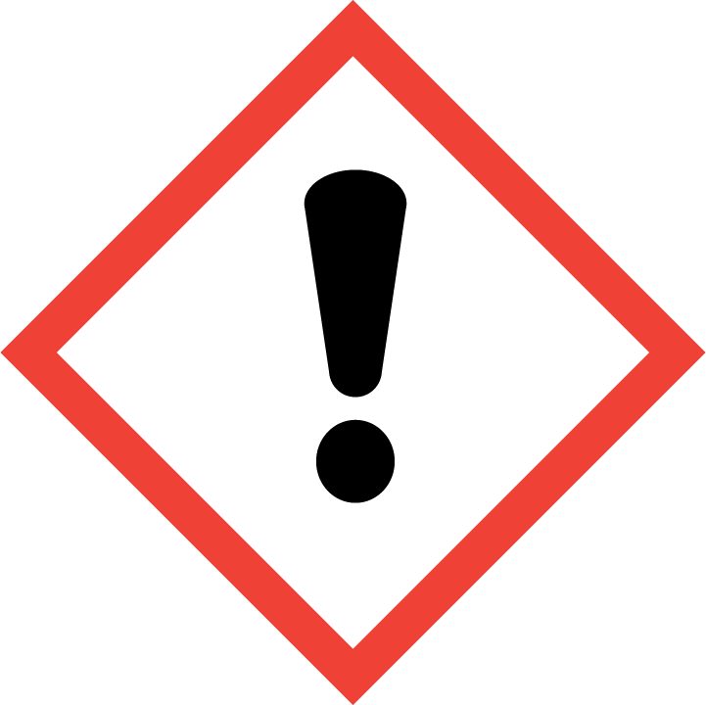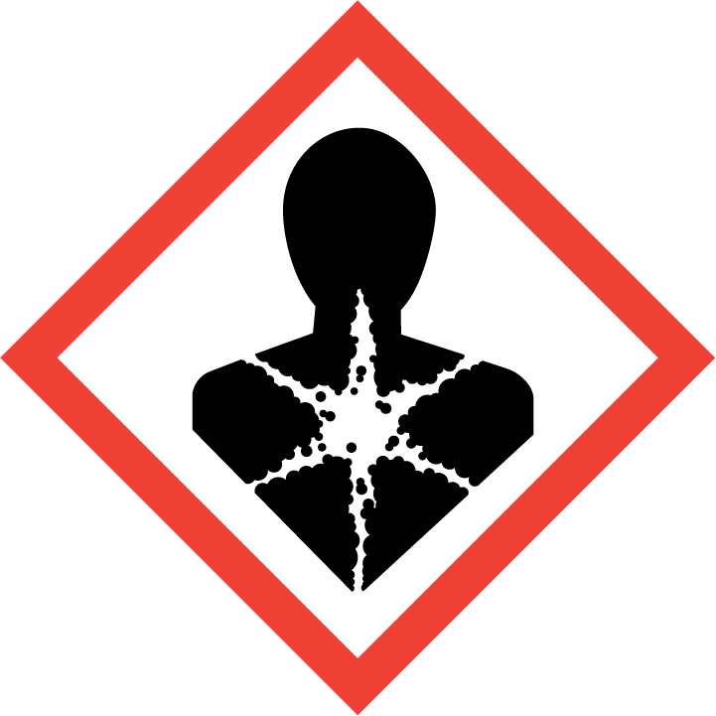

**Signal Word**

DANGER

**Hazard Statement(s):**

H317 May cause allergic skin reaction.

H341 Suspected of causing genetic effects.

H350 May cause cancer via inhalation.

H360 May damage fertility or the unborn child via inhalation.

**Precautionary Statement(s):**

P201 Obtain special instructions before use.

P202 Do not handle until all safety precautions have been ready and understood.

P261 Avoid breathing dust.

P264 Wash hands thoroughly after handling.

P270 Do not eat, drink, or smoke when using this product.

P272 Contaminated work clothing must not be allowed out of the workplace.

P280 Wear protective gloves, protective clothing, and eye protection.

P302+P352 If on skin: Wash with plenty of water.

P333+P313 If skin irritation or rash occurs: Get medical attention.

P308+P313 If exposed or concerned: Get medical attention.

P363 Wash contaminated clothing before reuse.

P405 Store locked up.

P501 Dispose of contents and container according to local regulations.

**Hazards Not Otherwise Classified:** Not applicable.

**Ingredients(s) with Unknown Acute Toxicity:** Not applicable.

|  |
| --- |
| **3. Composition and Information on Hazardous Ingredients** |

**Substance:** Nickel cyclohexanebutyrate

**Other Designations:** Cyclohexanebutanoic acid, nickel salt; nickel 4-cyclohexylbutyrate; nickel bis(4‑cyclohexylbutyrate); C20H36NiO4.

Components are listed in compliance with OSHA’s 29 CFR 1910.1200.

|  |  |  |  |
| --- | --- | --- | --- |
| **Hazardous Component(s)** | **CAS Number** | **EC Number** **(EINECS)** | **Nominal Mass Concentration (%)** |
| Nickel Cyclohexanebutyrate | 3906-55-6 | 223-463-2 | 100 |

|  |
| --- |
| **4. First Aid Measures** |

**Description of First Aid Measures**

**Inhalation:** Remove victim to fresh air. If not breathing, qualified personnel should give artificial respiration. Seek immediate medical attention.

**Skin Contact:** Rinse affected skin with water for at least 15 minutes, then wash thoroughly with soap or mild detergent and water. If skin irritation or rash persists, seek medical aid and bring the container or label.

**Eye Contact:** Immediately flush eyes, including under the eyelids, with copious amounts of water for at least 15 minutes.

**Ingestion:** If swallowed, get medical attention if you feel unwell.

**Most Important Symptoms/Effects, Acute and Delayed:** Kidney damage and cancer hazard (in humans).

**Indication of any immediate medical attention and special treatment needed, if necessary:** If any of the above symptoms are present, seek immediate medical attention.

|  |
| --- |
| **5. Fire Fighting Measures** |

**Fire and Explosion Hazards:** Slight fire hazard. Dust/air mixtures may ignite or explode. See Section 9, “Physical and Chemical Properties” for flammability properties.

**Extinguishing Media**

Suitable: Regular dry chemical, carbon dioxide, water, or alcohol‑resistant foam.

Unsuitable: None listed.

**Specific Hazards Arising from the Chemical**: Not applicable.

**Special Protective Equipment and Precautions for Fire‑Fighters:** Move container from fire area if it can be done without personal risk. Avoid inhalation of material or combustion by‑products. Wear full protective clothing and NIOSH‑approved self‑contained breathing apparatus (SCBA).

**NFPA Ratings** (0 = Minimal; 1 = Slight; 2 = Moderate; 3 = Serious; 4 = Severe)

Health = 2 Fire = 1 Reactivity = 0

|  |
| --- |
| **6. Accidental Release Measures** |

**Personal Precautions, Protective Equipment and Emergency Procedures:** Use suitable protective equipment; see Section 8, “Exposure Controls and Personal Protection”. Keep out of waters supplies and sewers.

**Methods and Materials for Containment and Clean up:** Collect in appropriate container for disposal.

|  |
| --- |
| **7. Handling and Storage** |

**Safe Handling Precautions:** Avoid dust formation. Avoid breathing vapors, mist or gas. See Section 8, “Exposure Controls and Personal Protection”.

**Storage and Incompatible Materials:** Store in a well‑ventilated area. Keep separated from incompatible substances (see Section 10, “Stability and Reactivity”).

|  |
| --- |
| **8. Exposure Controls and Personal Protection** |

**Exposure Limits**

OSHA (PEL): No occupation exposure limits established.

NIOSH (REL): 0.015 mg/m3 TWA – (Except nickel carbonyl) as Ni, related to nickel compounds

10 mg/m3 IDLH – (Except nickel carbonyl) as Ni, related to nickel compounds

ACGIH (TLV): No occupation exposure limits established.

**Engineering Controls:** Provide local exhaust or process enclosure ventilation system. Ensure compliance with applicable exposure limits.

**Personal Protection Measures:** In accordance with OSHA 29 CFR 1910.132, subpart I, wear appropriate Personal Protective Equipment (PPE) to minimize exposure to this material.

**Respiratory Protection:** If workplace conditions warrant a respirator, a respiratory protection program that meets OSHA 29CFR 1910.134 must be followed. Refer to NIOSH 42 CFR 84 for applicable certified respirators.

**Eye Protection:** Splash resistant safety goggles and emergency eyewash are recommended.

**Skin and Body Protection:** Chemical resistant clothing and gloves are recommended.

|  |
| --- |
| **9. Physical and Chemical Properties** |

| **Properties** |  |
| --- | --- |
| **Molar Mass (g/mol)** | 397.17 |
| **Molecular Formula** | C20H34NiO4 |
| **Appearance (physical state, color, etc.)** | solid |
| **Odor** | not available |
| **Odor threshold** | not available |
| **pH** | not available |
| **Evaporation rate** | not available |
| **Melting point/freezing point** | not available |
| **Relative Density** (water = 1) | not available |
| **Density** | not available |
| **Vapor Pressure** | not available |
| **Vapor Density (air = 1)** | not available |
| **Viscosity** | not available |
| **Solubilities** | not available |
| **Partition coefficient (n‑octanol/water)** | not available |
| **Particle size** | not available |
| **Thermal Stability Properties** |  |
| **Autoignition Temperature** | not available |
| **Thermal Decomposition** | not available |
| **Initial boiling point and boiling range** | not available |
| **Explosive Limits, LEL (Volume %)** | not available |
| **Explosive Limits, UEL (Volume %)** | not available |
| **Flash Point (Closed Cup)** | not available |
| **Flammability (solid, gas)** | not available |

|  |
| --- |
| **10. Stability and Reactivity** |

**Reactivity:** Stable at normal temperatures and pressure.

|  |  |  |  |  |
| --- | --- | --- | --- | --- |
| **Stability:** | X | Stable |  | Unstable |

**Possible Hazardous Reactions:** Not applicable.

**Conditions to Avoid:** Avoid generating dust. Avoid heat, flames, sparks and other sources of ignition.

**Incompatible Materials:** Strong oxidizing materials, strong acids, strong alkali.

**Hazardous Decomposition:** Nickel compounds; oxides of carbon.

|  |  |  |  |  |
| --- | --- | --- | --- | --- |
| **Hazardous Polymerization:** |  | Will Occur | X | Will Not Occur |

|  |
| --- |
| **11. Toxicological Information** |

|  |  |  |  |  |  |  |
| --- | --- | --- | --- | --- | --- | --- |
| **Route of Exposure:** | X | Inhalation | X | Skin | X | Ingestion |

**Symptoms Related to the Physical, Chemical and Toxicological Characteristics:** Nickel compounds are known to damage organs through prolonged or repeated exposure. May affect respiratory systems (allergy, asthma or cancer), may cause allergic skin reaction. May damage fertility or damage the unborn child; suspected of causing genetic effect.

**Potential Health Effects (Acute, Chronic, and Delayed)**

**Inhalation:** Inhalation of dust or fumes containing nickel salts may cause mouth and respiratory tract irritation, coughing, dyspnea, pneumonitis, and fever. Repeated or prolonged exposure to nickel salts may cause pulmonary irritation, sensitization, and lung cancer.

**Skin Contact:** Exposure to nickel compounds may cause irritation and sensitization dermatitis.

**Eye Contact:** Exposure may cause irritation and conjunctivitis.

**Ingestion:** Exposure may cause irritation of the digestive tract.

**Numerical Measures of Toxicity**

**Acute Toxicity:** Not classified; no data available.

**Skin Corrosion/Irritation:** Not classified.

**Serious Eye Damage/Eye Irritation:** Not classified; no data available.

**Respiratory Sensitization:** Not classified; no data available.

**Skin Sensitization:** Category 1.

Nickel compounds may cause skin sensitization.

**Germ Cell Mutagenicity:** Category 2

Nickel compounds are suspected of causing genetic defects.

**Carcinogenicity:** Category 1.

|  |  |  |  |  |
| --- | --- | --- | --- | --- |
| **Listed as a Carcinogen/Potential Carcinogen** | X | Yes |  | No |

Nickel compounds are listed by IARC as Group 1 (carcinogenic to humans), NTP (known human carcinogen) and is listed by OSHA as a carcinogen.

**Reproductive Toxicity:** Category 1B.

Nickel compounds may damage fertility or the unborn child.

**STOT, Single Exposure:** Not classified; no data available.

**STOT, Repeated Exposure:** Not classified; no data available.

**Aspiration Hazard:** Not applicable.

|  |
| --- |
| **12. Ecological Information** |

**Ecotoxicity Data:** L(E)C50: >0.1 mg/L to ≤1 mg/L; not readily biodegradable. Very toxic to aquatic life with long lasting effects.

**Persistence and Degradability:** No data available.

**Bioaccumulative Potential:** No data available.

**Mobility in Soil:** No data available.

**Other Adverse effects:** No data available.

|  |
| --- |
| **13. Disposal Considerations** |

**Waste Disposal:** Dispose in accordance with all applicable federal, state, and local regulations. Dispose of in accordance with US EPA 40 CFR 262 for concentrations at or above the regulatory level, 1.0 mg/L.

|  |
| --- |
| **14. Transportation Information** |

**U.S. DOT and IATA:** Not regulated by DOT or IATA.

|  |
| --- |
| **15. Regulatory Information** |

**U.S. Regulations**

CERCLA Sections 102a/103 (40 CFR 302.4): Not regulated.

SARA Title III Section 302 (40 CFR 355.30): Not regulated.

SARA Title III Section 304 (40 CFR 355.40): Not regulated.

SARA Title III Section 313 (40 CFR 372.65): 0.1 % de minimis concentration (related to Nickel compounds).

OSHA Process Safety (29 CFR 1910.119): Not regulated.

SARA Title III Sections 311/312 Hazardous Categories (40 CFR 370.21):

ACUTE HEALTH: Yes

CHRONIC HEALTH: Yes

FIRE: No

REACTIVE: No

PRESSURE: No

**State Regulations**

California Proposition 65: WARNING! This product contains a chemical (nickel) know to the state of California to cause cancer.

**U.S. TSCA Inventory:** Listed.

T**SCA 12(b), Export Notification:** Not listed.

**Canadian Regulations:** WHMIS Information is not provided for this material.

|  |
| --- |
| **16. Other Information** |

Issue Date: 06 July 2015

Sources: ChemADVISOR, Inc., SDS, *Cyclohexaebutanoic Acid, Nickel (2+) Salt*, 20 March 2015.

**Key of Acronyms:**

|  |  |  |  |
| --- | --- | --- | --- |
| ACGIH | American Conference of Governmental Industrial Hygienists | NTP | National Toxicology Program |
| CAS | Chemical Abstracts Service | OSHA | Occupational Safety and Health Administration |
| CERCLA | Comprehensive Environmental Response, Compensation, and Liability Act | PEL | Permissible Exposure Limit |
| CFR | Code of Federal Regulations | RCRA | Resource Conservation and Recovery Act |
| DOT | Department of Transportation | REL | Recommended Exposure Limit |
| EINECS | European Inventory of Existing Commercial Chemical Substances | RQ | Reportable Quantity |
| EPCRA | Emergency Planning and Community Right-to-Know Act | RTECS | Registry of Toxic Effects of Chemical Substances |
| IARC | International Agency for Research on Cancer | SARA | Superfund Amendments and Reauthorization Act |
| IATA | International Air Transportation Agency | SCBA | Self‑Contained Breathing Apparatus |
| IDLH | Immediately Dangerous to Life and Health | SRM | Standard Reference Material |
| LC50 | Lethal Concentration | STOT | Specific Target Organ Toxicity |
| LD50 | Median Lethal Dose or Lethal Dose, 50 % | STEL | Short Term Exposure Limit |
| LEL | Lower Explosive Limit | TLV | Threshold Limit Value |
| MSDS | Material Safety Data Sheet | TPQ | Threshold Planning Quantity |
| NFPA | National Fire Protection Association | TSCA | Toxic Substances Control Act |
| NIOSH | National Institute for Occupational Safety and Health | TWA | Time Weighted Average |
| NIST | National Institute of Standards and Technology | UEL | Upper Explosive Limit |
| n.o.s. | Not Otherwise Specified | WHMIS | Workplace Hazardous Materials Information System |

**Disclaimer:** Physical and chemical data contained in this SDS are provided only for use in assessing the hazardous nature of the material. The SDS was prepared carefully, using current references; however, NIST does not certify the data in the SDS. The values for this material are given in the NIST Certificate of Analysis.

Users of this SRM should ensure that the SDS in their possession is current. This can be accomplished by contacting the SRM Program: telephone (301) 975‑2200; fax (301) 948‑3730; e‑mail srmmsds@nist.gov; or via the Internet at <http://www.nist.gov/srm>.