Date of Issue:

29 July 2016

**SAFETY DATA SHEET**

|  |
| --- |
| **1. Substance and Source Identification** |

**Product Identifier**

**RM Number:** 8493

**RM Name:** Monterey Pine Whole Biomass Feedstock

**Other Means of Identification:** Not applicable.

**Recommended Use of This Material and Restrictions of Use**

This Reference Material (RM) is intended primarily for use in evaluating analytical methods for the determination of summative composition of lignocellulosic material. The RM can also be used for quality assurance when assigning values to in-house control materials. The whole softwood biomass material is derived from Monterey pine (*Pinus radiata)*. A unit of the RM consists of five single-use Mylar bags of whole biomass, each containing approximately 10 g of material.

**Company Information**

|  |  |
| --- | --- |
| National Institute of Standards and Technology |  |
| Standard Reference Materials Program |  |
| 100 Bureau Drive, Stop 2300 |  |
| Gaithersburg, Maryland 20899-2300 |  |
|  |  |
| Telephone: 301-975-2200 | Emergency Telephone ChemTrec: |
| FAX: 301-948-3730 | 1-800-424-9300 (North America) |
| E-mail: [SRMMSDS@nist.gov](mailto:SRMMSDS@nist.gov) | +1-703-527-3887 (International) |
| Website: <http://www.nist.gov/srm> |  |

|  |
| --- |
| **2. HAZARDS IDENTIFICATION** |

**Note:** RM 8493 is supplied in a small quantity and under normal laboratory conditions it does not constitute a combustible dust hazard. The physical properties of this material indicate that accumulated dust on surfaces generated where operations produce fine particulates, may lead to combustible dust concentrations in air.

**Classification**

**Physical Hazard:** Not classified.

**Health Hazard:** Respiratory Sensitization: Category 1

Skin Sensitization: Category 1

Carcinogenicity: Category 1A

STOT Single Exposure: Category 3

STOT Repeated Exposure: Category 1

**Label Elements**

**Symbol:**

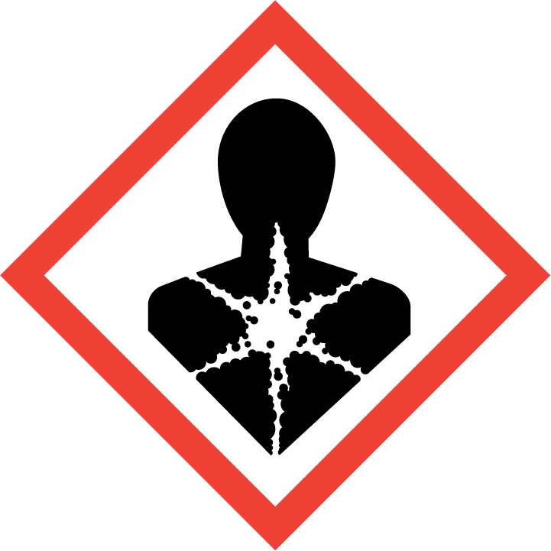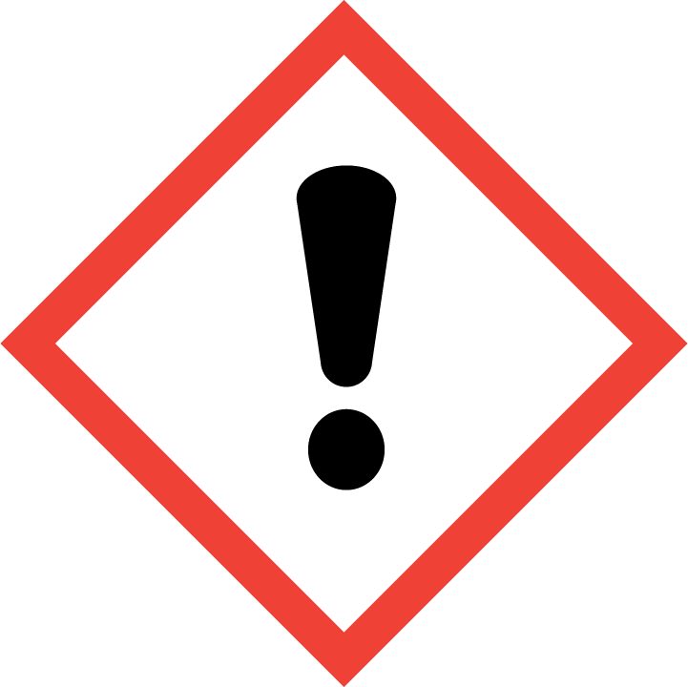

**Signal Word:** DANGER

**Hazard Statement(s):**

H334 May cause allergy or asthma symptoms or breathing difficulties if inhaled.

H317 May cause an allergic skin reaction.

H350 May cause cancer.

H335 May cause respiratory irritation.

H372 Causes damage to organs (respiratory system) through prolonged or repeated exposure (inhalation).

**Precautionary Statement(s):**

P201 Obtain special instructions before use.

P202 Do not handle until all safety precautions have been read and understood.

P261 Avoid breathing dust.

P271 Use only outdoors or in a well-ventilated area.

P272 Contaminated work clothing should not be allowed out of the workplace.

P280 Wear eye protection, protective gloves and clothing.

P284 Wear respiratory protection.

P302 + P352 If on skin: Wash with plenty of water.

P333 + P313 If skin irritation or rash occurs: get medical attention.

P362 + P364 Take off contaminated clothing and wash before reuse.

P304 + P340 If inhaled: Remove person to fresh air and keep comfortable for breathing.

P342 + P311 If experiencing respiratory symptoms: Call a doctor.

P308 + P313 If exposed or concerned: Get medical attention.

P403 + P233 Store in a well-ventilated place. Keep container tightly closed.

P405 Store locked up.

P501 Dispose of contents and container according to local regulations.

**Hazards Not Otherwise Classified:** Not applicable.

**Ingredients(s) with Unknown Acute Toxicity:** Not applicable.

|  |
| --- |
| **3. COMPOSITION AND INFORMATION ON HAZARDOUS INGREDIENTS** |

**Substance:** Wood dust

**Other Designations:** Sawdust; wood meal; wood flour

Components are listed in compliance with OSHA’s 29 CFR 1910.1200; for the actual values see the NIST Report of Investigation.

|  |  |  |  |
| --- | --- | --- | --- |
| **Hazardous Component(s)** | **CAS Number** | **EC Number**  **(EINECS)** | **Nominal Mass Concentration  (%)** |
| Wood dust | not available | not available | 100 |

|  |
| --- |
| **4. FIRST AID MEASURES** |

**Description of First Aid Measures:**

**Inhalation:** If adverse effects occur, remove to uncontaminated area. If not breathing, give artificial respiration or oxygen by qualified personnel. Seek immediate medical attention.

**Skin Contact:** Wash skin with soap and water.

**Eye Contact:** Flush eyes with water for at least 15 minutes. If necessary, seek medical attention.

**Ingestion:** If adverse effects occur after ingestion, seek medical treatment.

**Most Important Symptoms/Effects, Acute and Delayed:** Generated dust may cause irritation; chronic inhalation of wood dust may cause cancer.

**Indication of any immediate medical attention and special treatment needed, if necessary:** If any of the above symptoms are present, seek medical attention if needed.

|  |
| --- |
| **5. FIRE FIGHTING MEASURES** |

**Fire and Explosion Hazards:** Avoid generating dust; sufficient concentrations of fine dust dispersed in air, and in the presence of an ignition source is a potential hazard. See Section 9, “Physical and Chemical Properties” for flammability properties.

**Extinguishing Media:**

Suitable: Regular dry chemical, carbon dioxide, water, regular foam.

Unsuitable: None listed.

**Specific Hazards Arising from the Chemical:** None listed.

**Special Protective Equipment and Precautions for Fire-Fighters:** Avoid inhalation of material or combustion byproducts. Wear full protective clothing and NIOSH approved self-contained breathing apparatus (SCBA).

**NFPA Ratings** (0 = Minimal; 1 = Slight; 2 = Moderate; 3 = Serious; 4 = Severe)

Health = 1 Fire = 1 Reactivity = 0

|  |
| --- |
| **6. ACCIDENTAL RELEASE MEASURES** |

**Personal Precautions, Protective Equipment and Emergency Procedures:** Any accumulated material on surfaces should be removed and disposed of properly. Use suitable protective equipment; see Section 8, “Exposure Controls and Personal Protection”.

**Methods and Materials for Containment and Clean up:** Collect spilled material in appropriate container for disposal. Keep out of water supplies and sewers. Keep unnecessary people away, isolate hazard area and deny entry.

|  |
| --- |
| **7. HANDLING AND STORAGE** |

**Safe Handling Precautions:** Minimize dust generation and accumulation on surfaces. Routine housekeeping should be instituted to ensure that dusts do not accumulate on surfaces. See Section 8, “Exposure Controls and Personal Protection”. Avoid contact with incompatible materials (see Section 10, “Stability and Reactivity”).

**Storage:** Store and handle in accordance with all current regulations and standards.

|  |
| --- |
| **8. EXPOSURE CONTROLS AND PERSONAL PROTECTION** |

**Exposure Limits:** No occupational exposure limits established for wood dust. OSHA regulates wood dust exposure under the requirements for Particulates Not Otherwise Regulated.

OSHA (PEL): 15 mg/m3 TWA (total particulates)

5 mg/m3 TWA (respirable particulates)

NIOSH (REL): 1 mg/m3 TWA (wood dust)

ACGIH (TLV): 1 mg/m3 TWA (wood dust all species except western red cedar)

0.5 mg/m3 TWA (Western red cedar wood dust)

**Engineering Controls:** Provide local exhaust or process enclosure ventilation system. Ensure compliance with applicable exposure limits.

**Personal Protection:** In accordance with OSHA 29 CFR 1910.132, subpart I, wear appropriate Personal Protective Equipment (PPE) to minimize exposure to this material.

**Respiratory Protection:** If workplace conditions warrant a respirator, a respiratory protection program that meets OSHA 29CFR 1910.134 must be followed. Refer to NIOSH 42 CFR 84 for applicable certified respirators.

**Eye/Face Protection:** Wear splash resistant safety goggles with a face shield. An eye wash station should be readily available near areas of use.

**Skin and Body Protection:** Personal protective equipment for the body should be selected based on the task being performed and the risks involved and should be approved by a specialist before handling this product. Chemical-resistant gloves should be worn at all times when handling chemicals.

|  |
| --- |
| **9**. **Physical and Chemical Properties** |

|  |  |
| --- | --- |
| **Descriptive Properties:** | **Wood dust** |
| **Appearance (physical state, color, etc.)** | powder |
| **Molecular Formula** | not available |
| **Molar Mass (g/mol)** | not applicable |
| **Odor** | not available |
| **Odor threshold** | not available |
| **pH** | not available |
| **Evaporation rate** | not applicable |
| **Melting point/freezing point (ºC)** | not applicable |
| **Specific Gravity (water=1)** | not available |
| **Vapor Pressure (mmHg)** | not applicable |
| **Vapor Density (air = 1)** | not applicable |
| **Viscosity (cP)** | not applicable |
| **Solubility(ies)** | not available |
| **Partition coefficient (n-octanol/water)** | not available |
| **Particle Size** | not available |
| **Thermal Stability Properties:** |  |
| **Autoignition Temperature (ºC)** | not available |
| **Thermal Decomposition (ºC)** | not available |
| **Initial boiling point and boiling range (ºC)** | not applicable |
| **Explosive Limits, LEL (Volume %)** | not available |
| **Explosive Limits, UEL (Volume %)** | not available |
| **Flash Point (ºC)** | not available |
| **Flammability (solid, gas)** | not available |

|  |
| --- |
| **10. Stability and Reactivity** |

**Reactivity:** Stable at normal temperatures and pressure.

|  |  |  |  |  |
| --- | --- | --- | --- | --- |
| **Stability:** | X | Stable |  | Unstable |

**Possible Hazardous Reactions:** None listed.

**Conditions to Avoid:** Avoid generating dust. Avoid heat, flames, sparks and other sources of ignition. Avoid contact with incompatible materials.

**Incompatible Materials:** Oxidizing materials.

**Fire/Explosion Information:** See Section 5, “Fire Fighting Measures”.

**Hazardous Decomposition:** Thermal decomposition will produce oxides of carbon.

|  |  |  |  |  |
| --- | --- | --- | --- | --- |
| **Hazardous Polymerization:** |  | Will Occur | X | Will Not Occur |

|  |
| --- |
| **11. TOXICOLOGICAL INFORMATION** |

|  |  |  |  |  |  |  |
| --- | --- | --- | --- | --- | --- | --- |
| **Route of Exposure:** | X | Inhalation | X | Skin |  | Ingestion |

**Symptoms Related to the Physical, Chemical and Toxicological Characteristics:** Cough, nasal discomfort, and bronchitis.

**Potential Health Effects (Acute, Chronic and Delayed):**

**Inhalation:** Wood dust may cause cancer. Wood dust may cause allergy or asthma symptoms or breathing difficulties if inhaled. May cause respiratory irritation. Causes damage to organs through prolonged or repeated exposure (reduced lung function).

**Skin Contact:** May cause mechanical irritation and an allergic skin reaction.

**Eye Contact:** Generated dust may irritate the eyes.

**Ingestion:** No data available.

**Numerical Measures of Toxicity:**

**Acute Toxicity:** Not classified; no data available.

**Skin Corrosion/Irritation:** Not classified; no data available.

**Serious Eye Damage/Irritation:** Not classified; no data available.

**Respiratory Sensitization:** Category 1.

**Skin Sensitization:** Category 1.

**Germ Cell Mutagenicity:** Not classified; no data available.

**Carcinogenicity:** Category 1A.

|  |  |  |  |  |
| --- | --- | --- | --- | --- |
| **Listed as a Carcinogen/Potential Carcinogen** | X | Yes |  | No |

Wood dust is listed as known to be a human carcinogen by NTP; and listed as Group 1 Carcinogenic to humans by IARC.

**Reproductive Toxicity:** Not classified; no data available.

**Specific Target Organ Toxicity, Single Exposure:** Category 3, Respiratory tract irritation.

**Specific Target Organ Toxicity, Repeated Exposure:** Category 1, may cause damage to the respiratory system.

**Aspiration Hazard:** Not classified; no data available.

|  |
| --- |
| **12. ECOLOGICAL INFORMATION** |

**Ecotoxicity Data:** No data available.

**Persistence and Degradability:** No data available.

**Bioaccumulative Potential:** No data available.

**Mobility in Soil:** No data available.

**Other Adverse effects:** No data available.

|  |
| --- |
| **13. DISPOSAL CONSIDERATIONS** |

**Waste Disposal:** Dispose of waste in accordance with all applicable federal, state, and local regulations.

|  |
| --- |
| **14. TRANSPORTATION INFORMATION** |

**U.S. DOT and IATA:** Not regulated by DOT or IATA.

|  |
| --- |
| **15. REGULATORY INFORMATION** |

**U.S. Regulations:**

CERCLA Sections 102a/103 (40 CFR 302.4): Not regulated.

SARA Title III Section 302 (40 CFR 355.30): Not regulated.

SARA Title III Section 304 (40 CFR 355.40): Not regulated.

SARA Title III Section 313 (40 CFR 372.65): Not regulated.

OSHA Process Safety (29 CFR 1910.119): Not regulated.

SARA Title III Sections 311/312 Hazardous Categories (40 CFR 370.21):

ACUTE HEALTH: Yes.

CHRONIC HEALTH: Yes.

FIRE: No.

REACTIVE: No.

PRESSURE: No.

**State Regulations:**

California Proposition 65: Not listed.

**U.S. TSCA Inventory:** Not listed.

**TSCA 12(b), Export Notification:** Not listed.

**Canadian Regulations:** WHMIS Information is not provided for this material.

|  |
| --- |
| **16. OTHER INFORMATION** |

**Issue Date:** 29 July 2016

**Sources:** ChemAdvisor, Inc., SDS *Wood Dust,* 09 December 2015.

CDC; NIOSH;*NIOSH Pocket Guide to Chemical Hazards*; Department of Health and Human Services (DHHS), Centers for Disease Control and Prevention (CDC), National Institute for Safety and Health; *Particulates not otherwise regulated*, 11 April 2016; available at <http://www.cdc.gov/niosh/npg/npgd0480.html> (accessed July 2016).

World Health Organization, IARC Monographs on the Evaluation of Carcinogenic Risks to Humans; *Wood Dust*; available at <http://monographs.iarc.fr/ENG/Classification/index.php> (accessed July 2016).

U.S. Department of Health and Human Services, NTP 13th report on Carcinogens; *Wood Dust*; <http://ntp.niehs.nih.gov/pubhealth/roc/roc13/index.html> (accessed July 2016).

U.S. National Library of Medicine, Toxicology Data Network, HAZMAP Database, *Wood Dust*; available at <https://hazmap.nlm.nih.gov/category-details?table=copytblagents&id=674> (accessed July 2016).

U.S. Department of Labor, OSHA; Wood Dust Exposure Evaluation, available at <https://www.osha.gov/SLTC/wooddust/evaluation.html> (accessed July 2016).

**Key of Acronyms:**

|  |  |  |  |
| --- | --- | --- | --- |
| ACGIH | American Conference of Governmental Industrial Hygienists | NRC | Nuclear Regulatory Commission |
| ALI | Annual Limit on Intake | NTP | National Toxicology Program |
| CAS | Chemical Abstracts Service | OSHA | Occupational Safety and Health Administration |
| CERCLA | Comprehensive Environmental Response, Compensation, and Liability Act | PEL | Permissible Exposure Limit |
| CFR | Code of Federal Regulations | RCRA | Resource Conservation and Recovery Act |
| DOT | Department of Transportation | REL | Recommended Exposure Limit |
| EC50 | Effective Concentration, 50 % | RM | Reference Material |
| EINECS | European Inventory of Existing Commercial Chemical Substances | RQ | Reportable Quantity |
| EPCRA | Emergency Planning and Community Right-to-Know Act | RTECS | Registry of Toxic Effects of Chemical Substances |
| IARC | International Agency for Research on Cancer | SARA | Superfund Amendments and Reauthorization Act |
| IATA | International Air Transport Association | SCBA | Self‑Contained Breathing Apparatus |
| IDLH | Immediately Dangerous to Life and Health | SRM | Standard Reference Material |
| LC50 | Lethal Concentration, 50 % | STEL | Short Term Exposure Limit |
| LD50 | Lethal Dose, 50 % | TLV | Threshold Limit Value |
| LEL | Lower Explosive Limit | TPQ | Threshold Planning Quantity |
| MSDS | Material Safety Data Sheet | TSCA | Toxic Substances Control Act |
| NFPA | National Fire Protection Association | TWA | Time Weighted Average |
| NIOSH | National Institute for Occupational Safety and Health | UEL | Upper Explosive Level |
| NIST | National Institute of Standards and Technology | WHMIS | Workplace Hazardous Materials Information System |

**Disclaimer:** Physical and chemical data contained in this SDS are provided only for use in assessing the hazardous nature of the material. The SDS was prepared carefully, using current references; however, NIST does not certify the data in the SDS. The assigned values for this material are given in the NIST Report of Investigation.

Users of this RM should ensure that the SDS in their possession is current. This can be accomplished by contacting the SRM Program: telephone (301) 975-2200; fax (301) 948-3730; e-mail srmmsds@nist.gov; or via the Internet at http://www.nist.gov/srm.