Date of Issue:

08 July 2014

**SAFETY DATA SHEET**

|  |
| --- |
| **1. Substance and Source Identification** |

**Product Identifier**

**RM Number:** 8549

**RM Name:** Nitrogen and Oxygen Isotopes in Nitrate (IAEA‑NO‑3)

**Other Means of Identification:** Not applicable.

**Recommended Use of This Material and Restrictions of Use**

This Reference Material (RM) is intended primarily for use in developing and validating methods for measuring relative differences in nitrogen (N) and oxygen (O) isotope‑amount‑ratios in nitrate. A unit of RM 8549 consists of a plastic vial that contains approximately 0.4 g of KNO3 salt.

**Company Information**

|  |  |
| --- | --- |
| National Institute of Standards and Technology |  |
| Standard Reference Materials Program |  |
| 100 Bureau Drive, Stop 2300 |  |
| Gaithersburg, Maryland 20899-2300 |  |
|  |  |
| Telephone: 301-975-2200 | Emergency Telephone ChemTrec: |
| FAX: 301-948-3730 | 1-800-424-9300 (North America) |
| E-mail: [SRMMSDS@nist.gov](mailto:SRMMSDS@nist.gov) | +1-703-527-3887 (International) |
| Website: <http://www.nist.gov/srm> |  |

|  |
| --- |
| **2. HAZARDS IDENTIFICATION** |

**Classification**

**Physical Hazard:** Oxidizing Solids Category 3

**Health Hazard:** Eye Damage/Irritation Category 2B

STOT, Single Exposure Category 3

**Label Elements**

**Symbol**

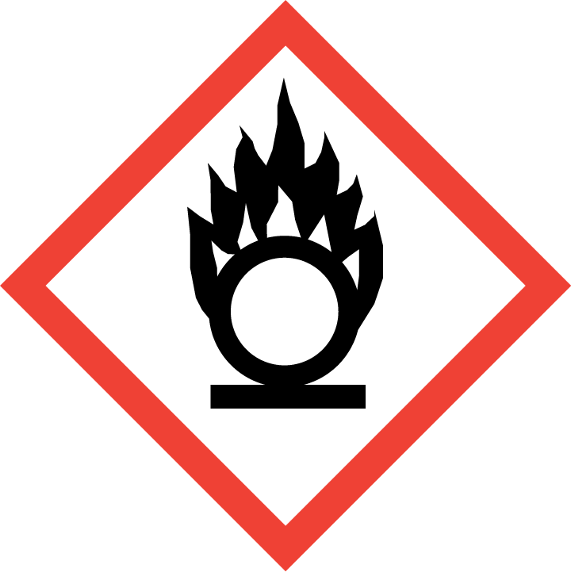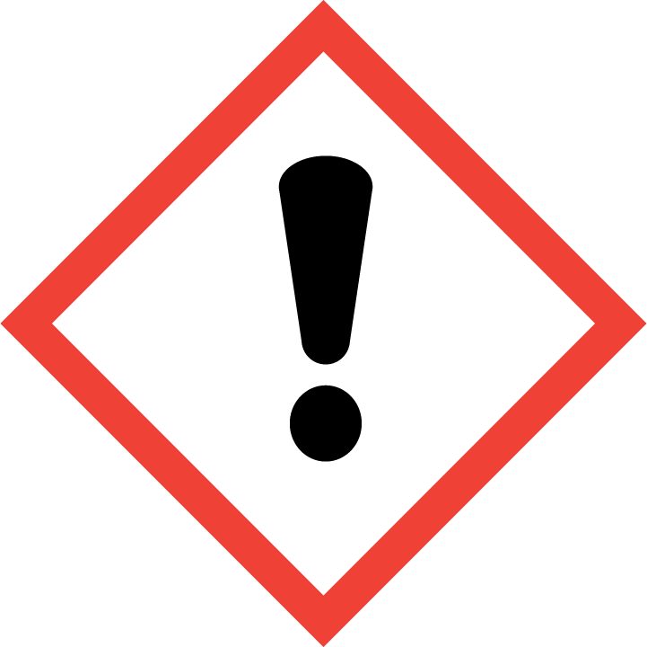

**Signal Word**

WARNING

**Hazard Statement(s)**

H272 May intensify fire; oxidizer.

H320 Causes eye irritation.

H335 May cause respiratory irritation.

**Precautionary Statement(s)**

P210 Keep away from heat.

P220 Keep away from combustible materials.

P221 Take any precaution to avoid mixing with combustible or flammable materials.

P261 Avoid breathing dust.

P264 Wash hands thoroughly after handling

P271 Use only outdoors or in a well-ventilated area.

P280 Wear protective gloves, protective clothing, and eye protection.

|  |  |
| --- | --- |
|  |  |

P304+P340 If inhaled: Remove person to fresh air and keep comfortable for breathing.

P305+P351+P338 If in eyes: Rinse cautiously with water for several minutes. Remove contact lenses if present and easy to do. Continue rinsing.

P312 Call a poison center or doctor if you feel unwell.

P337+P313 If eye irritation persists: Get medical attention

P403+P233 Store in a well-ventilated place. Keep container tightly closed.

P405 Store locked up.

P501 Dispose of contents and container according to local regulations.

**Hazards Not Otherwise Classified:** Not applicable.

**Ingredients(s) with Unknown Acute Toxicity:** Not applicable.

|  |
| --- |
| **3. COMPOSITION AND INFORMATION ON HAZARDOUS INGREDIENTS** |

**Substance:** Potassium nitrate

**Other Designations:**

Nitric acid potassium salt; saltpeter; KNO3

Components are listed in compliance with OSHA’s 29 CFR 1910.1200; for the actual values see the Report of Investigation.

|  |  |  |  |
| --- | --- | --- | --- |
| **Hazardous Component(s)** | **CAS Number** | **EC Number**  **(EINECS)** | **Nominal Mass Concentration (%)** |
| Potassium nitrate | 7757-79-1 | 231-818-8 | 100 |

|  |
| --- |
| **4. FIRST AID MEASURES** |

**Description of First Aid Measures:**

**Inhalation:** If adverse effects occur, remove to uncontaminated area. If not breathing, give artificial respiration or oxygen by qualified personnel. Seek immediate medical attention.

**Skin Contact:** Wash skin with soap and water for at least 15 minutes while removing contaminated clothing and shoes. Get medical attention if needed. Thoroughly clean and dry contaminated clothing before reuse.

**Eye Contact:** Immediately flush eyes, including under the eyelids with copious amounts of water for at least 15 minutes. Seek immediate medical attention.

**Ingestion:** If a large amount is swallowed, get medical attention.

**Most Important Symptoms/Effects, Acute and Delayed:** Skin, eye, and respiratory irritation; cyanosis.

**Indication of any immediate medical attention and special treatment needed, if necessary:** If any of the above symptoms are present, seek immediate medical attention.

|  |
| --- |
| **5. FIRE FIGHTING MEASURES** |

**Fire and Explosion Hazards:** Negligible fire hazard. Oxidizer, contact with combustible materials may enhance combustion; risk of fire or explosion on contact with reducing agents. See Section 9, “Physical and Chemical Properties” for flammability properties.

**Extinguishing Media:**

Suitable: Water or other appropriate media.

Unsuitable: None listed.

**Specific Hazards Arising from the Chemical:** None listed.

**Special Protective Equipment and Precautions for Fire-Fighters:** Avoid inhalation of material or combustion byproducts. Wear full protective clothing and NIOSH approved self-contained breathing apparatus (SCBA).

**NFPA Ratings** (0 = Minimal; 1 = Slight; 2 = Moderate; 3 = Serious; 4 = Severe)

Health = 1 Fire = 0 Reactivity = 0

|  |
| --- |
| **6. ACCIDENTAL RELEASE MEASURES** |

**Personal Precautions, Protective Equipment and Emergency Procedures:** Immediately contact emergency personnel. Keep unnecessary personnel away. Use suitable protective equipment; see Section 8, “Exposure Controls and Personal Protection”.

**Methods and Materials for Containment and Clean up:**  Do not touch spilled material. Notify safety personnel of spills. Absorb with sand or other non-combustible material. Collect spilled material in appropriate container for disposal. Isolate hazard area and deny entry.

|  |
| --- |
| **7. HANDLING AND STORAGE** |

**Safe Handling Precautions:** Use methods to minimize dust. See Section 8, “Exposure Controls and Personal Protection”.

**Storage:** Store and handling in accordance with all current regulations and standards. Keep separated from incompatible substances; see Section 10 “Stability and Reactivity” for incompatible substances.

|  |
| --- |
| **8. EXPOSURE CONTROLS AND PERSONAL PROTECTION** |

**Exposure Limits:**

NIOSH (REL): No exposure limits established for potassium nitrate.

ACGIH (TLV): No exposure limits established for potassium nitrate.

OSHA (PEL): 15 mg/m3 (TWA, total dust); 5 mg/m3 (TWA, respirable fraction);

Particulates not otherwise regulated.

**Engineering Controls:** Provide local exhaust or process enclosure ventilation system. Ensure compliance with applicable exposure limits.

**Personal Protection:** In accordance with OSHA 29 CFR 1910.132, subpart I, wear appropriate Personal Protective Equipment (PPE) to minimize exposure to this material.

**Respiratory Protection:** If workplace conditions warrant a respirator, a respiratory protection program that meets OSHA 29CFR 1910.134 must be followed. Refer to NIOSH 42 CFR 84 for applicable certified respirators.

**Eye/Face Protection:** Wear splash resistant safety goggles with a face shield. An eye wash station should be readily available near areas of use.

**Skin and Body Protection:** Personal protective equipment for the body should be selected based on the task being performed and the risks involved and should be approved by a specialist before handling this product. Chemical‑resistant gloves should be worn at all times when handling chemicals.

|  |
| --- |
| **9**. **Physical and Chemical Properties** |

|  |  |
| --- | --- |
| **Descriptive Properties:** | **Potassium Nitrate** |
| **Appearance  (physical state, color, etc.):** | clear to white crystalline powder |
| **Molecular Formula:** | KNO3 |
| **Molar Mass (g/mol):** | 101.11 |
| **Odor:** | not available |
| **Odor threshold:** | not available |
| **pH:** | 7 (approximate) |
| **Evaporation rate (ether = 1):** | not available |
| **Melting point/freezing point (ºC):** | 334 (633 ºF) |
| **Relative Density (g/L):** | 2.109 at 16 ºC |
| **Vapor Pressure (mmHg):** | not applicable |
| **Vapor Density (air = 1):** | not applicable |
| **Viscosity (cP):** | not applicable |
| **Solubility(ies):** | water: 13.3 % 0 ºC  soluble in liquid ammonia, glycerol |
| **Partition coefficient  (n-octanol/water):** | not available |
| **Particle Size:** | >0.177 mm |
| **Thermal Stability Properties:** |  |
| **Autoignition Temperature (ºC):** | not applicable |
| **Thermal Decomposition (ºC):** | 400 (752 ºF) |
| **Initial boiling point and boiling range (ºC):** | not applicable |
| **Explosive Limits, LEL (Volume %):** | not applicable |
| **Explosive Limits, UEL (Volume %):** | not applicable |
| **Flash Point (ºC):** | not applicable |
| **Flammability (solid, gas):** | not applicable |

|  |
| --- |
| **10. Stability and Reactivity** |

**Reactivity:** Stable at normal temperatures and pressure.

|  |  |  |  |  |
| --- | --- | --- | --- | --- |
| **Stability:** | X | Stable |  | Unstable |

**Possible Hazardous Reactions:** May ignite or explode on contact with reducing agents.

**Conditions to Avoid:** Avoid contact with combustible materials.

**Incompatible Materials:** Acids, combustible materials, halogens, metal salts, metals, reducing agents.

**Fire/Explosion Information:** See Section 5, “Fire Fighting Measures”.

**Hazardous Decomposition:** Thermal decomposition will produce oxides of nitrogen, oxides of potassium.

|  |  |  |  |  |
| --- | --- | --- | --- | --- |
| **Hazardous Polymerization:** |  | Will Occur | X | Will Not Occur |

|  |
| --- |
| **11. TOXICOLOGICAL INFORMATION** |

|  |  |  |  |  |  |  |
| --- | --- | --- | --- | --- | --- | --- |
| **Route of Exposure:** | X | Inhalation | X | Skin | X | Ingestion |

**Symptoms Related to the Physical, Chemical and Toxicological Characteristics:** Eye, skin, and respiratory irritation, cyanosis.

**Potential Health Effects (Acute, Chronic and Delayed):**

**Inhalation:** Acute exposure may result in cough, sore throat, respiratory tract irritation, and shortness of breath. No data listed for chronic exposure.

**Skin Contact:** Contact may cause irritation. Severity of the irritation depends on the duration of exposure. No data listed for chronic exposure.

**Eye Contact:** Contact may cause irritation with redness and pain. Severity of the damage depends on the duration of exposure.

**Ingestion:** Ingestion of large doses of potassium nitrate (15 g to 30 g) may be fatal due to methemoglobinemia. Symptoms of methemoglobinemia are cyanosis, stupor, and cerebral anoxia; effects may be delayed. Ingestion of large quantities may also cause violent gastroenteritis accompanied by severe abdominal pain, vomiting, vertigo, muscular weakness, irregular pulse, cyanosis, convulsions and collapse may occur. The effects of repeated exposure to small amounts may cause anemia, nephritis, and possible methemoglobinemia.

**Numerical Measures of Toxicity:**

**Acute Toxicity:** Not classified.

Rat, Oral LD50: 3015 mg/kg

**Skin Corrosion/Irritation:** Classified: Not classified; no data available.

**Serious Eye damage/ Eye irritation:** Classified: Category 2B

Rabbit, conjunctiva score (redness): 1.7 (fully reversible within seven days)

Rabbit, conjunctiva score (chemosis): 1 (fully reversible within seven days)

**Respiratory Sensitization:** No data available.

**Skin Sensitization:** No data available.

**Germ Cell Mutagenicity:** No data available.

**Carcinogenicity:** Not classified.

|  |  |  |  |  |
| --- | --- | --- | --- | --- |
| **Listed as a Carcinogen/Potential Carcinogen** |  | Yes | X | No |

Potassium nitrate is not listed by NTP, IARC, or OSHA as a carcinogen.

Mutagenic: *Escherichia coli* 5 pph

**Reproductive Toxicity:** Not classified.

Rat, Oral TDLo: 22 g/kg (pregnant 1‑22 days)

Guinea pig, Oral TDLo: 15 g/kg (prior to copulation 24 weeks)

**Specific Target Organ Toxicity (STOT), Single Exposure:** Classified: Category 3

Inhalation of this material may cause respiratory tract irritation.

**Specific Target Organ Toxicity, Repeated Exposure:** Not classified; no data available.

**Aspiration Hazard:** Not applicable.

|  |
| --- |
| **12. ECOLOGICAL INFORMATION** |

**Ecotoxicity Data:**

Fish: Bluegill (*Lepomis macrochirus*) LC50: 420 mg/L (96 h) fresh water (static)

Invertebrate: Water flea (*Daphnia magna*) LC50: 39 mg/L (96 h) fresh water (static)

**Persistence and Degradability:** No data available.

**Bioaccumulative Potential:** No data available.

**Mobility in Soil:** No data available.

**Other Adverse effects:** No data available.

|  |
| --- |
| **13. DISPOSAL CONSIDERATIONS** |

**Waste Disposal:** Dispose of waste in accordance with all applicable federal, state, and local regulations. Potassium nitrate subject to disposal regulations: U.S. EPA 40 CFR 262, Hazardous Waste Number: D001.

|  |
| --- |
| **14. TRANSPORTATION INFORMATION** |

**U.S. DOT and IATA:** UN1486, Potassium nitrate, Hazard Class 5.1, Packing Group III.

|  |
| --- |
| **15. REGULATORY INFORMATION** |

**U.S. Regulations:**

CERCLA Sections 102a/103 (40 CFR 302.4): Not regulated.

SARA Title III Section 302 (40 CFR 355.30): Not regulated.

SARA Title III Section 304 (40 CFR 355.40): Not regulated.

SARA Title III Section 313 (40 CFR 372.65): Not regulated.

OSHA Process Safety (29 CFR 1910.119): Not regulated.

SARA Title III Sections 311/312 Hazardous Categories (40 CFR 370.21):

ACUTE HEALTH: No.

CHRONIC HEALTH: No.

FIRE: Yes.

REACTIVE: No.

PRESSURE: No.

**State Regulations:**

California Proposition 65: Not listed.

**U.S. TSCA Inventory:** Listed.

**TSCA 12(b), Export Notification:** Not listed.

**Canadian Regulations:**

WHMIS Information: Not provided for this material.

|  |
| --- |
| **16. OTHER INFORMATION** |

**Issue Date:** 08 July 2014

**Sources:** ChemAdvisor, Inc., MSDS *Potassium Nitrate*, 21 March 2014.

Hazardous Substances Data Bank (HSDB), National Library of Medicine's TOXNET system  
*Potassium Nitrate,* *CAS No. 7757‑79‑1*, available at <http://toxnet.nlm.nih.gov> (accessed Jun 2014).

International Labor Organization International, International Chemical Safety Card (ICSC) database, *Potassium Nitrate*, available at: <http://www.ilo.org/dyn/icsc/showcard.display?p_lang=en&p_card_id=0184> (accessed Jun 2014).

European Chemicals Agency, Registered substances, *Potassium Nitrate, CAS No.7757-79-1,* available at <http://echa.europa.eu/information-on-chemicals> (accessed Jun 2014).

**Key of Acronyms:**

|  |  |  |  |
| --- | --- | --- | --- |
| ACGIH | American Conference of Governmental Industrial Hygienists | NRC | Nuclear Regulatory Commission |
| ALI | Annual Limit on Intake | NTP | National Toxicology Program |
| CAS | Chemical Abstracts Service | OSHA | Occupational Safety and Health Administration |
| CERCLA | Comprehensive Environmental Response, Compensation, and Liability Act | PEL | Permissible Exposure Limit |
| CFR | Code of Federal Regulations | RCRA | Resource Conservation and Recovery Act |
| DOT | Department of Transportation | REL | Recommended Exposure Limit |
| EC50 | Effective Concentration, 50% | RM | Reference Material |
| EINECS | European Inventory of Existing Commercial Chemical Substances | RQ | Reportable Quantity |
| EPCRA | Emergency Planning and Community Right-to-Know Act | RTECS | Registry of Toxic Effects of Chemical Substances |
| IARC | International Agency for Research on Cancer | SARA | Superfund Amendments and Reauthorization Act |
| IATA | International Air Transportation Agency | SCBA | Self‑Contained Breathing Apparatus |
| IDLH | Immediately Dangerous to Life and Health | RM | Reference Material |
| LC50 | Lethal Concentration, 50 % | STEL | Short Term Exposure Limit |
| LD50 | Lethal Dose, 50 % | TLV | Threshold Limit Value |
| LEL | Lower Explosive Limit | TPQ | Threshold Planning Quantity |
| MSDS | Material Safety Data Sheet | TSCA | Toxic Substances Control Act |
| NFPA | National Fire Protection Association | TWA | Time Weighted Average |
| NIOSH | National Institute for Occupational Safety and Health | UEL | Upper Explosive Limit |
| NIST | National Institute of Standards and Technology | WHMIS | Workplace Hazardous Materials Information System |
| n.o.s. | Not Otherwise Specified |  |  |

**Disclaimer:** Physical and chemical data contained in this SDS are provided only for use in assessing the hazardous nature of the material. The SDS was prepared carefully, using current references; however, NIST does not certify the data in the SDS. The reference values for this material are given in the NIST Report of Investigation.

Users of this RM should ensure that the SDS in their possession is current. This can be accomplished by contacting the SRM Program: telephone (301) 975-2200; fax (301) 948-3730; e-mail srmmsds@nist.gov; or via the Internet at http://www.nist.gov/srm.