**How to Run NLPParser**

**Run main.py :**

* Cd to C:\programs\NLP\NLPParser (or wherever the NLPParser program is located on a given computer)
* Type python3 main.py
* Hit enter.
* Follow the prompts.

**To convert pdf/word files to .txt form:**

* 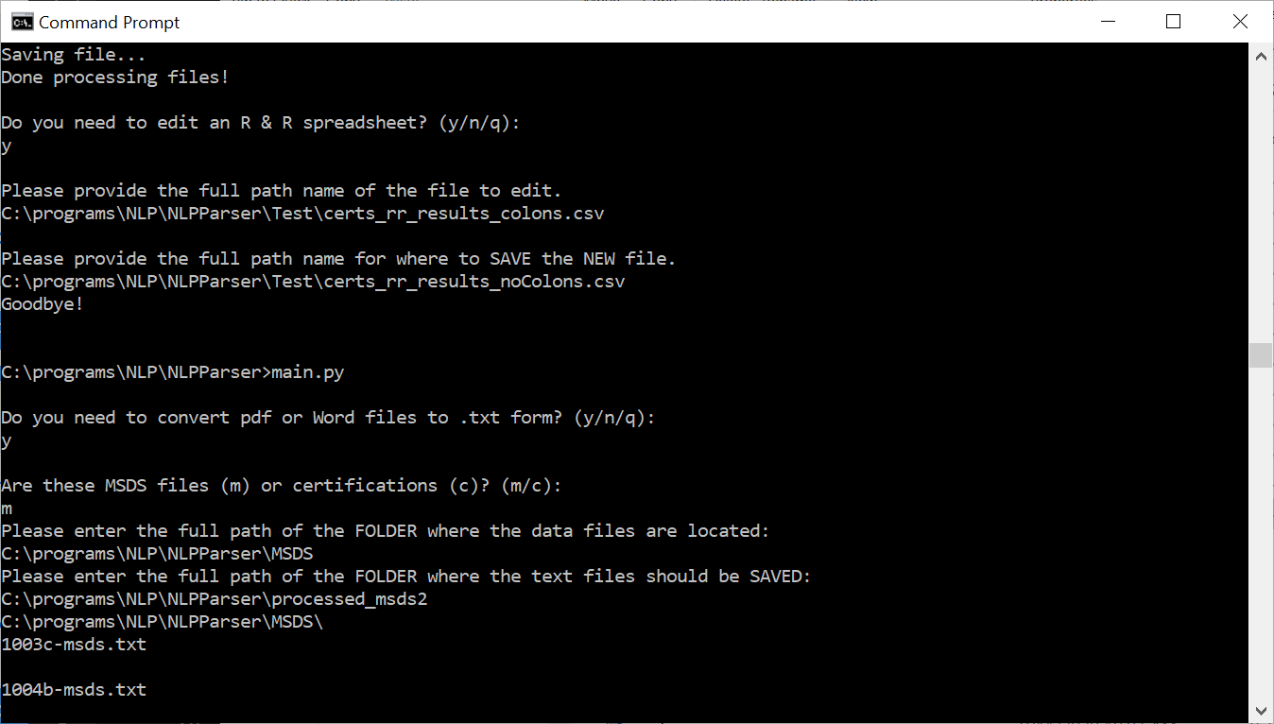
* NOTE: The **MSDS** folder and the **all_certs** folder contain the pdf/docx files.
  + The results go in C:\programs\NLP\NLPParser\processed_msds OR C:\programs\NLP\NLPParser\processed_certs
* You can just drag and drop the folders into the command prompt.
* The program should display files/SRM’s being processed.
* Technically, it will not make a difference if you choose ‘c’ versus ‘m.’

**To parse the data into an RandR-readable spreadsheet:**

* 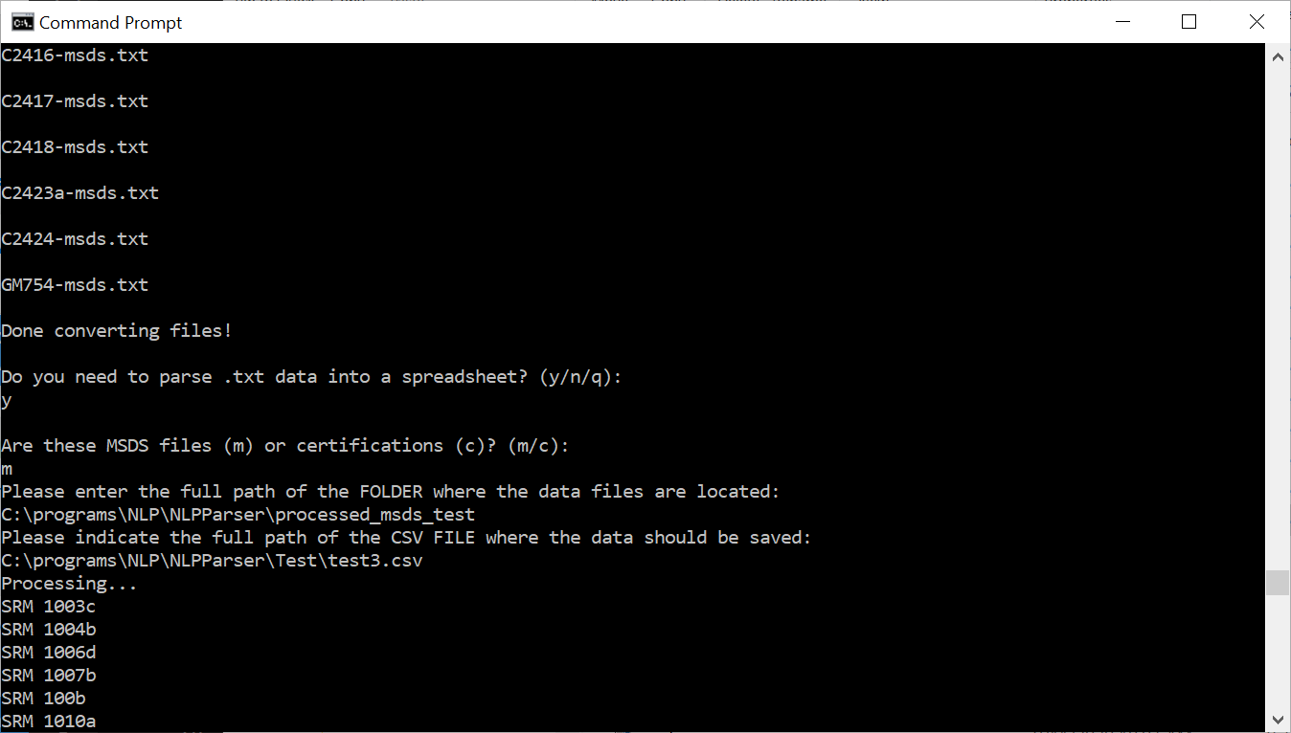
* The program will create the .csv. You just need to provide what you want the file name to be (full path).
* You can just drag and drop the folders into the command prompt.
* The program should display files/SRM’s being processed.
* If you choose ‘c’ versus ‘m’ (or vice versa) the parser will still parse, but the output will not be optimal.

At this point, the results must be run through RandR.

**RandR** → NIST’s proprietary NLP Program. It analyzes CSV file input and converts it into a CSV output file whose results can be loaded into a SQL Server database for use in a website

that generates search term suggestions for clients.