Oracle Solution Engineer Learning Plan

Contents

Overview 2

Training 2

Week 1: Overview 3

Overview: What we’ll learn over the next three weeks 4

Oracle’s IT Services 4

What is Cloud? 4

Creating a Work Journal with ALM & OraDocs: 4

What is Oracle Cloud? 4

Time-Keeping and Creating Assets 4

Access the Cloud: Workshop 4

About Cloud Accelerate 5

Week 2: Products 5

Origins: The Oracle Database 5

Who is Oracle? Organizational Structure 5

Who is Oracle? Hubs & Pillars 5

Hello <PILLAR> & <PRODUCT> Demo/Workshop 5

Week 3: Pillar 6

IM in-depth: The Complete Product Set 6

Self-Service BI Journey 6

Pick a Journey & Execute 6

Journey Demos 6

Shadow an SE 6

Hackathon 6

How to Present & Hackathon Presentations 7

Summary 7

# Overview

An outline for three weeks of Solution Engineering (SE) training is herein proposed. This proposal is IM-focused but the first and second weeks will be applicable to all pillars. Pillar-specific plans will require input from other pillar experts.

The training is organized to emphasize three key areas;

1. Inclusion. Everyone wants to be “part of The Club”, which is a reason beyond knowledge transfer that makes certification effective. It takes advantage of the cognitive dissonance to enforce loyalty to a certain name.
2. Holistic approach to technologies. One technology in isolation can’t compare to the Red Stack. Having tools to effectively capture an individual’s experience with that technology and share it with the greater organization multiplies value.
3. Collaboration. Collaboration will be important in delivering results, but also ensure that each member feels like they have a purpose in part of a bigger family.

# Training

Example Schedule:

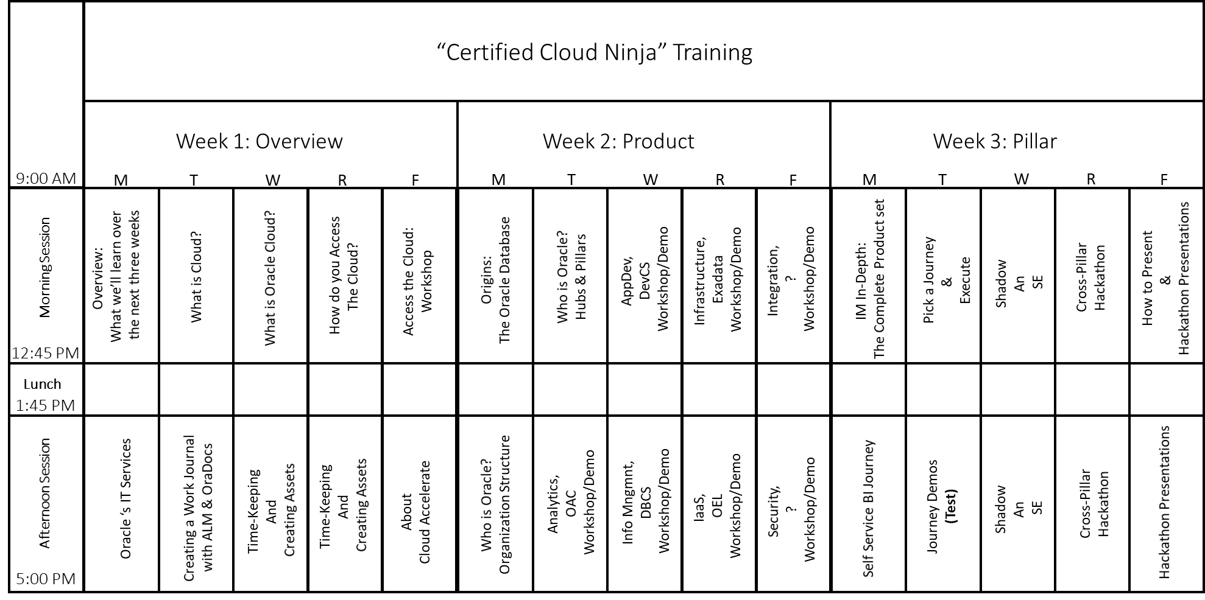

## Week 1: Overview

The first week will be an introduction to being an effective Oracle employee and Cloud Computing in general. This first week will provide new-hires the tools they need to grow into their new role and give everyone an opportunity to get to know one another.

Session (per example schedule) explained;

### Overview: What we’ll learn over the next three weeks

A teaser session to go over the “syllabus” for their training. Essentially this session will be to tell our new hubsters what we are going to tell them over the next three weeks. The key here will be to outline important points that will be repeated later to provide structure and repetition.

### Oracle’s IT Services

This session will be hands-on and will enable the hubsters to become comfortable with the tools Oracle provides their employees. Here we will walk through asking for permissions in OIM, sharing documents with OraDocs, sharing code with ALM, and downloading software from MyDesktop.

### What is Cloud?

An overview of what cloud is (IaaS, PaaS, SaaS), other cloud vendors in the market, and examples of cloud products. This session will also allow us to gauge the knowledge of our new hubsters.

### Creating a Work Journal with ALM & OraDocs:

Recording work is valuable as reference material but is also pivotal to the Hub’s workflow. This will reiterate concepts learned in previous sessions and give the hubsters an organized way to take notes for the coming weeks and beyond.

### What is Oracle Cloud?

This session will allow the new hubsters to apply the knowledge they gained in previous sessions new products. It will build off the previous cloud session and serve as a prelude to next week.

### Time-Keeping and Creating Assets

### Access the Cloud: Workshop

A first hands-on for oracle cloud products. This will more be an introduction to demo.oracle.com and tools they will use frequently like SSH, SFTP, and public key encryption.

### About Cloud Accelerate

Cloud accelerate provides a valuable framework for modeling the engagement process. The Accelerate Team also has some beautiful assets on their website that will be useful to hubsters.

## Week 2: Products

The second week will use the tools learned in the previous week to interact with Oracle products. This week will introduce open-note tests to assess knowledge and motivate students to keep utilize the tools and resources from week 1. Although the focus will be on the products, how SEs use them in their daily operations will also be emphasized.

Session (per example schedule) explained;

### Origins: The Oracle Database

The story of Larry Ellison, the birth of the Oracle Database, and it’s journey until now.

### Who is Oracle? Organizational Structure

The parts of the Oracle family relevant to our role (Hierarchy, Dev, GSE, SE Hubs, ECAs, Cloud Accelerate, Sales).

### Who is Oracle? Hubs & Pillars

An overview of the different hubs and the products they cover. This is a teaser as more depth will be given to each pillar and their products in the following sessions.

### Hello <PILLAR> & <PRODUCT> Demo/Workshop

A chance to explore the products behind the pillars, meet people already working with those products, and hopefully a chance to get some hands-on experience with that pillar’s flagship product.

## Week 3: Pillar

Finally, in the third week, SEs will get their hands dirty doing demos, workshops, and working with an “already certified” experienced buddy.

### IM in-depth: The Complete Product Set

The current products covered by the IM team as well as what may role out in the future. This session will echo what they learned last week but will go more in-depth into what these services do and why a company would want them.

### Self-Service BI Journey

Finally, a true hands-on experience where the hubsters get to be developers and create their own environment. Most of all this will be a chance for the hubsters to help one another through the steps and debug problems.

### Pick a Journey & Execute

An individual session where hubsters will pick a journey or demo from GSE to follow. The asset that they created will be assessed in a short demo in the next session.

### Journey Demos

Hubsters will be given the chance to learn from one another and will get to know first hand the golden rule for demos: always have a backup plan.

### Shadow an SE

This activity is given two sessions but could just as well be given more. The best way to learn is by doing, and here new hubsters will be given the chance to work on a live engagement while being monitored by an experienced SE. This will also foster relationships between the new hubsters and those already established, which will be critical in assuring the efficiency of the new SEs.

### Hackathon

This activity is for fun and to get a feel for the ability of the group to apply their creativity. Although they are not given much time these sessions will be able to tie nicely into innovation projects. If that is not pragmatic than more “Shadow an SE” sessions are proposed.

### How to Present & Hackathon Presentations

A brief introduction on how to present to a customer and the start of the presentations given by the different hackathon groups.

# Summary

Upon favorable review of this proposal we propose;

* The formation of a cross-pillar team
* Creation of a semi-formal certification program
* Creation of syllabi for each pillar

This organized approach will provide concrete assets (to display to upper management), help retention (important skills will be repeated and recorded), and slingshot the team into their role as effective SEs. The focus on application will also enthuse the new SEs to apply their developer skills to help the sales organization and transition them from aspiring developers to aspiring Sales Engineers.