HAR PROJECT PROPOSAL

## TEAM NAME: Explorers of Human Activity Recognition

## TEAM MEMBERS AND ROLES:

* Srinivas Reddy Gogula:
  + Collecting Data
  + Software: Programming
* Lakshmi Umarale:
  + Collecting Data
  + Software: Programming
* Shreya Suriya:
  + Hardware: Exploring MyoWare sensors
  + Collecting Data

## GOAL OF PROJECT:

The goal of this project is to explore Human Activity Recognition and to see how accurately we will be able to identify and classify a range of different movements a human may perform into their respective classes. Our motivation behind this project is the idea that Human Activity Recognition is becoming increasingly prominent as technology advances, and unlocking the tool of being able to recognize what a human is doing through a device can solve a variety of different issues. These issues include video surveillance, healthcare, and human-computer interaction.

## SOFTWARE AND DEVELOPMENT TOOLS:

* GitHub :
  + https://github.com/gsreddy99/har
* Whatsapp
* Programming Environment:
  + Anaconda, Jupyter Notebook
* Libraries:
  + python 3.8.10, tensorflow 2.5.0, tensorflow.keras 2.5.0, numpy 1.19.5, pandas 1.2.5, scipy 1.7.0, seaborn 0.11.1

## HARDWARE USED:

* Sensortile
* Myoware Sensors
* iPhone or Android Device

## DATASET USED: WISDM

* <https://www.cis.fordham.edu/wisdm/dataset.php>
* Files:
  + readdme.txt
  + WISDM_ar_v1.1_raw.txt
* Raw Time Series Data-
  + Number of examples – 1098203
  + Number of attributes – 6
  + Number of missing values – none
  + Class Distribution -  
    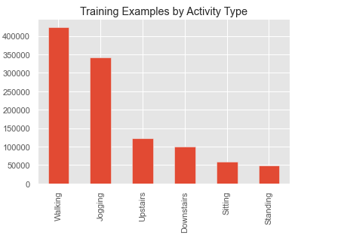

Walking: 424,400 (38.6%)

Jogging: 342,177 (31.2%)

Upstairs: 122,869 (11.2%)

Downstairs: 100,427 (9.1%)

Sitting: 59,939 (5.5%)

Standing: 48,395 (4.4%)

## PROJECT WORKFLOW:

* + Import the relevant libraries
  + Load, Inspect and Transform the Accelerometer data  
     Exploratory Data Analysis on the data set.
  + Split Data into Training and Test Set.

(Better Splitting Approach in our case, was to split based on the user IDs.   
We kept users with ID 1 to 28 for training the model and users with ID greater than 28 for the test set.

* + Normalize Training Data
  + Convert and reformat accelerometer data into a time-sliced representation (convert into segments)
  + Define a deep neural network model in Keras   
    Train the deep neural network for human activity recognition data Validate the performance of the trained DNN against the test data using learning curve and confusion matrix.  
     Save the model (save the weights).
  + Define a Convolutional Neural Network using TensorFlow Train the convolutional neural network for human activity recognition data Validate the performance of the trained CNN against the test data using learning curve and confusion matrix.  
     Save the model (save the weights)
  + Define a LSTM neural network Train the LSTM neural network for human activity recognition data Validate the performance of the trained LSTM against the test data using learning curve and confusion matrix.  
     Save the model (save the weights)
  + Validate all the models with the test data collected from the sensor tile for all the activities.  
    Added helper function to transform and represent the data collected from the sensor tile in the format of the dataset
  + Edge Impulse- Import the dataset in Edge Impulse and train using neural network. Collect the data from the sensor tile and validate the performance.   
    Use Transfer Learning in Edge Impulse and validate the performance
  + Followed the same Machine Learning Workflow as illustrated by Nils Ackerman in the diagram below -  
      
    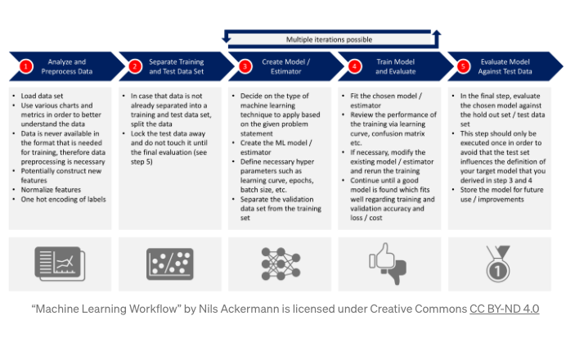

## MILESTONE CALENDAR:

|  |  |
| --- | --- |
| WEEKS | TASK |
| WEEK 1 | * Brainstorm Project Ideas * Narrowi Down on Project Idea |
| WEEK 2 | * Acquire Hardware for Project * Search for HAR datasets * Narrow down on the HAR dataset that best represents the data that can be collected from the SensorTile |
| WEEK 3 | * Build a simple model using DNN (Dense Neural Network) from the HAR dataset chosen (WISDM) * Continue to train model to high accuracy * Test the model using data collected from SensorTile * Work on Project Proposal |
| WEEK 4 | * Build a convolutional neural network and improvise on the models and choose the model with the highest accuracy * Continue to test model using data collected from Sensor Tile |
| WEEK 5 | * Import the dataset in Edge Impulse * Build the model in Edge Impulse using Neural Network * Test model in Edge Impulse against the sensor Tile Data * Use Transfer Learning to see if the accuracy improves * Try to build a model using LSTM network using Recurrent Neural Network * Begin Collecting Hand Gesture training data from Myoware Sensors |
| WEEK 6 | * Summarize all the findings   (Manual training using the dataset and using Edge Impulse) and document it   * Continue to collect Hand Gesture data * Develop and test Hand Gesture Model * Project Documentation |
| WEEK 7 | * Present Solution |

## REFERENCES:

* https://towardsdatascience.com/human-activity-recognition-har-tutorial-with-keras-and-core-ml-part-1-8c05e365dfa0

(Human Activity Recognition Tutorial with Keras)

* [https://www.kaggle.com](https://www.kaggle.com/)
* <https://machinelearningmastery.com/how-to-develop-rnn-models-for-human-activity-recognition-time-series-classification/>