**Long Answer**

This is the template for long answers. The template includes pictures and texts and other formatting that are unrelated to long answers. The only thing that matters is the table to insert long answers.

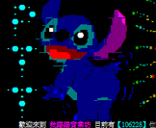



**Test of functions.**

**The answers start here:**

|  |
| --- |
| **Long Answer table [answers will be inserted]** |