**QUESTIONS**

This is the template for questions. The template includes pictures and texts and other formatting that are unrelated to the questions. The only thing that matters is the table to insert questions.

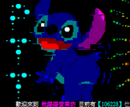



**Test of functions.**

**The questions start here:**

|  |
| --- |
| **Question tables [questions will be inserted]** |