**Short Answer**

This is the template for short answers. The template includes pictures and texts and other formatting that are unrelated to short answers. The only thing that matters is the table to insert short answers.

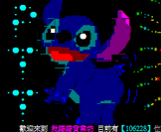



**Test of functions.**

**The short answers start here:**

|  |
| --- |
| **Short Answer table [short answers will be inserted]** |