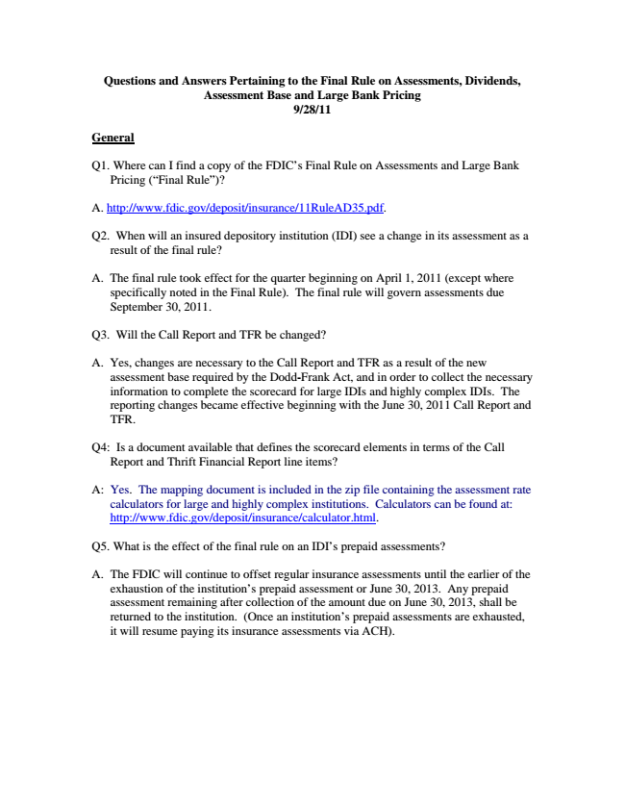

**Questions and Answers Pertaining to the Final Rule on Assessments, Dividends, Assessment Base and Large Bank Pricing 9/28/11**

**General**

Q1. Where can I find a copy of the FDIC’s Final Rule on Assessments and Large Bank

Pricing (“Final Rule”)?

A. http://www.fdic.gov/deposit/insurance/11RuleAD35.pdf.

Q2. When will an insured depository institution (IDI) see a change in its assessment as a

result of the final rule?

A. The final rule took effect for the quarter beginning on April 1, 2011 (except where

specifically noted in the Final Rule). The final rule will govern assessments due September 30, 2011.

Q3. Will the Call Report and TFR be changed?

A. Yes, changes are necessary to the Call Report and TFR as a result of the new

assessment base required by the Dodd-Frank Act, and in order to collect the necessary information to complete the scorecard for large IDIs and highly complex IDIs. The reporting changes became effective beginning with the June 30, 2011 Call Report and TFR.

Q4: Is a document available that defines the scorecard elements in terms of the Call

Report and Thrift Financial Report line items?

A: Yes. The mapping document is included in the zip file containing the assessment rate calculators for large and highly complex institutions. Calculators can be found at: http://www.fdic.gov/deposit/insurance/calculator.html.

Q5. What is the effect of the final rule on an IDI’s prepaid assessments?

A. The FDIC will continue to offset regular insurance assessments until the earlier of the exhaustion of the institution’s prepaid assessment or June 30, 2013. Any prepaid assessment remaining after collection of the amount due on June 30, 2013, shall be returned to the institution. (Once an institution’s prepaid assessments are exhausted, it will resume paying its insurance assessments via ACH).

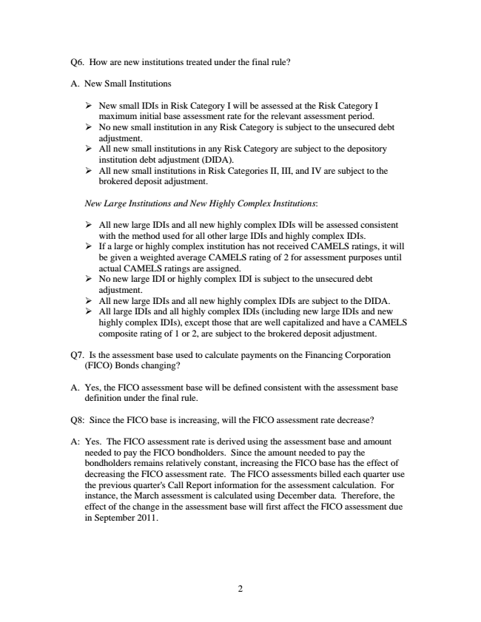

Q6. How are new institutions treated under the final rule?

A. New Small Institutions

➢ New small IDIs in Risk Category I will be assessed at the Risk Category I

maximum initial base assessment rate for the relevant assessment period. ➢ No new small institution in any Risk Category is subject to the unsecured debt

adjustment. ➢ All new small institutions in any Risk Category are subject to the depository

institution debt adjustment (DIDA). ➢ All new small institutions in Risk Categories II, III, and IV are subject to the

brokered deposit adjustment.

*New Large Institutions and New Highly Complex Institutions:*

➢ All new large IDIs and all new highly complex IDIs will be assessed consistent

with the method used for all other large IDIs and highly complex IDIs. ➢ If a large or highly complex institution has not received CAMELS ratings, it will

be given a weighted average CAMELS rating of 2 for assessment purposes until actual CAMELS ratings are assigned. ➢ No new large IDI or highly complex IDI is subject to the unsecured debt

adjustment. ➢ All new large IDIs and all new highly complex IDIs are subject to the DIDA. ➢ All large IDIs and all highly complex IDIs (including new large IDIs and new

highly complex IDIs), except those that are well capitalized and have a CAMELS composite rating of 1 or 2, are subject to the brokered deposit adjustment.

Q7. Is the assessment base used to calculate payments on the Financing Corporation

(FICO) Bonds changing?

A. Yes, the FICO assessment base will be defined consistent with the assessment base

definition under the final rule.

Q8: Since the FICO base is increasing, will the FICO assessment rate decrease?

A: Yes. The FICO assessment rate is derived using the assessment base and amount

needed to pay the FICO bondholders. Since the amount needed to pay the bondholders remains relatively constant, increasing the FICO base has the effect of decreasing the FICO assessment rate. The FICO assessments billed each quarter use the previous quarter's Call Report information for the assessment calculation. For instance, the March assessment is calculated using December data. Therefore, the effect of the change in the assessment base will first affect the FICO assessment due in September 2011.

2

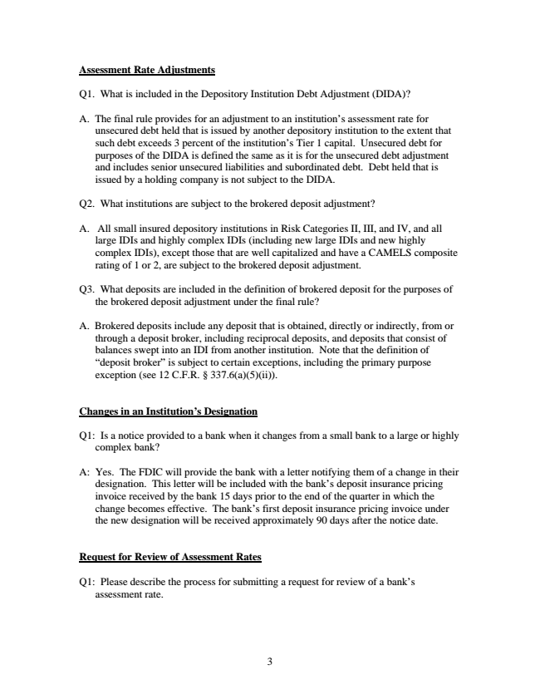

**Assessment Rate Adjustments**

Q1. What is included in the Depository Institution Debt Adjustment (DIDA)?

A. The final rule provides for an adjustment to an institution’s assessment rate for

unsecured debt held that is issued by another depository institution to the extent that such debt exceeds 3 percent of the institution’s Tier 1 capital. Unsecured debt for purposes of the DIDA is defined the same as it is for the unsecured debt adjustment and includes senior unsecured liabilities and subordinated debt. Debt held that is issued by a holding company is not subject to the DIDA.

Q2. What institutions are subject to the brokered deposit adjustment?

A. All small insured depository institutions in Risk Categories II, III, and IV, and all large IDIs and highly complex IDIs (including new large IDIs and new highly complex IDIs), except those that are well capitalized and have a CAMELS composite rating of 1 or 2, are subject to the brokered deposit adjustment.

Q3. What deposits are included in the definition of brokered deposit for the purposes of

the brokered deposit adjustment under the final rule?

A. Brokered deposits include any deposit that is obtained, directly or indirectly, from or

through a deposit broker, including reciprocal deposits, and deposits that consist of balances swept into an IDI from another institution. Note that the definition of “deposit broker” is subject to certain exceptions, including the primary purpose exception (see 12 C.F.R. § 337.6(a)(5)(ii)).

**Changes in an Institution’s Designation**

Q1: Is a notice provided to a bank when it changes from a small bank to a large or highly

complex bank?

A: Yes. The FDIC will provide the bank with a letter notifying them of a change in their designation. This letter will be included with the bank’s deposit insurance pricing invoice received by the bank 15 days prior to the end of the quarter in which the change becomes effective. The bank’s first deposit insurance pricing invoice under the new designation will be received approximately 90 days after the notice date.

**Request for Review of Assessment Rates**

Q1: Please describe the process for submitting a request for review of a bank’s

assessment rate.

3

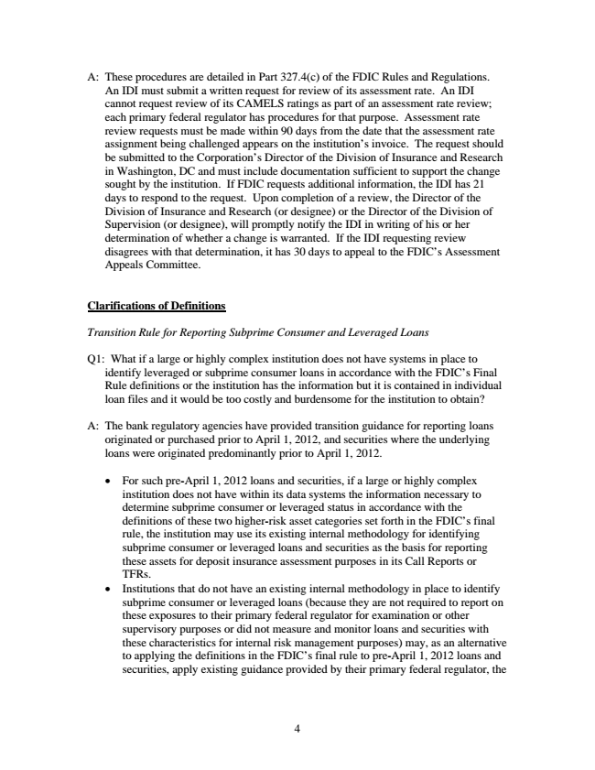

A: These procedures are detailed in Part 327.4(c) of the FDIC Rules and Regulations. An IDI must submit a written request for review of its assessment rate. An IDI cannot request review of its CAMELS ratings as part of an assessment rate review; each primary federal regulator has procedures for that purpose. Assessment rate review requests must be made within 90 days from the date that the assessment rate assignment being challenged appears on the institution’s invoice. The request should be submitted to the Corporation’s Director of the Division of Insurance and Research in Washington, DC and must include documentation sufficient to support the change sought by the institution. If FDIC requests additional information, the IDI has 21 days to respond to the request. Upon completion of a review, the Director of the Division of Insurance and Research (or designee) or the Director of the Division of Supervision (or designee), will promptly notify the IDI in writing of his or her determination of whether a change is warranted. If the IDI requesting review disagrees with that determination, it has 30 days to appeal to the FDIC’s Assessment Appeals Committee.

**Clarifications of Definitions**

*Transition Rule for Reporting Subprime Consumer and Leveraged Loans*

Q1: What if a large or highly complex institution does not have systems in place to

identify leveraged or subprime consumer loans in accordance with the FDIC’s Final Rule definitions or the institution has the information but it is contained in individual loan files and it would be too costly and burdensome for the institution to obtain?

A: The bank regulatory agencies have provided transition guidance for reporting loans

originated or purchased prior to April 1, 2012, and securities where the underlying loans were originated predominantly prior to April 1, 2012.

• For such pre-April 1, 2012 loans and securities, if a large or highly complex institution does not have within its data systems the information necessary to determine subprime consumer or leveraged status in accordance with the definitions of these two higher-risk asset categories set forth in the FDIC’s final rule, the institution may use its existing internal methodology for identifying subprime consumer or leveraged loans and securities as the basis for reporting these assets for deposit insurance assessment purposes in its Call Reports or TFRs.

• Institutions that do not have an existing internal methodology in place to identify subprime consumer or leveraged loans (because they are not required to report on these exposures to their primary federal regulator for examination or other supervisory purposes or did not measure and monitor loans and securities with these characteristics for internal risk management purposes) may, as an alternative to applying the definitions in the FDIC’s final rule to pre-April 1, 2012 loans and securities, apply existing guidance provided by their primary federal regulator, the

4

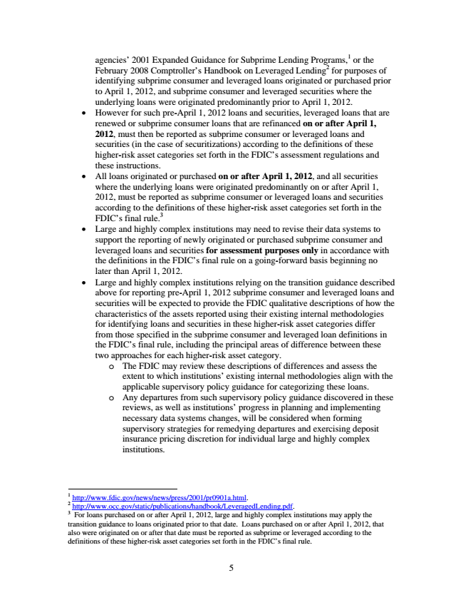

agencies’ 2001 Expanded Guidance for Subprime Lending Programs,1 or the February 2008 Comptroller’s Handbook on Leveraged Lending

2

for purposes of identifying subprime consumer and leveraged loans originated or purchased prior to April 1, 2012, and subprime consumer and leveraged securities where the underlying loans were originated predominantly prior to April 1, 2012.

• However for such pre-April 1, 2012 loans and securities, leveraged loans that are renewed or subprime consumer loans that are refinanced on or after April 1, 2012, must then be reported as subprime consumer or leveraged loans and securities (in the case of securitizations) according to the definitions of these higher-risk asset categories set forth in the FDIC’s assessment regulations and these instructions.

• All loans originated or purchased on or after April 1, 2012, and all securities where the underlying loans were originated predominantly on or after April 1, 2012, must be reported as subprime consumer or leveraged loans and securities according to the definitions of these higher-risk asset categories set forth in the FDIC’s final rule.

3

• Large and highly complex institutions may need to revise their data systems to support the reporting of newly originated or purchased subprime consumer and leveraged loans and securities for assessment purposes only in accordance with the definitions in the FDIC’s final rule on a going-forward basis beginning no later than April 1, 2012.

• Large and highly complex institutions relying on the transition guidance described above for reporting pre-April 1, 2012 subprime consumer and leveraged loans and securities will be expected to provide the FDIC qualitative descriptions of how the characteristics of the assets reported using their existing internal methodologies for identifying loans and securities in these higher-risk asset categories differ from those specified in the subprime consumer and leveraged loan definitions in the FDIC’s final rule, including the principal areas of difference between these two approaches for each higher-risk asset category.

o The FDIC may review these descriptions of differences and assess the

extent to which institutions’ existing internal methodologies align with the applicable supervisory policy guidance for categorizing these loans. o Any departures from such supervisory policy guidance discovered in these reviews, as well as institutions’ progress in planning and implementing necessary data systems changes, will be considered when forming supervisory strategies for remedying departures and exercising deposit insurance pricing discretion for individual large and highly complex institutions.

1 http://www.fdic.gov/news/news/press/2001/pr0901a.html. 2 http://www.occ.gov/static/publications/handbook/LeveragedLending.pdf. 3 For loans purchased on or after April 1, 2012, large and highly complex institutions may apply the transition guidance to loans originated prior to that date. Loans purchased on or after April 1, 2012, that also were originated on or after that date must be reported as subprime or leveraged according to the definitions of these higher-risk asset categories set forth in the FDIC’s final rule.

5

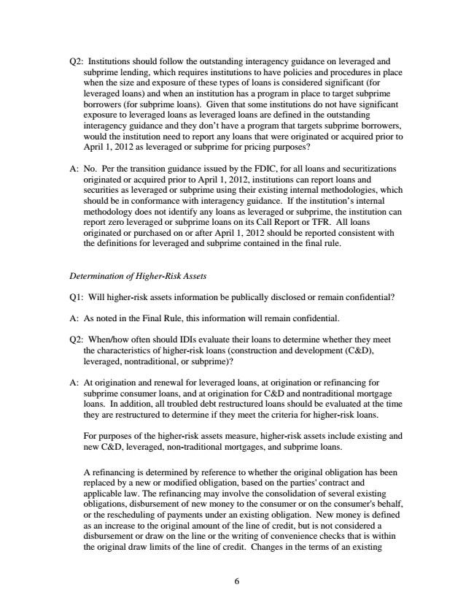

Q2: Institutions should follow the outstanding interagency guidance on leveraged and

subprime lending, which requires institutions to have policies and procedures in place when the size and exposure of these types of loans is considered significant (for leveraged loans) and when an institution has a program in place to target subprime borrowers (for subprime loans). Given that some institutions do not have significant exposure to leveraged loans as leveraged loans are defined in the outstanding interagency guidance and they don’t have a program that targets subprime borrowers, would the institution need to report any loans that were originated or acquired prior to April 1, 2012 as leveraged or subprime for pricing purposes?

A: No. Per the transition guidance issued by the FDIC, for all loans and securitizations

originated or acquired prior to April 1, 2012, institutions can report loans and securities as leveraged or subprime using their existing internal methodologies, which should be in conformance with interagency guidance. If the institution’s internal methodology does not identify any loans as leveraged or subprime, the institution can report zero leveraged or subprime loans on its Call Report or TFR. All loans originated or purchased on or after April 1, 2012 should be reported consistent with the definitions for leveraged and subprime contained in the final rule.

*Determination of Higher-Risk Assets*

Q1: Will higher-risk assets information be publically disclosed or remain confidential?

A: As noted in the Final Rule, this information will remain confidential.

Q2: When/how often should IDIs evaluate their loans to determine whether they meet the characteristics of higher-risk loans (construction and development (C&D), leveraged, nontraditional, or subprime)?

A: At origination and renewal for leveraged loans, at origination or refinancing for

subprime consumer loans, and at origination for C&D and nontraditional mortgage loans. In addition, all troubled debt restructured loans should be evaluated at the time they are restructured to determine if they meet the criteria for higher-risk loans.

For purposes of the higher-risk assets measure, higher-risk assets include existing and new C&D, leveraged, non-traditional mortgages, and subprime loans.

A refinancing is determined by reference to whether the original obligation has been replaced by a new or modified obligation, based on the parties' contract and applicable law. The refinancing may involve the consolidation of several existing obligations, disbursement of new money to the consumer or on the consumer's behalf, or the rescheduling of payments under an existing obligation. New money is defined as an increase to the original amount of the line of credit, but is not considered a disbursement or draw on the line or the writing of convenience checks that is within the original draw limits of the line of credit. Changes in the terms of an existing

6

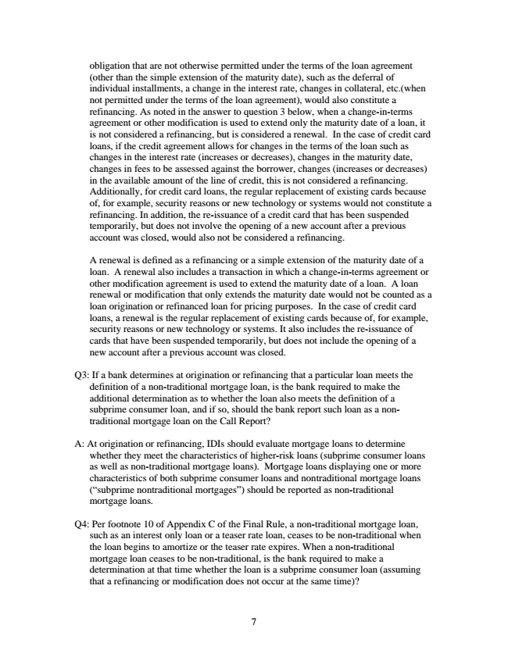

obligation that are not otherwise permitted under the terms of the loan agreement (other than the simple extension of the maturity date), such as the deferral of individual installments, a change in the interest rate, changes in collateral, etc.(when not permitted under the terms of the loan agreement), would also constitute a refinancing. As noted in the answer to question 3 below, when a change-in-terms agreement or other modification is used to extend only the maturity date of a loan, it is not considered a refinancing, but is considered a renewal. In the case of credit card loans, if the credit agreement allows for changes in the terms of the loan such as changes in the interest rate (increases or decreases), changes in the maturity date, changes in fees to be assessed against the borrower, changes (increases or decreases) in the available amount of the line of credit, this is not considered a refinancing. Additionally, for credit card loans, the regular replacement of existing cards because of, for example, security reasons or new technology or systems would not constitute a refinancing. In addition, the re-issuance of a credit card that has been suspended temporarily, but does not involve the opening of a new account after a previous account was closed, would also not be considered a refinancing.

A renewal is defined as a refinancing or a simple extension of the maturity date of a loan. A renewal also includes a transaction in which a change-in-terms agreement or other modification agreement is used to extend the maturity date of a loan. A loan renewal or modification that only extends the maturity date would not be counted as a loan origination or refinanced loan for pricing purposes. In the case of credit card loans, a renewal is the regular replacement of existing cards because of, for example, security reasons or new technology or systems. It also includes the re-issuance of cards that have been suspended temporarily, but does not include the opening of a new account after a previous account was closed.

Q3: If a bank determines at origination or refinancing that a particular loan meets the definition of a non-traditional mortgage loan, is the bank required to make the additional determination as to whether the loan also meets the definition of a subprime consumer loan, and if so, should the bank report such loan as a non- traditional mortgage loan on the Call Report?

A: At origination or refinancing, IDIs should evaluate mortgage loans to determine

whether they meet the characteristics of higher-risk loans (subprime consumer loans as well as non-traditional mortgage loans). Mortgage loans displaying one or more characteristics of both subprime consumer loans and nontraditional mortgage loans (“subprime nontraditional mortgages”) should be reported as non-traditional mortgage loans.

Q4: Per footnote 10 of Appendix C of the Final Rule, a non-traditional mortgage loan,

such as an interest only loan or a teaser rate loan, ceases to be non-traditional when the loan begins to amortize or the teaser rate expires. When a non-traditional mortgage loan ceases to be non-traditional, is the bank required to make a determination at that time whether the loan is a subprime consumer loan (assuming that a refinancing or modification does not occur at the same time)?

7

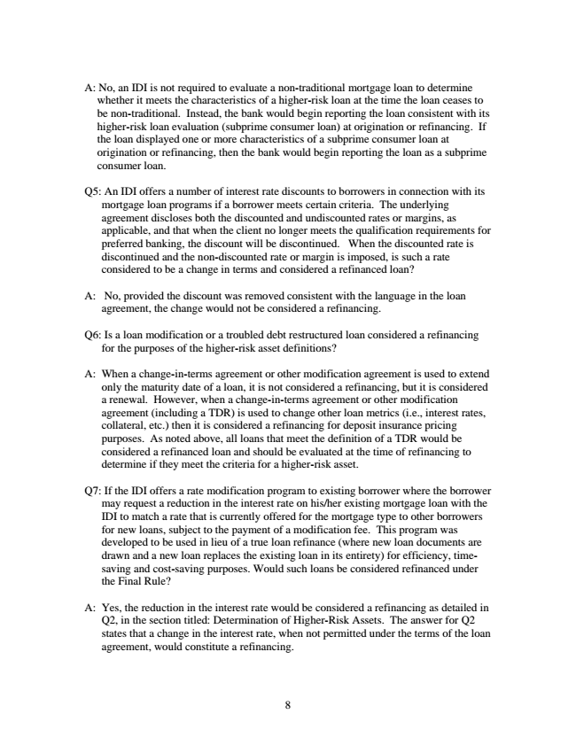

A: No, an IDI is not required to evaluate a non-traditional mortgage loan to determine

whether it meets the characteristics of a higher-risk loan at the time the loan ceases to be non-traditional. Instead, the bank would begin reporting the loan consistent with its higher-risk loan evaluation (subprime consumer loan) at origination or refinancing. If the loan displayed one or more characteristics of a subprime consumer loan at origination or refinancing, then the bank would begin reporting the loan as a subprime consumer loan.

Q5: An IDI offers a number of interest rate discounts to borrowers in connection with its

mortgage loan programs if a borrower meets certain criteria. The underlying agreement discloses both the discounted and undiscounted rates or margins, as applicable, and that when the client no longer meets the qualification requirements for preferred banking, the discount will be discontinued. When the discounted rate is discontinued and the non-discounted rate or margin is imposed, is such a rate considered to be a change in terms and considered a refinanced loan?

A: No, provided the discount was removed consistent with the language in the loan

agreement, the change would not be considered a refinancing.

Q6: Is a loan modification or a troubled debt restructured loan considered a refinancing

for the purposes of the higher-risk asset definitions?

A: When a change-in-terms agreement or other modification agreement is used to extend only the maturity date of a loan, it is not considered a refinancing, but it is considered a renewal. However, when a change-in-terms agreement or other modification agreement (including a TDR) is used to change other loan metrics (i.e., interest rates, collateral, etc.) then it is considered a refinancing for deposit insurance pricing purposes. As noted above, all loans that meet the definition of a TDR would be considered a refinanced loan and should be evaluated at the time of refinancing to determine if they meet the criteria for a higher-risk asset.

Q7: If the IDI offers a rate modification program to existing borrower where the borrower

may request a reduction in the interest rate on his/her existing mortgage loan with the IDI to match a rate that is currently offered for the mortgage type to other borrowers for new loans, subject to the payment of a modification fee. This program was developed to be used in lieu of a true loan refinance (where new loan documents are drawn and a new loan replaces the existing loan in its entirety) for efficiency, time- saving and cost-saving purposes. Would such loans be considered refinanced under the Final Rule?

A: Yes, the reduction in the interest rate would be considered a refinancing as detailed in Q2, in the section titled: Determination of Higher-Risk Assets. The answer for Q2 states that a change in the interest rate, when not permitted under the terms of the loan agreement, would constitute a refinancing.

8

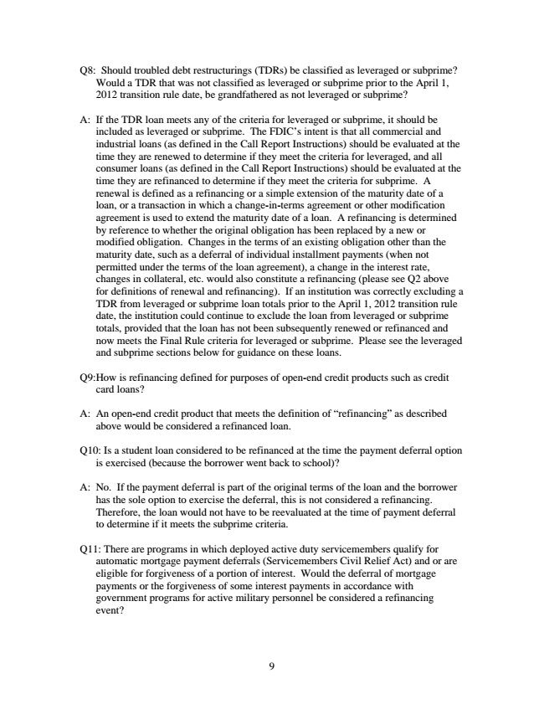

Q8: Should troubled debt restructurings (TDRs) be classified as leveraged or subprime?

Would a TDR that was not classified as leveraged or subprime prior to the April 1, 2012 transition rule date, be grandfathered as not leveraged or subprime?

A: If the TDR loan meets any of the criteria for leveraged or subprime, it should be

included as leveraged or subprime. The FDIC’s intent is that all commercial and industrial loans (as defined in the Call Report Instructions) should be evaluated at the time they are renewed to determine if they meet the criteria for leveraged, and all consumer loans (as defined in the Call Report Instructions) should be evaluated at the time they are refinanced to determine if they meet the criteria for subprime. A renewal is defined as a refinancing or a simple extension of the maturity date of a loan, or a transaction in which a change-in-terms agreement or other modification agreement is used to extend the maturity date of a loan. A refinancing is determined by reference to whether the original obligation has been replaced by a new or modified obligation. Changes in the terms of an existing obligation other than the maturity date, such as a deferral of individual installment payments (when not permitted under the terms of the loan agreement), a change in the interest rate, changes in collateral, etc. would also constitute a refinancing (please see Q2 above for definitions of renewal and refinancing). If an institution was correctly excluding a TDR from leveraged or subprime loan totals prior to the April 1, 2012 transition rule date, the institution could continue to exclude the loan from leveraged or subprime totals, provided that the loan has not been subsequently renewed or refinanced and now meets the Final Rule criteria for leveraged or subprime. Please see the leveraged and subprime sections below for guidance on these loans.

Q9:How is refinancing defined for purposes of open-end credit products such as credit

card loans?

A: An open-end credit product that meets the definition of “refinancing” as described

above would be considered a refinanced loan.

Q10: Is a student loan considered to be refinanced at the time the payment deferral option

is exercised (because the borrower went back to school)?

A: No. If the payment deferral is part of the original terms of the loan and the borrower

has the sole option to exercise the deferral, this is not considered a refinancing. Therefore, the loan would not have to be reevaluated at the time of payment deferral to determine if it meets the subprime criteria.

Q11: There are programs in which deployed active duty servicemembers qualify for

automatic mortgage payment deferrals (Servicemembers Civil Relief Act) and or are eligible for forgiveness of a portion of interest. Would the deferral of mortgage payments or the forgiveness of some interest payments in accordance with government programs for active military personnel be considered a refinancing event?

9

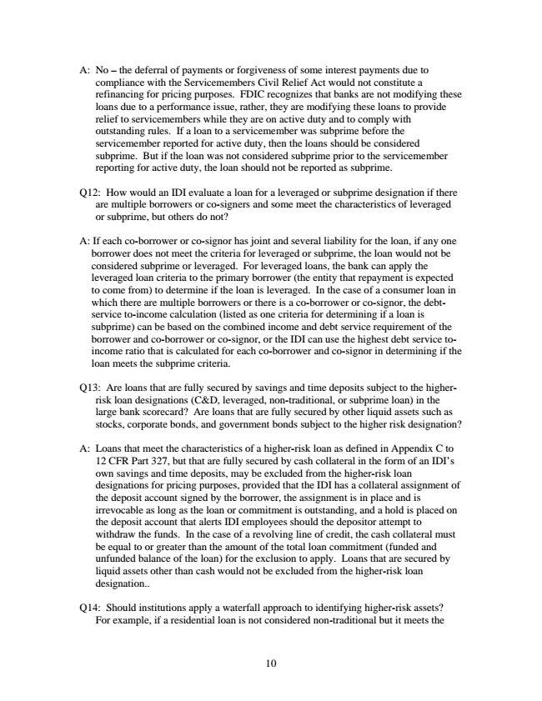

A: No – the deferral of payments or forgiveness of some interest payments due to

compliance with the Servicemembers Civil Relief Act would not constitute a refinancing for pricing purposes. FDIC recognizes that banks are not modifying these loans due to a performance issue, rather, they are modifying these loans to provide relief to servicemembers while they are on active duty and to comply with outstanding rules. If a loan to a servicemember was subprime before the servicemember reported for active duty, then the loans should be considered subprime. But if the loan was not considered subprime prior to the servicemember reporting for active duty, the loan should not be reported as subprime.

Q12: How would an IDI evaluate a loan for a leveraged or subprime designation if there

are multiple borrowers or co-signers and some meet the characteristics of leveraged or subprime, but others do not?

A: If each co-borrower or co-signor has joint and several liability for the loan, if any one

borrower does not meet the criteria for leveraged or subprime, the loan would not be considered subprime or leveraged. For leveraged loans, the bank can apply the leveraged loan criteria to the primary borrower (the entity that repayment is expected to come from) to determine if the loan is leveraged. In the case of a consumer loan in which there are multiple borrowers or there is a co-borrower or co-signor, the debt- service to-income calculation (listed as one criteria for determining if a loan is subprime) can be based on the combined income and debt service requirement of the borrower and co-borrower or co-signor, or the IDI can use the highest debt service to- income ratio that is calculated for each co-borrower and co-signor in determining if the loan meets the subprime criteria.

Q13: Are loans that are fully secured by savings and time deposits subject to the higher- risk loan designations (C&D, leveraged, non-traditional, or subprime loan) in the large bank scorecard? Are loans that are fully secured by other liquid assets such as stocks, corporate bonds, and government bonds subject to the higher risk designation?

A: Loans that meet the characteristics of a higher-risk loan as defined in Appendix C to 12 CFR Part 327, but that are fully secured by cash collateral in the form of an IDI’s own savings and time deposits, may be excluded from the higher-risk loan designations for pricing purposes, provided that the IDI has a collateral assignment of the deposit account signed by the borrower, the assignment is in place and is irrevocable as long as the loan or commitment is outstanding, and a hold is placed on the deposit account that alerts IDI employees should the depositor attempt to withdraw the funds. In the case of a revolving line of credit, the cash collateral must be equal to or greater than the amount of the total loan commitment (funded and unfunded balance of the loan) for the exclusion to apply. Loans that are secured by liquid assets other than cash would not be excluded from the higher-risk loan designation..

Q14: Should institutions apply a waterfall approach to identifying higher-risk assets? For example, if a residential loan is not considered non-traditional but it meets the

10