

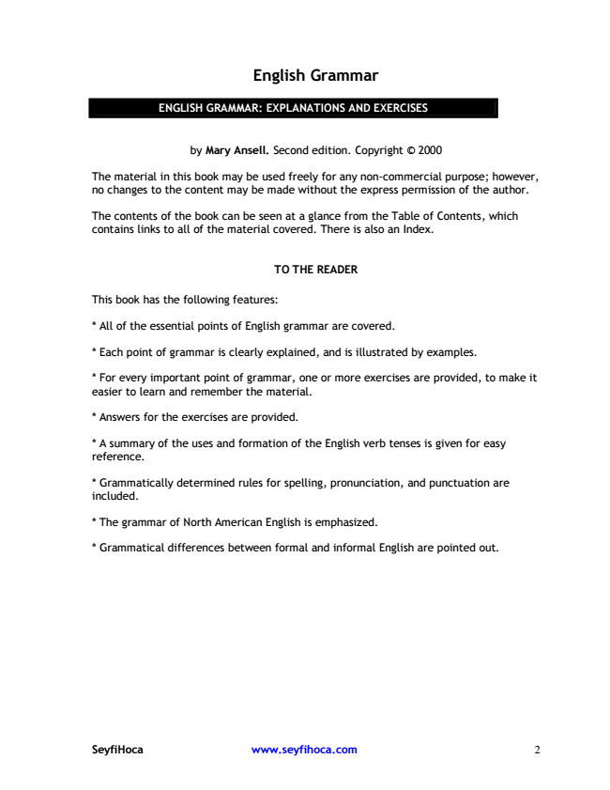

English Grammar

ENGLISH GRAMMAR: EXPLANATIONS AND EXERCISES

by Mary Ansell. Second edition. Copyright © 2000

The material in this book may be used freely for any non-commercial purpose; however, no changes to the content may be made without the express permission of the author.

The contents of the book can be seen at a glance from the Table of Contents, which contains links to all of the material covered. There is also an Index.

TO THE READER

This book has the following features:

\* All of the essential points of English grammar are covered.

\* Each point of grammar is clearly explained, and is illustrated by examples.

\* For every important point of grammar, one or more exercises are provided, to make it easier to learn and remember the material.

\* Answers for the exercises are provided.

\* A summary of the uses and formation of the English verb tenses is given for easy reference.

\* G rammatically determined rules for spelling, pronunciation, and punctuation are included.

\* The grammar of North American English is emphasized.

\* G rammatical differences between formal and informal English are pointed out.

SeyfiHoca www.seyfihoca.com 2

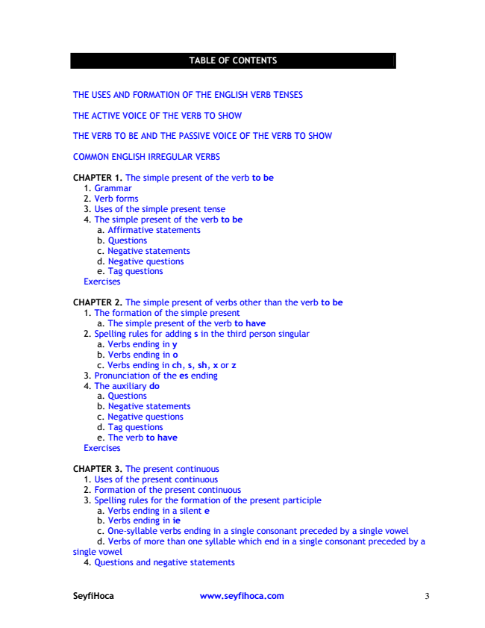

TABLE OF CONTENTS

TH E U SES AND FO RM ATIO N O F TH E ENG LISH VERB TENSES

TH E ACTIVE VO ICE O F TH E VERB TO SH O W

TH E VERB TO BE AND TH E PASSIVE VO ICE O F TH E VERB TO SH O W

CO M M O N ENG LISH IRREG U LAR VERBS

CHAPTER 1. The simple present of the verb to be

1. G rammar 2. Verb forms 3. U ses of the simple present tense 4. The simple present of the verb to be

a. Affirmative statements b. Questions c. Negative statements d. Negative questions e. Tag questions Exercises

CHAPTER 2. The simple present of verbs other than the verb to be

1. The formation of the simple present

a. The simple present of the verb to have 2. Spelling rules for adding s in the third person singular

a. Verbs ending in y b. Verbs ending in o c. Verbs ending in ch, s, sh, x or z 3. Pronunciation of the es ending 4. The auxiliary do a. Questions b. Negative statements c. Negative questions d. Tag questions e. The verb to have Exercises

CHAPTER 3. The present continuous 1. U ses of the present continuous 2. Formation of the present continuous 3. Spelling rules for the formation of the present participle

a. Verbs ending in a silent e b. Verbs ending in ie c. O ne-syllable verbs ending in a single consonant preceded by a single vowel d. Verbs of more than one syllable which end in a single consonant preceded by a single vowel

4. Questions and negative statements

SeyfiHoca www.seyfihoca.com 3

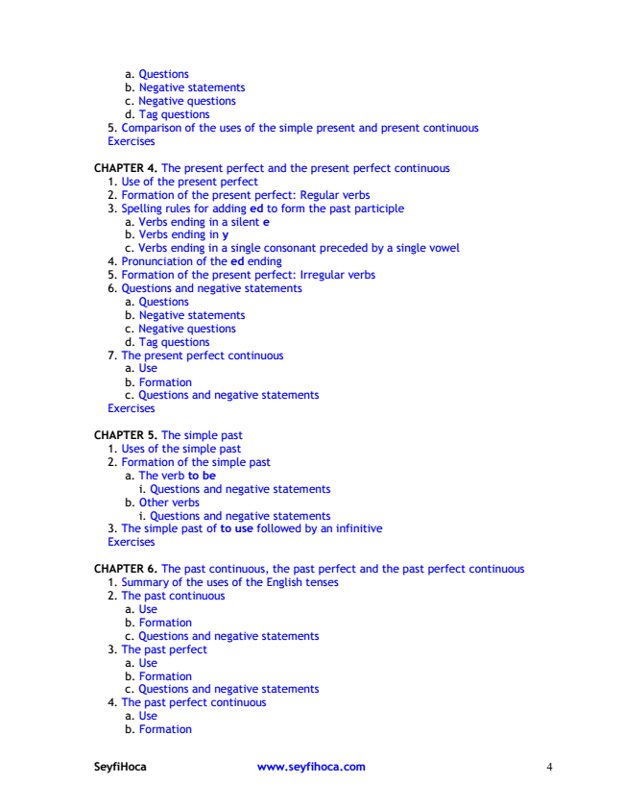

a. Questions b. Negative statements c. Negative questions d. Tag questions 5. Comparison of the uses of the simple present and present continuous Exercises

CHAPTER 4. The present perfect and the present perfect continuous

1. U se of the present perfect 2. Formation of the present perfect: Regular verbs 3. Spelling rules for adding ed to form the past participle

a. Verbs ending in a silent e b. Verbs ending in y c. Verbs ending in a single consonant preceded by a single vowel 4. Pronunciation of the ed ending 5. Formation of the present perfect: Irregular verbs 6. Questions and negative statements

a. Questions b. Negative statements c. Negative questions d. Tag questions 7. The present perfect continuous

a. Use b. Formation c. Questions and negative statements Exercises

CHAPTER 5. The simple past 1. U ses of the simple past 2. Formation of the simple past

a. The verb to be

i. Questions and negative statements b. O ther verbs

i. Questions and negative statements 3. The simple past of to use followed by an infinitive Exercises

CHAPTER 6. The past continuous, the past perfect and the past perfect continuous

1. Summary of the uses of the English tenses 2. The past continuous

a. Use b. Formation c. Questions and negative statements 3. The past perfect

a. Use b. Formation c. Questions and negative statements 4. The past perfect continuous

a. Use b. Formation

SeyfiHoca www.seyfihoca.com 4

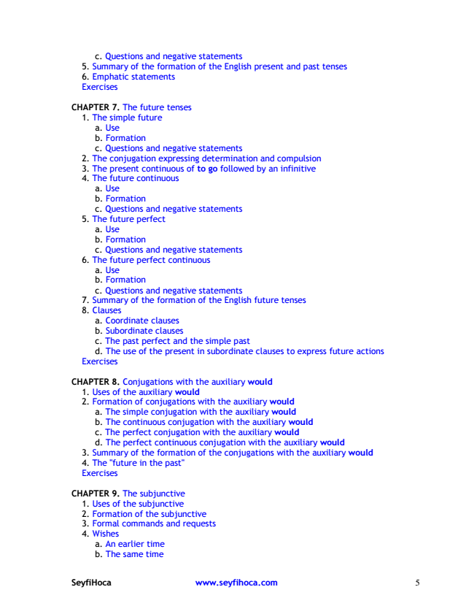

c. Questions and negative statements 5. Summary of the formation of the English present and past tenses 6. Emphatic statements Exercises

CHAPTER 7. The future tenses

1. The simple future

a. Use b. Formation c. Questions and negative statements 2. The conjugation expressing determination and compulsion 3. The present continuous of to go followed by an infinitive 4. The future continuous

a. Use b. Formation c. Questions and negative statements 5. The future perfect

a. Use b. Formation c. Questions and negative statements 6. The future perfect continuous

a. Use b. Formation c. Questions and negative statements 7. Summary of the formation of the English future tenses 8. Clauses

a. Coordinate clauses b. Subordinate clauses c. The past perfect and the simple past d. The use of the present in subordinate clauses to express future actions Exercises

CHAPTER 8. Conjugations with the auxiliary would

1. U ses of the auxiliary would 2. Formation of conjugations with the auxiliary would

a. The simple conjugation with the auxiliary would b. The continuous conjugation with the auxiliary would c. The perfect conjugation with the auxiliary would d. The perfect continuous conjugation with the auxiliary would 3. Summary of the formation of the conjugations with the auxiliary would 4. The "future in the past" Exercises

CHAPTER 9. The subjunctive 1. U ses of the subjunctive 2. Formation of the subjunctive 3. Formal commands and requests 4. Wishes

a. An earlier time b. The same time

SeyfiHoca www.seyfihoca.com 5

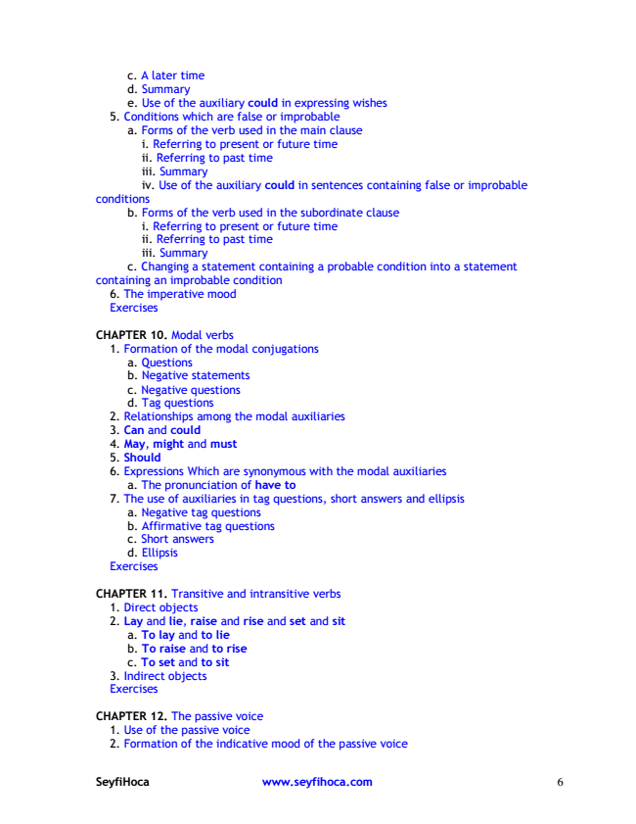

c. A later time d. Summary e. U se of the auxiliary could in expressing wishes 5. Conditions which are false or improbable

a. Forms of the verb used in the main clause

i. Referring to present or future time ii. Referring to past time iii. Summary iv. U se of the auxiliary could in sentences containing false or improbable conditions

b. Forms of the verb used in the subordinate clause

i. Referring to present or future time ii. Referring to past time iii. Summary c. Changing a statement containing a probable condition into a statement containing an improbable condition

6. The imperative mood Exercises

CHAPTER 10. M odal verbs

1. Formation of the modal conjugations

a. Questions b. Negative statements c. Negative questions d. Tag questions 2. Relationships among the modal auxiliaries 3. Can and could 4. May, might and must 5. Should 6. Expressions Which are synonymous with the modal auxiliaries

a. The pronunciation of have to 7. The use of auxiliaries in tag questions, short answers and ellipsis

a. Negative tag questions b. Affirmative tag questions c. Short answers d. Ellipsis Exercises

CHAPTER 11. Transitive and intransitive verbs

1. Direct objects 2. Lay and lie, raise and rise and set and sit

a. To lay and to lie b. To raise and to rise c. To set and to sit 3. Indirect objects Exercises

CHAPTER 12. The passive voice 1. U se of the passive voice 2. Formation of the indicative mood of the passive voice

SeyfiHoca www.seyfihoca.com 6

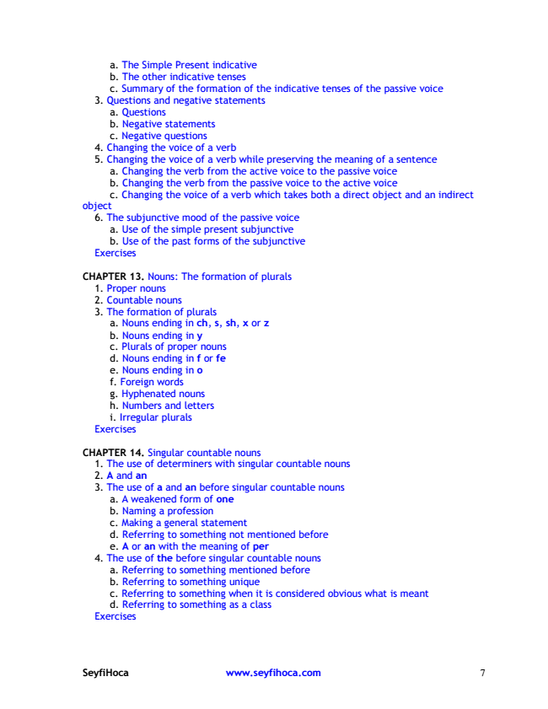

a. The Simple Present indicative b. The other indicative tenses c. Summary of the formation of the indicative tenses of the passive voice 3. Questions and negative statements

a. Questions b. Negative statements c. Negative questions 4. Changing the voice of a verb 5. Changing the voice of a verb while preserving the meaning of a sentence

a. Changing the verb from the active voice to the passive voice b. Changing the verb from the passive voice to the active voice c. Changing the voice of a verb which takes both a direct object and an indirect object

6. The subjunctive mood of the passive voice

a. Use of the simple present subjunctive b. Use of the past forms of the subjunctive Exercises

CHAPTER 13. Nouns: The formation of plurals

1. Proper nouns 2. Countable nouns 3. The formation of plurals

a. Nouns ending in ch, s, sh, x or z b. Nouns ending in y c. Plurals of proper nouns d. Nouns ending in f or fe e. Nouns ending in o f. Foreign words g. H yphenated nouns h. Numbers and letters i. Irregular plurals Exercises

CHAPTER 14. Singular countable nouns

1. The use of determiners with singular countable nouns 2. A and an 3. The use of a and an before singular countable nouns

a. A weakened form of one b. Naming a profession c. M aking a general statement d. Referring to something not mentioned before e. A or an with the meaning of per 4. The use of the before singular countable nouns

a. Referring to something mentioned before b. Referring to something unique c. Referring to something when it is considered obvious what is meant d. Referring to something as a class Exercises

SeyfiHoca www.seyfihoca.com 7

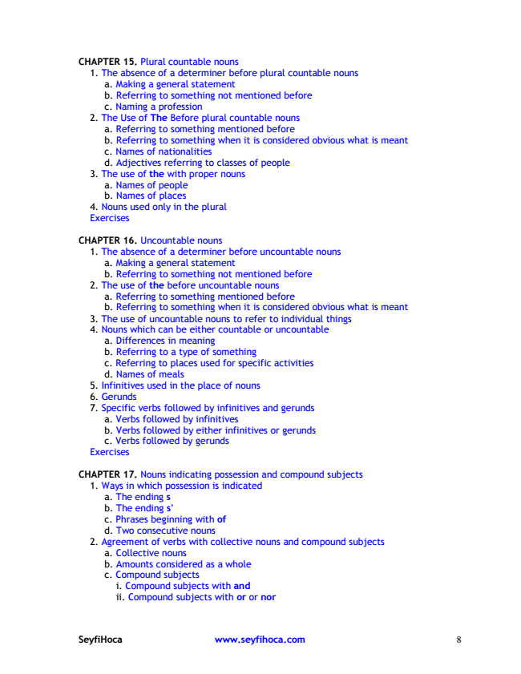

CHAPTER 15. Plural countable nouns

1. The absence of a determiner before plural countable nouns

a. M aking a general statement b. Referring to something not mentioned before c. Naming a profession 2. The U se of The Before plural countable nouns

a. Referring to something mentioned before b. Referring to something when it is considered obvious what is meant c. Names of nationalities d. Adjectives referring to classes of people 3. The use of the with proper nouns

a. Names of people b. Names of places 4. Nouns used only in the plural Exercises

CHAPTER 16. U ncountable nouns

1. The absence of a determiner before uncountable nouns

a. M aking a general statement b. Referring to something not mentioned before 2. The use of the before uncountable nouns

a. Referring to something mentioned before b. Referring to something when it is considered obvious what is meant 3. The use of uncountable nouns to refer to individual things 4. Nouns which can be either countable or uncountable

a. Differences in meaning b. Referring to a type of something c. Referring to places used for specific activities d. Names of meals 5. Infinitives used in the place of nouns 6. G erunds 7. Specific verbs followed by infinitives and gerunds

a. Verbs followed by infinitives b. Verbs followed by either infinitives or gerunds c. Verbs followed by gerunds Exercises

CHAPTER 17. Nouns indicating possession and compound subjects

1. Ways in which possession is indicated

a. The ending s b. The ending s' c. Phrases beginning with of d. Two consecutive nouns 2. Agreement of verbs with collective nouns and compound subjects

a. Collective nouns b. Amounts considered as a whole c. Compound subjects

i. Compound subjects with and ii. Compound subjects with or or nor

SeyfiHoca www.seyfihoca.com 8

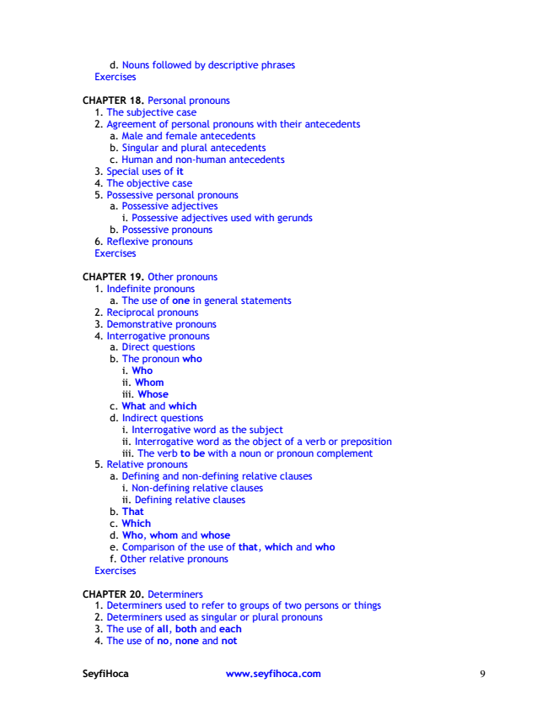

d. Nouns followed by descriptive phrases Exercises

CHAPTER 18. Personal pronouns

1. The subjective case 2. Agreement of personal pronouns with their antecedents

a. M ale and female antecedents b. Singular and plural antecedents c. H uman and non-human antecedents 3. Special uses of it 4. The objective case 5. Possessive personal pronouns

a. Possessive adjectives

i. Possessive adjectives used with gerunds b. Possessive pronouns 6. Reflexive pronouns Exercises

CHAPTER 19. O ther pronouns

1. Indefinite pronouns

a. The use of one in general statements 2. Reciprocal pronouns 3. Demonstrative pronouns 4. Interrogative pronouns a. Direct questions b. The pronoun who

i. Who ii. Whom iii. Whose c. What and which d. Indirect questions

i. Interrogative word as the subject ii. Interrogative word as the object of a verb or preposition iii. The verb to be with a noun or pronoun complement 5. Relative pronouns

a. Defining and non-defining relative clauses

i. Non-defining relative clauses ii. Defining relative clauses b. That c. Which d. Who, whom and whose e. Comparison of the use of that, which and who f. O ther relative pronouns Exercises

CHAPTER 20. Determiners

1. Determiners used to refer to groups of two persons or things 2. Determiners used as singular or plural pronouns 3. The use of all, both and each 4. The use of no, none and not

SeyfiHoca www.seyfihoca.com 9

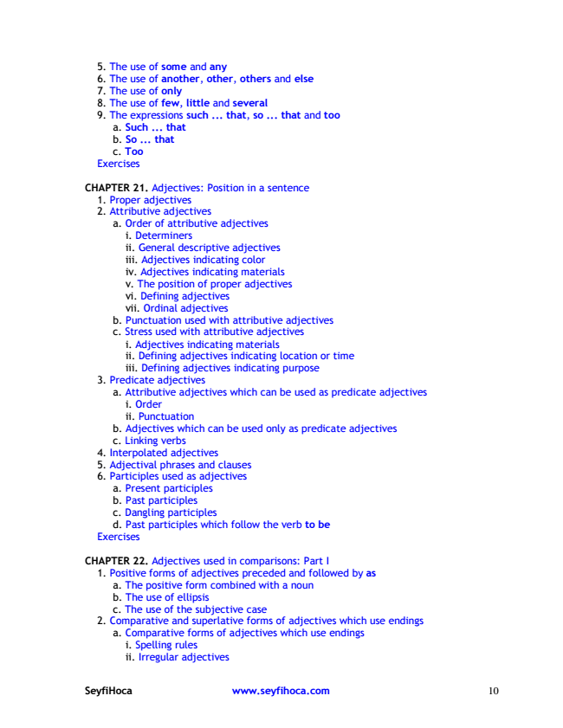

5. The use of some and any 6. The use of another, other, others and else 7. The use of only 8. The use of few, little and several 9. The expressions such ... that, so ... that and too

a. Such ... that b. So ... that c. Too Exercises

CHAPTER 21. Adjectives: Position in a sentence

1. Proper adjectives 2. Attributive adjectives

a. O rder of attributive adjectives

i. Determiners ii. G eneral descriptive adjectives iii. Adjectives indicating color iv. Adjectives indicating materials v. The position of proper adjectives vi. Defining adjectives vii. O rdinal adjectives b. Punctuation used with attributive adjectives c. Stress used with attributive adjectives

i. Adjectives indicating materials ii. Defining adjectives indicating location or time iii. Defining adjectives indicating purpose 3. Predicate adjectives

a. Attributive adjectives which can be used as predicate adjectives

i. O rder ii. Punctuation b. Adjectives which can be used only as predicate adjectives c. Linking verbs 4. Interpolated adjectives 5. Adjectival phrases and clauses 6. Participles used as adjectives

a. Present participles b. Past participles c. Dangling participles d. Past participles which follow the verb to be Exercises

CHAPTER 22. Adjectives used in comparisons: Part I

1. Positive forms of adjectives preceded and followed by as

a. The positive form combined with a noun b. The use of ellipsis c. The use of the subjective case 2. Comparative and superlative forms of adjectives which use endings

a. Comparative forms of adjectives which use endings

i. Spelling rules ii. Irregular adjectives

SeyfiHoca www.seyfihoca.com 10