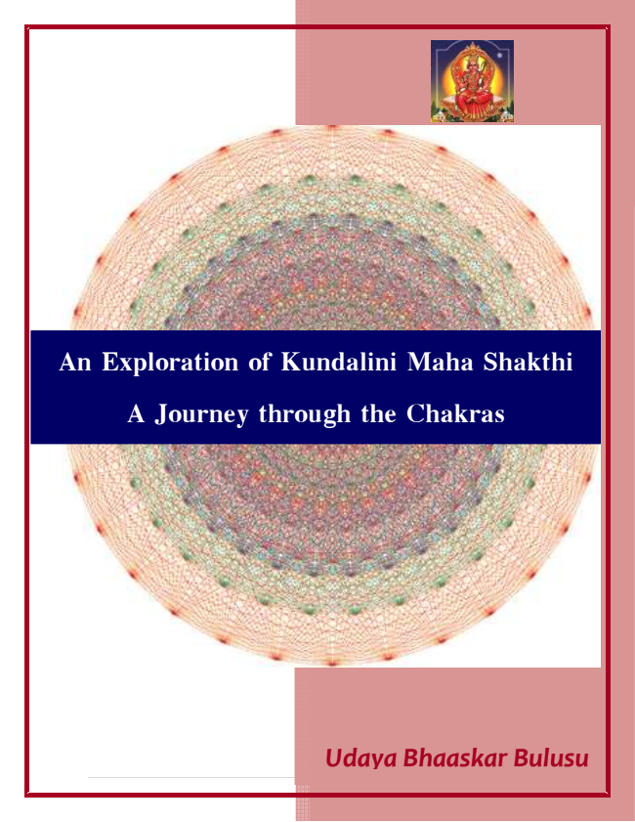

**An Exploration of Kundalini Maha Shakthi A Journey through the Chakras**

***Udaya Bhaaskar Bulusu***

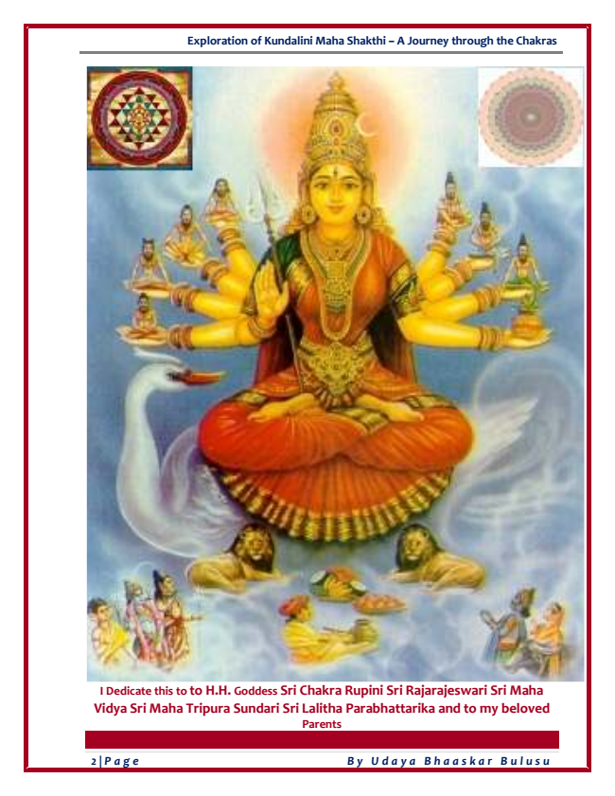

**Exploration of Kundalini Maha Shakthi – A Journey through the Chakras**

**I Dedicate this to to H.H. Goddess Sri Chakra Rupini Sri Rajarajeswari Sri Maha Vidya Sri Maha Tripura Sundari Sri Lalitha Parabhattarika and to my beloved Parents**

***2 | Page By Udaya Bhaaskar Bulusu***

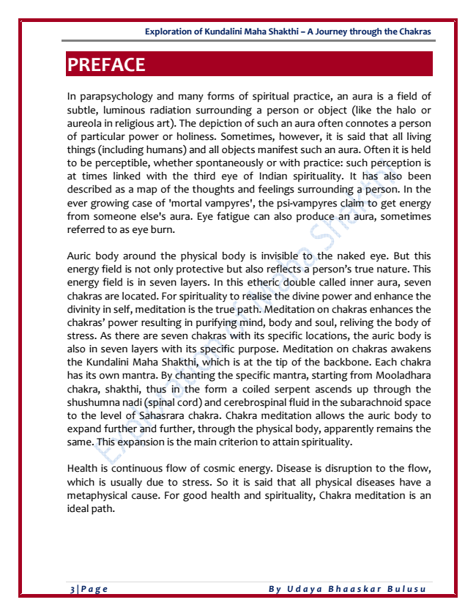

**Exploration of Kundalini Maha Shakthi – A Journey through the Chakras**

**PREFACE**

In parapsychology and many forms of spiritual practice, an aura is a field of subtle, luminous radiation surrounding a person or object (like the halo or aureola in religious art). The depiction of such an aura often connotes a person of particular power or holiness. Sometimes, however, it is said that all living things (including humans) and all objects manifest such an aura. Often it is held to be perceptible, whether spontaneously or with practice: such perception is at times linked with the third eye of Indian spirituality. It has also been described as a map of the thoughts and feelings surrounding a person. In the ever growing case of 'mortal vampyres', the psi-vampyres claim to get energy from someone else's aura. Eye fatigue can also produce an aura, sometimes referred to as eye burn.

Auric body around the physical body is invisible to the naked eye. But this energy field is not only protective but also reflects a person’s true nature. This energy field is in seven layers. In this etheric double called inner aura, seven chakras are located. For spirituality to realise the divine power and enhance the divinity in self, meditation is the true path. Meditation on chakras enhances the chakras’ power resulting in purifying mind, body and soul, reliving the body of stress. As there are seven chakras with its specific locations, the auric body is also in seven layers with its specific purpose. Meditation on chakras awakens the Kundalini Maha Shakthi, which is at the tip of the backbone. Each chakra has its own mantra. By chanting the specific mantra, starting from Mooladhara chakra, shakthi, thus in the form a coiled serpent ascends up through the shushumna nadi (spinal cord) and cerebrospinal fluid in the subarachnoid space to the level of Sahasrara chakra. Chakra meditation allows the auric body to expand further and further, through the physical body, apparently remains the same. This expansion is the main criterion to attain spirituality.

Health is continuous flow of cosmic energy. Disease is disruption to the flow, which is usually due to stress. So it is said that all physical diseases have a metaphysical cause. For good health and spirituality, Chakra meditation is an ideal path.

***3 | Page By Udaya Bhaaskar Bulusu***

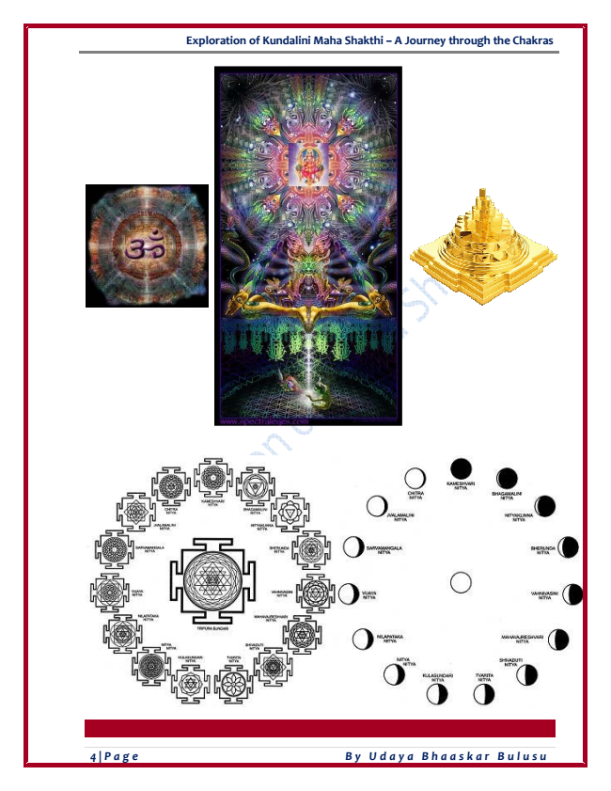

**Exploration of Kundalini Maha Shakthi – A Journey through the Chakras**

***4 | Page By Udaya Bhaaskar Bulusu***

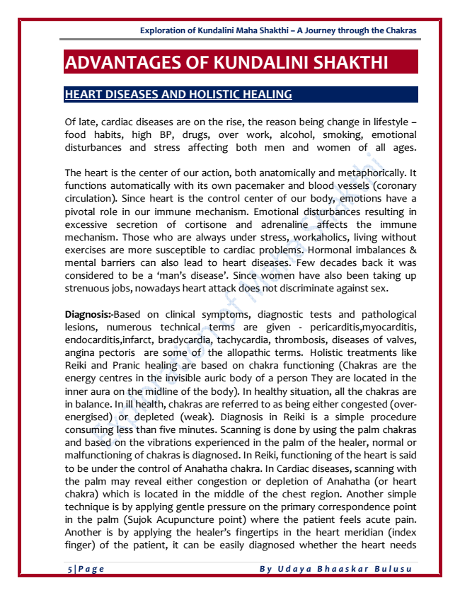

**Exploration of Kundalini Maha Shakthi – A Journey through the Chakras**

**ADVANTAGES OF KUNDALINI SHAKTHI**

**HEART DISEASES AND HOLISTIC HEALING**

Of late, cardiac diseases are on the rise, the reason being change in lifestyle – food habits, high BP, drugs, over work, alcohol, smoking, emotional disturbances and stress affecting both men and women of all ages.

The heart is the center of our action, both anatomically and metaphorically. It functions automatically with its own pacemaker and blood vessels (coronary circulation). Since heart is the control center of our body, emotions have a pivotal role in our immune mechanism. Emotional disturbances resulting in excessive secretion of cortisone and adrenaline affects the immune mechanism. Those who are always under stress, workaholics, living without exercises are more susceptible to cardiac problems. Hormonal imbalances & mental barriers can also lead to heart diseases. Few decades back it was considered to be a ‘man’s disease’. Since women have also been taking up strenuous jobs, nowadays heart attack does not discriminate against sex.

Diagnosis:-Based on clinical symptoms, diagnostic tests and pathological lesions, numerous technical terms are given - pericarditis,myocarditis, endocarditis,infarct, bradycardia, tachycardia, thrombosis, diseases of valves, angina pectoris are some of the allopathic terms. Holistic treatments like Reiki and Pranic healing are based on chakra functioning (Chakras are the energy centres in the invisible auric body of a person They are located in the inner aura on the midline of the body). In healthy situation, all the chakras are in balance. In ill health, chakras are referred to as being either congested (over- energised) or depleted (weak). Diagnosis in Reiki is a simple procedure consuming less than five minutes. Scanning is done by using the palm chakras and based on the vibrations experienced in the palm of the healer, normal or malfunctioning of chakras is diagnosed. In Reiki, functioning of the heart is said to be under the control of Anahatha chakra. In Cardiac diseases, scanning with the palm may reveal either congestion or depletion of Anahatha (or heart chakra) which is located in the middle of the chest region. Another simple technique is by applying gentle pressure on the primary correspondence point in the palm (Sujok Acupuncture point) where the patient feels acute pain. Another is by applying the healer’s fingertips in the heart meridian (index finger) of the patient, it can be easily diagnosed whether the heart needs

***5 | Page By Udaya Bhaaskar Bulusu***

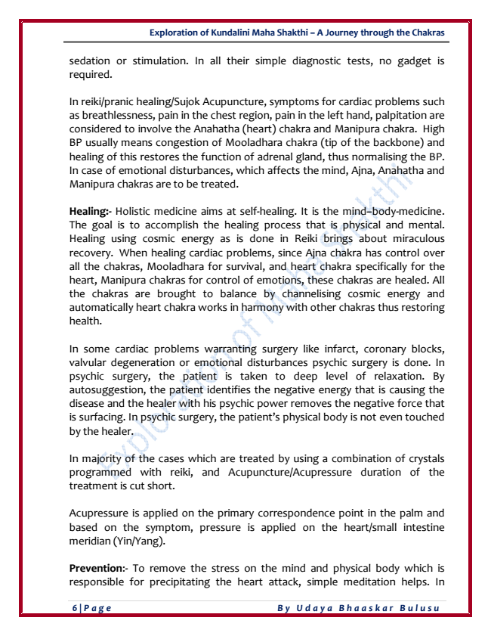

**Exploration of Kundalini Maha Shakthi – A Journey through the Chakras**

sedation or stimulation. In all their simple diagnostic tests, no gadget is required.

In reiki/pranic healing/Sujok Acupuncture, symptoms for cardiac problems such as breathlessness, pain in the chest region, pain in the left hand, palpitation are considered to involve the Anahatha (heart) chakra and Manipura chakra. High BP usually means congestion of Mooladhara chakra (tip of the backbone) and healing of this restores the function of adrenal gland, thus normalising the BP. In case of emotional disturbances, which affects the mind, Ajna, Anahatha and Manipura chakras are to be treated.

Healing:- Holistic medicine aims at self-healing. It is the mind–body-medicine. The goal is to accomplish the healing process that is physical and mental. Healing using cosmic energy as is done in Reiki brings about miraculous recovery. When healing cardiac problems, since Ajna chakra has control over all the chakras, Mooladhara for survival, and heart chakra specifically for the heart, Manipura chakras for control of emotions, these chakras are healed. All the chakras are brought to balance by channelising cosmic energy and automatically heart chakra works in harmony with other chakras thus restoring health.

In some cardiac problems warranting surgery like infarct, coronary blocks, valvular degeneration or emotional disturbances psychic surgery is done. In psychic surgery, the patient is taken to deep level of relaxation. By autosuggestion, the patient identifies the negative energy that is causing the disease and the healer with his psychic power removes the negative force that is surfacing. In psychic surgery, the patient’s physical body is not even touched by the healer.

In majority of the cases which are treated by using a combination of crystals programmed with reiki, and Acupuncture/Acupressure duration of the treatment is cut short.

Acupressure is applied on the primary correspondence point in the palm and based on the symptom, pressure is applied on the heart/small intestine meridian (Yin/Yang).

Prevention:- To remove the stress on the mind and physical body which is responsible for precipitating the heart attack, simple meditation helps. In

***6 | Page By Udaya Bhaaskar Bulusu***

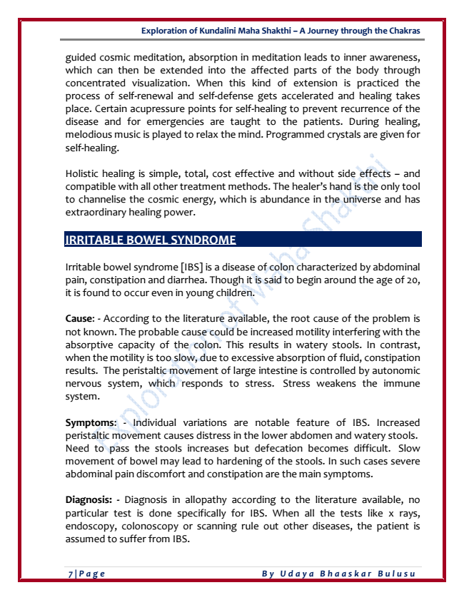

**Exploration of Kundalini Maha Shakthi – A Journey through the Chakras**

guided cosmic meditation, absorption in meditation leads to inner awareness, which can then be extended into the affected parts of the body through concentrated visualization. When this kind of extension is practiced the process of self-renewal and self-defense gets accelerated and healing takes place. Certain acupressure points for self-healing to prevent recurrence of the disease and for emergencies are taught to the patients. During healing, melodious music is played to relax the mind. Programmed crystals are given for self-healing.

Holistic healing is simple, total, cost effective and without side effects – and compatible with all other treatment methods. The healer’s hand is the only tool to channelise the cosmic energy, which is abundance in the universe and has extraordinary healing power.

**IRRITABLE BOWEL SYNDROME**

Irritable bowel syndrome [IBS] is a disease of colon characterized by abdominal pain, constipation and diarrhea. Though it is said to begin around the age of 20, it is found to occur even in young children.

Cause: - According to the literature available, the root cause of the problem is not known. The probable cause could be increased motility interfering with the absorptive capacity of the colon. This results in watery stools. In contrast, when the motility is too slow, due to excessive absorption of fluid, constipation results. The peristaltic movement of large intestine is controlled by autonomic nervous system, which responds to stress. Stress weakens the immune system.

Symptoms: - Individual variations are notable feature of IBS. Increased peristaltic movement causes distress in the lower abdomen and watery stools. Need to pass the stools increases but defecation becomes difficult. Slow movement of bowel may lead to hardening of the stools. In such cases severe abdominal pain discomfort and constipation are the main symptoms.

Diagnosis: - Diagnosis in allopathy according to the literature available, no particular test is done specifically for IBS. When all the tests like x rays, endoscopy, colonoscopy or scanning rule out other diseases, the patient is assumed to suffer from IBS.

***7 | Page By Udaya Bhaaskar Bulusu***

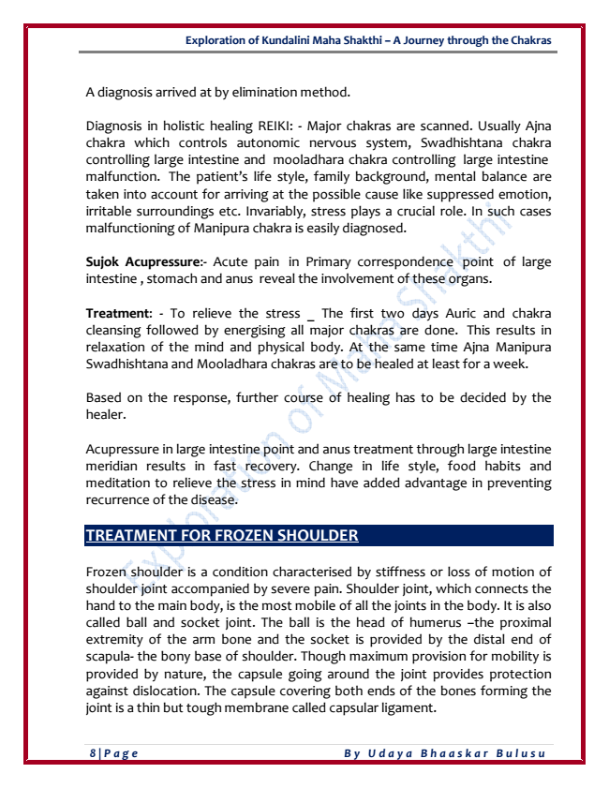

**Exploration of Kundalini Maha Shakthi – A Journey through the Chakras**

A diagnosis arrived at by elimination method.

Diagnosis in holistic healing REIKI: - Major chakras are scanned. Usually Ajna chakra which controls autonomic nervous system, Swadhishtana chakra controlling large intestine and mooladhara chakra controlling large intestine malfunction. The patient’s life style, family background, mental balance are taken into account for arriving at the possible cause like suppressed emotion, irritable surroundings etc. Invariably, stress plays a crucial role. In such cases malfunctioning of Manipura chakra is easily diagnosed.

Sujok Acupressure:- Acute pain in Primary correspondence point of large intestine , stomach and anus reveal the involvement of these organs.

Treatment: - To relieve the stress _ The first two days Auric and chakra cleansing followed by energising all major chakras are done. This results in relaxation of the mind and physical body. At the same time Ajna Manipura Swadhishtana and Mooladhara chakras are to be healed at least for a week.

Based on the response, further course of healing has to be decided by the healer.

Acupressure in large intestine point and anus treatment through large intestine meridian results in fast recovery. Change in life style, food habits and meditation to relieve the stress in mind have added advantage in preventing recurrence of the disease.

**TREATMENT FOR FROZEN SHOULDER**

Frozen shoulder is a condition characterised by stiffness or loss of motion of shoulder joint accompanied by severe pain. Shoulder joint, which connects the hand to the main body, is the most mobile of all the joints in the body. It is also called ball and socket joint. The ball is the head of humerus –the proximal extremity of the arm bone and the socket is provided by the distal end of scapula- the bony base of shoulder. Though maximum provision for mobility is provided by nature, the capsule going around the joint provides protection against dislocation. The capsule covering both ends of the bones forming the joint is a thin but tough membrane called capsular ligament.

***8 | Page By Udaya Bhaaskar Bulusu***

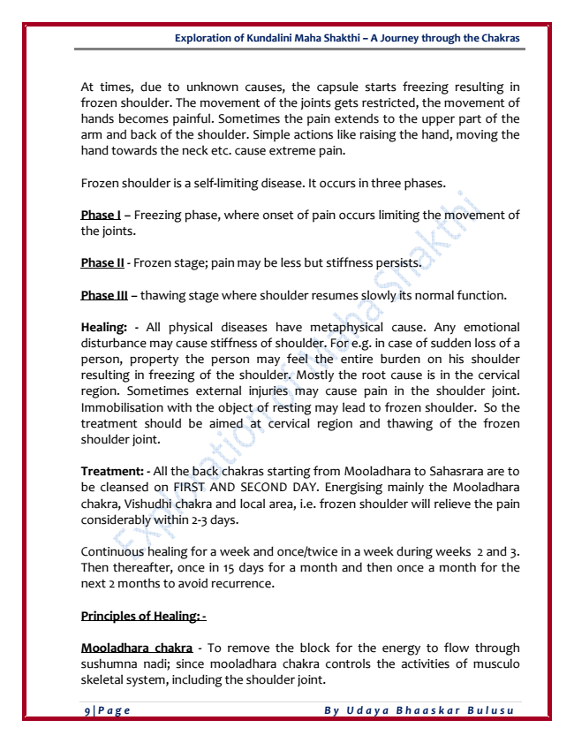

**Exploration of Kundalini Maha Shakthi – A Journey through the Chakras**

At times, due to unknown causes, the capsule starts freezing resulting in frozen shoulder. The movement of the joints gets restricted, the movement of hands becomes painful. Sometimes the pain extends to the upper part of the arm and back of the shoulder. Simple actions like raising the hand, moving the hand towards the neck etc. cause extreme pain.

Frozen shoulder is a self-limiting disease. It occurs in three phases.

Phase I – Freezing phase, where onset of pain occurs limiting the movement of the joints.

Phase II - Frozen stage; pain may be less but stiffness persists.

Phase III – thawing stage where shoulder resumes slowly its normal function.

Healing: - All physical diseases have metaphysical cause. Any emotional disturbance may cause stiffness of shoulder. For e.g. in case of sudden loss of a person, property the person may feel the entire burden on his shoulder resulting in freezing of the shoulder. Mostly the root cause is in the cervical region. Sometimes external injuries may cause pain in the shoulder joint. Immobilisation with the object of resting may lead to frozen shoulder. So the treatment should be aimed at cervical region and thawing of the frozen shoulder joint.

Treatment: - All the back chakras starting from Mooladhara to Sahasrara are to be cleansed on FIRST AND SECOND DAY. Energising mainly the Mooladhara chakra, Vishudhi chakra and local area, i.e. frozen shoulder will relieve the pain considerably within 2-3 days.

Continuous healing for a week and once/twice in a week during weeks 2 and 3. Then thereafter, once in 15 days for a month and then once a month for the next 2 months to avoid recurrence.

**Principles of Healing: -**

Mooladhara chakra - To remove the block for the energy to flow through sushumna nadi; since mooladhara chakra controls the activities of musculo skeletal system, including the shoulder joint.

***9 | Page By Udaya Bhaaskar Bulusu***

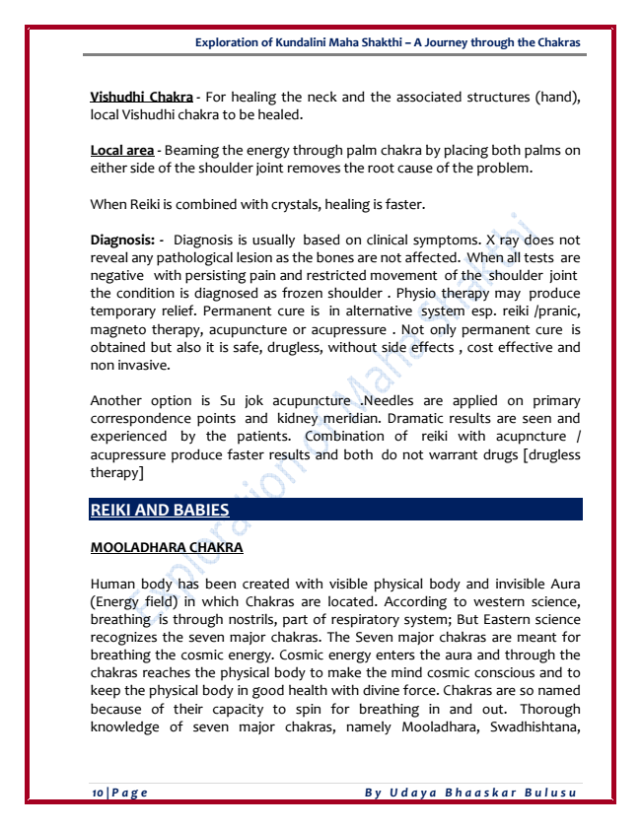

**Exploration of Kundalini Maha Shakthi – A Journey through the Chakras**

Vishudhi Chakra - For healing the neck and the associated structures (hand), local Vishudhi chakra to be healed.

Local area - Beaming the energy through palm chakra by placing both palms on either side of the shoulder joint removes the root cause of the problem.

When Reiki is combined with crystals, healing is faster.

Diagnosis: - Diagnosis is usually based on clinical symptoms. X ray does not reveal any pathological lesion as the bones are not affected. When all tests are negative with persisting pain and restricted movement of the shoulder joint the condition is diagnosed as frozen shoulder . Physio therapy may produce temporary relief. Permanent cure is in alternative system esp. reiki /pranic, magneto therapy, acupuncture or acupressure . Not only permanent cure is obtained but also it is safe, drugless, without side effects , cost effective and non invasive.

Another option is Su jok acupuncture .Needles are applied on primary correspondence points and kidney meridian. Dramatic results are seen and experienced by the patients. Combination of reiki with acupncture / acupressure produce faster results and both do not warrant drugs [drugless therapy]

**REIKI AND BABIES**

**MOOLADHARA CHAKRA**

Human body has been created with visible physical body and invisible Aura (Energy field) in which Chakras are located. According to western science, breathing is through nostrils, part of respiratory system; But Eastern science recognizes the seven major chakras. The Seven major chakras are meant for breathing the cosmic energy. Cosmic energy enters the aura and through the chakras reaches the physical body to make the mind cosmic conscious and to keep the physical body in good health with divine force. Chakras are so named because of their capacity to spin for breathing in and out. Thorough knowledge of seven major chakras, namely Mooladhara, Swadhishtana,

***10 | Page By Udaya Bhaaskar Bulusu***