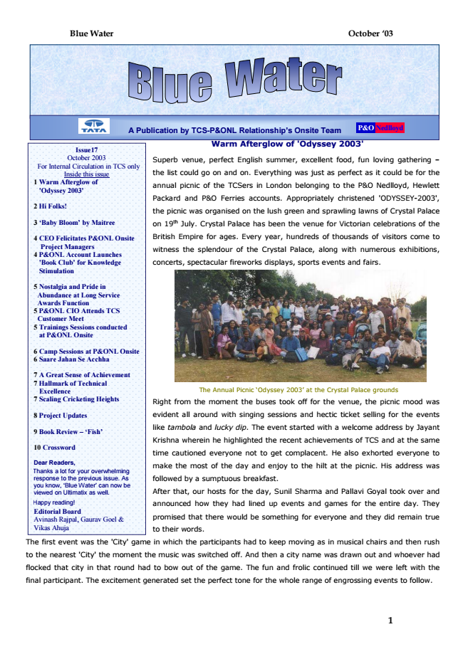

The Annual Picnic ‘Odyssey 2003’ at the Crystal Palace grounds

Right from the moment the buses took off for the venue, the picnic mood was

evident all around with singing sessions and hectic ticket selling for the events

like tambola and lucky dip. The event started with a welcome address by Jayant

Krishna wherein he highlighted the recent achievements of TCS and at the same

time cautioned everyone not to get complacent. He also exhorted everyone to

make the most of the day and enjoy to the hilt at the picnic. His address was

followed by a sumptuous breakfast.

After that, our hosts for the day, Sunil Sharma and Pallavi Goyal took over and

announced how they had lined up events and games for the entire day. They

promised that there would be something for everyone and they did remain true

to their words.

The first event was the 'City' game in which the participants had to keep moving as in musical chairs and then rush

to the nearest 'City' the moment the music was switched off. And then a city name was drawn out and whoever had

flocked that city in that round had to bow out of the game. The fun and frolic continued till we were left with the

final participant. The excitement generated set the perfect tone for the whole range of engrossing events to follow.

**Blue Water October ‘03**

**.**

Issue17 October 2003 For Internal Circulation in TCS only

**Inside this issue 1 Warm Afterglow of**

**'Odyssey 2003'**

**2 Hi Folks!**

**3 ‘Baby Bloom’ by Maitree**

**4 CEO Felicitates P&ONL Onsite**

**Project Managers 4 P&ONL Account Launches 'Book Club' for Knowledge Stimulation**

**5 Nostalgia and Pride in**

**Abundance at Long Service Awards Function 5 P&ONL CIO Attends TCS**

**Customer Meet 5 Trainings Sessions conducted**

**at P&ONL Onsite**

**6 Camp Sessions at P&ONL Onsite 6 Saare Jahan Se Acchha**

**7 A Great Sense of Achievement 7 Hallmark of Technical**

**Excellence 7 Scaling Cricketing Heights**

**8 Project Updates**

**9 Book Review – ‘Fish’**

**10 Crossword**

Dear Readers, Thanks a lot for your overwhelming response to the previous issue. As you know, ‘Blue Water’ can now be viewed on Ultimatix as well.

Happy reading! Editorial Board Avinash Rajpal, Gaurav Goel & Vikas Ahuja

**1**

**Nostalgia and Pride in Abundance at Long Service**

**A Publication by TCS-P&ONL Relationship’s Onsite Team**

**Warm Afterglow of 'Odyssey 2003'**

Superb venue, perfect English summer, excellent food, fun loving gathering –

the list could go on and on. Everything was just as perfect as it could be for the

annual picnic of the TCSers in London belonging to the P&O Nedlloyd, Hewlett

Packard and P&O Ferries accounts. Appropriately christened 'ODYSSEY-2003',

the picnic was organised on the lush green and sprawling lawns of Crystal Palace

on 19th July. Crystal Palace has been the venue for Victorian celebrations of the

British Empire for ages. Every year, hundreds of thousands of visitors come to

witness the splendour of the Crystal Palace, along with numerous exhibitions,

concerts, spectacular fireworks displays, sports events and fairs.

**Nedlloyd P&O**

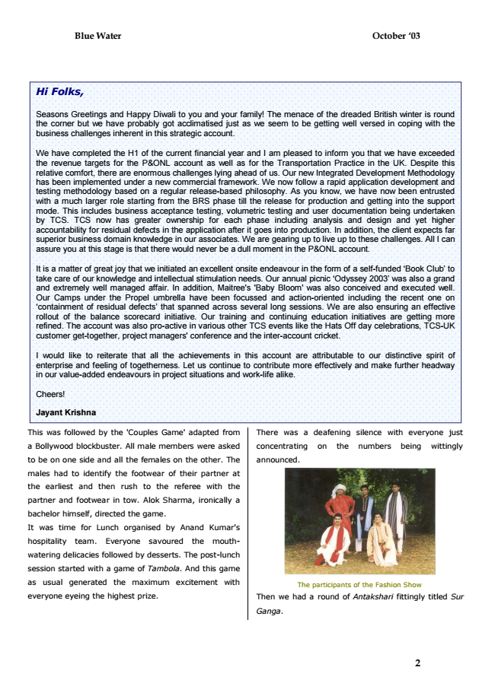

This was followed by the 'Couples Game' adapted from

a Bollywood blockbuster. All male members were asked

to be on one side and all the females on the other. The

males had to identify the footwear of their partner at

the earliest and then rush to the referee with the

partner and footwear in tow. Alok Sharma, ironically a

bachelor himself, directed the game.

It was time for Lunch organised by Anand Kumar's

hospitality team. Everyone savoured the mouth-

watering delicacies followed by desserts. The post-lunch

session started with a game of Tambola. And this game

as usual generated the maximum excitement with

everyone eyeing the highest prize.

**Blue Water October ‘03**

***Hi Folks,***

Seasons Greetings and Happy Diwali to you and your family! The menace of the dreaded British winter is round the corner but we have probably got acclimatised just as we seem to be getting well versed in coping with the business challenges inherent in this strategic account.

We have completed the H1 of the current financial year and I am pleased to inform you that we have exceeded the revenue targets for the P&ONL account as well as for the Transportation Practice in the UK. Despite this relative comfort, there are enormous challenges lying ahead of us. Our new Integrated Development Methodology has been implemented under a new commercial framework. We now follow a rapid application development and testing methodology based on a regular release-based philosophy. As you know, we have now been entrusted with a much larger role starting from the BRS phase till the release for production and getting into the support mode. This includes business acceptance testing, volumetric testing and user documentation being undertaken by TCS. TCS now has greater ownership for each phase including analysis and design and yet higher accountability for residual defects in the application after it goes into production. In addition, the client expects far superior business domain knowledge in our associates. We are gearing up to live up to these challenges. All I can assure you at this stage is that there would never be a dull moment in the P&ONL account.

It is a matter of great joy that we initiated an excellent onsite endeavour in the form of a self-funded ‘Book Club’ to take care of our knowledge and intellectual stimulation needs. Our annual picnic ‘Odyssey 2003’ was also a grand and extremely well managed affair. In addition, Maitree's 'Baby Bloom' was also conceived and executed well. Our Camps under the Propel umbrella have been focussed and action-oriented including the recent one on ‘containment of residual defects’ that spanned across several long sessions. We are also ensuring an effective rollout of the balance scorecard initiative. Our training and continuing education initiatives are getting more refined. The account was also pro-active in various other TCS events like the Hats Off day celebrations, TCS-UK customer get-together, project managers' conference and the inter-account cricket.

I would like to reiterate that all the achievements in this account are attributable to our distinctive spirit of enterprise and feeling of togetherness. Let us continue to contribute more effectively and make further headway in our value-added endeavours in project situations and work-life alike.

Cheers!

**Jayant Krishna**

There was a deafening silence with everyone just

concentrating on the numbers being wittingly

announced.

The participants of the Fashion Show

Then we had a round of Antakshari fittingly titled Sur

*Ganga.*

**2**

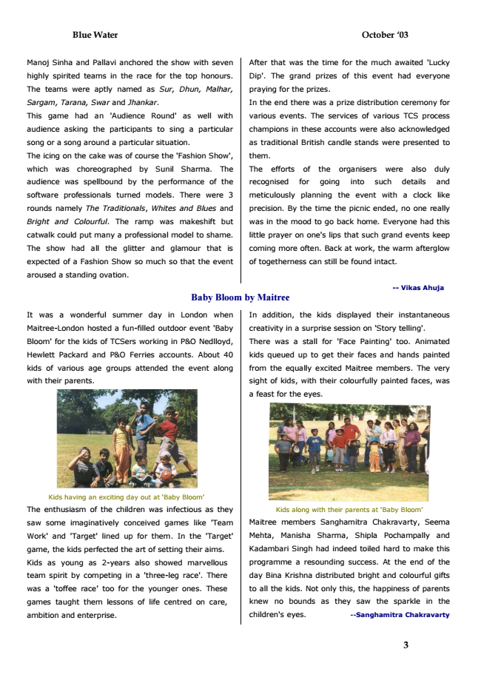

After Manoj Sinha and Pallavi anchored the show with seven

that was the time for the much awaited 'Lucky

highly spirited teams in the race for the top honours.

Dip'. The grand prizes of this event had everyone

The teams were aptly named as Sur, Dhun, Malhar,

praying for the prizes.

*Sargam, Tarana, Swar and Jhankar.*

In the end there was a prize distribution ceremony for

This game had an 'Audience Round' as well with

various events. The services of various TCS process

audience asking the participants to sing a particular

champions in these accounts were also acknowledged

song or a song around a particular situation.

as traditional British candle stands were presented to

The icing on the cake was of course the 'Fashion Show',

them.

which was choreographed by Sunil Sharma. The

The efforts of the organisers were also duly

audience was spellbound by the performance of the

recognised for going into such details and

software professionals turned models. There were 3

meticulously planning the event with a clock like

*rounds namely The Traditionals, Whites and Blues and*

precision. By the time the picnic ended, no one really

Bright and Colourful. The ramp was makeshift but

was in the mood to go back home. Everyone had this

catwalk could put many a professional model to shame.

little prayer on one's lips that such grand events keep

The show had all the glitter and glamour that is

coming more often. Back at work, the warm afterglow

expected of a Fashion Show so much so that the event

of togetherness can still be found intact.

aroused a standing ovation.

**-- Vikas Ahuja Baby Bloom by Maitree**

It was a wonderful summer day in London when

Maitree-London hosted a fun-filled outdoor event 'Baby

Bloom' for the kids of TCSers working in P&O Nedlloyd,

Hewlett Packard and P&O Ferries accounts. About 40

kids of various age groups attended the event along

with their parents.

Kids having an exciting day out at ‘Baby Bloom’

The enthusiasm of the children was infectious as they

saw some imaginatively conceived games like 'Team

Work' and 'Target' lined up for them. In the 'Target'

game, the kids perfected the art of setting their aims.

Kids as young as 2-years also showed marvellous

team spirit by competing in a 'three-leg race'. There

was a 'toffee race' too for the younger ones. These

games taught them lessons of life centred on care,

ambition and enterprise.

**Blue Water October ‘03**

In addition, the kids displayed their instantaneous

creativity in a surprise session on 'Story telling'.

There was a stall for 'Face Painting' too. Animated

kids queued up to get their faces and hands painted

from the equally excited Maitree members. The very

sight of kids, with their colourfully painted faces, was

a feast for the eyes.

Kids along with their parents at ‘Baby Bloom’

Maitree members Sanghamitra Chakravarty, Seema

Mehta, Manisha Sharma, Shipla Pochampally and

Kadambari Singh had indeed toiled hard to make this

programme a resounding success. At the end of the

day Bina Krishna distributed bright and colourful gifts

to all the kids. Not only this, the happiness of parents

knew no bounds as they saw the sparkle in the

**children's eyes. --Sanghamitra Chakravarty**

**3**

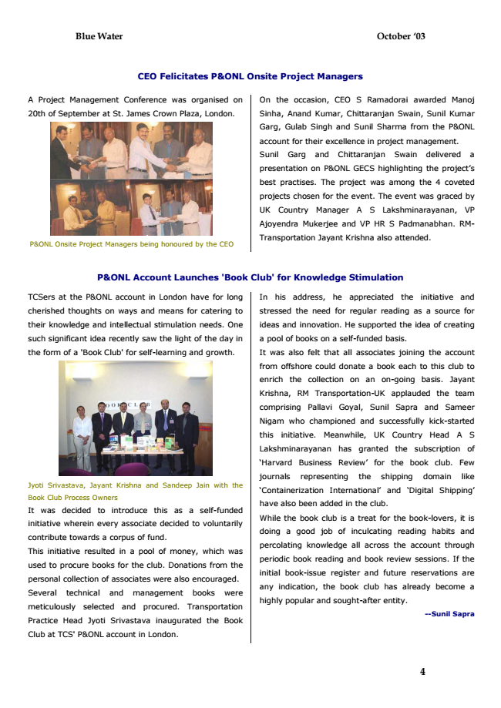

**Blue Water October ‘03**

**CEO Felicitates P&ONL Onsite Project Managers**

A Project Management Conference was organised on

On the occasion, CEO S Ramadorai awarded Manoj

20th of September at St. James Crown Plaza, London.

Sinha, Anand Kumar, Chittaranjan Swain, Sunil Kumar

Garg, Gulab Singh and Sunil Sharma from the P&ONL

account for their excellence in project management.

Sunil Garg and Chittaranjan Swain delivered a

presentation on P&ONL GECS highlighting the project’s

best practises. The project was among the 4 coveted

projects chosen for the event. The event was graced by

UK Country Manager A S Lakshminarayanan, VP

Ajoyendra Mukerjee and VP HR S Padmanabhan. RM-

P&ONL Onsite Project Managers being honoured by the CEO

Transportation Jayant Krishna also attended.

**P&ONL Account Launches 'Book Club' for Knowledge Stimulation**

TCSers at the P&ONL account in London have for long

cherished thoughts on ways and means for catering to

their knowledge and intellectual stimulation needs. One

such significant idea recently saw the light of the day in

the form of a 'Book Club' for self-learning and growth.

Jyoti Srivastava, Jayant Krishna and Sandeep Jain with the

Book Club Process Owners

It was decided to introduce this as a self-funded

initiative wherein every associate decided to voluntarily

contribute towards a corpus of fund.

This initiative resulted in a pool of money, which was

used to procure books for the club. Donations from the

personal collection of associates were also encouraged.

Several technical and management books were

meticulously selected and procured. Transportation

Practice Head Jyoti Srivastava inaugurated the Book

Club at TCS' P&ONL account in London.

**4**

In his address, he appreciated the initiative and

stressed the need for regular reading as a source for

ideas and innovation. He supported the idea of creating

a pool of books on a self-funded basis.

It was also felt that all associates joining the account

from offshore could donate a book each to this club to

enrich the collection on an on-going basis. Jayant

Krishna, RM Transportation-UK applauded the team

comprising Pallavi Goyal, Sunil Sapra and Sameer

Nigam who championed and successfully kick-started

this initiative. Meanwhile, UK Country Head A S

Lakshminarayanan has granted the subscription of

‘Harvard Business Review’ for the book club. Few

journals representing the shipping domain like

‘Containerization International’ and ‘Digital Shipping’

have also been added in the club.

While the book club is a treat for the book-lovers, it is

doing a good job of inculcating reading habits and

percolating knowledge all across the account through

periodic book reading and book review sessions. If the

initial book-issue register and future reservations are

any indication, the book club has already become a

highly popular and sought-after entity.

**--Sunil Sapra**

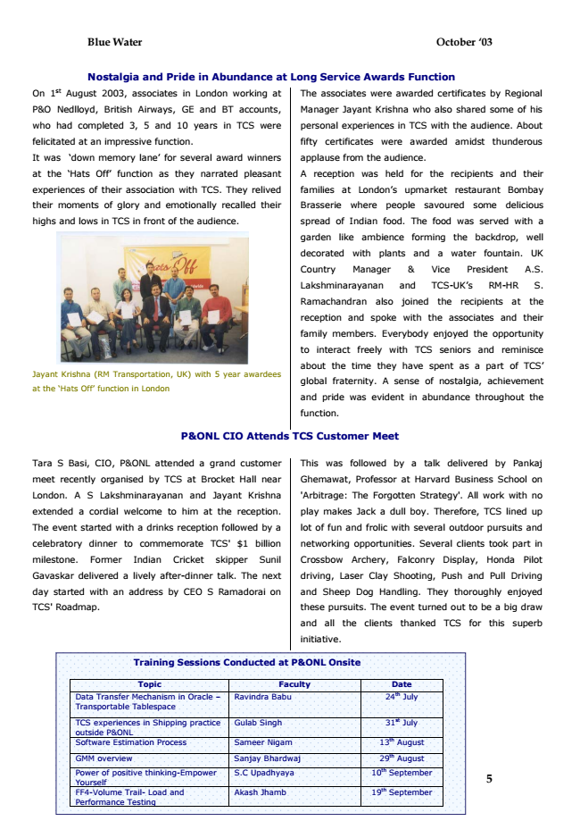

**Blue Water October ‘03**

**Nostalgia and Pride in Abundance at Long Service Awards Function**

On 1st August 2003, associates in London working at

The associates were awarded certificates by Regional

P&O Nedlloyd, British Airways, GE and BT accounts,

Manager Jayant Krishna who also shared some of his

who had completed 3, 5 and 10 years in TCS were

personal experiences in TCS with the audience. About

felicitated at an impressive function.

fifty certificates were awarded amidst thunderous

It was ‘down memory lane’ for several award winners

applause from the audience.

at the ‘Hats Off’ function as they narrated pleasant

A reception was held for the recipients and their

experiences of their association with TCS. They relived

families at London’s upmarket restaurant Bombay

their moments of glory and emotionally recalled their

Brasserie where people savoured some delicious

highs and lows in TCS in front of the audience.

spread of Indian food. The food was served with a

garden like ambience forming the backdrop, well

decorated with plants and a water fountain. UK

Country Manager & Vice President A.S.

Lakshminarayanan and TCS-UK’s RM-HR S.

Ramachandran also joined the recipients at the

reception and spoke with the associates and their

family members. Everybody enjoyed the opportunity

to interact freely with TCS seniors and reminisce

about the time they have spent as a part of TCS’ Jayant Krishna (RM Transportation, UK) with 5 year awardees

at the ‘Hats Off’ function in London

global fraternity. A sense of nostalgia, achievement

and pride was evident in abundance throughout the

function.

**P&ONL CIO Attends TCS Customer Meet**

Tara S Basi, CIO, P&ONL attended a grand customer

meet recently organised by TCS at Brocket Hall near

London. A S Lakshminarayanan and Jayant Krishna

extended a cordial welcome to him at the reception.

The event started with a drinks reception followed by a

celebratory dinner to commemorate TCS' $1 billion

milestone. Former Indian Cricket skipper Sunil

Gavaskar delivered a lively after-dinner talk. The next

day started with an address by CEO S Ramadorai on

TCS' Roadmap.

5 This was followed by a talk delivered by Pankaj

Ghemawat, Professor at Harvard Business School on

'Arbitrage: The Forgotten Strategy'. All work with no

play makes Jack a dull boy. Therefore, TCS lined up

lot of fun and frolic with several outdoor pursuits and

networking opportunities. Several clients took part in

Crossbow Archery, Falconry Display, Honda Pilot

driving, Laser Clay Shooting, Push and Pull Driving

and Sheep Dog Handling. They thoroughly enjoyed

these pursuits. The event turned out to be a big draw

and all the clients thanked TCS for this superb

initiative.

**Training Sessions Conducted at P&ONL Onsite**

Topic Faculty Date Data Transfer Mechanism in Oracle – Transportable Tablespace

Ravindra Babu 24th July

TCS experiences in Shipping practice outside P&ONL

Gulab Singh 31st July

Software Estimation Process Sameer Nigam 13th August

GMM overview Sanjay Bhardwaj 29th August

Power of positive thinking-Empower Yourself

S.C Upadhyaya 10th September

FF4-Volume Trail- Load and Performance Testing

Akash Jhamb 19th September

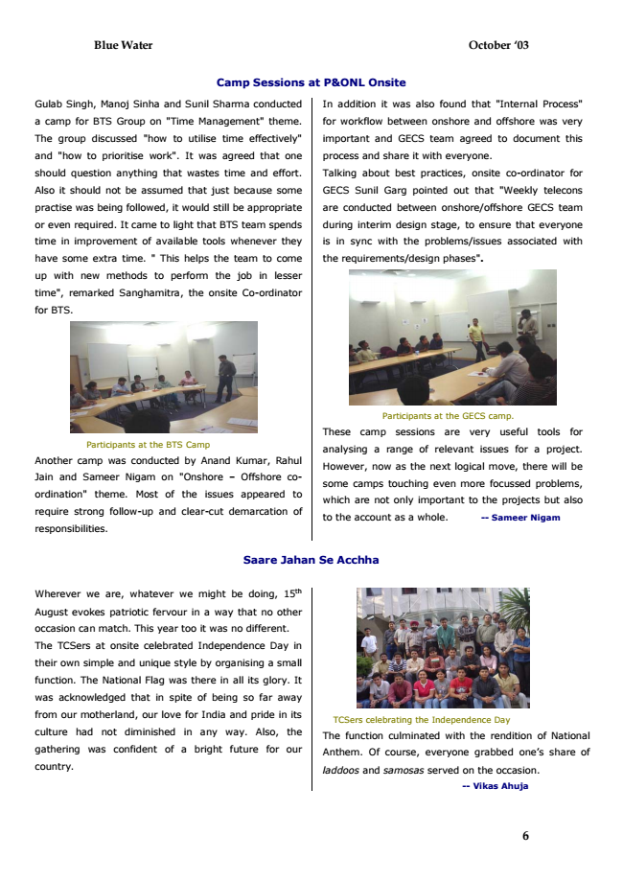

**Blue Water October ‘03**

**Camp Sessions at P&ONL Onsite**

Gulab Singh, Manoj Sinha and Sunil Sharma conducted

a camp for BTS Group on "Time Management" theme.

The group discussed "how to utilise time effectively"

and "how to prioritise work". It was agreed that one

should question anything that wastes time and effort.

Also it should not be assumed that just because some

practise was being followed, it would still be appropriate

or even required. It came to light that BTS team spends

time in improvement of available tools whenever they

have some extra time. " This helps the team to come

up with new methods to perform the job in lesser

time", remarked Sanghamitra, the onsite Co-ordinator

for BTS.

Participants at the GECS camp.

These camp sessions are very useful tools for

analysing a range of relevant issues for a project.

However, now as the next logical move, there will be

some camps touching even more focussed problems,

which are not only important to the projects but also

to the account as a whole. -- Sameer Nigam

**Saare Jahan Se Acchha**

Wherever we are, whatever we might be doing, 15th

August evokes patriotic fervour in a way that no other

occasion can match. This year too it was no different.

The TCSers at onsite celebrated Independence Day in

their own simple and unique style by organising a small

function. The National Flag was there in all its glory. It

was acknowledged that in spite of being so far away

from our motherland, our love for India and pride in its

culture had not diminished in any way. Also, the

gathering was confident of a bright future for our

country.

6 Participants at the BTS Camp

Another camp was conducted by Anand Kumar, Rahul

Jain and Sameer Nigam on "Onshore – Offshore co-

ordination" theme. Most of the issues appeared to

require strong follow-up and clear-cut demarcation of

responsibilities.

In addition it was also found that "Internal Process"

for workflow between onshore and offshore was very

important and GECS team agreed to document this

process and share it with everyone.

Talking about best practices, onsite co-ordinator for

GECS Sunil Garg pointed out that "Weekly telecons

are conducted between onshore/offshore GECS team

during interim design stage, to ensure that everyone

is in sync with the problems/issues associated with

the requirements/design phases".

TCSers celebrating the Independence Day

The function culminated with the rendition of National

Anthem. Of course, everyone grabbed one’s share of

laddoos and samosas served on the occasion.

**-- Vikas Ahuja**

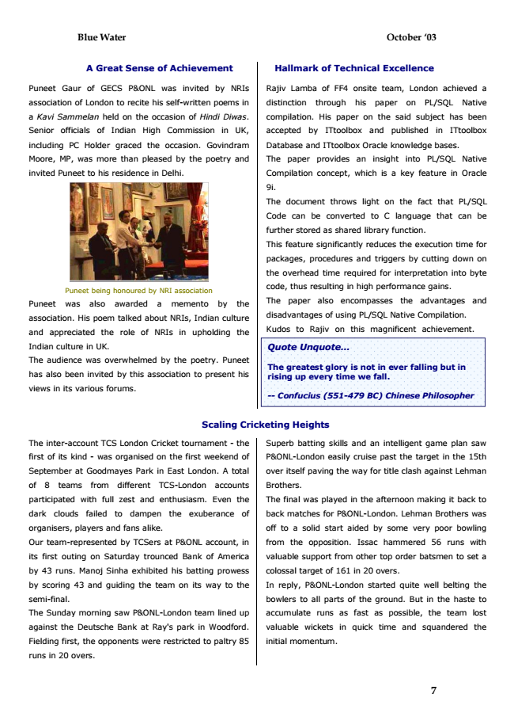

**Blue Water October ‘03**

**A Great Sense of Achievement**

**Hallmark of Technical Excellence**

Puneet Gaur of GECS P&ONL was invited by NRIs

Rajiv Lamba of FF4 onsite team, London achieved a

association of London to recite his self-written poems in

distinction through his paper on PL/SQL Native

*a Kavi Sammelan held on the occasion of Hindi Diwas.*

compilation. His paper on the said subject has been

Senior officials of Indian High Commission in UK,

accepted by ITtoolbox and published in ITtoolbox

including PC Holder graced the occasion. Govindram

Database and ITtoolbox Oracle knowledge bases.

Moore, MP, was more than pleased by the poetry and

The paper provides an insight into PL/SQL Native

invited Puneet to his residence in Delhi.

Compilation concept, which is a key feature in Oracle

9i.

The document throws light on the fact that PL/SQL

Code can be converted to C language that can be

further stored as shared library function.

This feature significantly reduces the execution time for

packages, procedures and triggers by cutting down on

the overhead time required for interpretation into byte

Puneet being honoured by NRI association

code, thus resulting in high performance gains.

Puneet was also awarded a memento by the

The paper also encompasses the advantages and

association. His poem talked about NRIs, Indian culture

disadvantages of using PL/SQL Native Compilation.

and appreciated the role of NRIs in upholding the

Kudos to Rajiv on this magnificent achievement.

Indian culture in UK.

The audience was overwhelmed by the poetry. Puneet

has also been invited by this association to present his

views in its various forums.

**Scaling Cricketing Heights**

The inter-account TCS London Cricket tournament - the

Superb batting skills and an intelligent game plan saw

first of its kind - was organised on the first weekend of

P&ONL-London easily cruise past the target in the 15th

September at Goodmayes Park in East London. A total

over itself paving the way for title clash against Lehman

of 8 teams from different TCS-London accounts

Brothers.

participated with full zest and enthusiasm. Even the

The final was played in the afternoon making it back to

dark clouds failed to dampen the exuberance of

back matches for P&ONL-London. Lehman Brothers was

organisers, players and fans alike.

off to a solid start aided by some very poor bowling

Our team-represented by TCSers at P&ONL account, in

from the opposition. Issac hammered 56 runs with

its first outing on Saturday trounced Bank of America

valuable support from other top order batsmen to set a

by 43 runs. Manoj Sinha exhibited his batting prowess

colossal target of 161 in 20 overs.

by scoring 43 and guiding the team on its way to the

In reply, P&ONL-London started quite well belting the

semi-final.

bowlers to all parts of the ground. But in the haste to

The Sunday morning saw P&ONL-London team lined up

accumulate runs as fast as possible, the team lost

against the Deutsche Bank at Ray's park in Woodford.

valuable wickets in quick time and squandered the

Fielding first, the opponents were restricted to paltry 85

initial momentum.

runs in 20 overs.

**7**

***Quote Unquote...***

**The greatest glory is not in ever falling but in rising up every time we fall.**

***-- Confucius (551-479 BC) Chinese Philosopher***

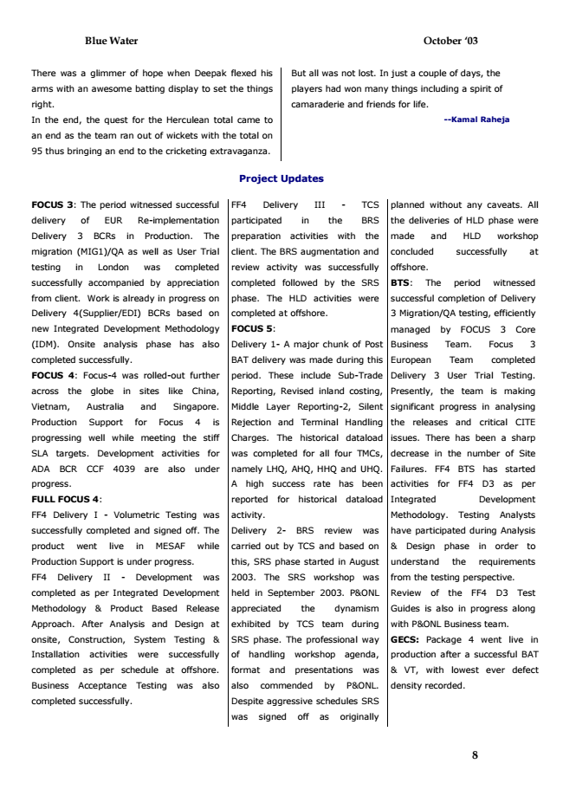

**Blue Water October ‘03**

There was a glimmer of hope when Deepak flexed his

But all was not lost. In just a couple of days, the

arms with an awesome batting display to set the things

players had won many things including a spirit of

right.

camaraderie and friends for life.

In the end, the quest for the Herculean total came to

**--Kamal Raheja**

an end as the team ran out of wickets with the total on

95 thus bringing an end to the cricketing extravaganza.

**Project Updates**

FOCUS 3: The period witnessed successful

FF4 Delivery III - TCS

planned without any caveats. All

delivery of EUR Re-implementation

participated in the BRS

the deliveries of HLD phase were

Delivery 3 BCRs in Production. The

preparation activities with the

made and HLD workshop

migration (MIG1)/QA as well as User Trial

client. The BRS augmentation and

concluded successfully at

testing in London was completed

review activity was successfully

offshore.

successfully accompanied by appreciation

completed followed by the SRS

BTS: The period witnessed

from client. Work is already in progress on

phase. The HLD activities were

successful completion of Delivery

Delivery 4(Supplier/EDI) BCRs based on

completed at offshore.

3 Migration/QA testing, efficiently

new Integrated Development Methodology

**FOCUS 5:**

managed by FOCUS 3 Core

(IDM). Onsite analysis phase has also

Delivery 1- A major chunk of Post

Business Team. Focus 3

completed successfully.

BAT delivery was made during this

European Team completed

FOCUS 4: Focus-4 was rolled-out further

period. These include Sub-Trade

Delivery 3 User Trial Testing.

across the globe in sites like China,

Reporting, Revised inland costing,

Presently, the team is making

Vietnam, Australia and Singapore.

Middle Layer Reporting-2, Silent

significant progress in analysing

Production Support for Focus 4 is

Rejection and Terminal Handling

the releases and critical CITE

progressing well while meeting the stiff

Charges. The historical dataload

issues. There has been a sharp

SLA targets. Development activities for

was completed for all four TMCs,

decrease in the number of Site

ADA BCR CCF 4039 are also under

namely LHQ, AHQ, HHQ and UHQ.

Failures. FF4 BTS has started

progress.

A high success rate has been

activities for FF4 D3 as per

**FULL FOCUS 4:**

reported for historical dataload

Integrated Development

FF4 Delivery I - Volumetric Testing was

activity.

Methodology. Testing Analysts

successfully completed and signed off. The

Delivery 2- BRS review was

have participated during Analysis

product went live in MESAF while

carried out by TCS and based on

& Design phase in order to

Production Support is under progress.

this, SRS phase started in August

understand the requirements

FF4 Delivery II - Development was

2003. The SRS workshop was

from the testing perspective.

completed as per Integrated Development

held in September 2003. P&ONL

Review of the FF4 D3 Test

Methodology & Product Based Release

appreciated the dynamism

Guides is also in progress along

Approach. After Analysis and Design at

exhibited by TCS team during

with P&ONL Business team.

onsite, Construction, System Testing &

SRS phase. The professional way

GECS: Package 4 went live in

Installation activities were successfully

of handling workshop agenda,

production after a successful BAT

completed as per schedule at offshore.

format and presentations was

& VT, with lowest ever defect

Business Acceptance Testing was also

also commended by P&ONL.

density recorded.

completed successfully.

Despite aggressive schedules SRS

was signed off as originally

**8**

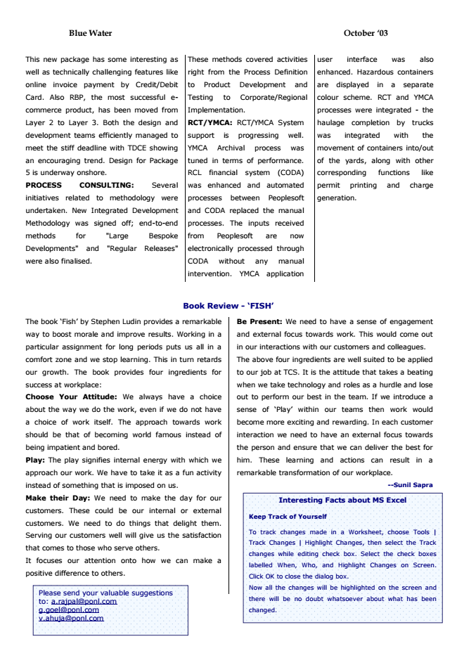

user This new package has some interesting as

interface was also

well as technically challenging features like

enhanced. Hazardous containers

online invoice payment by Credit/Debit

are displayed in a separate

Card. Also RBP, the most successful e-

colour scheme. RCT and YMCA

commerce product, has been moved from

processes were integrated - the

Layer 2 to Layer 3. Both the design and

haulage completion by trucks

development teams efficiently managed to

was integrated with the

meet the stiff deadline with TDCE showing

movement of containers into/out

an encouraging trend. Design for Package

of the yards, along with other

5 is underway onshore.

corresponding functions like

**PROCESS CONSULTING: Several**

permit printing and charge

initiatives related to methodology were

generation.

undertaken. New Integrated Development

Methodology was signed off; end-to-end

methods for "Large Bespoke

Developments" and "Regular Releases"

were also finalised.

**Book Review - ‘FISH’**

The book ‘Fish’ by Stephen Ludin provides a remarkable

way to boost morale and improve results. Working in a

particular assignment for long periods puts us all in a

comfort zone and we stop learning. This in turn retards

our growth. The book provides four ingredients for

success at workplace:

**Choose Your Attitude: We always have a choice**

about the way we do the work, even if we do not have

a choice of work itself. The approach towards work

should be that of becoming world famous instead of

being impatient and bored.

Play: The play signifies internal energy with which we

approach our work. We have to take it as a fun activity

instead of something that is imposed on us.

Make their Day: We need to make the day for our

customers. These could be our internal or external

customers. We need to do things that delight them.

Serving our customers well will give us the satisfaction

that comes to those who serve others.

It focuses our attention onto how we can make a

positive difference to others.

Be Present: We need to have a sense of engagement

and external focus towards work. This would come out

in our interactions with our customers and colleagues.

The above four ingredients are well suited to be applied

to our job at TCS. It is the attitude that takes a beating

when we take technology and roles as a hurdle and lose

out to perform our best in the team. If we introduce a

sense of ‘Play’ within our teams then work would

become more exciting and rewarding. In each customer

interaction we need to have an external focus towards

the person and ensure that we can deliver the best for

him. These learning and actions can result in a

remarkable transformation of our workplace.

**--Sunil Sapra**

**Blue Water October ‘03**

These methods covered activities

right from the Process Definition

to Product Development and

Testing to Corporate/Regional

Implementation.

RCT/YMCA: RCT/YMCA System

support is progressing well.

YMCA Archival process was

tuned in terms of performance.

RCL financial system (CODA)

was enhanced and automated

processes between Peoplesoft

and CODA replaced the manual

processes. The inputs received

from Peoplesoft are now

electronically processed through

CODA without any manual

intervention. YMCA application

Please send your valuable suggestions to: a.rajpal@ponl.com g.goel@ponl.com v.ahuja@ponl.com

**9**

**Interesting Facts about MS Excel**

**Keep Track of Yourself**

To track changes made in a Worksheet, choose Tools |

Track Changes | Highlight Changes, then select the Track

changes while editing check box. Select the check boxes

labelled When, Who, and Highlight Changes on Screen.

Click OK to close the dialog box.

Now all the changes will be highlighted on the screen and

there will be no doubt whatsoever about what has been

changed.

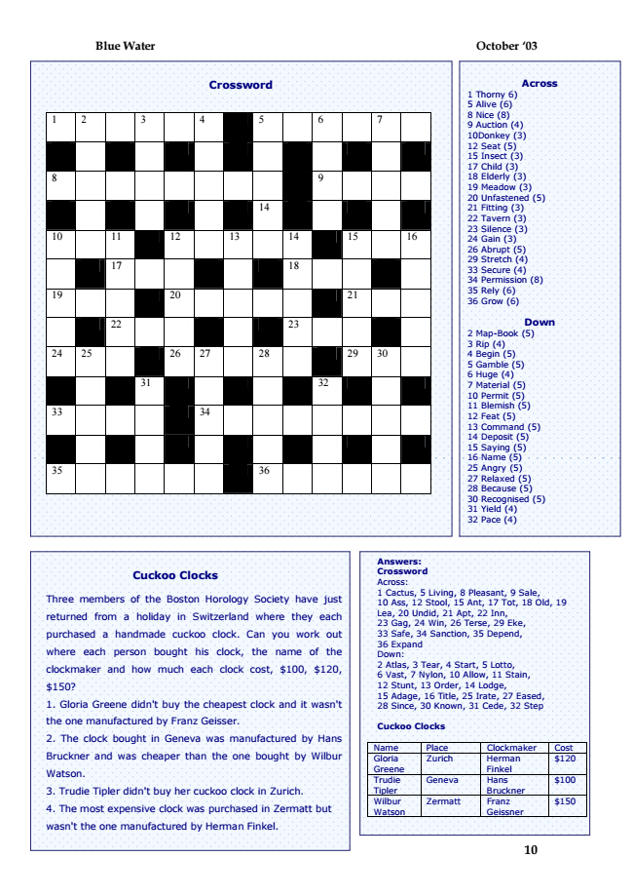

**Blue Water October ‘03**

**Crossword**

1 2 3 4 5 6 7

8 9

14

10 11 12 13 14 15 16

17 18

19 20 21

22 23

24 25 26 27 28 29 30

31 32

33 34

35 36

**Cuckoo Clocks**

Three members of the Boston Horology Society have just

returned from a holiday in Switzerland where they each

purchased a handmade cuckoo clock. Can you work out

where each person bought his clock, the name of the

clockmaker and how much each clock cost, $100, $120,

$150?

1. Gloria Greene didn't buy the cheapest clock and it wasn't

the one manufactured by Franz Geisser.

2. The clock bought in Geneva was manufactured by Hans

Bruckner and was cheaper than the one bought by Wilbur

Watson.

3. Trudie Tipler didn't buy her cuckoo clock in Zurich.

4. The most expensive clock was purchased in Zermatt but

wasn't the one manufactured by Herman Finkel.

**10**

Answers: Crossword Across: 1 Cactus, 5 Living, 8 Pleasant, 9 Sale, 10 Ass, 12 Stool, 15 Ant, 17 Tot, 18 Old, 19 Lea, 20 Undid, 21 Apt, 22 Inn, 23 Gag, 24 Win, 26 Terse, 29 Eke, 33 Safe, 34 Sanction, 35 Depend, 36 Expand Down: 2 Atlas, 3 Tear, 4 Start, 5 Lotto, 6 Vast, 7 Nylon, 10 Allow, 11 Stain, 12 Stunt, 13 Order, 14 Lodge, 15 Adage, 16 Title, 25 Irate, 27 Eased, 28 Since, 30 Known, 31 Cede, 32 Step

**Cuckoo Clocks**

Name Place Clockmaker Cost Gloria Greene

Zurich Herman

Finkel

$120

Trudie Tipler

Geneva Hans

Bruckner

$100

Wilbur Watson

Zermatt Franz

Geissner

$150

Across 1 Thorny 6) 5 Alive (6) 8 Nice (8) 9 Auction (4) 10Donkey (3) 12 Seat (5) 15 Insect (3) 17 Child (3) 18 Elderly (3) 19 Meadow (3) 20 Unfastened (5) 21 Fitting (3) 22 Tavern (3) 23 Silence (3) 24 Gain (3) 26 Abrupt (5) 29 Stretch (4) 33 Secure (4) 34 Permission (8) 35 Rely (6) 36 Grow (6)

Down 2 Map-Book (5) 3 Rip (4) 4 Begin (5) 5 Gamble (5) 6 Huge (4) 7 Material (5) 10 Permit (5) 11 Blemish (5) 12 Feat (5) 13 Command (5) 14 Deposit (5) 15 Saying (5) 16 Name (5) 25 Angry (5) 27 Relaxed (5) 28 Because (5) 30 Recognised (5) 31 Yield (4) 32 Pace (4)