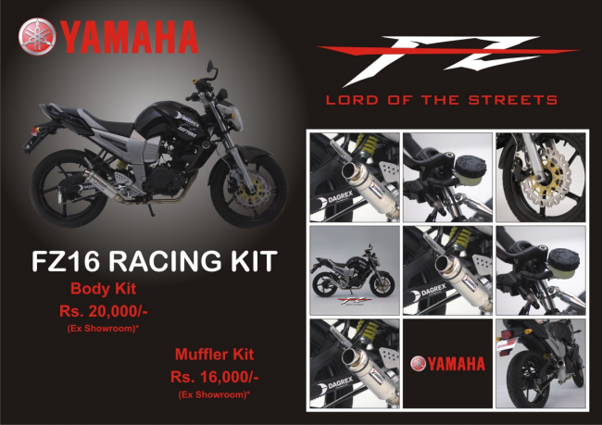

**که کصر**

S S S S S S S S S S S S S S S S S S S S S S S S S S S

**FZ16 RACING KIT**

Body Kit Rs. 20,000/

Ex Showroom)"

|er

Rs. 16,000/

Ex Showroom)

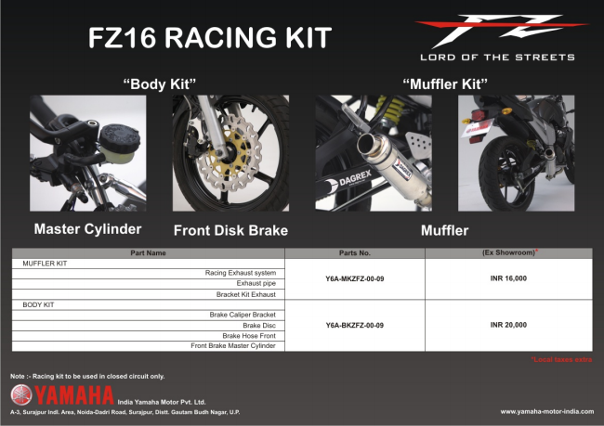

MLJFFLEF KIT

BODY KIT

**Part Name**

Racing Exhaust system Exhaust pipe

Bracket Kit Exhaust

Brake Caliper Bracket

Brak E DISC

Brak E HĽSE Ffrynt Front Brake Master Cylinder

**Parts No.**

**YБА-МКулРум-00-09**

**Y5A-EKZFZ-00-09**

**(Ex Showroom**

**INR 16,000**

**INR 20,000**