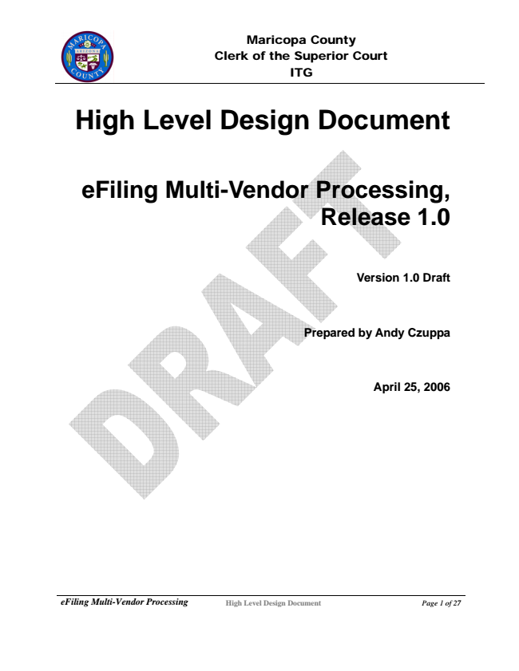

Maricopa County Clerk of the Superior Court ITG

**High Level Design Document**

**eFiling Multi-Vendor Processing, Release 1.0**

**Version 1.0 Draft**

**Prepared by Andy Czuppa**

**April 25, 2006**

***eFiling Multi-Vendor Processing***

**High Level Design Document Page 1 of 27**

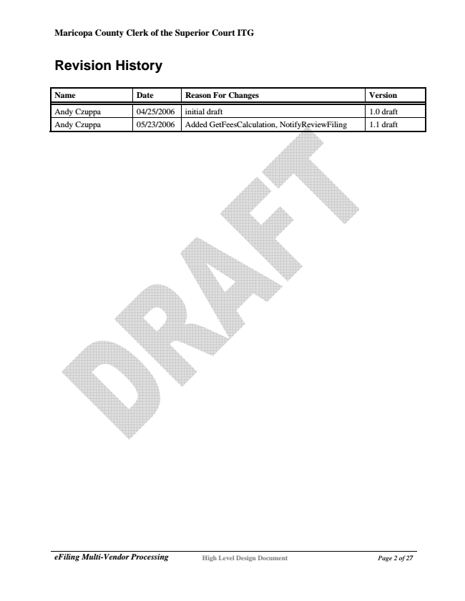

**Maricopa County Clerk of the Superior Court ITG**

**Revision History**

**Name Date Reason For Changes Version**

Andy Czuppa 04/25/2006 initial draft 1.0 draft Andy Czuppa 05/23/2006 Added GetFeesCalculation, NotifyReviewFiling 1.1 draft

***eFiling Multi-Vendor Processing***

**High Level Design Document Page 2 of 27**

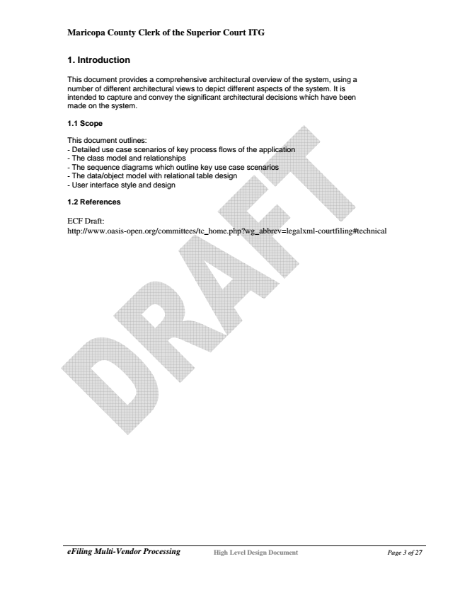

**Maricopa County Clerk of the Superior Court ITG**

**1. Introduction**

This document provides a comprehensive architectural overview of the system, using a number of different architectural views to depict different aspects of the system. It is intended to capture and convey the significant architectural decisions which have been made on the system.

**1.1 Scope**

This document outlines: - Detailed use case scenarios of key process flows of the application - The class model and relationships - The sequence diagrams which outline key use case scenarios - The data/object model with relational table design - User interface style and design

**1.2 References**

ECF Draft: http://www.oasis-open.org/committees/tc_home.php?wg_abbrev=legalxml-courtfiling#technical

***eFiling Multi-Vendor Processing***

**High Level Design Document Page 3 of 27**

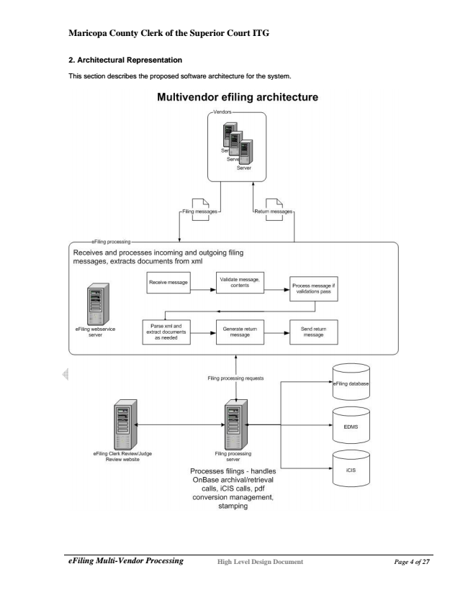

**Maricopa County Clerk of the Superior Court ITG**

**2. Architectural Representation**

This section describes the proposed software architecture for the system.

***eFiling Multi-Vendor Processing***

**High Level Design Document Page 4 of 27**

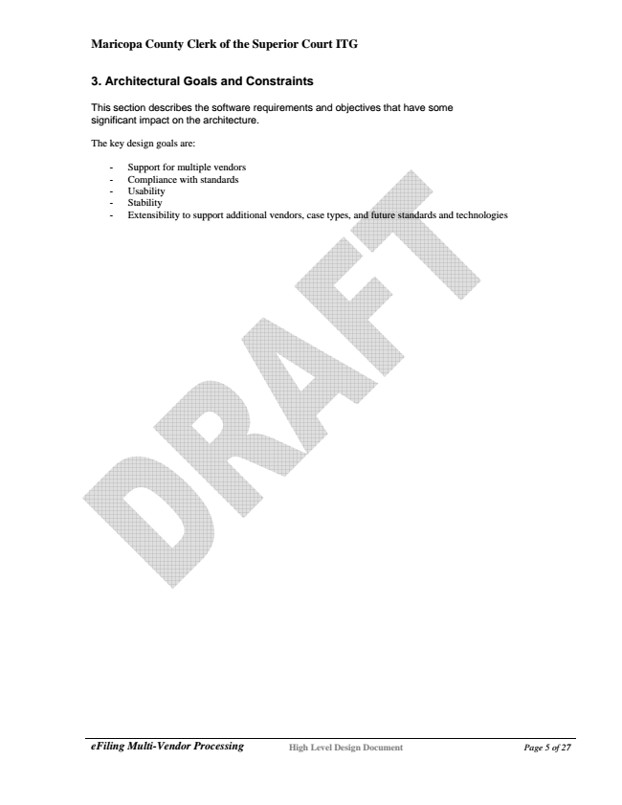

**Maricopa County Clerk of the Superior Court ITG**

**3. Architectural Goals and Constraints**

This section describes the software requirements and objectives that have some significant impact on the architecture.

The key design goals are:

- Support for multiple vendors - Compliance with standards - Usability - Stability - Extensibility to support additional vendors, case types, and future standards and technologies

***eFiling Multi-Vendor Processing***

**High Level Design Document Page 5 of 27**

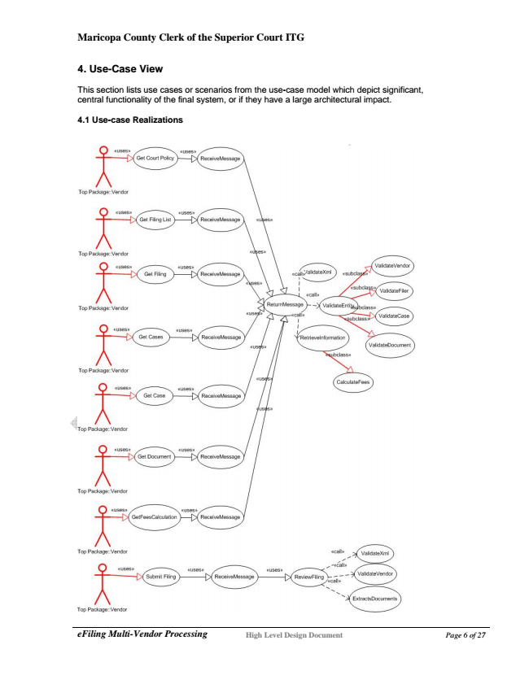

**Maricopa County Clerk of the Superior Court ITG**

**4. Use-Case View**

This section lists use cases or scenarios from the use-case model which depict significant, central functionality of the final system, or if they have a large architectural impact.

**4.1 Use-case Realizations**

***eFiling Multi-Vendor Processing***

**High Level Design Document Page 6 of 27**

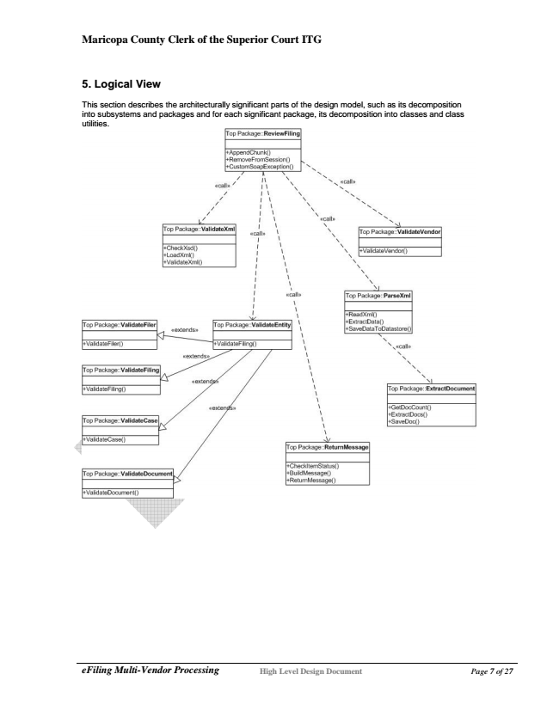

**Maricopa County Clerk of the Superior Court ITG**

**5. Logical View**

This section describes the architecturally significant parts of the design model, such as its decomposition into subsystems and packages and for each significant package, its decomposition into classes and class utilities.

***eFiling Multi-Vendor Processing***

**High Level Design Document Page 7 of 27**

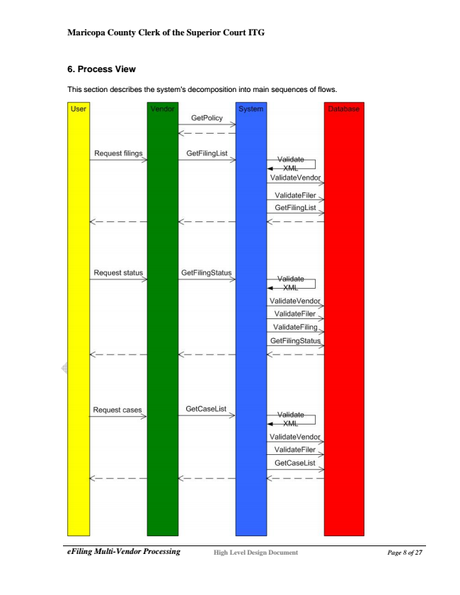

**Maricopa County Clerk of the Superior Court ITG**

**6. Process View**

This section describes the system's decomposition into main sequences of flows.

***eFiling Multi-Vendor Processing***

**High Level Design Document Page 8 of 27**

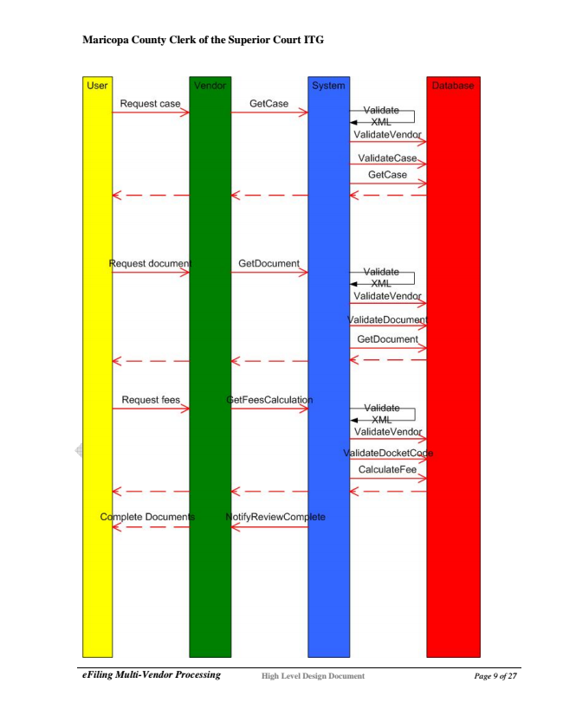

**Maricopa County Clerk of the Superior Court ITG**

***eFiling Multi-Vendor Processing***

**High Level Design Document Page 9 of 27**

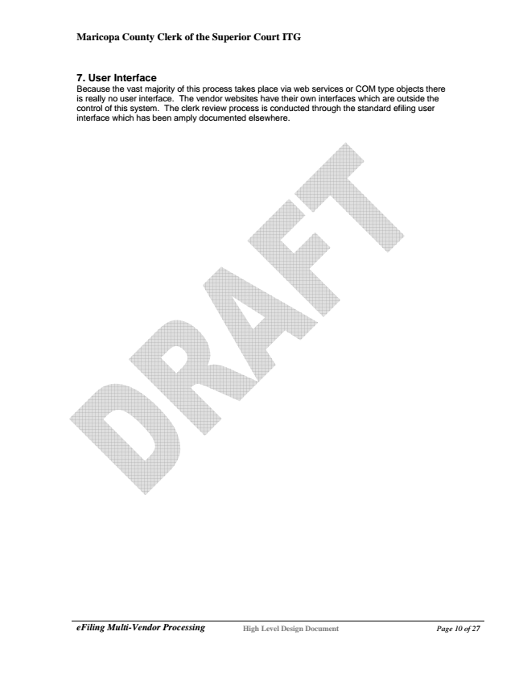

**Maricopa County Clerk of the Superior Court ITG**

7. User Interface Because the vast majority of this process takes place via web services or COM type objects there is really no user interface. The vendor websites have their own interfaces which are outside the control of this system. The clerk review process is conducted through the standard efiling user interface which has been amply documented elsewhere.

***eFiling Multi-Vendor Processing***

**High Level Design Document Page 10 of 27**