

**GridMix**

**Table of contents**

1 Overview............................................................................................................................2 2 Usage..................................................................................................................................2 3 General Configuration Parameters.....................................................................................3 4 Job Types........................................................................................................................... 5 5 Job Submission Policies.....................................................................................................6 6 Emulating Users and Queues............................................................................................. 8 7 Emulating Distributed Cache Load..................................................................................10 8 Configuration of Simulated Jobs..................................................................................... 10 9 Emulating Compression/Decompression.........................................................................10 10 Emulating High-Ram jobs..............................................................................................11 11 Emulating resource usages............................................................................................. 12 12 Simplifying Assumptions............................................................................................... 13 13 Appendix........................................................................................................................ 13

*Copyright © 2008 The Apache Software Foundation. All rights reserved.*

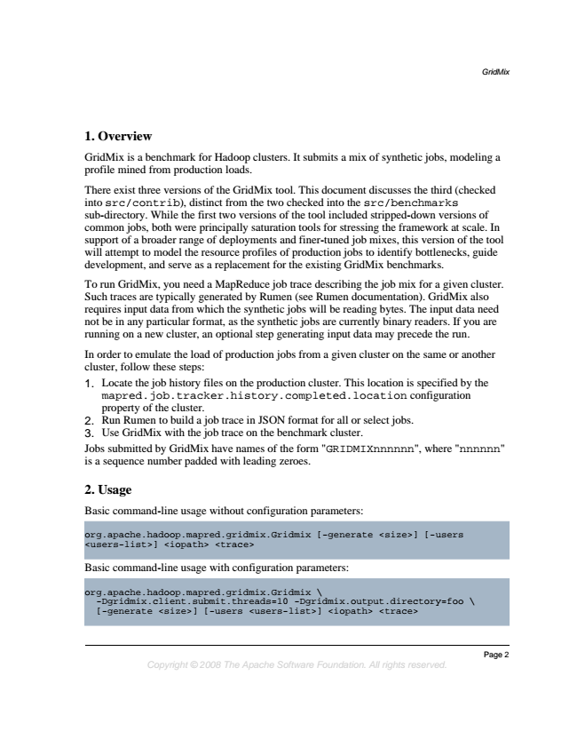

*GridMix*

**1. Overview**

GridMix is a benchmark for Hadoop clusters. It submits a mix of synthetic jobs, modeling a profile mined from production loads.

There exist three versions of the GridMix tool. This document discusses the third (checked into src/contrib), distinct from the two checked into the src/benchmarks sub-directory. While the first two versions of the tool included stripped-down versions of common jobs, both were principally saturation tools for stressing the framework at scale. In support of a broader range of deployments and finer-tuned job mixes, this version of the tool will attempt to model the resource profiles of production jobs to identify bottlenecks, guide development, and serve as a replacement for the existing GridMix benchmarks.

To run GridMix, you need a MapReduce job trace describing the job mix for a given cluster. Such traces are typically generated by Rumen (see Rumen documentation). GridMix also requires input data from which the synthetic jobs will be reading bytes. The input data need not be in any particular format, as the synthetic jobs are currently binary readers. If you are running on a new cluster, an optional step generating input data may precede the run.

In order to emulate the load of production jobs from a given cluster on the same or another cluster, follow these steps: 1. Locate the job history files on the production cluster. This location is specified by the mapred.job.tracker.history.completed.location configuration property of the cluster. 2. Run Rumen to build a job trace in JSON format for all or select jobs. 3. Use GridMix with the job trace on the benchmark cluster. Jobs submitted by GridMix have names of the form "GRIDMIXnnnnnn", where "nnnnnn" is a sequence number padded with leading zeroes.

**2. Usage**

Basic command-line usage without configuration parameters:

org.apache.hadoop.mapred.gridmix.Gridmix <users-list>] <iopath> <trace>

[-generate <size>] [-users

Basic command-line usage with configuration parameters:

org.apache.hadoop.mapred.gridmix.Gridmix -Dgridmix.client.submit.threads=10 [-generate <size>] [-users <users-list>] -Dgridmix.output.directory=foo \

<iopath> <trace>

\

*Page 2 Copyright © 2008 The Apache Software Foundation. All rights reserved.*

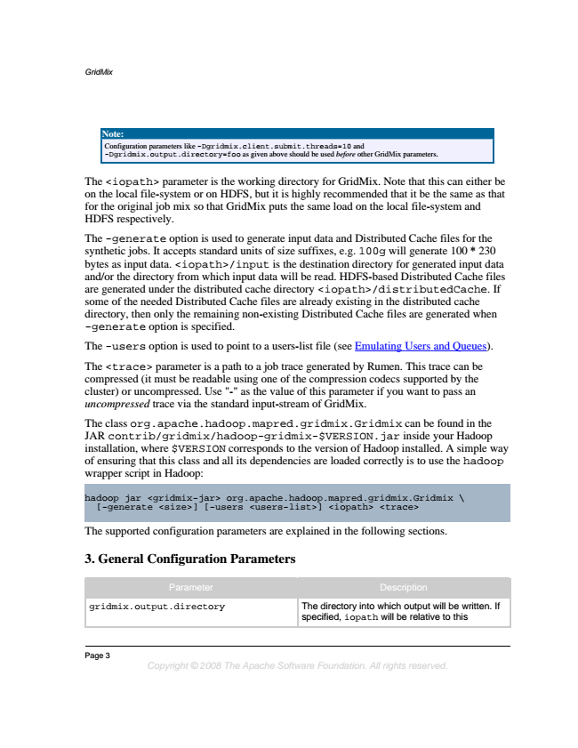

*GridMix*

**Note:**

Configuration parameters like -Dgridmix.client.submit.threads=10 and -Dgridmix.output.directory=foo as given above should be used before other GridMix parameters.

The <iopath> parameter is the working directory for GridMix. Note that this can either be on the local file-system or on HDFS, but it is highly recommended that it be the same as that for the original job mix so that GridMix puts the same load on the local file-system and HDFS respectively.

The -generate option is used to generate input data and Distributed Cache files for the synthetic jobs. It accepts standard units of size suffixes, e.g. 100g will generate 100 * 230 bytes as input data. <iopath>/input is the destination directory for generated input data and/or the directory from which input data will be read. HDFS-based Distributed Cache files are generated under the distributed cache directory <iopath>/distributedCache. If some of the needed Distributed Cache files are already existing in the distributed cache directory, then only the remaining non-existing Distributed Cache files are generated when -generate option is specified.

The -users option is used to point to a users-list file (see Emulating Users and Queues).

The <trace> parameter is a path to a job trace generated by Rumen. This trace can be compressed (it must be readable using one of the compression codecs supported by the cluster) or uncompressed. Use "-" as the value of this parameter if you want to pass an uncompressed trace via the standard input-stream of GridMix.

The class org.apache.hadoop.mapred.gridmix.Gridmix can be found in the JAR contrib/gridmix/hadoop-gridmix-$VERSION.jar inside your Hadoop installation, where $VERSION corresponds to the version of Hadoop installed. A simple way of ensuring that this class and all its dependencies are loaded correctly is to use the hadoop wrapper script in Hadoop:

hadoop [-generate jar <gridmix-jar> <size>] [-users org.apache.hadoop.mapred.gridmix.Gridmix <users-list>] <iopath> <trace>

\

The supported configuration parameters are explained in the following sections.

**3. General Configuration Parameters**

Parameter Description

gridmix.output.directory The directory into which output will be written. If

specified, iopath will be relative to this

Page 3

*Copyright © 2008 The Apache Software Foundation. All rights reserved.*

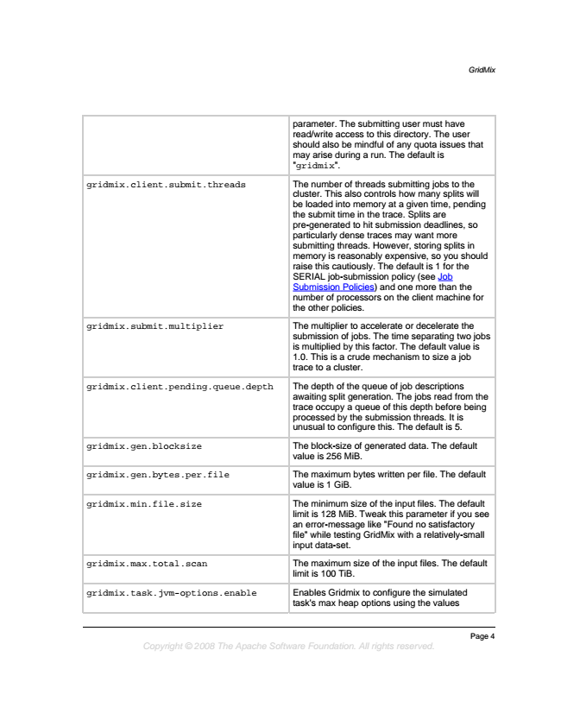

*GridMix*

parameter. The submitting user must have read/write access to this directory. The user should also be mindful of any quota issues that may arise during a run. The default is "gridmix".

gridmix.client.submit.threads The number of threads submitting jobs to the

cluster. This also controls how many splits will be loaded into memory at a given time, pending the submit time in the trace. Splits are pre-generated to hit submission deadlines, so particularly dense traces may want more submitting threads. However, storing splits in memory is reasonably expensive, so you should raise this cautiously. The default is 1 for the SERIAL job-submission policy (see Job Submission Policies) and one more than the number of processors on the client machine for the other policies.

gridmix.submit.multiplier The multiplier to accelerate or decelerate the

submission of jobs. The time separating two jobs is multiplied by this factor. The default value is 1.0. This is a crude mechanism to size a job trace to a cluster.

gridmix.client.pending.queue.depth The depth of the queue of job descriptions

awaiting split generation. The jobs read from the trace occupy a queue of this depth before being processed by the submission threads. It is unusual to configure this. The default is 5.

gridmix.gen.blocksize The block-size of generated data. The default

value is 256 MiB.

gridmix.gen.bytes.per.file The maximum bytes written per file. The default

value is 1 GiB.

gridmix.min.file.size The minimum size of the input files. The default

limit is 128 MiB. Tweak this parameter if you see an error-message like "Found no satisfactory file" while testing GridMix with a relatively-small input data-set.

gridmix.max.total.scan The maximum size of the input files. The default

limit is 100 TiB.

gridmix.task.jvm-options.enable Enables Gridmix to configure the simulated

task's max heap options using the values

*Page 4 Copyright © 2008 The Apache Software Foundation. All rights reserved.*

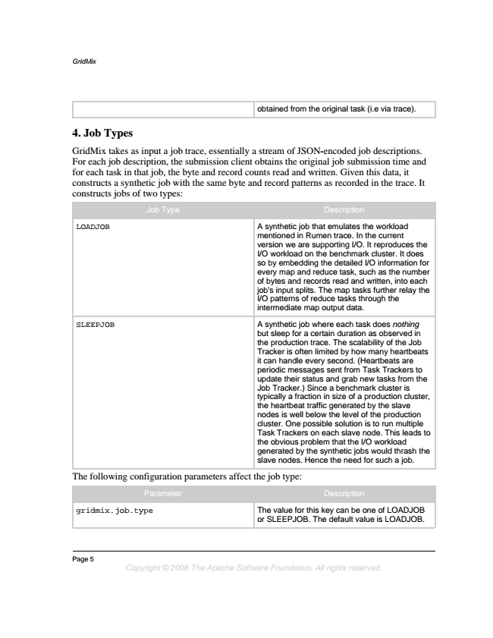

*GridMix*

obtained from the original task (i.e via trace).

**4. Job Types**

GridMix takes as input a job trace, essentially a stream of JSON-encoded job descriptions. For each job description, the submission client obtains the original job submission time and for each task in that job, the byte and record counts read and written. Given this data, it constructs a synthetic job with the same byte and record patterns as recorded in the trace. It constructs jobs of two types:

Job Type Description

LOADJOB A synthetic job that emulates the workload

mentioned in Rumen trace. In the current version we are supporting I/O. It reproduces the I/O workload on the benchmark cluster. It does so by embedding the detailed I/O information for every map and reduce task, such as the number of bytes and records read and written, into each job's input splits. The map tasks further relay the I/O patterns of reduce tasks through the intermediate map output data.

SLEEPJOB A synthetic job where each task does nothing

but sleep for a certain duration as observed in the production trace. The scalability of the Job Tracker is often limited by how many heartbeats it can handle every second. (Heartbeats are periodic messages sent from Task Trackers to update their status and grab new tasks from the Job Tracker.) Since a benchmark cluster is typically a fraction in size of a production cluster, the heartbeat traffic generated by the slave nodes is well below the level of the production cluster. One possible solution is to run multiple Task Trackers on each slave node. This leads to the obvious problem that the I/O workload generated by the synthetic jobs would thrash the slave nodes. Hence the need for such a job.

The following configuration parameters affect the job type:

Parameter Description

gridmix.job.type The value for this key can be one of LOADJOB or SLEEPJOB. The default value is LOADJOB.

Page 5

*Copyright © 2008 The Apache Software Foundation. All rights reserved.*

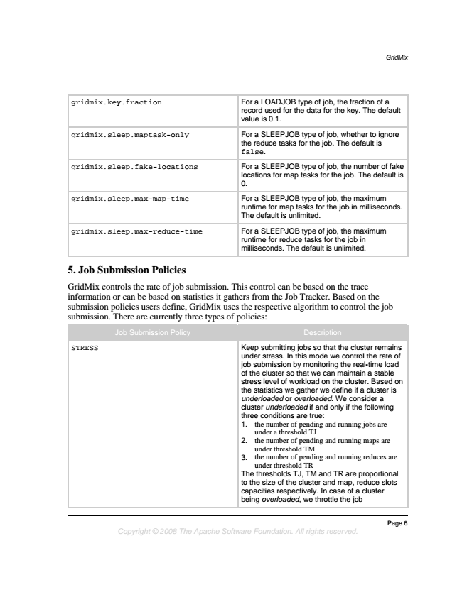

*GridMix*

gridmix.key.fraction For a LOADJOB type of job, the fraction of a

record used for the data for the key. The default value is 0.1.

gridmix.sleep.maptask-only For a SLEEPJOB type of job, whether to ignore

the reduce tasks for the job. The default is false.

gridmix.sleep.fake-locations For a SLEEPJOB type of job, the number of fake locations for map tasks for the job. The default is 0.

gridmix.sleep.max-map-time For a SLEEPJOB type of job, the maximum

runtime for map tasks for the job in milliseconds. The default is unlimited.

gridmix.sleep.max-reduce-time For a SLEEPJOB type of job, the maximum

runtime for reduce tasks for the job in milliseconds. The default is unlimited.

**5. Job Submission Policies**

GridMix controls the rate of job submission. This control can be based on the trace information or can be based on statistics it gathers from the Job Tracker. Based on the submission policies users define, GridMix uses the respective algorithm to control the job submission. There are currently three types of policies:

Job Submission Policy Description

STRESS Keep submitting jobs so that the cluster remains under stress. In this mode we control the rate of job submission by monitoring the real-time load of the cluster so that we can maintain a stable stress level of workload on the cluster. Based on the statistics we gather we define if a cluster is underloaded or overloaded. We consider a cluster underloaded if and only if the following three conditions are true: 1. the number of pending and running jobs are

under a threshold TJ 2. the number of pending and running maps are

under threshold TM 3. the number of pending and running reduces are

under threshold TR The thresholds TJ, TM and TR are proportional to the size of the cluster and map, reduce slots capacities respectively. In case of a cluster being overloaded, we throttle the job

*Page 6 Copyright © 2008 The Apache Software Foundation. All rights reserved.*

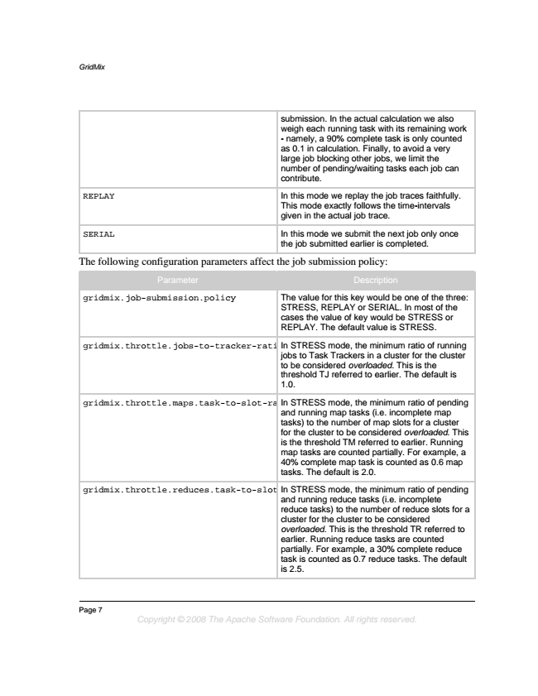

*GridMix*

submission. In the actual calculation we also weigh each running task with its remaining work - namely, a 90% complete task is only counted as 0.1 in calculation. Finally, to avoid a very large job blocking other jobs, we limit the number of pending/waiting tasks each job can contribute.

REPLAY In this mode we replay the job traces faithfully.

This mode exactly follows the time-intervals given in the actual job trace.

SERIAL In this mode we submit the next job only once

the job submitted earlier is completed.

The following configuration parameters affect the job submission policy:

Parameter Description

gridmix.job-submission.policy The value for this key would be one of the three:

STRESS, REPLAY or SERIAL. In most of the cases the value of key would be STRESS or REPLAY. The default value is STRESS.

gridmix.throttle.jobs-to-tracker-ratioIn STRESS mode, the minimum ratio of running jobs to Task Trackers in a cluster for the cluster to be considered overloaded. This is the threshold TJ referred to earlier. The default is 1.0.

gridmix.throttle.maps.task-to-slot-ratio In STRESS mode, the minimum ratio of pending

and running map tasks (i.e. incomplete map tasks) to the number of map slots for a cluster for the cluster to be considered overloaded. This is the threshold TM referred to earlier. Running map tasks are counted partially. For example, a 40% complete map task is counted as 0.6 map tasks. The default is 2.0.

gridmix.throttle.reduces.task-to-slot-ratio In STRESS mode, the minimum ratio of pending

and running reduce tasks (i.e. incomplete reduce tasks) to the number of reduce slots for a cluster for the cluster to be considered overloaded. This is the threshold TR referred to earlier. Running reduce tasks are counted partially. For example, a 30% complete reduce task is counted as 0.7 reduce tasks. The default is 2.5.

Page 7

*Copyright © 2008 The Apache Software Foundation. All rights reserved.*

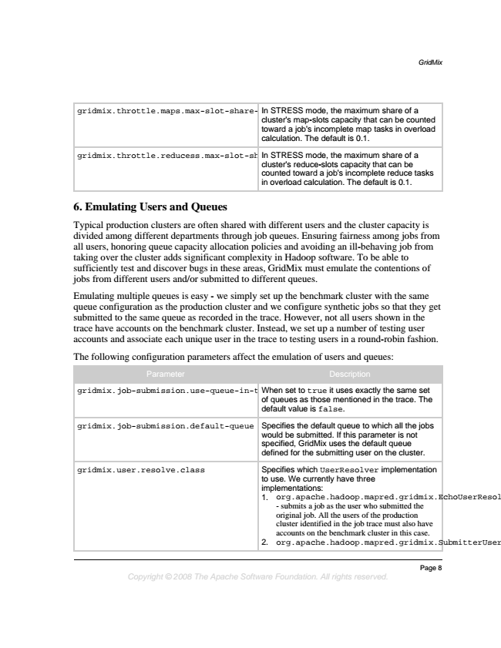

*GridMix*

gridmix.throttle.maps.max-slot-share-per-job In STRESS mode, the maximum share of a

cluster's map-slots capacity that can be counted toward a job's incomplete map tasks in overload calculation. The default is 0.1.

gridmix.throttle.reducess.max-slot-share-per-job In STRESS mode, the maximum share of a

cluster's reduce-slots capacity that can be counted toward a job's incomplete reduce tasks in overload calculation. The default is 0.1.

**6. Emulating Users and Queues**

Typical production clusters are often shared with different users and the cluster capacity is divided among different departments through job queues. Ensuring fairness among jobs from all users, honoring queue capacity allocation policies and avoiding an ill-behaving job from taking over the cluster adds significant complexity in Hadoop software. To be able to sufficiently test and discover bugs in these areas, GridMix must emulate the contentions of jobs from different users and/or submitted to different queues.

Emulating multiple queues is easy - we simply set up the benchmark cluster with the same queue configuration as the production cluster and we configure synthetic jobs so that they get submitted to the same queue as recorded in the trace. However, not all users shown in the trace have accounts on the benchmark cluster. Instead, we set up a number of testing user accounts and associate each unique user in the trace to testing users in a round-robin fashion.

The following configuration parameters affect the emulation of users and queues:

Parameter Description

gridmix.job-submission.use-queue-in-trace When set to true it uses exactly the same set

of queues as those mentioned in the trace. The default value is false.

gridmix.job-submission.default-queue Specifies the default queue to which all the jobs

would be submitted. If this parameter is not specified, GridMix uses the default queue defined for the submitting user on the cluster.

gridmix.user.resolve.class Specifies which UserResolver implementation

to use. We currently have three implementations: 1. org.apache.hadoop.mapred.gridmix.EchoUserResolver

- submits a job as the user who submitted the original job. All the users of the production cluster identified in the job trace must also have accounts on the benchmark cluster in this case. 2. org.apache.hadoop.mapred.gridmix.SubmitterUserResolver

*Page 8 Copyright © 2008 The Apache Software Foundation. All rights reserved.*

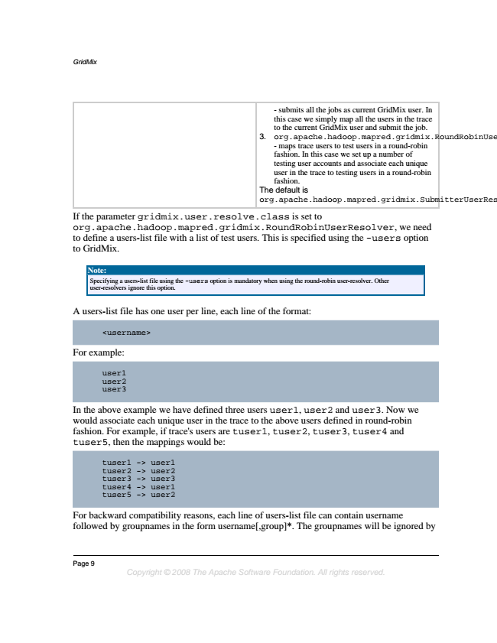

*GridMix*

- submits all the jobs as current GridMix user. In this case we simply map all the users in the trace to the current GridMix user and submit the job. 3. org.apache.hadoop.mapred.gridmix.RoundRobinUserResolver

- maps trace users to test users in a round-robin fashion. In this case we set up a number of testing user accounts and associate each unique user in the trace to testing users in a round-robin fashion. The default is org.apache.hadoop.mapred.gridmix.SubmitterUserResolver.

If the parameter gridmix.user.resolve.class is set to org.apache.hadoop.mapred.gridmix.RoundRobinUserResolver, we need to define a users-list file with a list of test users. This is specified using the -users option to GridMix.

**Note:**

Specifying a users-list file using the -users option is mandatory when using the round-robin user-resolver. Other user-resolvers ignore this option.

A users-list file has one user per line, each line of the format:

<username>

For example:

user1 user2 user3

In the above example we have defined three users user1, user2 and user3. Now we would associate each unique user in the trace to the above users defined in round-robin fashion. For example, if trace's users are tuser1, tuser2, tuser3, tuser4 and tuser5, then the mappings would be:

tuser1 tuser2 tuser3 tuser4 tuser5 -> -> -> -> -> user1 user2 user3 user1 user2

For backward compatibility reasons, each line of users-list file can contain username followed by groupnames in the form username[,group]*. The groupnames will be ignored by

Page 9

*Copyright © 2008 The Apache Software Foundation. All rights reserved.*

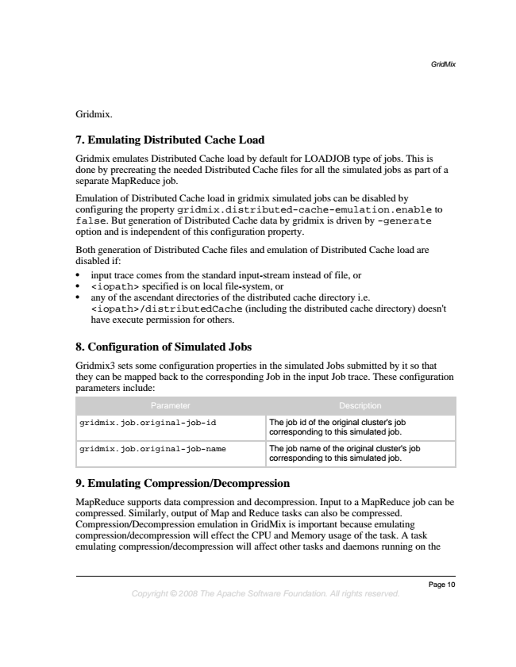

*GridMix*

Gridmix.

**7. Emulating Distributed Cache Load**

Gridmix emulates Distributed Cache load by default for LOADJOB type of jobs. This is done by precreating the needed Distributed Cache files for all the simulated jobs as part of a separate MapReduce job.

Emulation of Distributed Cache load in gridmix simulated jobs can be disabled by configuring the property gridmix.distributed-cache-emulation.enable to false. But generation of Distributed Cache data by gridmix is driven by -generate option and is independent of this configuration property.

Both generation of Distributed Cache files and emulation of Distributed Cache load are disabled if:

• input trace comes from the standard input-stream instead of file, or

• <iopath> specified is on local file-system, or

• any of the ascendant directories of the distributed cache directory i.e. <iopath>/distributedCache (including the distributed cache directory) doesn't have execute permission for others.

**8. Configuration of Simulated Jobs**

Gridmix3 sets some configuration properties in the simulated Jobs submitted by it so that they can be mapped back to the corresponding Job in the input Job trace. These configuration parameters include:

Parameter Description

gridmix.job.original-job-id The job id of the original cluster's job

corresponding to this simulated job.

gridmix.job.original-job-name The job name of the original cluster's job

corresponding to this simulated job.

**9. Emulating Compression/Decompression**

MapReduce supports data compression and decompression. Input to a MapReduce job can be compressed. Similarly, output of Map and Reduce tasks can also be compressed. Compression/Decompression emulation in GridMix is important because emulating compression/decompression will effect the CPU and Memory usage of the task. A task emulating compression/decompression will affect other tasks and daemons running on the

*Page 10 Copyright © 2008 The Apache Software Foundation. All rights reserved.*