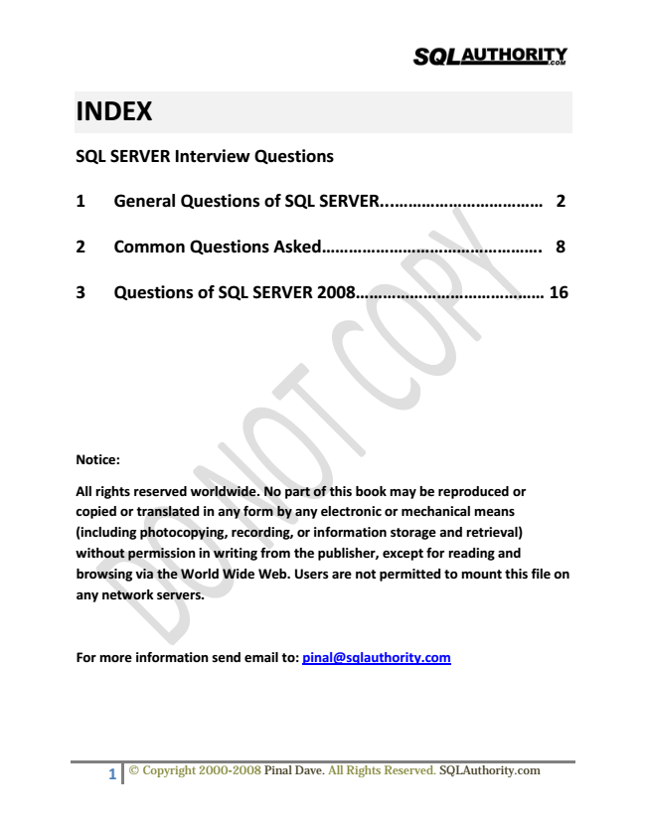

**INDEX**

**SQL SERVER Interview Questions**

**1 General Questions of SQL SERVER.................................... 2**

**2 Common Questions Asked................................................. 8**

**3 Questions of SQL SERVER 2008.......................................... 16**

**Notice:**

**All rights reserved worldwide. No part of this book may be reproduced or copied or translated in any form by any electronic or mechanical means (including photocopying, recording, or information storage and retrieval) without permission in writing from the publisher, except for reading and browsing via the World Wide Web. Users are not permitted to mount this file on any network servers.**

**For more information send email to: pinal@sqlauthority.com**

1 © Copyright 2000-2008 Pinal Dave. All Rights Reserved. SQLAuthority.com

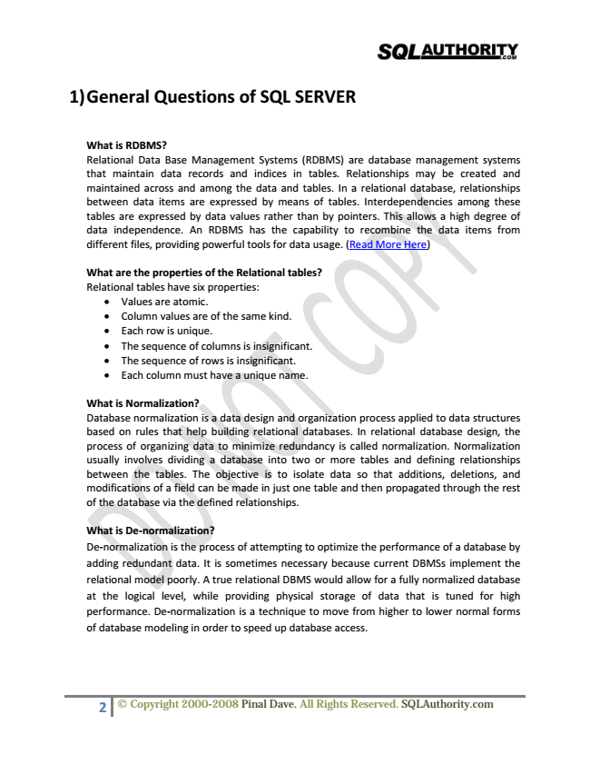

**1) General Questions of SQL SERVER**

What is RDBMS? Relational Data Base Management Systems (RDBMS) are database management systems that maintain data records and indices in tables. Relationships may be created and maintained across and among the data and tables. In a relational database, relationships between data items are expressed by means of tables. Interdependencies among these tables are expressed by data values rather than by pointers. This allows a high degree of data independence. An RDBMS has the capability to recombine the data items from different files, providing powerful tools for data usage. (Read More Here)

**What are the properties of the Relational tables? Relational tables have six properties:**

• Values are atomic.

• Column values are of the same kind.

• Each row is unique.

• The sequence of columns is insignificant.

• The sequence of rows is insignificant.

• Each column must have a unique name.

What is Normalization? Database normalization is a data design and organization process applied to data structures based on rules that help building relational databases. In relational database design, the process of organizing data to minimize redundancy is called normalization. Normalization usually involves dividing a database into two or more tables and defining relationships between the tables. The objective is to isolate data so that additions, deletions, and modifications of a field can be made in just one table and then propagated through the rest of the database via the defined relationships.

What is De-normalization? De-normalization is the process of attempting to optimize the performance of a database by adding redundant data. It is sometimes necessary because current DBMSs implement the relational model poorly. A true relational DBMS would allow for a fully normalized database at the logical level, while providing physical storage of data that is tuned for high performance. De-normalization is a technique to move from higher to lower normal forms of database modeling in order to speed up database access.

2 © Copyright 2000-2008 Pinal Dave. All Rights Reserved. SQLAuthority.com

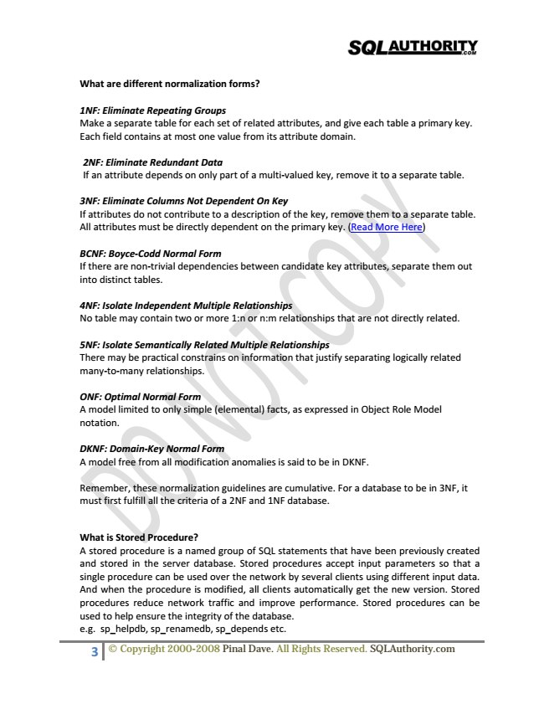

**What are different normalization forms?**

1NF: Eliminate Repeating Groups Make a separate table for each set of related attributes, and give each table a primary key. Each field contains at most one value from its attribute domain.

2NF: Eliminate Redundant Data If an attribute depends on only part of a multi-valued key, remove it to a separate table.

3NF: Eliminate Columns Not Dependent On Key If attributes do not contribute to a description of the key, remove them to a separate table. All attributes must be directly dependent on the primary key. (Read More Here)

BCNF: Boyce-Codd Normal Form If there are non-trivial dependencies between candidate key attributes, separate them out into distinct tables.

4NF: Isolate Independent Multiple Relationships No table may contain two or more 1:n or n:m relationships that are not directly related.

5NF: Isolate Semantically Related Multiple Relationships There may be practical constrains on information that justify separating logically related many-to-many relationships.

ONF: Optimal Normal Form A model limited to only simple (elemental) facts, as expressed in Object Role Model notation.

DKNF: Domain-Key Normal Form A model free from all modification anomalies is said to be in DKNF.

Remember, these normalization guidelines are cumulative. For a database to be in 3NF, it must first fulfill all the criteria of a 2NF and 1NF database.

What is Stored Procedure? A stored procedure is a named group of SQL statements that have been previously created and stored in the server database. Stored procedures accept input parameters so that a single procedure can be used over the network by several clients using different input data. And when the procedure is modified, all clients automatically get the new version. Stored procedures reduce network traffic and improve performance. Stored procedures can be used to help ensure the integrity of the database. e.g. sp_helpdb, sp_renamedb, sp_depends etc.

3 © Copyright 2000-2008 Pinal Dave. All Rights Reserved. SQLAuthority.com

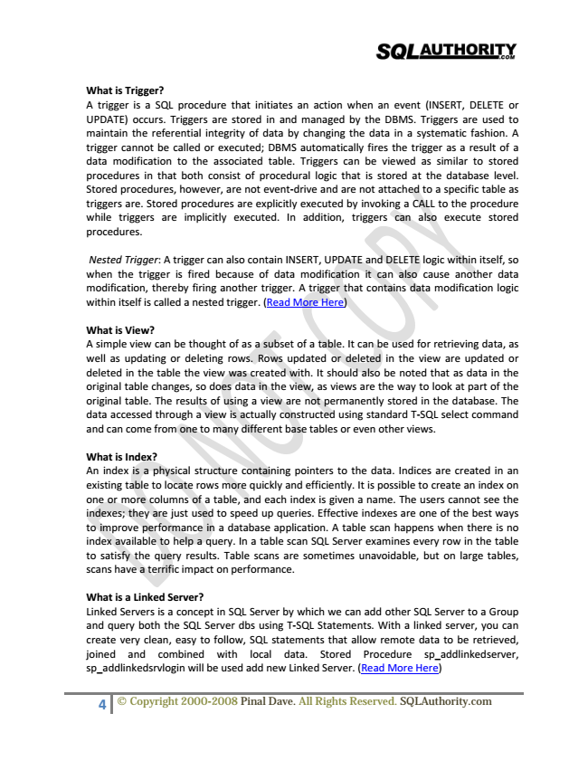

What is Trigger? A trigger is a SQL procedure that initiates an action when an event (INSERT, DELETE or UPDATE) occurs. Triggers are stored in and managed by the DBMS. Triggers are used to maintain the referential integrity of data by changing the data in a systematic fashion. A trigger cannot be called or executed; DBMS automatically fires the trigger as a result of a data modification to the associated table. Triggers can be viewed as similar to stored procedures in that both consist of procedural logic that is stored at the database level. Stored procedures, however, are not event-drive and are not attached to a specific table as triggers are. Stored procedures are explicitly executed by invoking a CALL to the procedure while triggers are implicitly executed. In addition, triggers can also execute stored procedures.

Nested Trigger: A trigger can also contain INSERT, UPDATE and DELETE logic within itself, so when the trigger is fired because of data modification it can also cause another data modification, thereby firing another trigger. A trigger that contains data modification logic within itself is called a nested trigger. (Read More Here)

What is View? A simple view can be thought of as a subset of a table. It can be used for retrieving data, as well as updating or deleting rows. Rows updated or deleted in the view are updated or deleted in the table the view was created with. It should also be noted that as data in the original table changes, so does data in the view, as views are the way to look at part of the original table. The results of using a view are not permanently stored in the database. The data accessed through a view is actually constructed using standard T-SQL select command and can come from one to many different base tables or even other views.

What is Index? An index is a physical structure containing pointers to the data. Indices are created in an existing table to locate rows more quickly and efficiently. It is possible to create an index on one or more columns of a table, and each index is given a name. The users cannot see the indexes; they are just used to speed up queries. Effective indexes are one of the best ways to improve performance in a database application. A table scan happens when there is no index available to help a query. In a table scan SQL Server examines every row in the table to satisfy the query results. Table scans are sometimes unavoidable, but on large tables, scans have a terrific impact on performance.

What is a Linked Server? Linked Servers is a concept in SQL Server by which we can add other SQL Server to a Group and query both the SQL Server dbs using T-SQL Statements. With a linked server, you can create very clean, easy to follow, SQL statements that allow remote data to be retrieved, joined and combined with local data. Stored Procedure sp_addlinkedserver, sp_addlinkedsrvlogin will be used add new Linked Server. (Read More Here)

4 © Copyright 2000-2008 Pinal Dave. All Rights Reserved. SQLAuthority.com

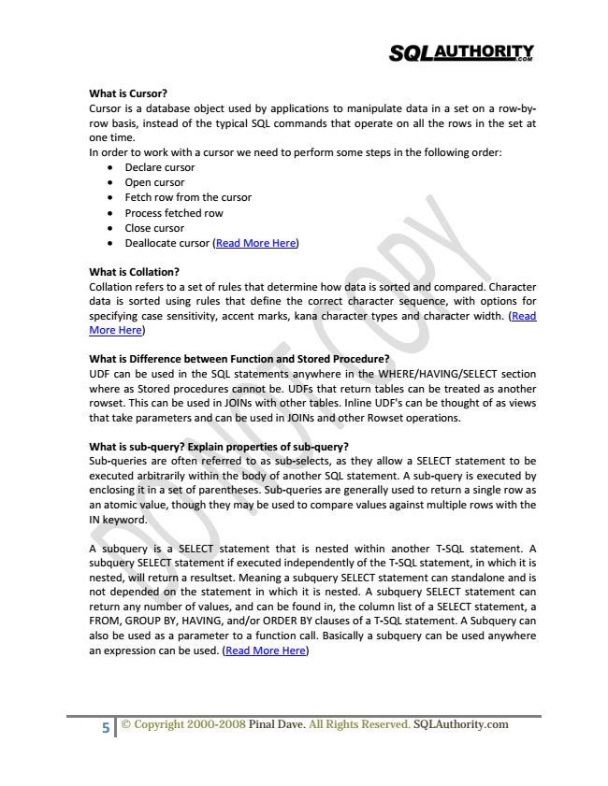

What is Cursor? Cursor is a database object used by applications to manipulate data in a set on a row-by- row basis, instead of the typical SQL commands that operate on all the rows in the set at one time. In order to work with a cursor we need to perform some steps in the following order:

• Declare cursor

• Open cursor

• Fetch row from the cursor

• Process fetched row

• Close cursor

• Deallocate cursor (Read More Here)

What is Collation? Collation refers to a set of rules that determine how data is sorted and compared. Character data is sorted using rules that define the correct character sequence, with options for specifying case sensitivity, accent marks, kana character types and character width. (Read More Here)

What is Difference between Function and Stored Procedure? UDF can be used in the SQL statements anywhere in the WHERE/HAVING/SELECT section where as Stored procedures cannot be. UDFs that return tables can be treated as another rowset. This can be used in JOINs with other tables. Inline UDF's can be thought of as views that take parameters and can be used in JOINs and other Rowset operations.

What is sub-query? Explain properties of sub-query? Sub-queries are often referred to as sub-selects, as they allow a SELECT statement to be executed arbitrarily within the body of another SQL statement. A sub-query is executed by enclosing it in a set of parentheses. Sub-queries are generally used to return a single row as an atomic value, though they may be used to compare values against multiple rows with the IN keyword.

A subquery is a SELECT statement that is nested within another T-SQL statement. A subquery SELECT statement if executed independently of the T-SQL statement, in which it is nested, will return a resultset. Meaning a subquery SELECT statement can standalone and is not depended on the statement in which it is nested. A subquery SELECT statement can return any number of values, and can be found in, the column list of a SELECT statement, a FROM, GROUP BY, HAVING, and/or ORDER BY clauses of a T-SQL statement. A Subquery can also be used as a parameter to a function call. Basically a subquery can be used anywhere an expression can be used. (Read More Here)

5 © Copyright 2000-2008 Pinal Dave. All Rights Reserved. SQLAuthority.com

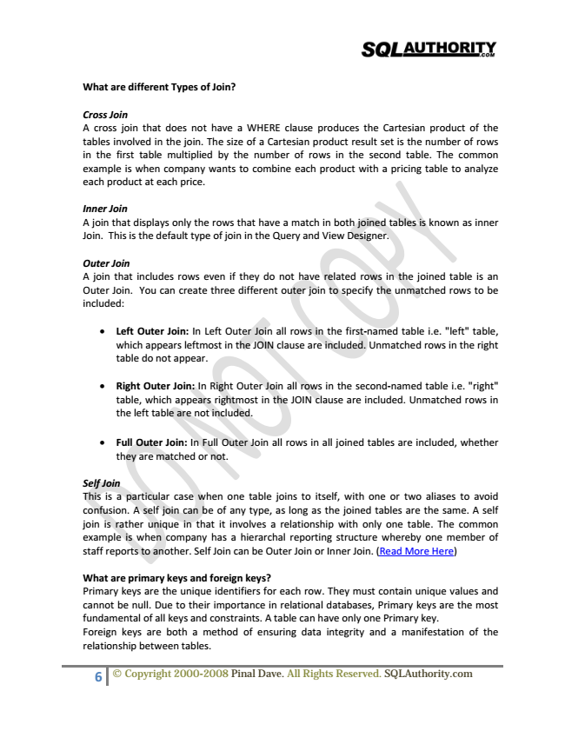

**What are different Types of Join?**

Cross Join A cross join that does not have a WHERE clause produces the Cartesian product of the tables involved in the join. The size of a Cartesian product result set is the number of rows in the first table multiplied by the number of rows in the second table. The common example is when company wants to combine each product with a pricing table to analyze each product at each price.

Inner Join A join that displays only the rows that have a match in both joined tables is known as inner Join. This is the default type of join in the Query and View Designer.

Outer Join A join that includes rows even if they do not have related rows in the joined table is an Outer Join. You can create three different outer join to specify the unmatched rows to be included:

• Left Outer Join: In Left Outer Join all rows in the first-named table i.e. "left" table, which appears leftmost in the JOIN clause are included. Unmatched rows in the right table do not appear.

• Right Outer Join: In Right Outer Join all rows in the second-named table i.e. "right" table, which appears rightmost in the JOIN clause are included. Unmatched rows in the left table are not included.

• Full Outer Join: In Full Outer Join all rows in all joined tables are included, whether they are matched or not.

Self Join This is a particular case when one table joins to itself, with one or two aliases to avoid confusion. A self join can be of any type, as long as the joined tables are the same. A self join is rather unique in that it involves a relationship with only one table. The common example is when company has a hierarchal reporting structure whereby one member of staff reports to another. Self Join can be Outer Join or Inner Join. (Read More Here)

What are primary keys and foreign keys? Primary keys are the unique identifiers for each row. They must contain unique values and cannot be null. Due to their importance in relational databases, Primary keys are the most fundamental of all keys and constraints. A table can have only one Primary key. Foreign keys are both a method of ensuring data integrity and a manifestation of the relationship between tables.

6 © Copyright 2000-2008 Pinal Dave. All Rights Reserved. SQLAuthority.com

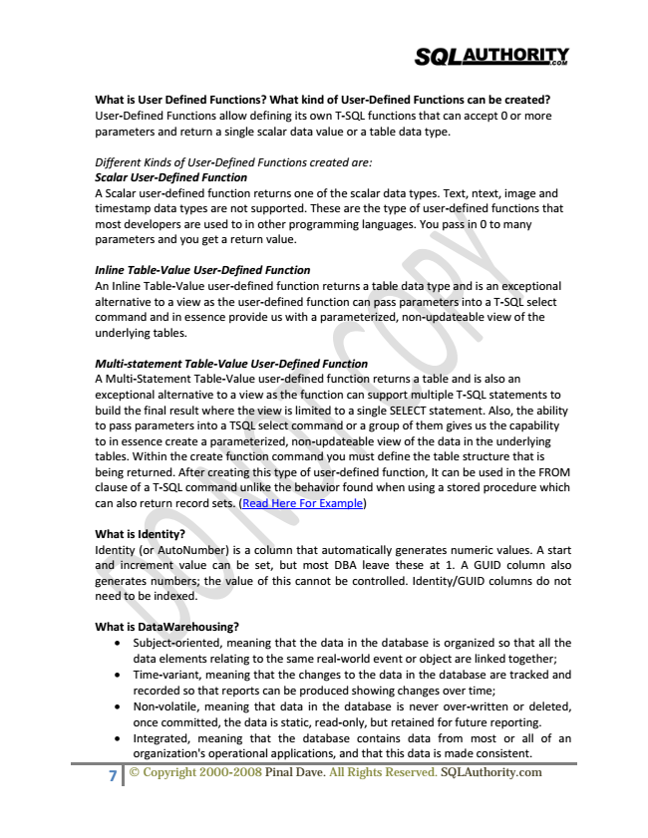

What is User Defined Functions? What kind of User-Defined Functions can be created? User-Defined Functions allow defining its own T-SQL functions that can accept 0 or more parameters and return a single scalar data value or a table data type.

Different Kinds of User-Defined Functions created are: Scalar User-Defined Function A Scalar user-defined function returns one of the scalar data types. Text, ntext, image and timestamp data types are not supported. These are the type of user-defined functions that most developers are used to in other programming languages. You pass in 0 to many parameters and you get a return value.

Inline Table-Value User-Defined Function An Inline Table-Value user-defined function returns a table data type and is an exceptional alternative to a view as the user-defined function can pass parameters into a T-SQL select command and in essence provide us with a parameterized, non-updateable view of the underlying tables.

Multi-statement Table-Value User-Defined Function A Multi-Statement Table-Value user-defined function returns a table and is also an exceptional alternative to a view as the function can support multiple T-SQL statements to build the final result where the view is limited to a single SELECT statement. Also, the ability to pass parameters into a TSQL select command or a group of them gives us the capability to in essence create a parameterized, non-updateable view of the data in the underlying tables. Within the create function command you must define the table structure that is being returned. After creating this type of user-defined function, It can be used in the FROM clause of a T-SQL command unlike the behavior found when using a stored procedure which can also return record sets. (Read Here For Example)

What is Identity? Identity (or AutoNumber) is a column that automatically generates numeric values. A start and increment value can be set, but most DBA leave these at 1. A GUID column also generates numbers; the value of this cannot be controlled. Identity/GUID columns do not need to be indexed.

**What is DataWarehousing?**

• Subject-oriented, meaning that the data in the database is organized so that all the data elements relating to the same real-world event or object are linked together;

• Time-variant, meaning that the changes to the data in the database are tracked and recorded so that reports can be produced showing changes over time;

• Non-volatile, meaning that data in the database is never over-written or deleted, once committed, the data is static, read-only, but retained for future reporting.

• Integrated, meaning that the database contains data from most or all of an organization's operational applications, and that this data is made consistent.

7 © Copyright 2000-2008 Pinal Dave. All Rights Reserved. SQLAuthority.com

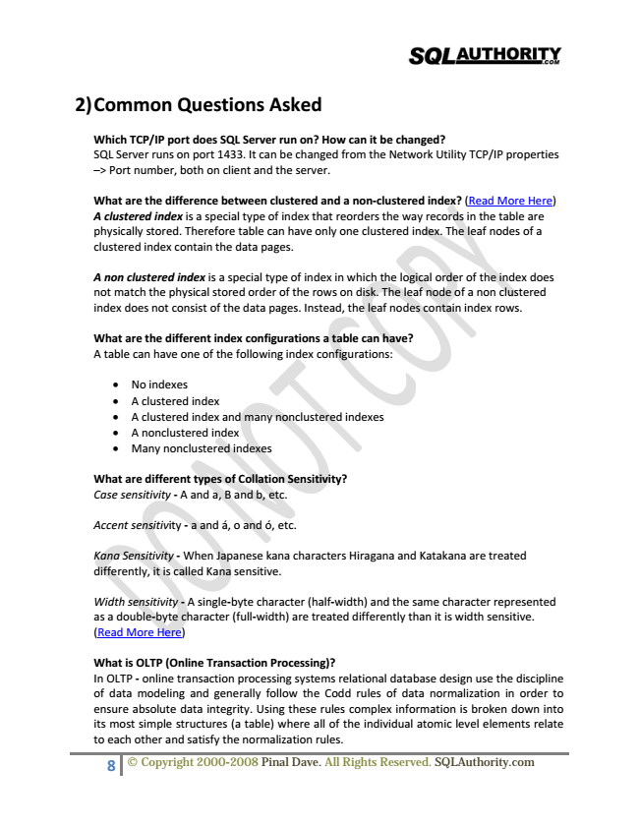

**2) Common Questions Asked**

Which TCP/IP port does SQL Server run on? How can it be changed? SQL Server runs on port 1433. It can be changed from the Network Utility TCP/IP properties –> Port number, both on client and the server.

What are the difference between clustered and a non-clustered index? (Read More Here) A clustered index is a special type of index that reorders the way records in the table are physically stored. Therefore table can have only one clustered index. The leaf nodes of a clustered index contain the data pages.

A non clustered index is a special type of index in which the logical order of the index does not match the physical stored order of the rows on disk. The leaf node of a non clustered index does not consist of the data pages. Instead, the leaf nodes contain index rows.

**What are the different index configurations a table can have? A table can have one of the following index configurations:**

• No indexes

• A clustered index

• A clustered index and many nonclustered indexes

• A nonclustered index

• Many nonclustered indexes

**What are different types of Collation Sensitivity? Case sensitivity - A and a, B and b, etc.**

Accent sensitivity - a and á, o and ó, etc.

Kana Sensitivity - When Japanese kana characters Hiragana and Katakana are treated differently, it is called Kana sensitive.

Width sensitivity - A single-byte character (half-width) and the same character represented as a double-byte character (full-width) are treated differently than it is width sensitive. (Read More Here)

What is OLTP (Online Transaction Processing)? In OLTP - online transaction processing systems relational database design use the discipline of data modeling and generally follow the Codd rules of data normalization in order to ensure absolute data integrity. Using these rules complex information is broken down into its most simple structures (a table) where all of the individual atomic level elements relate to each other and satisfy the normalization rules.

8 © Copyright 2000-2008 Pinal Dave. All Rights Reserved. SQLAuthority.com

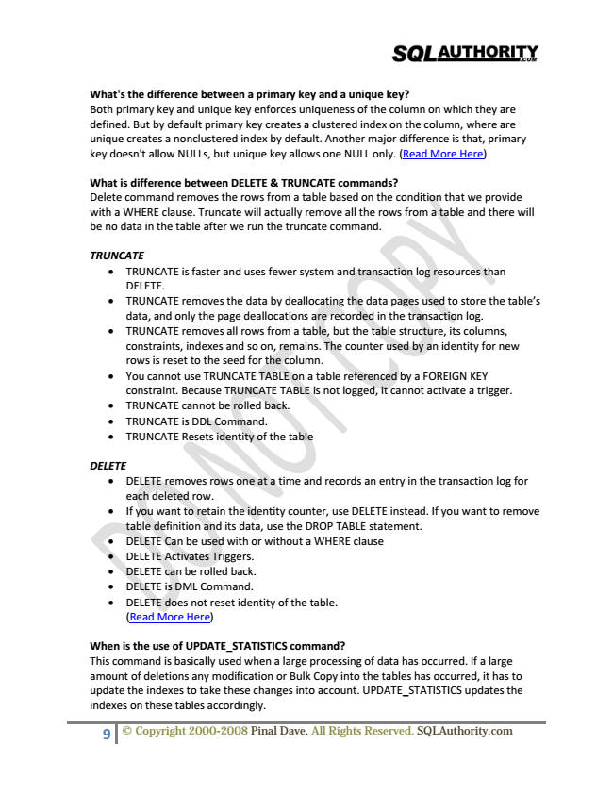

What's the difference between a primary key and a unique key? Both primary key and unique key enforces uniqueness of the column on which they are defined. But by default primary key creates a clustered index on the column, where are unique creates a nonclustered index by default. Another major difference is that, primary key doesn't allow NULLs, but unique key allows one NULL only. (Read More Here)

What is difference between DELETE & TRUNCATE commands? Delete command removes the rows from a table based on the condition that we provide with a WHERE clause. Truncate will actually remove all the rows from a table and there will be no data in the table after we run the truncate command.

***TRUNCATE***

• TRUNCATE is faster and uses fewer system and transaction log resources than DELETE.

• TRUNCATE removes the data by deallocating the data pages used to store the table’s data, and only the page deallocations are recorded in the transaction log.

• TRUNCATE removes all rows from a table, but the table structure, its columns, constraints, indexes and so on, remains. The counter used by an identity for new rows is reset to the seed for the column.

• You cannot use TRUNCATE TABLE on a table referenced by a FOREIGN KEY constraint. Because TRUNCATE TABLE is not logged, it cannot activate a trigger.

• TRUNCATE cannot be rolled back.

• TRUNCATE is DDL Command.

• TRUNCATE Resets identity of the table

***DELETE***

• DELETE removes rows one at a time and records an entry in the transaction log for each deleted row.

• If you want to retain the identity counter, use DELETE instead. If you want to remove table definition and its data, use the DROP TABLE statement.

• DELETE Can be used with or without a WHERE clause

• DELETE Activates Triggers.

• DELETE can be rolled back.

• DELETE is DML Command.

• DELETE does not reset identity of the table. (Read More Here)

When is the use of UPDATE_STATISTICS command? This command is basically used when a large processing of data has occurred. If a large amount of deletions any modification or Bulk Copy into the tables has occurred, it has to update the indexes to take these changes into account. UPDATE_STATISTICS updates the indexes on these tables accordingly.

9 © Copyright 2000-2008 Pinal Dave. All Rights Reserved. SQLAuthority.com

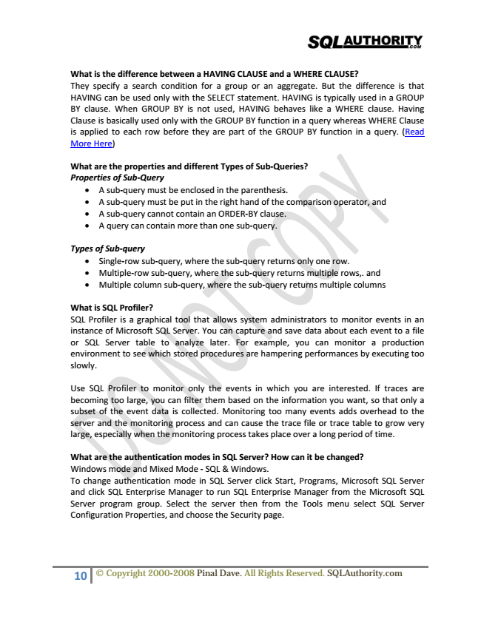

What is the difference between a HAVING CLAUSE and a WHERE CLAUSE? They specify a search condition for a group or an aggregate. But the difference is that HAVING can be used only with the SELECT statement. HAVING is typically used in a GROUP BY clause. When GROUP BY is not used, HAVING behaves like a WHERE clause. Having Clause is basically used only with the GROUP BY function in a query whereas WHERE Clause is applied to each row before they are part of the GROUP BY function in a query. (Read More Here)

**What are the properties and different Types of Sub-Queries? Properties of Sub-Query**

• A sub-query must be enclosed in the parenthesis.

• A sub-query must be put in the right hand of the comparison operator, and

• A sub-query cannot contain an ORDER-BY clause.

• A query can contain more than one sub-query.

***Types of Sub-query***

• Single-row sub-query, where the sub-query returns only one row.

• Multiple-row sub-query, where the sub-query returns multiple rows,. and

• Multiple column sub-query, where the sub-query returns multiple columns

What is SQL Profiler? SQL Profiler is a graphical tool that allows system administrators to monitor events in an instance of Microsoft SQL Server. You can capture and save data about each event to a file or SQL Server table to analyze later. For example, you can monitor a production environment to see which stored procedures are hampering performances by executing too slowly.

Use SQL Profiler to monitor only the events in which you are interested. If traces are becoming too large, you can filter them based on the information you want, so that only a subset of the event data is collected. Monitoring too many events adds overhead to the server and the monitoring process and can cause the trace file or trace table to grow very large, especially when the monitoring process takes place over a long period of time.

What are the authentication modes in SQL Server? How can it be changed? Windows mode and Mixed Mode - SQL & Windows. To change authentication mode in SQL Server click Start, Programs, Microsoft SQL Server and click SQL Enterprise Manager to run SQL Enterprise Manager from the Microsoft SQL Server program group. Select the server then from the Tools menu select SQL Server Configuration Properties, and choose the Security page.

10 © Copyright 2000-2008 Pinal Dave. All Rights Reserved. SQLAuthority.com