**THE EFFECT OF COVID-19 ON AIR POLLUTION IN DELHI   
 USING REGRESSION METHODS**

Ayush Nishad (190215), Ashish (190190), Abhinav Agarwal (190024), Srujith Reddy (190332), Nootana Lakshmi Podilapu (190603), Malla Sri Harsha (190472), Rishi Prakash (190706), Mayank Sarwa (190490), Manish kumar Mina (190481), Rutuj Warungase (190992)

# Introduction

Delhi, a Union Territory that is home to India’s capital, New Delhi, is among the world’s urban agglomerations with the most toxic air. The magnitude of air pollution is massive. It causes devastating impacts on people’s health, the city’s environment, and economic well-being.

On account of the COVID-19 pandemic, the Government of India imposed a complete cross-country lockdown from 24 March 2020 to 31 May 2020. Due to this, all transport services, i.e., road, air, and rail, were suspended with exceptions for essential services, including power generation, transmission, and distribution units, Petrol pumps, LPG, petroleum and gas retail, and storage outlets. Sectors like industrial establishments, construction activities, commercial and hospitality services, etc., were also suspended. It resulted in a 40-50% increase in the Air Quality Index within 4 days of lockdown.

The primary reasons for the rise in pollution in Delhi are industrial emissions, climatic factors such as temperature and wind speed, anthropogenic factors like vehicular traffic, variation in the price of petrol and diesel, burning of agricultural residue in surrounding states, traffic congestion, population density, and industrial activity.

We examine how the lockdown due to COVID-19 affects pollution in Delhi. For this purpose, we have selected three distinct locations in Delhi - Siri Fort, DTU, and Wazirpur. Wazirpur is an industrial area, DTU is residential, and Siri Fort is a residential-cum-commercial area. Our research is mainly focused on the impact of lockdown on air pollution, i.e., effect of anthropogenic activities on pollution in Delhi, therefore; we choose five different pollutants- PM10, PM2.5, Carbon Monoxide (CO), Nitrogen dioxide (NO2), Sulphur dioxide (SO2) which include the significant pollutants arising from anthropogenic activities.

*Sources of Pollutants*: -

**PM2.5:** Mainly from vehicular traffic and grinding operations, wastage burning, industries, construction activities, and road dust

**PM10:** Produced from combustion, motor vehicles, power plants, residential wood burning, forest fires, agricultural burning, and some industrial processes

**SO2:** Emitted from fossil fuel at power plants and other industrial facilities and fuel combustion.

**NO2:** primary sources are vehicular traffic and power plants.

**CO:** produce in the incomplete combustion of carbon-containing fuels, such as gasoline, natural gas, oil, coal, and wood. In the urban areas, its primary source is vehicular emission.

To attribute the changes in pollutant measures to the lockdown/unlocking, we use the Regression Discontinuity (RD) approach. It involves using dummy variables representing lockdown/unlocking and a cut-off, which divides each time series into two groups partitioned by the lockdown/unlocking date.

# Objective

To present a critical yet comprehensive review of the effect of COVID-19 on air pollution in three distinctly polluted areas of Delhi. We analyse the sudden change in pollutant concentrations due to lockdown and unlock, which translates to the human contribution to the air pollution of Delhi.

# Literature Review

Deepti Goel and Sonam Gupta (May 2015) broke down how augmentation of Metro in Delhi diminishes the contamination level as far as NO2, CO, PM2.5. They tracked down that the expansions of DM prompted a 34% decrease in restricted CO.

Muhammad et al. (2020) found a 20–30% diminishing in the surge of NO2 in China, Spain, France, Italy, and the USA due to lockdown.

Chauhan and Singh (2020) saw a diminishing in PM2.5in critical metropolitan networks of the world.

S.K. Mathur and Praveen Kulshrestha (2019), in their spatial investigation of the effect of transportation strategy on contamination in Delhi. Climatic factors (Rainfall, wind speed, temperature, and relative dampness), cost of petroleum derivative, employing of electric CNG vehicle, and enlistment of public and private vehicles may have fundamentally affected the contamination in Delhi.

Sharma et al (2017) examined the marker components, and isotopic investigation of PM2.5 and PM10 tests showed that vehicle exhaust is one of the significant wellsprings of PM2.5 and PM10 at the inspecting site of Delhi.

# Model and Methodology

We study a time series of ordinary least square regression of daily pollutant data at three distinct locations in Delhi for five distinct pollutants across the whole year (2020) and particularly around lockdown and unlock dates to estimate the effect of COVID-19 on the pollution levels. Covid 19 causes sharp discontinuity at lockdown and unlock period due to sudden closing/opening of all major activities, and that is why we use regression discontinuity. One of the RD approach's main virtues is that it can be naturally presented using simple graphs, which greatly enhances its credibility and transparency.

Example of Regression discontinuity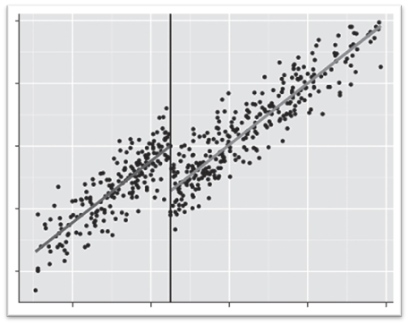

Source: SAGE PUBLICATIONS

The above graph represents discontinuity in some data at a particular cut-off. Similarly, we are estimating the discontinuity in pollutant level around lockdown and unlock period separately. In the case of lockdown, the portion of plot, left to the discontinuity represents data points from 1/1/20 - 23/3/20, and the right part represents data points from 24/3/20 - 31/5/20. Similarly, in unlocking, the left portion represents data points from 24/3/20 - 31/5/20, and the right part represents data points from 1/6/20 - 31/12/20.

The selected five pollutants cover primary pollutants emitted from all these regions. Some contaminants are more specific to some areas and some to others. Hence the regression plot will also tell us which pollutants are majorly responsible for pollution in a particular area.

We have also incorporated controls for weather parameters, fuel prices and dummy variables for festivals like Diwali, and burning of agricultural residue in nearby states. Each regression will estimate the effect of each included controls and dummy on pollutant level.

To estimate the causal effect of the Covid-19 we would ideally have liked to compare the pollutant level in the presence of the lockdown, with the pollutant level that would have been observed if the lockdown had not been there but everything else had remained the same. We build the latter counterfactual by assuming that in the absence of lockdown, pollution at any particular location would have shown a smooth transition over time after accounting for discontinuous changes due to weather conditions or events such as strikes and public holidays.

For each combination of location and pollutant, we plot two regressions, one to estimate discontinuity of pollutants level due to lockdown and another to estimate the same due to unlock. Using the data lying within the period, The regression discontinuity approach is implemented by estimating the following ordinary least squares regression for each period:

***ytl = θ0 + θ1DMt + θ′2xt + θ3P(t) + utl***

*where,*

***ytl*** is the daily pollutant measure  recorded for day *t* in location *l*.

***θ1***measure*s* the proportionate change in pollutant level as a result of lockdown-1 and unlock-1. It is to be interpreted as the immediate localised (at location *l*) effect on pollution that can be attributed to lockdown or unlock.

***DMt*** is the discontinuity dummy for Lockdown/Unlocking: In case of pre-Lockdown-Lockdown regression, it takes the value 1 in lockdown and 0otherwise. In Lockdown-Post Lockdown regression, it takes the value 1 in Unlock period and 0otherwise. Any sudden change in the pollutant level on the regression plot is due to the *DMt*.

***xt***is the vector of covariates and includes the control of relative humidity, rainfall, temperature, and wind speed; control of petrol and diesel prices; dummy variable for burning of agricultural waste; and dummy variable for Diwali.

***P(t)***is a third-order polynomial in time and captures all smooth variations in pollutant levels.

***utl***is the error term**.**

# *We use Regression Discontinuity Design(RDD) since our model satisfies its following assumptions:*

* The specified model is chosen assuming that the actual ***ytl*** vs ***t*** relationship is a polynomial function which gets validated from the obtained adjusted R2 value of the regression outputs.
* Internal validity issue is the degree to which the groups are comparable before the study. If they are comparable, and the only difference between them is the program, post-test differences can be attributed to the program; the test being lockdown in our case. The pollutant concentration before and during the lockdown would have been comparable in the absence of pandemic. We can infer this from previous year data.
* Treatment is assigned on the basis of an observable variable or index which is *time* in our case. Government imposed lockdown at *time* when conditions became critical.
* The cut off value of the index for treatment is arbitrary, and thus days on either side of the cut-off point are identical on average in absence of treatment.

We have used OLS Estimator to find the error term ***utl***.

# *Assumptions involved in using the OLS Estimator are:*

1. **E*ui* = 0** for **i** = 1,2…,n.
2. **E*ui uj* = 0** ;i ≠ j **;** i.e. No autocorrelation.
3. **E*ui2* = 𝝈2** **;** i.e. Homoscedastic variance.
4. Mean value of y actual = mean value of estimated y
5. Error should have a normal distribution.

In the table given below, we have calculated expectation values for random 10 regressions and hence proved that above mentioned conditions holds true.

|  |  |  |  |  |  |  |
| --- | --- | --- | --- | --- | --- | --- |
| **S.No** | **E*ui*** | **E*ui uj*** | **Eui2** | **𝝈2** | **Mean of actual y values** | **Mean of estimated y values** |
| 1 | -0.00411 | -0.00073 | 0.109197 | 0.109180 | 0.759452 | 0.755332 |
| 2 | -0.01908 | -0.00255 | 0.432492 | 0.432128 | 0.983758 | 0.964673 |
| 3 | -0.00070 | -0.00082 | 0.22662 | 0.226628 | 1.042554 | 1.041847 |
| 4 | -0.32152 | -1.03999 | 169.3214 | 169.218 | 40.60322 | 40.2817 |
| 5 | -0.07206 | -1.01656 | 278.9444 | 278.9392 | 34.32084 | 34.24878 |
| 6 | -0.1102 | -0.0206 | 4.858378 | 4.846234 | 7.376376 | 7.266176 |
| 7 | -0.01092 | -0.1272 | 34.75788 | 34.75776 | 14.02766 | 14.01674 |
| 8 | -1.19386 | -7.12514 | 1266.932 | 1265.507 | 87.88691 | 86.69305 |
| 9 | -0.12643 | -7.25936 | 1986.184 | 1986.168 | 80.07741 | 79.95098 |
| 10 | -0.31075 | -0.947 | 151.3539 | 151.2574 | 29.19021 | 29.50096 |

**Frequency distribution of Error random variable (one particular regression)**

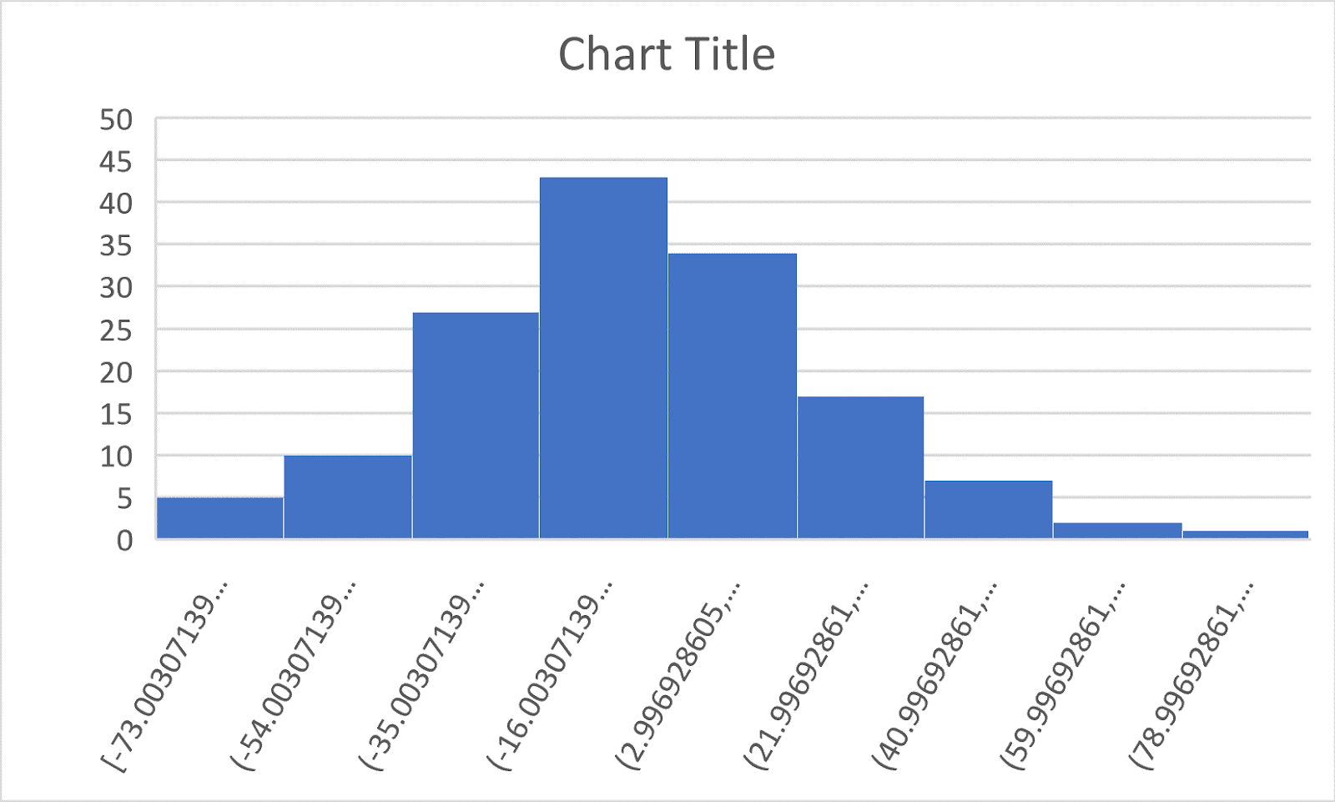

**Normal Approximation for the above Distribution**

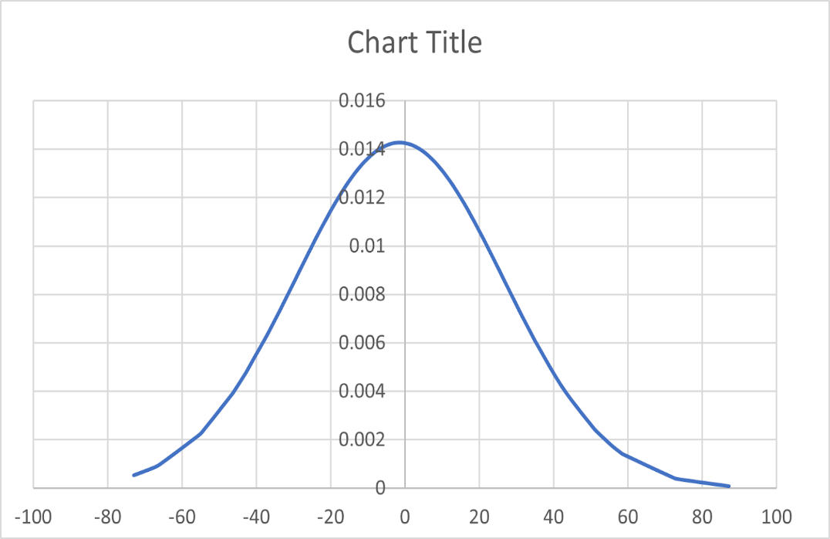

# Data Extraction and processing

For this research, we are using five different pollutants for analysis.

**List of Pollutants**: PM10 (µg/m3), PM2.5 (µg/m3), Carbon Monoxide (CO)(mg/m3), Nitrogen dioxide (NO2) (µg/m3), Sulphur dioxide (SO2) (µg/m3).

We have collected the daily data for different pollutants at DTU, Siri Fort, and Wazirpur from CPCB websites.

Data for daily weather conditions such as temperature, wind speed, rainfall, and relative humidity is collected from CPCB websites.

Daily data of petrol and diesel prices is collected from the website of Indian Oil.

**Time Span:** 1st January to 23rd March (Pre lockdown phase), 24th March to 31st May (lockdown phase), 1st June to 31st December (Unlock phase).

For analysis, we collected daily data of pollutants and all the variables for the whole year of 2020 (Data shown in Appendix-I) for all three stations. Then We divided the data into two parts, first from 1-01-2020 - 31-05-2020 to analyse the effect of Lockdown and second from 24-03-2020 - 31-12-2020 to examine the impact of Unlock for every station and every pollutant. *Since the data after Lockdown will affect our analysis of the lockdown period, we split the whole data into two parts to get the least interference possible.* After that, we import our final data into the code to get the coefficients.

We utilize python libraries NumPy, pandas, SK Learn to solve the regression equation for its control variable and dummy variables coefficients and Microsoft-excel to plot all the graphs. In the SK Learn library, the modules that we have utilized mainly are train test split, Linear Regression, and metrics.

# Missing Data

The data collected from CPCB shows missing data of few pollutants and weather conditions. We have around 8% missing data of Wazirpur, 3% missing data of DTU, and 2.8 % missing data of Siri Fort. We considered ignoring missing data as it will not impact the result; it is less than 10% of total data.

# Results

**Adjusted R square**indicates the proportion of variance in the dependent variable (Y) explained by the independent variable (X). It is a measure of “explained variation.”

For all the 30 regressions, we have found that the adjusted R square value for all of them was between 0.407 to 0.780, which indicates that our model is adequately good. The chosen variables explain a significant variation in pollution level.

**Prob (F-statistic)**is the probability that the null hypothesis in a regression model cannot be rejected, i.e., it indicates the probability that all the coefficients in our regression output are zero.

For all the regressions, the probability of F statistic is very close to zero, some of them being as small as of order -83. It implies that our model’s regression parameters are non-zero and that the regression equation fits the data quite well.

|  |  |  |  |  |  |  |  |  |  |  |  |  |
| --- | --- | --- | --- | --- | --- | --- | --- | --- | --- | --- | --- | --- |
| **REGRESSION STATISTICS** | | | | | | | | | | | | |
| **Stations** | **Parameters** | **Lockdown phase** | | | | | **Unlock Phase** | | | | | |
| ***PM2.5*** | ***PM10*** | ***NO2*** | ***SO2*** | ***CO*** | ***PM2.5*** | ***PM10*** | ***NO2*** | ***SO2*** | ***CO*** |
| **DTU** | **Adjusted R2** | 0.636 | 0.551 | 0.452 | 0.780 | 0.601 | 0.644 | 0.687 | 0.791 | 0.538 | 0.655 |
| **Prob**  **(F-statistic)** | 1.18E-26 | 9.22E-21 | 2.72E-5 | 5.74E-41 | 4.70E-24 | 1.46E-53 | 1.47E-60 | 7.8E-83 | 2.69E-39 | 3.1E-55 |
| **Sirifort** | **Adjusted R2** | 0.709 | 0.632 | 0.702 | 0.407 | 0.597 | 0.635 | 0.687 | 0.596 | 0.701 | 0.636 |
| **Prob**  **(F-statistic)** | 9.03E-34 | 5.93E-27 | 5E-33 | 1.71E-13 | 2.46E-24 | 1.03E-52 | 2.99E-61 | 4.06E-47 | 6.69E-64 | 5.87E-53 |
| **Wazirpur** | **Adjusted R2** | 0.769 | 0.731 | 0.71 | 0.692 | 0.528 | 0.592 | 0.695 | 0.703 | 0.416 | 0.56 |
| **Prob**  **(F-statistic)** | 7.27E-36 | 6.27E-32 | 5.13E-30 | 1.88E-28 | 1.4E-17 | 1.14E-45 | 1.48E-61 | 6.33E-63 | 2.07E-26 | 1.23E-41 |

**P-value**is the probability that the coefficient of the independent variable in our regression model is not reliable or that the coefficient in our regression output is actually zero.

We have established the significance level of 5% and use it as a cut-off point in evaluating the coefficients.

According to the P-value, significant independent variables in our study are:

Wind speed, Petrol prices, Diesel prices, Lockdown dummy, unlock dummy, the dummy for the burning of residue (during unlock), Diwali dummy (during unlock).

|  |  |  |  |  |  |  |  |  |  |  |  |
| --- | --- | --- | --- | --- | --- | --- | --- | --- | --- | --- | --- |
| **COEFFICIENT OF LOCKDOWN & UNLOCK DUMMY AND ITS P-VALUE** | | | | | | | | | | | |
| **Stations** | **Parameters** | **Lockdown phase** | | | | | **Unlock Phase** | | | | |
| ***PM2.5*** | ***PM10*** | ***NO2*** | ***SO2*** | ***CO*** | ***PM2.5*** | ***PM10*** | ***NO2*** | ***SO2*** | ***CO*** |
| **DTU** | **Dummy** | -19.9287 | -78.7940 | -25.0932 | -0.5455 | -0.269 | 73.9031 | 101.1326 | 0.5331 | 0.4335 | 0.6263 |
| **P-Value** | 0.438 | 0.071 | 0.003 | 0.736 | 0.235 | 0.004 | 0.001 | 0.938 | 0.039 | 0.004 |
| **Siri Fort** | **Dummy** | -35.6766 | -117.0934 | -24.3270 | -0.6631 | -0.3563 | 38.31 | 73.3124 | 14.6436 | 3.6745 | 0.4335 |
| **P-value** | 0.054 | 0.000 | 0.001 | 0.570 | 0.305 | 0.048 | 0.007 | 0.036 | 0.140 | 0.039 |
| **Wazirpur** | **Dummy** | -74.9866 | -178.2497 | -20.8675 | 4.7295 | -0.3571 | 12.4424 | 74.9917 | 4.6330 | 4.6423 | 0.3009 |
| **P-Value** | 0.005 | 0.000 | 0.001 | 0.015 | 0.158 | 0.486 | 0.052 | 0.354 | 0.036 | 0.212 |

The above table shows the P-value of lockdown and unlock dummy for every location and pollutant. We can conclude that in areas where the p-value is less than 0.05, the pollution level is significantly impacted by lockdown/unlocking.

In places where the p-value is greater than 0.05, the causes of variation in pollution can be attributed to factors other than lockdown/unlocking.

PM2.5

During Lockdown, PM 2.5 concentration decreased by 27.5%, 13.57%, and 39.86% at Siri Fort, DTU, and Wazirpur, respectively. PM2.5 is mainly released from vehicular traffic, biomass burning, wastage burning, industries, construction activities, and road dust. Hence, we find its maximum reduction in the Wazirpur area, an industrial area, followed by Siri Fort, a residential-cum-commercial site, and lowest at DTU, a purely residential area. Also, the unlocking of the lockdown reported a significant increase in the pollutant’s concentration by 117.26%, 129.38%, and 24.36% at Siri fort, DTU, and Wazirpur respectively. From the data, the concentration of PM2.5 for all three locations during lockdown is well below National Ambient Air Quality Standards (NAAQS) value which is 60 µg/m3. In contrast, before lockdown, the concentration level was more than twice the standard value.

NO2

NO2 concentration reduced dramatically in all the 3 chosen locations in Delhi during the Lockdown period. Siri Fort, DTU, and Wazirpur witnessed reductions of 45.45%, 67.50%, and 44.15%, respectively. The primary reasons for the dramatic decline are the stoppage of vehicular movements and the functioning of powerplants.

CO

CO concentration decreased by 20.98%, 25.28%, 14.61% at Siri Fort, DTU and Wazirpur during lockdown. Carbon monoxide is primarily released from exhaust of fuel-burning appliances such as furnaces, ranges, water heaters and engine-powered equipment such as portable generators and charcoal that is burned in homes and other enclosed areas. Since significant amount of CO comes from household, maximum CO reduction is observed at DTU, a residential area, followed by Siri Fort and Wazirpur. Similarly, at unlocking maximum increase comes in DTU, followed by Siri Fort and Wazirpur.

PM10

PM10 levels were seen to decrease during the lockdown by 50.06%, 30.80%, 59.41% at Siri Fort, DTU and Wazirpur respectively. Mainly produced from combustion, motor vehicles, power plants, agricultural burning, and some industrial processes. During lockdown PM10 values were closer to NAAQS standard value of 100 µg/m3 while during unlock the value was almost double of the standard.

SO2

SO2 levels decreased by less amount during lockdown but remained similar to pre-lockdown levels, seemingly due to operation of industries in the surrounding areas. Further, over 70% of Delhi's SO2 originates from power plants located around Delhi (as per TERI Emission Inventory, 2018) which were operational during lockdown period, with factors like electricity generated, coal consumption, etc. influencing the emissions from the plants. Since summers have kicked in, it may be likely that electricity demand may also have increased. However, this needs further data to conclusively derive a reason.

|  |  |  |  |  |  |
| --- | --- | --- | --- | --- | --- |
| **Siri Fort** | | | | | |
| ***Time period*** | ***PM2.5*** | ***PM10*** | ***NO2*** | ***SO2*** | ***CO*** |
| Lockdown Phase | -27.5 | -50.06 | -45.45 | -8.15 | -20.98 |
| Unlock Phase | 117.26 | 87.61 | 102.17 | 89.71 | 145 |
|  |  |  |  |  |  |
| **DTU** | | | | | |
| Lockdown Phase | -13.57 | -30.80 | -67.50 | -7.85 | -25.28 |
| Unlock Phase | 129.38 | 70.22 | 2.88 | -28.52 | 161.53 |
|  |  |  |  |  |  |
| **Wazirpur** | | | | | |
| Lockdown Phase | -39.86 | -59.41 | -44.15 | 55.34 | -14.61 |
| Unlock Phase | 24.36 | 66.87 | 16.54 | 30.87 | 20.12 |

# Conclusion

The COVID-19 pandemic has shaken the whole world, causing severe damage to economies, the health care system, and societies. The lockdowns imposed to arrest the spread of the virus restricted vehicular movements, industries, power plants, which are the significant sources of air pollutions in Delhi. The above analysis shows that lockdown has caused a dramatic decrease in all five pollutants (P2.5, PM10, SO2, NO2, and CO) for each of the three chosen locations (Siri fort, DTU, and Wazirpur) in Delhi. Almost all pollutants’ concentration levels came below or close to the NAAQS standard value of the respective pollutant. The AQI of Delhi that remains very severe shows dramatic improvement from the very beginning of the lockdown.

All this implies that anthropogenic activities have contributed gravely to high pollutant concentrations and worsened air quality. It shows that economic development, urbanisation, and environmental protection are not going hand in hand.

The only positive side of this deadly pandemic is its impact on the environment due to reduced anthropogenic activities. No nation can make policies keeping only the environment in mind since that will be at the cost of economic development and growth of the country. Therefore, now is the need to come up and continue with sustainable models of development. The lockdown period compelled the people and the nations to follow new models for working, education, and businesses that require minimum movements and is environment friendly. Many organizations have allowed working from home, and a minimum impact on the work front is seen, especially in the IT industry. Also, in the fieldwork sectors, people should do online mode meetings that require minimum vehicular movements. The government should set standards for the technologies to be used in factories and industries to arrest the unnecessary pollution caused by older technology. The government should make stricter rules to control emissions and strictly monitor them. Many service sectors have started their businesses online in which customer doesn’t need to come to them; they reach to them. We should continue this model to decrease the travel of the people.

# References

***Goel, D., & Gupta, S. (2015)****. Delhi Metro and Air Pollution, Centre for Development Economics, Working Paper No. 229 May 2014*

***Mathur et al****., “The impact of odd- even transportation policy and other factors on pollution in Delhi: A spatial and RDD analysis,” March 2019*

***Mukesh Sharma****; PhD and Onkar Dikshit; PhD, Comprehensive Study on Air Pollution and Greenhouse Gases (GHGs) in Delhi, Indian Institute of Technology Kanpur*

***Guttikunda S. and Apte J.*** *Monitoring and Mapping Urban Air Pollution: A One Day Experiment in Delhi, India. 2009. SIM-air Working Paper No. 29.*

***Chauhan, Akshansha & Singh, Ramesh. (2020)****. Decline in PM2.5 Concentrations over Major Cities Around the World Associated with COVID-19. Environmental Research. 187. 109634. 10.1016/j.envres.2020.10963*4.

***Apurva Goel. (2020).*** *Impact of the COVID-19 Pandemic on the Air Quality in Delhi, India*

# ***Appendix***

**Table 1**

|  |  |  |  |  |  |  |  |  |  |  |  |  |  |  |  |  |  |
| --- | --- | --- | --- | --- | --- | --- | --- | --- | --- | --- | --- | --- | --- | --- | --- | --- | --- |
| **CPCB Air Quality Profile** | | | | | | | | | | | | | | | | | |
| **Stations** | **Parameters** | **Pre-Lockdown** | | | | | **During Lockdown** | | | | | | **Post-Lockdown** | | | | |
| ***PM2.5*** | ***PM10*** | ***NO2*** | ***SO2*** | ***CO*** | ***PM2.5*** | ***PM10*** | ***NO2*** | ***SO2*** | ***CO*** | ***PM2.5*** | | ***PM10*** | ***NO2*** | ***SO2*** | ***CO*** |
| **DTU** | **Min.** | 28.62 | 49.25 | 4.38 | 2.71 | 0.34 | 24.8 | 46.1 | 11.09 | 6.33 | 0.15 | 12 | | 24.77 | 4.13 | 2.98 | 0.17 |
| **Max.** | 304.32 | 485.38 | 119.32 | 14.95 | 2.75 | 131.42 | 296.36 | 41.12 | 32.61 | 0.9 | 624.63 | | 729.84 | 206.83 | 19.91 | 4.31 |
| **Avg.** | 139.97 | 252.17 | 36.56 | 6.12 | 1.04 | 57.68 | 147.05 | 20.44 | 13.46 | 0.39 | 114.87 | | 213.1 | 37.96 | 8.25 | 1.03 |
| **St.Dev.** | 62.77 | 94.09 | 19.56 | 2.84 | 0.56 | 25.38 | 66.51 | 5.53 | 4.68 | 0.18 | 107.99 | | 134.28 | 37.79 | 3.88 | 0.88 |
| **Sirifort** | **Min.** | 18.4 | 36.46 | 25.01 | 3.98 | 0.29 | 16.29 | 32.45 | 8.82 | 3.44 | 0.12 | 10.31 | | 19.69 | 5.99 | 1.18 | 0.32 |
| **Max.** | 446.66 | 541.86 | 129.56 | 21.78 | 6.22 | 84.84 | 244.24 | 68.89 | 14.16 | 0.66 | 469.08 | | 644.36 | 142.77 | 54.33 | 3.52 |
| **Avg.** | 124.48 | 232.62 | 54.98 | 7.6 | 1.62 | 43.09 | 105.12 | 23 | 7.1 | 0.33 | 92.046 | | 186.86 | 37.98 | 16.26 | 1.27 |
| **St.Dev.** | 67.867 | 88.524 | 20.86 | 3.13 | 1.159 | 15.6 | 41.03 | 13.81 | 2.55 | 0.12 | 81.49 | | 119.46 | 27.08 | 11.18 | 0.79 |
| **Wazirpur** | **Min.** | 42.09 | 86.75 | 7.69 | 6.45 | 0.98 | 22.85 | 44.84 | 20.69 | 11.22 | 1.18 | 7 | | 44.56 | 16.85 | 11.84 | 1.04 |
| **Max.** | 409.96 | 562.2 | 79.56 | 20.26 | 3.94 | 130.03 | 249.66 | 56.25 | 32.95 | 2.08 | 422.19 | | 772.7 | 127.68 | 46.86 | 5.14 |
| **Avg.** | 159.97 | 273.59 | 42.01 | 10.01 | 2.08 | 54.8 | 121.13 | 33.06 | 15.61 | 1.54 | 82.02 | | 227.01 | 46.23 | 22.28 | 1.97 |
| **St.Dev.** | 75.61 | 93.15 | 19.06 | 93.15 | 0.58 | 23.312 | 47.76 | 8.12 | 47.76 | 0.19 | 67.75 | | 165 | 21.68 | 5.84 | 0.88 |

**CODE(Python)**

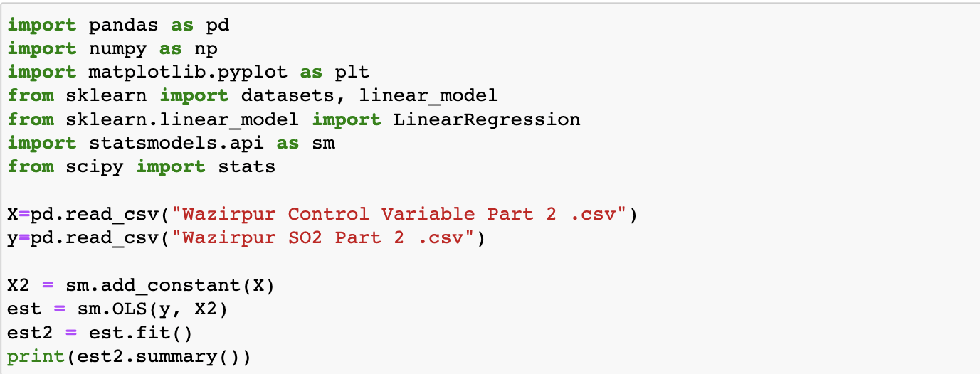

**Graphs of different pollutants**

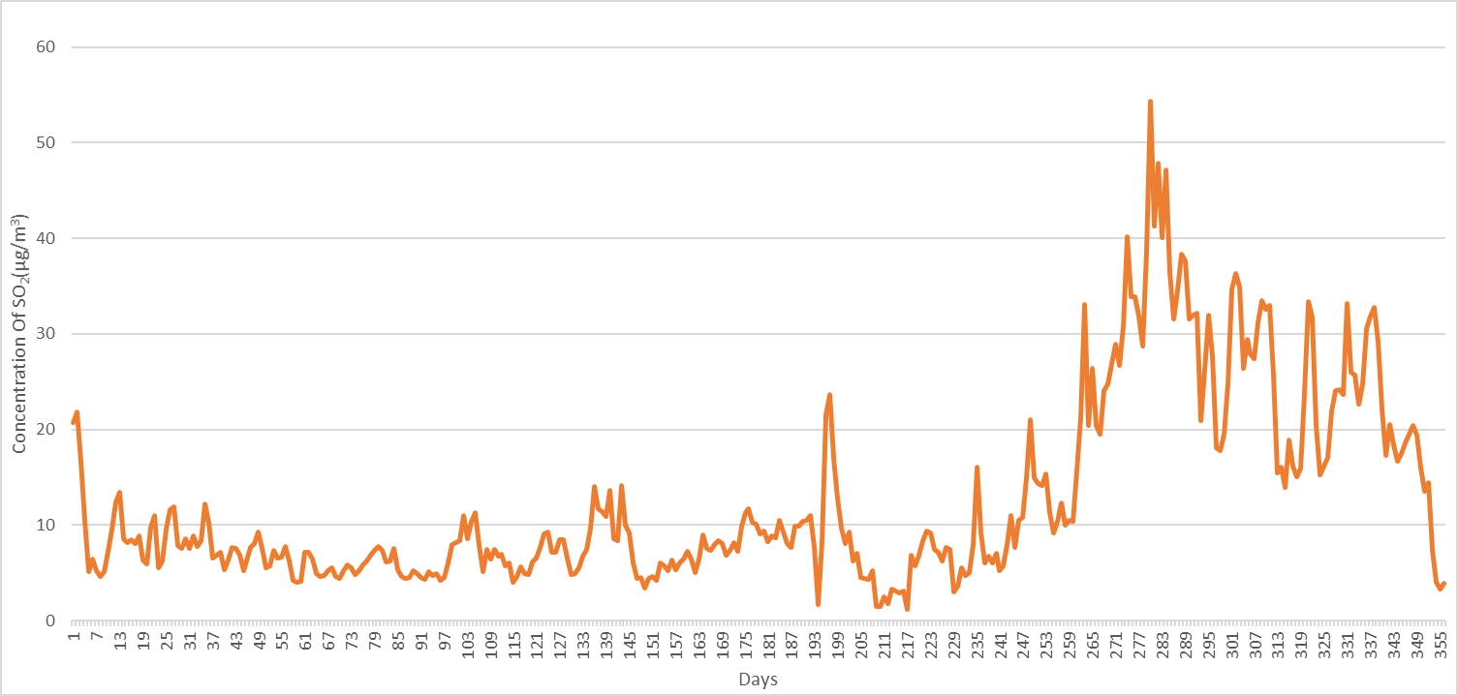

Sirifort SO2

Sirifort PM10

Sirifort PM2.5

Sirifort CO

Sirifort NO2

Wazirpur PM2.5

Wazirpur CO

Wazirpur SO2

Wazirpur PM10

Wazirpur NO2

DTU SO2

DTU PM10

DTU PM2.5

DTU NO2

DTU CO