COMMUNITY S E R V I C E P R O J E C T R E P O R T
ON

AG R I C U L T U R E
(Irrigation & Modern Farming Techniques)

(Submitted in partial fulfillment of the requirements for the award of degree of)

B AC HE L OR OF TECHNOL OG Y
IN
C OM P UT E R S C I E N C E AND ENGINEERING

K. RAM MOHAN
A. PAVAN SAI SRINIVAS
N. PAVAN
T. GOWRI NADH
Submitted by

232W1A0525
232W1A0504
232W1A0537
242W5A0514

UNDER T HE GUIDANCE OF
Prof CH.SRINIVASA KUMAR
Professor Dept. of C S E

DEPARTMENT OF C OM P UT E R S C I E N C E AND ENGINEERING
G VR & S C O L L E G E OF ENGINEERING & TECHNOL OG Y
Approved by AICTE, New Delhi – Affiliated to JNTUK-Kakinada, NAAC ‘A’ Grade, ISO Certified
BUDAMPADU, GUNTUR (DT), ANDHRA PRADESH

2025-2026

G VR & S C O L L E G E OF ENGINEERING & TECHNOL OG Y
Approved by AICTE, New Delhi – Affiliated to JNTUK-Kakinada, NAAC ‘A’ Grade, ISO Certified
BUDAMPADU, GUNTUR (DT), ANDHRA PRADESH


C E R T I F I C A T E
This is to certify that the Community Service Project work entitled “ AGRICULTURE (Irrigation & Modern Farming Techniques)” done by K. RAM MOHAN (232W1A0525), A. PAVAN SAI SRINIVAS (232W1A0504), N. PAVAN (232W1A0537), and T. GOWRI
NADH (242W5A0514) of Computer Science and Engineering is a record of bonafide work carried out by them.
This Community Service Project is done as a partial fulfilment of obtaining the Bachelor of Technology Degree to be awarded by JNTU-Kakinada. The matter embodied in this Community Service Project report has not been submitted to any other University for the award of any other degree.

GUIDE HOD PRINCIPAL

ACKNOWLEDGEMENT
Great acknowledgement is expressed to the G VR & S Management members, whose guidance was invaluable in completing this Community Service Project on time.
We take this opportunity to place on record our heartiest thanks to Dr. P. BH ASKAR NAIDU, Principal of our college, for his guidance and co-operation throughout our course of study.
We express our sincere gratitude to Prof CH.SRINIVASA KUMAR, HOD, Dept. of C S E , for her motivation and inspiration provided during the Community Service Project work.
We express our sincere gratitude towards our Community Service Project Guide and Dr. P. BH ASKAR NAIDU, Principal of our college, for his advice, support, and guidance throughout this Community Service Project.
Finally, we would like to acknowledge our deep sense of gratitude to all well-wishers and friends who helped us, directly or indirectly, to complete this work.

K. RAM MOHAN
With all sincerity,
TEAM M E M B E R S

232W1A0525

A. PAVAN SAI SRINIVAS
N. PAVAN
T. GOWRI NADH
232W1A0504
232W1A0537
242W5A0514

DECLARATION
We hereby declare that the work presented in this Community Service Project titled “ AGRICULTURE (Irrigation & Modern Farming Techniques)” is submitted towards completion of the B.Tech Community Service Project in C OM P UT E R S C I E N C E AND ENGINEERING at G VR & S C O L L E G E OF ENGINEERING AND TECHNOLOGY, BUDAMPADU, GUNTUR (DT), ANDHRA PRADESH.
We have not submitted the matter embodied in this Community Service Project for the award of any other degree.

K. RAM MOHAN
TEAM M E M B E R S

232W1A0525

A. PAVAN SAI SRINIVAS
N. PAVAN
T. GOWRI NADH
232W1A0504
232W1A0537
242W5A0514

C ONT E NT S
- Executive Summary
Introduction
- Overview of the Community About the Community / Village Location Details & Map
- Community Service Part
Activities Undertaken
Values, Life Skills & Technical Skills Acquired
- Agriculture – An Overview
- Crop Selection and Soil Suitability
- Irrigation – An Overview
Types of Irrigation
- Benefits of Irrigation in Agriculture
- Modern Farming Techniques
Drip Irrigation Sprinkler Irrigation
- Which Inputs Do Crops Need, and When?
- Storage and Handling of Agricultural Inputs
- Major Problems Faced in Farming
- Equipment for Maintenance and Repairs
Digging Tools Levelling Tools
Pumps, Pipes and Nets/Tools
- Harvesting Practices
- Improving Harvesting and Post-Harvest Handling
- Solutions for Sustainable Farming
- Government Schemes and Support for Farmers
- Economic Impact of Irrigation
- Water Conservation Practices in Agriculture
- Pest and Disease Management in Crops

- Farmer Training and Awareness Programs
- Summary of Farmer Interactions
- Role of Technology in Modern Agriculture
- Challenges and Recommendations
- Conclusion

E X E C U T I V E SUMMARY
This Community Service Report presents a one-page executive summary covering a brief description of the community visited, a summary of all activities carried out by the students during the Community Service Project ( CSP), and the key learning objectives and outcomes achieved through this experience.

Introduction
We visited a village called [ Chintalapudi ], located in [Duggirala] Mandal of [ G u n t u r ] District, Andhra Pradesh, as part of our B.Tech Community Service Project.
As per the instructions given by our college, we surveyed the village to understand the agricultural conditions, irrigation facilities, and farming-related problems faced by the residents of [ Chintalapudi ]. We gathered preliminary information about the village from the local sachivalayam office before proceeding with our own field survey.
We interacted directly with farmers to understand the day-to-day issues they face in irrigation and modern farming, and surveyed the locations of irrigation sources such as canals, borewells, and water storage tanks across the village. Additionally, we visited several agricultural fields, observed ongoing farming activities, and captured photographs documenting the irrigation infrastructure and farming practices in use.

Key Learning Objectives
To understand the socio-economic conditions of a rural farming community. To identify the irrigation methods currently practiced and their limitations.
To study modern farming techniques that could improve productivity and water efficiency.
To engage directly with farmers and document their first-hand experiences and challenges.
To propose practical, low-cost solutions that could be implemented at the village level.
[ Village, Mandal, and District name.]

OVERVIEW OF T HE COMMUNITY
About the Community / Village / Habitation, including historical profile of the community, habitation, community diversity, traditions, ethics and values. A brief note on the socio-economic conditions of the Community/Habitation is given below.

Village Profile
[ Chintalapudi] [village] [Duggirala] [mandal]
[ Guntur] [district]
[ T e l u g u ] village's local language is Telugu.
[ Chintalapudi] village consists of a total population (2025-26) of [1,613].
Number of households: [ 450]
Female population: [%] (50.03% (807)) Village literacy rate: [73%]
Female literacy rate: [68%] Male literacy rate: [77%]
The villagers are primarily engaged in agriculture, growing paddy and other seasonal crops, with irrigation playing a central role in their farming practices. Many households also depend on allied activities such as dairy farming and small-scale poultry to supplement their income during the off-season.

Location Details
Village: [ Chintalapudi] | Mandal: [Duggirala] | District: [ Guntur]
The gram panchayat headquarters is [Chintalapudi]. The mandal headquarters is [Duggirala ], located approximately [ 7 km] km away. The district headquarters is [ Guntur ], located approximately [ 2 5 ] km away. The village pin code is [522306].
[]

COMMUNITY S E R V I C E P AR T
Description of the activities undertaken in the Community during the Community Service Project, along with the values, life skills, and technical skills the students acquired through this experience.

Activities Undertaken
Conducted a detailed survey in the village and collected information about the farmers and their irrigation practices.
Prepared notes on the village's mobility, transactions, social structure, and basic location maps.
Identified key agricultural and irrigation-related problems faced by the village community.
Collected photographs of the village and took photos with the farmers; selected irrigation and modern farming as the focus topic from the listed problems.
Visited the agricultural fields and irrigation sources where the topic information was gathered first-hand.
Studied the identified problems in depth to suggest practical remedies and conclusions.
Discussed the problems and possible solutions with the farmers directly, and documented the interaction through photos and videos.

Values, Life Skills, and Technical Skills Acquired
Improved communication skills through direct interaction with farmers and village residents.
Strengthened leadership qualities while coordinating survey activities as a team.
Developed problem-solving skills by identifying practical solutions to real village issues.
Gained deeper knowledge of rural society, diversity, and socio-economic conditions.
Built confidence in approaching unfamiliar people, and enhanced creativity in proposing practical solutions.

AG R I C U L T U R E – AN OVERVIEW
Agriculture is the science and practice of cultivating soil, growing crops, and raising livestock to produce food, fiber, and other products essential for human life. It remains one of the largest sources of employment and livelihood in rural India, and forms the economic backbone of villages such as the one we surveyed.
Agriculture can also be defined as the systematic cultivation of land, involving the preparation of soil, sowing of seeds, irrigation, application of fertilizers, pest control, and harvesting of mature crops. Each of these stages requires careful timing and resource management to achieve a good yield.
A major problem in agriculture, as observed during our survey, is the lack of availability of timely and adequate irrigation water. To overcome this problem, farmers have increasingly turned towards borewells and motor pumps to draw groundwater for their fields. This has eased the supply of water in desired quantities during dry spells, although it has also placed additional pressure on groundwater resources in the long run.
The problems involved in modern agriculture also include soil degradation due to continuous cultivation, over-use of chemical fertilizers that reduce long-term soil fertility, and pest infestation that can damage standing crops if not managed in time.
The advantage of agriculture is that it provides high-quality food and raw material for human consumption and industry, while also supporting allied sectors such as food processing, textiles, and animal husbandry.
Agriculture can be integrated with allied activities such as dairy farming and horticulture to create additional income streams for farming households and improve overall farm water management through better planning and shared resources.

C R O P S E L E C T I O N AND S OI L SUITABILITY
Selecting the right crop for the available soil type and irrigation facility is one of the most important decisions a farmer makes each season, directly affecting both yield and profitability.
Soil testing helps determine the nutrient content, pH level, and water-holding capacity of the land, which in turn guides the choice of crop and the type of irrigation method best suited for it. Despite its importance, soil testing remains under-utilized among small farmers due to limited access to testing facilities.

Soil Types and Suitable Crops
Clayey soils retain water for longer periods and are well suited for paddy cultivation under flood irrigation, since paddy requires standing water for much of its growth cycle.
Sandy soils drain quickly and are better suited for crops grown under drip irrigation, which can supply water frequently in small, controlled amounts to compensate for the soil's low water retention.
Loamy soils, which balance water retention and drainage, are suitable for a wide range of crops including vegetables, pulses, and oilseeds.
Black cotton soils, common in parts of Andhra Pradesh, are highly fertile but require careful water management since they expand and crack when dry.
Farmers in the surveyed area generally rely on traditional knowledge passed down through generations to choose crops; however, scientific soil testing is gradually being adopted with support from agricultural extension officers and Krishi Vigyan Kendras.
Crop selection is also influenced by market demand and price trends, with many farmers increasingly considering commercial crops alongside traditional staple crops to improve household income.

IRRIGATION – AN OVERVIEW

What is Irrigation
Irrigation is the artificial application of water to land or soil to assist in the growth of agricultural crops, maintenance of landscapes, and re-vegetation of disturbed soils in dry areas and during periods of inadequate rainfall.
Irrigation can also be defined as the controlled supply of water to crops at the right time and in the right quantity, ensuring optimum growth and yield throughout the crop cycle.
It is one of the most important factors that determines the productivity of farmland, especially in regions with uneven or insufficient rainfall. Improved irrigation practices have helped increase crop yields in coastal and inland farming areas due to growing food demand and changing rainfall patterns caused by climate variability.

Types of Irrigation
Surface irrigation (flood/furrow irrigation) – the most traditional and widely used method, suitable for crops like paddy.
Drip irrigation – delivers water directly to the root zone through a network of pipes and emitters.
Sprinkler irrigation – distributes water through pipes and sprinkler heads, mimicking natural rainfall.
Sub-surface irrigation – supplies water below the soil surface directly to the root zone.
Canal irrigation – channels water from rivers or reservoirs through a network of canals to the fields.
Borewell / tube-well irrigation – draws groundwater using motorized pumps, widely used in the surveyed village.
Each method has its own advantages and limitations in terms of cost, water efficiency, and suitability for different crops and soil types, which farmers must weigh carefully based on their specific circumstances.

B E N E F I T S OF IRRIGATION IN AG R I C U L T U R E
Proper irrigation offers several benefits to farmers and the wider community, making it one of the most valuable investments in modern agriculture.
Increases crop yield by ensuring a steady and adequate water supply throughout the growing season, rather than depending solely on unpredictable rainfall.
Reduces dependency on rainfall, allowing farmers to grow crops even during dry spells or delayed monsoons.
Enables farmers to grow more than one crop per year, increasing overall farm income and making better use of available land.
Improves soil fertility when combined with proper drainage and nutrient management, preventing waterlogging and salinity build-up.
Supports the cultivation of high-value crops that require precise water control, such as vegetables and fruits, which often fetch better market prices.
Helps in better utilization of fertilizers, since nutrients dissolve and reach the root zone more effectively with controlled irrigation, reducing wastage.
Reduces soil erosion compared to uncontrolled flooding, particularly when drip or sprinkler systems are used.
Provides greater predictability in farm planning, allowing farmers to schedule sowing, fertilizer application, and harvesting more accurately.
Overall, a well-planned irrigation system is one of the key factors that determines the long-term sustainability and profitability of farming operations in any region, and was repeatedly highlighted by farmers during our survey as the single most important factor affecting their livelihood.

MODERN FARMING TECHNIQUES
Modern farming techniques involve the use of improved irrigation systems, machinery, and scientific practices to increase productivity while conserving natural resources. It is therefore important for farmers to adopt techniques that ensure crops receive the right amount of water and nutrients at the right time.
There are mainly three modern methods of irrigation used in farms today: drip irrigation, sprinkler irrigation, and sub-surface/underground irrigation. Each is suited to different crop types, soil conditions, and farm budgets.
Drip irrigation conserves water by delivering it directly to the base of each plant through a network of valves, pipes, and emitters, significantly reducing water wastage compared to traditional flood irrigation. It is particularly effective for row crops and orchards.
Sprinkler irrigation distributes water through a system of pipes and sprinklers, similar to natural rainfall, and is suitable for a wide variety of crops and soil types, including those with uneven terrain.

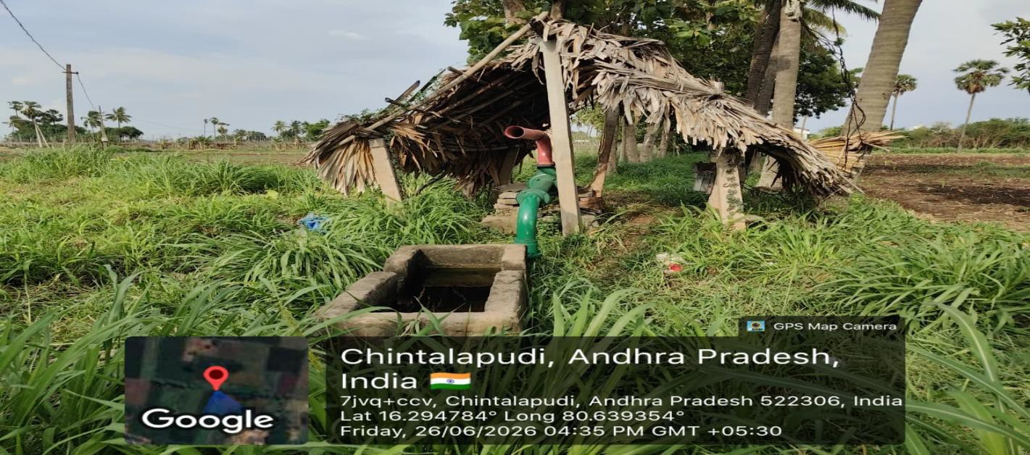
Figure 1: Discussing modern irrigation practices with a local farmer

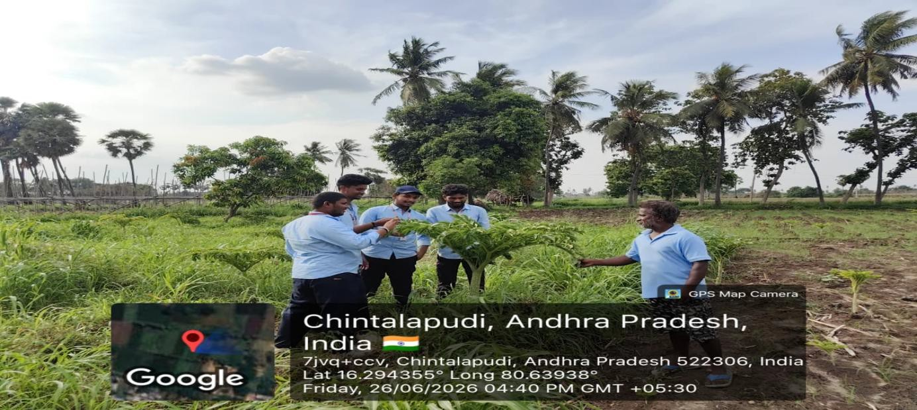

WHICH INPUTS DO C R O P S NEED, AND WHEN?
The inputs required by crops vary considerably depending on the crop type and growth stage. Understanding this timing is essential for efficient resource use and maximizing yield.
During the early germination stage, crops require careful moisture management and minimal but regular irrigation, since both excess and insufficient water can damage emerging seedlings.
As seedlings grow into young plants, irrigation frequency increases, and the first dose of fertilizer is generally applied to support vegetative growth and root development.
As the crop matures and enters the flowering and fruiting stages, water and nutrient requirements increase further, since this is typically the most resource-intensive phase of the crop cycle.

Figure 2: Group with a farmer near the field, examining seed/fertilizer bags

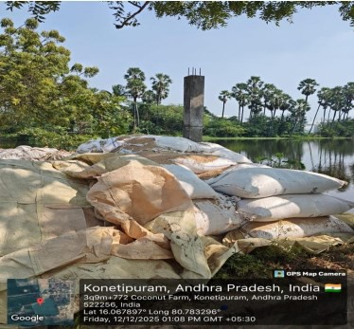

S T O R A G E AND HANDLING OF AG R I C UL T UR AL INPUTS
The general rule for preservation of seeds, fertilizers, and pesticides is to store them in a dry, well-ventilated area that affords some protection from rapid changes in temperature.
Cooler temperatures are best, although the actual ambient temperature is less important than minimizing extreme changes, which can degrade the quality and effectiveness of stored inputs over time.

Figure 3: Fertilizer/seed bags stored near the field, awaiting transport

Figure 3:Examining seed/fertilizer bags

Rather than leaving the bag exposed in the open, all seed and fertilizer stock should be kept in an airtight, opaque storage container in the cooler temperatures of a godown.
Bags that allow storing bigger volumes of input, starting from 50 kg, are ideal for intensive farming and reduce the cost per unit of transportation.
It is important to provide a housing/building for input storage which is waterproof, secured, and can be adequately locked up to prevent theft or spoilage.

MAJOR P R O B L E M S F AC E D IN FARMING
The health and subsequent growth of crops are directly related to the quality and timeliness of irrigation water supplied to the fields, making water management one of the most critical aspects of successful farming.
In general, factors affecting crop growth and production in agricultural systems can be classified as physical, chemical/biochemical, or a combination of both, each requiring different management approaches.
The physical properties of soil and water that are important to crop production and growth include moisture content, drainage, and temperature; important chemical parameters include soil pH, salinity, and nutrient availability such as nitrogen, phosphorus, and potassium levels.
Farming is also a physically demanding occupation, with high rates of work-related musculoskeletal disorders, particularly in the lower back, shoulders, and knees, due to prolonged manual labor involved in activities such as planting, weeding, and harvesting.

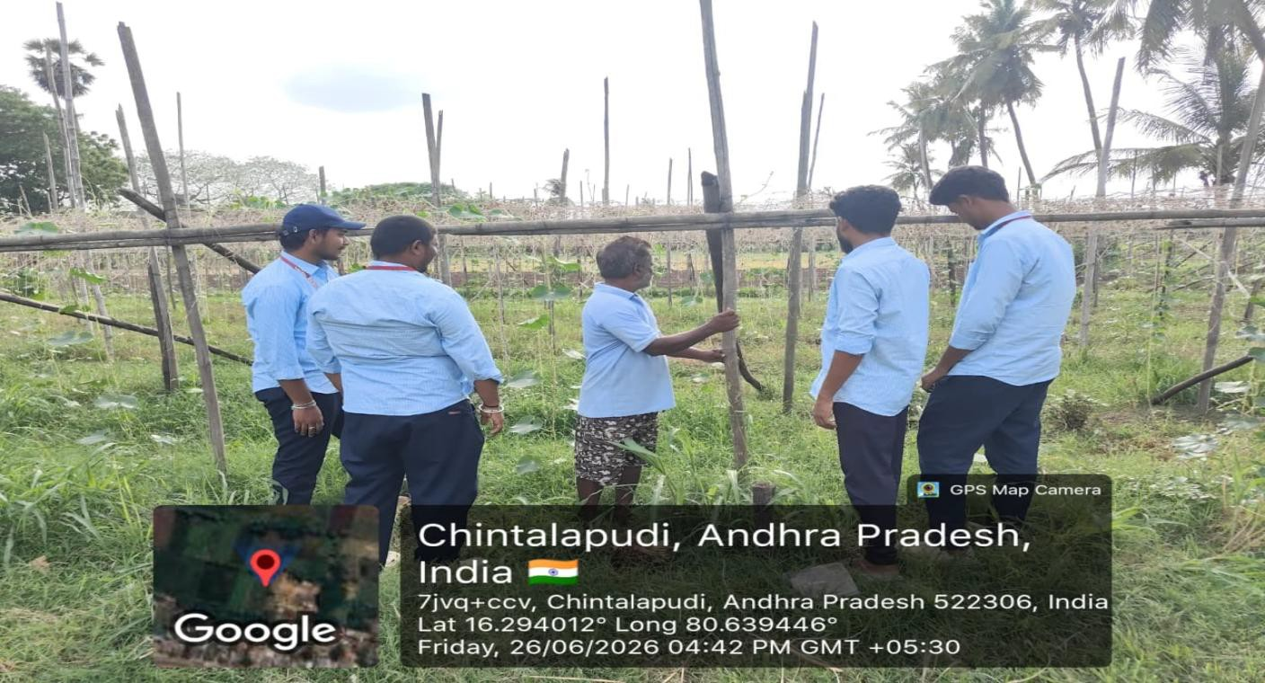

Figure 4: Asking the farmer about the irrigation and farming problems faced

EQUIPMENT F OR MAINTENANCE AND R E P A I R S
Digging tools Levelling tools Pumps and pipes
Sprinkler and drip irrigation sets Hand tools (sickles, hoes, ploughs)

Digging Tools
Most of the maintenance and repair works on irrigation channels are devoted to bunds and field channels. Practically, the same implements used in manual construction work are also used in repairing channel bunds.
Digging tools, spades, and small carts are most appropriate for work like digging out trenches and backfilling them with puddled soil to repair leakage/seepage, and for deepening canals and similar jobs.

Levelling Tools
Practical and simple equipment has also been devised for levelling agricultural field surfaces to ensure even water distribution. The simple manual rake is a good example, while a levelling board manned by two or more workers is also commonly used in the region.
For manual removal of silt in field channels or drains, a simple metallic or wooden shovel is typically used. If the area to be cleared is extensive, a motorized pump can be used to remove excess silt or sludge more efficiently.

Pumps, Pipes and Other Tools
Small portable pumps, used for lifting water from borewells or canals, are compact and easy to transport between fields. Sprinkler heads and drip emitters are supported by a network of pipes laid across the field, with valves to regulate flow at different points. Hand tools such as sickles, hoes, and ploughs remain essential for land preparation, weeding, and harvesting, especially on smaller farms where mechanization is limited.

HARVESTING P R A C T I C E S
To harvest crops efficiently, farmers typically wait until the produce reaches optimum maturity, which varies depending on the crop being grown and the prevailing weather conditions.
In such cases, the produce is gathered either manually or with the help of machinery, depending on the scale of the farm operation and the availability of labor during the harvest season.
The harvesting method greatly depends on the kind of crop being grown, with grains, vegetables, and fruits each requiring different techniques.
During harvest, damage to the crop should be reduced to a minimum to preserve market value and reduce post-harvest losses.
After harvesting, produce should be moved to a clean, dry storage area as soon as possible to prevent spoilage.
Timing of Harvest: Harvesting should be planned during favorable weather conditions, typically early morning or late evening, to reduce crop loss and ensure better grain quality.
Use of Equipment: Sickles, harvesters, and threshers are commonly used depending on the scale of farming and the resources available to the farmer.

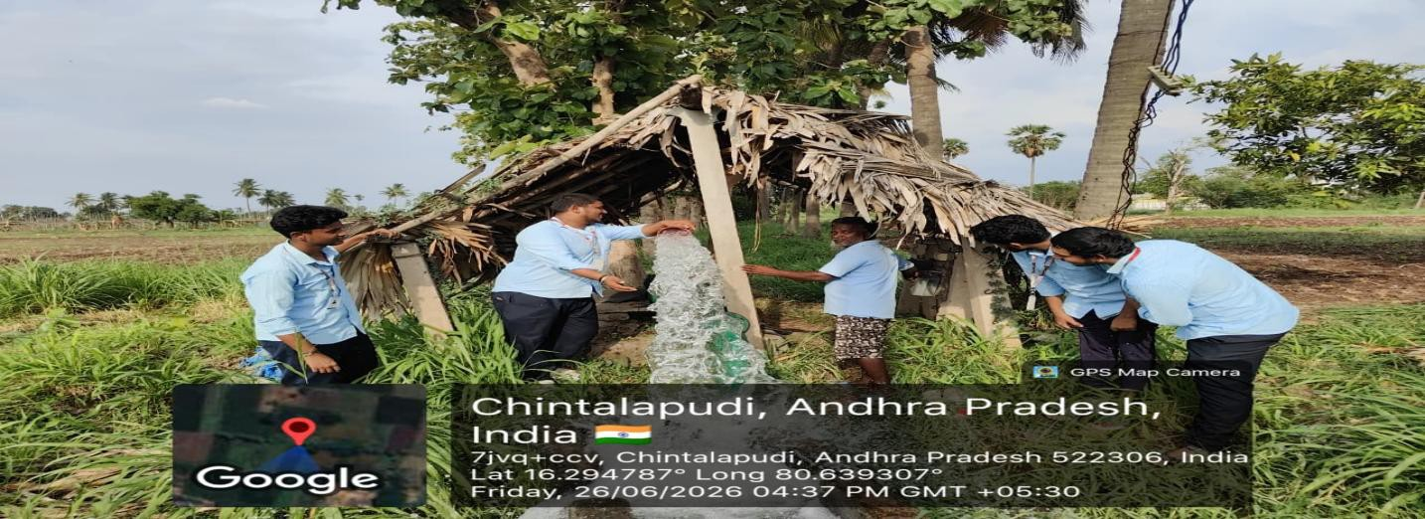

Figure 5: Group field survey near the water source used for irrigation

HARVESTING AND POST- HARVEST HANDLING
Good post-harvest practices are just as important as the harvesting process itself, since improper handling after harvest can lead to significant losses in quality and quantity of produce.
Water Quality: Ensure that the irrigation water used in the final growth stage is free from contaminants to maintain crop health and quality.
Hygiene Practices: Maintain cleanliness during handling of harvested produce to prevent contamination and spoilage.
Transportation: Use clean, covered containers or vehicles for produce transport to maintain freshness and avoid losses during transit.
Post-Harvest Processing: For perishable crops, immediate cooling, sorting, or drying is recommended to preserve quality before reaching the market.
Record Keeping: Document harvest details such as quantity, quality, and yield per acre for future planning and comparison across seasons.

Improving Your Harvesting
To produce good quality crops from the field, farmers should endeavor to maintain proper irrigation scheduling and reduce stress on the crop caused by water shortage, especially during the final growth stage before harvest.
Farmers can provide an ample supply of good irrigation water from a source close to the field being harvested. This is especially useful towards the end of the cropping season, when water demand is highest and water availability may be limited.
Additional water may be brought from a neighboring field's water source, by pumping from any conveniently available source using a small portable pump, from upstream irrigation channels along a main distribution canal, or from a special water canal or pipeline branched off one of the main feeding canals, using a control box to regulate flow as required.

SOLUTIONS F OR S US T AINAB L E FARMING
All fields are unique, including the management strategies and overall goals of the farmer. For some farmers, increasing crop production is at the top of their list, while for others, water conservation and cost reduction take priority.
Common management strategies implemented to increase crop production include proper irrigation scheduling, balanced fertilization, and timely pest control, all of which require careful planning and consistent monitoring throughout the season.
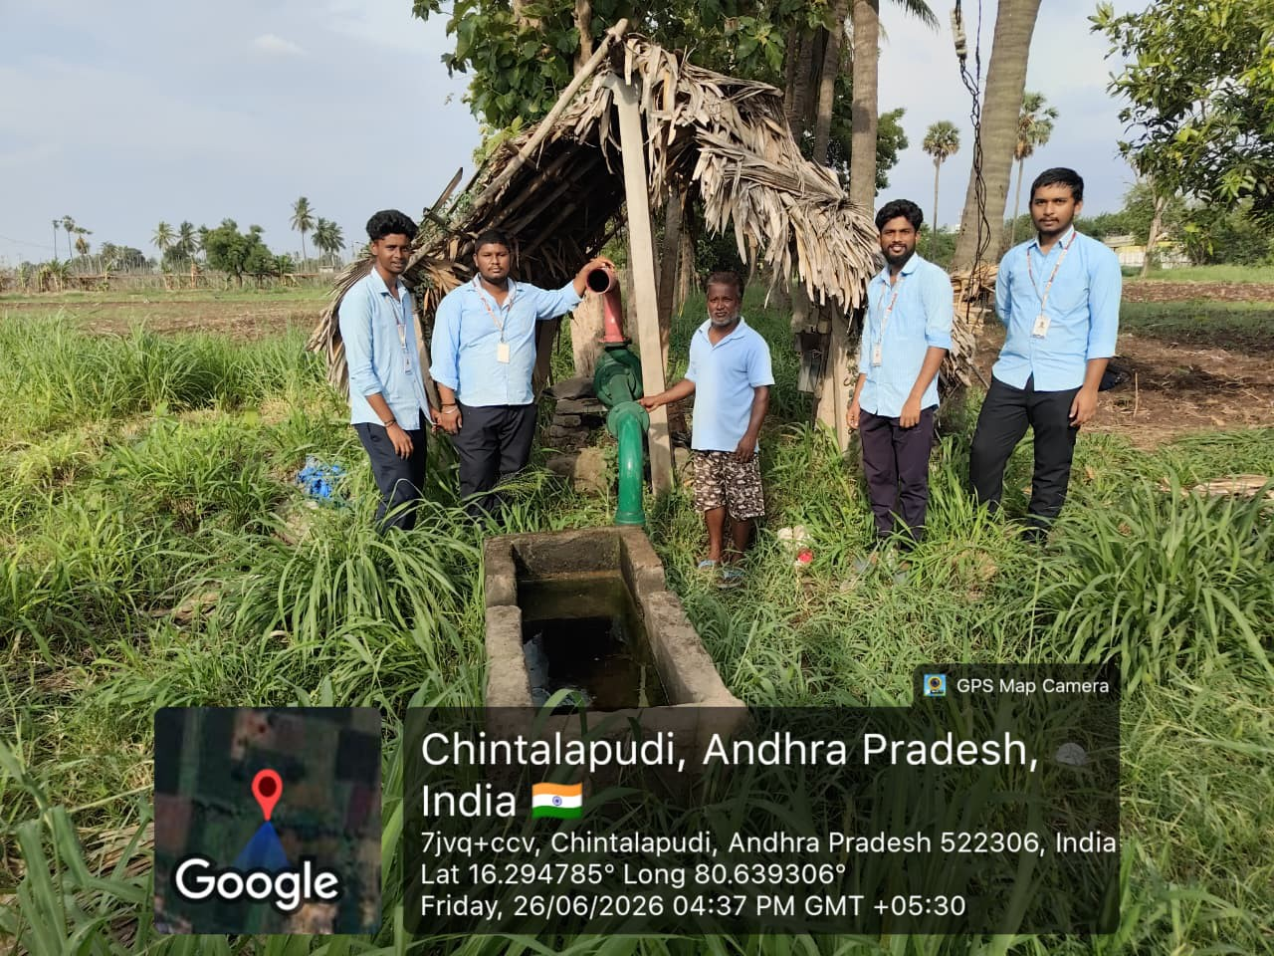

Figure 6: Survey discussion with a farmer about the irrigation source used for the fields
[ ]

The Methods Used Include
The control (and maintenance) of irrigation water quality The control of weeds and pest infestation
The control of crop diseases
The control and proper use of fertilizers

GOVERNMENT S C H E M E S AND S U P P OR T F OR F A R M E R S
The Government of India and the State Government of Andhra Pradesh run several schemes to support farmers in adopting modern irrigation and farming techniques. Awareness of these schemes among farmers in the surveyed village was found to be limited, highlighting the need for better outreach by agricultural extension officers.
Pradhan Mantri Krishi Sinchayee Yojana ( P M K S Y ) – promotes water-use efficiency through micro-irrigation, including drip and sprinkler systems, with financial subsidies for farmers.
PM-KISAN – provides direct income support to landholding farmer families to meet their agricultural input needs.
Soil Health Card Scheme – enables farmers to get their soil tested periodically and receive fertilizer recommendations.
Crop Insurance Schemes (Pradhan Mantri Fasal Bima Yojana) – protect farmers against crop loss due to calamities, pests, and diseases.

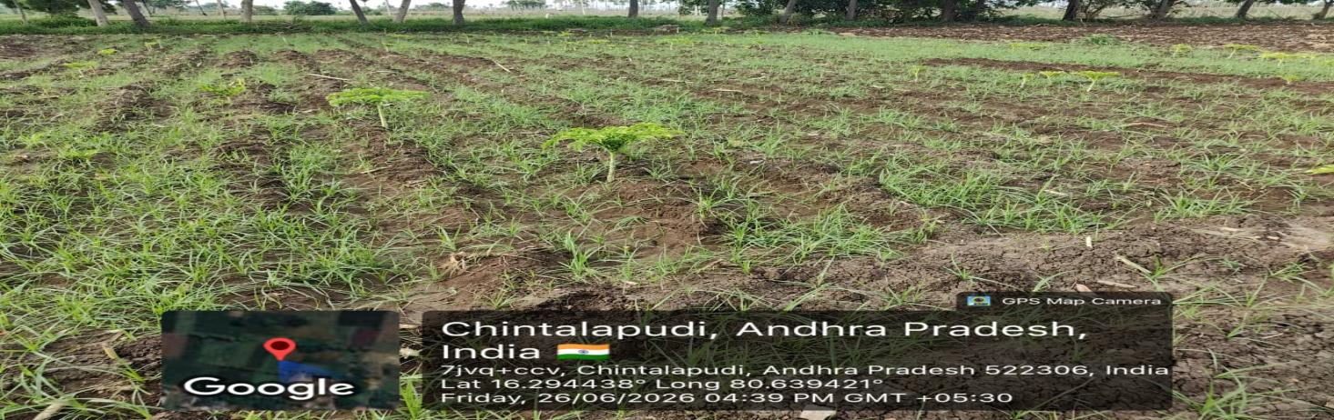

Figure 7: Group interacting with a local farmer near the irrigation source

ECONOMIC IMPACT OF IRRIGATION ON FARMING HOUSEHOLDS
Access to reliable irrigation has a direct and measurable impact on the income and economic stability of farming households in rural Andhra Pradesh, influencing nearly every aspect of household financial planning.
Farmers with assured irrigation are generally able to cultivate two to three crop cycles per year, compared to a single rain-fed crop cycle for farmers without irrigation access.
Improved water availability allows diversification into higher-value crops such as vegetables and commercial crops, which fetch better market prices than traditional staple crops alone.
Reduced crop failure due to drought lowers the financial risk faced by farming households, making it easier for them to invest in better seeds, fertilizers, and equipment in subsequent seasons.
Irrigation infrastructure also creates indirect employment opportunities, such as pump operation, maintenance work, and agricultural labor during the additional cropping cycles enabled by irrigation.
Access to irrigation also reduces seasonal migration of agricultural labor, as more consistent farm work becomes available throughout the year.
However, the initial cost of setting up modern irrigation infrastructure, such as borewells, pump sets, and drip systems, remains a significant barrier for small and marginal farmers. Cooperative or group investment models, supported by government subsidies, were suggested as a practical way to make modern irrigation more accessible and affordable for smaller landholders in the village.

WATER CONSERVATION P R A C T I C E S IN AG R I C U L T U R E
With increasing pressure on groundwater resources, water conservation has become an essential part of sustainable agriculture in the region surveyed, and was a recurring theme in our discussions with farmers.
Mulching: Covering the soil around crops with straw, dry leaves, or plastic sheets to reduce evaporation and retain soil moisture.
Rainwater Harvesting: Constructing small farm ponds or check dams to capture and store rainwater for use during dry periods.
Contour Farming: Ploughing and planting along the natural contours of the land to slow water runoff and improve absorption.
Scheduled Irrigation: Watering crops based on actual soil moisture levels and crop growth stage, rather than fixed schedules, to avoid over-irrigation.
Watershed Management: Community-level efforts to manage rainfall, runoff, and groundwater recharge across a connected area of farmland.
Lining of Canals: Reducing seepage losses in unlined earthen canals by lining them with concrete or other impermeable materials.
Night Irrigation: Watering crops during cooler night hours to reduce water loss through evaporation, a practice gradually being adopted by progressive farmers in the region.
During our survey, we observed that most farmers in the village still rely on conventional flood irrigation due to the lower upfront cost, even though it leads to higher water wastage compared to drip or sprinkler systems. Promoting awareness of water conservation practices, alongside financial support for adopting them, could significantly improve long-term water security for the farming community.
Local self-help groups and farmer cooperatives could also play an important role in collectively maintaining shared water sources, ensuring equitable distribution among all farmers in the area during periods of scarcity.

P E S T AND DI S E AS E MANAGEMENT IN C R O P S
Pest infestation and crop disease remain among the most significant threats to agricultural productivity. Farmers in the surveyed village reported recurring issues with stem borers, leaf folders, and fungal infections, particularly during the monsoon season when humidity levels are high.
Chemical Pesticides: Widely used for quick control of pest outbreaks, although overuse can lead to pest resistance and soil contamination over time.
Biological Control: Introducing natural predators or using bio-pesticides derived from neem and other plants, which is gradually gaining acceptance among farmers in the region.
Crop Rotation: Alternating crops across seasons to break the life cycle of pests that are specific to a particular crop.
Resistant Varieties: Use of pest- and disease-resistant seed varieties recommended by agricultural extension officers.
Field Sanitation: Removing crop residue and weeds that can harbor pests and pathogens between growing seasons.
Pheromone Traps: Low-cost traps that attract and capture specific pest species, helping farmers monitor pest population levels before they reach damaging thresholds.
Integrated Pest Management (IPM), which combines multiple approaches rather than relying solely on chemical pesticides, was explained to farmers during our visit as a more sustainable long-term strategy. Several farmers expressed willingness to try bio-pesticides if reliable sources and proper guidance were made available locally, indicating an opportunity for targeted awareness campaigns.
We also noted that timely identification of pest and disease symptoms, through regular field monitoring, can significantly reduce the extent of crop damage and the quantity of pesticide required for effective control.

F AR M E R TRAINING AND AW AR E NE S S P R OG R AM S
Continuous learning and skill development are essential for farmers to keep pace with evolving agricultural technologies and best practices in irrigation and crop management.
During our survey, we found that most farmers in the village rely primarily on traditional knowledge passed down through generations, with limited exposure to formal training programs conducted by the State Agriculture Department or Krishi Vigyan Kendras (KVKs).

Recommended Awareness Initiatives
Periodic demonstration sessions on modern irrigation techniques, conducted directly in the village rather than at distant training centers.
Distribution of simple, illustrated guides in Telugu covering topics such as soil testing, fertilizer dosage, and pest identification.
Formation of farmer groups or cooperatives to collectively access training, subsidies, and bulk purchase of inputs at lower cost.
Use of mobile-based advisory services that send weather alerts, irrigation schedules, and pest warnings directly to farmers' phones.
Encouraging progressive farmers who have successfully adopted modern techniques to mentor others in the community.
Partnering with local schools and colleges to organize student-led awareness drives, similar to this Community Service Project, on a more regular basis.
As engineering students, we also discussed the potential for simple, low-cost technology solutions, such as soil moisture sensors and mobile alerts, to bridge the awareness gap and make modern farming techniques more accessible to small farmers in the village.
Several farmers mentioned that seeing a successful demonstration on a neighboring farm was far more convincing than reading about a new technique in a pamphlet, reinforcing the value of peer-to-peer learning within the farming community.

SUMMARY OF F AR M E R INTERACTIONS
During our field visits, we interacted with several farmers to understand their day-to-day experiences with irrigation and modern farming techniques. The following is a summary of the key points raised during these conversations.
Most farmers depend on a combination of borewell water and seasonal canal water, with availability varying significantly between the dry and monsoon seasons.
Power supply interruptions affecting borewell pump operation were repeatedly mentioned as a major source of frustration, particularly during peak irrigation periods.
Several farmers who had adopted drip irrigation on a small portion of their land reported noticeably lower water bills and better crop health, but cited high initial installation cost as the reason for not expanding it further.
Older farmers expressed a preference for traditional flood irrigation methods due to familiarity, while younger farmers showed greater openness to adopting new techniques if proper guidance and financial support were available.
Farmers unanimously agreed that timely access to accurate weather forecasts would help them plan irrigation and fertilizer application more effectively.
Many farmers also raised concerns about fluctuating market prices for their produce, which affects their ability to invest in better irrigation infrastructure each season.
These conversations gave us valuable first-hand insight into the practical challenges of implementing modern irrigation techniques at the ground level, beyond what is typically covered in textbooks and classroom discussions.

R O L E OF T E C HNOL OG Y IN MODERN AG R I C U L T U R E
As Computer Science and Engineering students, our visit also gave us an opportunity to think about how technology could be applied to address some of the irrigation and farming challenges observed in the village.
Soil Moisture Sensors: Low-cost sensors placed in the field can measure real-time soil moisture and trigger irrigation only when needed, preventing both under- and over-watering.
Automated Drip Controllers: Simple microcontroller-based systems can automate drip irrigation valves based on a pre-set schedule or sensor input, reducing manual labor.
Mobile Weather and Advisory Apps: Applications that provide localized weather forecasts and crop advisories in Telugu can help farmers make better-informed decisions.
Farm Record-Keeping Apps: Simple mobile applications can help farmers track input costs, yields, and expenses across seasons, supporting better financial planning.
Drone-Based Field Monitoring: Drones can be used for aerial monitoring of crop health and irrigation coverage across large fields, although the cost remains prohibitive for small farmers at present.
While most of these technologies are not yet widely adopted in the surveyed village, discussing them with the farmers helped us understand both the potential benefits and the practical barriers — such as cost, internet connectivity, and digital literacy — that need to be addressed before such solutions can be meaningfully adopted in rural farming communities.

C H A L L E N G E S AND RECOMMENDATIONS
Based on our survey and interactions with farmers, we identified the following key challenges and corresponding recommendations for improving irrigation and farming practices in the village.

Key Challenges Identified
Inconsistent power supply affecting borewell-based irrigation, especially during peak summer months.
High upfront cost of modern irrigation equipment such as drip and sprinkler systems.
Limited awareness of government subsidy schemes and the application process involved.
Over-reliance on traditional flood irrigation, leading to water wastage.
Limited access to soil testing facilities and scientific farming guidance at the village level.

Recommendations
Set up local-level demonstration plots showcasing drip and sprinkler irrigation to encourage adoption through direct observation.
Organize periodic visits by agricultural extension officers to assist farmers with subsidy applications and soil testing.
Promote farmer cooperatives to enable shared investment in costly irrigation infrastructure.
Encourage community-level rainwater harvesting structures to supplement groundwater during dry periods.
These recommendations, if implemented with support from local administration and agricultural departments, could meaningfully improve both the productivity and sustainability of farming in the village over the long term.

CONCLUSION
The Community Service Project on Agriculture, focusing on Irrigation & Modern Farming Techniques, provided valuable insights into sustainable farming practices and the socio-economic conditions of [ C h i n t a l a p u d i ] village. Through surveys, farmer interactions, and hands-on observation, we identified key challenges such as irrigation water management, input storage, and equipment maintenance.
By suggesting practical solutions and best practices, this project contributed to improving local agricultural operations and farmer awareness regarding modern irrigation techniques. Our recommendations, ranging from low-cost technology solutions to better access to government schemes, are aimed at making meaningful, achievable improvements within the resources available to the farming community.
Beyond technical learning, the project enhanced our communication, leadership, and problem-solving skills, fostering a sense of social responsibility. Agriculture, when supported by efficient irrigation and modern farming techniques, not only ensures food security but also creates employment opportunities and supports rural development.
This experience has strengthened our understanding of community engagement and the importance of applying engineering knowledge for societal benefit. We are grateful for the opportunity to learn directly from the farming community and hope that the insights and recommendations from this project, in some small way, contribute to improving the lives of the farmers we interacted with.

