
ACADEMIC YEAR: 2026-27
ASSIGNMENT FRONT SHEET
Name of the Student: | Sriram G S
Register Number: | 717825F152
Course Code & Title: | 23CSR306 JAVA PROGRAMMING
Year / Dept. / Sem / Section: | II / IT / III / A
Assignment: | II – OOP Mini Project (any one of 35)
Specification No. & Title: | Specification 29: Digital Wallet & Transfers (Wallet++)
GitHub Repository Link: | https://github.com/gssriram9050/wallet-plus-plus
Date of Issue: | 06-10-2026
Date of Submission:
Marks Details
CO / K Level | Maximum Marks | Marks Obtained
CO4 / K3 | 50
CO5 / K3 | 50
Total | 100

Course In-charge

Rubrics for Assignment Evaluation
Assignment Number | : | II | Date | :
Course Code & Title | : | 23CSR306 Java Programming | Specification No. & Title | : | Specification 29: Digital Wallet & Transfers (Wallet++)
Register Number | : | 717825F152 | Name of the Student | : | Sriram G S
Name of the Evaluator | : |  | GitHub Link | : | https://github.com/gssriram9050/wallet-plus-plus
Marks for each criterion = Level (1 – 5) × Weightage. Total: 100 (CO4: 50 + CO5: 50).
Criterion | CO | Wt. | Exemplary (5) | Excellent (4) | Adequate (3) | Average (2) | Inadequate (1) | Max | Marks
Program Correctness & Business Rules | CO4 | 4 | All menu options work; every business rule enforced correctly. | All options work; minor gaps in one rule. | Main flow works; some rules missing. | Partially working; several rules not handled. | Does not run or most features missing. | 20
Input Validation & Exception Handling | CO4 | 3 | All inputs validated; custom exceptions; program never crashes. | Most inputs validated with try-catch. | Basic validation; some invalid inputs not handled. | Little validation; crashes on bad input. | No validation or exception handling. | 15
Menu-driven Interface & Expected Outputs | CO4 | 3 | Clear menu; all expected outputs (bills/receipts/status) shown neatly. | Clear menu; most expected outputs shown. | Menu works; outputs basic or incomplete. | Menu unclear; few outputs shown. | No proper menu or outputs. | 15
OOP Design (Encapsulation, Inheritance, Aggregation, Polymorphism) | CO5 | 4 | All four concepts applied meaningfully; all required classes present. | Concepts applied well; minor design gaps. | Classes present; concepts used in a basic way. | Weak design; some required classes missing. | No OOP design; mostly procedural. | 20
Code Quality & Package Structure | CO5 | 2 | Clean packages, naming, indentation and comments. | Good structure with few lapses. | Acceptable structure; average readability. | Poor naming / structure. | Single file; unreadable code. | 10
GitHub Repository & README | CO5 | 1 | Complete code with clear README (problem, run steps, name, roll no.). | Complete code; README missing minor details. | Code present; README incomplete. | Partial code; no README. | No repository. | 5
Viva / Explanation | CO5 | 3 | Explains design, rules and code clearly; answers all questions. | Explains well; answers most questions. | Explains main logic; answers some questions. | Limited explanation of own code. | Unable to explain the code. | 15
CO4 Total (Criteria 1 – 3) |  |  |  |  |  |  |  | 50
CO5 Total (Criteria 4 – 7) |  |  |  |  |  |  |  | 50
Total Marks |  |  |  |  |  |  |  | 100
Signature of the Evaluator with date

23CSR306 JAVA PROGRAMMING

Specification No. & Title: Specification 29: Digital Wallet & Transfers (Wallet++)
1. Assignment Question
Problem Statement: Design and implement a Java console application for a Digital Wallet system that manages users, wallets, top-ups, transfers, payments, and statements. The application should demonstrate object-oriented principles and ensure accurate balances.
Class Requirements: User, Wallet, TopUp, Transfer, Payment, Refund, StatementEntry

Business Rules:
1. Top-ups increase wallet balance after confirmation.
2. Transfers require sufficient balance and update both source and destination.
3. Payments to merchants reduce balance and create statement entries.
4. Refunds credit the wallet against a valid payment.
5. Every transaction must generate a statement entry.

Menu Options: Add User / Create Wallet / Top-up / Transfer / Pay Merchant / Refund / View Statement / Exit

Expected Output:
• Show transaction receipts with amounts, fees (if any), and resulting balances.
• Show statement with chronological entries and running balance.
• Show validation errors for insufficient funds.
2. Java Source Code
exception/WalletException.java
package exception;

/**
* Base class for every business-rule or validation error in Wallet++.
* All other custom exceptions extend this class, so one catch block in
* the menu loop can handle them all.
*/
public class WalletException extends Exception {

private static final long serialVersionUID = 1L;

public WalletException(String message) {
super(message);
}
}
exception/InvalidInputException.java
package exception;

/** Thrown when text typed by the user is not in the expected format. */
public class InvalidInputException extends WalletException {

private static final long serialVersionUID = 1L;

public InvalidInputException(String message) {
super(message);
}
}
exception/InvalidAmountException.java
package exception;

/** Thrown when an amount is not a valid number or is outside the allowed range. */
public class InvalidAmountException extends InvalidInputException {

private static final long serialVersionUID = 1L;

public InvalidAmountException(String message) {
super(message);
}
}
exception/InsufficientFundsException.java
package exception;

import java.math.BigDecimal;

/** Thrown when a wallet does not have enough balance for a debit. */
public class InsufficientFundsException extends WalletException {

private static final long serialVersionUID = 1L;

private final BigDecimal available;
private final BigDecimal required;

public InsufficientFundsException(String message, BigDecimal available, BigDecimal required) {
super(message);
this.available = available;
this.required = required;
}

public BigDecimal getAvailable() { return available; }
public BigDecimal getRequired() { return required; }
}
exception/RecordNotFoundException.java
package exception;

/** Thrown when a user, wallet or payment ID does not exist. */
public class RecordNotFoundException extends WalletException {

private static final long serialVersionUID = 1L;

public RecordNotFoundException(String message) {
super(message);
}
}
exception/DuplicateRecordException.java
package exception;

/** Thrown when a user (same phone/email) or a wallet (one per user) already exists. */
public class DuplicateRecordException extends WalletException {

private static final long serialVersionUID = 1L;

public DuplicateRecordException(String message) {
super(message);
}
}
exception/RefundNotAllowedException.java
package exception;

/** Thrown when a refund is requested for a payment that is not eligible. */
public class RefundNotAllowedException extends WalletException {

private static final long serialVersionUID = 1L;

public RefundNotAllowedException(String message) {
super(message);
}
}
util/Validator.java
package util;

import java.math.BigDecimal;
import java.util.regex.Pattern;

import exception.InvalidAmountException;
import exception.InvalidInputException;

/** All input checks live here so the same rules are used by the menu and the service. */
public final class Validator {

public static final BigDecimal MIN_AMOUNT = new BigDecimal("1.00");
public static final BigDecimal MAX_AMOUNT = new BigDecimal("50000.00");

private static final Pattern NAME = Pattern.compile("[A-Za-z][A-Za-z .'-]{1,29}");
private static final Pattern PHONE = Pattern.compile("[6-9][0-9]{9}");
private static final Pattern EMAIL = Pattern.compile("[A-Za-z0-9._%+-]+@[A-Za-z0-9.-]+\\.[A-Za-z]{2,}");
private static final Pattern MERCHANT = Pattern.compile("[A-Za-z0-9][A-Za-z0-9 &.'-]{1,29}");
private static final Pattern ID = Pattern.compile("[A-Za-z0-9]{2,12}");
private static final Pattern AMOUNT = Pattern.compile("[0-9]+(\\.[0-9]{1,2})?");

private Validator() {
// utility class - no objects needed
}

private static String clean(String input) { return input == null ? "" : input.trim(); }

public static String validateName(String input) throws InvalidInputException {
String value = clean(input);
if (!NAME.matcher(value).matches()) {
throw new InvalidInputException(
"Name must be 2-30 characters long and contain only letters, spaces, '.', '-' or an apostrophe.");
}
return value;
}

public static String validatePhone(String input) throws InvalidInputException {
String value = clean(input);
if (!PHONE.matcher(value).matches()) {
throw new InvalidInputException("Phone number must be 10 digits and start with 6, 7, 8 or 9.");
}
return value;
}

public static String validateEmail(String input) throws InvalidInputException {
String value = clean(input);
if (!EMAIL.matcher(value).matches()) {
throw new InvalidInputException("Enter a valid email address (for example name@example.com).");
}
return value;
}

public static String validateMerchant(String input) throws InvalidInputException {
String value = clean(input);
if (!MERCHANT.matcher(value).matches()) {
throw new InvalidInputException(
"Merchant name must be 2-30 characters (letters, digits, spaces, & . ' -).");
}
return value;
}

/** Checks an ID such as U101 / W1001 / PAY1004 and returns it in upper case. */
public static String validateId(String input) throws InvalidInputException {
String value = clean(input);
if (!ID.matcher(value).matches()) {
throw new InvalidInputException("Enter a valid ID (letters and digits only, for example W1001).");
}
return value.toUpperCase();
}

/** Converts typed text such as "250" or "250.50" to a BigDecimal with 2 decimals. */
public static BigDecimal parseAmount(String input) throws InvalidAmountException {
String value = clean(input);
if (!AMOUNT.matcher(value).matches()) {
throw new InvalidAmountException(
"Enter the amount as a number with up to 2 decimals (for example 250 or 250.50).");
}
BigDecimal amount = new BigDecimal(value).setScale(2);
checkAmount(amount);
return amount;
}

/** Amount must be between Rs. 1.00 and Rs. 50,000.00 per transaction. */
public static void checkAmount(BigDecimal amount) throws InvalidAmountException {
if (amount == null || amount.compareTo(MIN_AMOUNT) < 0) {
throw new InvalidAmountException("Amount must be at least " + Format.money(MIN_AMOUNT) + ".");
}
if (amount.compareTo(MAX_AMOUNT) > 0) {
throw new InvalidAmountException(
"Amount cannot exceed " + Format.money(MAX_AMOUNT) + " per transaction.");
}
}
}
util/InputUtil.java
package util;

import java.math.BigDecimal;
import java.util.Scanner;

import exception.InvalidInputException;

/**
* Reads and validates everything the user types.
* If the text is in the wrong format, the error is shown and the same
* question is asked again, so the program never crashes on bad input.
*/
public class InputUtil {

/** One validation rule: turns typed text into a value or throws InvalidInputException. */
private interface Checker<T> {
T check(String input) throws InvalidInputException;
}

private final Scanner scanner;

public InputUtil(Scanner scanner) { this.scanner = scanner; }

private <T> T read(String prompt, Checker<T> checker) {
while (true) {
System.out.print(prompt);
String line = scanner.nextLine();
try {
return checker.check(line);
} catch (InvalidInputException e) {
System.out.println(" [INVALID INPUT] " + e.getMessage());
}
}
}

public int readMenuChoice(String prompt, int min, int max) { return read(prompt, text -> parseChoice(text, min, max)); }

private static Integer parseChoice(String text, int min, int max) throws InvalidInputException {
try {
int choice = Integer.parseInt(text.trim());
if (choice < min || choice > max) {
throw new InvalidInputException("Please enter a number between " + min + " and " + max + ".");
}
return choice;
} catch (NumberFormatException e) {
throw new InvalidInputException("Please enter a number between " + min + " and " + max + ".");
}
}

public String readName(String prompt) { return read(prompt, Validator::validateName); }
public String readPhone(String prompt) { return read(prompt, Validator::validatePhone); }
public String readEmail(String prompt) { return read(prompt, Validator::validateEmail); }
public String readMerchant(String prompt) { return read(prompt, Validator::validateMerchant); }
public String readId(String prompt) { return read(prompt, Validator::validateId); }
public BigDecimal readAmount(String prompt) { return read(prompt, Validator::parseAmount); }

public boolean readYesNo(String prompt) {
return read(prompt, text -> {
String answer = text.trim().toUpperCase();
if (answer.equals("Y") || answer.equals("YES")) {
return Boolean.TRUE;
}
if (answer.equals("N") || answer.equals("NO")) {
return Boolean.FALSE;
}
throw new InvalidInputException("Please enter Y or N.");
});
}
}
util/FeeCalculator.java
package util;

import java.math.BigDecimal;
import java.math.RoundingMode;

/**
* Fee rules of Wallet++.
* The assignment says "fees (if any)" without fixing a rate, so this project
* uses a simple rule: transfers up to Rs. 1,000 are free; above that a 1% fee
* is charged. Top-ups, payments and refunds have no fee.
*/
public final class FeeCalculator {

public static final BigDecimal FREE_TRANSFER_LIMIT = new BigDecimal("1000.00");
public static final BigDecimal TRANSFER_FEE_RATE = new BigDecimal("0.01");

private FeeCalculator() {
// utility class - no objects needed
}

public static BigDecimal transferFee(BigDecimal amount) {
if (amount.compareTo(FREE_TRANSFER_LIMIT) <= 0) {
return new BigDecimal("0.00");
}
return amount.multiply(TRANSFER_FEE_RATE).setScale(2, RoundingMode.HALF_UP);
}
}
util/Format.java
package util;

import java.math.BigDecimal;
import java.time.LocalDateTime;
import java.time.format.DateTimeFormatter;
import java.util.Locale;

/** Small helper methods that format text for the console. */
public final class Format {

private static final DateTimeFormatter LONG_DATE = DateTimeFormatter.ofPattern("dd-MM-yyyy HH:mm:ss");
private static final DateTimeFormatter SHORT_DATE = DateTimeFormatter.ofPattern("dd-MM-yy HH:mm:ss");

private Format() {
// utility class - no objects needed
}

/** 1500 -> "Rs. 1,500.00" (plain "Rs." is used because the Windows CMD cannot always show the rupee symbol). */
public static String money(BigDecimal value) { return "Rs. " + number(value); }

/** 1500 -> "1,500.00" */
public static String number(BigDecimal value) { return String.format(Locale.US, "%,.2f", value); }
public static String dateTime(LocalDateTime time) { return time.format(LONG_DATE); }
public static String shortDateTime(LocalDateTime time) { return time.format(SHORT_DATE); }

/** Repeats one character, e.g. line('=', 5) -> "=====". */
public static String line(char ch, int length) {
StringBuilder sb = new StringBuilder();
for (int i = 0; i < length; i++) {
sb.append(ch);
}
return sb.toString();
}

/** "Label : value" with the label padded to a fixed width. */
public static String row(String label, Object value) { return String.format("%-16s: %s", label, value); }

public static String center(String text, int width) {
if (text.length() >= width) {
return text;
}
int left = (width - text.length()) / 2;
return line(' ', left) + text;
}

/** Cuts long text so table columns stay aligned. */
public static String truncate(String text, int maxLength) {
if (text.length() <= maxLength) {
return text;
}
return text.substring(0, maxLength - 3) + "...";
}
}
model/User.java
package model;

/** A person who uses Wallet++. A user may own one Wallet (aggregation). */
public class User {

private final String userId;
private String name;
private String phone;
private String email;
private Wallet wallet; // null until the user creates a wallet

public User(String userId, String name, String phone, String email) {
this.userId = userId;
this.name = name;
this.phone = phone;
this.email = email;
}

public String getUserId() { return userId; }
public String getName() { return name; }
public void setName(String name) { this.name = name; }
public String getPhone() { return phone; }
public void setPhone(String phone) { this.phone = phone; }
public String getEmail() { return email; }
public void setEmail(String email) { this.email = email; }
public Wallet getWallet() { return wallet; }
public void setWallet(Wallet wallet) { this.wallet = wallet; }
public boolean hasWallet() { return wallet != null; }

@Override
public String toString() { return userId + " (" + name + ")"; }
}
model/Wallet.java
package model;

import java.math.BigDecimal;
import java.util.ArrayList;
import java.util.Collections;
import java.util.List;

import exception.InsufficientFundsException;
import util.Format;

/**
* A wallet holds a balance and its statement (composition: the statement entries
* belong to the wallet). The balance can only change through credit() and debit(),
* and both of them always add a StatementEntry, so no transaction can be missed.
*/
public class Wallet {

private final String walletId;
private final User owner;
private BigDecimal balance = new BigDecimal("0.00");
private final List<StatementEntry> statement = new ArrayList<>();

public Wallet(String walletId, User owner) {
this.walletId = walletId;
this.owner = owner;
}

public String getWalletId() { return walletId; }
public User getOwner() { return owner; }
public BigDecimal getBalance() { return balance; }

/** Read-only view, so other classes cannot edit the statement. */
public List<StatementEntry> getStatement() { return Collections.unmodifiableList(statement); }
public boolean hasSufficientBalance(BigDecimal amount) { return balance.compareTo(amount) >= 0; }

/** Adds money to the wallet and records a statement entry. */
public StatementEntry credit(String txnId, String type, String description, BigDecimal amount) {
balance = balance.add(amount);
return addEntry(txnId, type, description, amount, new BigDecimal("0.00"));
}

/** Takes money out of the wallet (if the balance allows) and records a statement entry. */
public StatementEntry debit(String txnId, String type, String description, BigDecimal amount)
throws InsufficientFundsException {
if (!hasSufficientBalance(amount)) {
throw new InsufficientFundsException("Insufficient funds in wallet " + walletId
+ ". Available: " + Format.money(balance) + ", required: " + Format.money(amount) + ".",
balance, amount);
}
balance = balance.subtract(amount);
return addEntry(txnId, type, description, new BigDecimal("0.00"), amount);
}

private StatementEntry addEntry(String txnId, String type, String description,
BigDecimal credit, BigDecimal debit) {
StatementEntry entry = new StatementEntry(statement.size() + 1, txnId, type, description,
credit, debit, balance);
statement.add(entry);
return entry;
}

@Override
public String toString() { return walletId + " (" + owner.getName() + ")"; }
}
model/Transaction.java
package model;

import java.math.BigDecimal;
import java.time.LocalDateTime;
import java.util.List;

import util.Format;

/**
* Parent (abstract) class of TopUp, Transfer, Payment and Refund.
* It holds what every transaction has in common and prints the receipt layout.
* Each child class overrides getType() and getDetailLines() (polymorphism), so
* calling getReceipt() on any Transaction gives the right receipt for that type.
*/
public abstract class Transaction {

protected static final BigDecimal NO_FEE = new BigDecimal("0.00");
private static final int RECEIPT_WIDTH = 56;

private final String txnId;
private final BigDecimal amount;
private final BigDecimal fee;
private final LocalDateTime timestamp;
private TransactionStatus status;

protected Transaction(String txnId, BigDecimal amount, BigDecimal fee, TransactionStatus status) {
this.txnId = txnId;
this.amount = amount;
this.fee = fee;
this.status = status;
this.timestamp = LocalDateTime.now();
}

public String getTxnId() { return txnId; }
public BigDecimal getAmount() { return amount; }
public BigDecimal getFee() { return fee; }

/** Amount plus fee. */
public BigDecimal getTotalAmount() { return amount.add(fee); }
public LocalDateTime getTimestamp() { return timestamp; }
public TransactionStatus getStatus() { return status; }
public void setStatus(TransactionStatus status) { this.status = status; }

/** Short name such as "TOP-UP" or "TRANSFER". Every child class gives its own. */
public abstract String getType();

/** The receipt lines that are specific to this kind of transaction. */
protected abstract List<String> getDetailLines();

/** Builds the complete receipt text. */
public String getReceipt() {
String nl = System.lineSeparator();
StringBuilder sb = new StringBuilder();
sb.append(Format.line('=', RECEIPT_WIDTH)).append(nl);
sb.append(Format.center(getType() + " RECEIPT", RECEIPT_WIDTH)).append(nl);
sb.append(Format.line('=', RECEIPT_WIDTH)).append(nl);
sb.append(Format.row("Transaction ID", txnId)).append(nl);
sb.append(Format.row("Type", getType())).append(nl);
sb.append(Format.row("Date & Time", Format.dateTime(timestamp))).append(nl);
sb.append(Format.row("Status", status)).append(nl);
sb.append(Format.line('-', RECEIPT_WIDTH)).append(nl);
for (String line : getDetailLines()) {
sb.append(line).append(nl);
}
sb.append(Format.line('-', RECEIPT_WIDTH)).append(nl);
sb.append(Format.center("Thank you for using Wallet++", RECEIPT_WIDTH)).append(nl);
sb.append(Format.line('=', RECEIPT_WIDTH));
return sb.toString();
}
}
model/TransactionStatus.java
package model;

/** The state of a transaction. Only top-ups are PENDING (waiting for the user's confirmation). */
public enum TransactionStatus {
PENDING,
SUCCESS,
CANCELLED
}
model/TopUp.java
package model;

import java.math.BigDecimal;
import java.util.ArrayList;
import java.util.List;

import util.Format;

/** Adding money to a wallet. A top-up starts as PENDING and only changes the balance once confirmed. */
public class TopUp extends Transaction {

private final Wallet wallet;
private final String source; // UPI / Debit Card / Net Banking
private BigDecimal balanceAfter;

public TopUp(String txnId, Wallet wallet, BigDecimal amount, String source) {
super(txnId, amount, NO_FEE, TransactionStatus.PENDING);
this.wallet = wallet;
this.source = source;
}

public Wallet getWallet() { return wallet; }
public String getSource() { return source; }
public BigDecimal getBalanceAfter() { return balanceAfter; }
public void setBalanceAfter(BigDecimal balanceAfter) { this.balanceAfter = balanceAfter; }

@Override
public String getType() { return "TOP-UP"; }

@Override
protected List<String> getDetailLines() {
List<String> lines = new ArrayList<>();
lines.add(Format.row("Wallet", wallet));
lines.add(Format.row("Payment Source", source));
lines.add(Format.row("Amount Added", Format.money(getAmount())));
lines.add(Format.row("Fee", Format.money(getFee())));
lines.add(Format.row("New Balance", balanceAfter == null ? "-" : Format.money(balanceAfter)));
return lines;
}
}
model/Transfer.java
package model;

import java.math.BigDecimal;
import java.util.ArrayList;
import java.util.List;

import util.Format;

/** Moving money from one wallet to another. The sender pays the amount plus any fee. */
public class Transfer extends Transaction {

private final Wallet source;
private final Wallet destination;
private BigDecimal sourceBalanceAfter;
private BigDecimal destinationBalanceAfter;

public Transfer(String txnId, Wallet source, Wallet destination, BigDecimal amount, BigDecimal fee) {
super(txnId, amount, fee, TransactionStatus.SUCCESS);
this.source = source;
this.destination = destination;
}

public Wallet getSource() { return source; }
public Wallet getDestination() { return destination; }
public BigDecimal getSourceBalanceAfter() { return sourceBalanceAfter; }
public BigDecimal getDestinationBalanceAfter() { return destinationBalanceAfter; }

public void setBalancesAfter(BigDecimal sourceBalanceAfter, BigDecimal destinationBalanceAfter) {
this.sourceBalanceAfter = sourceBalanceAfter;
this.destinationBalanceAfter = destinationBalanceAfter;
}

@Override
public String getType() { return "TRANSFER"; }

@Override
protected List<String> getDetailLines() {
List<String> lines = new ArrayList<>();
lines.add(Format.row("From Wallet", source));
lines.add(Format.row("To Wallet", destination));
lines.add(Format.row("Amount", Format.money(getAmount())));
lines.add(Format.row("Fee", Format.money(getFee())));
lines.add(Format.row("Total Debited", Format.money(getTotalAmount())));
lines.add(Format.row("Sender Balance", sourceBalanceAfter == null ? "-" : Format.money(sourceBalanceAfter)));
lines.add(Format.row("Receiver Balance",
destinationBalanceAfter == null ? "-" : Format.money(destinationBalanceAfter)));
return lines;
}
}
model/Payment.java
package model;

import java.math.BigDecimal;
import java.util.ArrayList;
import java.util.List;

import util.Format;

/** A payment from a wallet to a merchant. It can be refunded once. */
public class Payment extends Transaction {

private final Wallet wallet;
private final String merchant;
private boolean refunded;
private BigDecimal balanceAfter;

public Payment(String txnId, Wallet wallet, String merchant, BigDecimal amount) {
super(txnId, amount, NO_FEE, TransactionStatus.SUCCESS);
this.wallet = wallet;
this.merchant = merchant;
}

public Wallet getWallet() { return wallet; }
public String getMerchant() { return merchant; }
public boolean isRefunded() { return refunded; }
public void markRefunded() { this.refunded = true; }
public BigDecimal getBalanceAfter() { return balanceAfter; }
public void setBalanceAfter(BigDecimal balanceAfter) { this.balanceAfter = balanceAfter; }

@Override
public String getType() { return "PAYMENT"; }

@Override
protected List<String> getDetailLines() {
List<String> lines = new ArrayList<>();
lines.add(Format.row("Wallet", wallet));
lines.add(Format.row("Merchant", merchant));
lines.add(Format.row("Amount Paid", Format.money(getAmount())));
lines.add(Format.row("Fee", Format.money(getFee())));
lines.add(Format.row("New Balance", balanceAfter == null ? "-" : Format.money(balanceAfter)));
return lines;
}
}
model/Refund.java
package model;

import java.math.BigDecimal;
import java.util.ArrayList;
import java.util.List;

import util.Format;

/** Money returned to a wallet against an earlier Payment (the refund keeps a link to that payment). */
public class Refund extends Transaction {

private final Payment payment;
private BigDecimal balanceAfter;

public Refund(String txnId, Payment payment) {
super(txnId, payment.getAmount(), NO_FEE, TransactionStatus.SUCCESS);
this.payment = payment;
}

public Payment getPayment() { return payment; }
public Wallet getWallet() { return payment.getWallet(); }
public BigDecimal getBalanceAfter() { return balanceAfter; }
public void setBalanceAfter(BigDecimal balanceAfter) { this.balanceAfter = balanceAfter; }

@Override
public String getType() { return "REFUND"; }

@Override
protected List<String> getDetailLines() {
List<String> lines = new ArrayList<>();
lines.add(Format.row("Wallet", payment.getWallet()));
lines.add(Format.row("Original Payment", payment.getTxnId()));
lines.add(Format.row("Merchant", payment.getMerchant()));
lines.add(Format.row("Refund Amount", Format.money(getAmount())));
lines.add(Format.row("Fee", Format.money(getFee())));
lines.add(Format.row("New Balance", balanceAfter == null ? "-" : Format.money(balanceAfter)));
return lines;
}
}
model/StatementEntry.java
package model;

import java.math.BigDecimal;
import java.time.LocalDateTime;

import util.Format;

/**
* One line of a wallet statement. Every balance change creates exactly one entry,
* and each entry remembers the balance after it (the "running balance").
*/
public class StatementEntry {

/** Total character width of the statement table (fits the default 120-column CMD window). */
public static final int TABLE_WIDTH = 113;

private final int entryNo;
private final LocalDateTime timestamp;
private final String txnId;
private final String type;
private final String description;
private final BigDecimal credit;
private final BigDecimal debit;
private final BigDecimal balanceAfter;

public StatementEntry(int entryNo, String txnId, String type, String description,
BigDecimal credit, BigDecimal debit, BigDecimal balanceAfter) {
this.entryNo = entryNo;
this.timestamp = LocalDateTime.now();
this.txnId = txnId;
this.type = type;
this.description = description;
this.credit = credit;
this.debit = debit;
this.balanceAfter = balanceAfter;
}

public int getEntryNo() { return entryNo; }
public LocalDateTime getTimestamp() { return timestamp; }
public String getTxnId() { return txnId; }
public String getType() { return type; }
public String getDescription() { return description; }
public BigDecimal getCredit() { return credit; }
public BigDecimal getDebit() { return debit; }
public BigDecimal getBalanceAfter() { return balanceAfter; }

/** Column headings for the statement table. */
public static String header() {
return String.format("%-3s %-17s %-8s %-12s %-32s %11s %11s %12s",
"No", "Date & Time", "Txn ID", "Type", "Description", "Credit", "Debit", "Balance");
}

/** This entry formatted as one table row (zero amounts are shown as "-"). */
public String toRow() {
return String.format("%-3d %-17s %-8s %-12s %-32s %11s %11s %12s",
entryNo,
Format.shortDateTime(timestamp),
txnId,
type,
Format.truncate(description, 32),
showAmount(credit),
showAmount(debit),
Format.number(balanceAfter));
}

private static String showAmount(BigDecimal value) { return value.signum() == 0 ? "-" : Format.number(value); }
}
service/WalletService.java
package service;

import java.math.BigDecimal;
import java.util.ArrayList;
import java.util.Collection;
import java.util.Collections;
import java.util.LinkedHashMap;
import java.util.List;
import java.util.Map;

import exception.DuplicateRecordException;
import exception.InsufficientFundsException;
import exception.InvalidInputException;
import exception.RecordNotFoundException;
import exception.RefundNotAllowedException;
import exception.WalletException;
import model.Payment;
import model.Refund;
import model.StatementEntry;
import model.TopUp;
import model.TransactionStatus;
import model.Transfer;
import model.User;
import model.Wallet;
import util.FeeCalculator;
import util.Format;
import util.Validator;

/**
* All business rules of Wallet++ are enforced here.
* Data is kept in memory only (no files or database), so it is cleared when the program exits.
*/
public class WalletService {

private final Map<String, User> users = new LinkedHashMap<>();
private final Map<String, Wallet> wallets = new LinkedHashMap<>();
private final Map<String, Payment> payments = new LinkedHashMap<>();

private int nextUserNo = 101;
private int nextWalletNo = 1001;
private int nextTxnNo = 1001;

// ------------------------------------------------------------ users and wallets

public User addUser(String name, String phone, String email) throws WalletException {
String cleanName = Validator.validateName(name);
String cleanPhone = Validator.validatePhone(phone);
String cleanEmail = Validator.validateEmail(email);

for (User existing : users.values()) {
if (existing.getPhone().equals(cleanPhone)) {
throw new DuplicateRecordException("A user with phone number " + cleanPhone
+ " already exists (" + existing.getUserId() + ").");
}
if (existing.getEmail().equalsIgnoreCase(cleanEmail)) {
throw new DuplicateRecordException("A user with email " + cleanEmail
+ " already exists (" + existing.getUserId() + ").");
}
}

User user = new User("U" + nextUserNo++, cleanName, cleanPhone, cleanEmail);
users.put(user.getUserId(), user);
return user;
}

/** Opens a wallet with Rs. 0.00 for a user. A user can have only one wallet. */
public Wallet createWallet(String userId) throws WalletException {
User user = findUser(userId);
if (user.hasWallet()) {
throw new DuplicateRecordException(
user.getName() + " already has wallet " + user.getWallet().getWalletId() + ".");
}
Wallet wallet = new Wallet("W" + nextWalletNo++, user);
user.setWallet(wallet);
wallets.put(wallet.getWalletId(), wallet);
return wallet;
}

public User findUser(String userId) throws WalletException {
String id = Validator.validateId(userId);
User user = users.get(id);
if (user == null) {
throw new RecordNotFoundException("User " + id + " was not found.");
}
return user;
}

public Wallet getWallet(String walletId) throws WalletException {
String id = Validator.validateId(walletId);
Wallet wallet = wallets.get(id);
if (wallet == null) {
throw new RecordNotFoundException("Wallet " + id + " was not found.");
}
return wallet;
}

public Collection<User> getUsers() { return Collections.unmodifiableCollection(users.values()); }
public Collection<Wallet> getWallets() { return Collections.unmodifiableCollection(wallets.values()); }

/** All payments made from one wallet (used to choose a payment to refund). */
public List<Payment> getPaymentsOf(String walletId) throws WalletException {
Wallet wallet = getWallet(walletId);
List<Payment> result = new ArrayList<>();
for (Payment payment : payments.values()) {
if (payment.getWallet() == wallet) {
result.add(payment);
}
}
return result;
}

// ------------------------------------------------------------ top-up (two steps)

/** Step 1: creates a PENDING top-up. The balance does NOT change yet. */
public TopUp requestTopUp(String walletId, BigDecimal amount, String source) throws WalletException {
Validator.checkAmount(amount);
Wallet wallet = getWallet(walletId);
return new TopUp(nextTxnId("TOP"), wallet, amount, source);
}

/** Step 2 (after the user confirms): adds the money and writes the statement entry. */
public void confirmTopUp(TopUp topUp) throws InvalidInputException {
if (topUp.getStatus() != TransactionStatus.PENDING) {
throw new InvalidInputException("This top-up has already been processed.");
}
StatementEntry entry = topUp.getWallet().credit(topUp.getTxnId(), "TOP-UP",
"Top-up via " + topUp.getSource(), topUp.getAmount());
topUp.setBalanceAfter(entry.getBalanceAfter());
topUp.setStatus(TransactionStatus.SUCCESS);
}

/** The user said "No": nothing is added and no statement entry is created. */
public void cancelTopUp(TopUp topUp) throws InvalidInputException {
if (topUp.getStatus() != TransactionStatus.PENDING) {
throw new InvalidInputException("This top-up has already been processed.");
}
topUp.setStatus(TransactionStatus.CANCELLED);
}

// ------------------------------------------------------------ transfer

/**
* Moves money between two wallets. The sender pays amount + fee. Both wallets
* get a statement entry (the sender also gets a separate FEE entry when a fee applies).
*/
public Transfer transfer(String fromWalletId, String toWalletId, BigDecimal amount) throws WalletException {
Validator.checkAmount(amount);
Wallet from = getWallet(fromWalletId);
Wallet to = getWallet(toWalletId);
if (from == to) {
throw new InvalidInputException("Source and destination wallets must be different.");
}

BigDecimal fee = FeeCalculator.transferFee(amount);
BigDecimal total = amount.add(fee);
if (!from.hasSufficientBalance(total)) {
String detail = fee.signum() > 0
? " (amount " + Format.money(amount) + " + fee " + Format.money(fee) + ")"
: "";
throw new InsufficientFundsException("Insufficient funds in wallet " + from.getWalletId()
+ ". Available: " + Format.money(from.getBalance())
+ ", required: " + Format.money(total) + detail + ".", from.getBalance(), total);
}

String txnId = nextTxnId("TRF");
from.debit(txnId, "TRANSFER OUT", "Transfer to " + to, amount);
if (fee.signum() > 0) {
from.debit(txnId, "FEE", "Transfer fee", fee);
}
to.credit(txnId, "TRANSFER IN", "Transfer from " + from, amount);

Transfer transfer = new Transfer(txnId, from, to, amount, fee);
transfer.setBalancesAfter(from.getBalance(), to.getBalance());
return transfer;
}

// ------------------------------------------------------------ merchant payment

public Payment payMerchant(String walletId, String merchant, BigDecimal amount) throws WalletException {
Validator.checkAmount(amount);
String merchantName = Validator.validateMerchant(merchant);
Wallet wallet = getWallet(walletId);

if (!wallet.hasSufficientBalance(amount)) {
throw new InsufficientFundsException("Insufficient funds in wallet " + wallet.getWalletId()
+ ". Available: " + Format.money(wallet.getBalance())
+ ", required: " + Format.money(amount) + ".", wallet.getBalance(), amount);
}

String txnId = nextTxnId("PAY");
StatementEntry entry = wallet.debit(txnId, "PAYMENT", "Paid to " + merchantName, amount);
Payment payment = new Payment(txnId, wallet, merchantName, amount);
payment.setBalanceAfter(entry.getBalanceAfter());
payments.put(txnId, payment);
return payment;
}

// ------------------------------------------------------------ refund

/** Credits the full payment amount back, but only for a valid, not-yet-refunded payment of that wallet. */
public Refund refund(String walletId, String paymentId) throws WalletException {
Wallet wallet = getWallet(walletId);
String id = Validator.validateId(paymentId);

Payment payment = payments.get(id);
if (payment == null) {
throw new RecordNotFoundException("Payment " + id + " was not found.");
}
if (payment.getWallet() != wallet) {
throw new RefundNotAllowedException(
"Payment " + id + " was not made from wallet " + wallet.getWalletId() + ".");
}
if (payment.isRefunded()) {
throw new RefundNotAllowedException("Payment " + id + " has already been refunded.");
}

String txnId = nextTxnId("REF");
StatementEntry entry = wallet.credit(txnId, "REFUND",
"Refund of " + id + " (" + payment.getMerchant() + ")", payment.getAmount());
payment.markRefunded();

Refund refund = new Refund(txnId, payment);
refund.setBalanceAfter(entry.getBalanceAfter());
return refund;
}

// ------------------------------------------------------------ helpers

private String nextTxnId(String prefix) { return prefix + nextTxnNo++; }
}
main/WalletPlusPlusApp.java
package main;

import java.math.BigDecimal;
import java.time.LocalDateTime;
import java.util.Collection;
import java.util.List;
import java.util.NoSuchElementException;
import java.util.Scanner;

import exception.RecordNotFoundException;
import exception.WalletException;
import model.Payment;
import model.Refund;
import model.StatementEntry;
import model.TopUp;
import model.Transfer;
import model.User;
import model.Wallet;
import service.WalletService;
import util.FeeCalculator;
import util.Format;
import util.InputUtil;

/**
* Wallet++ - a menu-driven Digital Wallet console application.
* Assignment II, Specification 29: Digital Wallet & Transfers.
*/
public class WalletPlusPlusApp {

private static final String[] TOP_UP_SOURCES = {"UPI", "Debit Card", "Net Banking"};

private final WalletService service = new WalletService();
private final InputUtil input;

public WalletPlusPlusApp(Scanner scanner) {
this.input = new InputUtil(scanner);
}

public static void main(String[] args) {
Scanner scanner = new Scanner(System.in);
new WalletPlusPlusApp(scanner).run();
}

/** The main menu loop. Every error is caught here, so the program never crashes. */
public void run() {
boolean running = true;
while (running) {
try {
printMenu();
int choice = input.readMenuChoice("Enter your choice (1-8): ", 1, 8);
running = handleChoice(choice);
} catch (WalletException e) {
System.out.println();
System.out.println(" [ERROR] " + e.getMessage());
} catch (NoSuchElementException e) {
System.out.println();
System.out.println("Input ended. Exiting Wallet++.");
running = false;
} catch (RuntimeException e) {
System.out.println();
System.out.println(" [ERROR] Something went wrong: " + e.getMessage());
}
}
}

private void printMenu() {
System.out.println();
System.out.println(Format.line('=', 46));
System.out.println(Format.center("WALLET++ - DIGITAL WALLET", 46));
System.out.println(Format.line('=', 46));
System.out.println(" 1. Add User");
System.out.println(" 2. Create Wallet");
System.out.println(" 3. Top-up");
System.out.println(" 4. Transfer");
System.out.println(" 5. Pay Merchant");
System.out.println(" 6. Refund");
System.out.println(" 7. View Statement");
System.out.println(" 8. Exit");
System.out.println(Format.line('-', 46));
}

/** Returns false when the user chooses Exit. */
private boolean handleChoice(int choice) throws WalletException {
switch (choice) {
case 1:
addUser();
return true;
case 2:
createWallet();
return true;
case 3:
topUp();
return true;
case 4:
transfer();
return true;
case 5:
payMerchant();
return true;
case 6:
refund();
return true;
case 7:
viewStatement();
return true;
default:
System.out.println();
System.out.println("Thank you for using Wallet++. Goodbye!");
return false;
}
}

// ------------------------------------------------------------ menu actions

private void addUser() throws WalletException {
System.out.println();
System.out.println("--- Add User ---");
String name = input.readName("Enter name: ");
String phone = input.readPhone("Enter 10-digit phone number: ");
String email = input.readEmail("Enter email: ");

User user = service.addUser(name, phone, email);
System.out.println();
System.out.println("User added successfully.");
System.out.println(Format.row("User ID", user.getUserId()));
System.out.println(Format.row("Name", user.getName()));
System.out.println(Format.row("Phone", user.getPhone()));
System.out.println(Format.row("Email", user.getEmail()));
}

private void createWallet() throws WalletException {
System.out.println();
System.out.println("--- Create Wallet ---");
boolean anyWithoutWallet = false;
for (User user : service.getUsers()) {
if (!user.hasWallet()) {
if (!anyWithoutWallet) {
System.out.println("Users without a wallet:");
anyWithoutWallet = true;
}
System.out.println(" " + user.getUserId() + " - " + user.getName());
}
}
if (!anyWithoutWallet) {
throw new RecordNotFoundException("There is no user without a wallet. Add a user first.");
}

String userId = input.readId("Enter User ID (for example U101): ");
Wallet wallet = service.createWallet(userId);
System.out.println();
System.out.println("Wallet created successfully.");
System.out.println(Format.row("Wallet ID", wallet.getWalletId()));
System.out.println(Format.row("Owner", wallet.getOwner().getName()));
System.out.println(Format.row("Balance", Format.money(wallet.getBalance())));
}

private void topUp() throws WalletException {
System.out.println();
System.out.println("--- Top-up ---");
showWallets();
String walletId = input.readId("Enter Wallet ID: ");
BigDecimal amount = input.readAmount("Enter top-up amount (Rs.): ");

System.out.println("Payment source:");
for (int i = 0; i < TOP_UP_SOURCES.length; i++) {
System.out.println(" " + (i + 1) + ". " + TOP_UP_SOURCES[i]);
}
int sourceChoice = input.readMenuChoice("Choose source (1-3): ", 1, TOP_UP_SOURCES.length);

// Step 1: create a pending top-up (balance unchanged)
TopUp topUp = service.requestTopUp(walletId, amount, TOP_UP_SOURCES[sourceChoice - 1]);
System.out.println();
System.out.println("You are about to add " + Format.money(amount) + " to wallet "
+ topUp.getWallet() + " using " + topUp.getSource() + ".");

// Step 2: add the money only after confirmation
if (input.readYesNo("Confirm top-up? (Y/N): ")) {
service.confirmTopUp(topUp);
System.out.println();
System.out.println(topUp.getReceipt());
} else {
service.cancelTopUp(topUp);
System.out.println();
System.out.println("Top-up cancelled. No money was added.");
}
}

private void transfer() throws WalletException {
System.out.println();
System.out.println("--- Transfer ---");
showWallets();
System.out.println("Fee rule: transfers up to " + Format.money(FeeCalculator.FREE_TRANSFER_LIMIT)
+ " are free; above that a 1% fee is charged to the sender.");
String fromId = input.readId("Enter SOURCE Wallet ID: ");
String toId = input.readId("Enter DESTINATION Wallet ID: ");
BigDecimal amount = input.readAmount("Enter transfer amount (Rs.): ");

Transfer transfer = service.transfer(fromId, toId, amount);
System.out.println();
System.out.println(transfer.getReceipt());
}

private void payMerchant() throws WalletException {
System.out.println();
System.out.println("--- Pay Merchant ---");
showWallets();
String walletId = input.readId("Enter Wallet ID: ");
String merchant = input.readMerchant("Enter merchant name: ");
BigDecimal amount = input.readAmount("Enter payment amount (Rs.): ");

Payment payment = service.payMerchant(walletId, merchant, amount);
System.out.println();
System.out.println(payment.getReceipt());
}

private void refund() throws WalletException {
System.out.println();
System.out.println("--- Refund ---");
showWallets();
String walletId = input.readId("Enter Wallet ID: ");

List<Payment> payments = service.getPaymentsOf(walletId);
if (payments.isEmpty()) {
throw new RecordNotFoundException("Wallet " + walletId + " has no payments to refund.");
}
System.out.println("Payments made from this wallet:");
for (Payment payment : payments) {
System.out.println(" " + payment.getTxnId() + " | " + payment.getMerchant() + " | "
+ Format.money(payment.getAmount()) + " | "
+ (payment.isRefunded() ? "REFUNDED" : "refundable"));
}
String paymentId = input.readId("Enter Payment ID to refund (for example PAY1004): ");

Refund refund = service.refund(walletId, paymentId);
System.out.println();
System.out.println(refund.getReceipt());
}

private void viewStatement() throws WalletException {
System.out.println();
System.out.println("--- View Statement ---");
showWallets();
String walletId = input.readId("Enter Wallet ID: ");
Wallet wallet = service.getWallet(walletId);
List<StatementEntry> entries = wallet.getStatement();

String bar = Format.line('=', StatementEntry.TABLE_WIDTH);
System.out.println();
System.out.println(bar);
System.out.println(Format.center("WALLET STATEMENT", StatementEntry.TABLE_WIDTH));
System.out.println(bar);
System.out.println(Format.row("Wallet", wallet));
System.out.println(Format.row("Generated On", Format.dateTime(LocalDateTime.now())));
System.out.println(Format.line('-', StatementEntry.TABLE_WIDTH));

if (entries.isEmpty()) {
System.out.println("No transactions yet.");
} else {
System.out.println(StatementEntry.header());
System.out.println(Format.line('-', StatementEntry.TABLE_WIDTH));
BigDecimal totalCredit = new BigDecimal("0.00");
BigDecimal totalDebit = new BigDecimal("0.00");
for (StatementEntry entry : entries) {
System.out.println(entry.toRow());
totalCredit = totalCredit.add(entry.getCredit());
totalDebit = totalDebit.add(entry.getDebit());
}
System.out.println(Format.line('-', StatementEntry.TABLE_WIDTH));
System.out.println(Format.row("Total Credits", Format.money(totalCredit)));
System.out.println(Format.row("Total Debits", Format.money(totalDebit)));
}
System.out.println(Format.row("Closing Balance", Format.money(wallet.getBalance())));
System.out.println(bar);
}

/** Lists the wallets so the user knows which IDs can be typed. */
private void showWallets() throws RecordNotFoundException {
Collection<Wallet> wallets = service.getWallets();
if (wallets.isEmpty()) {
throw new RecordNotFoundException("No wallets exist yet. Add a user and create a wallet first.");
}
System.out.println("Available wallets:");
for (Wallet wallet : wallets) {
System.out.println(" " + wallet.getWalletId() + " - " + wallet.getOwner().getName()
+ " (Balance: " + Format.money(wallet.getBalance()) + ")");
}
}
}
3. Execution Output Screenshots
(Eclipse Console screenshots only – menu display, a validation / error-handling example, and every Expected Output item in your specification, each with a one-line caption)

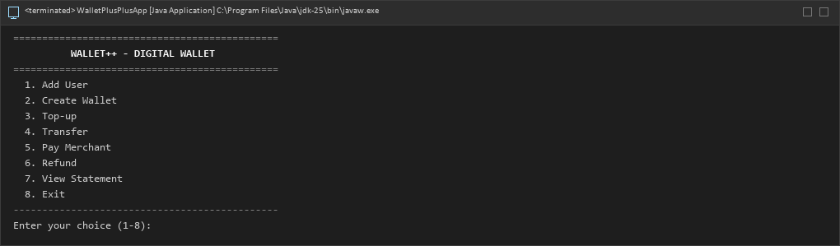
Figure 1: Main menu of Wallet++ showing options 1 to 8.

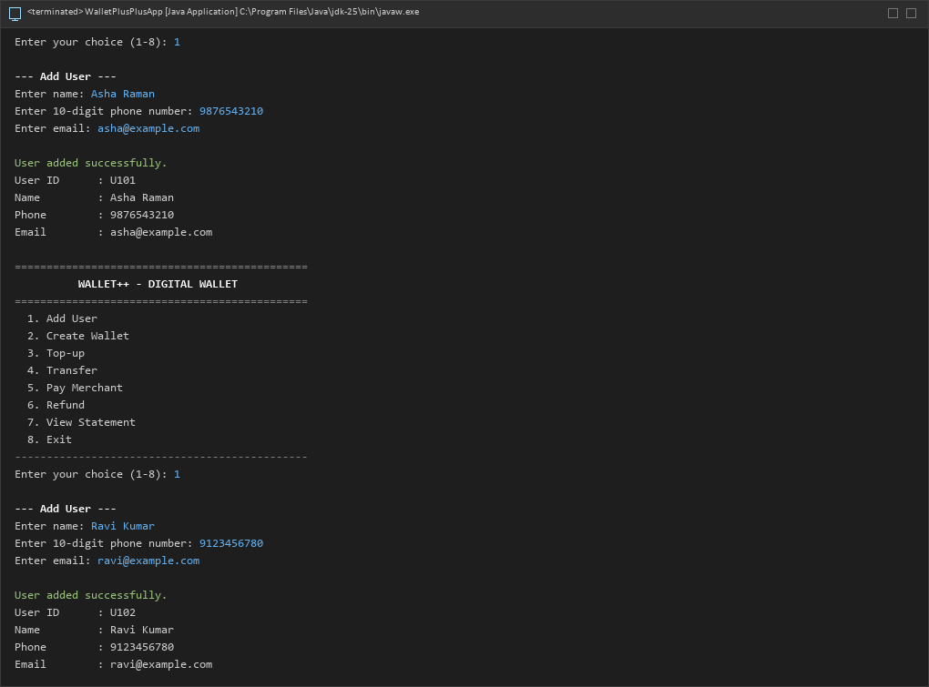
Figure 2: Add User: valid details accepted and User ID U101 generated.

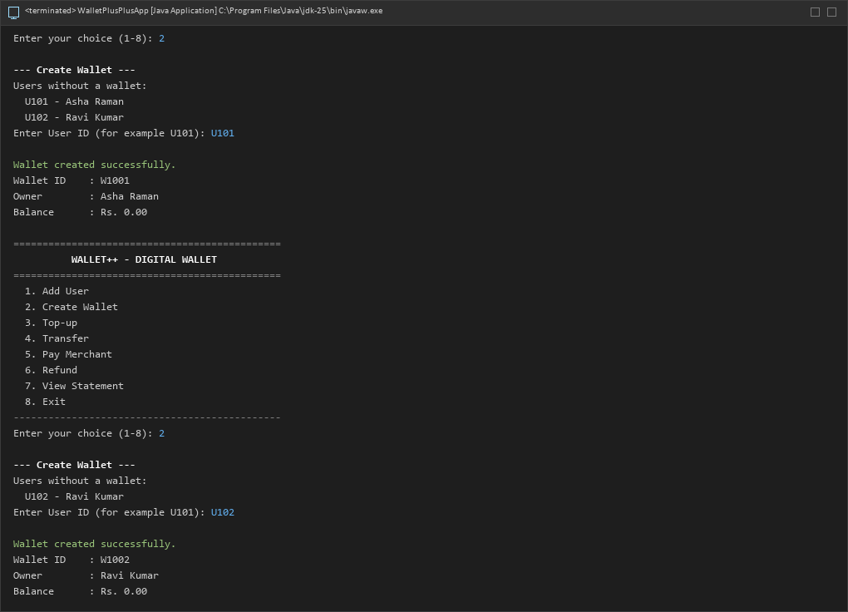
Figure 3: Create Wallet: wallet W1001 created with an opening balance of Rs. 0.00.

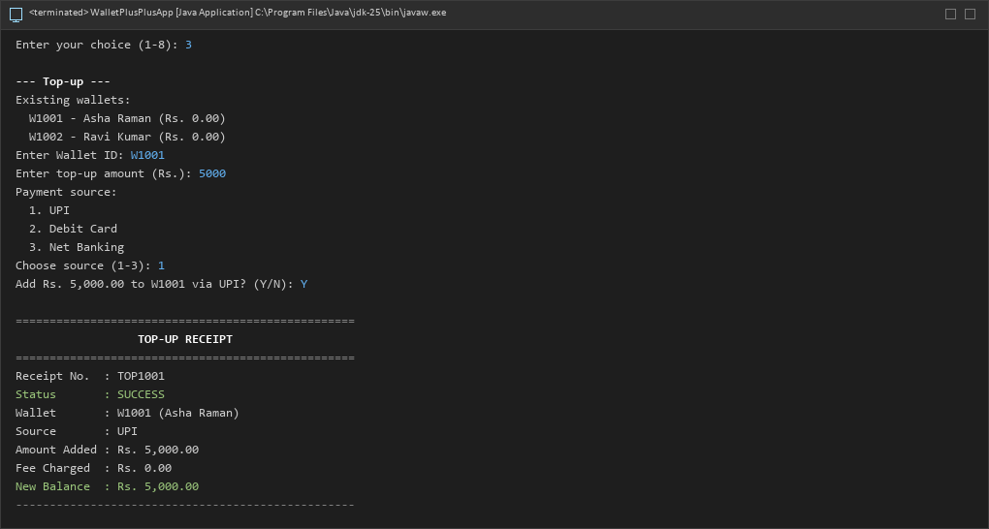
Figure 4: Top-up confirmed (Y): receipt showing amount, fee and resulting balance.

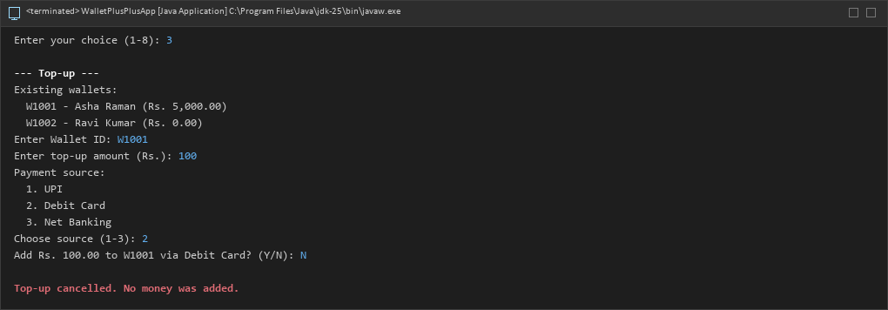
Figure 5: Top-up cancelled (N): no money is added to the wallet.

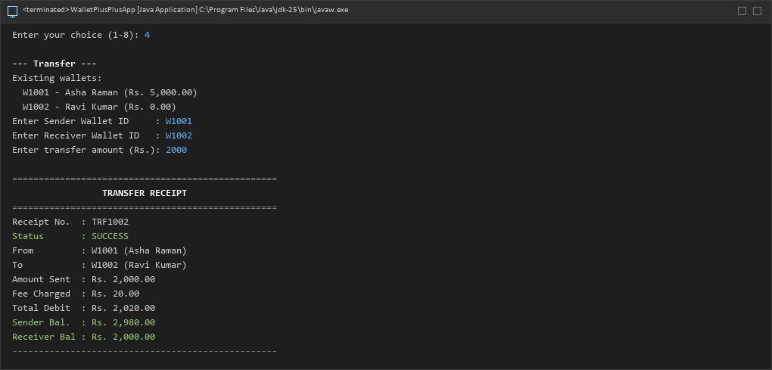
Figure 6: Transfer receipt: amount, 1% fee, total debited and both resulting balances.

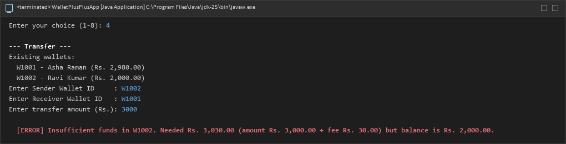
Figure 7: Validation error: transfer rejected for insufficient funds; balances unchanged.

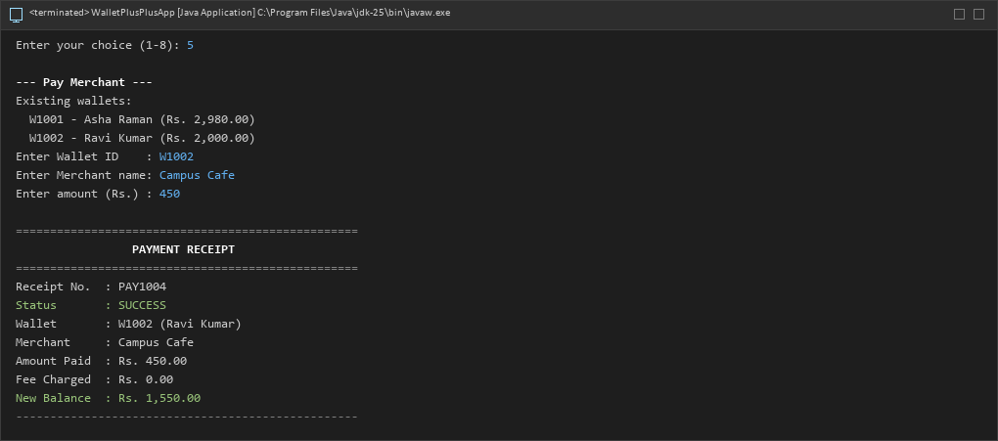
Figure 8: Pay Merchant: payment receipt and reduced wallet balance.

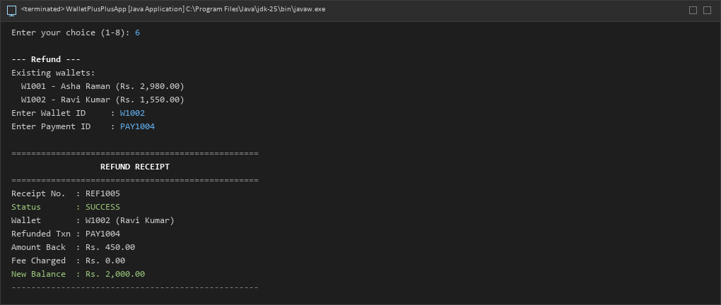
Figure 9: Refund receipt: payment amount credited back to the wallet.

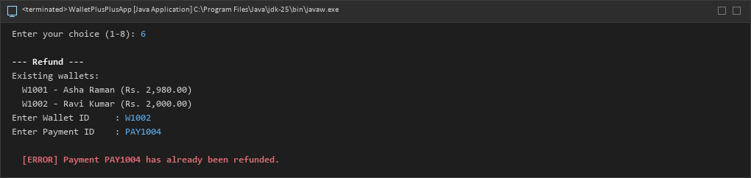
Figure 10: Refund validation: refunding the same payment again is rejected.

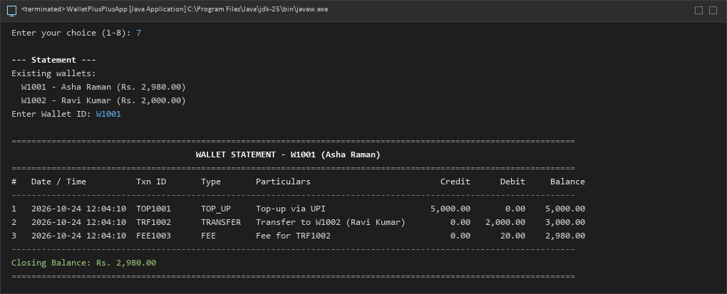
Figure 11: Statement of wallet W1001: chronological entries with running balance.

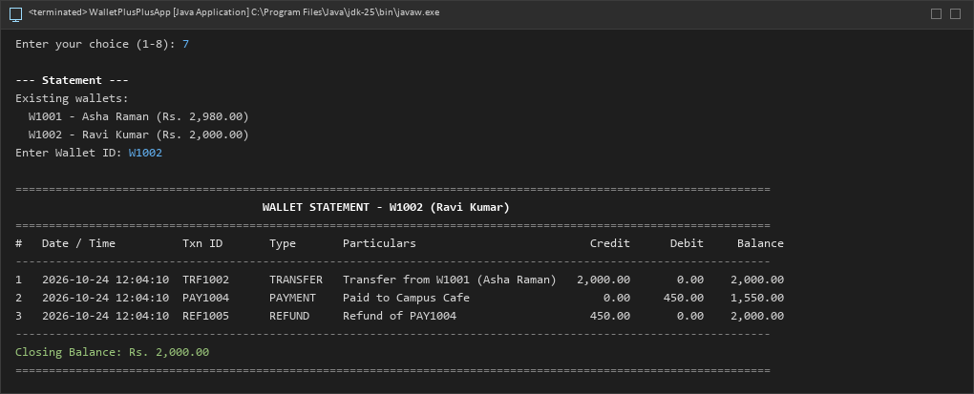
Figure 12: Statement of wallet W1002: transfer in, payment and refund with running balance.

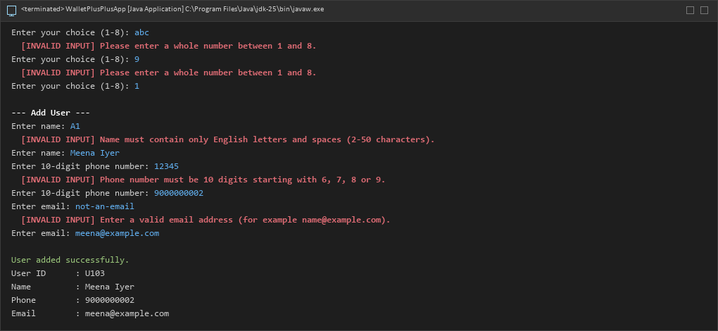
Figure 13: Input validation: invalid menu choice, name, phone and amount are rejected and asked again.

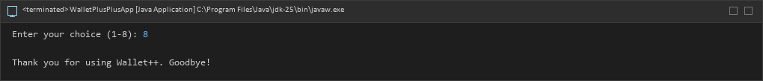
Figure 14: Exit: the program ends gracefully.
4. GitHub Repository Link
(Paste the repository URL. README.md must contain the problem statement, how to compile/run, and your name & roll no.)
GitHub Repository URL: https://github.com/gssriram9050/wallet-plus-plus
README.md contents: problem statement (Specification 29), features, business rules, prerequisites, project structure, compile and run steps for Windows CMD and Eclipse, OOP concepts, assumptions, testing, name and register number.
Student: Sriram G S | Register No.: 717825F152 | Department: Information Technology | II Year / III Semester / Section A
Packages (22 source files): exception (7), util (4), model (9), service (1), main (1).
Compile: javac -d out -sourcepath src src\main\WalletPlusPlusApp.java
Run: java -cp out main.WalletPlusPlusApp

