**CS 303**

**Project 2**

**Gavin Stark**

**Alexandria Piatt**

**April 9, 2017**

**We completed project 2B for this assignment**

**Assumptions:**

* Assumed that the text files to be read in would have consistent formatting depending on the type of file to be read in.
  + Each class has a specifically written input function to read in the correct format.
* Assumed the text files would be in the same directory as the source code
  + No path for the input files are needed if in the same directory.

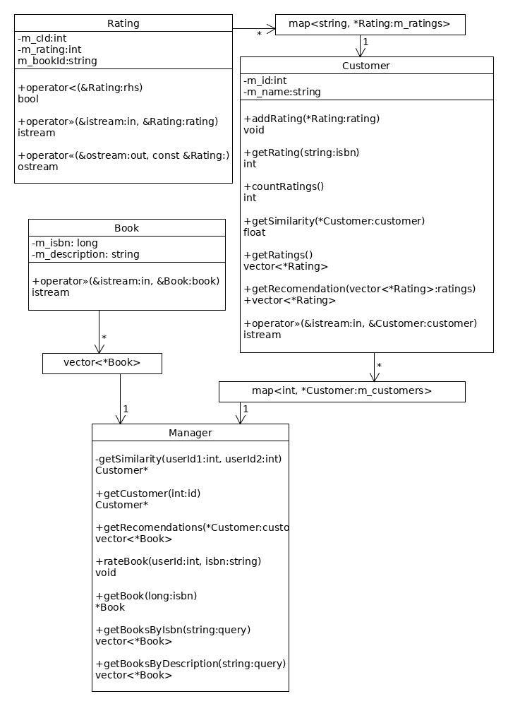

**Efficiency of Algorithms**

**References:**

* Linux Man Pages(a copy can be found here: <https://linux.die.net/>)
* <http://www.cplusplus.com/reference>
* <https://www.tutorialspoint.com/cplusplus/>