**CS 303**

**Project 2**

**Gavin Stark**

**Alexandria Piatt**

**April 9, 2017**

**We completed project 2B for this assignment**

**Assumptions:**

* Assumed that the text files to be read in would have consistent formatting depending on the type of file to be read in.
  + Each class has a specifically written input function to read in the correct format.
* Assumed the text files would be in the same directory as the source code
  + No path for the input files are needed if in the same directory.

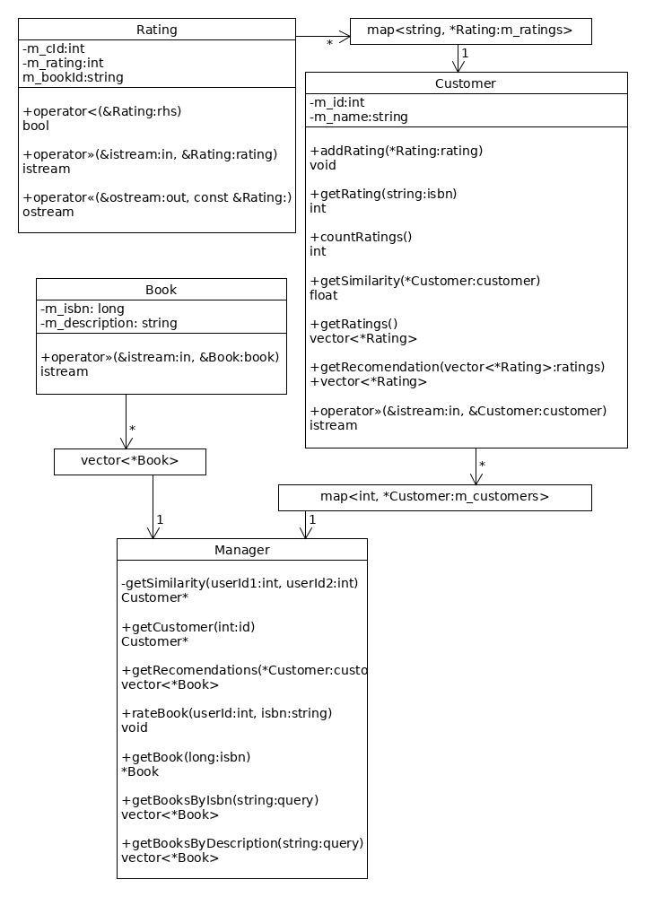

**Efficiency of Algorithms**

Customer::getSimilarity(Customer *customer)

* the method iterates over the internal m_ratings vector and does a calculation for each item (it also references a map object, but reading from the map is O(1)) so O(n)

Customer::getRecomendations(vector<Rating*> ratings)

* the method iterates over the internal m_ratings vector and iterates over the provided ratings vector for each item, making a single push to a third vector for each item not present in the ratings vector, so O(n^2)

Manager::getRecomendations(Customer *customer)

* the method spawns multiple threads (one for each customer object) that call the Customer::getSimilarity and Customer::getRecomendations methods, these are O(n) and O(n^2) respectively. the method also has multiple O(n) and O(n^2) loops, so O(n^3) since n * n^2 = n^3 (number of customers * Customer::getSimilarity)

Manager::getBooksByIsbn and getBooks by Description

* the method iterates over all books in the m_books object performing an O(n^2) string search for each book, so O(n^3)

**Screenshot of Compiled Program**

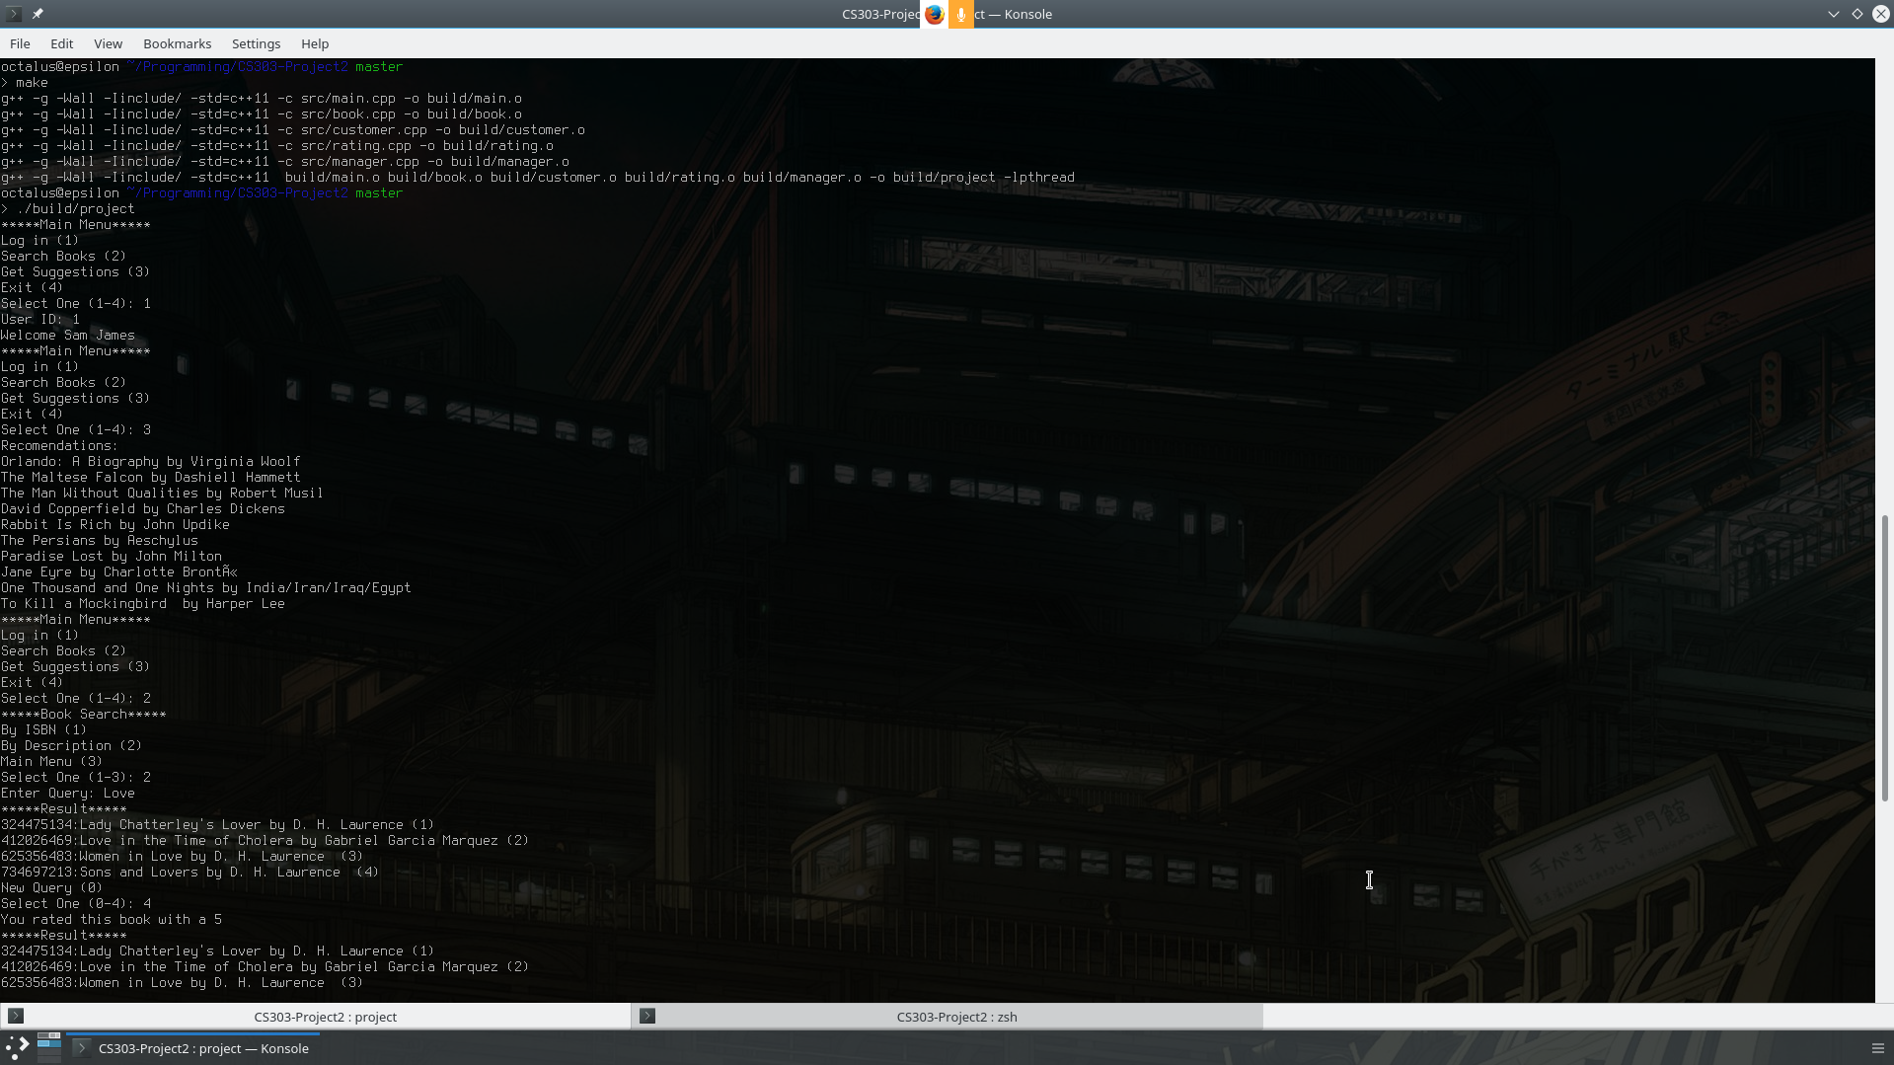

**References:**

* Linux Man Pages(a copy can be found here: <https://linux.die.net/>)
* <http://www.cplusplus.com/reference>
* <https://www.tutorialspoint.com/cplusplus/>