01-A-BHM-Casestudy-ORR-Larotrectinib

Sandro Gsteiger

April 03, 2020

Table of Contents

# Description

Reproduce Bayesian hierarchical model for Larotrectinib ORR data from ERG analysis, NICE STA Committee papers (ID1299).

In addition:

* Fit fixed effects (FE) meta-analysis (MA) model.
* Fit random effects (RE) meta-analysis (MA) with alternative prior 1: Half-normal(sigma = 1).
* Fit random effects (RE) meta-analysis (MA) with alternative prior 2: Half-normal(sigma = 0.5).
* Fit RE MA models to subset of data where only tissues with at least one event and one non-event retained.
* Fit RE MA models to subset of data where only tissues with sample size >= 5 are retained.

The half-normal HN(sigma) is defined as: HN(sigma) = abs(N(Mean = 0, Var = sigma^2))

# Reproduce ERG meta-analysis of ORR data

Read in response rate data extracted from ERG report in NICE Committee papers.

**Table** ORR data included in BHM by ERG

|  |  |  |  |
| --- | --- | --- | --- |
| Tumour type | n | x | orr |
| Soft tissue sarcoma | 20 | 16 | 0.8 |
| Salivary gland | 17 | 15 | 0.88 |
| Infantile fibrosarcoma | 13 | 12 | 0.92 |
| Thyroid | 10 | 7 | 0.7 |
| Lung | 7 | 5 | 0.71 |
| Melanoma | 7 | 3 | 0.43 |
| Colon | 6 | 2 | 0.33 |
| GIST | 5 | 5 | 1 |
| Bone sarcoma | 2 | 1 | 0.5 |
| Cholangiocarcinoma | 2 | 0 | 0 |
| Appendix | 1 | 0 | 0 |
| Breast | 1 | 0 | 0 |
| Congenital mesoblastic nephroma | 1 | 1 | 1 |
| Pancreas | 1 | 0 | 0 |

Total sample size matches ERG analysis: 93.

Global parameters for BHM.

djags <- list(ns = nrow(dorr_erg),  
 r = dorr_erg$x,  
 n = dorr_erg$n)  
  
n_chains <- 3  
n_iter <- 15000  
n_burnin <- 2000  
n_thin <- 1  
  
pars_fe <- c("mu", "p.pop", "p", "theta", "theta.new", "p.new")

Priors selected by ERG, see Section 4.6 (ERG report page 66 (which is page 490 in Committee papers pdf)).

**Note:** there are two inconsistencies in the ERG report page 66 regarding prior distributions:

1. “The prior distribution for p was centred around a probability of 0.3 (a log-odds of -1.3863)”. -> logit(0.3) = -0.847 -> inv.logit(-1.3863) ~= 0.2 (which sounds low) I select p=0.3.
2. They sey they have selected a uniform prior U(0,5) for the random effects variance as suggested by Cunanan (2019). But the recommendation from Cunanan is to put this prior on the heterogeneity sd, not on the var. I will put the U(0,5) on the sd. This leads to the same results as and in particular to the same predictive distribution of a new effect as presented by the ERG. Therefore, I believe the ERG did, in their modelling, put the prior on the sd, while the text contains a slight error.

Fit the random effects MA model used by the ERG.

## module glm loaded

## Compiling model graph  
## Resolving undeclared variables  
## Allocating nodes  
## Graph information:  
## Observed stochastic nodes: 14  
## Unobserved stochastic nodes: 17  
## Total graph size: 70  
##   
## Initializing model

**Results: reproducing the ERG analysis**

**Table** Reproducing ERG analysis: Study specific estimates

|  |  |  |  |
| --- | --- | --- | --- |
| node | est | ci_lo | ci_up |
| Soft tissue sarcoma | 0.78 | 0.59 | 0.92 |
| Salivary gland | 0.85 | 0.65 | 0.96 |
| Infantile fibrosarcoma | 0.87 | 0.66 | 0.98 |
| Thyroid | 0.7 | 0.42 | 0.9 |
| Lung | 0.71 | 0.39 | 0.92 |
| Melanoma | 0.5 | 0.18 | 0.79 |
| Colon | 0.44 | 0.11 | 0.77 |
| GIST | 0.87 | 0.56 | 1 |
| Bone sarcoma | 0.6 | 0.11 | 0.93 |
| Cholangiocarcinoma | 0.35 | 0.0077 | 0.8 |
| Appendix | 0.46 | 0.012 | 0.88 |
| Breast | 0.46 | 0.011 | 0.88 |
| Congenital mesoblastic nephroma | 0.76 | 0.22 | 0.99 |
| Pancreas | 0.46 | 0.011 | 0.88 |
| p.pop | 0.65 | 0.31 | 0.83 |
| p.new | 0.66 | 0.031 | 0.99 |

**Figure** Reproducing ERG analysis: Forest plot 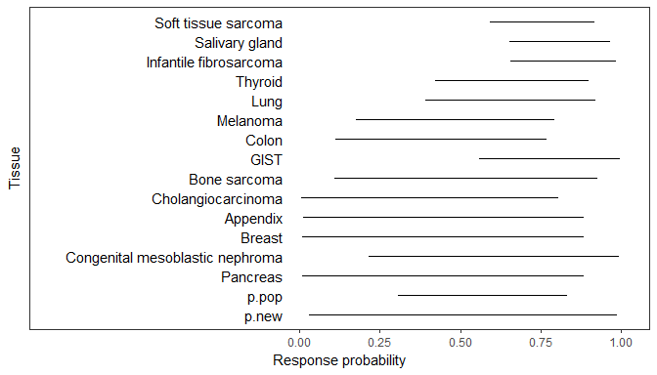

**Table** Reproducing ERG analysis: Threshold probabilities

|  |  |  |  |  |
| --- | --- | --- | --- | --- |
| node | ProbAbove0.1 | ProbAbove0.2 | ProbAbove0.3 | ProbAbove0.5 |
| Soft tissue sarcoma | 1 | 1 | 1 | 0.998 |
| Salivary gland | 1 | 1 | 1 | 1 |
| Infantile fibrosarcoma | 1 | 1 | 1 | 0.999 |
| Thyroid | 1 | 1 | 0.998 | 0.926 |
| Lung | 1 | 0.999 | 0.994 | 0.907 |
| Melanoma | 0.997 | 0.963 | 0.871 | 0.503 |
| Colon | 0.981 | 0.9 | 0.754 | 0.376 |
| GIST | 1 | 1 | 1 | 0.989 |
| Bone sarcoma | 0.979 | 0.932 | 0.864 | 0.653 |
| Cholangiocarcinoma | 0.824 | 0.687 | 0.558 | 0.312 |
| Appendix | 0.875 | 0.777 | 0.677 | 0.456 |
| Breast | 0.873 | 0.773 | 0.671 | 0.453 |
| Congenital mesoblastic nephroma | 0.995 | 0.979 | 0.951 | 0.842 |
| Pancreas | 0.873 | 0.775 | 0.672 | 0.453 |
| p.pop | 0.999 | 0.993 | 0.977 | 0.844 |
| p.new | 0.939 | 0.886 | 0.828 | 0.678 |

**Figure** Reproducing ERG analysis: Density estimates of response probability per tissue 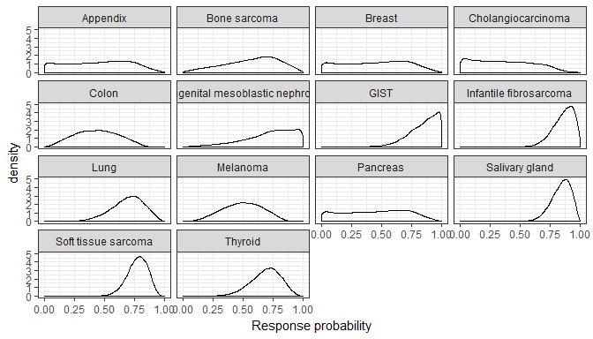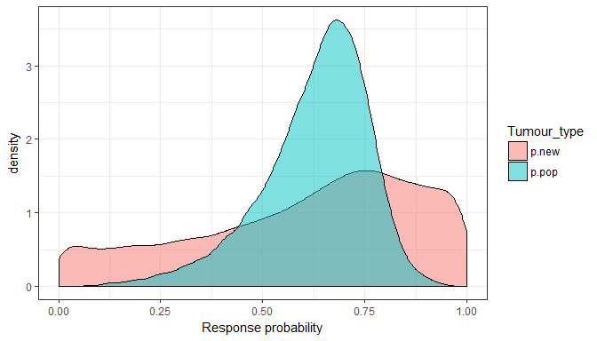

**Figure** Reproducing ERG analysis: Prior and posterior of random effect standard deviation 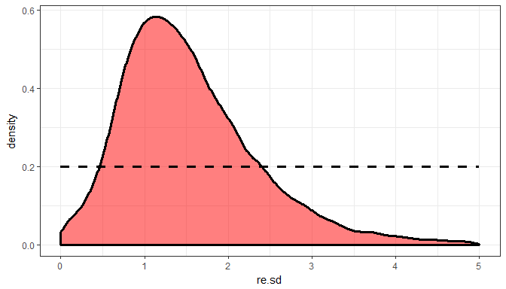

# For comparison: corresponding fixed effect model

## Compiling model graph  
## Resolving undeclared variables  
## Allocating nodes  
## Graph information:  
## Observed stochastic nodes: 14  
## Unobserved stochastic nodes: 1  
## Total graph size: 33  
##   
## Initializing model

**Results: FE model**

**Table** FE model estimates

|  |  |  |  |
| --- | --- | --- | --- |
| node | est | ci_lo | ci_up |
| Soft tissue sarcoma | 0.72 | 0.63 | 0.8 |
| Salivary gland | 0.72 | 0.63 | 0.8 |
| Infantile fibrosarcoma | 0.72 | 0.63 | 0.8 |
| Thyroid | 0.72 | 0.63 | 0.8 |
| Lung | 0.72 | 0.63 | 0.8 |
| Melanoma | 0.72 | 0.63 | 0.8 |
| Colon | 0.72 | 0.63 | 0.8 |
| GIST | 0.72 | 0.63 | 0.8 |
| Bone sarcoma | 0.72 | 0.63 | 0.8 |
| Cholangiocarcinoma | 0.72 | 0.63 | 0.8 |
| Appendix | 0.72 | 0.63 | 0.8 |
| Breast | 0.72 | 0.63 | 0.8 |
| Congenital mesoblastic nephroma | 0.72 | 0.63 | 0.8 |
| Pancreas | 0.72 | 0.63 | 0.8 |
| p.pop | 0.72 | 0.63 | 0.8 |
| p.new | 0.72 | 0.63 | 0.8 |

**Figure** FE model: Forest plot 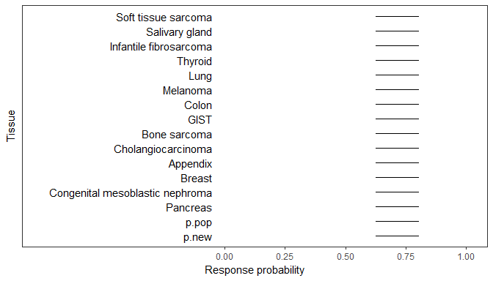

**Table** FE model: Threshold probabilities

|  |  |  |  |  |
| --- | --- | --- | --- | --- |
| node | ProbAbove0.1 | ProbAbove0.2 | ProbAbove0.3 | ProbAbove0.5 |
| Soft tissue sarcoma | 1 | 1 | 1 | 1 |
| Salivary gland | 1 | 1 | 1 | 1 |
| Infantile fibrosarcoma | 1 | 1 | 1 | 1 |
| Thyroid | 1 | 1 | 1 | 1 |
| Lung | 1 | 1 | 1 | 1 |
| Melanoma | 1 | 1 | 1 | 1 |
| Colon | 1 | 1 | 1 | 1 |
| GIST | 1 | 1 | 1 | 1 |
| Bone sarcoma | 1 | 1 | 1 | 1 |
| Cholangiocarcinoma | 1 | 1 | 1 | 1 |
| Appendix | 1 | 1 | 1 | 1 |
| Breast | 1 | 1 | 1 | 1 |
| Congenital mesoblastic nephroma | 1 | 1 | 1 | 1 |
| Pancreas | 1 | 1 | 1 | 1 |
| p.pop | 1 | 1 | 1 | 1 |
| p.new | 1 | 1 | 1 | 1 |

**Figure** FE model: Density estimates of response probability per tissue 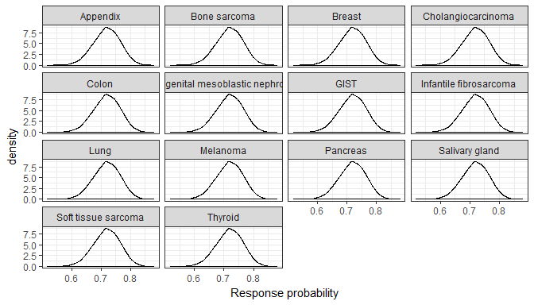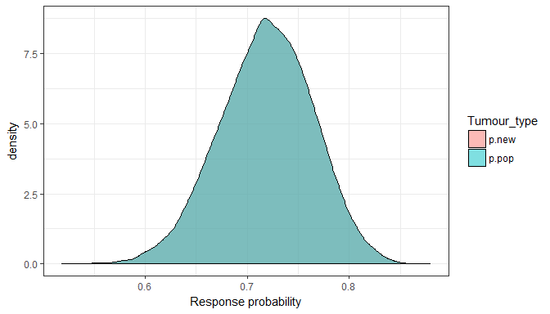

# Alternative prior 1: HN(sigma = 1)

Use the same priors for the population mean mu, but instead of the U(0,5) for RE SD, use a half-normal(sigma = 1).

## Compiling model graph  
## Resolving undeclared variables  
## Allocating nodes  
## Graph information:  
## Observed stochastic nodes: 14  
## Unobserved stochastic nodes: 17  
## Total graph size: 71  
##   
## Initializing model

**Results: Alternative RE prior 1: HN(sigma = 1)**

**Table** Alternative RE prior 1: HN(sigma = 1): response estimates

|  |  |  |  |
| --- | --- | --- | --- |
| node | est | ci_lo | ci_up |
| Soft tissue sarcoma | 0.77 | 0.59 | 0.9 |
| Salivary gland | 0.82 | 0.64 | 0.95 |
| Infantile fibrosarcoma | 0.84 | 0.64 | 0.97 |
| Thyroid | 0.7 | 0.44 | 0.88 |
| Lung | 0.7 | 0.41 | 0.9 |
| Melanoma | 0.55 | 0.22 | 0.79 |
| Colon | 0.51 | 0.16 | 0.78 |
| GIST | 0.81 | 0.55 | 0.98 |
| Bone sarcoma | 0.64 | 0.19 | 0.9 |
| Cholangiocarcinoma | 0.49 | 0.057 | 0.81 |
| Appendix | 0.58 | 0.073 | 0.88 |
| Breast | 0.58 | 0.079 | 0.88 |
| Congenital mesoblastic nephroma | 0.72 | 0.28 | 0.97 |
| Pancreas | 0.58 | 0.073 | 0.88 |
| p.pop | 0.67 | 0.43 | 0.81 |
| p.new | 0.68 | 0.13 | 0.95 |

**Figure** Alternative RE prior 1: HN(sigma = 1): Forest plot 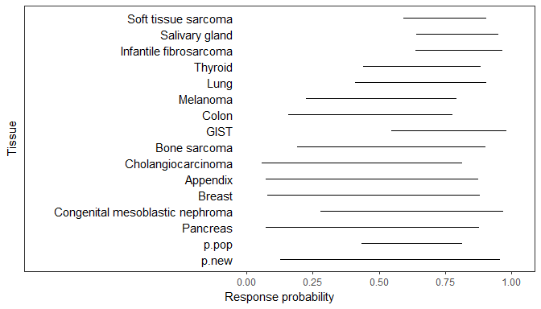

**Table** Alternative RE prior 1: HN(sigma = 1): Threshold probabilities

|  |  |  |  |  |
| --- | --- | --- | --- | --- |
| node | ProbAbove0.1 | ProbAbove0.2 | ProbAbove0.3 | ProbAbove0.5 |
| Soft tissue sarcoma | 1 | 1 | 1 | 0.997 |
| Salivary gland | 1 | 1 | 1 | 1 |
| Infantile fibrosarcoma | 1 | 1 | 1 | 0.999 |
| Thyroid | 1 | 1 | 0.999 | 0.938 |
| Lung | 1 | 1 | 0.997 | 0.92 |
| Melanoma | 0.999 | 0.984 | 0.924 | 0.614 |
| Colon | 0.994 | 0.951 | 0.854 | 0.513 |
| GIST | 1 | 1 | 1 | 0.988 |
| Bone sarcoma | 0.994 | 0.973 | 0.928 | 0.746 |
| Cholangiocarcinoma | 0.948 | 0.86 | 0.753 | 0.484 |
| Appendix | 0.963 | 0.903 | 0.829 | 0.613 |
| Breast | 0.964 | 0.903 | 0.826 | 0.613 |
| Congenital mesoblastic nephroma | 0.997 | 0.99 | 0.97 | 0.869 |
| Pancreas | 0.962 | 0.903 | 0.827 | 0.612 |
| p.pop | 1 | 1 | 0.998 | 0.934 |
| p.new | 0.982 | 0.953 | 0.909 | 0.767 |

**Figure** Alternative RE prior 1: HN(sigma = 1): Density estimates of response probability per tissue 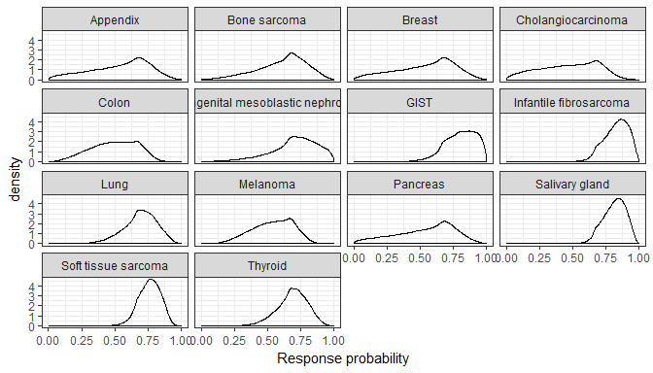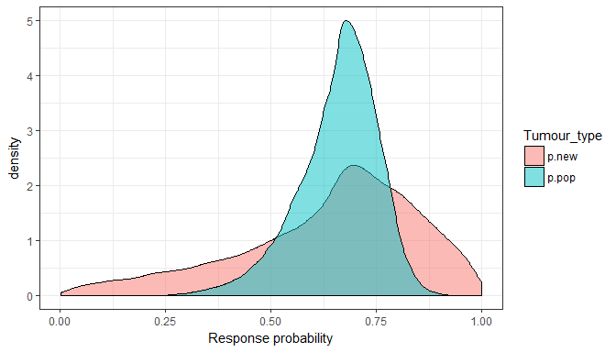

**Figure** Alternative RE prior 1: HN(sigma = 1): Prior and posterior of random effect standard deviation 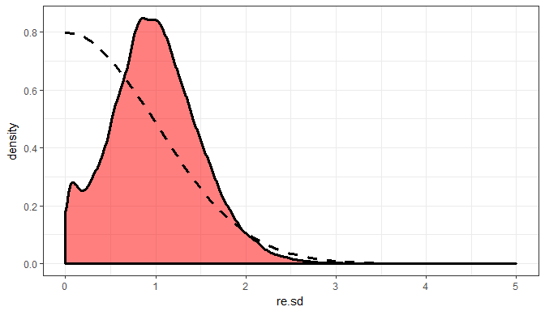

# Alternative prior 2: HN(sigma = 0.5)

Use the same priors for the population mean mu, but instead of the U(0,5) for RE SD, use a half-normal(sigma = 0.5).

## Compiling model graph  
## Resolving undeclared variables  
## Allocating nodes  
## Graph information:  
## Observed stochastic nodes: 14  
## Unobserved stochastic nodes: 17  
## Total graph size: 71  
##   
## Initializing model

**Results: Alternative RE prior 2: HN(sigma = 0.5)**

**Table** Alternative RE prior 2: HN(sigma = 0.5): response estimates

|  |  |  |  |
| --- | --- | --- | --- |
| node | est | ci_lo | ci_up |
| Soft tissue sarcoma | 0.75 | 0.59 | 0.89 |
| Salivary gland | 0.79 | 0.62 | 0.93 |
| Infantile fibrosarcoma | 0.8 | 0.62 | 0.94 |
| Thyroid | 0.7 | 0.46 | 0.87 |
| Lung | 0.71 | 0.45 | 0.88 |
| Melanoma | 0.61 | 0.29 | 0.81 |
| Colon | 0.59 | 0.24 | 0.8 |
| GIST | 0.77 | 0.55 | 0.95 |
| Bone sarcoma | 0.67 | 0.29 | 0.88 |
| Cholangiocarcinoma | 0.6 | 0.16 | 0.83 |
| Appendix | 0.65 | 0.2 | 0.86 |
| Breast | 0.65 | 0.2 | 0.86 |
| Congenital mesoblastic nephroma | 0.72 | 0.36 | 0.93 |
| Pancreas | 0.65 | 0.2 | 0.86 |
| p.pop | 0.69 | 0.51 | 0.81 |
| p.new | 0.7 | 0.27 | 0.91 |

**Figure** Alternative RE prior 2: HN(sigma = 0.5): Forest plot 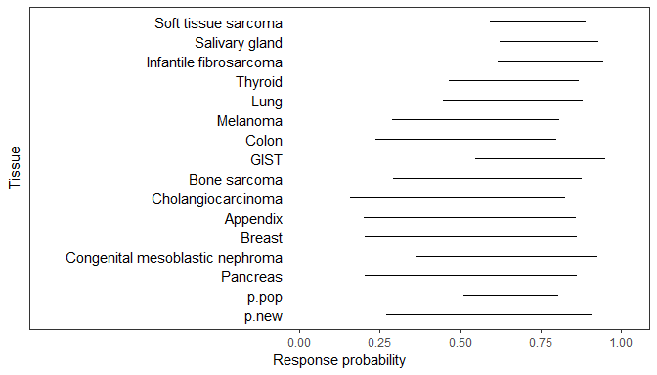

**Table** Alternative RE prior 2: HN(sigma = 0.5): Threshold probabilities

|  |  |  |  |  |
| --- | --- | --- | --- | --- |
| node | ProbAbove0.1 | ProbAbove0.2 | ProbAbove0.3 | ProbAbove0.5 |
| Soft tissue sarcoma | 1 | 1 | 1 | 0.998 |
| Salivary gland | 1 | 1 | 1 | 0.999 |
| Infantile fibrosarcoma | 1 | 1 | 1 | 0.999 |
| Thyroid | 1 | 1 | 0.999 | 0.957 |
| Lung | 1 | 1 | 0.998 | 0.947 |
| Melanoma | 1 | 0.995 | 0.971 | 0.755 |
| Colon | 0.999 | 0.987 | 0.942 | 0.687 |
| GIST | 1 | 1 | 1 | 0.988 |
| Bone sarcoma | 0.999 | 0.994 | 0.972 | 0.844 |
| Cholangiocarcinoma | 0.99 | 0.96 | 0.904 | 0.688 |
| Appendix | 0.994 | 0.976 | 0.94 | 0.773 |
| Breast | 0.995 | 0.976 | 0.939 | 0.773 |
| Congenital mesoblastic nephroma | 1 | 0.996 | 0.987 | 0.913 |
| Pancreas | 0.994 | 0.976 | 0.94 | 0.777 |
| p.pop | 1 | 1 | 1 | 0.979 |
| p.new | 0.998 | 0.988 | 0.968 | 0.863 |

**Figure** Alternative RE prior 2: HN(sigma = 0.5): Density estimates of response probability per tissue 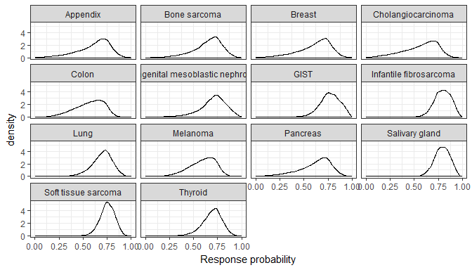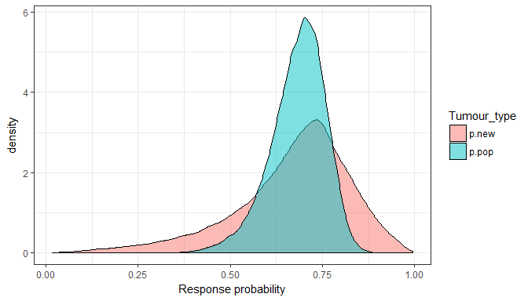

**Figure** Alternative RE prior 2: HN(sigma = 0.5): Prior and posterior of random effect standard deviation 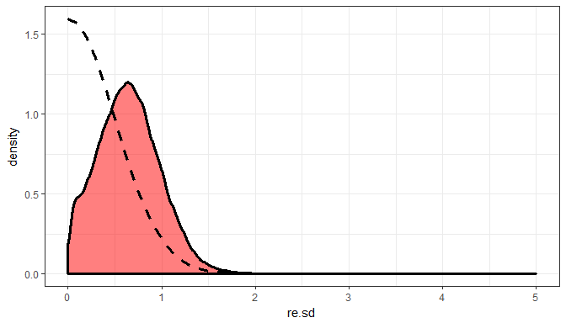

# At least one event/non-event (but with ERG prior)

ERG model applied to a reduced data set: contains only tissue types with at least 1 event and 1 non-event. This means the analysis data set is the following.

**Table** ORR data (reduced set)

|  |  |  |  |
| --- | --- | --- | --- |
| Tumour type | n | x | orr |
| Soft tissue sarcoma | 20 | 16 | 0.8 |
| Salivary gland | 17 | 15 | 0.88 |
| Infantile fibrosarcoma | 13 | 12 | 0.92 |
| Thyroid | 10 | 7 | 0.7 |
| Lung | 7 | 5 | 0.71 |
| Melanoma | 7 | 3 | 0.43 |
| Colon | 6 | 2 | 0.33 |
| Bone sarcoma | 2 | 1 | 0.5 |

## Compiling model graph  
## Resolving undeclared variables  
## Allocating nodes  
## Graph information:  
## Observed stochastic nodes: 8  
## Unobserved stochastic nodes: 11  
## Total graph size: 46  
##   
## Initializing model

**Results: Reduced data set**

**Table** Reduced data set: response estimates

|  |  |  |  |
| --- | --- | --- | --- |
| node | est | ci_lo | ci_up |
| Soft tissue sarcoma | 0.78 | 0.6 | 0.91 |
| Salivary gland | 0.83 | 0.65 | 0.96 |
| Infantile fibrosarcoma | 0.84 | 0.65 | 0.97 |
| Thyroid | 0.72 | 0.46 | 0.89 |
| Lung | 0.73 | 0.43 | 0.91 |
| Melanoma | 0.59 | 0.22 | 0.82 |
| Colon | 0.55 | 0.16 | 0.81 |
| Bone sarcoma | 0.69 | 0.2 | 0.92 |
| p.pop | 0.72 | 0.46 | 0.87 |
| p.new | 0.73 | 0.13 | 0.97 |

**Figure** Reduced data set: Forest plot 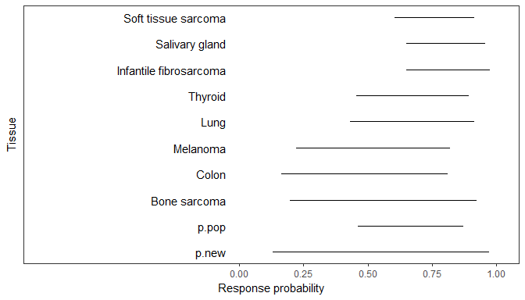

**Table** Reduced data set: Threshold probabilities

|  |  |  |  |  |
| --- | --- | --- | --- | --- |
| node | ProbAbove0.1 | ProbAbove0.2 | ProbAbove0.3 | ProbAbove0.5 |
| Soft tissue sarcoma | 1 | 1 | 1 | 0.998 |
| Salivary gland | 1 | 1 | 1 | 1 |
| Infantile fibrosarcoma | 1 | 1 | 1 | 0.999 |
| Thyroid | 1 | 1 | 0.999 | 0.952 |
| Lung | 1 | 1 | 0.997 | 0.94 |
| Melanoma | 0.999 | 0.983 | 0.936 | 0.675 |
| Colon | 0.993 | 0.958 | 0.877 | 0.584 |
| Bone sarcoma | 0.994 | 0.975 | 0.942 | 0.797 |
| p.pop | 1 | 0.999 | 0.996 | 0.961 |
| p.new | 0.981 | 0.959 | 0.93 | 0.825 |

**Figure** Reduced data set: Density estimates of response probability per tissue 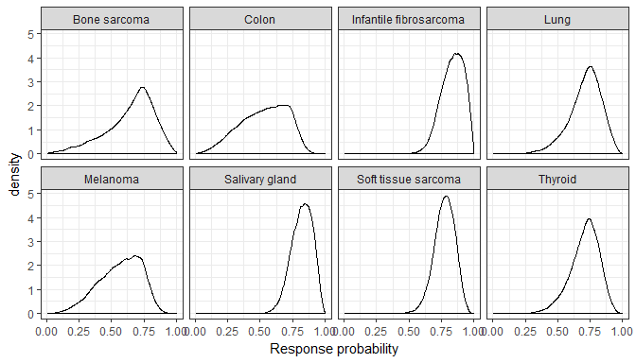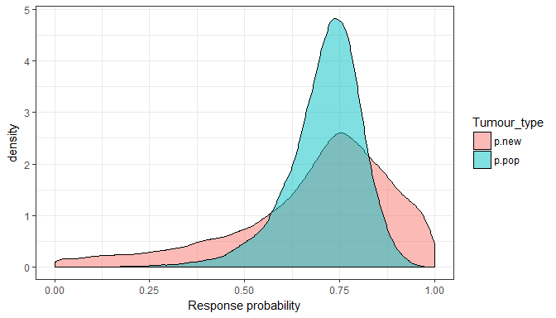

**Figure** Reduced data set: Prior and posterior of random effect standard deviation 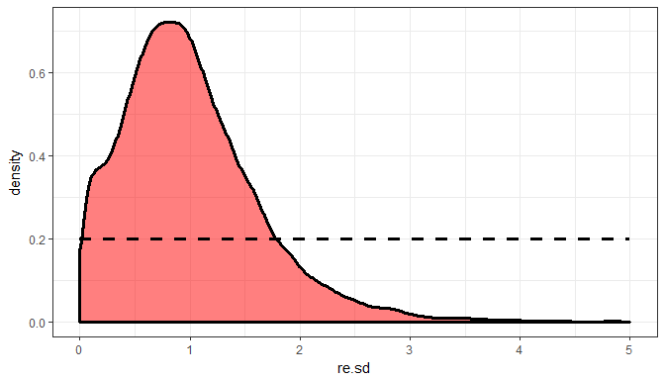

# At least one event/non-event and with alternative prior 1: HN(sigma = 1)

## Compiling model graph  
## Resolving undeclared variables  
## Allocating nodes  
## Graph information:  
## Observed stochastic nodes: 8  
## Unobserved stochastic nodes: 11  
## Total graph size: 47  
##   
## Initializing model

**Results: Reduced data set and Alternative RE prior 1: HN(sigma = 1)**

**Table** Reduced data set and Alternative RE prior 1: HN(sigma = 1): response estimates

|  |  |  |  |
| --- | --- | --- | --- |
| node | est | ci_lo | ci_up |
| Soft tissue sarcoma | 0.77 | 0.6 | 0.9 |
| Salivary gland | 0.81 | 0.64 | 0.94 |
| Infantile fibrosarcoma | 0.82 | 0.64 | 0.96 |
| Thyroid | 0.72 | 0.48 | 0.88 |
| Lung | 0.73 | 0.46 | 0.9 |
| Melanoma | 0.62 | 0.27 | 0.82 |
| Colon | 0.59 | 0.22 | 0.82 |
| Bone sarcoma | 0.7 | 0.28 | 0.9 |
| p.pop | 0.72 | 0.52 | 0.85 |
| p.new | 0.73 | 0.26 | 0.95 |

**Figure** Reduced data set and Alternative RE prior 1: HN(sigma = 1): Forest plot 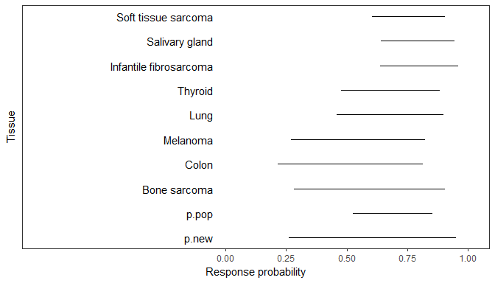

**Table** Reduced data set and Alternative RE prior 1: HN(sigma = 1): Threshold probabilities

|  |  |  |  |  |
| --- | --- | --- | --- | --- |
| node | ProbAbove0.1 | ProbAbove0.2 | ProbAbove0.3 | ProbAbove0.5 |
| Soft tissue sarcoma | 1 | 1 | 1 | 0.999 |
| Salivary gland | 1 | 1 | 1 | 1 |
| Infantile fibrosarcoma | 1 | 1 | 1 | 0.999 |
| Thyroid | 1 | 1 | 1 | 0.964 |
| Lung | 1 | 1 | 0.999 | 0.955 |
| Melanoma | 1 | 0.992 | 0.962 | 0.756 |
| Colon | 0.998 | 0.981 | 0.931 | 0.682 |
| Bone sarcoma | 0.999 | 0.99 | 0.971 | 0.854 |
| p.pop | 1 | 1 | 0.999 | 0.984 |
| p.new | 0.996 | 0.985 | 0.966 | 0.877 |

**Figure** Reduced data set and Alternative RE prior 1: HN(sigma = 1): Density estimates of response probability per tissue 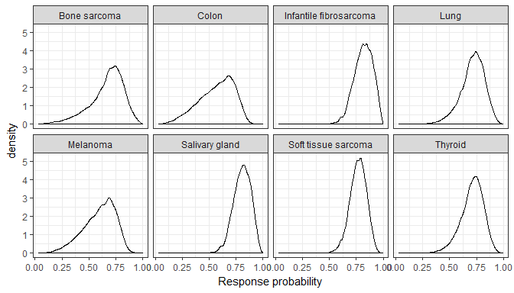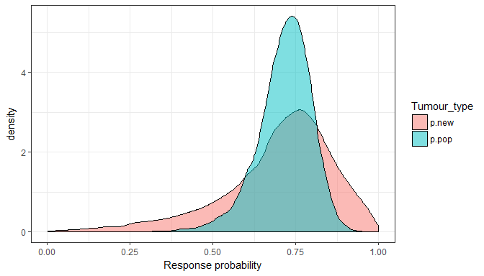

**Figure** Reduced data set and Alternative RE prior 1: HN(sigma = 1): Prior and posterior of random effect standard deviation 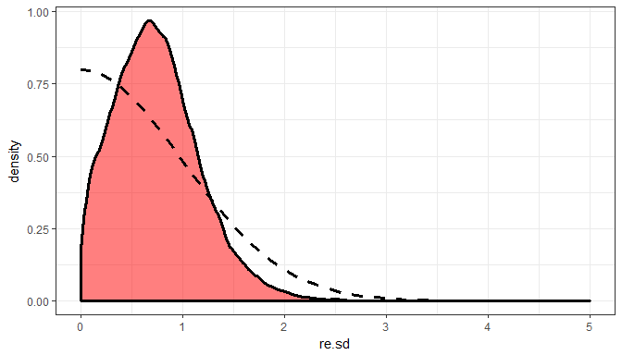

# At least one event/non-event and with alternative prior 2: HN(sigma = 0.5)

## Compiling model graph  
## Resolving undeclared variables  
## Allocating nodes  
## Graph information:  
## Observed stochastic nodes: 8  
## Unobserved stochastic nodes: 11  
## Total graph size: 47  
##   
## Initializing model

**Results: Reduced data set and Alternative RE prior 2: HN(sigma = 0.5)**

**Table** Reduced data set and Alternative RE prior 2: HN(sigma = 0.5): response estimates

|  |  |  |  |
| --- | --- | --- | --- |
| node | est | ci_lo | ci_up |
| Soft tissue sarcoma | 0.76 | 0.61 | 0.88 |
| Salivary gland | 0.79 | 0.64 | 0.92 |
| Infantile fibrosarcoma | 0.79 | 0.64 | 0.93 |
| Thyroid | 0.73 | 0.51 | 0.86 |
| Lung | 0.73 | 0.51 | 0.88 |
| Melanoma | 0.67 | 0.36 | 0.83 |
| Colon | 0.66 | 0.32 | 0.82 |
| Bone sarcoma | 0.72 | 0.39 | 0.88 |
| p.pop | 0.73 | 0.58 | 0.84 |
| p.new | 0.73 | 0.4 | 0.91 |

**Figure** Reduced data set and Alternative RE prior 2: HN(sigma = 0.5): Forest plot 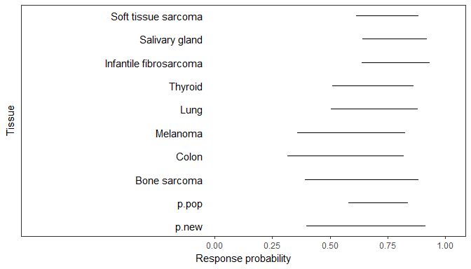

**Table** Reduced data set and Alternative RE prior 2: HN(sigma = 0.5): Threshold probabilities

|  |  |  |  |  |
| --- | --- | --- | --- | --- |
| node | ProbAbove0.1 | ProbAbove0.2 | ProbAbove0.3 | ProbAbove0.5 |
| Soft tissue sarcoma | 1 | 1 | 1 | 0.999 |
| Salivary gland | 1 | 1 | 1 | 1 |
| Infantile fibrosarcoma | 1 | 1 | 1 | 0.999 |
| Thyroid | 1 | 1 | 1 | 0.979 |
| Lung | 1 | 1 | 1 | 0.978 |
| Melanoma | 1 | 0.998 | 0.989 | 0.877 |
| Colon | 1 | 0.997 | 0.98 | 0.832 |
| Bone sarcoma | 1 | 0.998 | 0.991 | 0.929 |
| p.pop | 1 | 1 | 1 | 0.996 |
| p.new | 1 | 0.998 | 0.991 | 0.94 |

**Figure** Reduced data set and Alternative RE prior 2: HN(sigma = 0.5): Density estimates of response probability per tissue 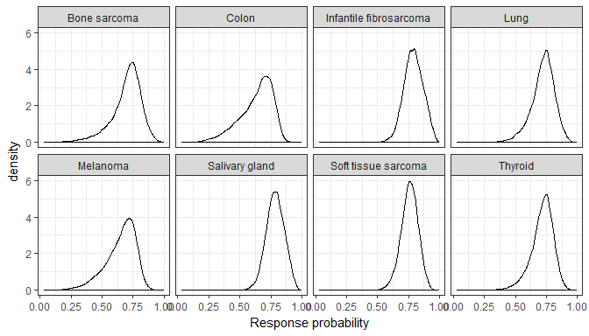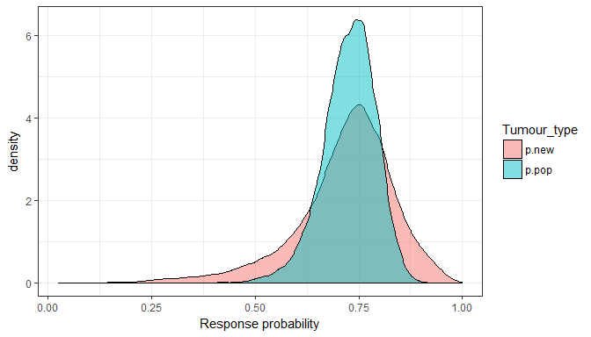

**Figure** Reduced data set and Alternative RE prior 2: HN(sigma = 0.5): Prior and posterior of random effect standard deviation 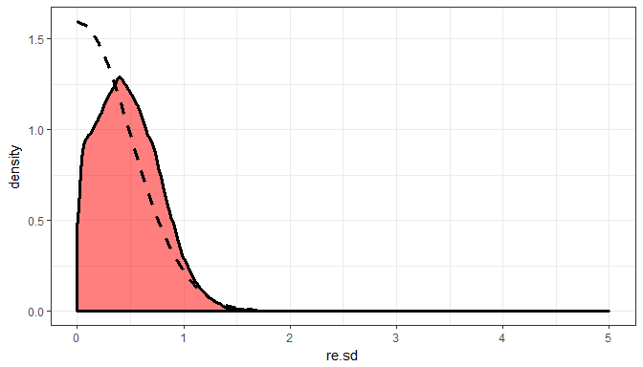

# Minimal size of 5 (but with ERG prior)

ERG model applied to a reduced data set: contains only tissue types with at least five observations. This means the analysis data set is the following.

**Table** ORR data (reduced to tissues with size >= 5)

|  |  |  |  |
| --- | --- | --- | --- |
| Tumour type | n | x | orr |
| Soft tissue sarcoma | 20 | 16 | 0.8 |
| Salivary gland | 17 | 15 | 0.88 |
| Infantile fibrosarcoma | 13 | 12 | 0.92 |
| Thyroid | 10 | 7 | 0.7 |
| Lung | 7 | 5 | 0.71 |
| Melanoma | 7 | 3 | 0.43 |
| Colon | 6 | 2 | 0.33 |
| GIST | 5 | 5 | 1 |

## Compiling model graph  
## Resolving undeclared variables  
## Allocating nodes  
## Graph information:  
## Observed stochastic nodes: 8  
## Unobserved stochastic nodes: 11  
## Total graph size: 46  
##   
## Initializing model

**Results: subset (n>=5)**

**Table** subset (n>=5): response estimates

|  |  |  |  |
| --- | --- | --- | --- |
| node | est | ci_lo | ci_up |
| Soft tissue sarcoma | 0.79 | 0.61 | 0.92 |
| Salivary gland | 0.85 | 0.67 | 0.96 |
| Infantile fibrosarcoma | 0.87 | 0.68 | 0.98 |
| Thyroid | 0.73 | 0.46 | 0.9 |
| Lung | 0.74 | 0.43 | 0.93 |
| Melanoma | 0.58 | 0.22 | 0.83 |
| Colon | 0.54 | 0.16 | 0.82 |
| GIST | 0.87 | 0.6 | 0.99 |
| p.pop | 0.76 | 0.51 | 0.91 |
| p.new | 0.76 | 0.12 | 0.99 |

**Figure** subset (n>=5): Forest plot 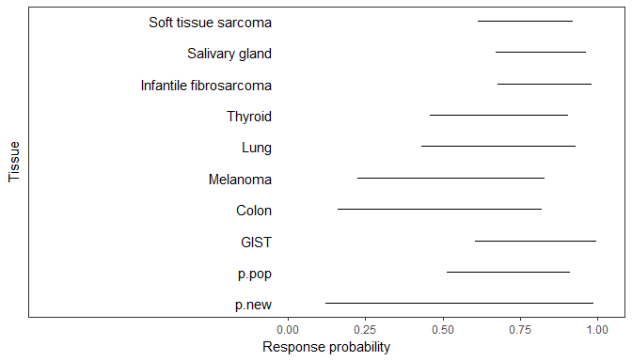

**Table** subset (n>=5): Threshold probabilities

|  |  |  |  |  |
| --- | --- | --- | --- | --- |
| node | ProbAbove0.1 | ProbAbove0.2 | ProbAbove0.3 | ProbAbove0.5 |
| Soft tissue sarcoma | 1 | 1 | 1 | 0.998 |
| Salivary gland | 1 | 1 | 1 | 1 |
| Infantile fibrosarcoma | 1 | 1 | 1 | 1 |
| Thyroid | 1 | 1 | 0.999 | 0.953 |
| Lung | 1 | 0.999 | 0.997 | 0.943 |
| Melanoma | 0.999 | 0.983 | 0.933 | 0.663 |
| Colon | 0.993 | 0.954 | 0.868 | 0.566 |
| GIST | 1 | 1 | 1 | 0.995 |
| p.pop | 1 | 0.999 | 0.998 | 0.979 |
| p.new | 0.979 | 0.958 | 0.93 | 0.838 |

**Figure** subset (n>=5): Density estimates of response probability per tissue 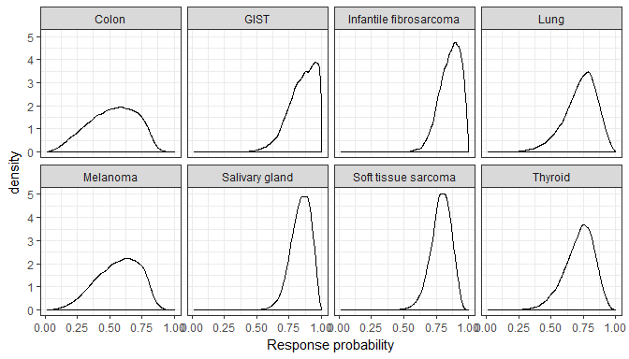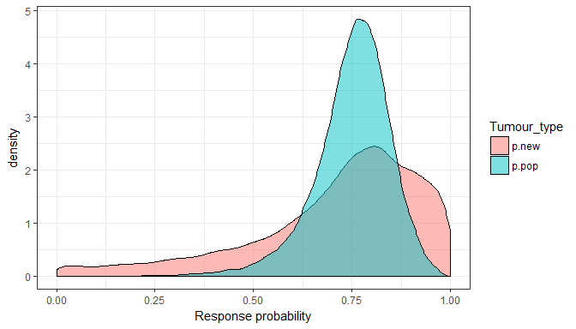

**Figure** subset (n>=5): Prior and posterior of random effect standard deviation 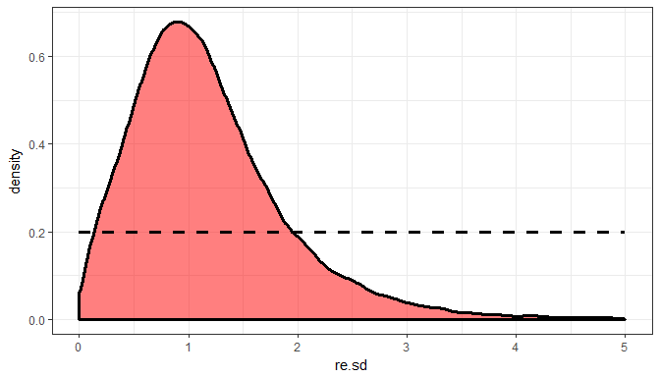

# Minimal size of 5 and with alternative prior 1: HN(sigma = 1)

## Compiling model graph  
## Resolving undeclared variables  
## Allocating nodes  
## Graph information:  
## Observed stochastic nodes: 8  
## Unobserved stochastic nodes: 11  
## Total graph size: 47  
##   
## Initializing model

**Results: subset (n>=5) and Alternative RE prior 1: HN(sigma = 1)**

**Table** subset (n>=5) and Alternative RE prior 1: HN(sigma = 1): response estimates

|  |  |  |  |
| --- | --- | --- | --- |
| node | est | ci_lo | ci_up |
| Soft tissue sarcoma | 0.79 | 0.62 | 0.91 |
| Salivary gland | 0.83 | 0.67 | 0.95 |
| Infantile fibrosarcoma | 0.84 | 0.66 | 0.97 |
| Thyroid | 0.74 | 0.49 | 0.9 |
| Lung | 0.75 | 0.47 | 0.91 |
| Melanoma | 0.63 | 0.28 | 0.84 |
| Colon | 0.6 | 0.22 | 0.83 |
| GIST | 0.83 | 0.6 | 0.98 |
| p.pop | 0.76 | 0.58 | 0.88 |
| p.new | 0.76 | 0.28 | 0.97 |

**Figure** subset (n>=5) and Alternative RE prior 1: HN(sigma = 1): Forest plot 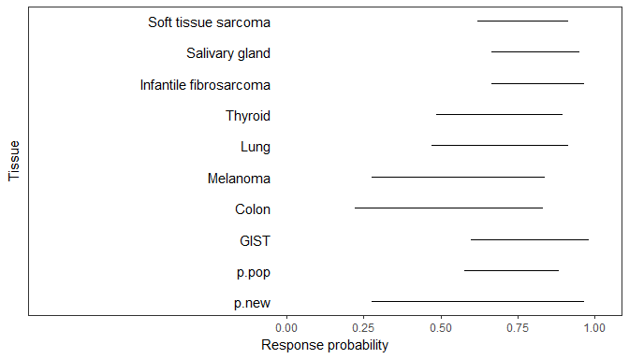

**Table** subset (n>=5) and Alternative RE prior 1: HN(sigma = 1): Threshold probabilities

|  |  |  |  |  |
| --- | --- | --- | --- | --- |
| node | ProbAbove0.1 | ProbAbove0.2 | ProbAbove0.3 | ProbAbove0.5 |
| Soft tissue sarcoma | 1 | 1 | 1 | 0.999 |
| Salivary gland | 1 | 1 | 1 | 1 |
| Infantile fibrosarcoma | 1 | 1 | 1 | 1 |
| Thyroid | 1 | 1 | 1 | 0.97 |
| Lung | 1 | 1 | 0.999 | 0.964 |
| Melanoma | 0.999 | 0.993 | 0.966 | 0.767 |
| Colon | 0.998 | 0.982 | 0.932 | 0.694 |
| GIST | 1 | 1 | 1 | 0.995 |
| p.pop | 1 | 1 | 1 | 0.994 |
| p.new | 0.995 | 0.986 | 0.971 | 0.899 |

**Figure** subset (n>=5) and Alternative RE prior 1: HN(sigma = 1): Density estimates of response probability per tissue 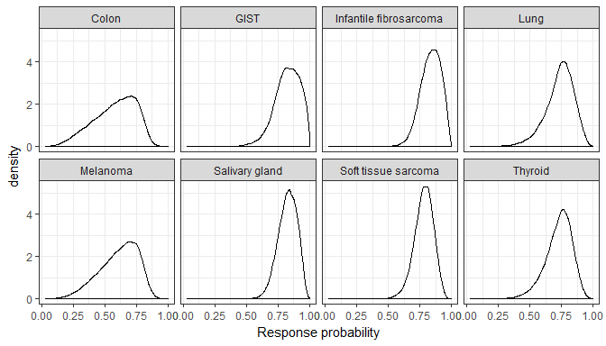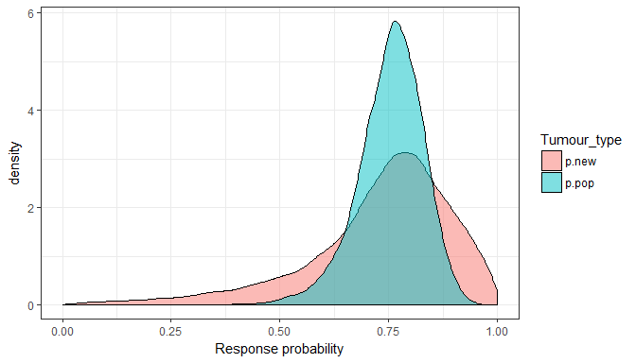

**Figure** subset (n>=5) and Alternative RE prior 1: HN(sigma = 1): Prior and posterior of random effect standard deviation 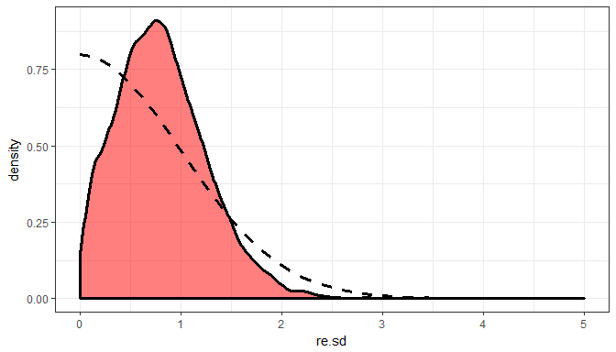

# Minimal size of 5 and with alternative prior 2: HN(sigma = 0.5)

## Compiling model graph  
## Resolving undeclared variables  
## Allocating nodes  
## Graph information:  
## Observed stochastic nodes: 8  
## Unobserved stochastic nodes: 11  
## Total graph size: 47  
##   
## Initializing model

**Results: subset (n>=5) and Alternative RE prior 2: HN(sigma = 0.5)**

**Table** subset (n>=5) and Alternative RE prior 2: HN(sigma = 0.5): response estimates

|  |  |  |  |
| --- | --- | --- | --- |
| node | est | ci_lo | ci_up |
| Soft tissue sarcoma | 0.78 | 0.63 | 0.9 |
| Salivary gland | 0.8 | 0.66 | 0.93 |
| Infantile fibrosarcoma | 0.81 | 0.66 | 0.94 |
| Thyroid | 0.75 | 0.53 | 0.88 |
| Lung | 0.75 | 0.52 | 0.89 |
| Melanoma | 0.69 | 0.37 | 0.84 |
| Colon | 0.68 | 0.32 | 0.83 |
| GIST | 0.8 | 0.61 | 0.95 |
| p.pop | 0.76 | 0.62 | 0.86 |
| p.new | 0.76 | 0.42 | 0.93 |

**Figure** subset (n>=5) and Alternative RE prior 2: HN(sigma = 0.5): Forest plot 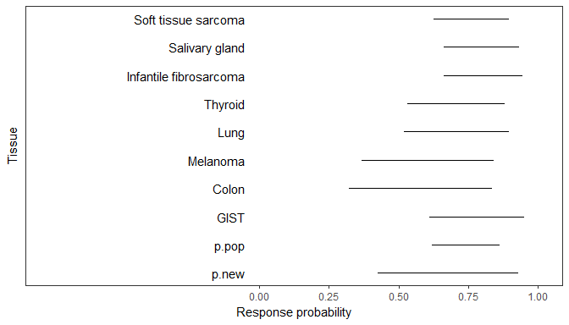

**Table** subset (n>=5) and Alternative RE prior 2: HN(sigma = 0.5): Threshold probabilities

|  |  |  |  |  |
| --- | --- | --- | --- | --- |
| node | ProbAbove0.1 | ProbAbove0.2 | ProbAbove0.3 | ProbAbove0.5 |
| Soft tissue sarcoma | 1 | 1 | 1 | 0.999 |
| Salivary gland | 1 | 1 | 1 | 1 |
| Infantile fibrosarcoma | 1 | 1 | 1 | 0.999 |
| Thyroid | 1 | 1 | 1 | 0.985 |
| Lung | 1 | 1 | 0.999 | 0.982 |
| Melanoma | 1 | 0.999 | 0.991 | 0.89 |
| Colon | 1 | 0.996 | 0.981 | 0.852 |
| GIST | 1 | 1 | 1 | 0.997 |
| p.pop | 1 | 1 | 1 | 0.999 |
| p.new | 1 | 0.997 | 0.992 | 0.954 |

**Figure** subset (n>=5) and Alternative RE prior 2: HN(sigma = 0.5): Density estimates of response probability per tissue 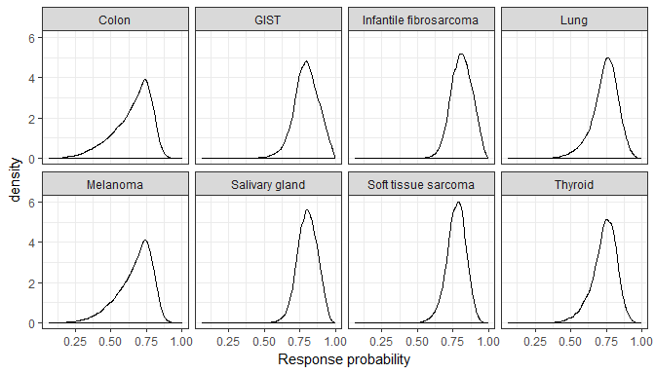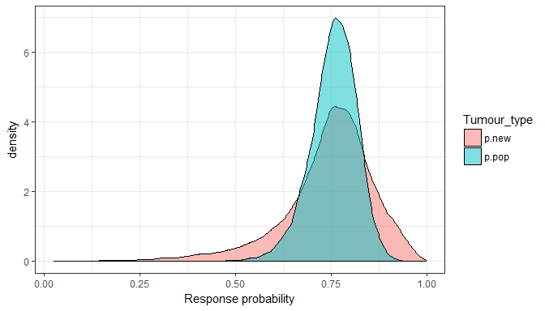

**Figure** subset (n>=5) and Alternative RE prior 2: HN(sigma = 0.5): Prior and posterior of random effect standard deviation 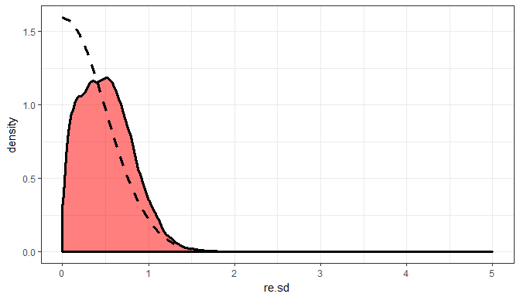

# Compare posterior inferences across RE fits

**Table** Compare RE SD posterior summaries across models

|  |  |  |  |  |  |  |  |
| --- | --- | --- | --- | --- | --- | --- | --- |
| Model | 2.5% | 25% | 50% | 75% | 97.5% | IQR | CrI.range |
| U(0,5) | 0.315 | 0.967 | 1.4 | 1.97 | 3.58 | 1 | 3.27 |
| HN(1) | 0.0677 | 0.658 | 0.972 | 1.3 | 2.04 | 0.645 | 1.97 |
| HN(0.5) | 0.0643 | 0.408 | 0.635 | 0.863 | 1.33 | 0.454 | 1.26 |
| Event/non-event and U(0,5) | 0.0756 | 0.564 | 0.917 | 1.34 | 2.57 | 0.774 | 2.49 |
| Event/non-event and HN(1) | 0.0701 | 0.437 | 0.709 | 0.999 | 1.7 | 0.562 | 1.63 |
| Event/non-event and HN(0.5) | 0.0275 | 0.252 | 0.454 | 0.677 | 1.11 | 0.426 | 1.08 |
| Min. size 5 and U(0,5) | 0.166 | 0.689 | 1.06 | 1.53 | 3 | 0.839 | 2.83 |
| Min. size 5 and HN(1) | 0.0893 | 0.485 | 0.772 | 1.08 | 1.8 | 0.6 | 1.71 |
| Min. size 5 and HN(0.5) | 0.0427 | 0.27 | 0.487 | 0.712 | 1.17 | 0.443 | 1.12 |

**Table** Compare p.new posterior summaries across models

|  |  |  |  |  |  |  |  |
| --- | --- | --- | --- | --- | --- | --- | --- |
| Model | 2.5% | 25% | 50% | 75% | 97.5% | IQR | CrI.range |
| U(0,5) | 0.0309 | 0.415 | 0.659 | 0.821 | 0.986 | 0.406 | 0.955 |
| HN(1) | 0.127 | 0.517 | 0.678 | 0.792 | 0.955 | 0.275 | 0.828 |
| HN(0.5) | 0.269 | 0.59 | 0.696 | 0.774 | 0.912 | 0.185 | 0.643 |
| Event/non-event and U(0,5) | 0.13 | 0.584 | 0.727 | 0.828 | 0.972 | 0.244 | 0.842 |
| Event/non-event and HN(1) | 0.263 | 0.618 | 0.728 | 0.812 | 0.95 | 0.194 | 0.687 |
| Event/non-event and HN(0.5) | 0.399 | 0.66 | 0.734 | 0.795 | 0.912 | 0.135 | 0.513 |
| Min. size 5 and U(0,5) | 0.121 | 0.607 | 0.76 | 0.866 | 0.986 | 0.258 | 0.865 |
| Min. size 5 and HN(1) | 0.276 | 0.655 | 0.762 | 0.843 | 0.965 | 0.188 | 0.69 |
| Min. size 5 and HN(0.5) | 0.424 | 0.69 | 0.759 | 0.818 | 0.93 | 0.128 | 0.505 |

**Table** Compare threshold probabilities: Prob(p.new >= threshold)

|  |  |  |  |  |  |  |  |  |  |
| --- | --- | --- | --- | --- | --- | --- | --- | --- | --- |
| Model | >=0.1 | >=0.2 | >=0.3 | >=0.4 | >=0.5 | >=0.6 | >=0.7 | >=0.8 | >=0.9 |
| U(0,5) | 0.939 | 0.886 | 0.828 | 0.761 | 0.678 | 0.575 | 0.441 | 0.283 | 0.139 |
| HN(1) | 0.982 | 0.953 | 0.909 | 0.849 | 0.767 | 0.647 | 0.448 | 0.233 | 0.0789 |
| HN(0.5) | 0.998 | 0.988 | 0.968 | 0.931 | 0.863 | 0.732 | 0.489 | 0.187 | 0.0344 |
| Event/non-event and U(0,5) | 0.981 | 0.959 | 0.93 | 0.886 | 0.825 | 0.73 | 0.565 | 0.314 | 0.117 |
| Event/non-event and HN(1) | 0.996 | 0.985 | 0.966 | 0.933 | 0.877 | 0.777 | 0.579 | 0.283 | 0.0775 |
| Event/non-event and HN(0.5) | 1 | 0.998 | 0.991 | 0.975 | 0.94 | 0.857 | 0.634 | 0.232 | 0.0347 |
| Min. size 5 and U(0,5) | 0.979 | 0.958 | 0.93 | 0.892 | 0.838 | 0.758 | 0.623 | 0.405 | 0.18 |
| Min. size 5 and HN(1) | 0.995 | 0.986 | 0.971 | 0.944 | 0.899 | 0.821 | 0.665 | 0.379 | 0.122 |
| Min. size 5 and HN(0.5) | 1 | 0.997 | 0.992 | 0.98 | 0.954 | 0.892 | 0.724 | 0.323 | 0.059 |

**Table** Compare threshold probabilities: Prob(p.new < threshold)

|  |  |  |  |  |  |  |  |  |  |
| --- | --- | --- | --- | --- | --- | --- | --- | --- | --- |
| Model | <0.1 | <0.2 | <0.3 | <0.4 | <0.5 | <0.6 | <0.7 | <0.8 | <0.9 |
| U(0,5) | 0.0611 | 0.114 | 0.172 | 0.239 | 0.322 | 0.425 | 0.559 | 0.717 | 0.861 |
| HN(1) | 0.0176 | 0.0471 | 0.0912 | 0.151 | 0.233 | 0.353 | 0.552 | 0.767 | 0.921 |
| HN(0.5) | 0.00228 | 0.0123 | 0.032 | 0.0692 | 0.137 | 0.268 | 0.511 | 0.813 | 0.966 |
| Event/non-event and U(0,5) | 0.0185 | 0.0414 | 0.0703 | 0.114 | 0.175 | 0.27 | 0.435 | 0.686 | 0.883 |
| Event/non-event and HN(1) | 0.00433 | 0.015 | 0.0344 | 0.0669 | 0.123 | 0.223 | 0.421 | 0.717 | 0.923 |
| Event/non-event and HN(0.5) | 0.000333 | 0.00208 | 0.00941 | 0.0251 | 0.0597 | 0.143 | 0.366 | 0.768 | 0.965 |
| Min. size 5 and U(0,5) | 0.0213 | 0.0425 | 0.0701 | 0.108 | 0.162 | 0.242 | 0.377 | 0.595 | 0.82 |
| Min. size 5 and HN(1) | 0.00459 | 0.014 | 0.0293 | 0.0557 | 0.101 | 0.179 | 0.335 | 0.621 | 0.878 |
| Min. size 5 and HN(0.5) | 0.000487 | 0.00254 | 0.00751 | 0.02 | 0.0465 | 0.108 | 0.276 | 0.677 | 0.941 |

**Table** Compare input data sets

# Session info

## [1] "C:/GIT/punta"

## R version 3.4.2 (2017-09-28)  
## Platform: x86_64-w64-mingw32/x64 (64-bit)  
## Running under: Windows 10 x64 (build 17763)  
##   
## Matrix products: default  
##   
## locale:  
## [1] LC_COLLATE=English_United Kingdom.1252   
## [2] LC_CTYPE=English_United Kingdom.1252   
## [3] LC_MONETARY=English_United Kingdom.1252  
## [4] LC_NUMERIC=C   
## [5] LC_TIME=English_United Kingdom.1252   
##   
## attached base packages:  
## [1] stats graphics grDevices utils datasets methods base   
##   
## other attached packages:  
## [1] ggplot2_2.2.1 R2jags_0.5-7 rjags_4-6 coda_0.19-3 reshape2_1.4.2  
## [6] dplyr_0.8.0.1 readxl_1.3.1   
##   
## loaded via a namespace (and not attached):  
## [1] Rcpp_1.0.1 cellranger_1.1.0 pillar_1.4.3 compiler_3.4.2   
## [5] plyr_1.8.4 tools_3.4.2 boot_1.3-24 digest_0.6.12   
## [9] evaluate_0.14 tibble_2.1.1 gtable_0.2.0 lattice_0.20-35   
## [13] pkgconfig_2.0.3 rlang_0.3.4 yaml_2.2.0 parallel_3.4.2   
## [17] xfun_0.12 stringr_1.4.0 knitr_1.28 grid_3.4.2   
## [21] tidyselect_0.2.5 glue_1.3.1 R6_2.2.2 rmarkdown_2.1   
## [25] pander_0.6.1 purrr_0.3.2 magrittr_1.5 scales_0.5.0   
## [29] htmltools_0.3.6 R2WinBUGS_2.1-21 assertthat_0.2.0 abind_1.4-5   
## [33] colorspace_1.3-2 labeling_0.3 stringi_1.4.3 lazyeval_0.2.1   
## [37] munsell_0.4.3 crayon_1.3.4