01-B-BHM-Simstudy-ORR-report

Sandro Gsteiger

April 14, 2020

Table of Contents

# Introduction

## General description

Simulation study to assess the predictive uncertainty in a binary endpoint analyzed with a Bayesian hierarchical model as a function of number of groups and sample size per group.

How perform different design choices (number of groups, size of groups, larger lead group or not)?

What about the analysis model (HN(sigma=1), HN(sigma=0.5), or U(0,5) prior)?

## Defining and interpreting true levels of heterogeneity - how to define a meaningful (analysis) prior for the RE SD?

Assume the true population event rate is $p_{0}$ and the between-tissue-heterogeneity is $τ$. Let $p_{i}$ be the true rate for tissue $i$ and $θ_{i}=logit(p_{i})$. The random effects model assumes exchangeability on the logit scale, this means

$$θ_{i}∼N(θ_{0},τ^{2}).$$

The range of true tissue specific event rates $p_{i}$ as well as threshold probabilities will depend on $τ$.

**Figure** 95% and 50% ranges of tissue specific event rates as a function of heterogeneity (random effects SD)

## Warning: Removed 80 rows containing missing values (geom_path).  
  
## Warning: Removed 80 rows containing missing values (geom_path).

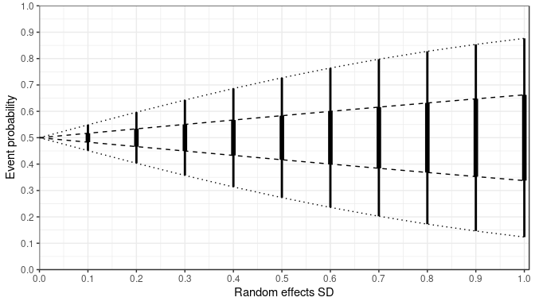

**Figure** idem (alternative version)

## Warning: Removed 40 rows containing missing values (geom_linerange).  
  
## Warning: Removed 40 rows containing missing values (geom_linerange).

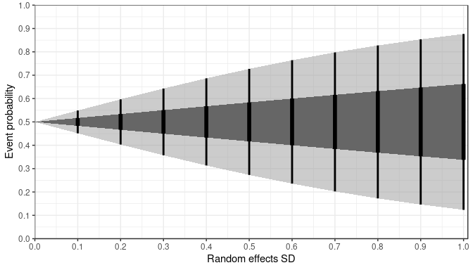

**Table** 95% and 50% ranges of tissue specific event rates for selected levels of heterogeneity (random effects SD) as well as probability of being below 0.3

|  |  |  |  |  |  |
| --- | --- | --- | --- | --- | --- |
| re.sd | PrIlo | Q1 | Q3 | PrIup | ProbBelow0.3 |
| 0.1 | 0.45 | 0.48 | 0.52 | 0.55 | 0 |
| 0.3 | 0.36 | 0.45 | 0.55 | 0.64 | 0 |
| 0.7 | 0.2 | 0.38 | 0.62 | 0.8 | 0.11 |

**Figure** 50% prediction intervals (dark grey) and 95% prediction intervals (light grey) for true tissue specific event probabilities as a function of RE SD along wtih different prior distributions 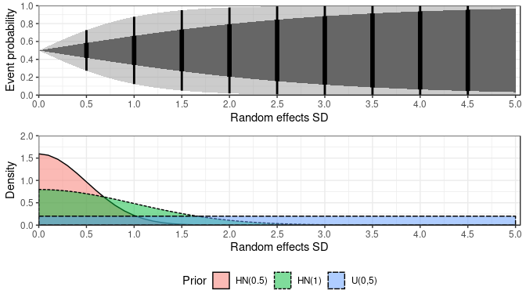

# Simulation settings

## Simulation scenarios

Simulations were run over the full grid of combinations below.

# True rate and heterogeneity  
bin_grid

## p.pop re.sd  
## 1 0.5 0.1  
## 2 0.5 0.3  
## 3 0.5 0.7

# Sample sizes of lead group and subsequent groups  
size_grid

## lead.grp lead.grp.size subseq.grp.size  
## 1 yes 20 2  
## 2 yes 20 5  
## 3 yes 20 10  
## 4 no 2 2  
## 5 no 5 5  
## 6 no 10 10  
## 7 no 20 20

# Number of groups  
grp_grid

## n.grp  
## 1 5  
## 2 7  
## 3 10  
## 4 15  
## 5 20

# Analysis priors (RE SD)  
prior_grid

## dist  
## 1 U(0,5)  
## 2 HN(0.5)  
## 3 HN(1)

# Resulting full scenario grid  
dim(full_grid)

## [1] 315 7

head(full_grid)

## p.pop re.sd lead.grp lead.grp.size subseq.grp.size n.grp dist  
## 1 0.5 0.1 yes 20 2 5 U(0,5)  
## 2 0.5 0.1 yes 20 2 5 HN(0.5)  
## 3 0.5 0.1 yes 20 2 5 HN(1)  
## 4 0.5 0.1 yes 20 2 7 U(0,5)  
## 5 0.5 0.1 yes 20 2 7 HN(0.5)  
## 6 0.5 0.1 yes 20 2 7 HN(1)

tail(full_grid)

## p.pop re.sd lead.grp lead.grp.size subseq.grp.size n.grp dist  
## 310 0.5 0.7 no 20 20 15 U(0,5)  
## 311 0.5 0.7 no 20 20 15 HN(0.5)  
## 312 0.5 0.7 no 20 20 15 HN(1)  
## 313 0.5 0.7 no 20 20 20 U(0,5)  
## 314 0.5 0.7 no 20 20 20 HN(0.5)  
## 315 0.5 0.7 no 20 20 20 HN(1)

## Global parameters

global_par

## $n_sim  
## [1] 500  
##   
## $n_chains  
## [1] 3  
##   
## $n_iter  
## [1] 6000  
##   
## $n_burnin  
## [1] 1000  
##   
## $n_thin  
## [1] 1  
##   
## $p.threshold  
## [1] 0.3

# Simulation results

Dimension, first and last few lines of results data frame.

## [1] 2520 15

## scenario node var1 var2 value p.pop re.sd lead.grp  
## 1 1 p.new CrIR mean 0.96835863 0.5 0.1 yes  
## 2 1 p.new IQR mean 0.42787929 0.5 0.1 yes  
## 3 1 p.new ProbAbove0.3 mean 0.71046440 0.5 0.1 yes  
## 4 1 re.sd 50% mean 1.54242349 0.5 0.1 yes  
## 5 1 p.new CrIR sd 0.03448412 0.5 0.1 yes  
## 6 1 p.new IQR sd 0.13293801 0.5 0.1 yes  
## lead.grp.size subseq.grp.size n.grp dist n.tot n_first n_others  
## 1 20 2 5 U(0,5) 28 20 2  
## 2 20 2 5 U(0,5) 28 20 2  
## 3 20 2 5 U(0,5) 28 20 2  
## 4 20 2 5 U(0,5) 28 20 2  
## 5 20 2 5 U(0,5) 28 20 2  
## 6 20 2 5 U(0,5) 28 20 2

## scenario node var1 var2 value p.pop re.sd lead.grp  
## 2515 315 p.new ProbAbove0.3 mean 0.86717573 0.5 0.7 no  
## 2516 315 re.sd 50% mean 0.71206870 0.5 0.7 no  
## 2517 315 p.new CrIR sd 0.10670514 0.5 0.7 no  
## 2518 315 p.new IQR sd 0.06140606 0.5 0.7 no  
## 2519 315 p.new ProbAbove0.3 sd 0.06860940 0.5 0.7 no  
## 2520 315 re.sd 50% sd 0.18581582 0.5 0.7 no  
## lead.grp.size subseq.grp.size n.grp dist n.tot n_first n_others  
## 2515 20 20 20 HN(1) 400 20 20  
## 2516 20 20 20 HN(1) 400 20 20  
## 2517 20 20 20 HN(1) 400 20 20  
## 2518 20 20 20 HN(1) 400 20 20  
## 2519 20 20 20 HN(1) 400 20 20  
## 2520 20 20 20 HN(1) 400 20 20

## Estimating between-study-heterogeneity (RE SD)

### Posterior median RE SD ($τ$)

**Figure** Posterior median of $τ$ (mean over 500 simulations) 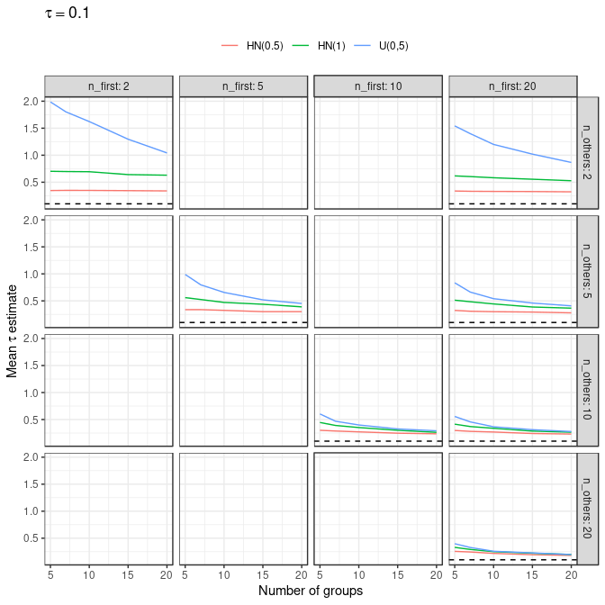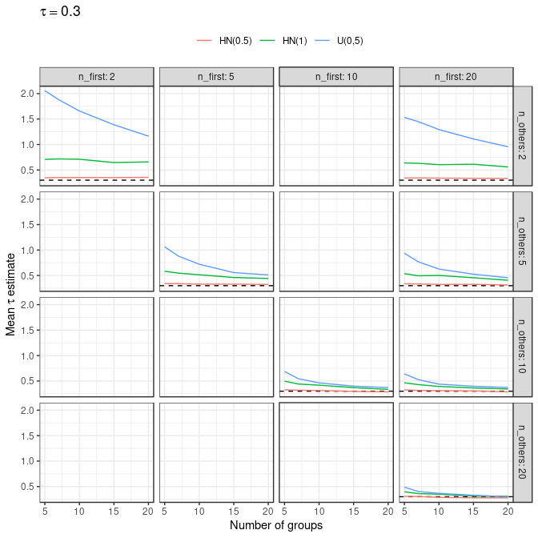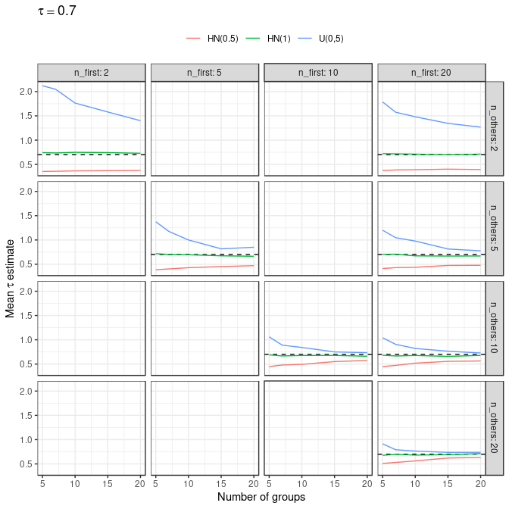

### Mean Squared Error

**Mean Squared Error (MSE)** of the posterior median as an estimator for $τ$,

$$MSE=Var+bias^{2}.$$

**Figure** MSE of the posterior median RE SD 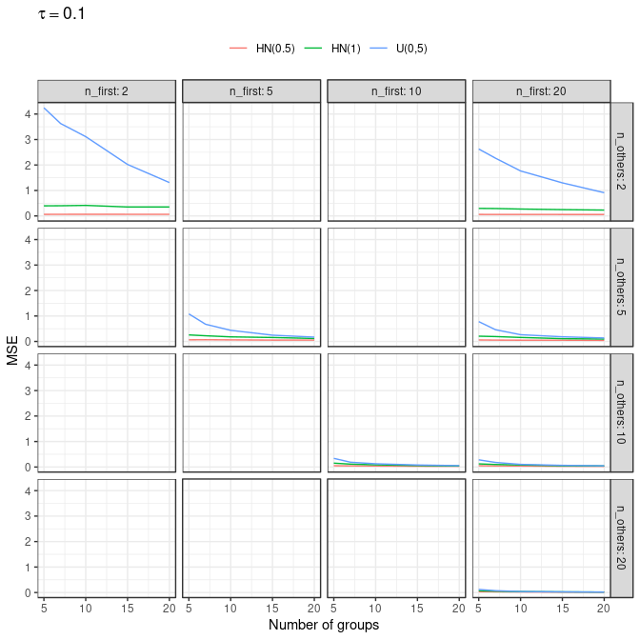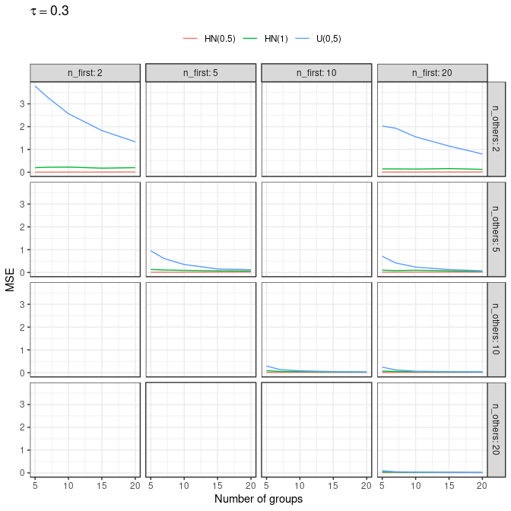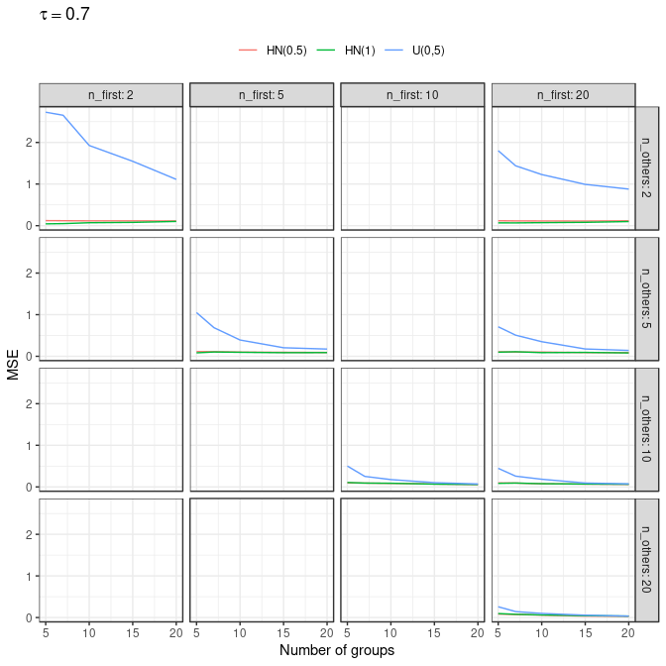

## Predictive uncertainty: new tissue response rate

### 95% Prediction interval

**Figure** Length of 95% prediction interval of new group event probability (mean over 500 simulations) 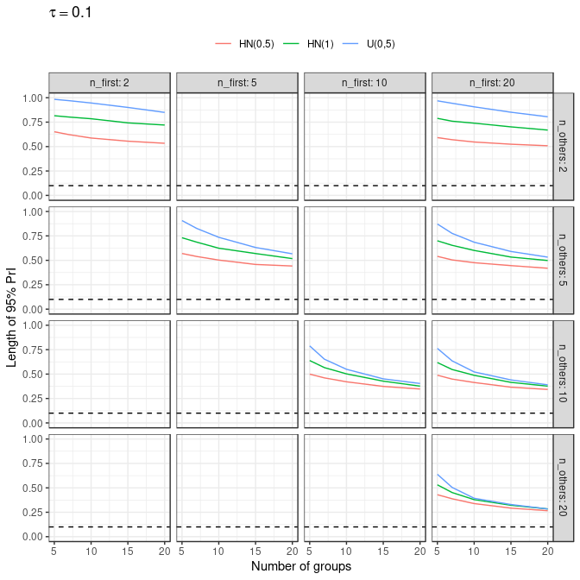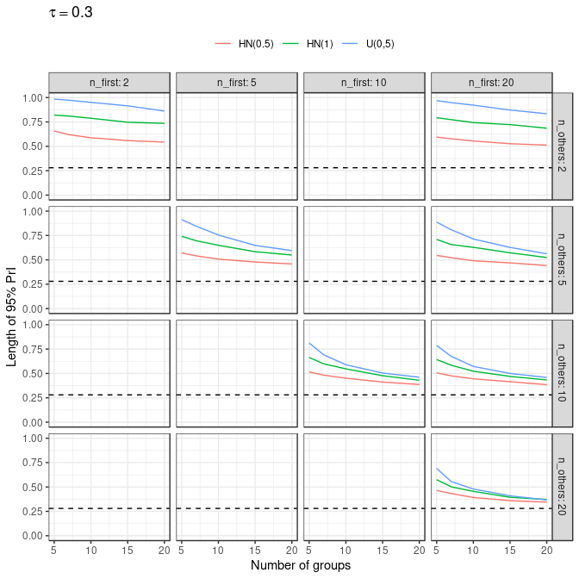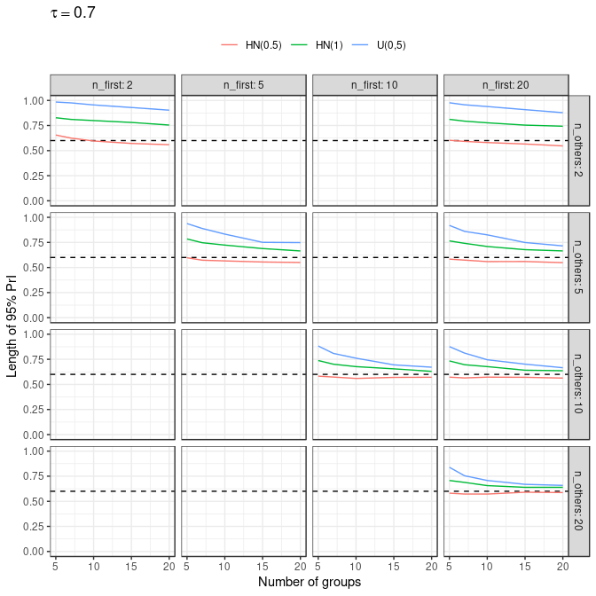

### Interquartile range

**Figure** Inter-quartile range of prediction interval of new group event probability (mean over 500 simulations) 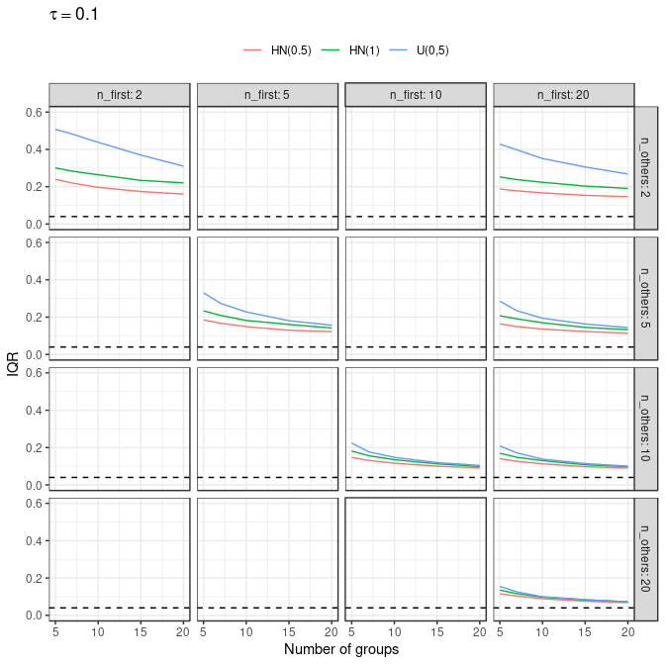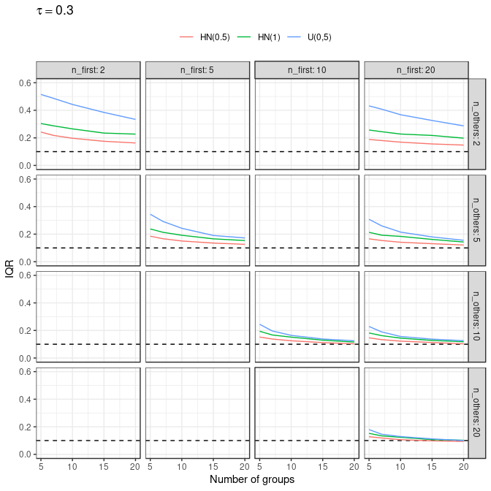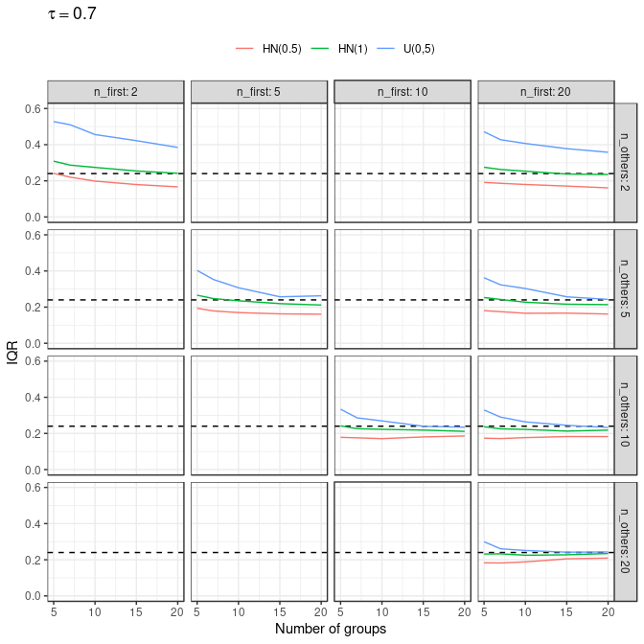

### Threshold probabilities

**Figure** Estimated posterior probability of new group event probability being lower than 0.3, P(p.new<0.3) (mean over 500 simulations) 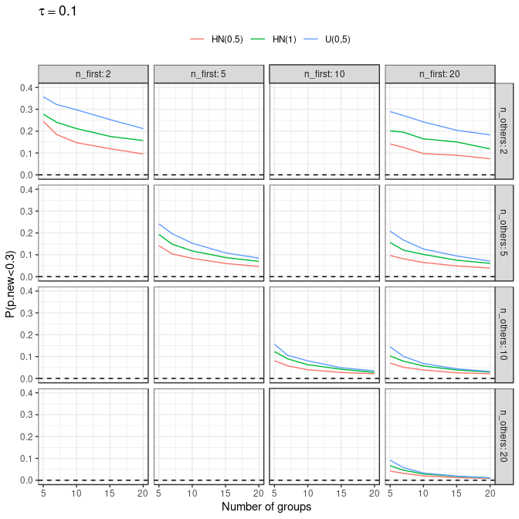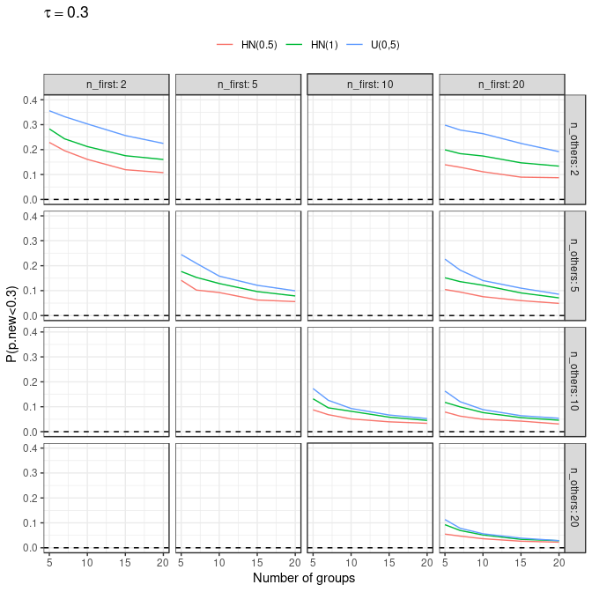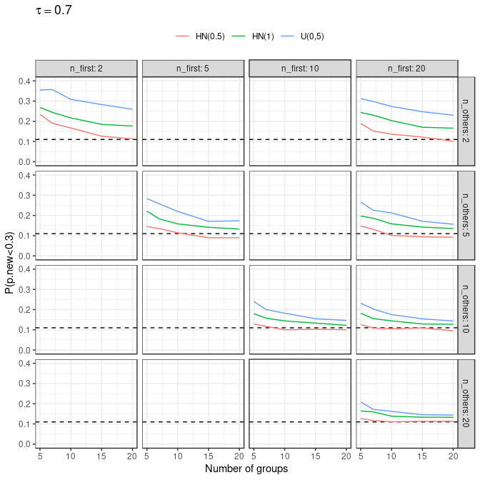

# Session info

## [1] "/home/bceuser/gsteigs1/GITHUB.COM/punta"

## R version 3.5.3 (2019-03-11)  
## Platform: x86_64-pc-linux-gnu (64-bit)  
## Running under: Red Hat Enterprise Linux  
##   
## Matrix products: default  
## BLAS/LAPACK: /usr/lib64/libopenblas-r0.3.3.so  
##   
## locale:  
## [1] LC_CTYPE=en_US.UTF-8 LC_NUMERIC=C   
## [3] LC_TIME=en_US.UTF-8 LC_COLLATE=en_US.UTF-8   
## [5] LC_MONETARY=en_US.UTF-8 LC_MESSAGES=en_US.UTF-8   
## [7] LC_PAPER=en_US.UTF-8 LC_NAME=C   
## [9] LC_ADDRESS=C LC_TELEPHONE=C   
## [11] LC_MEASUREMENT=en_US.UTF-8 LC_IDENTIFICATION=C   
##   
## attached base packages:  
## [1] stats graphics grDevices utils datasets methods base   
##   
## other attached packages:  
## [1] ggplot2_3.2.1 tidyr_0.8.3 dplyr_0.8.3 rocheBCE_2.4   
##   
## loaded via a namespace (and not attached):  
## [1] Rcpp_1.0.2 pillar_1.4.2 compiler_3.5.3 plyr_1.8.4   
## [5] tools_3.5.3 boot_1.3-20 digest_0.6.21 evaluate_0.14   
## [9] tibble_2.1.3 gtable_0.3.0 pkgconfig_2.0.3 rlang_0.4.0   
## [13] egg_0.4.5 yaml_2.2.0 xfun_0.7 gridExtra_2.3   
## [17] withr_2.1.2 stringr_1.4.0 knitr_1.23 grid_3.5.3   
## [21] tidyselect_0.2.5 glue_1.3.1 R6_2.4.0 rmarkdown_1.12   
## [25] pander_0.6.3 purrr_0.3.2 reshape2_1.4.3 magrittr_1.5   
## [29] scales_1.0.0 htmltools_0.3.6 assertthat_0.2.1 colorspace_1.4-1  
## [33] labeling_0.3 stringi_1.4.3 lazyeval_0.2.2 munsell_0.5.0   
## [37] crayon_1.3.4