01-B2-BHM-Simstudy-ORR-report

Sandro Gsteiger

April 13, 2020

Table of Contents

# Introduction

**Table** 95% and 50% ranges of tissue specific event rates for selected levels of heterogeneity (random effects SD) as well as probability of being below 0.3

|  |  |  |  |  |  |
| --- | --- | --- | --- | --- | --- |
| re.sd | PrIlo | Q1 | Q3 | PrIup | ProbBelow0.3 |
| 0.1 | 0.45 | 0.48 | 0.52 | 0.55 | 0 |
| 0.3 | 0.36 | 0.45 | 0.55 | 0.64 | 0 |
| 0.7 | 0.2 | 0.38 | 0.62 | 0.8 | 0.11 |

# Simulation settings

## Simulation scenarios

Simulations were run over the full grid of combinations below.

# True rate and heterogeneity  
bin_grid

## p.pop re.sd  
## 1 0.5 0.1  
## 2 0.5 0.3  
## 3 0.5 0.7

# Sample sizes of lead group and subsequent groups  
size_grid

## lead.grp lead.grp.size subseq.grp.size  
## 1 yes 5 2  
## 2 yes 5 3  
## 3 yes 5 4  
## 4 no 5 5

# Number of groups  
grp_grid

## n.grp  
## 1 5  
## 2 6  
## 3 7  
## 4 8  
## 5 9  
## 6 10

# Analysis priors (RE SD)  
prior_grid

## dist  
## 1 U(0,5)  
## 2 HN(0.5)  
## 3 HN(1)

# Resulting full scenario grid  
dim(full_grid)

## [1] 216 7

head(full_grid)

## p.pop re.sd lead.grp lead.grp.size subseq.grp.size n.grp dist  
## 1 0.5 0.1 yes 5 2 5 U(0,5)  
## 2 0.5 0.1 yes 5 2 5 HN(0.5)  
## 3 0.5 0.1 yes 5 2 5 HN(1)  
## 4 0.5 0.1 yes 5 2 6 U(0,5)  
## 5 0.5 0.1 yes 5 2 6 HN(0.5)  
## 6 0.5 0.1 yes 5 2 6 HN(1)

tail(full_grid)

## p.pop re.sd lead.grp lead.grp.size subseq.grp.size n.grp dist  
## 211 0.5 0.7 no 5 5 9 U(0,5)  
## 212 0.5 0.7 no 5 5 9 HN(0.5)  
## 213 0.5 0.7 no 5 5 9 HN(1)  
## 214 0.5 0.7 no 5 5 10 U(0,5)  
## 215 0.5 0.7 no 5 5 10 HN(0.5)  
## 216 0.5 0.7 no 5 5 10 HN(1)

## Global parameters

global_par

## $n_sim  
## [1] 500  
##   
## $n_chains  
## [1] 3  
##   
## $n_iter  
## [1] 6000  
##   
## $n_burnin  
## [1] 1000  
##   
## $n_thin  
## [1] 1  
##   
## $p.threshold  
## [1] 0.3

# Simulation results

Dimension, first and last few lines of results data frame.

## [1] 1728 15

## scenario node var1 var2 value p.pop re.sd lead.grp  
## 1 1 p.new CrIR mean 0.97439709 0.5 0.1 yes  
## 2 1 p.new IQR mean 0.46294851 0.5 0.1 yes  
## 3 1 p.new ProbAbove0.3 mean 0.67632000 0.5 0.1 yes  
## 4 1 re.sd 50% mean 1.71812496 0.5 0.1 yes  
## 5 1 p.new CrIR sd 0.02840784 0.5 0.1 yes  
## 6 1 p.new IQR sd 0.14306798 0.5 0.1 yes  
## lead.grp.size subseq.grp.size n.grp dist n.tot n_first n_others  
## 1 5 2 5 U(0,5) 13 5 2  
## 2 5 2 5 U(0,5) 13 5 2  
## 3 5 2 5 U(0,5) 13 5 2  
## 4 5 2 5 U(0,5) 13 5 2  
## 5 5 2 5 U(0,5) 13 5 2  
## 6 5 2 5 U(0,5) 13 5 2

## scenario node var1 var2 value p.pop re.sd lead.grp  
## 1723 216 p.new ProbAbove0.3 mean 0.83147707 0.5 0.7 no  
## 1724 216 re.sd 50% mean 0.70410621 0.5 0.7 no  
## 1725 216 p.new CrIR sd 0.12471592 0.5 0.7 no  
## 1726 216 p.new IQR sd 0.08111975 0.5 0.7 no  
## 1727 216 p.new ProbAbove0.3 sd 0.11024782 0.5 0.7 no  
## 1728 216 re.sd 50% sd 0.31980336 0.5 0.7 no  
## lead.grp.size subseq.grp.size n.grp dist n.tot n_first n_others  
## 1723 5 5 10 HN(1) 50 5 5  
## 1724 5 5 10 HN(1) 50 5 5  
## 1725 5 5 10 HN(1) 50 5 5  
## 1726 5 5 10 HN(1) 50 5 5  
## 1727 5 5 10 HN(1) 50 5 5  
## 1728 5 5 10 HN(1) 50 5 5

## Estimating between-study-heterogeneity (RE SD)

### Posterior median RE SD ($τ$)

**Figure** Posterior median of $τ$ (mean over 500 simulations) 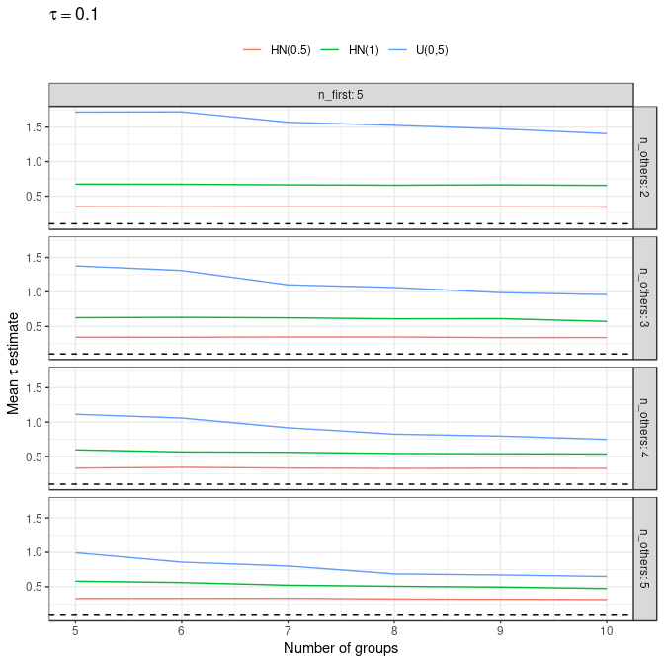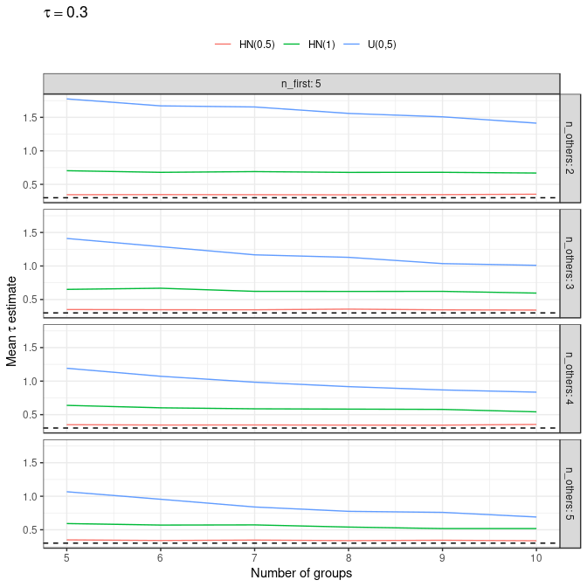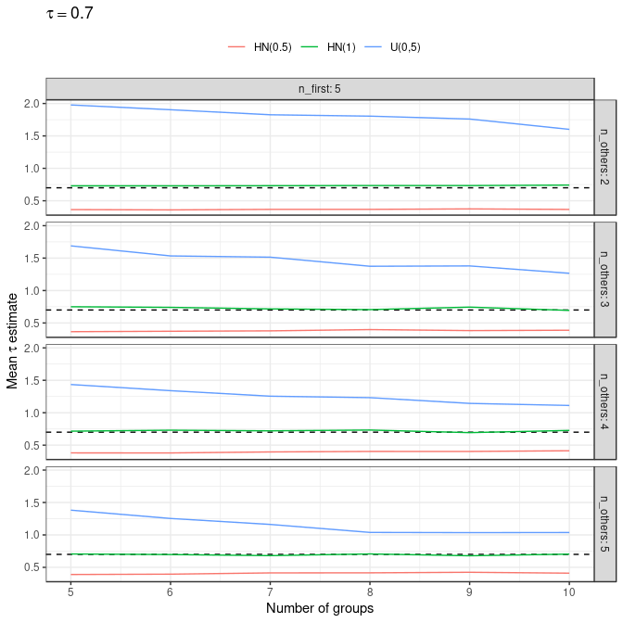

### Mean Squared Error

**Mean Squared Error (MSE)** of the posterior median as an estimator for $τ$,

$$MSE=Var+bias^{2}.$$

**Figure** MSE of the posterior median RE SD 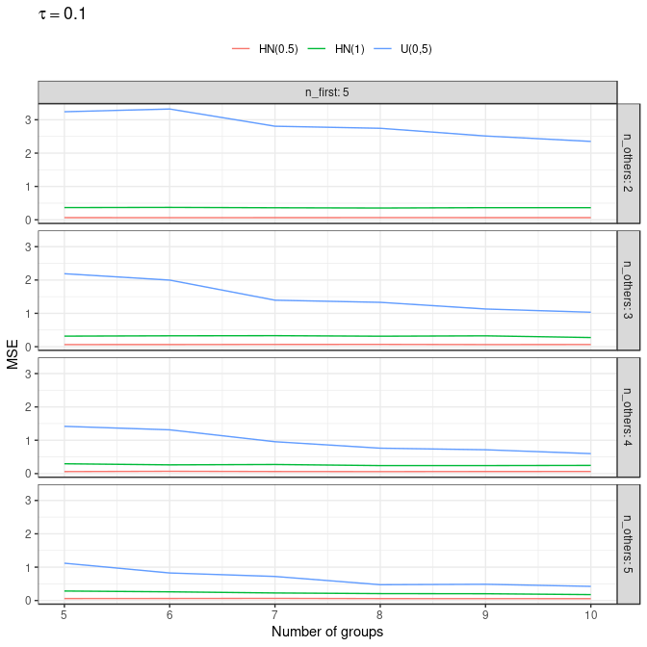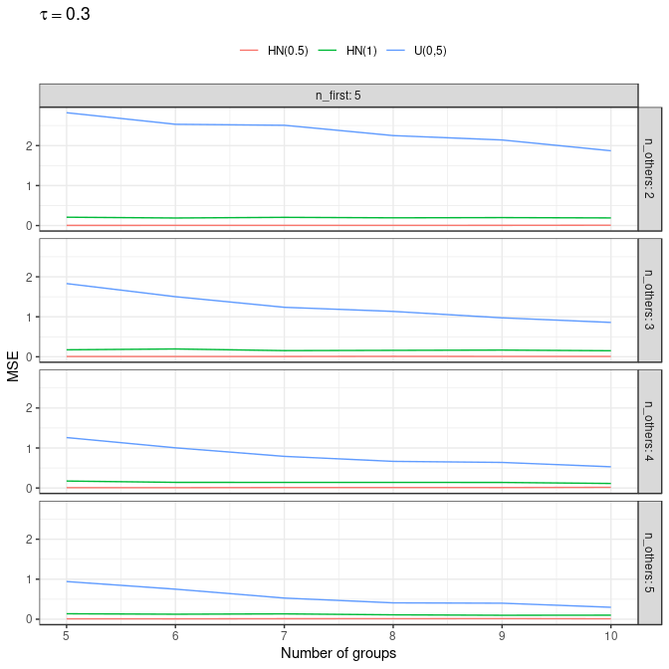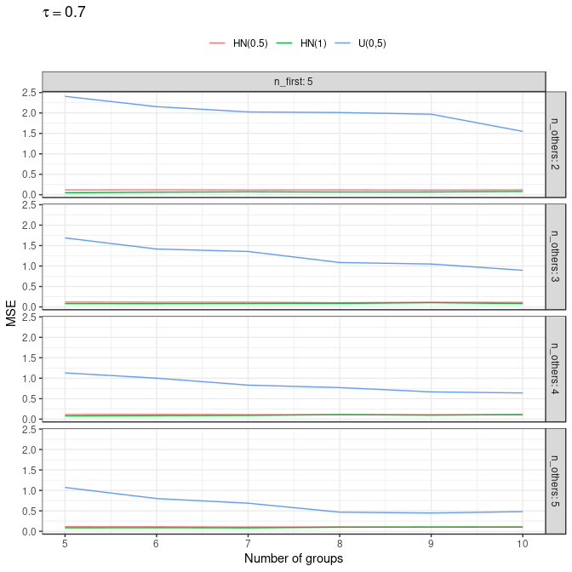

## Predictive uncertainty: new tissue response rate

### 95% Prediction interval

**Figure** Length of 95% prediction interval of new group event probability (mean over 500 simulations) 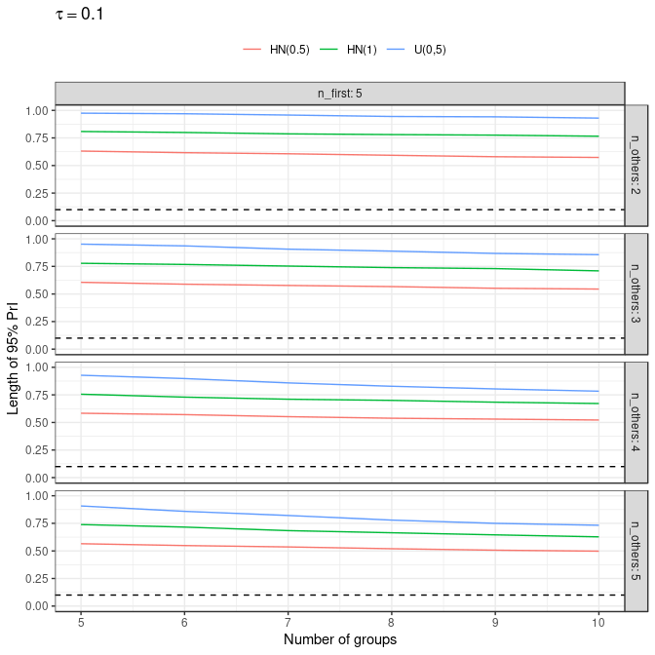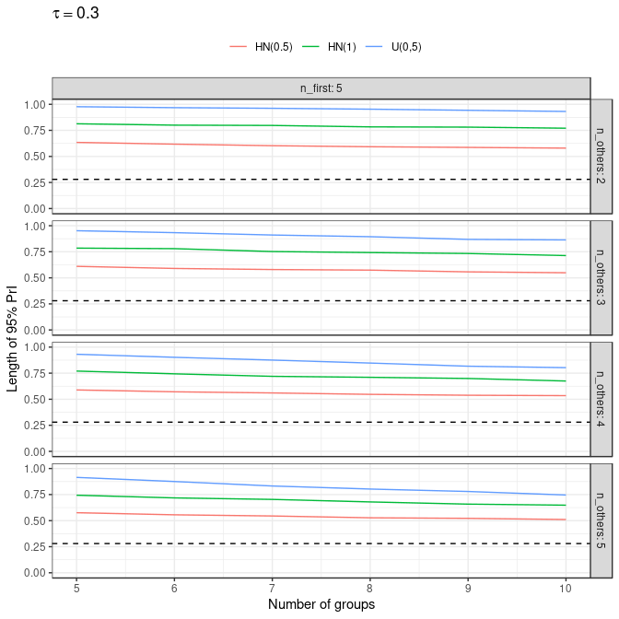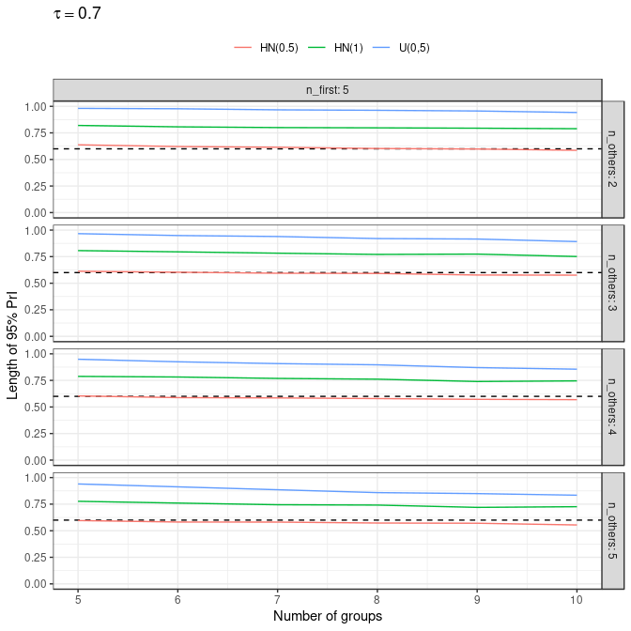

### Interquartile range

**Figure** Inter-quartile range of prediction interval of new group event probability (mean over 500 simulations) 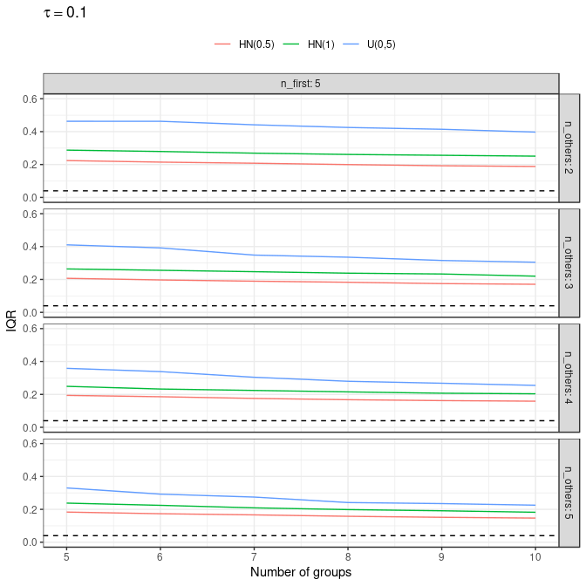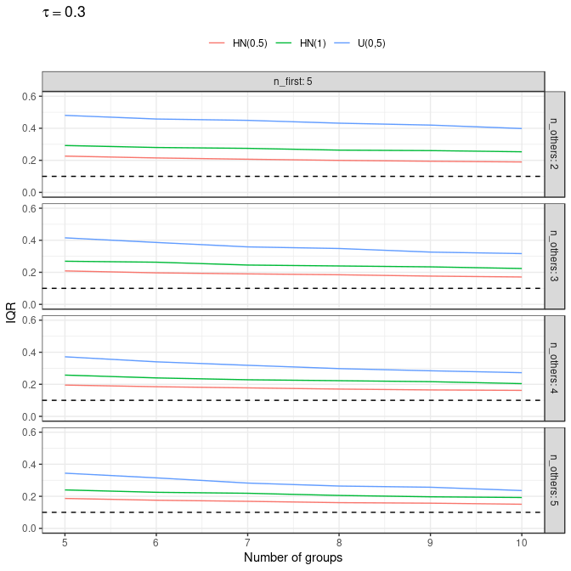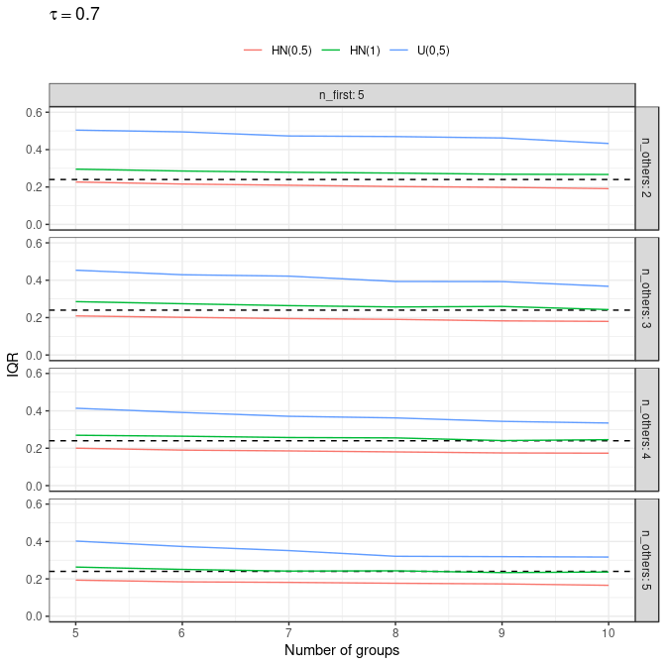

### Threshold probabilities

**Figure** Estimated posterior probability of new group event probability being lower than 0.3, P(p.new<0.3) (mean over 500 simulations) 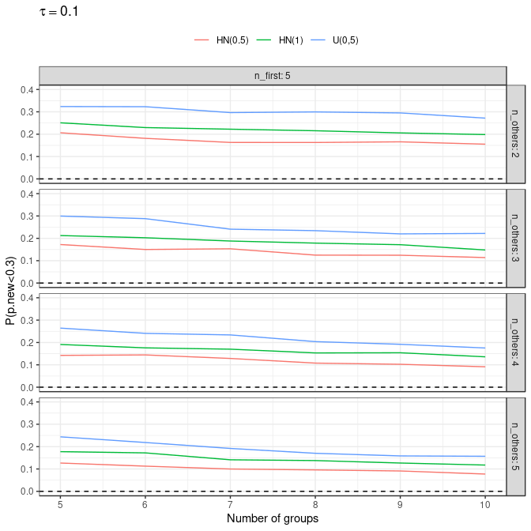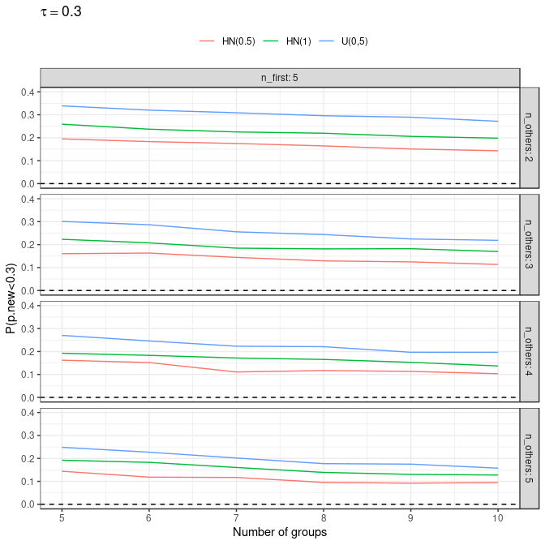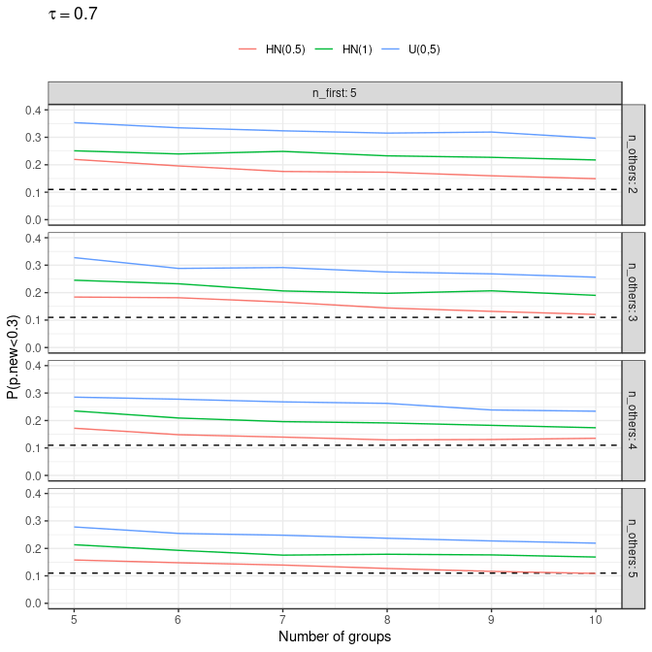

# Session info

## [1] "/home/bceuser/gsteigs1/GITHUB.COM/punta"

## R version 3.5.3 (2019-03-11)  
## Platform: x86_64-pc-linux-gnu (64-bit)  
## Running under: Red Hat Enterprise Linux  
##   
## Matrix products: default  
## BLAS/LAPACK: /usr/lib64/libopenblas-r0.3.3.so  
##   
## locale:  
## [1] LC_CTYPE=en_US.UTF-8 LC_NUMERIC=C   
## [3] LC_TIME=en_US.UTF-8 LC_COLLATE=en_US.UTF-8   
## [5] LC_MONETARY=en_US.UTF-8 LC_MESSAGES=en_US.UTF-8   
## [7] LC_PAPER=en_US.UTF-8 LC_NAME=C   
## [9] LC_ADDRESS=C LC_TELEPHONE=C   
## [11] LC_MEASUREMENT=en_US.UTF-8 LC_IDENTIFICATION=C   
##   
## attached base packages:  
## [1] stats graphics grDevices utils datasets methods base   
##   
## other attached packages:  
## [1] ggplot2_3.2.1 tidyr_0.8.3 dplyr_0.8.3 rocheBCE_2.4   
##   
## loaded via a namespace (and not attached):  
## [1] Rcpp_1.0.2 knitr_1.23 magrittr_1.5 munsell_0.5.0   
## [5] tidyselect_0.2.5 colorspace_1.4-1 R6_2.4.0 rlang_0.4.0   
## [9] plyr_1.8.4 stringr_1.4.0 tools_3.5.3 grid_3.5.3   
## [13] gtable_0.3.0 xfun_0.7 withr_2.1.2 htmltools_0.3.6   
## [17] lazyeval_0.2.2 yaml_2.2.0 assertthat_0.2.1 digest_0.6.21   
## [21] tibble_2.1.3 crayon_1.3.4 reshape2_1.4.3 purrr_0.3.2   
## [25] glue_1.3.1 evaluate_0.14 rmarkdown_1.12 labeling_0.3   
## [29] stringi_1.4.3 pander_0.6.3 compiler_3.5.3 pillar_1.4.2   
## [33] scales_1.0.0 boot_1.3-20 pkgconfig_2.0.3