02-A-EDA-TTE-Larotrectinib

Sandro Gsteiger

June 01, 2020

Table of Contents

# Description

Exploratory data analysis for Larotrectinib OS/PFS data reported in G-BA Modul 4. The results here will serve to select realistic values in the stylized decision model later on used for VoI analysis. But the VoI case study will be for a stylized decision model and will not reflect any real data.

# Exponential survival model

The OS/PFS data from Larotrectinib used in the G-BA dossier are not mature yet and also the reporting is limited. For both endpoints, 12-months survival rates are given. The simplest standard survival model uses the exponential distribution. The rate paramter $λ$ can be derived from the landmark survival probability since

$$S(t)=e^{−λt}.$$

This implies that a monthly rate estiamte is $\overset{̂}{λ}=−log(\overset{̂}{S}(12))/12.$

## # A tibble: 15 x 14  
## `Tumour type` n OS_n_event OS_median OS_6month  
## <chr> <dbl> <dbl> <dbl> <dbl>  
## 1 Soft tissue sarcoma 21 3 NA 0.95  
## 2 Salivary gland 17 2 NA 0.94  
## 3 Infantile fibrosarcoma 13 0 NA 1   
## 4 Thyroid 10 2 NA 0.9   
## 5 Lung 7 1 NA 1   
## 6 Melanoma 7 2 8.44 0.83  
## 7 Colon 6 2 NA 0.6   
## 8 GIST 4 0 NA 1   
## 9 Bone sarcoma 2 0 NA 1   
## 10 Cholangiocarcinoma 2 1 NA 0.5   
## 11 Appendix 1 0 NA 1   
## 12 Breast 1 0 NA NA   
## 13 Congenital mesoblastic nephroma 1 0 NA 1   
## 14 Pancreas 1 1 14.1 1   
## 15 Pooled 93 14 NA NA   
## OS_12month OS_12month_CIlo OS_12month_CIup PFS_n_event PFS_median PFS_6month  
## <dbl> <dbl> <dbl> <dbl> <dbl> <dbl>  
## 1 0.85 NA NA 8 27.4 0.8   
## 2 0.94 NA NA 4 NA 0.88  
## 3 1 NA NA 3 NA 0.83  
## 4 0.9 NA NA 4 NA 0.7   
## 5 1 NA NA 1 NA 1   
## 6 0.42 NA NA 2 NA 0.53  
## 7 0.6 NA NA 4 5.36 0.4   
## 8 1 NA NA 2 19.3 1   
## 9 1 NA NA 2 7.39 0.5   
## 10 0.5 NA NA 1 NA 0.5   
## 11 NA NA NA 1 3.48 0   
## 12 NA NA NA 1 0.95 0   
## 13 1 NA NA 0 NA 1   
## 14 1 NA NA 1 7.2 1   
## 15 0.88 0.81 0.95 34 27.4 0.77  
## PFS_12month PFS_12month_CIlo PFS_12month_CIup  
## <dbl> <dbl> <dbl>  
## 1 0.69 NA NA   
## 2 0.8 NA NA   
## 3 0.69 NA NA   
## 4 0.7 NA NA   
## 5 0.8 NA NA   
## 6 0.53 NA NA   
## 7 NA NA NA   
## 8 0.67 NA NA   
## 9 0 NA NA   
## 10 0.5 NA NA   
## 11 0 NA NA   
## 12 0 NA NA   
## 13 NA NA NA   
## 14 0 NA NA   
## 15 0.64 0.53 0.75

**12-months survival probabilities, yearly rates, and expected mean survival (in years)**

*OS data*

## # A tibble: 1 x 11  
## `Tumour type` n OS_12month OS_12month_CIlo OS_12month_CIup rate rate_lo  
## <chr> <dbl> <dbl> <dbl> <dbl> <dbl> <dbl>  
## 1 Pooled 93 0.88 0.81 0.95 0.128 0.0513  
## rate_up mean mean_lo mean_up  
## <dbl> <dbl> <dbl> <dbl>  
## 1 0.211 7.82 4.75 19.5

*PFS data*

## # A tibble: 1 x 11  
## `Tumour type` n PFS_12month PFS_12month_CIlo PFS_12month_CIup rate  
## <chr> <dbl> <dbl> <dbl> <dbl> <dbl>  
## 1 Pooled 93 0.64 0.53 0.75 0.446  
## rate_lo rate_up mean mean_lo mean_up  
## <dbl> <dbl> <dbl> <dbl> <dbl>  
## 1 0.288 0.635 2.24 1.58 3.48

**Figure** Exponential survival models for Larotrectinib estimated from 12-months survival rates for OS (black line/area) and PFS (blue line/area).

**Figure** OS and PFS survival probabilities from exponential model fits (long-term extrapolation) 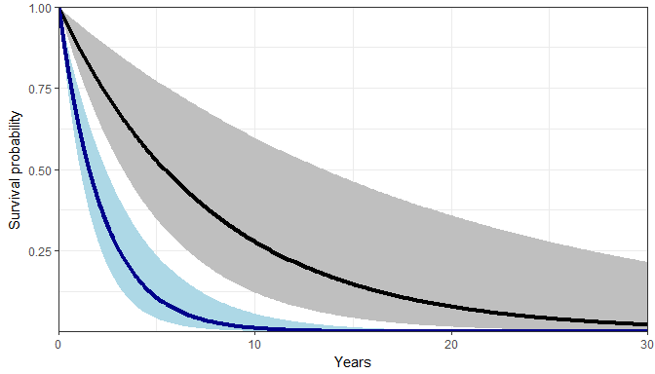

## Scale for 'x' is already present. Adding another scale for 'x', which will  
## replace the existing scale.

## Scale for 'y' is already present. Adding another scale for 'y', which will  
## replace the existing scale.

## Warning: Removed 260 rows containing missing values (geom_path).  
  
## Warning: Removed 260 rows containing missing values (geom_path).

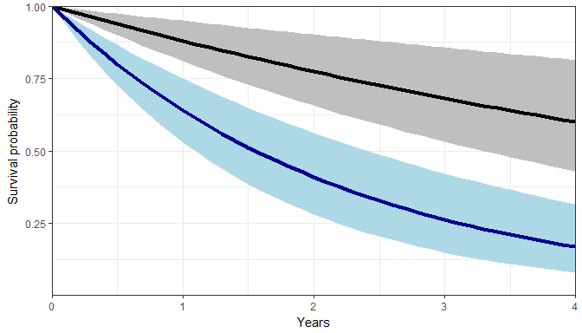

**Table** OS and PFS survival probabilities from exponential model fits

|  |  |  |  |  |  |  |
| --- | --- | --- | --- | --- | --- | --- |
| x | OS | OS_lo | OS_up | PFS | PFS_lo | PFS_up |
| 5 | 0.528 | 0.349 | 0.774 | 0.107 | 0.0418 | 0.237 |
| 10 | 0.279 | 0.122 | 0.599 | 0.0115 | 0.00175 | 0.0563 |
| 15 | 0.147 | 0.0424 | 0.463 | 0.00124 | 7.31e-05 | 0.0134 |
| 20 | 0.0776 | 0.0148 | 0.358 | 0.000133 | 3.06e-06 | 0.00317 |
| 25 | 0.0409 | 0.00515 | 0.277 | 1.43e-05 | 1.28e-07 | 0.000753 |
| 30 | 0.0216 | 0.0018 | 0.215 | 1.53e-06 | 5.35e-09 | 0.000179 |

OS seems rather on the long end, though this seems to reflect the potential of a cured subgroup (with relatively early age of onset). For the sake of the example here, these estimates might be “good enough” (?) to serve as rough guides for selecting values for a stylized decision model.

For the stylized example we may need to select much smaller uncertainty around the population average to be able to study the effect of adding prediction uncertainty. Otherwise the “initial” uncertainty may be too large to make meaningful case studies.

Test also the Weibull model, which may proof more suitable.

# Weibull model

I fit the Weibull survival model,

$$S(t)=e^{−λt^{γ}}$$

to two data points (t, S(t)), with time **t in years** to derive the shape parameter $γ$ and the scale parameter $λ$.

For this purpose, I add the (arbitrary) tail constraint of OS at 20 years being 1%.

Solving the survivor function equation for the two points.

I wil take the **shape parameter as fixed**.

To derive a CI for the scale parameter, I solve the equation again (now with one single parameter) and plug-in the lower and upper values from the 12-month OS estimates.

This leads to:

|  |  |  |  |  |  |  |  |  |  |
| --- | --- | --- | --- | --- | --- | --- | --- | --- | --- |
| t1 | S1 | S1_lo | S1_up | t2 | S2 | shape | os_scale | os_scale_lo | os_scale_up |
| 1 | 0.88 | 0.81 | 0.95 | 20 | 0.01 | 1.2 | 0.128 | 0.0513 | 0.211 |

Redo the “same”" for PFS: take the shape parameter from above, derive scale from the 12-months landmark PFS values.

|  |  |  |  |  |  |  |  |
| --- | --- | --- | --- | --- | --- | --- | --- |
| t1 | S1 | S1_lo | S1_up | shape | pfs_scale | pfs_scale_lo | pfs_scale_up |
| 1 | 0.64 | 0.53 | 0.75 | 1.2 | 0.446 | 0.288 | 0.635 |

Resulting Weibull survivor function along with point-wise CI.

**Figure** OS and PFS survival probabilities from exponential model fits (long-term extrapolation) 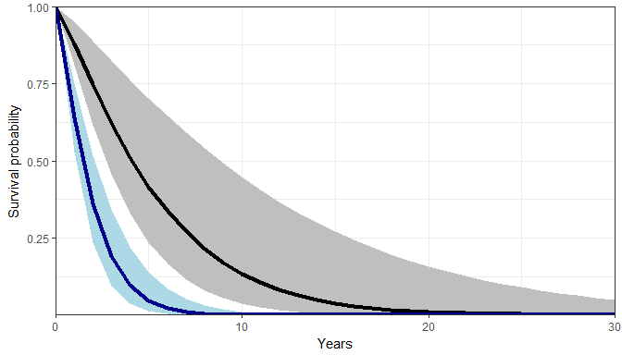

## Scale for 'x' is already present. Adding another scale for 'x', which will  
## replace the existing scale.

## Scale for 'y' is already present. Adding another scale for 'y', which will  
## replace the existing scale.

## Warning: Removed 10 rows containing missing values (geom_path).  
  
## Warning: Removed 10 rows containing missing values (geom_path).

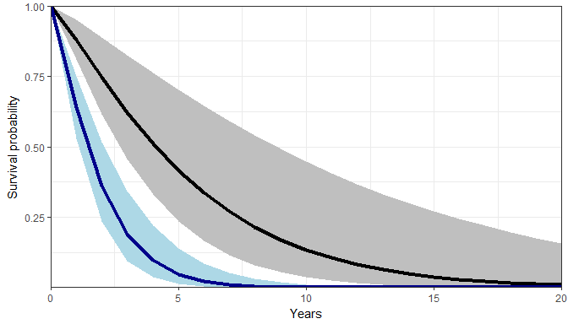

## Scale for 'x' is already present. Adding another scale for 'x', which will  
## replace the existing scale.  
## Scale for 'y' is already present. Adding another scale for 'y', which will  
## replace the existing scale.

## Warning: Removed 26 rows containing missing values (geom_path).

## Warning: Removed 26 rows containing missing values (geom_path).

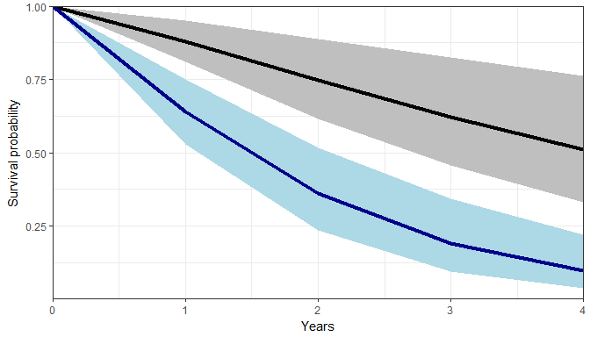

**Table** OS and PFS survival probabilities from Weibull model fits

|  |  |  |  |  |  |  |
| --- | --- | --- | --- | --- | --- | --- |
| x | OS | OS_lo | OS_up | PFS | PFS_lo | PFS_up |
| 5 | 0.416 | 0.236 | 0.703 | 0.0468 | 0.0128 | 0.139 |
| 10 | 0.134 | 0.0364 | 0.447 | 0.000898 | 4.63e-05 | 0.0109 |
| 15 | 0.0382 | 0.00461 | 0.27 | 1.12e-05 | 9.11e-08 | 0.000645 |
| 20 | 0.01 | 0.000505 | 0.158 | 1.04e-07 | 1.17e-10 | 3.16e-05 |
| 25 | 0.00244 | 4.95e-05 | 0.0895 | 7.6e-10 | 1.07e-13 | 1.32e-06 |
| 30 | 0.000564 | 4.41e-06 | 0.0497 | 4.55e-12 | 7.33e-17 | 4.89e-08 |

**Transforming between time scales** Shape and scale parameters (defined as per the Weibull model at the beginning of the section) were derived using time in years. For different time units, e.g. months, the transformation is as follows:

* Shape $γ$ is time-invariant and does not change.
* Scale in months ($λ_{m}$) from scale in years ($λ_{y}$):

$$λ_{m}=λ_{y}/{12}^{γ}$$

In this case, we get:

# OS scale in months  
os_scale / 12 ^ shape

## [1] 0.006538393

os_scale_lo / 12 ^ shape

## [1] 0.002623538

os_scale_up / 12 ^ shape

## [1] 0.01077791

# PFS scale in months  
pfs_scale / 12 ^ shape

## [1] 0.02282659

pfs_scale_lo / 12 ^ shape

## [1] 0.0147143

pfs_scale_up / 12 ^ shape

## [1] 0.03247261

# Session info

## [1] "C:/GIT/punta"

## R version 3.4.2 (2017-09-28)  
## Platform: x86_64-w64-mingw32/x64 (64-bit)  
## Running under: Windows 10 x64 (build 17763)  
##   
## Matrix products: default  
##   
## locale:  
## [1] LC_COLLATE=English_United Kingdom.1252   
## [2] LC_CTYPE=English_United Kingdom.1252   
## [3] LC_MONETARY=English_United Kingdom.1252  
## [4] LC_NUMERIC=C   
## [5] LC_TIME=English_United Kingdom.1252   
##   
## attached base packages:  
## [1] stats graphics grDevices utils datasets methods base   
##   
## other attached packages:  
## [1] ggplot2_2.2.1 tidyr_0.8.3 dplyr_0.8.0.1 readxl_1.3.1   
##   
## loaded via a namespace (and not attached):  
## [1] Rcpp_1.0.1 cellranger_1.1.0 pillar_1.4.3 compiler_3.4.2   
## [5] plyr_1.8.4 tools_3.4.2 zeallot_0.1.0 digest_0.6.12   
## [9] evaluate_0.14 tibble_2.1.1 gtable_0.2.0 pkgconfig_2.0.3   
## [13] rlang_0.3.4 cli_2.0.2 yaml_2.2.0 xfun_0.12   
## [17] stringr_1.4.0 knitr_1.28 vctrs_0.1.0 grid_3.4.2   
## [21] tidyselect_0.2.5 glue_1.3.1 R6_2.2.2 fansi_0.4.0   
## [25] rmarkdown_2.1 pander_0.6.1 purrr_0.3.2 magrittr_1.5   
## [29] scales_0.5.0 backports_1.1.1 htmltools_0.3.6 assertthat_0.2.0  
## [33] colorspace_1.3-2 labeling_0.3 utf8_1.1.4 stringi_1.4.3   
## [37] lazyeval_0.2.1 munsell_0.4.3 crayon_1.3.4