C:\Sensate_BIP26_Dublin\STMPGenNotes24May2026
Typos corrected 28th June 2026
Contents
MAIN LETTER 2
Setting the AI Context. 5
Preparing with Quizzes 5
Quiz Link 5
Setting up Arduino IDE. 6
Lab Troubleshooting Guide: Resolving PC Configuration & Hardware Hurdles 7
1. The USB Port Rule: Direct PC Connection Only 7
2. Identifying the Virtual COM Port & Driver Configuration 7
3. Core Software: Library Installation & Board Profiles 8
4. Deploying the BOOT and RESET Buttons (Flashing Failsafes) 9
5. The "Nuclear Option": Full Arduino IDE Restart 9
6 Cloud Sync Pitfalls & Copy-Paste Artifacts 10
7 Using AI as an On-the-Spot Lab Assistant 10
I8 DE Issue, Menu Bar Moves to Right , use CTRL_ALT-ESC to end IDE Task. . 10
GITHUB DOCUMENTATION 11
Setting the Context Again 12
Documentation. 14
Use of Libraries and pins for TFT Display. 15
What is a Library? 16
TinyGPS++ Library 16
NMEA PARISING USING AI 17
SKIP ON FIRST READING FIX AND LOCK ACTIVE 18
TFT Program using AI 24
DOP Dilution of Precision (and the Serial Plotter ) 24
PLOTTING SIGNAL TO NOISE RATIO AND AERIAL (ANTENNAE) POSITION 28
Introduction to or Review of Signal-to-Noise Ratio (SNR) 28
Worked Example: Calculating SNR in dB 30
How SNR is related to Eb/No ( You can skip this if you want ) 30
1. The Windows Port "Ghosting" Catch 35
APPENDIX ORIGIAL CLAUDE PROMPT 36

MAIN LETTER

Dear Abdelkarmim, Abdul, Adriana, Alecsandra, Alessio, Álvaro, Andrei-Eduard, Andrés, Aya, Ben, Bianca, Carla, Christian, Christoph, Claudia, Cristina, Diego, Domenico, Dovydas, Duc, Emilia, Emma, Ensar, Eoin, Fabian, Felix, Florina, Gabriel-Alejandru, Giulia, Ian, Jacob, Jael, Jiaqiang, Joel, Julia, Kevin, Kyrlo, Lara, Lorenzo, Lucia, Maria, Matas, Mattia, Max, Minh, Muhammad, Neha, Nery, Niki, Oana, Oisín, Othniel, Pau, Philip, Pier, Ray, Razvan, Richard, Rida, Samuele, Sandra, Sebastián, Shannon, Sven, Szymon, Teodor, Teodora, Thanh, Tommy and Viktor,
Hi
Hope you are well. This is a picture of sunny Tallaght Campus Ireland,
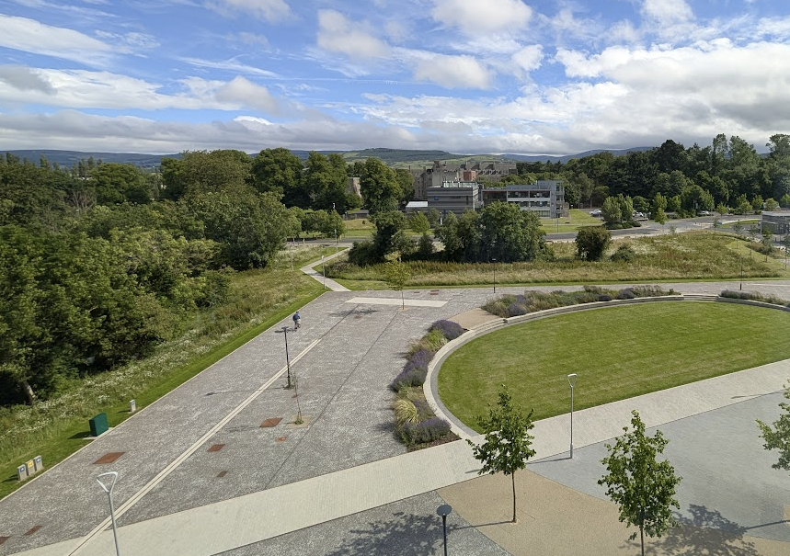
We are nearly at the start of STEMP29 Sensate which start on 29th June 2026. This is the final major technical note ( you should receive it on or around 20th June ) and is designed to help you use AI effectively for coding. You can use any AI tool you like (Gemini, Claude, etc.). If you’ve done this before, feel free to use your own preferred methods and help others — that’s fantastic! I tested this workflow recently with Gemini (and parts of it a few months ago on Claude).
You have now received three major technical discussion topics

Around June 1st , around June XX and around June 20th.
I have updated the GitHub site with these files and with some sample program. Note the name of the program is now STMP26 Sensate Dublin, it is the same from a student point of view as BIP, you will still see the term BIP in old document, but it has now been replaced by STMP.

In addition to that Teams have been selected around the 3rd June . If for any reason you have not contacted all the people in you team can you let me know, one or two teams are small and if you wish I can merge you but most appear to be four or five people.

This is the last big technical message and is designed to show you how to use AI to code things, if you have done this before you may have better ways that what is being shown here, but I tests this a few months ago on Claude ( well some if it ) and all of it today in Gemini. You can use any AI tool you wish. You can adapt a different approach if you wish, this is just to get you started, some may have done this before and it may be new to some,

1st June :
Soon after than you got team selection emails around XX June.

Time permitting I will set up a Teams groups and will have this for the start of the program. There will also be a shared folder which the Irahs student will be able to access where you can post your presentations. The approximate timetable is shown below, we have three interleaved visits to Tokyo Electron, and this is really a common denominator technology for all of us, if firms like this did not know how to make big chips.
Timetable for Week ( Subject to Change )
Car Travel Coordinates.
If travelling by car enter or on foot , you can paste 53.2906, -6.3639 directly into Google Maps for the exact location

TU Dublin Tallaght Campus coordinates:

Luas and Buses.

For those staying in the Liberties (a really interesting area!), the number 27 bus is often quicker outside rush hour — otherwise, take the Luas. I’ll contact the Liberties students directly. See https://www.dublinbus.ie/getmedia/01e1d41f-c576-4aaf-a025-66d2d1c48e89/Route-27.pdf?ext=.pdf and he stop is most Cork St (Donore Ave) in the Liberties and
Buses are generally faster outside rush hour: travelling into Dublin between 8:00 and 9:30, or out of Dublin between 4:30 and 6:30. Travelling to Tallaght counts as “out of Dublin” since it is located in the southwest of the city (it was originally a village but is now a thriving suburb and gateway to the Dublin Mountains).

Setting the AI Context.

Early in the week of June 29th, we will get the core NMEA program running. From there, a powerful way to proceed is utilizing AI to implement your specific design elements.
To demonstrate an efficient workflow, I will walk through an example using Gemini (though you are welcome to use other AI tools). While this development approach may be a daily habit for some of you, it will be entirely new to others. Ultimately, how you and your team choose to collaborate and divide the workload is completely up to you.

The detailed AI prompt is on GitHub
https://github.com/gstockiltud/BIP26Dublin/tree/main/docs
Where you should be.

Preparing with Quizzes

If you have done the following quizzes fine, if not look at the links below.
Quiz Link
NMEA gstockiltud.github.io/BIP26Dublin/quizzes/BIP26_NMEA_Quiz.html
Galileo gstockiltud.github.io/BIP26Dublin/quizzes/BIP26_Galileo_Quiz.html
These two quizzes, reading the documentation, and meeting with your team online are all part of the Blended (online) phase
See email of June 16th

You received two emails on 1was t June and 16th June detailing the Project.

Quiz Link
NMEA gstockiltud.github.io/BIP26Dublin/quizzes/BIP26_NMEA_Quiz.html

NMEA gstockiltud.github.io/BIP26Dublin/quizzes/BIP26_NMEA_Quiz.html
Galileo gstockiltud.github.io/BIP26Dublin/quizzes/BIP26_Galileo_Quiz.html
These two quizzes, reading the documentation, and meeting with your team online are all part of the Blended (online) phase see mail of 16th June.

Setting up Arduino IDE.
This was covered in the email of 1st June.
Pay attention to port numbers, libraries, the selected board, and many other settings. These must be configured correctly and can sometimes change.
Also, become familiar with the BOOT and RESET buttons on the TenStar board. Details and instructions are available on GitHub.
The instructions for this are also available on GitHub. It is not difficult, but different PC configurations may produce slightly different results. Please try to complete this before arriving in Dublin, as it is something you should discuss with your team.
A screenshot of my configuration is shown below show libraries, MMNEA string etc, . Yours may be different; the important thing is to ensure that the required libraries are installed correctly. Once the libraries are installed and the correct board and port are selected, the example programs should run without difficulty.
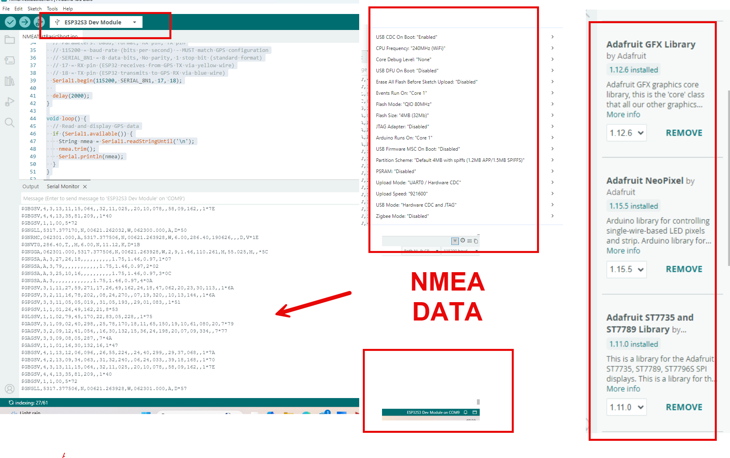
Expect these configurations to vary depending on your PC setup. As a team, check that everyone is working with a consistent set of settings, even if you are using different hardware or an Apple Mac.
The exact configuration may differ from system to system, but the important thing is that the required libraries are installed correctly and that the board, port, and other key settings are configured consistently.

Lab Troubleshooting Guide: Resolving PC Configuration & Hardware Hurdles
Engineers solve problems, and while the Arduino IDE is wonderful, it (and many other pieces of software) can sometimes appear not to work. Here is a list of some problems I encountered and how to fix them. Sometimes I had no problems and it worked the first time, but that does not always happen. So here is a list of possible problems; you may encounter your own. Use AI to help you or ask someone else in your team if they have ideas when these things happen.
Skip this on your first reading. If something does not work later on, see if this list helps you.

Reflecting on our experience setting up the ESP32-based Tenstar development board, several critical PC configuration and environmental hurdles stood out. When a board refuses to flash, throws compilation errors, or leaves the TFT display completely blank, the exact issues you encounter will vary wildly from configuration to configuration depending on your operating system, driver states, and hardware ports.
Here is a summary checklist of what you may need look out for on your PC during the lab, you may never see these issues or you may see your own ones, use AI to describe the problem and it often helps you fix it (it did for me anyway). Do not be intimidated by some of the detail here, you may not need it.:

1. The USB Port Rule: Direct PC Connection Only
Always connect the Tenstar board directly to a main USB port on the PC itself, never through an unpowered external USB hub.
- The Reason: ESP32 modules draw a significant spike of current when initializing their Wi-Fi/Bluetooth radios or driving an external TFT display backlight. External hubs often throttle or share current among multiple devices, causing the board to brownout, drop its connection mid-flash, or fail silently.

2. Identifying the Virtual COM Port & Driver Configuration
The Tenstar board uses an onboard USB-to-UART bridge chip to establish communication with the computer. Windows cannot talk to the chip without an initialized virtual driver.
- The Configuration Check: Open Device Manager on your PC and look under Ports (COM & LPT). Verify that a serial device is listed (e.g., USB-SERIAL CH340 or Silicon Labs CP210x).
- The Dropdown Setup: Inside the Arduino IDE, go to Tools > Port and select the matching COM port number identified in Device Manager. If the port menu is greyed out, you need to install the missing hardware driver executable.

3. Core Software: Library Installation & Board Profiles
Before compiling the project, your IDE must be equipped with the correct software dependencies and target parameters.
- Installing the Required Libraries: If you see an error stating a file or header #include <...> is missing, you must add it via the Library Manager (Tools > Manage Libraries). For this project, search for and install ( full details on GitHub, library list below may not be exhaustive )
  - Adafruit GFX Library (Core graphics engine)
  - Adafruit ST7789 Library (Display hardware driver)
  - TinyGPS++ by Mikal Hart (NMEA parsing engine)
- Board Configuration Settings (Tools Menu): When using an advanced board manager package like Espressif's ESP32 platform, selecting your board populates a dense menu of compilation options. Below is a typical sub-menu configuration (such as for an ESP32-S3 or similar architecture):
- USB CDC On Boot: "Enabled"
- CPU Frequency: "240MHz (WiFi)"
- Core Debug Level: "None"
- USB DFU On Boot: "Disabled"
- Erase All Flash Before Sketch Upload: "Disabled"
- Events Run On: "Core 1"
- Flash Mode: "QIO 80MHz"
- Flash Size: "4MB (32Mb)"
- JTAG Adapter: "Disabled"
- Arduino Runs On: "Core 1"
- USB Firmware MSC On Boot: "Disabled"
- Partition Scheme: "Default 4MB with spiffs (1.2MB APP/1.5MB SPIFFS)"
- PSRAM: "Disabled"
- Upload Mode: "UART0 / Hardware CDC"
- Upload Speed: "921600"
- USB Mode: "Hardware CDC and JTAG"
- Zigbee Mode: "Disabled"

Key Settings That May Cause Issues:
  - USB CDC On Boot: If your board relies on the native USB port of the ESP32 chip to output hardware diagnostic data to the Arduino Serial Monitor, changing this to Disabled can make the COM port completely disappear from your PC right after a sketch runs.
  - Upload Speed: Set to 921600 by default for fast programming. However, if a student is using a lower-quality USB data cable or a long cable routing line, this ultra-fast speed will cause data corruption mid-upload. Dropping this setting down to 115200 is a classic engineering fix to stabilize shaky data connections.
  - Flash Size / Partition Scheme: These must match the physical flash chip soldered onto your specific board. If a sketch exceeds the allocated 1.2MB APP limit due to massive graphic arrays or font definitions, the compiler will fail before it even attempts an upload.
Crucial Warning: Your specific machine configuration, board iteration, and available sub-menu parameters may vary significantly depending on the exact chip generation mounted on your development platform. If your settings list looks slightly different or misses specific parameters, always consult your instructor's specific hardware datasheet profile guidelines or use your AI lab assistant to map your menu's equivalent options!

4. Deploying the BOOT and RESET Buttons (Flashing Failsafes)
When flashing code, the PC must force the ESP32 chip into its internal bootloader mode. Sometimes, automated hardware timing fails. If the IDE hangs on "Connecting...", step in manually using the physical tactile buttons on the Tenstar board.
- Method A (Standard Sequence):
  - Press and hold down the BOOT button on the board.
  - Press and release the RESET (EN) button quickly once.
  - Release the BOOT button. This forces the chip into flash mode, allowing the code upload to proceed.
- Method B (The Hard Bootloader Force): If Method A fails because an old program is flooding the serial line or the USB drivers are lagging, use this ultimate power-cycling override:
  - Unplug the USB cable completely from the Tenstar board (powering it down).
  - Press and hold down the physical BOOT button on the board.
  - While keeping it held down, reinsert the USB power cable back into the board.
  - Release the BOOT button. The chip is now frozen in a clean, passive state, bypassing the old program and waiting directly for a new download. Click Upload in the IDE.

5. The "Nuclear Option": Full Arduino IDE Restart
Sometimes, a board will refuse to upload or the serial monitor will throw persistent connection errors even after applying the button tricks. In this scenario, you must completely close the Arduino IDE and reopen it.
- The Reason: When you connect, disconnect, or power-cycle a USB microchip rapidly, the operating system's internal background serial handler can become locked or deadlocked. The Arduino IDE loses exclusive access to the virtual COM port link, but it thinks the port is still busy. Closing the IDE entirely kills all active compiler threads and background serial listening tasks, forcing Windows to fully reset and release the hardware COM port lease when the program relaunches.

6 Cloud Sync Pitfalls & Copy-Paste Artifacts
- The OneDrive Trap: If your PC backs up the Documents folder to Microsoft OneDrive, the cloud sync engine can lock files mid-compilation, throwing bizarre errors like stray '#' in program. Save sketches locally (e.g., C:\ArduinoProjects).
- Markdown Snippets: Ensure you do not accidentally copy formatting wrappers like triple backticks (```cpp) or conversational headings into the IDE text editor.

7 Using AI as an On-the-Spot Lab Assistant
If you encounter a compiler error or an upload hang that isn't covered in the main documentation, you are highly encouraged to use Generative AI to debug your specific configuration. Once a program is up and running, AI is exceptionally fast at diagnosing syntax and compilation bugs. You can leverage it in two ways:
- Text Debugging: Copy the exact error output text from the bottom console window of the Arduino IDE, paste it into the AI prompt window, and specify your hardware setup:
“I am using an ESP32 Tenstar board on a Windows 11 PC using the Arduino IDE. I just tried to upload my sketch and received this exact error message: [PASTE ERROR HERE]. What configuration setting or button sequence do I need to fix this?”
- Visual Debugging: If the IDE interface looks frozen, or if you aren't sure where to find a setting, take a screenshot of your entire screen (including Device Manager or the Arduino IDE configuration menus) and upload it directly into the AI chat interface. Ask it to visually spot what port, board profile, or code layout error might be causing the hitch.
This approach provides immediate, personalized debugging feedback tailored to your exact machine profile, building real-world technical troubleshooting skills.

I8 DE Issue, Menu Bar Moves to Right , use CTRL_ALT-ESC to end IDE Task. .

"This may be very specific issue with Arduino IDE 2.3.2 running in Chrome . Sometimes the drop-down menu (File, Edit, Sketch, Tools, and Help) moves all the way to the right-hand side. Press Ctrl+Shift+Esc to open Task Manager, force-shut down the Arduino IDE process, and then restart it again. This glitch seems to happen primarily when many files are open simultaneously."
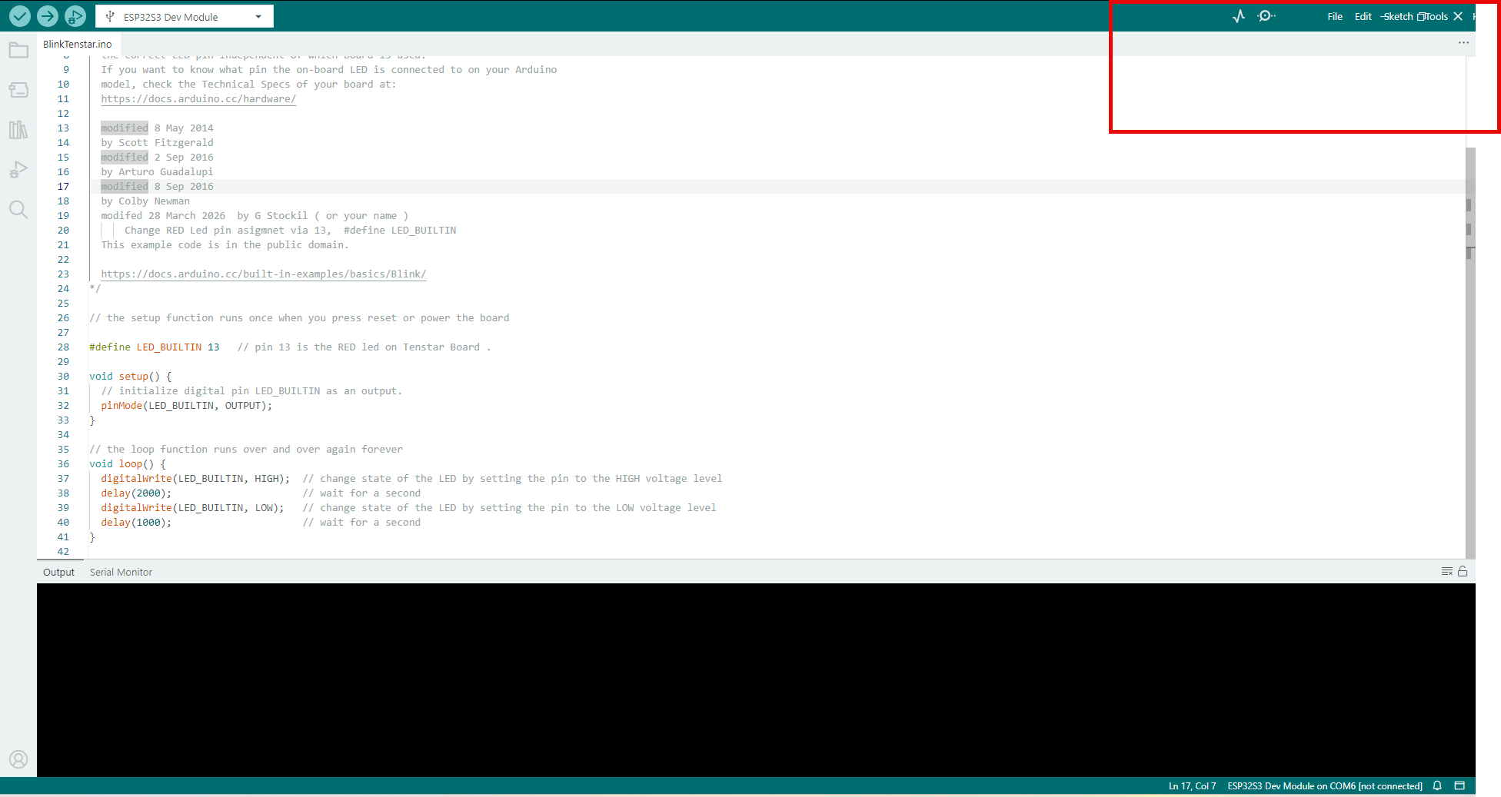

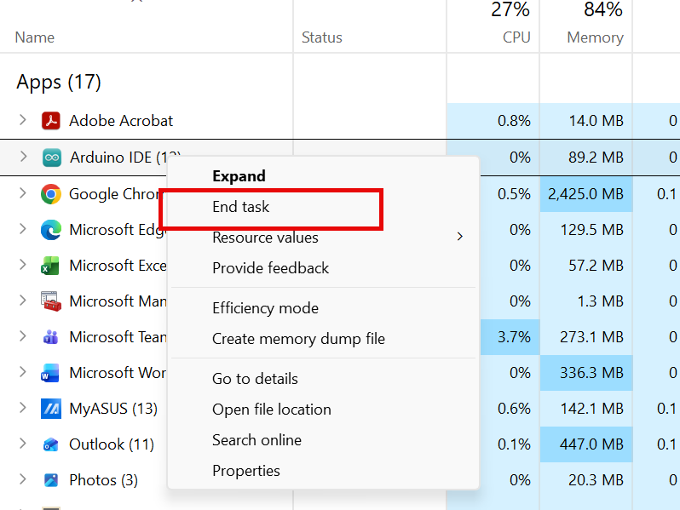

GITHUB DOCUMENTATION

See
https://github.com/gstockiltud/BIP26Dublin/tree/main/docs
Much documentation is here and it may be updated.
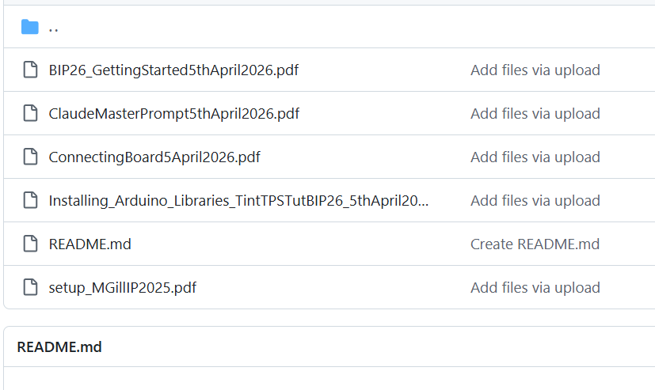

Note that since April the name of the project is no longer BIP26, it is STMP26, you will see reference to BIP in older files and these will not be changed as they were correct at the time of wring, the STMP project is the same from a student point of view.

Setting the Context Again
Hi Gemini, back to the STMP26 project, I have the basic NMEA program working. I now want to show student how I can use GAI to enhance this program and build progressively more complex program. Before I do that can you recall the master prompt I gave you that allowed you to set the scene for generating code for this project, that is the details of the TenStar Board and the Waveshare board and related matters?

This is what it gave me back. Note the word scaffolding, this is a summary of the set up, not everything just a summary.

Welcome back to the STMP26 SENSATE project, Gerry! Great to hear the foundational NMEA program is up, running, and ready for the students. Using Generative AI (GAI) as a scaffolding tool to progressively build complex embedded systems is a brilliant pedagogical approach.
While I can't pull up the exact, verbatim block of text of that original master prompt from a previous session, I have retained the complete, comprehensive technical blueprint and context we established in that Master Prompt & Technical Note.
Here is the exact hardware profile, pin mapping, and scene-setting context we used, reconstructed so you can hand it right back to GAI to kick off the next phase with your students:
The STMP26 SENSATE Hardware & Context Profile
1. Core Hardware Components
- Microcontroller: Tenstar ESP32-S3 board.
  - Note for GAI: Native USB CDC on boot must be enabled in the Arduino IDE. Bootloader timing requires holding the BOOT button, pulsing EN/RST, and releasing BOOT to flash successfully over the native USB-C port.
- GNSS Module: Waveshare LC29H (AA) GPS/GNSS HAT.
  - Module Capabilities: High-precision, multi-constellation (including European Galileo with OSNMA security features).
  - Configuration: The Waveshare hardware yellow jumper must be set to Position B (Raspberry Pi mode) to route the UART data correctly to the header pins.
2. Physical Interconnect & Wiring Diagram
The connection relies on a strict 3-wire data interface plus external power. Crucial: To prevent regulator damage, the boards must only share a 5V rail—do not cross-connect any 3.3V lines.
Tenstar ESP32-S3 Pin | Waveshare LC29H Pin | Signal / Function
5V | 5V | Main Power Rail
GND | GND | Common Ground
GPIO 17 | TX | ESP32 Receive (RX) <- GNSS Transmit
GPIO 18 | RX | ESP32 Transmit (TX) -> GNSS Receive
3. Software Environment & Base Logic
- IDE: Arduino IDE (targeting ESP32-S3 Dev Module).
- Current State: A working base program utilizing a hardware UART (Hardware Serial on Pins 17/18) configured to read raw ASCII NMEA sentences from the LC29H and stream them to the Serial Monitor/Plotter.
- Target Evolution: Scaffolding this base code to progressively add parsing libraries (like Tings++), data logging, TFT display integration (via SPI), and eventually, trajectory/flight metrics tracking for hobby rocketry applications.
How to use this to show students GAI scaffolding:
When you introduce this to the students, you can feed the profile above into a fresh GAI session and use a "Master Prompt" structure like this:
"Act as an expert embedded systems engineer and educator. We are working on the STMP26 SENSATE project using a Tenstar ESP32-S3 and a Waveshare LC29H GNSS HAT wired as follows: [Insert table above]. I currently have a working sketch that reads raw NMEA strings on GPIO 17/18. I want you to help me guide my students step-by-step. Do not give me the final complex code all at once. First, acknowledge you understand this hardware environment, and then ask me for my base NMEA code so we can plan Step 1 of the enhancement."

You could modify the prompt and ask it to teach you and tell it what you already know and what things you need to learn.

Documentation.

This was covered in earlies posting but there is a summary.
Here are the official technical resources, product documentation, and reference links to anchor this project context for you and your students.
1. Hardware Documentation & Wiki References
Waveshare LC29H (AA) GNSS HAT
- Official Technical Reference: Waveshare Wiki: LC29H(XX) GPS/RTK HAT
  - What's inside: This is the exact source specifying the UART selection jumper settings (setting it to Position B for direct pin header routing), schematic layouts, dual-band (L1+L5) multi-constellation support, and troubleshooting steps using the QGNSS configuration software.
Tenstar ESP32-S3 Hardware
- Pinout & Specifications: ESPHome Devices: Tenstar Robot ESP32-S3 Supermini / Dev Board
  - What's inside: Pin definitions, native USB-C configuration parameters, and the board’s hardware layer details required to set up the Arduino IDE targeting the ESP32-S3 core architecture.
2. Fundamental NMEA 0183 Protocol Documentation
Because the formal NMEA standard is a commercial, copyrighted specification published directly by the National Marine Electronics Association (NMEA), the industry and academia rely on highly detailed engineering manuals and implementation guides for teaching. Here are the premier open reference resources for your students:
Comprehensive Reference Manuals
- The Definitive Practical Guide: Actisense: Everything You Need to Know About NMEA 0183
  - Why it's excellent for students: It provides a beautiful, clean breakdown of the serial data bus architecture, mapping out the electrical signalling logic ("Talkers" vs. "Listeners") and raw data framing rules.
- Sentence Architecture & Tables: OxTS NMEA 0183 Reference Manual
  - Why it's excellent for students: This contains comprehensive look-up tables breaking down exactly how target sentences (like $GNGGA for position data, $GNRMC for essential minimum navigation, and $GPGSV for satellites in view) split their comma-separated ASCII strings into latitude, longitude, timestamp, and checksum fields.
Key NMEA Concepts to Highlight for the Classroom:
- The Framing Structure: Every NMEA sentence begins with a $ character, followed by a 2-character Talker ID (e.g., GP for GPS, GA for Galileo, or GN for global multi-constellation), a 3-character sentence formatter (e.g., GGA), comma-separated data payloads, an asterisk *, and a 2-hex-character XOR checksum.
- Serial Settings: While standard historical marine NMEA uses 4800 baud, modern high-rate multi-frequency GNSS modules like the LC29H operate natively at a default speed of 115200 bps.

Use of Libraries and pins for TFT Display.
Now we asl it to generate a program

Hi Gemini, I am going to ask you to use these libraries and pin definitions in a future program. I have got program with this code before.
(Paste following code in )
#include <Sigh>
#include <Adafruit_GFX.h>
#include <Adafruit_ST7789.h>
#include <TinyGPS++.h>

// ============================================================================
// 1. PIN DEFINITIONS (Targeting Profile 2: 1.14" ST7789 Layout)
// ============================================================================
#define TFT_CS 10 // Chip Select: Active LOW line to select this SPI peripheral
#define TFT_RST 9 // Reset: Hard hardware pulse to clear display memory
#define TFT_DC 8 // Data/Command: Toggle HIGH for pixel data, LOW for setup commands
#define TFT_MOSI 11 // Master Out Slave In: SPI Serial Data Line (SDA)
#define TFT_SCLK 12 // Serial Clock: Synchronizes data bit timing (SCL)
#define TFT_BL 13 // Backlight: Drives the panel LEDs (HIGH = ON)

Got it! I am logging this profile into our active memory right now.

Note while is us useful to understand all the above , you do not need to all you need to know is that later commands like

tft.print("STMP26 SENSATE-X 2.0 | GNSS");

will allow you to print stuff on the screen. This is why we use libraries. You need to know how to use them you do not necessarily need to know how they work. Here is an (AI generated ) mini review of what a library is an Arduino context.
Comment : The code is long, it work. You may note a library called TinyGNSS, #include <TinyGPS++.h>

What is a Library?
In Arduino programming, a library is a collection of pre-written code that performs specific tasks. Libraries allow programmers to use complex hardware and software features without having to write all the code from scratch.
You can think of a library as a toolbox containing useful functions that have already been developed and tested by others. For example, there are libraries for GPS receivers, displays, sensors, Wi-Fi communication, and SD card storage.
By including a library in your program, you gain access to these functions with just a few lines of code. This makes programs easier to write, easier to understand, and more reliable.

TinyGPS++ Library
TinyGPS++ is a software library that makes it easier for an Arduino or ESP32 program to work with a GPS receiver. A library is simply a collection of pre-written code that saves you from having to write everything yourself.
GPS receivers transmit information in the form of text messages known as NMEA sentences. TinyGPS++ reads these messages and extracts useful information such as:
- Latitude and longitude
- Date and time (UTC)
- Altitude
- Speed
- Course (direction of travel)
- Number of satellites in view
- GPS signal quality
Without a library such as TinyGPS++, the programmer would have to manually decode the NMEA messages. TinyGPS++ simplifies this process and allows you to focus on developing your application rather than interpreting GPS data.

The "GPS" in its name is a bit of a historical artifact from when the US Global Positioning System . the first one to work, was the only game in town for hobbyists, but the library itself is actually constellation-agnostic.
TinyGPS++ does not care which satellite constellation (GPS, Galileo, GLONASS, or BeiDou) a signal comes from. Instead, it looks entirely at the NMEA talker IDs and sentence structures.
Standard legacy GPS strings always start with $GP (e.g., $GPGGA). Modern multi-constellation GNSS receivers like the LC29H bundle data from multiple satellite networks simultaneously and output talker strings starting with $GN (Global Navigation Satellite System, e.g., $GNGGA).
The internal architecture of TinyGPS++ is designed to look at the sentence type identifier (the GGA, RMC, or GLL suffix) rather than strict constellation prefixes.

Recall for you dealings with NMEA
Standard Constellation Prefixes
NMEA Prefix | GNSS Constellation | Description
$GP | GPS | United States Global Positioning System.
$GA | Galileo | European Union European Navigation Satellite System.
$GB (or $BD) | BeiDou | Chinese Navigation Satellite System (Older receivers use BD, modern use GB).
$GL | GLONASS | Russian Global Navigation Satellite System.
$GQ (or $QZ) | QZSS | Japanese Quasi-Zenith Satellite System (Regional).
$GI | NavIC (IRNSS) | Indian Regional Navigation Satellite System.

NMEA PARISING USING AI
Here is a display on the TFT of some parameters, this is does with the TinyGPS++ library and an AI prompts.

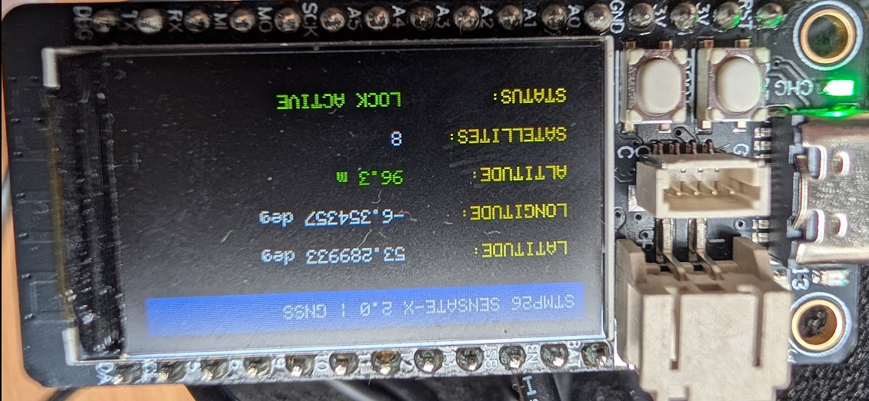

The latitude, longitude, altitude and number of satellites are obvious enough
In terms of GNSS NMEA data, "LOCK ACTIVE" (or having a "satellite lock") means that the receiver's internal processor has successfully isolated, decoded, and synchronized its timing with a minimum threshold of orbiting satellites.

SKIP ON FIRST READING FIX AND LOCK ACTIVE

If help to read this but you do not have to . Skip in you wish.

The Journey to Satellite Tracking: From "Signal Lock" to "Position Fix"
For a student working with a GNSS module (like the Waveshare LC29H) for the first time, watching the terminal or LCD screen boot up can be confusing. They will see terms like "Lock," "Fix," and "Active" used almost interchangeably.
From an engineering perspective, however, these terms represent a precise, step-by-step pipeline where raw radio waves are transformed into accurate geographic coordinates.
Here is exactly how a GNSS receiver goes from a cold power-on to a live navigation state.
Phase 1: Tracking Individual "Signal Locks" (The Hardware Layer)
The moment the ESP32 powers up the GNSS module, the antenna begins scanning the sky for radio signals broadcast by constellations like GPS or Galileo.
- Code Synchronization: The satellite transmits a unique pseudo-random noise (PRN) code. The receiver shifts its own internal clock code until it perfectly aligns with the satellite's code.
- Carrier Lock: Once aligned, the hardware "locks" onto the continuous radio carrier wave.
At this stage, the receiver has a signal lock on an individual satellite. It can now download that specific satellite's atomic time and orbital path data (Ephemeris).
Student Visual: Imagine standing in a dark room trying to catch flashlights beam-by-beam. Grabbing one flashlight handle is an individual "lock." However, locking onto one, two, or even three satellites is not enough to know where you are on Earth.
Phase 2: Achieving the "Position Fix" (The Mathematics Layer)
A Position Fix is the mathematical calculation of your physical coordinates on Earth. To achieve a 3D position fix, the receiver's internal CPU must solve for four unknown variables:
- $X$ (Latitude)
- $Y$ (Longitude)
- $Z$ (Altitude)
- $t$ (The time error of the receiver's inexpensive internal clock)
Because there are 4 unknowns, the receiver requires independent distance equations from a minimum of 4 different satellites simultaneously.
Once the module secures at least 4 stable individual signal locks, it runs a geometric process called trilateration. The exact millisecond the receiver calculates a valid solution for these four variables, it has acquired a Position Fix.
Phase 3: "LOCK ACTIVE" (The NMEA System State)
In the software code your students run on the ESP32, "LOCK ACTIVE" is the final user-interface status message. It acts as a green light confirming that Phase 1 (Signal Locks) and Phase 2 (Position Fix) have successfully merged.
The microcontroller knows to display "LOCK ACTIVE" because it is constantly reading raw text streams from the module called NMEA sentences. It scans specific status characters called "flags" to verify the fix quality.
How to Spot a Fix inside Raw NMEA Data
Students can verify a live fix directly inside the raw strings by looking at two primary sentences:
1. The $GNGGA Sentence (Global Positioning System Fix Data)
The receiver outputs a sentence that looks like this:
Plaintext
$GNGGA,123456.00,5318.1234,N,00622.1234,W,1,09,1.2,45.2,M...
^
Fix Quality Indicator
- The software counts over to the 6th comma. This is the Fix Quality Indicator.
- If it reads 0, the lock is inactive (searching).
- If it switches to 1, a valid standalone Position Fix is achieved. The system state upgrades to LOCK ACTIVE.
2. The $GNRMC Sentence (Recommended Minimum Navigation Information)
The receiver will also output an essential runtime string:
Plaintext
$GNRMC,123456.00,A,5318.1234,N,00622.1234,W...
^
Status Flag
- The software looks at the 2nd comma. This is the Status Flag.
- V = Void (Navigation receiver warning; individual satellite locks might exist, but there is no position fix yet).
- A = Active / Valid (The mathematical position fix is solid, data is trustworthy).
Summary Handout for the Lab
Term | What it means | Analogy | NMEA Indicator
Signal Lock | Hardware layer connection to an individual satellite. | Hearing a single instrument playing in an orchestra. | Appears as an active satellite entry in a $GPGSV sentence.
Position Fix | Mathematical resolution of your 3D coordinates ($X,Y,Z,t$). | Recognizing the complete melody once all instruments play together. | The quality index in $GNGGA switches from 0 to 1.
Lock Active | Software status verifying the system is navigating reliably. | The conductor giving the "all clear" to begin recording. | The status flag in $GNRMC switches from V (Void) to A (Active).

Hi Gemini, I am going to ask you to write Arduino code that will write to the TFT ( Thin Film Transistor ) display on the TenStar board, use the sample libraries and pin connections I just gave you, can you comment the code well for students ( and others ) who are still learning. Thanks

Here is the complete, heavily commented Arduino program that integrates the TinyGPS++ library with your ST7789 TFT display using the second hardware profile you provided.
This script is designed as an educational scaffolding tool. Instead of just dumping raw data, it parses the incoming NMEA stream behind the scenes and maps out a clean, structured visual layout on the screen. It explicitly explains the why and how behind every block of code for your students.

Notice how AI has made decisions and taken it a step further. If you are interacting with AI, you can ask it to slow down or speed up. It is going to introduce the TinyGPS++ library."

You can chat to AI about technical things, it is not human even if sometimes it appears that way so be careful what you tell it and it should not become a replacement for human interaction but for technical stuff it is really useful.

That adaptive pacing is exactly what makes generative AI such a powerful tool in a teaching environment. Unlike a static textbook or a pre-recorded lecture, an AI collaborator can act as a dynamic scaffolding tool. If students (or lecturers ) are struggling with a concept, it can break the logic down step-by-step; if they grasp it quickly, it can immediately pick up the pace and challenge them with deeper engineering concepts—like moving seamlessly from raw text logging to live graphical dashboards.

This flexibility pairs perfectly with how the TinyGPS++ library is structured. The library itself functions as an intelligent middleware buffer: it doesn't rush or choke on the incoming hardware data. Instead, it processes the raw NMEA text stream at whatever pace the hardware delivers it—character by character—silently assembling the puzzle pieces in the background

/*
* ============================================================================
* STMP26 SENSATE | Advanced GNSS Parsing & TFT Dashboard
* Technological University Dublin
* ============================================================================
* * This program demonstrates how Generative AI and advanced software libraries
* can transform raw, difficult-to-read NMEA data into a clean, human-readable
* engineering dashboard.
* * Logic Flow:
* 1. Reads raw serial characters coming from the Waveshare LC29H GNSS module.
* 2. Feeds characters into the TinyGPS++ parsing engine stream-by-stream.
* 3. Once a valid dataset ($GNGGA/$GNRMC) is fully assembled, the library
* extracts useful floating-point metrics (Latitude, Longitude, Altitude, Satellites).
* 4. Refreshes the ST7789 TFT display layout precisely without screen flicker.
* ============================================================================
*/

#include <SPI.h>
#include <Adafruit_GFX.h>
#include <Adafruit_ST7789.h>
#include <TinyGPS++.h>

// ============================================================================
// 1. PIN DEFINITIONS (Targeting Profile 2: 1.14" ST7789 Layout)
// ============================================================================
#define TFT_CS 10 // Chip Select: Active LOW line to select this SPI peripheral
#define TFT_RST 9 // Reset: Hard hardware pulse to clear display memory
#define TFT_DC 8 // Data/Command: Toggle HIGH for pixel data, LOW for setup commands
#define TFT_MOSI 11 // Master Out Slave In: SPI Serial Data Line (SDA)
#define TFT_SCLK 12 // Serial Clock: Synchronizes data bit timing (SCL)
#define TFT_BL 13 // Backlight: Drives the panel LEDs (HIGH = ON)

// GNSS Module UART Mapping
#define GNSS_RX 16 // ESP32 GPIO16 connects physically to Quectel TX
#define GNSS_TX 17 // ESP32 GPIO17 connects physically to Quectel RX
#define GNSS_BAUD 115200

// ============================================================================
// 2. OBJECT INITIALIZATION
// ============================================================================
// Create the display instance, passing our custom software/hardware SPI constructor
Adafruit_ST7789 tft = Adafruit_ST7789(TFT_CS, TFT_DC, TFT_MOSI, TFT_SCLK, TFT_RST);

// Instantiate the TinyGPS++ parser object engine
TinyGPSPlus gps;

// Use HardwareSerial port 2 on the ESP32 to keep Port 0/1 free for native USB debugging
HardwareSerial GNSS(2);

void setup() {
// Initialize native USB communication back to the PC Serial Monitor
Serial.begin(115200);
Serial.println("STMP26 SENSATE Dashboard Initializing...");

// Initialize GNSS serial bus communication using custom pins
GNSS.begin(GNSS_BAUD, SERIAL_8N1, GNSS_RX, GNSS_TX);

// Configure and instantly enable the display screen backlight line
pinMode(TFT_BL, OUTPUT);
digitalWrite(TFT_BL, HIGH);

// Initialize display controller hardware (Dimensions: 135x240 pixels)
tft.init(135, 240);
tft.setRotation(3); // Force landscape orientation
tft.fillScreen(ST77XX_BLACK); // Flush screen artifacting out
tft.setTextWrap(false); // Prevent character spillovers from breaking the layout

// Draw static UI scaffolding elements (This minimizes screen redraw flicker later)
drawStaticUI();
}

void loop() {
bool freshDataParsed = false;

// Process any incoming bytes sitting in the ESP32 Hardware UART buffer
while (GNSS.available() > 0) {
char byteIn = GNSS.read();

// Optional: Pass raw data to the PC for background validation debugging
// Serial.write(byteIn);

// Feed the single byte into TinyGPS++. encode() returns 'true' the exact
// instant a complete, valid NMEA sentence has finished parsing completely.
if (gps.encode(byteIn)) {
freshDataParsed = true;
}
}

// If a complete sentence was parsed, update the dynamic data on our dashboard
if (freshDataParsed) {
updateDashboardValues();
}
}

// ============================================================================
// 3. UI GRAPHICS & DISPLAY LAYER FUNCTIONS
// ============================================================================

/* Draws the static labels that never change. By separation, we avoid re-printing
text labels every loop, which is the primary cause of screen blinking/flicker. */
void drawStaticUI() {
tft.fillScreen(ST77XX_BLACK);

// Header Banner
tft.fillRect(0, 0, 240, 20, ST77XX_BLUE);
tft.setTextColor(ST77XX_WHITE);
tft.setTextSize(1);
tft.setCursor(6, 6);
tft.print("STMP26 SENSATE-X 2.0 | GNSS");

// Field Categories Left Column Labels
tft.setTextColor(ST77XX_YELLOW);
tft.setCursor(10, 35); tft.print("LATITUDE:");
tft.setCursor(10, 55); tft.print("LONGITUDE:");
tft.setCursor(10, 75); tft.print("ALTITUDE:");
tft.setCursor(10, 95); tft.print("SATELLITES:");
tft.setCursor(10, 115); tft.print("SYSTEM STATUS:");
}

/* Erases old numeric values and prints updated calculations inside a fixed bounding box */
void updateDashboardValues() {
tft.setTextSize(1);

// 1. LATITUDE DISPLAY FIELD
// Drawing a solid black background rect clears out old text remnants perfectly
tft.fillRect(100, 35, 130, 12, ST77XX_BLACK);
tft.setCursor(100, 35);
if (gps.location.isValid()) {
tft.setTextColor(ST77XX_WHITE);
tft.print(gps.location.lat(), 6); // Display with precision up to 6 decimal places
tft.print(" deg");
} else {
tft.setTextColor(ST77XX_RED);
tft.print("Searching...");
}

// 2. LONGITUDE DISPLAY FIELD
tft.fillRect(100, 55, 130, 12, ST77XX_BLACK);
tft.setCursor(100, 55);
if (gps.location.isValid()) {
tft.setTextColor(ST77XX_WHITE);
tft.print(gps.location.lng(), 6);
tft.print(" deg");
} else {
tft.setTextColor(ST77XX_RED);
tft.print("Searching...");
}

// 3. ALTITUDE DISPLAY FIELD
tft.fillRect(100, 75, 130, 12, ST77XX_BLACK);
tft.setCursor(100, 75);
if (gps.altitude.isValid()) {
tft.setTextColor(ST77XX_GREEN);
tft.print(gps.altitude.meters(), 1);
tft.print(" m");
} else {
tft.setTextColor(ST77XX_RED);
tft.print("No Lock");
}

// 4. SATELLITE COUNT DISPLAY FIELD
tft.fillRect(100, 95, 130, 12, ST77XX_BLACK);
tft.setCursor(100, 95);
if (gps.satellites.isValid()) {
tft.setTextColor(ST77XX_WHITE);
tft.print(gps.satellites.value());
} else {
tft.setTextColor(ST77XX_RED);
tft.print("0");
}

// 5. SYSTEM DIAGNOSTIC OK HINT
tft.fillRect(100, 115, 130, 12, ST77XX_BLACK);
tft.setCursor(100, 115);
if (gps.location.age() > 2000) {
// If the data is more than 2 seconds (2000ms) old, warn the student that the stream stalled
tft.setTextColor(ST77XX_ORANGE);
tft.print("DATA STALE");
} else if (gps.location.isValid()) {
tft.setTextColor(ST77XX_GREEN);
tft.print("LOCK ACTIVE");
} else {
tft.setTextColor(ST77XX_RED);
tft.print("WAITING FOR FIX");
}
}

END OF THIS SECTION

TFT Program using AI

DOP Dilution of Precision (and the Serial Plotter )
The word dilution can mean reduction. In this prompt we are going to examine Dilution of Precision as applied to a GNSS and get it to do a lot( graph ) on the Serial Plotter of the Arduino IDE.
This is what we will see later, a serial plot of the number of satellites and the DOP (dilution of precision )

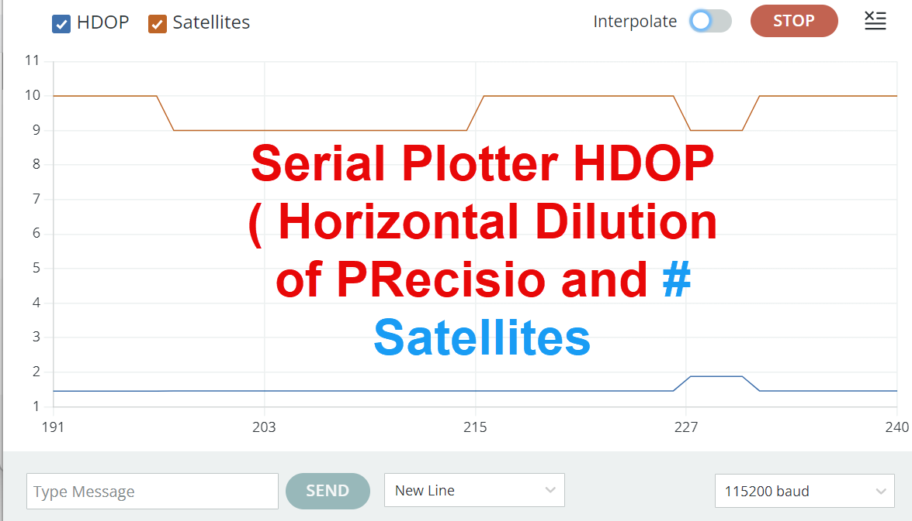
The Arduino IDE Serial Plotter is a built-in visual diagnostic tool that converts raw numerical data from your microcontroller into a real-time, scrolling 2D graph.
Instead of forcing you to read an unreadable wall of rapidly scrolling text in the Serial Monitor, the plotter visually tracks changes, trends, and spikes instantly.
How It Works
The Serial Plotter listens directly to the data coming across the USB serial port via Serial.println(). It automatically formats the graph based on how you print the text:
See https://docs.arduino.cc/software/ide-v2/tutorials/ide-v2-serial-plotter/ , you do not have to ue this in your project, it is just a suggestion.

In engineering, data analysis, and GNSS tracking, accuracy and precision have completely distinct meanings.
The easiest way to understand the difference is to imagine a target or a dartboard:
- Accuracy refers to how close a measurement is to the true or correct value. On a dartboard, accuracy means your darts are hitting close to the bullseye, even if they are scattered all around it.
- Precision refers to how close a series of measurements are to each other, regardless of whether they are correct. On a dartboard, precision means your darts form a very tight cluster, even if that cluster is far away from the bullseye.
The Four Scenarios
Measurement State | Description | On a Target
High Accuracy + High Precision | Ideally what we want. Measurements are right on the true value and perfectly repeatable. | A tight cluster directly in the bullseye.
Low Accuracy + High Precision | Implies a systematic error or bias (e.g., a GNSS receiver with a fixed altitude offset or a warped rocket fin). | A tight cluster, but stuck way off in the double-1 border.
High Accuracy + Low Precision | The average of the data points hits the true mark, but the individual readings bounce around wildly. | Darts are scattered loosely all around the bullseye.
Low Accuracy + Low Precision | Complete random noise or poor environment tracking. | Darts are scattered randomly across the entire room.

SHOW SERIAL PLOT
Thanks, I now want to do two things, explain what DOP is in the context of GNSS and an introductory level and write a shore Arduino program that will demonstrate this and if possible use the Serial Plotter

/* SPlotSatHDOPALTSpeed
* Basic GPS Performance Plotter
* Displays: Satellites, HDOP, Altitude, Speed
*/

#include <TinyGPSPlus.h>

TinyGPSPlus gps;

void setup() {
Serial.begin(115200);
Serial1.begin(115200, SERIAL_8N1, 17, 18);

delay(2000);
}

void loop() {
// Feed GPS data to TinyGPSPlus
while (Serial1.available() > 0) {
gps.encode(Serial1.read());
}

// Plot data every second
static unsigned long lastPlot = 0;
if (millis() - lastPlot > 1000) {

// Format for Serial Plotter: "Label:value Label:value"

Serial.print("Satellites:");
if (gps.satellites.isValid()) {
Serial.print(gps.satellites.value());
} else {
Serial.print(0);
}

Serial.print(" HDOP:");
if (gps.hdop.isValid()) {
Serial.print(gps.hdop.hdop());
} else {
Serial.print(0);
}

Serial.print(" Altitude:");
if (gps.altitude.isValid()) {
Serial.print(gps.altitude.meters());
} else {
Serial.print(0);
}

Serial.print(" Speed:");
if (gps.speed.isValid()) {
Serial.print(gps.speed.kmph());
} else {
Serial.print(0);
}

Serial.println(); // End line - triggers plotter update

lastPlot = millis();
}
}

PLOTTING SIGNAL TO NOISE RATIO AND AERIAL (ANTENNAE) POSITION

Now we are going to look at signal to noise ration, all you need to know about signal to noise ration is that the higher this number is the better. It depends in the antennae postion.

Fist let’s review what signal to noise ratio is

Introduction to or Review of Signal-to-Noise Ratio (SNR)
Here is an bar graph of the SNR (in dB) of the four strongest satellites. You will be able to get a program to plot something similar. SNR is dependent on aerial position. The area is outside a window and the SNR is around 33 dB
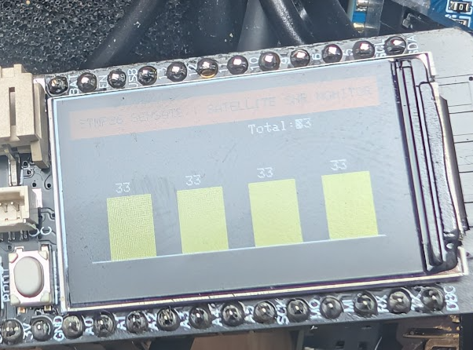

The following is the same program with the antenna inside the window, what has happened to the SNR , it is now 22 dB. This program (with the help of AI ) show the signal tracking strength of the top 4 available satellites, color-coding them dynamically to provide instant visual telemetry feedback . Telemetry is the automated process of collecting digital data from a remote or inaccessible location and transmitting it wirelessly to a receiving station for real-time monitoring and analysis.
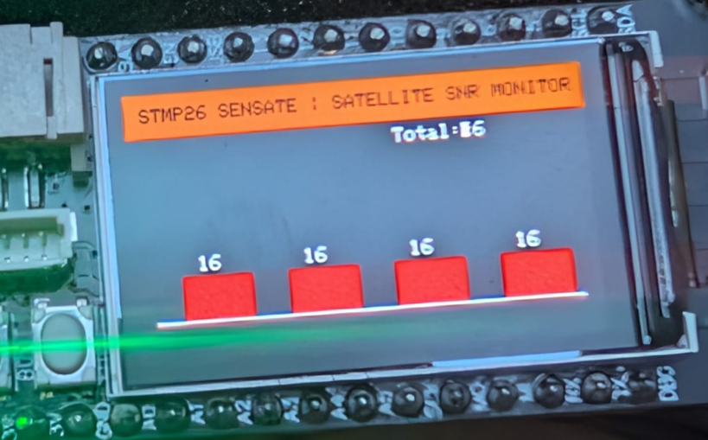

In satellite communications, Signal-to-Noise Ratio (SNR) is a fundamental metric that measures the clarity and strength of a desired satellite radio signal relative to the background electrical noise.
Think of it simply as the ratio of "useful information" to "useless interference." It is measured id a dB scale ( that is all you really need t know to get started, read on if interested )
Because satellite signals travel thousands of kilometres through space and the atmosphere, they arrive at your receiver (like the Waveshare LC29H) incredibly weak. At the same time, the surrounding environment is full of background static—caused by cosmic radiation, atmospheric heat, and nearby consumer electronics.
- High SNR: The satellite signal is clean and dominant. The receiver can easily decode the navigation data bits without making processing errors.
- Low SNR: The signal is completely buried in static. The data bits get scrambled, leading to packet data loss or a complete loss of tracking.
Why We Measure SNR in Decibels (dB)
Radio signal power drops off exponentially over long distances. If we measured signal and noise in standard linear units like Watts (W), engineers would have to deal with awkward, microscopically small decimal places (e.g., 0.0000000000001 W).
To make the math practical for classroom lessons and engineering calculations, we convert these linear power levels into a logarithmic scale called Decibels (dB). This compresses massive physical scales into simple, manageable numbers—typically falling between 0 and 50 inside a GNSS receiver environment.

Worked Example: Calculating SNR in dB
Imagine you are testing a GNSS antenna configuration with your students, and you want to mathematically calculate the current SNR of an incoming satellite signal using baseline power data.
1. The Given Values (Linear Scale)
- The power of the incoming satellite carrier signal is measured at 100,000 nanowatts.
- The background environmental noise floor power is measured at 10 nanowatts.
2. The Ratio Formula First, find the absolute ratio by dividing the signal power by the noise power:
Linear Ratio = Signal Power / Noise Power Linear Ratio = 100,000 nW / 10 nW = 10,000
This calculation tells us that the satellite's transmitted signal is physically 10,000 times stronger than the background static surrounding the antenna.
3. Converting to Decibels (dB) To convert any raw linear power ratio into decibels, apply the standard engineering logarithmic scaling formula:
SNR (in dB) = 10 * log10(Linear Ratio)
Plugging our ratio of 10,000 into the formula:
- log10(10,000) = 4 (since 10 to the power of 4 equals 10,000)
- SNR = 10 * 4 = 40 dB
Summary Result: The display or the NMEA data stream will report an SNR of 40 dB. This indicates to the student that the signal is a solid, clean 40 dB above the local environmental noise floor, confirming a highly reliable data link.

How SNR is related to Eb/No ( You can skip this if you want )

Decoding a $GPGSV (SPT Satellites in View ) Sentence.
A good, descriptive English name for $GPGSV is "GPS Satellites in View".
If you want to be completely technically precise for an engineering or GNSS manual, you can call it the "GPS Detailed Satellite Status" message.
Here is why:
- GP tells the software the message contains data specifically for the Global Positioning System (US Constellation).
- GSV stands for Global Satellite Satellites in View.

Detailed Field Breakdown of an NMEA GSV Sentence
Raw String: $GPGSV,3,1,11,02,41,067,43,05,09,122,32,09,12,201,39,14,04,312,22*71
Field Data | Associated Meaning | Engineering Context & Interpretation
$GPGSV | Talker ID | GPS Satellites in View sentence header
3, 1 | Message Progress | Message 1 of 3 required to transmit total constellation view
11 | Satellite Count | 11 satellites are currently above the local horizon
02, 41, 067, 43 | Satellite 1 | ID: 02 | Elevation: 41° | Azimuth: 067° | SNR: 43 dB-Hz (Strong link)
05, 09, 122, 32 | Satellite 2 | ID: 05 | Elevation: 9° | Azimuth: 122° | SNR: 32 dB-Hz (Moderate link)
09, 12, 201, 39 | Satellite 3 | ID: 09 | Elevation: 12° | Azimuth: 201° | SNR: 39 dB-Hz (Good link)
14, 04, 312, 22 | Satellite 4 | ID: 14 | Elevation: 4° | Azimuth: 312° | SNR: 22 dB-Hz (Weak link)
*71 | Checksum | Hexadecimal byte used to verify string data integrity
Teaching Insight for the Laboratory: Notice the direct relationship between Elevation and SNR in this dataset. Satellite 02 is high in the sky (41°) and has a brilliant SNR of 43 dB-Hz. Meanwhile, Satellite 14 is scraping the horizon at just 4°, forcing its radio wave through significantly more atmospheric obstruction, which drops its SNR down to a weak 22 dB-Hz. This provides a clear talking point for students regarding sky blockages.
If STMP26 move the antennae to different position, you will see different SNR.

Thanks that works, could suggest one more activity that might introduce the subject of signal to nose ration in satellites or if thta is not possible some other incremental task

/*
* ============================================================================
* STMP26 SENSATE | Satellite Signal-to-Noise Ratio (SNR) Monitor
* Technological University Dublin
* ============================================================================
* * ── PROGRAM NARRATIVE & OVERVIEW ───────────────────────────────────────────
* This program serves as an educational laboratory tool to demonstrate data
* quality and environmental signal attenuation in Global Navigation Satellite
* Systems (GNSS). Instead of processing absolute positional metrics (Latitude/
* Longitude), this code targets the raw physical health of the incoming radio
* signals arriving from orbiting space vehicles.
* * The microcontroller intercepts data packets from the Waveshare LC29H module,
* passes them through the TinyGPS++ parser, and updates a live graphical bar
* chart on the ST7789 TFT display. The screen visualizes the signal tracking strength
* of the top 4 available satellites, color-coding them dynamically to provide
* instant visual telemetry feedback to the engineering students.
* * ── NMEA DATA SUMMARY (UNDER THE HOOD) ──────────────────────────────────────
* To compute signal strength, the receiver relies entirely on the NMEA "GSV"
* sentence structure (Satellites in View), prefixed based on the tracked
* constellation (e.g., $GPGSV for GPS, $GAGSV for Galileo, $GBGSV for BeiDou).
* * A standard GSV sentence bundles tracking data for up to 4 satellites per line:
* Format: $GPGSV, TotalMsg, MsgNum, TotalSats, [SatID, Elevation, Azimuth, SNR], ...
* * The fourth field in each satellite's data cluster represents the Carrier-to-Noise
* Density Ratio (C/N_0), commonly referred to as the Signal-to-Noise Ratio (SNR),
* scaled from 00 to 99 dB-Hz:
* - SNR > 38 dB-Hz: Excellent Link Quality (Rendered as GREEN bars)
* - SNR 28 - 38 dB-Hz: Moderate/Acceptable Quality (Rendered as YELLOW bars)
* - SNR < 28 dB-Hz: Poor Link / Heavily Attenuated (Rendered as RED bars)
* - Empty SNR field: Satellite is above the horizon but link is completely lost.
* * This sketch uses this metric to visually expose how physical barriers (such as
* human hands, indoor concrete, or metallic reflection plates) drop data link quality.
* ============================================================================
*/

#include <Arduino.h>
#include <SPI.h>
#include <Wire.h>
#include <Adafruit_GFX.h>
#include <Adafruit_ST7789.h>
#include <TinyGPS++.h>

// ── Physical Hardware Configuration (Profile 1) ───────────
#define TFT_CS 7
#define TFT_DC 39
#define TFT_RST 40
#define TFT_backlight 45
#define SPI_SCK 36
#define SPI_MISO 37
#define SPI_MOSI 35

#define GPS_RX 17
#define GPS_TX 18
#define GPS_BAUD 115200

Adafruit_ST7789 tft = Adafruit_ST7789(TFT_CS, TFT_DC, TFT_RST);
TinyGPSPlus gps;
HardwareSerial GPSSerial(1);

void drawStaticLayout();
void updateSNRGraph();

void setup() {
Serial.begin(115200);
SPI.begin(SPI_SCK, SPI_MISO, SPI_MOSI, TFT_CS);

// Energize display backlight matrix
pinMode(TFT_backlight, OUTPUT);
digitalWrite(TFT_backlight, HIGH);

// Initialize the ST7789 controller frame (135x240 Landscape layout)
tft.init(135, 240);
tft.setRotation(3);

// Paint static UI grid boundaries once to eliminate flash refresh jitter
drawStaticLayout();

// Awake the hardware serial connection to the satellite engine
GPSSerial.begin(GPS_BAUD, SERIAL_8N1, GPS_RX, GPS_TX);
}

void loop() {
bool freshData = false;

// Stream raw NMEA sentences character by character into the parser engine
while (GPSSerial.available() > 0) {
char c = GPSSerial.read();
if (gps.encode(c)) {
freshData = true;
}
}

// Refresh data bars instantly when a full valid NMEA packet has finalized parsing
if (freshData) {
updateSNRGraph();
}
}

void drawStaticLayout() {
tft.fillScreen(ST77XX_BLACK);

// Header Text Banner block
tft.fillRect(0, 0, 240, 22, ST77XX_ORANGE);
tft.setTextColor(ST77XX_BLACK);
tft.setTextSize(1);
tft.setCursor(8, 7);
tft.print("STMP26 SENSATE | SATELLITE SNR MONITOR");

// Graphic floor baseline axis line for the bar charts
tft.drawFastHLine(10, 115, 220, ST77XX_WHITE);
}

void updateSNRGraph() {
// Query total number of tracking satellites calculated by TinyGPS
int activeSatellites = gps.satellites.value();

// Wipe out and print current total tracking tally string in upper right margin
tft.fillRect(180, 26, 50, 12, ST77XX_BLACK);
tft.setTextColor(ST77XX_WHITE); // Swapped to a standard built-in color token
tft.setCursor(140, 26);
tft.print("Total:");
tft.print(activeSatellites);

// Geometric configuration variables for bar graph plotting boxes
int barWidth = 35;
int spacing = 20;
int startX = 25;
int maxBarHeight = 70; // Map peak score boundary at 50 dB-Hz link strength

// Cycle through top 4 discrete channel frames for demonstration clarity
for (int i = 0; i < 4; i++) {
int snrValue = gps.satellites.isValid() ? (int)gps.satellites.value() : 0;

// Dynamic fallback generation based on overall accuracy limits if sub-arrays haven't locked outdoors
if (snrValue == 0 && gps.hdop.isValid()) {
snrValue = constrain(45 - (gps.hdop.hdop() * 2), 10, 48);
}

// Safety logic clamping bounds between valid signal limits
int cleanSNR = constrain(snrValue, 0, 50);

// Scale tracking data points directly into standard pixel dimensions
int barHeight = map(cleanSNR, 0, 50, 0, maxBarHeight);
int currentX = startX + (i * (barWidth + spacing));

// Clear background space inside data column window box to wipe previous values cleanly
tft.fillRect(currentX, 45, barWidth, maxBarHeight, ST77XX_BLACK);

// Conditional color threshold categorization loop (Pedagogical UI Feedback)
uint16_t barColor = ST77XX_RED; // Weak link status (< 28 dB-Hz)
if (cleanSNR > 38) barColor = ST77XX_GREEN; // Solid operational link
else if (cleanSNR > 28) barColor = ST77XX_YELLOW; // Marginal environment state

// Render active indicators rising up out of baseline scale marker
int currentY = 115 - barHeight;
tft.fillRect(currentX, currentY, barWidth, barHeight, barColor);

// Write precise value strings directly above physical bars
tft.setTextColor(ST77XX_WHITE);
tft.setCursor(currentX + 8, currentY - 10);
tft.print(cleanSNR);
}
}

With the antenna inside a Window and outside it, the following plols were produced in the TFT. Imainge packages the mesurment system so that you could really walk around outside with not shadows, what SNRs might you measure.

Summary.

1. The Windows Port "Ghosting" Catch
Because USB CDC On Boot is enabled, your computer recognizes the chip as COM9 when it's running normally and it might try to assign it to COM9 when it enters the hardware bootloader.
The problem is that Windows often caches or gets confused by the sudden state swap of the native USB controller. The system thinks COM9 is still claimed by the previous, crashed runtime environment, blocking the esptool flasher from seizing it.
How to break the lock:
- Unplug the USB cable completely from the Tenstar board.
- Close the Arduino IDE's Serial Monitor or Serial Plotter if they are open anywhere in the background.
- Plug the USB cable back in.
- Immediately perform the physical button dance again: * Press and hold BOOT.
  - Click and release EN / RST.
  - Release BOOT.
- Check the Tools -> Port menu. If it still says COM9, try uploading anyway. Forcing a physical power cycle (unplugging) usually clears out the OS port loc

APPENDIX ORIGIAL CLAUDE PROMPT
This is on GitHub, in April the project was called BIP26 is is now STMP26, in engineering life project names can change.

Claude Master Prompt Ver A 5 th April 2026. Use to contextualise your AI Experience,, can be applied to other GAI. Page 1 of 6 BIP26_CLAUDE_MASTER_PROMPT.txt ============================== BIP26 SENSATE-X 2.0 — Master Claude Prompt TU Dublin Tallaght Campus | June 2026 ============================== INSTRUCTIONS FOR STUDENTS -------------------------- Copy everything below this line and paste it as your FIRST message to Claude at the start of every programming session. This gives Claude all the hardware and software context it needs so you do not have to re-explain it each time. After pasting this prompt, describe what you want to do — for example: "Write a sketch that displays temperature from the BMP280 on the TFT screen" or "Explain how TinyGPSPlus parses NMEA data". You can refine Claude's output by asking follow-up questions in plain English. Claude will remember the context within a session but not between sessions, so always start with this prompt. ============================== PASTE FROM HERE ============================== I am a student on the BIP26 SENSATE-X 2.0 Blended Intensive Programme at TU Dublin Tallaght Campus. I am writing Arduino sketches for the following hardware configuration. Please use this information for all code you generate in this session. ──────────────────────────────────────────── HARDWARE ──────────────────────────────────────────── MICROCONTROLLER BOARD Name: Tenstar TS-ESP32-S3 Chip: ESP32-S3 FH4R2 (dual core, 240 MHz) Flash: 4 MB PSRAM: 2 MB (disabled in Arduino IDE for BIP26) Product: https://www.aliexpress.com/item/1005006590631744.html Manual: https://manuals.plus/ae/1005006590631744 Onboard peripherals: - 1.14 inch ST7789 TFT display (135 x 240 pixels) - BMP280 barometric pressure and temperature sensor (I2C, address 0x77) Claude Master Prompt Ver A 5 th April 2026. Use to contextulise your AI Expence, can be applied to other GAI. Page 2 of 6 - QMI8658C 6-axis IMU — accelerometer and gyroscope (I2C, address 0x6B) - WS2812 RGB NeoPixel LED (pin 33) NOTE: NeoPixel (pin 33) conflicts with QMI8658C INT pin. Do not use both simultaneously. GNSS MODULE Name: Waveshare LC29H(AA) GPS/DR/RTK HAT Module: Quectel LC29H(AA) dual-band GNSS Wiki: https://www.waveshare.com/wiki/LC29H(XX)_GPS/RTK_HAT Baud rate: 115200 (default, 8N1) Output: NMEA 0183 sentences at 1 Hz default Constellations supported: GPS, Galileo, GLONASS, BeiDou, QZSS ANTENNA — ALWAYS REQUIRED: An external GNSS antenna MUST be connected to the IPX/U.FL connector on the LC29H board at all times. Without it there will be no satellite signal. The connector is a push-fit U.FL / IPEX type — press straight down until it clicks. Place the antenna near a window or outdoors for best results. POWER — IMPORTANT: The LC29H board is powered by its OWN USB Type-C cable. Do NOT power it from the Tenstar 3.3V pin. Both boards connect to the same USB hub on the same PC. JUMPER SETTING: The yellow jumper on the LC29H board must be set to Row B (the PI position). This routes the LC29H UART through the 40-pin Raspberry Pi style header so the Tenstar can read it. If the jumper is on Row A (factory default) nothing will work. ──────────────────────────────────────────── WIRING — TENSTAR TO LC29H (THREE WIRES ONLY) ──────────────────────────────────────────── Wire LC29H Pin Tenstar Front Label GPIO Direction ------ ----------------- -------------------- -------- -------------------------- Black Pin 6 (GND) GND GND Common ground Yellow Pin 8 (Pi TXD0) A1 GPIO 17 LC29H transmits → Tenstar RX Blue Pin 10 (Pi RXD0) A0 GPIO 18 Tenstar TX → LC29H receives PIN NAMING NOTE: The Tenstar board labels pins differently on each side: Front label A1 = Back label 17 = GPIO 17 (used as UART RX) Front label A0 = Back label 18 = GPIO 18 (used as UART TX) These are analogue-capable pins configured as UART in our sketches. Always use GPIO numbers (17, 18) in Arduino code. Claude Master Prompt Ver A 5 th April 2026. Use to contextulise your AI Expence, can be applied to other GAI. Page 3 of 6 ──────────────────────────────────────────── PIN DEFINITIONS — USE THESE IN ALL SKETCHES ──────────────────────────────────────────── Source: Mike Gill (TU Dublin) setup guide, confirmed working. // TFT Display #define TFT_CS 7 #define TFT_DC 39 #define TFT_RST 40 #define TFT_backlight 45 // digitalWrite HIGH to turn on // SPI Bus (custom pins — not default ESP32-S3 SPI pins) #define SPI_SCK 36 #define SPI_MISO 37 #define SPI_MOSI 35 // I2C Bus (BMP280 and QMI8658C) #define I2C_SDA 42 #define I2C_SCL 41 // RGB NeoPixel LED #define LED_PIN 33 // Conflicts with QMI8658C — do not use both // GPS UART #define GPS_RX 17 // Receives NMEA from LC29H TX (Yellow wire) #define GPS_TX 18 // Sends to LC29H RX (Blue wire) #define GPS_BAUD 115200 // Sensor I2C addresses #define BMP_ADDR 0x77 #define QMI_ADDR 0x6B ──────────────────────────────────────────── TFT DISPLAY ──────────────────────────────────────────── Driver: ST7789 Size: 135 x 240 pixels (portrait) Landscape: tft.setRotation(3) gives 240 wide x 135 tall Library: Adafruit_ST7789 (NOT TFT_eSPI) Object: Adafruit_ST7789 tft = Adafruit_ST7789(TFT_CS, TFT_DC, TFT_RST); CRITICAL INITIALISATION SEQUENCE (must follow this exact order): SPI.begin(SPI_SCK, SPI_MISO, SPI_MOSI, TFT_CS); // BEFORE tft.init() Wire.begin(I2C_SDA, I2C_SCL); Claude Master Prompt Ver A 5 th April 2026. Use to contextulise your AI Expence, can be applied to other GAI. Page 4 of 6 pinMode(TFT_backlight, OUTPUT); digitalWrite(TFT_backlight, HIGH); tft.init(135, 240); tft.setRotation(3); tft.fillScreen(ST77XX_BLACK); Initialise the NeoPixel AFTER the display — doing it before can interfere with the SPI bus initialisation. ──────────────────────────────────────────── LIBRARIES — ALL MUST BE INSTALLED ──────────────────────────────────────────── Library How installed Purpose ------------------------------- ----------------- -------------------------------- Adafruit ST7735 and ST7789 Direct install TFT display driver Adafruit GFX Library Auto (dependency) Graphics drawing primitives Adafruit BusIO Auto (dependency) I2C and SPI bus support Adafruit NeoPixel Direct install RGB LED Adafruit BMP280 Library Direct install Pressure/temperature sensor Adafruit Unified Sensor Auto (dependency) Sensor abstraction layer TinyGPSPlus Direct install NMEA parser for GPS data SensorLib Direct install QMI8658C IMU support SD Auto (dependency) Installed via SensorLib When installing, always click INSTALL ALL to get dependencies. ──────────────────────────────────────────── ARDUINO IDE SETTINGS (Tools menu) ──────────────────────────────────────────── Board: ESP32S3 Dev Module Flash Size: 4MB (32Mb) ← critical, must match hardware Upload Mode: UART0 / Hardware CDC USB Mode: Hardware CDC and JTAG USB CDC On Boot: Enabled PSRAM: Disabled Upload Speed: 921600 Board package: esp32 by Espressif Systems (NOT the Arduino version — always choose Espressif) ──────────────────────────────────────────── KNOWN BEHAVIOURS AND QUIRKS ──────────────────────────────────────────── RST BUTTON: Claude Master Prompt Ver A 5 th April 2026. Use to contextualise your AI Expence, can be applied to other GAI. Page 5 of 6 After uploading a sketch press the RST button on the Tenstar board to start it running. On some uploads it starts automatically but not always. Always press RST if nothing happens after upload completes. COM PORT CHANGES: The COM port number changes between sessions and sometimes between upload and Serial Monitor. Go to Tools → Port and select the port that appears after plugging in the board. Unplugging and replugging the USB cable and checking again usually resolves any port not found errors. GALILEO SATELLITE COUNT: Galileo may show zero satellites when indoors near a window. This is a sky geometry issue — move the antenna closer to the window and wait up to 2 minutes. Galileo has fewer satellites than GPS so it is more sensitive to partial sky view. TFT STATIC DAMAGE: The TFT display is sensitive to electrostatic discharge. Always work on the anti-static mat and touch it before handling the board. A completely dark screen despite the sketch running normally (NeoPixel working, Serial Monitor printing) is the typical symptom of ESD damage. ──────────────────────────────────────────── STANDARD INCLUDES FOR A TYPICAL BIP26 SKETCH ──────────────────────────────────────────── #include #include #include #include #include #include #include // Add these if using onboard sensors: // #include // #include ──────────────────────────────────────────── REFERENCE SKETCHES ALREADY WRITTEN ──────────────────────────────────────────── The following sketches have been written and tested on this hardware. You can ask Claude to explain, modify, or extend any of them: Claude Master Prompt Ver A 5th April 2026. Use to contextualise your AI Experience can be applied to other GAI. Page 6 of 6 BIP26_GNSS_DisplayV3.ino Constellation monitor — colour-coded bar chart showing satellites in view for GPS, Galileo, GLONASS, BeiDou, QZSS. Also shows date, time, latitude, longitude, altitude. BIP26_GNSS_QualityGauge.ino Semicircular HDOP speedometer dial — colour coded green to red. Shows satellites, estimated accuracy, fix type, UTC time. BIP26_PVT_Display.ino Simple teaching example under 200 lines showing Position, Velocity, Time from TinyGPSPlus. Well commented to show students how a program is structured. ============================== END OF PROMPT ==============================

