Twelve Ways to Make

Code Suck Less

Venkat Subramaniam

venkats@agiledeveloper.com @venkat_s

Why should we care about code quality?

We can’t be agile if our code sucks
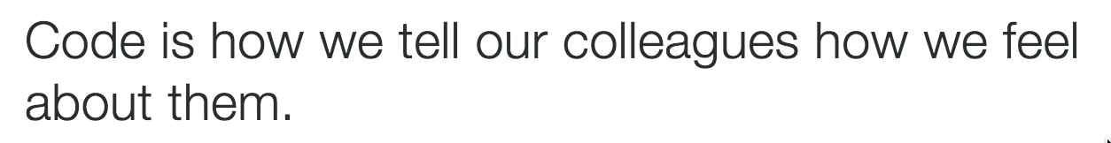

“Lowering quality lengthens development time.”—First Law of Programming.

http://c2.com/cgi/wiki?FirstLawOfProgramming

What’s Quality Code?

The quality of code is inversely proportional to the effort it takes to understand it.

http://blog.agiledeveloper.com/2010/05/thoughts-through-tweets_15.html

Twelve ways We can Help

- Schedule Time to Lower Technical Debt

What’s Technical Debt?


Ward Cunningham

http://c2.com/cgi/wiki?WardExplainsDebtMetaphor

Example of Technical Debts

Low quality is not technical debt

What Causes Technical Debt?

Not “All or Nothing”

Schedule Time

Development |  |  | …
Development |  | Technical
 | Planning
Paying

Debt Vacation/sickness Meetings

…

Slack

time


Linda Rising


Development |  |  | …
Development |  | Technical
 | Planning
Paying

Debt Vacation/sickness Meetings

…

Slack

time

11. Favor High Cohesion

Narrow, focused,

does only one thing well

Why?

Think about frequency of change

high cohesion ==

low cyclomatic complexity

10. Favor Loose Coupling

Tight coupling make code

hard to extend

hard to test

Lower coupling

Loose vs. tight coupling

Eliminate where possible

Excessive | Non deterministic
Mocking | Dependency
to Test
This

Non deterministic

Dependency
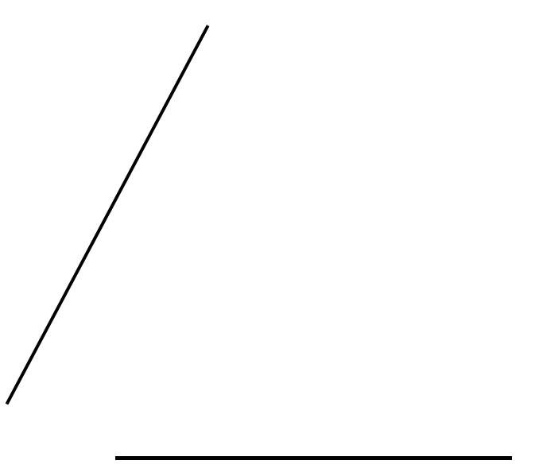

Light | No
Mocking | Mocking
to Test | to Test
This | This

9. Program with Intention

http://stackoverflow.com/questions/184618/what-is-the-best-comment-in-source-code-you-have-ever-encountered
Beck’s Rule for Simple Design
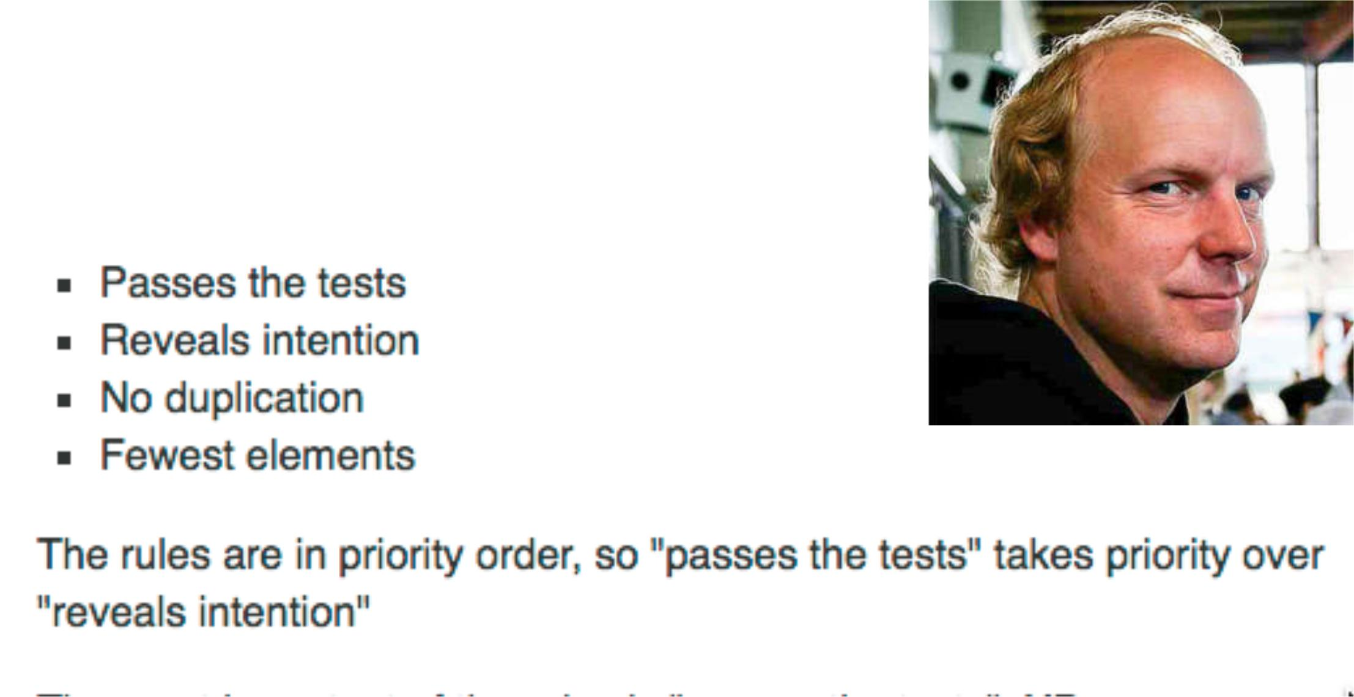

http://martinfowler.com/bliki/BeckDesignRules.html

Programming Deliberately

- When you write test before writing code…

8. Avoid Primitive Obsession
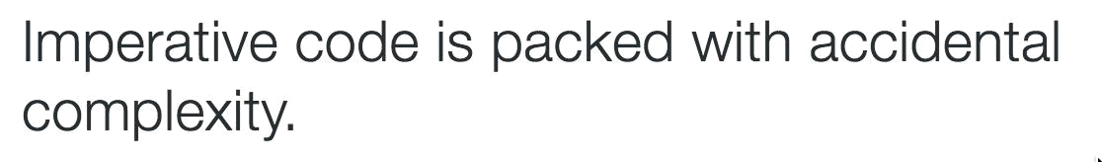
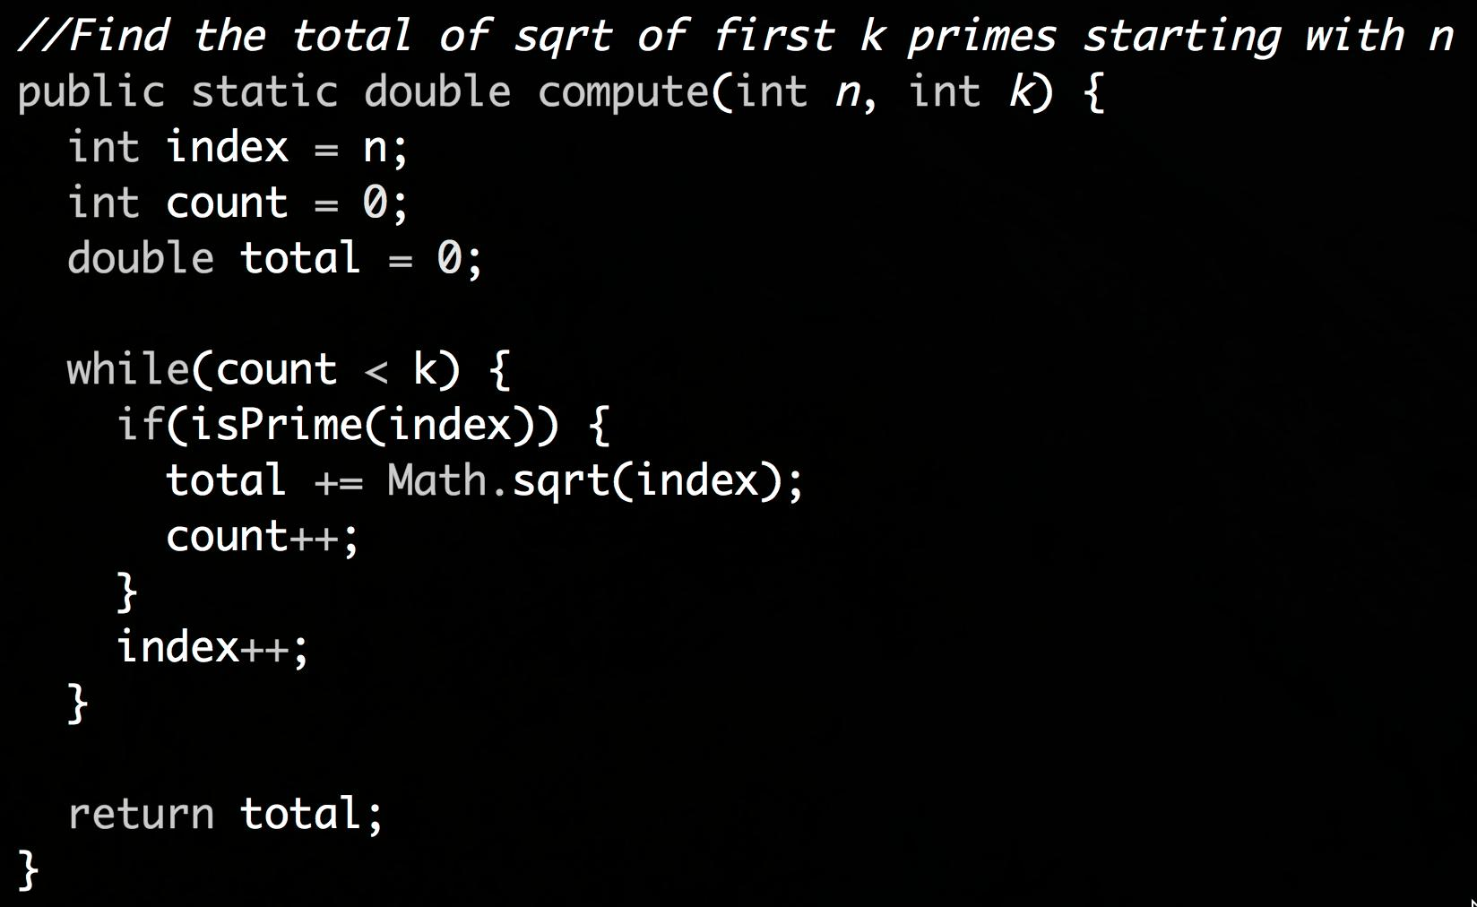

It’s code like this that prematurely turns programmers into managers
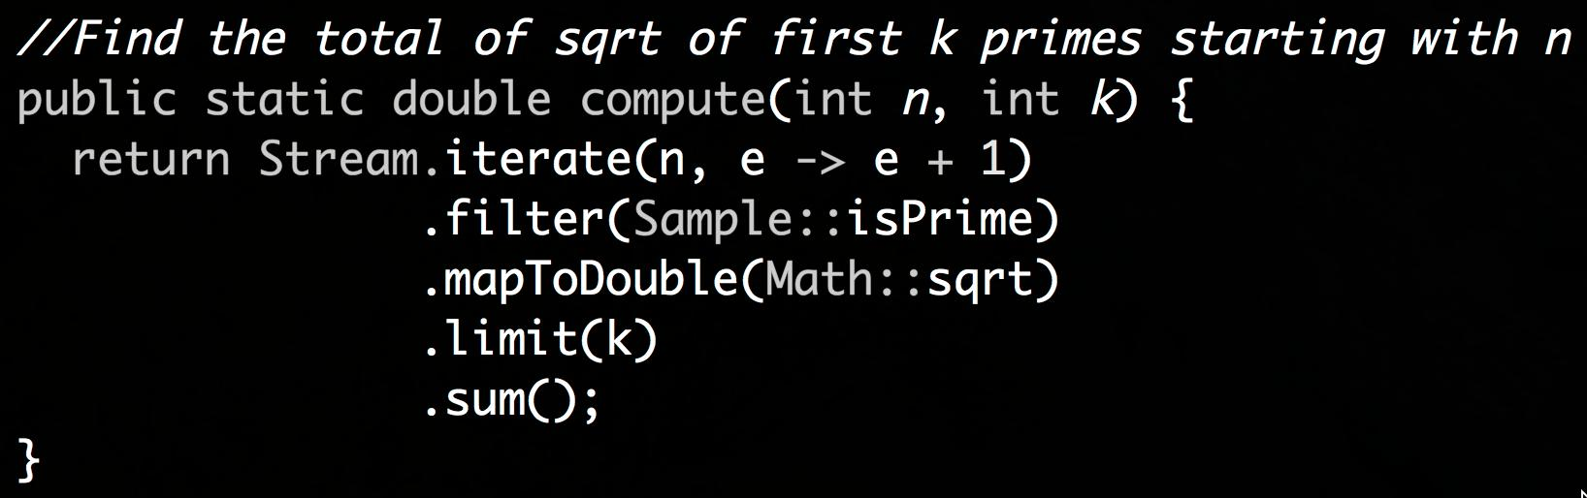
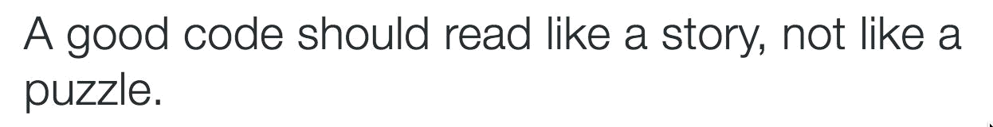
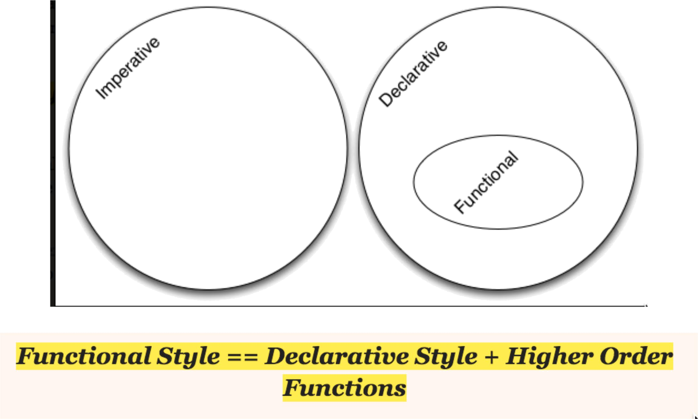

http://blog.agiledeveloper.com/2015/08/the-functional-style.html

- Prefer Clear Code over Clever Code
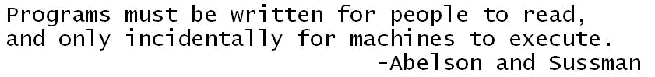

10% of the time, we write ugly code for performance reasons, the other 90% of the time, we write ugly code to be consistent.

http://blog.agiledeveloper.com/2010/05/thoughts-through-tweets_15.html

Those who sacrifice quality to get performance may end up getting neither.

http://blog.agiledeveloper.com/2010/05/thoughts-through-tweets_15.html

“There are two ways of constructing a software design. One way is to make it so simple that there are obviously no deficiencies and the other is to make it so complicated that there are no obvious deficiencies”— Tony Hoare


- Apply Zinsser's Principle on Writing
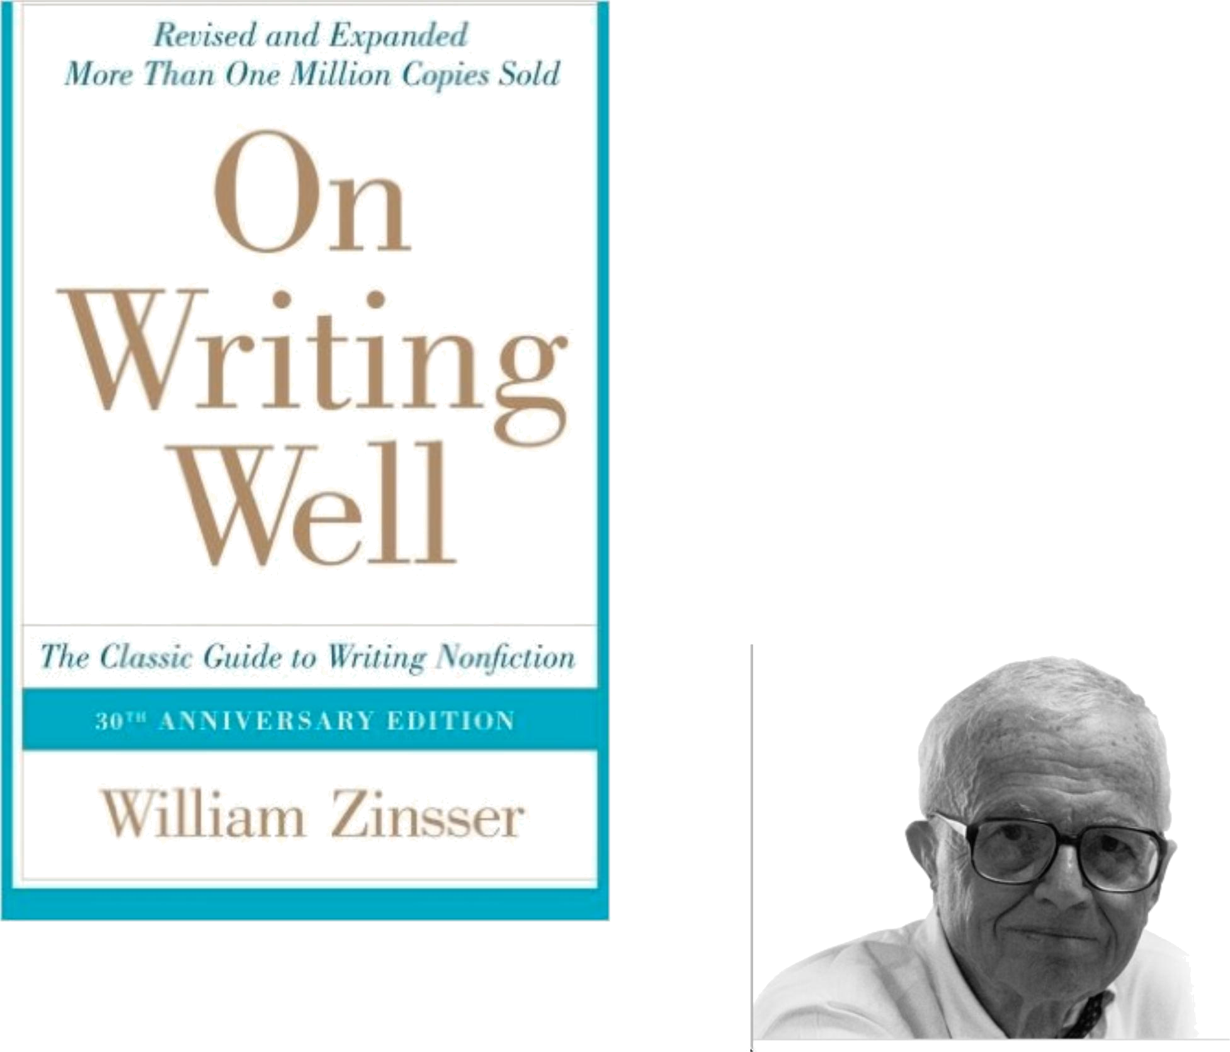
Simplicity

Clarity

Brevity

Humanity

5. Comment Why, not What

Don’t comment to cover up bad code

Write Expressive Self-Documenting Code

A good code is like a good joke

Writing comments is like

explaining a joke

http://blog.agiledeveloper.com/2006/01/comments-on-comments.html

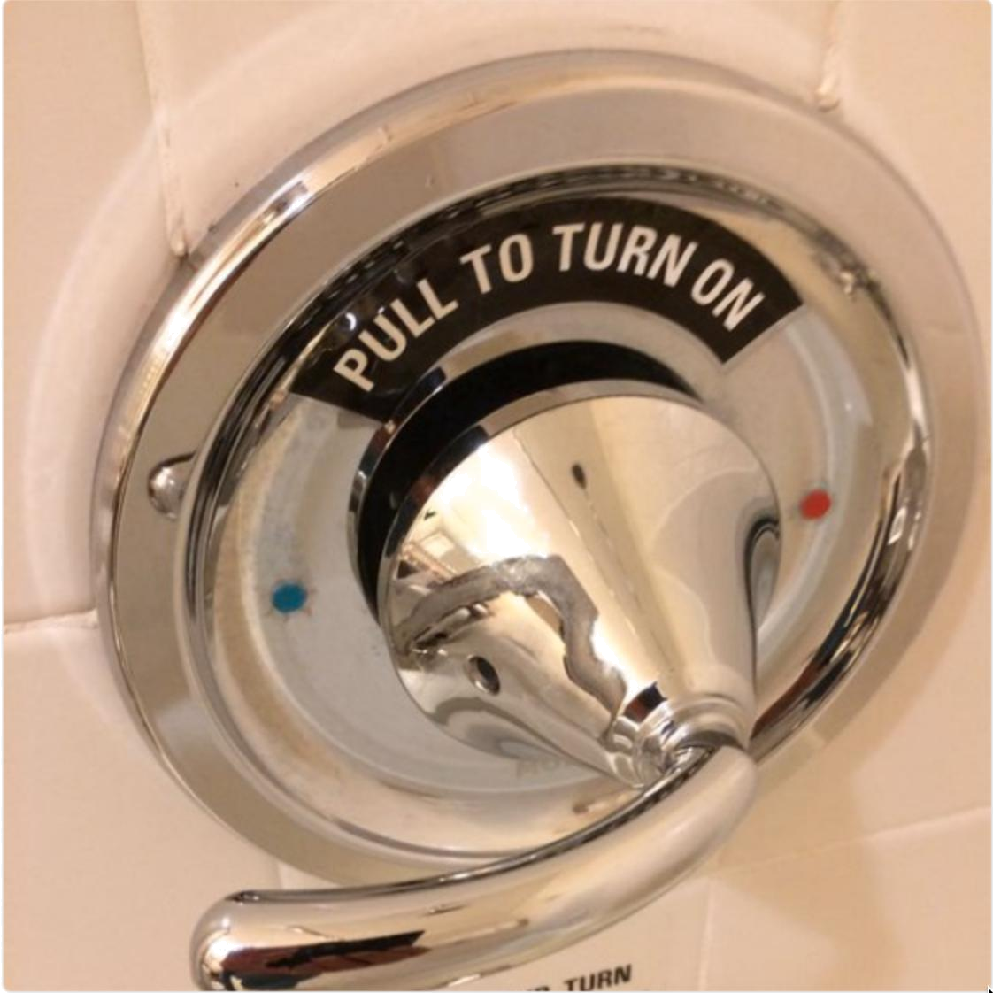
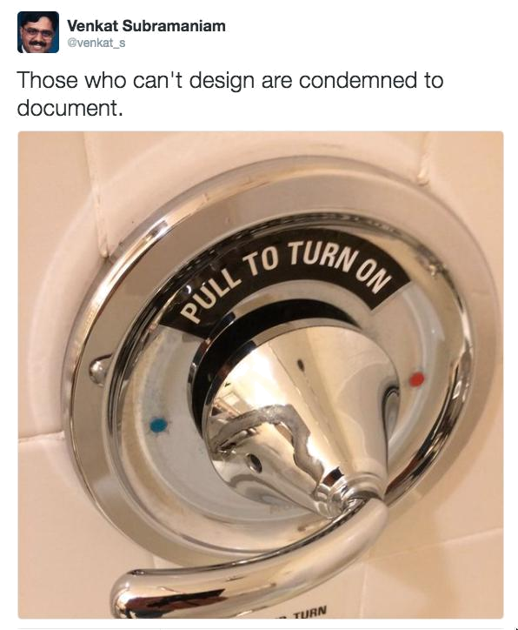

order(3) 3 cups?…

order(3) // large coffee

order(CoffeeSize.LARGE)
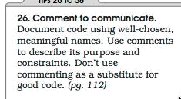

https://media.pragprog.com/titles/pad/PAD-pulloutcard.pdf

- Avoid Long Methods—Apply

SLAP

Perils of Long Methods

How long is long?

Turns out long is not about length of code, but levels of abstraction

3. Give Good Meaningful Names
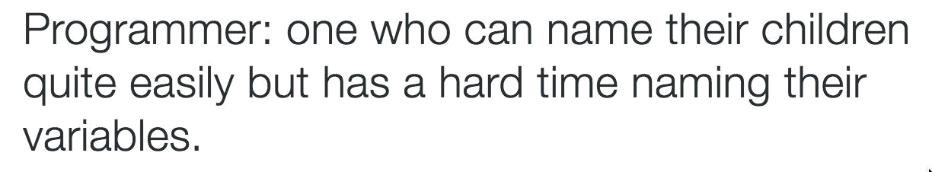
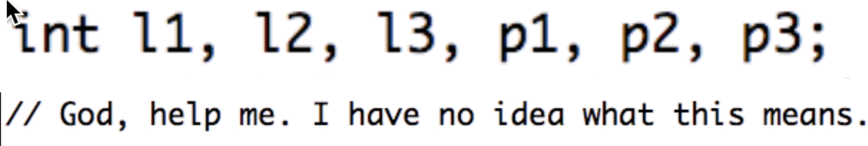

Variable Names Represent Abstractions
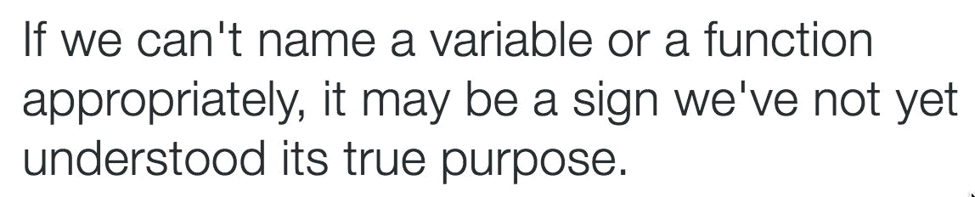

2. Do Tactical Code Reviews

Peer reviews catch 60% of defects.

Perspective-based reviews catch 35% more defects than nondirected reviews.

Peer reviews complement testing.

Technical and social activity.

https://www.cs.umd.edu/projects/SoftEng/ESEG/papers/82.78.pdf

Facilitating Tactical Code Reviews

1. Reduce State & State Mutation
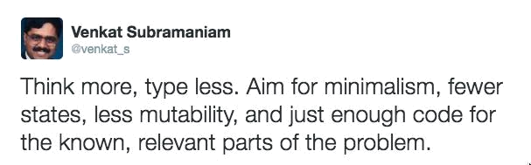
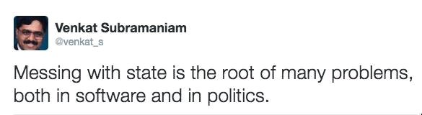
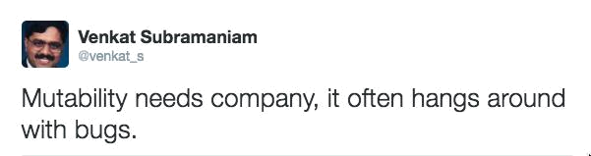

Twelve Ways to Make Code Suck Less
- Schedule Time to Lower Technical Debt

- Favor High Cohesion

- Favor Loose Coupling

- Program with Intention

- Avoid Primitive Obsession

- Prefer Clear Code over Clever Code

- Apply Zinsser's Principle on Writing

- Comment Why, not What

- Avoid Long Methods—Apply SLAP

- Give Good Meaningful Names

- Do Tactical Code Reviews

- Reduce State & State Mutation
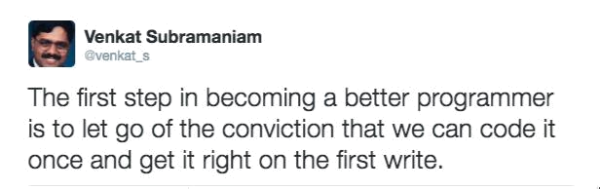

http://agiledeveloper.com/downloads.html
Thank you

http://agiledeveloper.com/downloads.html

venkats@agiledeveloper.com

@venkat_s

