1. 5 devices – The Schottky inputs will use 0.4 mA when driven low and 20 uA when driven high. Since it is using more current when low we can take the output maximum of 2mA and divide it by 0.4mA/device. This gives us a total of 5 devices.
2. Using the example in Figure 8.25, the only required change is the LED now has an amperage of 5mA and a Voltage of 3V to light up. Due to this the new resistor used will be: $R= \frac{5V-3V-0.5V}{5mA}=300 Ω$  
   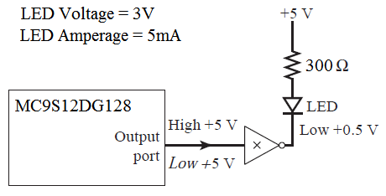
3. Same as logic as the last example with slightly modifed values:  
   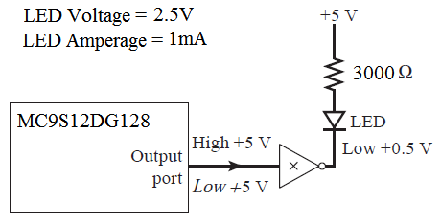
4. The max amperage of the 74LS04 durring an input high signal is 20uA. Therefore: $$R= \frac{5V}{20uA}=250000 Ω$$ 