Lab Exercise Number 03

Understanding the Addressing Modes

Lab Partners:

Gabriel Stroe

Mostapha Baydoun

**Academic Honor Code:**

*"I have neither given nor received unauthorized aid in completing this work, nor have I presented someone else’s work as my own"*

Lab Dates: 1/28/16 – 2/4/16

Date Submitted: 1/28/16

# Introduction:

# The objective of this experiment is for us to understand the addressing modes better beyond classroom coverage. We were given a code to run and understand how it functions line by line. We were also given a table which will be used to analyze the code that we ran and analyzed. This lab was a very good lab that helped us to understand addressing modes better.

# Required Resources:

|  |  |
| --- | --- |
| Lab Resource Identification: | |
| Easy68k Assembler | v5.15.04 |

# Lab Description & Pre-Lab:

# This lab focuses on the data registers and memory locations. More specifically how the given functions effect said data registers and memory locations.

# Set-up and Procedure:

We typed the code that was given to us in the lab manual in Easy68k. And as said in the introduction, we ran the code and tried and succeeded to understand the functionality each line by line. As we ran the code we were looking at the address and data registers noticing what is changing and noting it each line by line.

# Results:

# The results were exactly as we have expected them to be. Our expected and experimental results are shown in Figure 1 and the log file.

# Conclusion:

This lab was a great help for us in understanding Addressing modes better. It enhanced our debugging skills, since for most the lab we were trying to understand the functionality of each command and how does it affect the registers and memory locations before/after the code is executed.

**Figure 1:**

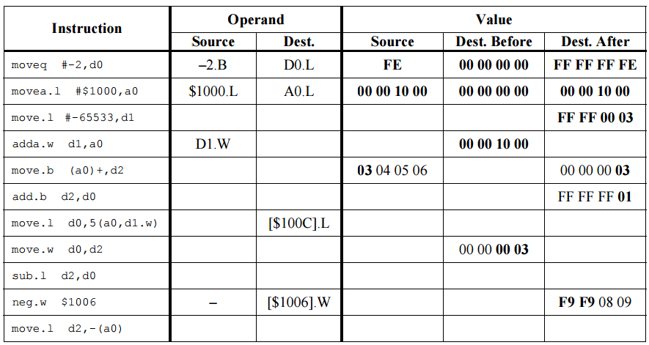

D2.L A0.L 0000FF01 00001004 00001000

--- 106

D2.L D0.L 0000FF01 FFFFFF01 F9F90809

D0.W D2.W FFFFFF01 0000FF01

D0.L FFFFFF01 0C0D0E0F FFFFFF01

D2.B D0.B 00000003 FFFFFFFE

A0.B D2.B 00000000

* A0 .W 0003 00001003

-65533.l D1.L FFFF0003 00000000