**Evaluation**

This is the rubric that would be used to evaluate your project if you were enrolled in the Front-End Web Developer Nanodegree. Under those circumstances, all criteria must "meet specifications" in order to pass.

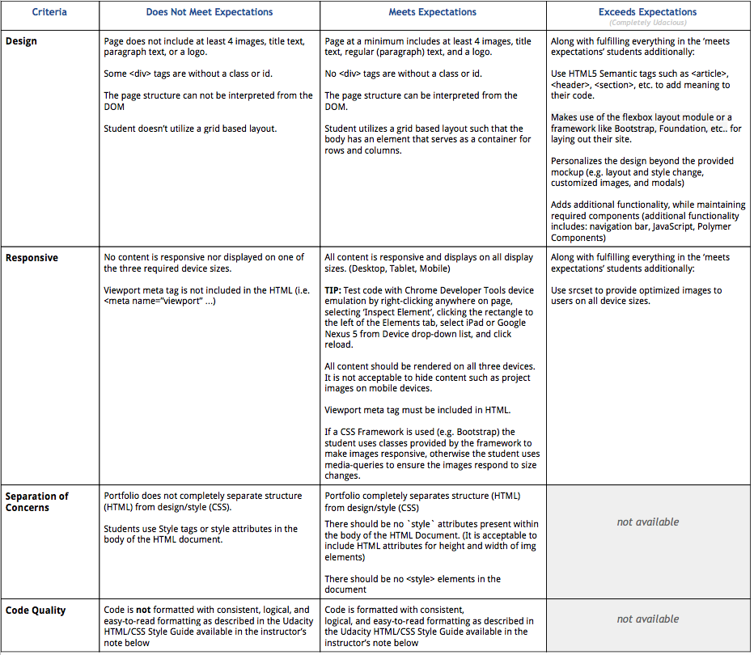

**Style Guidelines**

**CSS REQUIRED Rules**

* CSS - Use consistent indentation (tabs or spaces). (See: CSS General Formatting Rules-Indentation)
* CSS - Selectors, properties and property values (with the exception of strings) should be lowercase, including letters in hexadecimal color values. For example #f06c13 instead of #F06C13 and #ccc rather than #CCC. (See: CSS-General Formatting Rules-Capitalization.)
* CSS - Use IDs and class names that are meaningful or generic. (See: CSS-ID and Class Naming.)
* CSS - Use ID and class names that are as short as possible but as long as necessary. (See: CSS-ID and Class Naming.)
* CSS - Use Shorthand properties in all possible places for margin, border, padding, background. Examples:[https://developer.mozilla.org/en-US/docs/Web/CSS/Shorthand\_properties](https://developer.mozilla.org/en-US/docs/Web/CSS/Shorthand_properties" \t "_blank). (See: CSS Style Rules-Shorthand Properties.)
* CSS - Indent block content between curly braces. (See: CSS Formatting Rules-Block Content Indentation.)
* CSS - End all declarations with a semicolon. (See: CSS Formatting Rules-Declaration Stops.)
* CSS - Add single spaces after each property name’s colon (See: CSS Formatting Rules-Property Name Stops.)
* CSS - Remove trailing white spaces from code. (See: CSS General Formatting Rules-Trailing Whitespace)
* CSS - there should be a single space after each colon. (See: CSS Formatting Rules-Property Name Stops.)
* CSS - Include a single space before the opening curly brace. (See: CSS-Declaration Block Separation.)
* CSS - ID and class names should not be used with type selectors. (See Style Guide: CSS Style Rules-Type Selectors.)
* CSS - Separate style rules with a blank line. (See: CSS-Rule Separations.)

**CSS SUGGESTED Rules**

* CSS - Remove units of measure after 0 values. (See: CSS Style Rules-0 and Units.)
* CSS - Use leading zeros for values in the code. (See: CSS Style Rules-Leading 0s.)
* CSS - Use 3 character hexadecimal notation for color in all possible places. For example #ccc rather than #cccccc. (See: CSS Style Rules-Hexadecimal Notation.)
* CSS - Separate words in ID and class names with a hyphen. (See: CSS Style Rules-ID and Class Name Delimiters.)
* CSS - Remove CSS hacks or user detection from code. (See: CSS Style Rules-Hacks.)
* CSS - Separate selectors and declarations with new lines. (See: CSS-Selector and Declaration Separation.)
* CSS - Use double quotes for all attribute selectors and property values. (See: CSS Formatting Rules-CSS Quotation Marks.)
* CSS - Identify groups of related style rules with section comments. (See: CSS Meta Rules-Section Comments.)

**HTML REQUIRED Rules**

* HTML - Element and attribute names should all be lowercase. (See: Capitalization.)
* HTML - Use HTML5. (See: HTML Style Rules-Document Type.)
* HTML - Use UTF-8 as character encoding. (See: General Meta Rules-Encoding.)
* HTML - Place all block/list/table elements on a separate line and indent child elements. (See: HTML-General Formatting.)
* HTML - Use semantic tags. (See: HTML Style Rules-Semantics.)
* HTML - Provide alternate content for multimedia. (See: HTML Style Rules-Multimedia Fallback.)
* HTML - Remove trailing white spaces from code. (See: HTML - General Formatting Rules - Trailing Whitespace.)
* HTML - Use consistent indentation (tabs or spaces) (See HTML - General Formatting Rules - Indentation)

**HTML SUGGESTED Rules**

* HTML - Use comments to explain the code. (See: General Meta Rules-Comments.)
* HTML - Mark action items with TODO. (See: General Meta Rules-Action Items.)
* HTML - Remove entity references. (See: HTML Style Rules-Entity References.)
* HTML - Remove type attribute from link and script elements. (See: HTML Style Rules-Type Attributes.)
* HTML - Use double rather than single quotation marks for attribute values. (See: HTML-HTML Quotation Marks.)