Avocado Toast: An Online Banking Platform

Spring 2019
Group 1

Alex Petros • Anandita Dubey • Danh Pham
Carlos Deleon • Flaviu Tamas

Planning and Scheduling

Assignment 1
Assignee | Email | Task | Dur. (h) | Dependency | Due Date | Evaluation
Alex Petros | apetros1 | System architecture | 2 | GitHub, GroupMe | 2019-01-31 | Great job,  did 100%
Anandita Dubey | adubey2 | User Requirements (1-5) | 2 | GitHub, GroupMe | 2019-01-31 | Great job,  did 100%
Danh Pham | dpham16 | User requirements (6-10) | 2 | GitHub, GroupMe | 2019-01-31 | Great job,  did 100%
Carlos Deleon | cdeleon1 | Teamwork basics | 2 | GitHub, GroupMe, System architecture | 2019-01-31 | Great job,  did 100%
Flaviu Tamas | ftamas1 | Create GitHub & GroupMe, report | 2 | None | 2019-02-01 | Great job,  did 100%

Assignment 2
Assignee | Email | Task | Dur. (h) | Dependency | Due Date | Evaluation
Alex Petros | apetros1 | System model | 2 | None | 2019-02-14 | Great job,  did 100%
Anandita Dubey | adubey2 | Refine problem statement | 2 | None | 2019-02-14 | Great job,  did 100%
Danh Pham | dpham16 | Use case requirements | 2 | Use cases | 2019-02-14 | Great job,  did 100%
Carlos Deleon | cdeleon1 | Use case diagram | 2 | Use cases | 2019-02-14 | Great job,  did 100%
Flaviu Tamas | ftamas1 | Use cases | 2 | None | 2019-02-11 | Great job,  did 100%

Assignment 3
Assignee | Email | Task | Dur. (h) | Dependency | Due Date | Evaluation
Alex Petros | apetros1 | Implementation (Backend) | 2 | Use cases | 2019-03-03 | Great job,  did 100%
Anandita Dubey | adubey2 | Refine System  Architecture Model | 2 | Implementation (Frontend) | 2019-03-03 | Great job,  did 100%
Danh Pham | dpham16 | Testing | 2 | Use cases | 2019-03-02 | Great job,  did 100%
Carlos Deleon | cdeleon1 | Behavioral Model | 2 | Implementation | 2019-03-02 | Great job,  did 100%
Flaviu Tamas | ftamas1 | Implementation (Frontend) | 2 | None | 2019-03-02 | Great job,  did 100%

Assignment 4
Assignee | Email | Task | Dur. (h) | Dependency | Due Date | Evaluation
Alex Petros | apetros1 | Revise and refine your system | 2 | System requirements, system modeling | 2019-03-15 | Great job,  did 100%
Anandita Dubey | adubey2 | System modeling | 2 | Use cases, class diagrams | 2019-03-15 | Great job,  did 100%
Danh Pham | dpham16 | Testing | 2 | Implementation | 2019-03-15 | Great job,  did 100%
Carlos Deleon | cdeleon1 | Planning, Scheduling, Collaboration | 2 | None | 2019-03-15 | Great job,  did 100%
Flaviu Tamas | ftamas1 | Implementation | 2 | Use cases, previous implementation | 2019-03-15 | Great job,  did 100%

Assignment 5
Assignee | Email | Task | Dur. (h) | Dependency | Due Date | Evaluation
Alex Petros | apetros1 | Write unit tests | 2 | Previous implementation | 2019-04-13 | Great job,  did 100%
Anandita Dubey | adubey2 | Determine cohesion & coupling, document design patterns | 2 | Previous implementation | 2019-04-13 | Great job,  did 100%
Danh Pham | dpham16 | Write test documentation | 2 | Previous implementation | 2019-04-13 | Great job,  did 100%
Carlos Deleon | cdeleon1 | Improve database schema | 2 | Previous implementation | 2019-04-13 | Great job,  did 100%
Flaviu Tamas | ftamas1 | Coordinate, write report | 2 | All other tasks | 2019-04-13 | Great job,  did 100%

Problem Statement

What is your product, on a high level?
Our product is an online banking application, which will allow the customers of a bank or other another financial institution to perform money-management without physically visiting the bank.
It will allow the customers to open their accounts, manage them electronically, to monitor them, to make transactions, pay their bills, transfer money, make deposits, and so on.

Whom is it for?
An online banking application is beneficial to everyone but is especially useful for those people with a stringent work schedule. It will help them to manage their accounts and keep track of their activities in a quick manner with minimal costs without the need to to visit a physical bank during working hours or make a phone call.

What problem does it solve?
- 24/7 availability, saving the customer from rushing the banks during working hours. With an online banking system, people can perform their tasks at a time that suits their work schedule. • Stringent schedules, where customers with strict working hours to perform their banking activities effectively and conveniently.
- Centralized source of information, where instead of visiting different officials specialized in different tasks, the customer can use an online banking application flexible enough to do any task in a single click. Human bankers are not always available, but the application always will be, meaning there is no need to rush to the bank to get things done.
- Remain informed: With the online banking system, customers can easily receive up-to-date information regarding their upcoming deadlines or dues through notifications, emails, or text messages.
- Easy bill payments, so that there is no need to rush to the bank. Everything can be done at home instead.

What alternatives are available?
- Services provided by 3rd party application, like Mint
- A phone app
- In person banking services
- Phone calls
- ATMs

Why is this project compelling and worth developing?
- It would reduce costs for banks by reducing the amount of human labor required.
- An electronic banking system would enable banks to keep stringent records
- A computerized ledger would reduce the number of mistakes when calculating interests, making transactions, and so on.
- It would increase customer satisfaction because they would have access to our banks from any place with WiFi.

Describe the top-level objectives, differentiators, target customers, and scope of your product.
- Objective: To create a product that performs to our requirements and have it sustainable for multiple lifecycles.
- Differentiators: Our system won’t sell data to any third parties, have no hidden transaction fees, and will not participate in predatory lending practices
- Target customers: Our target customer is the average citizen, anyone that currently uses or will use a bank for their transaction needs.
- Scope: The scope of our project is building an online business ledger, making a database to store our information, developing a web app and making a UI for our customers.

What are the competitors and what is novel in your approach?
Our competitors are Finacle, nCino, Oracle, etc. What we bring new to the table is that our system will be entirely online. Additionally, our platform is customer focused and will be fully transparent. We won’t sell customer data or charge hidden fees.

Make it clear that the system can be built, making good use of the available resources and technology.
Our system is possible because it will be very simplistic and direct. Clients will connect to our application software where they will be greeted by a user-friendly interface, which will primarily be coded in HTML, with CSS used to create a beautiful design for our clients. Finally, the frontend of our application will be connected to a backend SQL database. The database will be responsible for recording transactions such as withdrawals, deposits, bill pays, and more.

What is interesting about this project from a technical point of view?
The project will use a client-server architecture in order to be accessible to clients from anywhere.
Emphasis will also be placed on graphical design, using our creativity to design a nice interface for our clients.

Changes
There have been no significant changes to our problem statement since it was written.

Requirements

User Requirements

1: Register Customer
- Actors: Banker
- Description: Add a new customer, with their own username and password
- Alternate Path: None
- Pre-Condition: Logged in

2: Deposit Cash
- Actors: Banker
- Description: Take a certain amount of cash from the customer, adding the amount to their balance
- Alternate Path: None
- Pre-Condition: Logged in

3: Withdraw Cash
- Actors: Banker
- Description: Give the customer a certain amount of cash, subtracting the amount from their balance
- Alternate Path: None
- Pre-Condition: Logged in, account has sufficient balance

4: View Transactions
- Actors: Banker, Customer
- Description: View a list of all the transactions in the account, as well as the overall account balance
- Alternate Path: None
- Pre-Condition: Logged in

5: Transfer Funds
- Actors: Customer
- Description: Send someone else money electronically through the website
- Alternate Path: None
- Pre-Condition: Logged in, account has sufficient balance

6: Analyze Transaction Volume
- Actors: Analyst
- Description: View the amount of money that was deposited and withdrawn in a single day, for the entire bank
- Alternate Path: Manual SQL access
- Pre-Condition: Logged in

7: Log in
- Actors: Banker, Customer, Analyst
- Description: Authenticate themselves to the system
- Alternate Path: None
- Pre-Condition: None

Use case requirements

1: Register Customer
- Introduction: this system interacts with the user, authentication utility, SQL database
- Inputs: Username Password
- Requirements Description: Registers a new customer, they must input a user-name and password for their account
- Outputs: Their login information is logged into the system to be recalled later
- Alternate Path: None

2: Deposit Cash
- Introduction: this system interacts with the user SQL database
- Inputs: Cash
- Requirements Description: Insert cash from the customer, the amount is added into the balance
- Outputs: Cash amount is added into their balance
- Alternate Path: None

3: Withdraw Cash
- Introduction: this system interacts with the user SQL database
- Inputs: Cash amount
- Requirements Description: Withdraw cash from the bank, the amount is de-ducted from the balance
- Outputs: Cash is given to the customer and cash amount is deducted from balance
- Alternate Path: None

4: View Transactions
- Introduction: this system interacts with the user SQL database
- Inputs: User PIN number
- Requirements Description: View a list of all the transactions in the account, as well as the overall account balance
- Outputs: Transaction record is displayed on the screen, with their account balance
- Alternate Path: None

5: Transfer Funds
- Introduction: this system interacts with the user, SQL database, and the recipient
- Inputs: Cash amount and information of the recipient
- Requirements Description: Send a person or company money electronically through the website
- Outputs: Deducts cash amount from overall balance and cash is sent to recipient
- Alternate Path: None

6: Analyze Transaction Volume
- Introduction: this system interacts with the user SQL database
- Inputs: User PIN number
- Requirements Description: Views the amount of money deposited and with-drawn in a single day
- Outputs: Shows deposit withdraw amount in specified day
- Alternate Path: Manual SQL Access

7: Log in
- Introduction: this system interacts with the user and authentication utility
- Inputs: User ID and password
- Requirements Description: Authenticate a user to their account
- Outputs: User is logged into the system and given access to use their account
- Alternate Path: None

System Requirements
- CPU: Any x86_64 or ARM processor
- RAM: 200MiB min
- OS: Window 10, macOS, GNU/Linux

System Modeling

Class Diagram
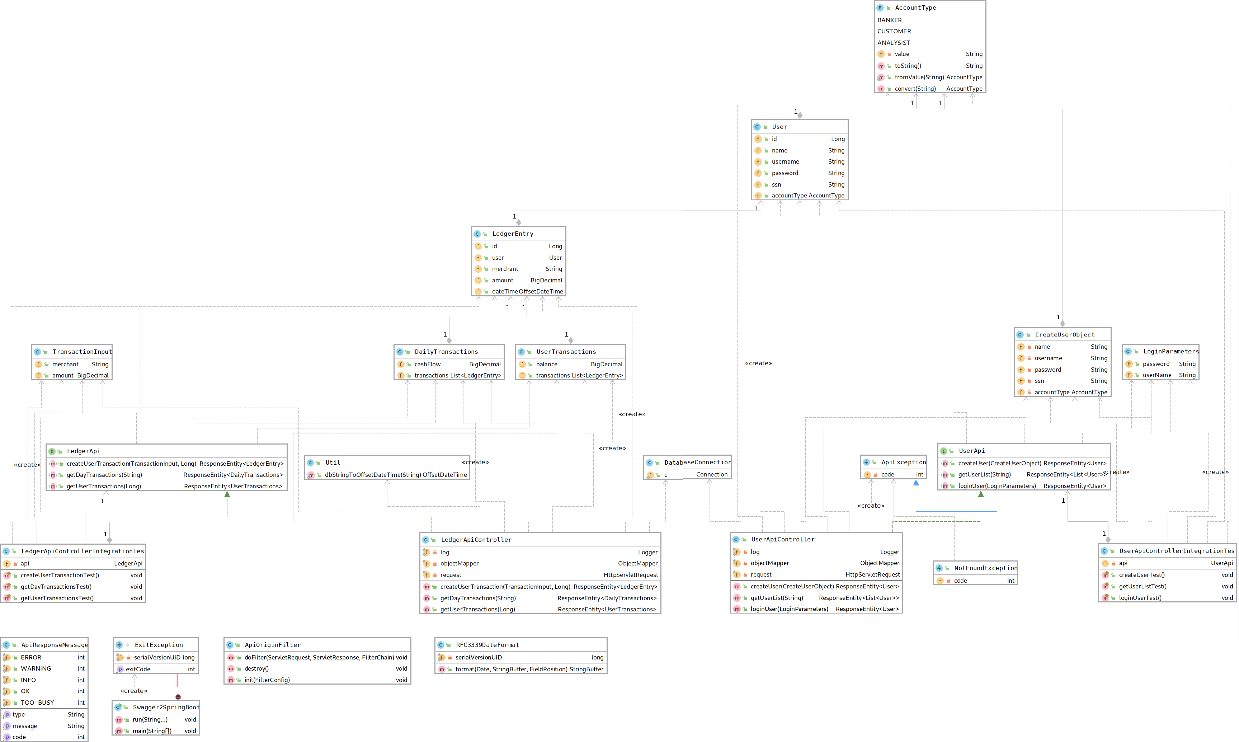

Database Specification

Tables
create table Analyst (
id INTEGER primary key,
username TEXT not null unique,
password TEXT not null,
name TEXT not null,
account_type TEXT not null
);
create table Banker (
id INTEGER primary key,
username TEXT not null unique,
password TEXT not null,
name TEXT not null,
account_type TEXT not null
);
create table Customer (
id INTEGER primary key,
username TEXT not null unique,
password TEXT not null,
name TEXT not null,
ssn INTEGER not null,
account_type TEXT not null
);
create table Transactions (
id INTEGER primary key,
customer_user_id INTEGER not null references Customer,
merchant TEXT not null,
amount INTEGER not null,
date_time STRING not null
);

Database system
This project uses SQLite for the database.

Architecture modeling

Client Server pattern
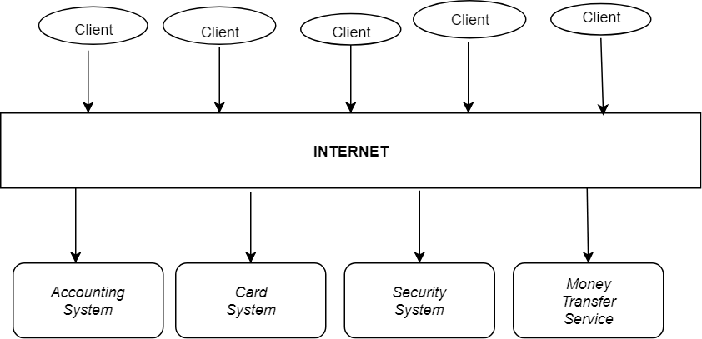

Context Model
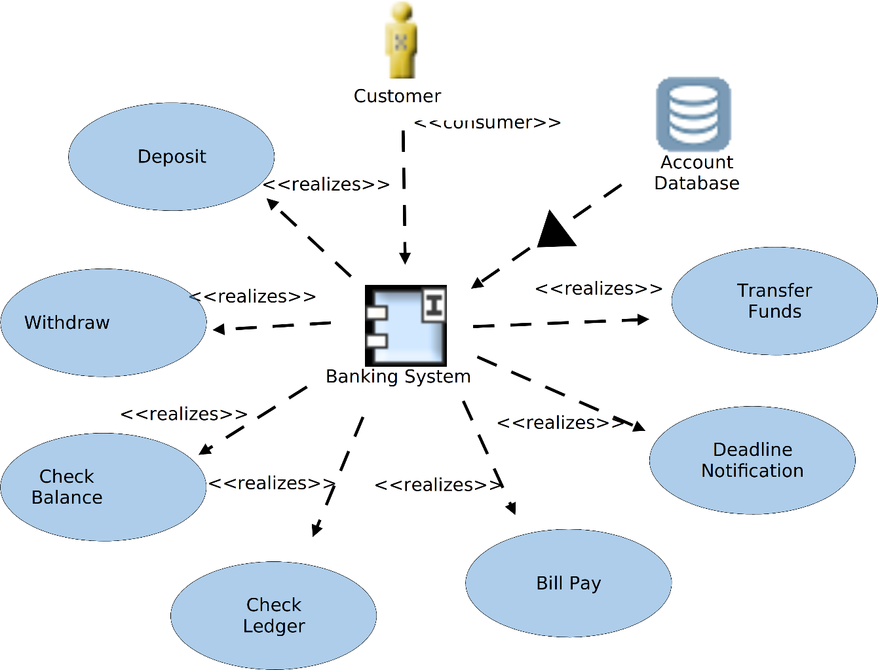

Views

Logical
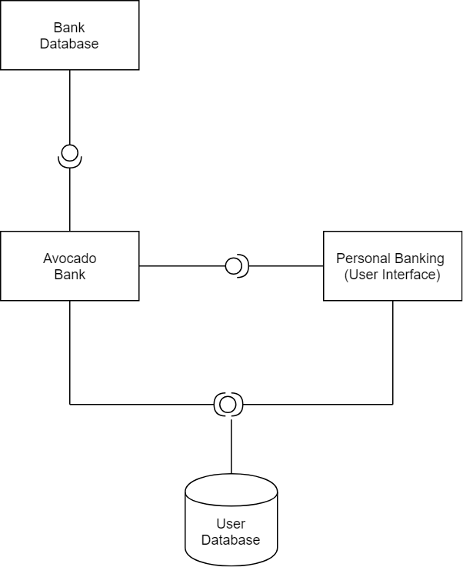

Process
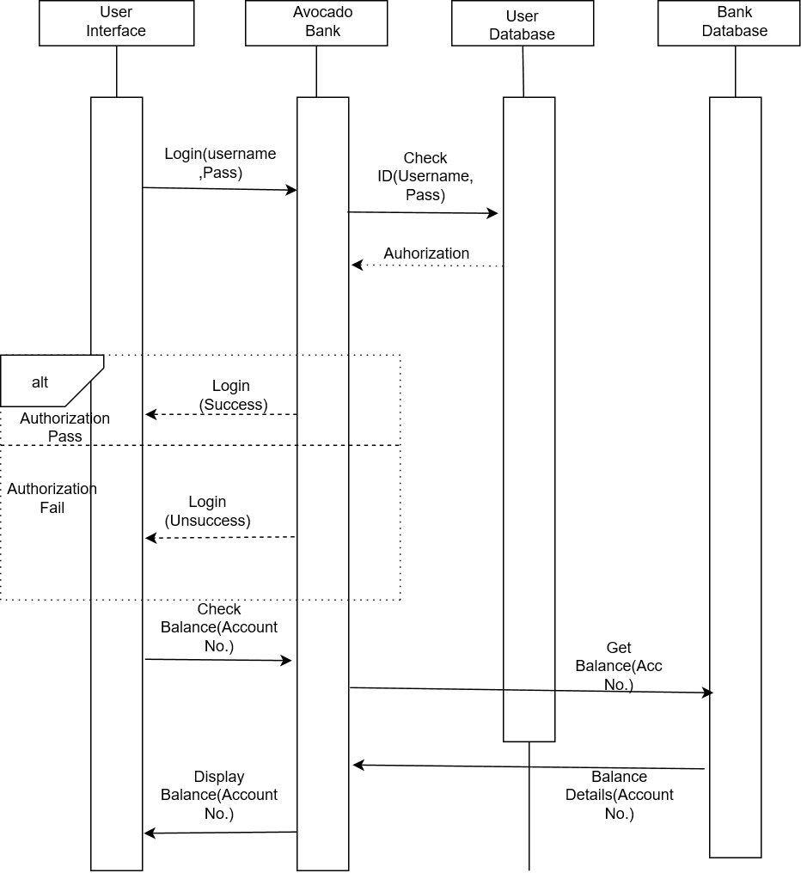

Development
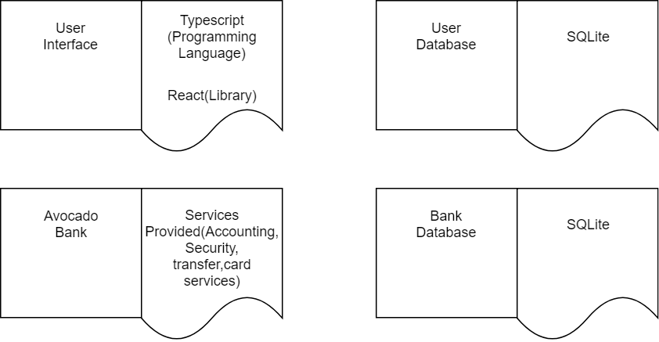

Physical

Coupling & Cohesion
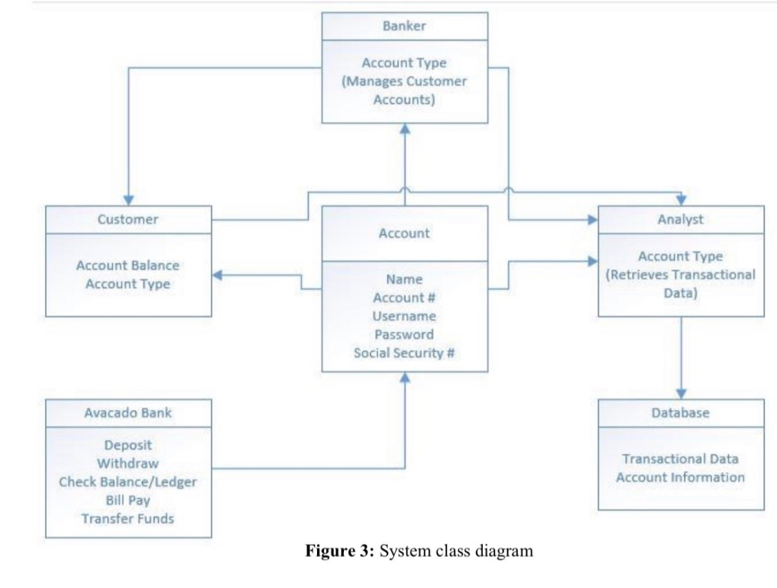

Cohesion Formula
cohesion(Class n) = Classes on which n directly-indirectly potentially depends/total no. of classes

Calculations:

Banker class
Cohesion = 3/6=0.5

Customer class
Cohesion= 2/6= 0.34

Avocado Bank
Cohesion = 5/6=0.83

Analyst class
Cohesion = 1/6=0.16

Database class
Cohesion = 0/6=0

Account class
Cohesion = 4/6=0.67

Classes | Directly or indirectly depends on | Values
Banker | Customer, Analyst, Database | 0.5
Customer | Analyst, Database | 0.34
Avocado Bank | Account, customer, banker, analyst, Database | 0.83
Analyst | Database | 0.16
Database | - | 0
Account | Customer, Analyst, Database, Banker | 0.67

Coupling Formula
A coupling measure between classes, which class directly coupled with other class
Flow P (C2, C1) = Slice (P, c1, V c1) | N (c2) / N (C1)
Flow P (c2, c1) implies that information flow from class c2 to class c1 in a modular P, employee information modular.
Coupling P (C1, C2) = Flow p (C1, C2) +Flow p (C2, C1)/N(C1) N(C2)

Design Patterns

Major Issues During Implementation | Design Patterns used to rectify the issues | Reasons for the Design patterns chosen
Database Connectivity | Singleton Pattern  (Creational Design Pattern) | It is used for the database connection so that it can be easily accessed from anywhere in the program.
Implementation of HTTP API | Strategy Pattern (Behavioral Design Pattern) | Since it lets the algorithm vary independently from clients that use it.
To provide controller with Object Mapper (to translate between JSON and Java objects | Dependency Injection pattern | It is used since we did not create the Object Mapper but instead ask the provider to create one for us.
Note: The design patterns that has been used in order to improve the system that might change the way the classes interact with each other or the relationships between the classes. (See Class Diagram, 4.1)

Behavioral modeling

Use Case Diagram
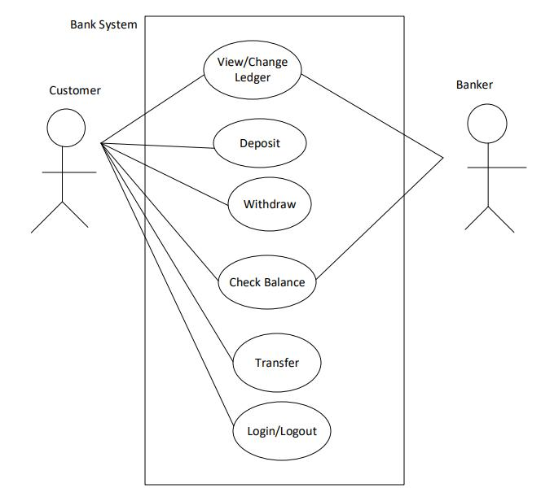

Sequence Diagrams

Use case 3, Withdraw cash
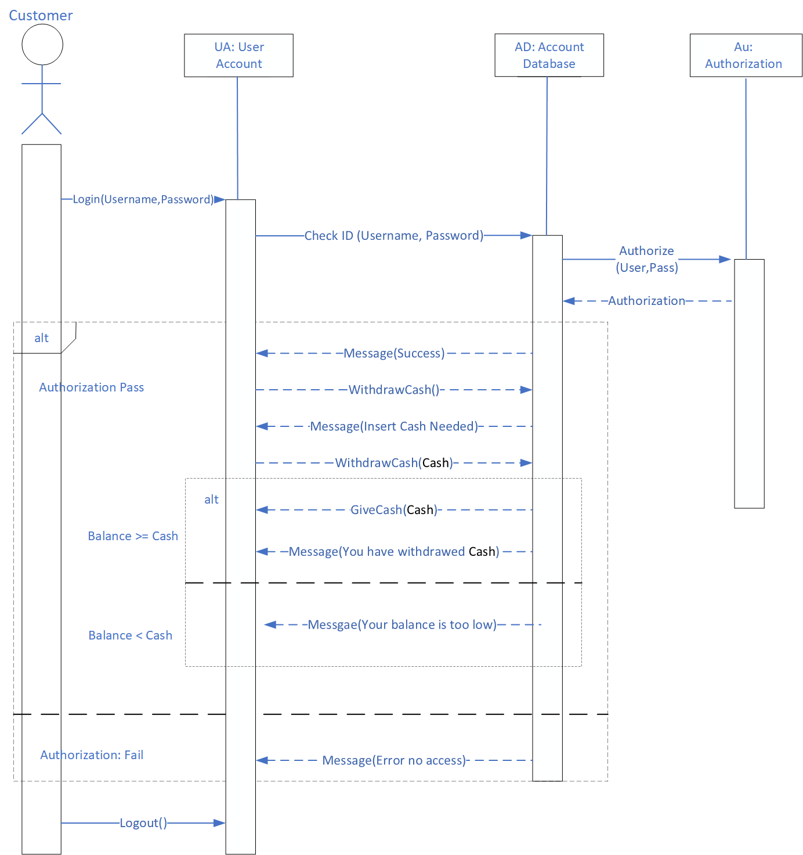

Use Case 2, Deposit cash
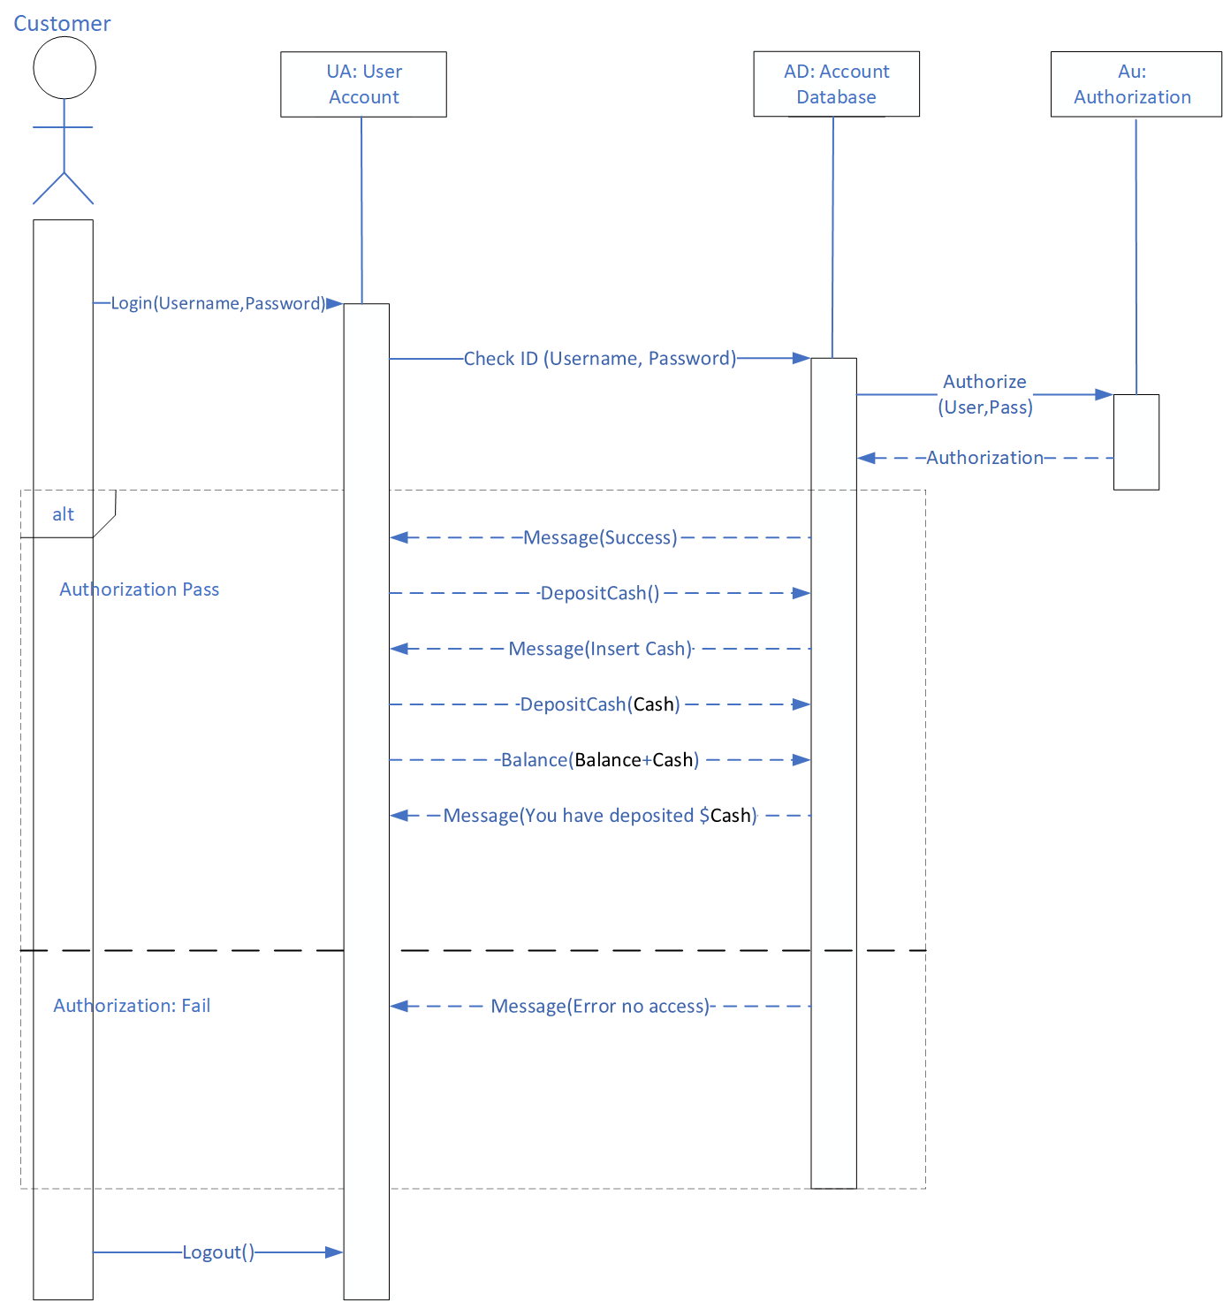

Use Case 1, Register customer
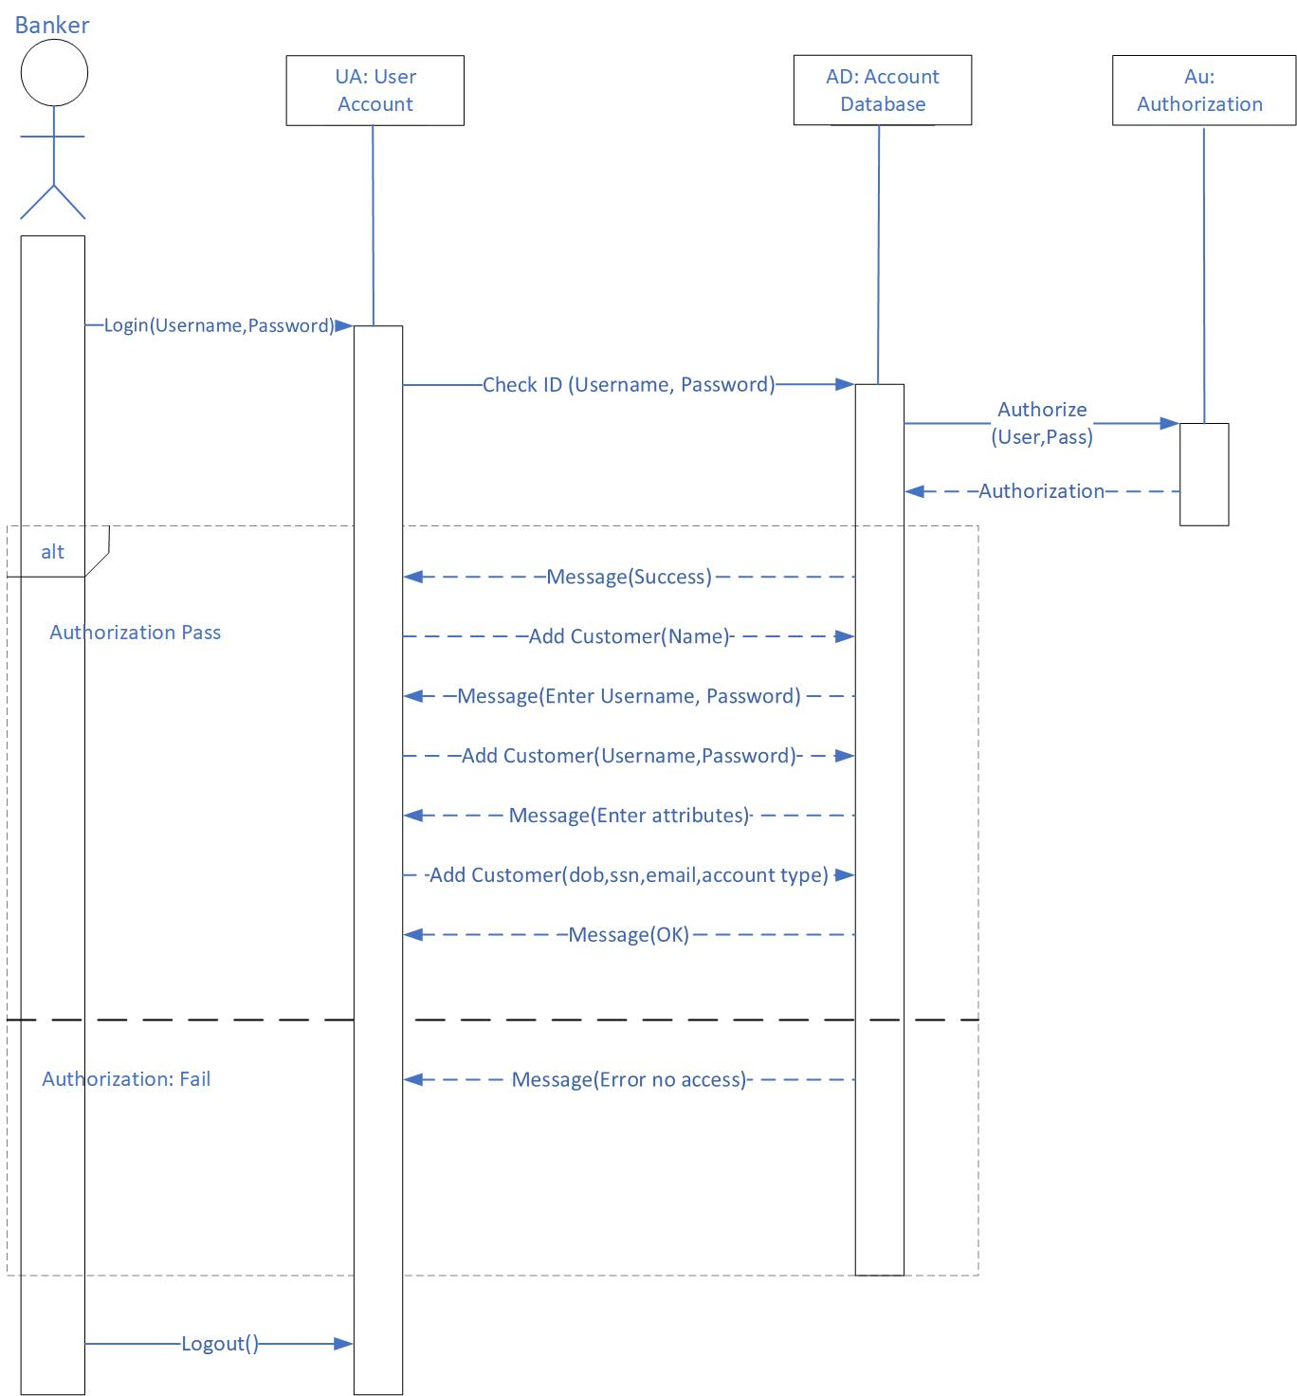

Use Case 6, Analyze Transaction Volume
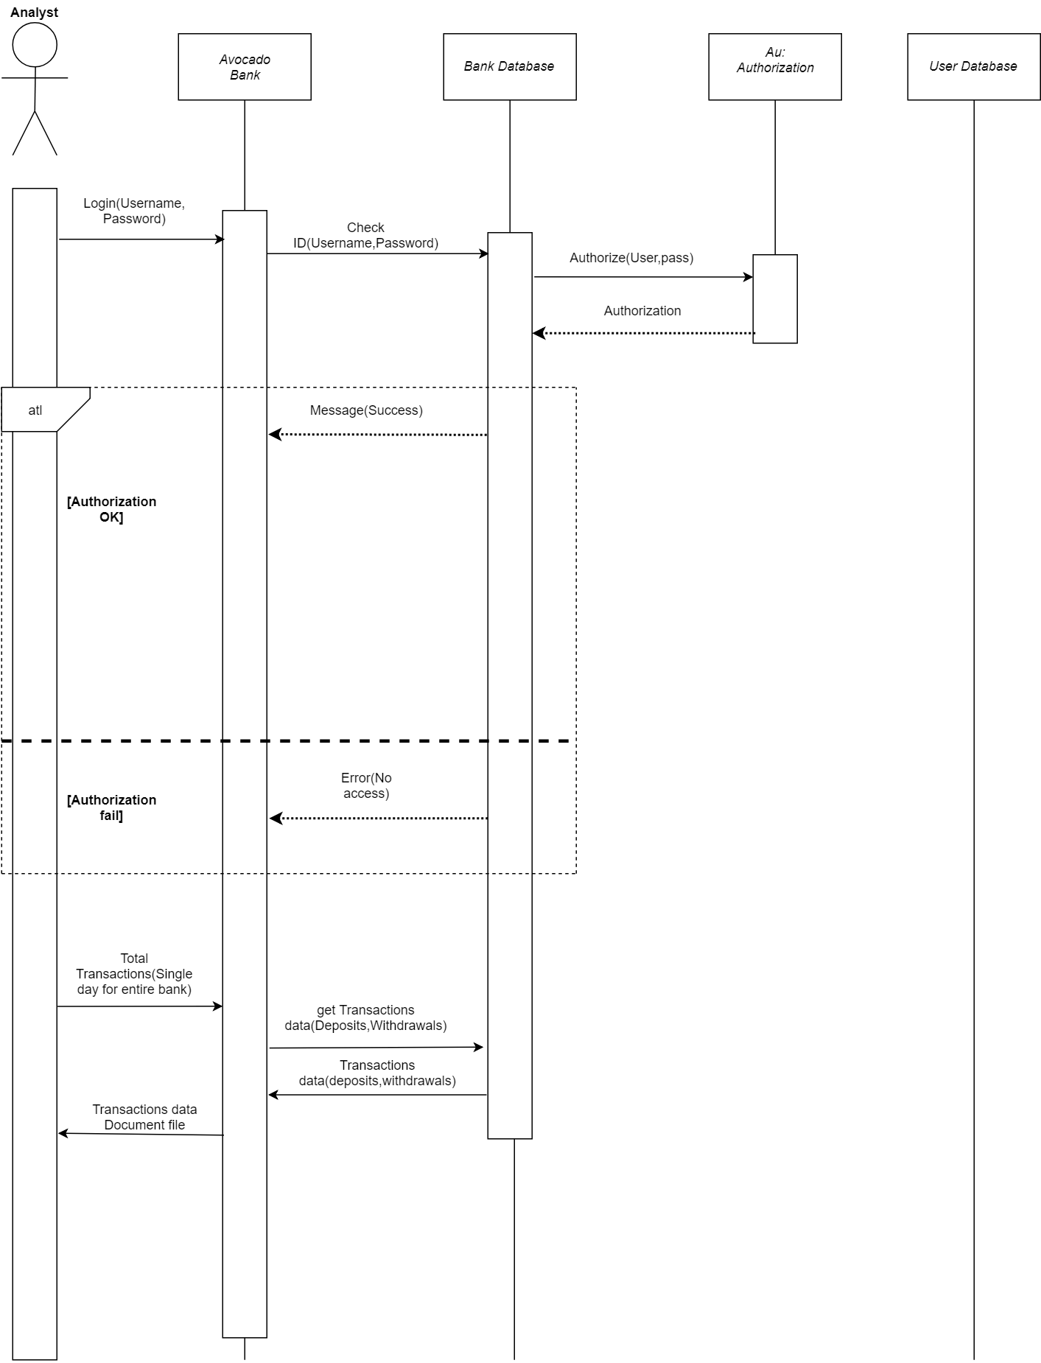

Implementation

Backend
The backend is implemented in Java 1.8, using Spring Boot. It communicates between the frontend and the database according contract described by ‘api.yaml’.
Start your server by running ‘gradle.bat run’ in ‘backend/’.
Run unit tests by running ‘gradle.bat test’ in ‘backend/’.
You can view the api documentation by starting the server and navigating to http://localhost:8000/api/
The source code for the backend can be found at https://github.com/gsu-swe-s2019-group-1/project/tree/master/backend.

Frontend
The frontend is implemented in TypeScript, with React as the framework library, and Ant Design as the component library. It provides the user with a beautiful and easy-to-use interface. Building it requires NodeJS, and running it requires a modern web browser.
Install dependencies using ‘npm install’ in ‘frontend/’.
A live-reloading development server can be started by running ‘npm start’ in ‘frontend/’. Your browser will automatically be opened. The default username & password is ‘admin’ and ‘admin’.
The code can be compiled for deployment using ‘npm run build’
The source code for the frontend can be found at https://github.com/gsu-swe-s2019-group-1/project/tree/master/frontend.

Deployment
Deployment instructions and files required for deployment can be found at https://github.com/gsu-swe-s2019-group-1/project/tree/master/deploy.

Testing

Functionality Testing

Login
Partition Input: login(String U, string P)
- String U is a string for the user’s Username
  - One possible partition is string with length < 0, string with length = 0, string with length > 0
- String P is a string for the user’s Password
  - One possible partition is string with length < 0, string with length = 0, string with length > 0
Test Specification:
- Username: <String a-z, A-Z, 0-9, special characters>
- Password: <String a-z, A-Z, 0-9, special characters>
Test Case:

  - Inputs:
    - Username: admin
    - Password: admin
  - Outputs:
    - Logs in

  - Inputs:
    - Username:
    - Password:
  - Outputs:
    - Please input your username! Please input your Password!

Send Money
Partition Input: sendMoney(String ID, int N)
- String ID is a string for the recipient’s Username
  - One possible partition is string with length < 0, string with length = 0, string with length > 0
- double N is an integer between 0 and the user’s maximum balance
  - One possible partition is a number: < -∞ - 0.00,0.00-∞, 0.00-…*>, …* is the user’s maximum balance
Test Specification:
- Recipient’s ID: <String a-Z, A-Z, 0-9, special characters>
- Amount: <0…*>, * is the user’ maximum balance
Test Case:
Assume user has $10 in balance

  - Inputs:
    - ID: bobross
    - Amount: $3.01
  - Outputs:
    - Successfully sent $3.01 to bobross

  - Inputs:
    - ID:
    - Amount: $3.01
  - Outputs:
    - Please add a destination

  - Inputs:
    - ID: bobross
    - Amount:$ -3.01
  - Outputs:
    - You can only transfer money out of your account

  - Inputs:
    - ID: bobross
    - Amount: $500
  - Outputs:
    - You can’t transfer more money than you have

Unit Testing Documentation

createUserTest()
Test ID | createUserTest()
Purpose of Test | To test if a user object can be created and inserted into database successfully
Test Environment | JUnit
Test Steps | Run ‘gradle.bat test’ in the ‘backend/’ directory of the git repo
Test Input | CreateUserObject body = new CreateUserObject();  body.setName("John Doe");  body.setUsername("jdoe1");  body.setAccountType(AccountType.CUSTOMER);  body.setPassword("pass123");  body.setSsn("123456");
Expected Result | Test passed: 1  The test uses an .assertEquals() methods that checks if two objects are equals or not. If they are not, an AssertionError without a message is thrown. It checks if the createUser() method returns "HttpStatus.NOT_IMPLEMENTED", meaning the server does not support the functionality required to fulfill the request.
Likely Problems/Bugs Revealed | Vulnerability to SQL injections in username and password field to bypass user authentication  Vulnerability to SQL injections in username and password field to data manipulation (inserting, deleting, changing data, etc)

loginUserTest()
Test ID | loginUserTest()
Purpose of Test | To test if a user object’s username and password can be used to access system functionalities.
Test Environment | JUnit
Test Steps | Run ‘gradle.bat test’ in the ‘backend/’ directory of the git repo
Test Input | LoginParameters body = new LoginParameters();  body.setUserName("jdoe1");  body.setPassword("pass123");
Expected Result | Test passed: 1  The test uses an .assertEquals() methods that checks if two objects are equals or not. If they are not, an AssertionError without a message is thrown. It checks if the loginUser() method returns "HttpStatus.NOT_IMPLEMENTED", meaning the server does not support the functionality required to fulfill the request.
Likely Problems/Bugs Revealed | Vulnerability to SQL injections in username and password field to bypass user authentication  Vulnerability to SQL injections in username and password field to data manipulation (inserting, deleting, changing data, etc)

Bug Documentation
Bug | The test uncovered the bug | Description of the bug | Action taken to fix the bug
Vulnerability to SQL injections to bypass user authentication | loginUserTest() | A user could bypass our authentication software and enter the website without a valid username and password | Change the permission and privileges so user does not have privilege to login if its invalid
Vulnerability to SQL injections in username, password, and SSN ID field to data manipulation (inserting, deleting, changing data, etc) | loginUserTest()  createUserTest() | A user could bypass manipulate our data and insert, delete, or update the data in the username, password, and SSN ID field | Change permission and privilege so user does not have privilege to change data

Appendix A: Links
GitHub: https://github.com/gsu-swe-s2019-group-1
Website: https://avocado-toast.wp6.pw/

Appendix B: Screenshots
