Case study: Task Manager

Database structure:

Task table:

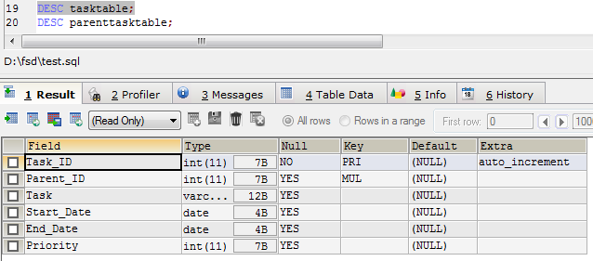

ParentTask table:

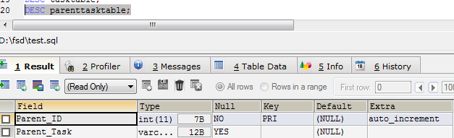

**TESTING THE APPLICATION:**

***ADD TASK:***

On opening the angular application with the ng serve we will see the below page with add task page loads by default:

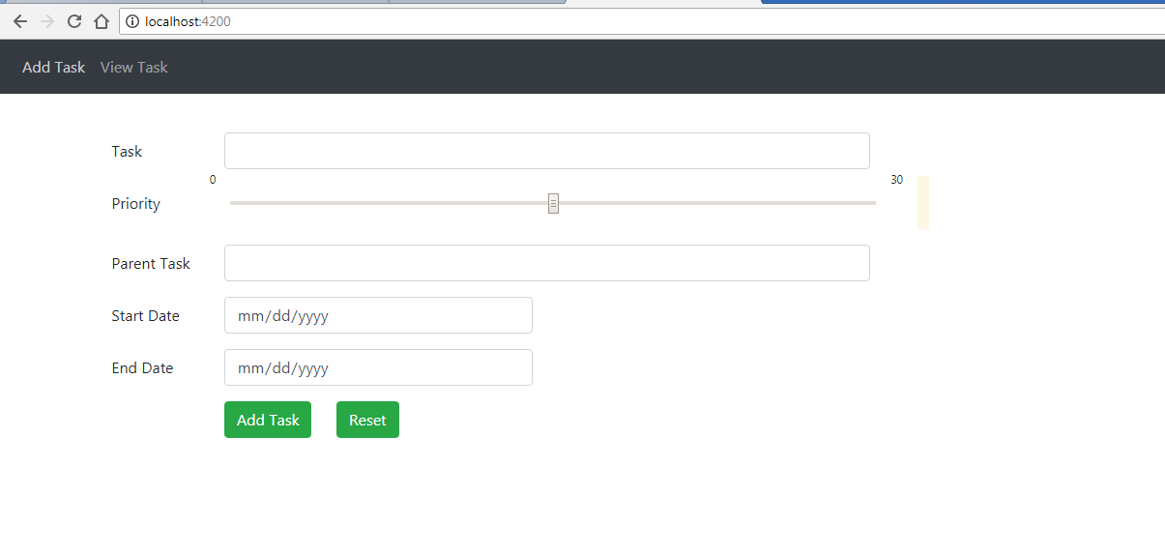

Add the task details

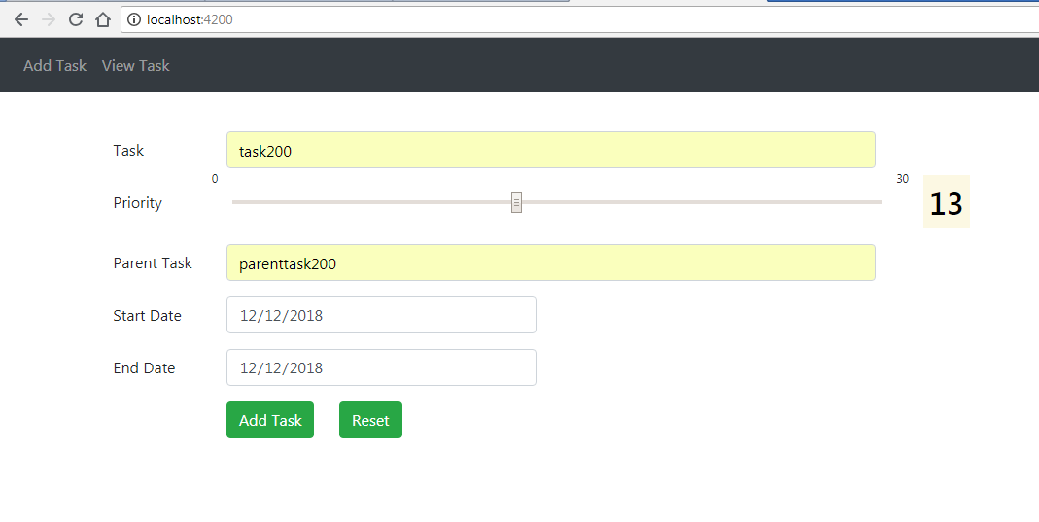

Click the add task button and we can verify the table for the newly added task in both the task table and parent task table

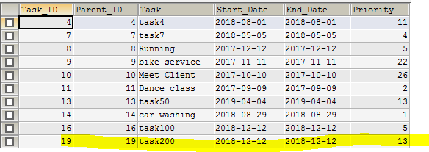

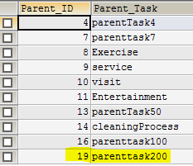

Note: Click on the reset button will reset all the task fields

***VIEW TASK:***

On clicking the view task in the nav bar we will see the view task page as below,

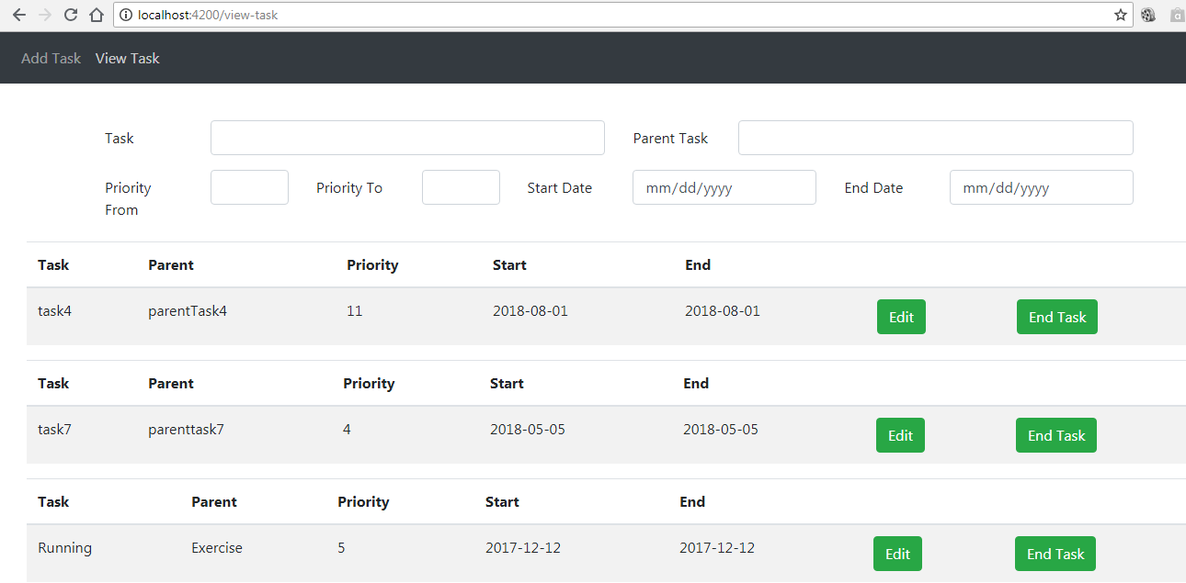

**AUTO FILTER SEARCH FIELDS:**

We can do the search using all the search fields as below,

1. Search ‘ca’ in the **task search** field will give the below task,

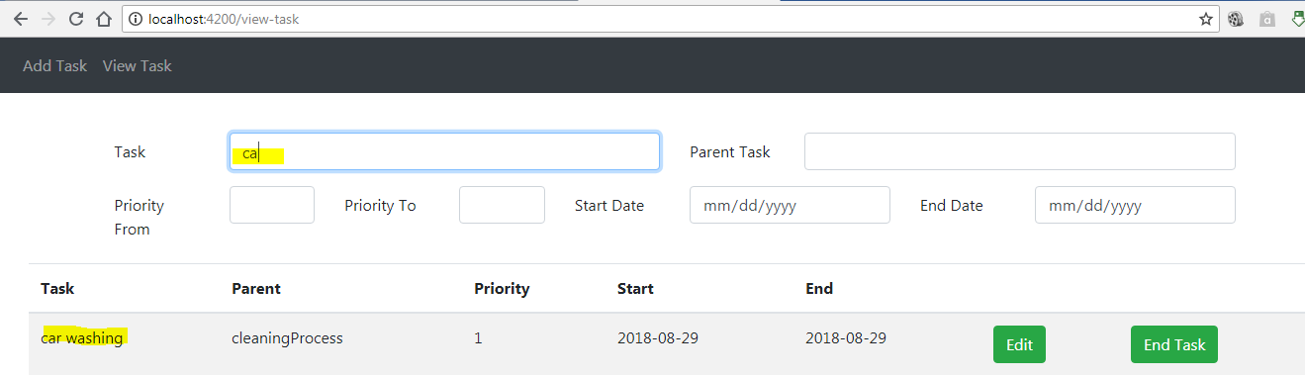

1. Search ‘ment’ in the **parent task search** field will give the below task,

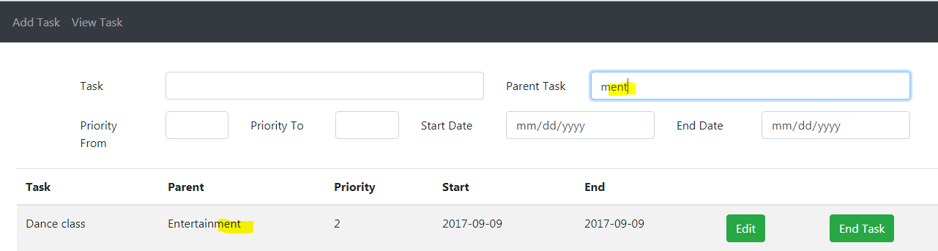

1. Search ’1’ in the **priority from** and ‘12’ in the **priority to** will give the below task list,

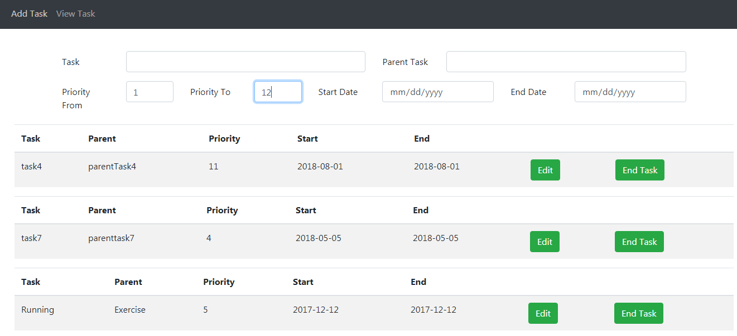

1. We can search only using the **priority from** and left the **priority to** blank, which will give the task list **greater than the priority from** search field

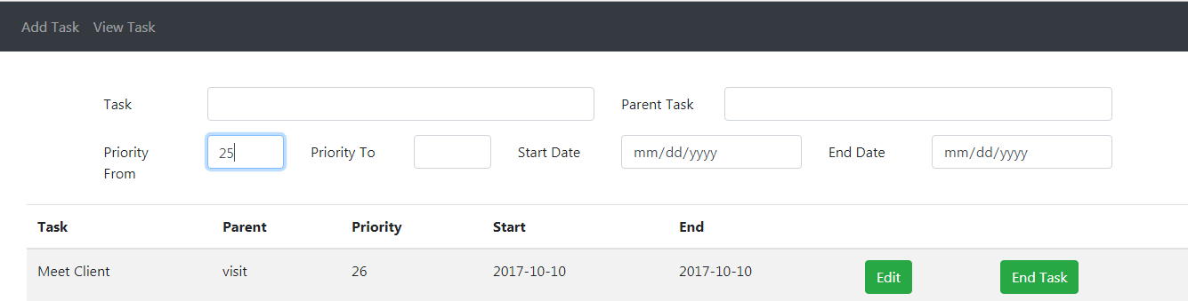

1. We can search only using the **priority to** and left the **priority from** blank, which will give the task list **lesser than the priority to** search field

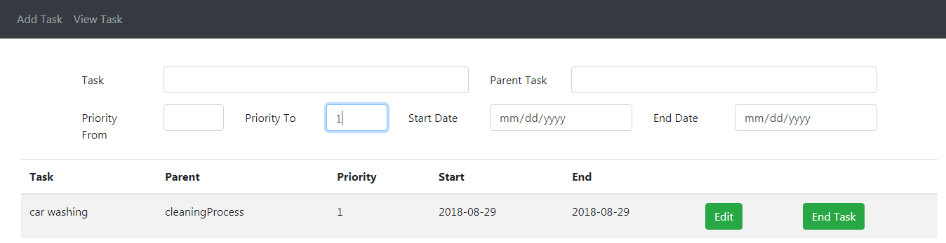

1. Search the ‘12/12/2018’ in the start date field will give the below task,

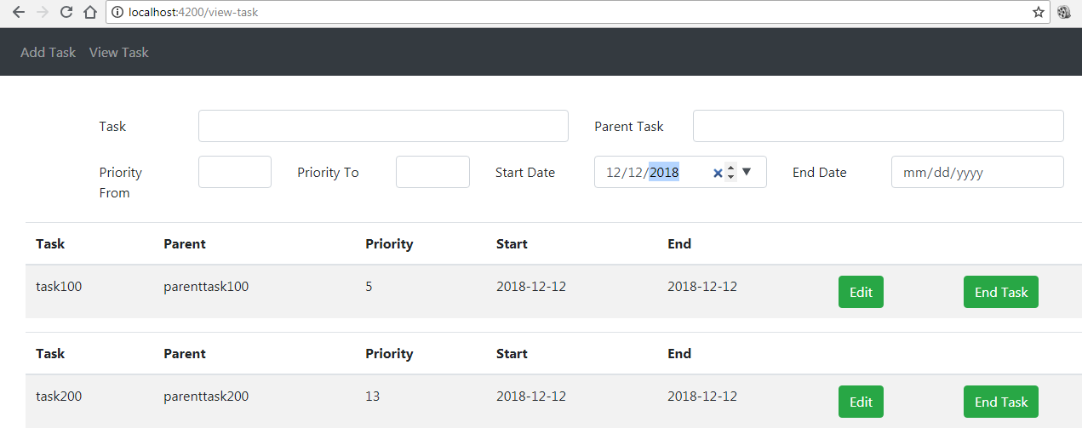

1. Search the ‘04/04/2019’ in the end date field will give the below task,

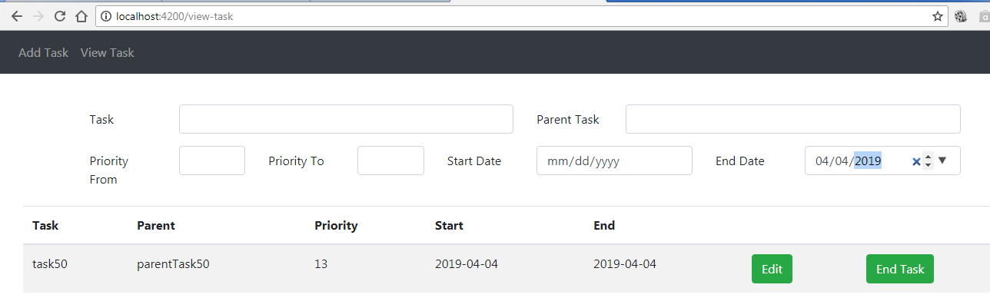

Note: Search ‘ca’ in the task search field gives the ‘car washing’ task and if we clear that field will give the complete task list again.

***EDIT/UPDATE TASK:***

Click on the edit button for ‘task200’ will give the form with the task details prefilled,

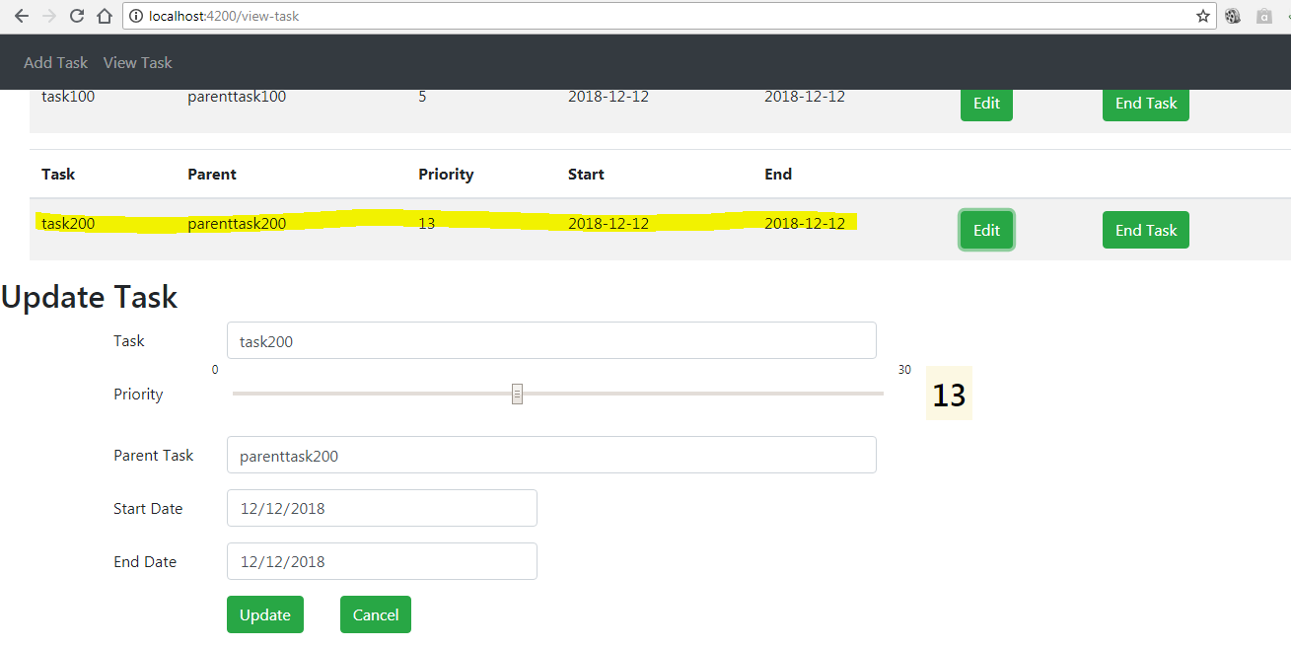

Update the any fields, eg., the priority from 13 to 20 as below,

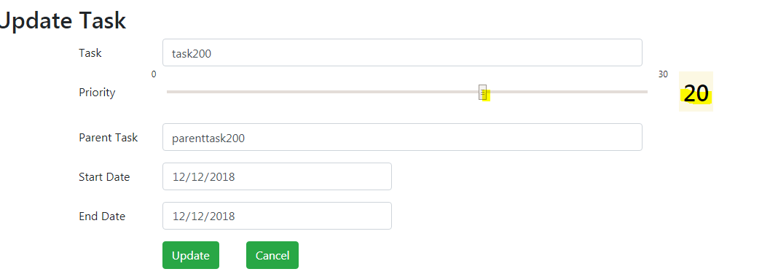

Click on the update button will update the task



Note: Click on the cancel button will remove the update form give above

***END TASK:***

On clicking the end task will disable both the end and the edit buttons as given below,

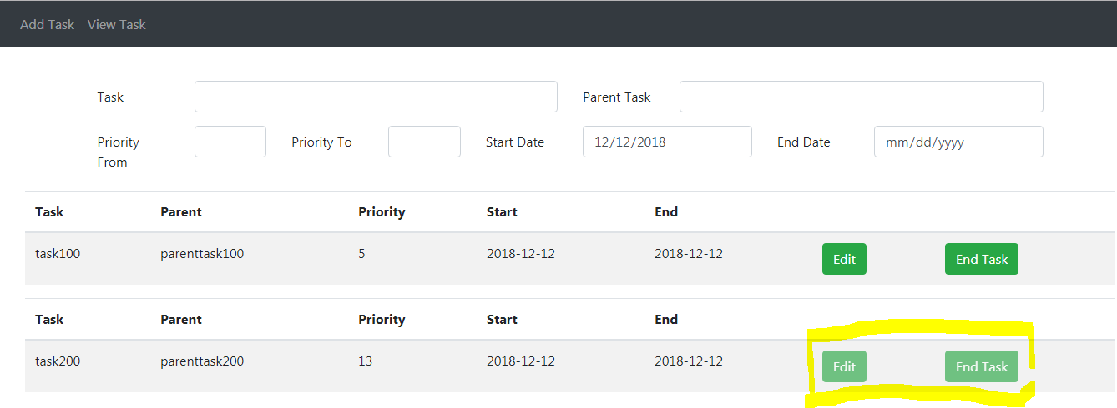

**UNIT TESTING:**

Screenshot for both JUNIT using easymock and Angular unit testing using karma jasmine.

