Capturing and Parsing Network Packets

Objective
It is fundamentally important to capture, parse, and analyze network packets. Although several off-the-shelf systems such as TCPDUMP and WIRESHARK are readily available for packet capturing, parsing, and basic analyzing, designing and implementing customized packet analysis systems are still common practices in the field of network security. Through this project, students will
- Gain fundamental skills to capture network packets by directly programming with packet-capture library (pcap).
- Enhance the knowledge of network protocols and practice with packet parsing.
- Performing simple statistics over the captured packets to profile the network situation.

Environment
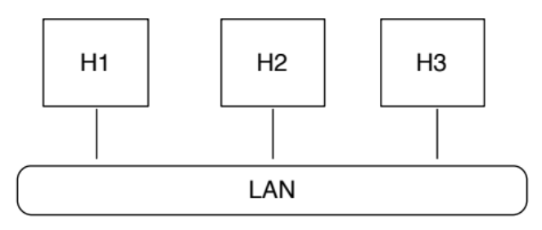
Three computers (H1, H2, and H3) reside in the same LAN.

- H1 has an IRC client.
- H3 has an IRC server.
- H2 has libpcap installed.
You can start the IRC server in H3 using the command. Then you can start the IRC client in H1 to connect to the IRC server in H3 (using H3’s IP address and the default port for IRC protocol - 6667). Then you can use the IRC client to create a channel and then join it. This environment provides you a network environment that a client is communicating with a server. Meanwhile, a detection engine or an attacker can monitor the traffic.

A working system written in C, accompanied by its make files, has been given to you. You can study it source code, identifying the missing functionalities, and then expand it by adding your own code. You are not required to use the C code given to you to finish this project. However, it may significantly expedite your process by expanding the given system rather than building the system from scratch. In addition, writing code in C helps you better understand the protocols and how to parse packets.

You can generate pcap traces by yourself to test your system. You can also download a piece of botnet trace from this URL ( https://www.dropbox.com/s/xq0ahipgsikg3rv/botTrace?dl=0 )

Building
The included system code is done as an Eclipse CDT project. While the included C code (in the 'src/' directory) can be used on any system with GCC available as a compiler and libpcap installed (such as the lab environment). Here is how to take advantage of the included makefiles.
Option 1: Use Makefiles
If all you want to do is edit the included files, (this MAY also work for adding extra code files) you can use the included makefiles by going into the 'Debug/' (for debugging support) or 'Release/' folders (without debugging support) and execute 'make'. 'make clean' can be used to remove the results of previous compiles.
Option 2: Set up Eclipse
If you wish to edit this in the Eclipse IDE, you can download and install Eclipse (from https://www.eclipse.org/downloads/, the basic Java version) or as packaged by your linux distribution of choice), and then install the Eclipse CDT plugin on top of the base from here: http://www.eclipse.org/cdt/downloads.php. Installing CDT is a bit trickier:
1. Select Help->Install New Software
2. Copy from the download page the “p2 software repository” url into the “work with:” field in the “Install” dialogue that pops up.
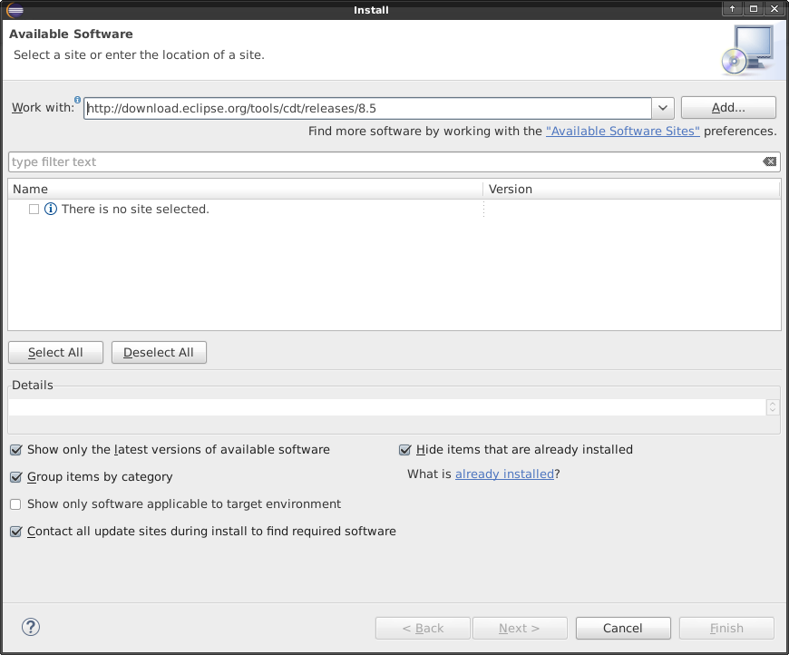
3. Hit add, name it “Eclipse CDT” in the resulting pop-up and and hit OK.
4. Select “CDT Main Features” and “CDT Optional Features” and hit “Next >”.
5. Follow the wizard from here – you just need to approve each step, let it download and install.

From there, you can import the project with:
1. Select File->Import.
2. Select General, and then Existing Projects into Workspace
3. Hit “Browse” in the “Select Root Directory” option and select the base directory of the project (the “Project1-PacketCapture” folder).
4. Hit Finish. The project should be automatically configured to compile.

NOTE: Running the program in Eclipse isn't possible as root, and you need root in order to packet capture. Please execute outside Eclipse for that. The binaries are in the Debug or Release folder depending on the build configuration you are using. By default, it is set to Debug, which is what you will want for testing.

Execution
To run the project, go to the folder with the compiled program and run it with “sudo ./Project1-PacketCapture”. This should be followed by the following command line flags if needed:
- -i interface: Specifies the networking card to read packets from. A list of interfaces can be found by running ifconfig at the command prompt – you probably want one of the “eth#” or “enp#s#” interfaces for a Linux wired ethernet card, and the “wlan#” or “wlp#s#” interfaces for a wireless ethernet card. These vary from system to system. If not specified, the default card according to libpcap will be used.
- -o filename: Outputs the output of the program to the specified filename as well as writing it to the terminal.
- -l limit: Sets a limit on the number of packets the program will read in before it stops automatically. If not specified it will go on infinitely until killed (I recommend using Ctrl-C to cancel it.)
- -f file: Reads in from a libpcap dump (from Wireshark or such, NOT from this) to allow offline analysis.

Task 1
You are asked to build a system to capture network packets and then parse them. We should be able to configure your system to capture packets from

- An assigned network interface (make sure you set this interface in the promiscuous mode)
- A file that contains network packets in the format of PCAP
This system only concerns with TCP packets. In other words, packets other than TCP (e.g., UDP) will be ignored by your system. For each packet, your system will output:

- Timestamp, SrcIP, SrcPort, DstIP, DstPort, Seq Number, Ack Number
- TCP Flags: SYN, SYNACK, ACK, FIN, RST
- Each letter in the payload
Task 2
You are asked to build a system to derive basic statistics from network packets. Again, we should be able to configure your system to capture packets from

- An assigned network interface (make sure you set this interface in the promiscuous mode)
- A file that contains network packets in the format of PCAP
This system only concerns with TCP packets. In other words, packets other than TCP (e.g., UDP) will be ignored by your system. You can use different means to fulfill this “filter”. For example, you can use BPF filter rules or dynamically verify this condition (e.g., UDP packets or TCP packets) in your program after a packet is parsed. I highly recommend the second option (e.g., parsing and then checking) as it gives you more flexibility in practice.

Your system needs to identify those TCP sessions that failed to accomplish 3-way handshake. To simply the design in this project, we consider Host-A initiates a failed TCP session to Host-B if the following two conditions are satisfied:

- Host-A sends a SYN packet to Host-B (to initiate a new TCP session)
- Host-B sends no packet to Host-A or only RST packet(s) (for this session)
Your system will summarize the statistics of failed connections initiated from each IP addresses. To be more specific, each line in the output contains:

- The IP address
- Total number of failed TCP sessions initiated by this IP address

A large number of failed connections initiated from an IP address usually indicates that this IP address is performing scanning attacks.
Submission
For each task, you need to submit an individual package, which includes:

- The source code of the system.
- A report that illustrates how you implemented the system. If you expand the given system, please clearly indicate the locations you have made the changes.
- A manual that illustrates how we can compile your code and run your system. You should give some examples to illustrate the usage of your system.
It is worth noting that if your manual is not comprehensible and therefore we cannot successfully compile/run your code, you will lose score for that.

