

**Georgia State University**

Department of Computer Science

**title of report**

Ph.D Qualifier Report

Xiulong Yang

Committee:

Dr.(Chair), Dr., and Dr.

**Abstract**

The background.

In this work, two XXX algorithms will be investigated, including A and B. Experiments show that they are good.

**Key words:** Deep Learning, Machine Learning

**Contents**

1 Introduction 3

2 Related Work 4

3 title 5

3.1 subsection 5

4 paper2’s title 6

4.1 Motivation 6

5 Future Work 7

6 Conclusion 7

# Introduction

Over the past few years, the issues have raised some what.

In this work, two selected papers ”A” and ”B” presented two approaches.

The outline of the report is as follows: In Section II, we will review some related work of . In Section III, . The next method is then introduced in Section III. Finally,conclusions and future work in Section V and VI.

# Related Work

I guess this part is very important too.

# title

## subsection

a equation *p*(*y* = *c*|*x,w*) = *softmax*(*f*(*x*))

. The *w* is the parameters of a neural network, and *f* is the output of the model. So for each input image, we can get a probability vector *p*(*y* = *c*|*x,w*).

The authors evaluated the models on MNIST ([6]), CIFAR-10 ([5]), a diabetic retinopathy dataset ([1]) and ImageNet([3]). Shaded areas in the plots denote ± one standard deviation.

1. MNIST: The network architecture for MNIST, referred to as “S-CNN”, contains two convolutional layers and one dense layer. It is the same as the Keras MNIST CNN implementation ([2]).
2. CIFAR-10: The authors experiment a CNN model with four convolutional layers and one dense layer as the Keras CIFAR CNN implementation ([2]), which we refer to as “K-CNN”.

Additionally they also evaluate with DenseNet-121 (k = 12, with bottleneck), using the learning rate schedule as proposed in [4].

1. diabetic retinopathy dataset: Details for the inceptionV3 architecture are described in section 4.5.
2. ImageNet: ResNet-50[3] is used in the experiments. The network is trained for 100 epochs without data augmentation using stochastic gradient descent. The initial learning rate of 0.1 is changed to 0.01 at epoch 50, and 0.001 at epoch 75. The initial 40,000 images are class-balanced.

Figure.1 is show below:

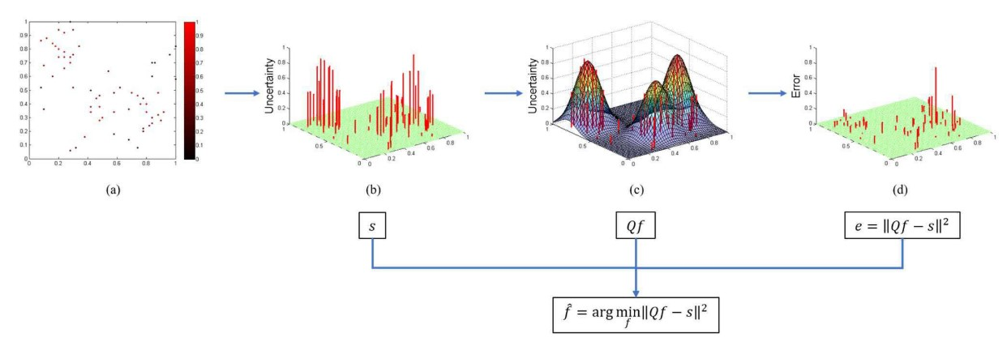

Figure 1: overview

# paper2’s title

## Motivation

*f*b=argmin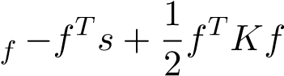

*n* (1)

s.t.X*fi* = 1*, fi* ≥ 0

*i*=1

**Algorithm 1** SMGS

**Input:** original uncertainty values *s*, similarity matrix *Q*, labeled set *L*, unlabeled set *U* **Initialization:** Set *s*1 = *s* **for** *t* = 1 : *Bq* **do**

Choose *kt* = *arg* max*j*∈*U qjTst* from *U*

Compute *fkt* by

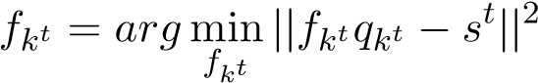*.*

Update the uncertainty values for the next iteration.

using *st*+1 = *max*(*st* − *fkt,*0)*.*

Move sample index *kt* from *U* to *L*.

**endfor**

**Output:**

updatedlabeledsetL

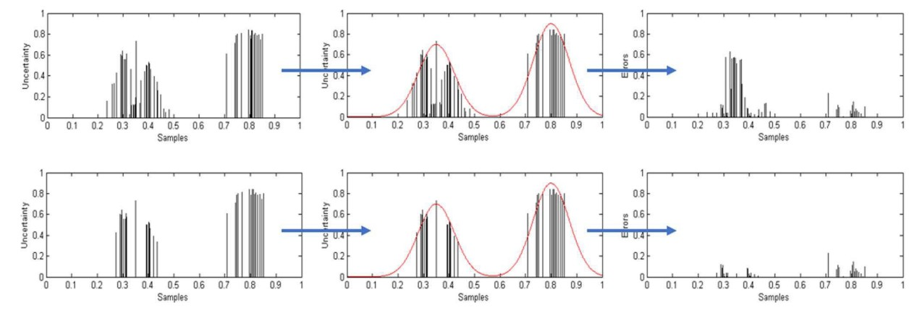

Figure2:Theoverview

The Figure.2 shows the idea.

# Future Work

Future is good

# Conclusion

it’s the conclusion

**References**

[1] EyePacs. https://www.kaggle.com/c/diabetic-retinopathy-detection. Technical report, 2015. [2] fchollet. Keras. Technical report, 2015.

1. K. He, X. Zhang, S. Ren, and J. Sun. Deep residual learning for image recognition. In *2016 IEEE Conference on Computer Vision and Pattern Recognition (CVPR)*, pages 770–778, June 2016.
2. Gao Huang, Zhuang Liu, Laurens van der Maaten, and Kilian Q. Weinberger. Densely connected convolutional networks. *2017 IEEE Conference on Computer Vision and Pattern Recognition (CVPR)*, pages 2261–2269, 2017.
3. Alex Krizhevsky. Learning multiple layers of features from tiny images. Technical report, 2009.
4. Y. LECUN. The mnist database of handwritten digits. *http://yann.lecun.com/exdb/mnist/*.