**Deploying a Spring Boot App to Kubernetes**

Objective: Deploying a Spring Boot app using Kubernetes

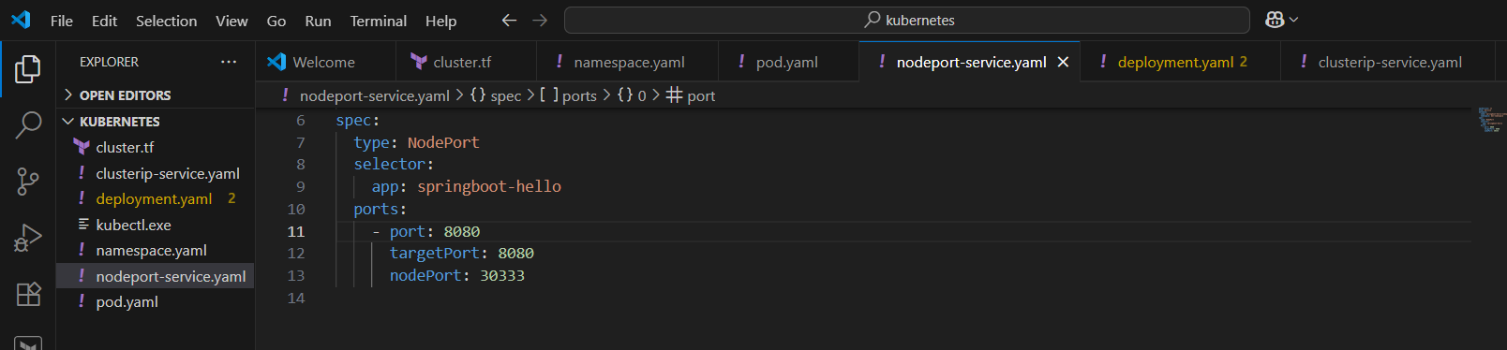

Namespace: Dev-Namespace

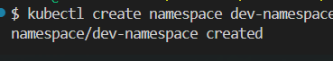

We Can See That Namespace Created Successfully

Deployment Configuration:

Command : Kubectl Apply -F Deployment.Yaml -N Dev-Namespace

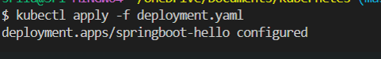

Result: Springboot-Hello Deployment Created

Screenshot: Terminal Showing Successful Deployment Creation

Pod Status Check

Command:

Kubectl Get Pods -N Dev-Namespace

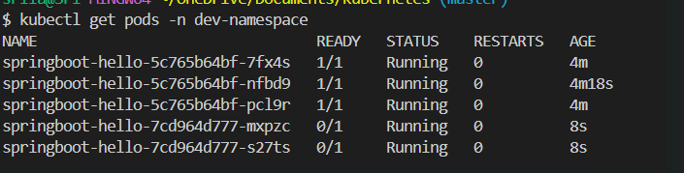

Outcome:

Multiple Pods In Running State

Some Pods In Containercreating (Initialization Phase)

Screenshot: Pod List With READY And STATUS Columns

Exposing The App Via Nodeport

Command:

Kubectl Get Svc -N Dev-Namespace

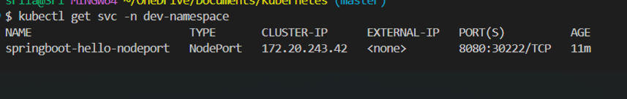

Service: Springboot-Hello-Nodeport

Port Mapping: 8080:30222/TCP

Screenshot: Service Details With Clusterip And Nodeport

Accessing The App

Browser URL: Http://:30222

Output: “Hi This Is Sunil.”

Screenshot: Webpage Showing The Message

