

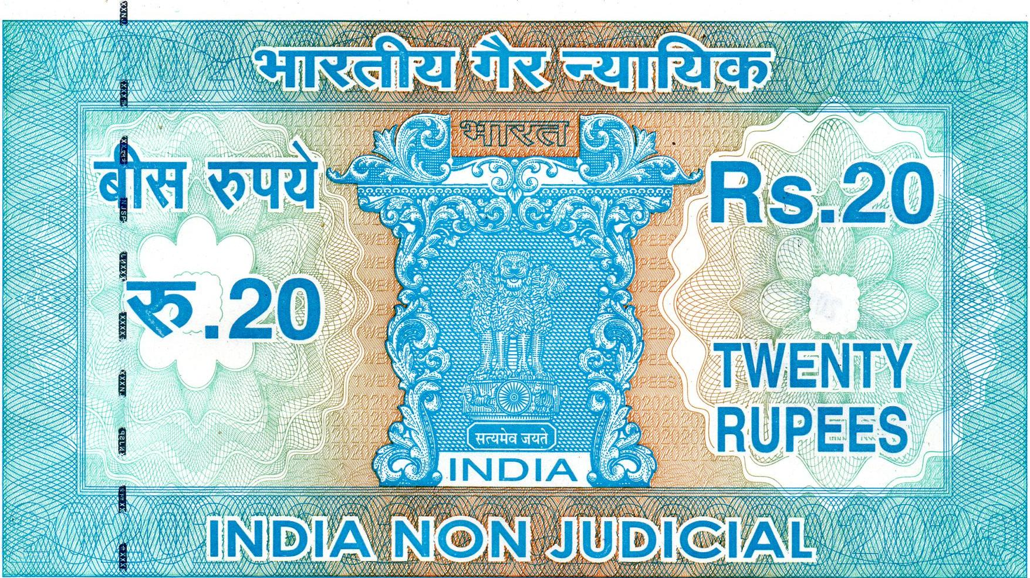

**ANOTf .3;;;;;;;Vr;**

**en ,44ftto.,**

**40..7 4Y,A..e2**

iffite:;;043,,z•stY441,;!;;SAft

AV   
Av/DA 'kelieZa•

$;;;;.417;r44„

*'.761/4* #i

get.44

**TWENTY**

* **RUPEES..**
* wo vt,404040470;;",,t4, IMISRAITeT W • V

:fare INVIOVVe44400111" 44' (41. F4f414 A 7714,

U **11: I A 12**

**I**VS Ott' 4+4011L

ANNVO4444S,

*AA., .4!4442.1../1414S..4.44:!!!..

ICENSED JENDOP

9AA 224184 GYES.L3 KUMAR,.

N15-27-0581201, b-27:004r .°

4:No:2-3•77, Nage, R.R.Dis,

rest: 9133764253

J.0

**fr**

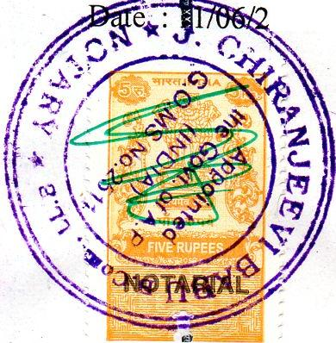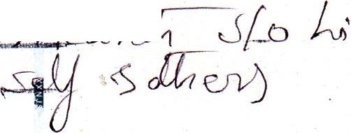**AFFIDAVIT OF SUPPORT**

tipu0

Sl.N t

Sold t

**Frg 4.fiv**

|  |  |
| --- | --- |
|  | TE LAN GANA |

*If*

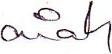

We Mr. Srinivasulu Vardineni, Mrs. Padmavathi Vardineni, Residents of H.No. 3-25, Chagallu, Uli/apadu, Prakasam-523292, Andhra Pradesh, India, do hereby solemnly affirm and state as under:

I. pat, **Mr. HARISH KUMAR VARDINENI (Visa Applicant)** citizen of India and holding valid Passport is our son.

1. iThat, he has been admitted to the Master's level Education in Learning Language at **;Governors state University** in United States of America. The expenses is estimated to be **US $ 22,730/-as** per the Student 1-20 issued by the University.
2. Plat, we have sufficient funds to pay the expenses for our son study & stay in USA.
3. That, we will not hesitate to utilize/ realize the above - mentioned income / assets for the purpose of supporting his stay in America. He will come back to India immediately after his tudies.

Place : derabad

016 Deponent (1) Deponent (2)

**//ATT *STED I/***

**jeevf eabu**

**8.Com.LL.S.**

A IIPVOCATE & NOTARY

W 127/128/C, Sri **Krishna *Nagar***

**Near** sal ***Kiran*** Public ***School*Yausufguda, Hyderabad - 500 044**