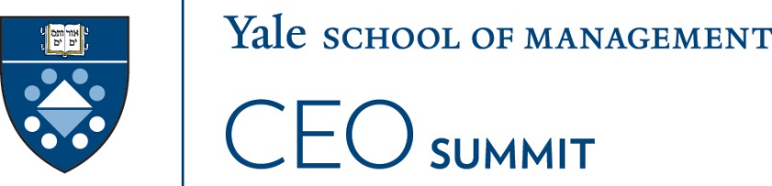 | Roosevelt Hotel New York  Wednesday, December 13, 2017

YALE CEO College

7:15 am Breakfast – Palm Room

8:00 am Welcome & Introductions – Terrace Ballroom
Jeffrey Sonnenfeld; Senior Associate Dean & Professor of Management Practice, YALE School of Management; President & CEO, YALE Chief Executive Leadership Institute

8:45 am Your Leadership Style, Your Leadership Team, and Your Enterprise: Revisiting 360
Ron Warren, Founder, LMAP
Respondent
Lori Malcolm, Chief Culture Officer, United Way Worldwide

9:45 am Blockchain for Blockheads: Fintech Financiers - Cryptocurrency, AI, & Asset Management
Panelists
Gregory Fleming; CEO, Rockefeller Capital Group; Sr. Research Scholar, YALE Law School
Seraina Macia; EVP & CEO, Planned Technology-Focused Subsidiary; AIG
Anders Brownworth, Chief Evangelist, Circle Internet Financial
Dario Gil; Vice President, AI and IBM Q; IBM Research
Alex Benke; Vice President, Financial Advice & Planning; Betterment
Bruce Greenwald, Professor of Finance & Asset Management, Columbia Business School
Respondents
Ronan Ryan, President, IEX
Elena Kvochko; CIO, Security Division; Barclays Bank
Michael Zuckert, General Counsel, Silicon Valley Bank Financial Group
John Wilcox, Chief Strategy & Venture Officer, The Hartford Financial Services Group
Marina Niessner, Assistant Professor of Finance, YALE School of Management

Noon Lunch Discussion Groups – Palm Room

1:15 pm Redrawing Global Geopolitical Maps: Continental Drifts – Terrace Ballroom
Quinn Mills, Professor, Harvard Business School
Respondents
Ester Baiget; President, Industrial Solutions; The Dow Chemical Company
Donald Allan Jr.; Executive Vice President, Chief Financial Officer; Stanley Black & Decker
Dave Yawman; Executive Vice President Government Affairs & General Counsel; PepsiCo
Christina P. Minnis; Co-Head, Americas Credit Finance Group; Goldman Sachs & Co.
Luciano Azum, President, Tupperware Brands Mexico
Roger Arrieux, Audit & Assurance Partner, Deloitte & Touche LLP
Christopher Shays, Member of Congress (1987-2009), State of Connecticut
Marshall W. Meyer; Professor Emeritus, The Wharton School; University of Pennsylvania
Jing Tsu; Chair, Council on East Asian Studies; Professor of Chinese Literature; YALE University
Douglas W. Rae, Professor of Management, YALE School of Management

2:15 pm Competing Smarter: Technologies as New Tools or New Territories
William P. Putsis, Professor of Marketing, UNC Chapel Hill
Respondents
Robert J. McDonough; President, Climate, Controls & Security; United Technologies Corporation
Gitte Schjotz; Senior Vice President & President, Software; UL
Benn R. Konsynski; Professor, Goizueta Business School; Emory University
Jon Banner; Executive Vice President, Communications; PepsiCo
Justin MacFarlane; Chief Strategy, Analytics & Innovation Officer; Macy’s Inc.
Don Weinstein, Chief Strategy Officer, ADP
Charles Kriete, Senior Vice President, TESSCO Technologies
Ravi Dhar; Professor & Director, Center for Customer Insights; YALE School of Management
Andrew Hermalyn; Executive Vice President, University Partnerships & Programs; 2U
Chitra D. Nawbatt, Global Head of Market Solutions, Genpact

3:15 pm Driving into the Future with No Roadmaps: New Directions for Smart Mobility
Mark Fields; Partner, TPG; Former Chief Executive Officer, Ford Motor Company
Respondents
James J. Barber, President, UPS International
John Paul MacDuffie; Professor of Management, The Wharton School; University of Pennsylvania
Kyle Jensen; Associate Dean & Director of Entrepreneurship; YALE School of Management

4:15 pm Bosses as Brands: Charisma, Courage & Character
Jeffrey Sonnenfeld; Senior Associate Dean & Professor of Management Practice, YALE School of Management; President & CEO, YALE Chief Executive Leadership Institute

5:30 pm Adjourn

