Title: Sonifying character strings to produce synthetic vocal identity signals and testing identity information detection

Short Title: Detection of identity information in sonified character strings

Authors: Coppinger, B.A^{1,2}., Eckhardt, S.G. ^{1,2}, Cross, A. ^{3,4†}, Samman, R. ^{1,5†}, Juárez, G.A. ^{1†}, Ferdinand, V.^{6,7*}, Smith-Vidaurre, G. ^{1,2,5*}

Affiliations:
¹Department of Integrative Biology, Michigan State University, East Lansing, MI USA
²Ecology, Evolution, and Behavior Program, Michigan State University, East Lansing, MI USA
³Department of Statistical and Data Sciences, Smith College, Northhampton, MA, USA
⁴Department of Psychology, Smith College, Northhampton, MA, USA
⁵Department of Computational Mathematics, Science, and Engineering, Michigan State University, East Lansing, MI USA
⁶Complex Human Data Hub, Melbourne School of Psychological Sciences, University of Melbourne, Melbourne, VIC, Australia
⁷Melbourne Centre for Data Science, University of Melbourne, Melbourne, VIC, Australia
†equal contributions
*co-senior authors

Corresponding Author:
Grace Smith-Vidaurre
smithvid@msu.edu
ORCID: 0000-0002-0155-8159

Acknowledgements: We thank Madison Honore, Parker Major, Nina Safranski, and Mikayla Data for feedback on this research. We are grateful to Parker Major, Nina Safranski, and Mikayla Datka for reviewing early versions of our R package vignettes. This research was supported by funding to GSV from the Department of Integrative Biology, the Department of Computational Mathematics, Science, and Engineering, the College of Natural Science, and the Office of the Provost at Michigan State University (MSU). AC was supported by the MSU Advanced Computational Research Experiences (ACRES) NSF REU Program in summer 2024 (grant number 2349002).

Data Availability: The pipeline we developed for the sonification of character strings is available as an R package on GitHub: https://github.com/gsvidaurre/paRsynth. All code associated with this manuscript, which we used to generate example datasets of synthetic vocalizations, perform simulation experiments, analyze simulated data, and create figures, is available on GitHub: https://github.com/gsvidaurre/paRsynth-methods-paper. We have made accuracy data from our simulation experiments available in this GitHub repository as well.

Conflict of Interests: Authors declare no conflicts of interest.

Author Contributions: GSV, VF, and AC conceived the idea and developed the initial code and documentation. AC wrote the first version of all package functions and contributed to the fine-tuning of functions and the foundation for package development. RS, GAJ, and GSV contributed to further code development, specifically package development, bug fixes, documentation, fine-tuning functions, and unit testing. GAJ was responsible for vignette development. GSV led the design and implementation of simulation experiments with additional contributions by AC, VF, and BAC. BAC, VF, and GSV were responsible for simulated data analysis. BAC, SGE, and GSV led figure development. BAC and GSV led the writing of the manuscript, with feedback first from SGE, then all other co-authors. BAC and GSV performed the first round of code review for all code associated with the manuscript. BAC, SGE, RS, GAJ performed a second round of code review. All authors read final versions of drafts and gave their final approval for publication.

Abstract:
Animals capable of vocal learning can encode multiple types of information about their identities in vocal signals, such as group membership or unique individual identity. Quantifying such complex information encoding can yield new discoveries about the functions of vocal learning for social recognition, but the accuracy with which bioacoustics tools detect vocal identity information is difficult to assess with empirical datasets. Synthetic vocalizations are a powerful tool to first control identity information encoding and then test how well bioacoustics approaches can detect known identity information. We developed a pipeline to control the amount of group membership and/or individual identity information encoded in frequency modulation patterns, acoustic structures that vocal learners can modify via social learning. We created character strings to represent directional changes in frequency, then began sonifying strings by using Parsons code, a musical notation, to convert strings to frequency values, and generated synthetic frequency-modulated vocalizations with the R package soundgen. We performed simulation experiments to test how spectrographic cross-correlation could be used to detect varying amounts of identity information encoded in synthetic vocalizations over two social levels, as well as over social conditions expected to influence the uniqueness of identity information. We used a parallel analytical pipeline with the edit distance to detect identity information encoded in character strings. For both analytical approaches, we found that the accuracy of detecting identity information at each social level varied with the amounts of information originally encoded and the simulated social conditions expected to influence the distinctiveness of identity information. However, effect size calculations indicated that both analytical approaches could significantly detect the social level at which we had encoded the most identity information. These findings are important for future computational and empirical work on how learned vocal information encoding may facilitate social recognition.

Author Summary:
Animals that modify their vocalizations through social learning, or “vocal learners”, can also transmit diverse types of information about their identities. For instance, when an individual modifies the shape of their vocalization to sound like their social companions, this vocal convergence can signify group membership. Animals may also change their vocalizations to encode more than one type of identity information, such as group membership and unique individual identity. Detecting identity information in learned vocalizations can help us better understand why vocal learning evolved across distantly related mammalian and avian species, including humans. However, it remains difficult to know whether the field’s quantitative tools accurately detect identity information in animal vocalizations. Here, we developed a pipeline, available as an R package, to control group membership and individual identity encoding in synthetic vocalizations. We then used simulation experiments to test how well our field’s quantitative tools could detect known identity information in these synthetic vocalizations. Our simulation results show that the field’s quantitative tools can accurately detect the level of social structure at which the greatest amount of identity information was encoded. These findings can help guide future computational and empirical research on identity information detection across diverse animal species.

Introduction:
Flexible information encoding though vocal production learning may offer a solution to navigate complex social environments, especially when tracking social affiliates is important for reproduction and survival (1–3). Species capable of vocal learning can encode group or individual-level information in learned vocalizations by converging on vocal structures shared with social affiliates, or by producing vocalizations that are individually distinctive within their social group(s) (1–4). Group or individually-specific learned vocalizations can facilitate recognition of unique individuals and familiar conspecifics (5–9). Vocal learners can also encode multiple types of information in a single vocalization, producing complex patterns of “hierarchical mapping” of information over different social levels, such as encoding individual-identity and group-specific information in the same vocalization (10). For instance, killer whales (Orcinus orca) produce vocalizations that contain both group and individual identity information (11–15). Monk parakeets (Myiopsitta monachus) in their native and introduced ranges exhibit hierarchical mapping patterns in social calls known as “contact” calls, such that contact calls are individually distinctive but still display statistically significant vocal similarity within flocks and nesting sites (16,17) as well as regional populations (18,19). Similarly, while the “chick-a-dee” call of black-capped chickadees (Poecile atricapillus) is individually distinctive, individuals also converge on structurally similar calls within groups (20,21).
The ability to flexibly encode identity information over different social levels, including the group and individual levels, may help animals track social interactions in multi-level social environments. However, addressing this idea requires detecting identity information over multiple social levels in animal vocalizations. Assessing how well bioacoustics tools detect vocal identity information remains challenging with empirical datasets, because we do not know a priori which types or amounts of information animals encode in their vocalizations, nor the acoustic structures that hold such information. In turn, it can be difficult to determine whether empirical results are artefacts of analytical methods.
To address these issues, we developed a pipeline to control the encoding of group and individual identity information in synthetic vocalizations. We encoded information through variation in frequency modulation patterns, or changes in frequency over time, that guide the overall “shape” of vocal signals, which are one of several acoustic structures that animals can modify via social learning (22). In addition, receivers can use frequency modulation patterns for social recognition, which further highlights the biological relevance of this form of vocal identity information encoding (5–8). Through our pipeline, we first generated character strings to control identity information encoding over the group and individual levels. Next, we converted character strings to directional changes in frequency using Parsons code, a musical notation that has been used to decode individual identity information in bottlenose dolphin (Tursiops truncatus) whistles (23). We then sonified the character strings to produce audio files of frequency-modulated synthetic vocalizations.
We designed and performed experiments to test how well a computational bioacoustics tool could detect known identity information in synthetic vocalizations over varying regimes of multi-level identity information encoding, as well as variation in the signaling environment. We manipulated how much information was encoded in synthetic signals at the group and individual levels. Additionally, we manipulated the size of signal sets, or the number of classes over which signals were generated at the group and individual levels, such that the number of classes was equivalent to number of unique groups, or the number of unique individuals within a group, respectively. We expected the size of signal sets to influence the distinctiveness of identity information, as it should be more difficult to create unique signatures in larger social groups (24). Across this simulated variation in information encoding and signaling environments, we measured the distances amongst vocalizations, represented as character strings (pre-sonification) and audio files (post-sonification), with the edit distance and spectrographic cross-correlation, respectively. For each analytical approach, we performed k-means-clustering on distance measurements across call datasets, then computed how accurately k-means clustering recovered original class labels at both social levels (e.g. original group or individual labels). We calculated the effect size of the difference in clustering accuracies between social levels to assess how well we could detect the social level (group or individual) with the greatest amount of information encoded. As we had originally encoded identity information in character strings prior to sonification, we used effect sizes computed from the analytical pipeline with character strings as our baseline for assessing how well we could detect identity information in the audio files of synthetic vocalizations. We expected greater detection accuracy of identity information when we encoded more information at one social level compared to the other. Additionally, we expected to find similar statistical significance of information detection at either social level in the synthetic audio files (post-sonification) compared to the character string representations (pre-sonification) of the vocal identity signals. Taken together, our computational pipeline and rigorous simulation experiments provide a novel tool for generating synthetic vocalizations with controlled types and amounts of identity information encoding, or synthetic vocal identity signals. We also address how well a widely used computational tool in bioacoustics can detect identity information under varying information encoding and signaling environment conditions that we expected to influence the distinctiveness of identity information.

Results
A computational pipeline to generate synthetic vocal identity signals
We developed a computational pipeline to create synthetic vocalizations that serve as vocal identity signals, in which we could control the types and amounts of group and individual identity information encoded in frequency modulation patterns. Our pipeline followed four main steps (Figure 1). First, we generated character strings with sections corresponding to group-specific and individually distinctive information. Second, we converted characters to Parsons code, a musical notation indicating directional changes in frequency. Third, we used Parsons code to convert strings to frequency values. Fourth, we sonified character strings with the soundgen R package (25). This sonification yielded audio files of synthetic vocalizations with group and/or individual information encoded in frequency modulation patterns.
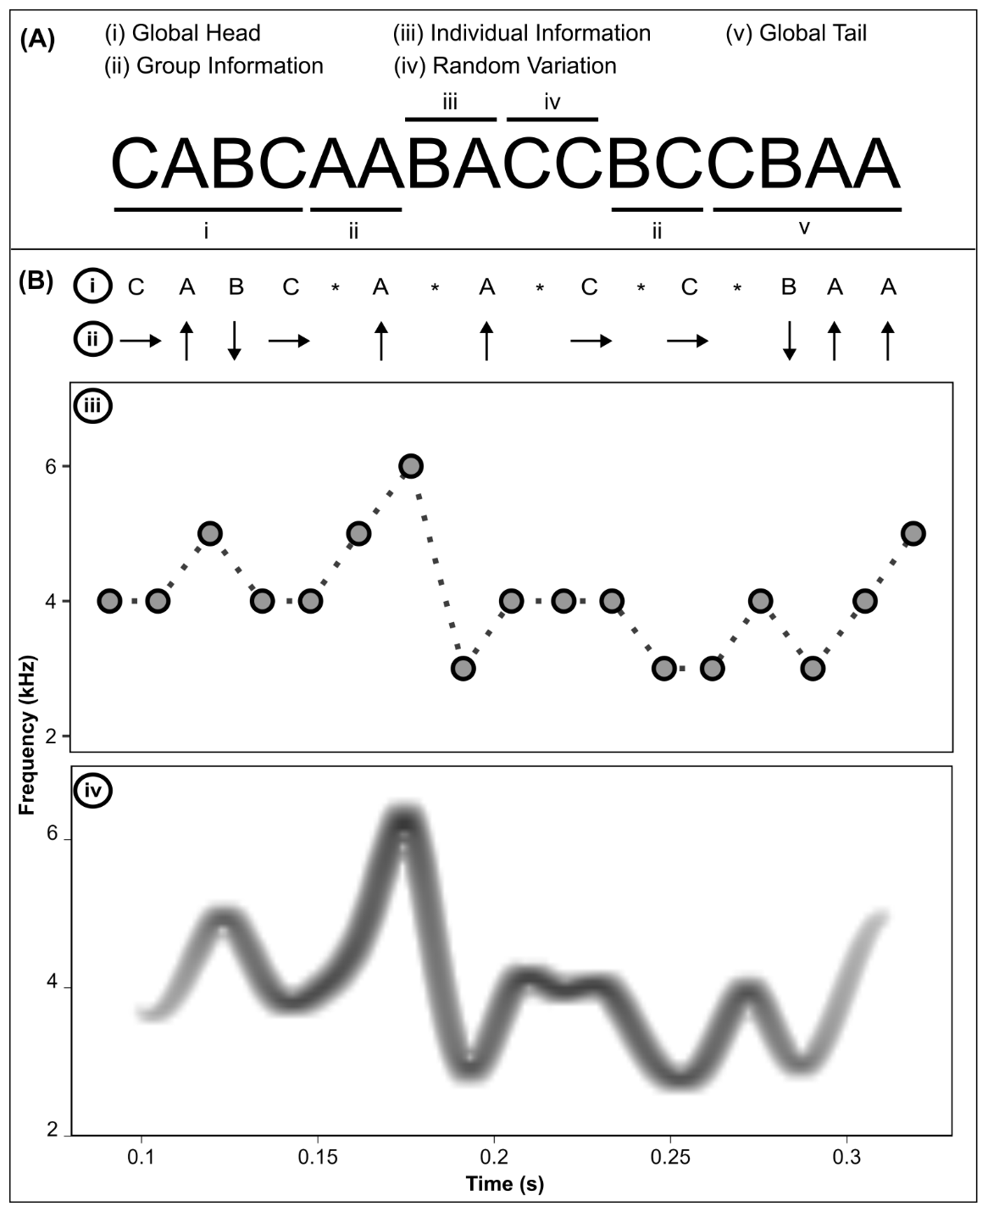
Fig 1: Panel A shows an example of a character string generated from our pipeline. Each position of the character string contains a trit of information (each position can contain the symbols A, B, or C). The string comprises four distinct sections. Sections (i) and (v) indicate the global head and tail, which bounds the structural variation (see Methods). Sections (ii) and (iii) indicate where group and individual identity information are encoded, respectively. Section (iv) represents random variation, which simulates within-individual variation. All sections are created by random generation in ways that to control how these sections are preserved or vary across classes and social levels in a dataset. Panel B depicts the steps of the sonification process. Character strings are generated in Step (i) and transformed into directional changes using Parsons code in Step (ii). The asterisks in Step (i) denote the start positions of separate sections, which were used to guide the generation of frequency timeseries (see Methods). In Step (iii), Parsons code is converted to a timeseries of frequency values used to guide the generation of frequency-modulated synthetic vocalizations with the R package soundgen. Step (iv) shows a spectrogram of an example audio file generated for the character string in Step (i).

We generated two datasets of tonal, frequency-modulated vocalizations as examples of the synthetic vocal identity signals that can be produced by our pipeline. First, we encoded twice the amount of group membership information in character strings compared to individual identity information (“group-specific” dataset) (Fig 2). Second, we reversed the amount of information encoding over social levels from the previous dataset, such that individual identity information outweighed group membership information by twofold (“individually distinctive” dataset) (Fig 3). To highlight the structural variation in frequency modulation patterns across social classes at either social level, as well as consistency within social classes, we created catalogues of spectrograms, or visual representations of the synthetic audio files, for a subsample of the synthetic vocalizations in either dataset (Fig 2A, Fig 3A). These call catalogues demonstrate sections of frequency modulation patterns that are shared within classes, and other sections that are distinct amongst classes. For instance, in the group-specific dataset, spectrograms for individuals in the same group share more structural similarity of frequency modulation patterns than individuals from two different groups (Fig 2A). In the individually distinctive dataset, vocalizations produced by the same simulated individual display frequency modulation patterns that are consistently different from other individuals in the same group (Fig 3A).

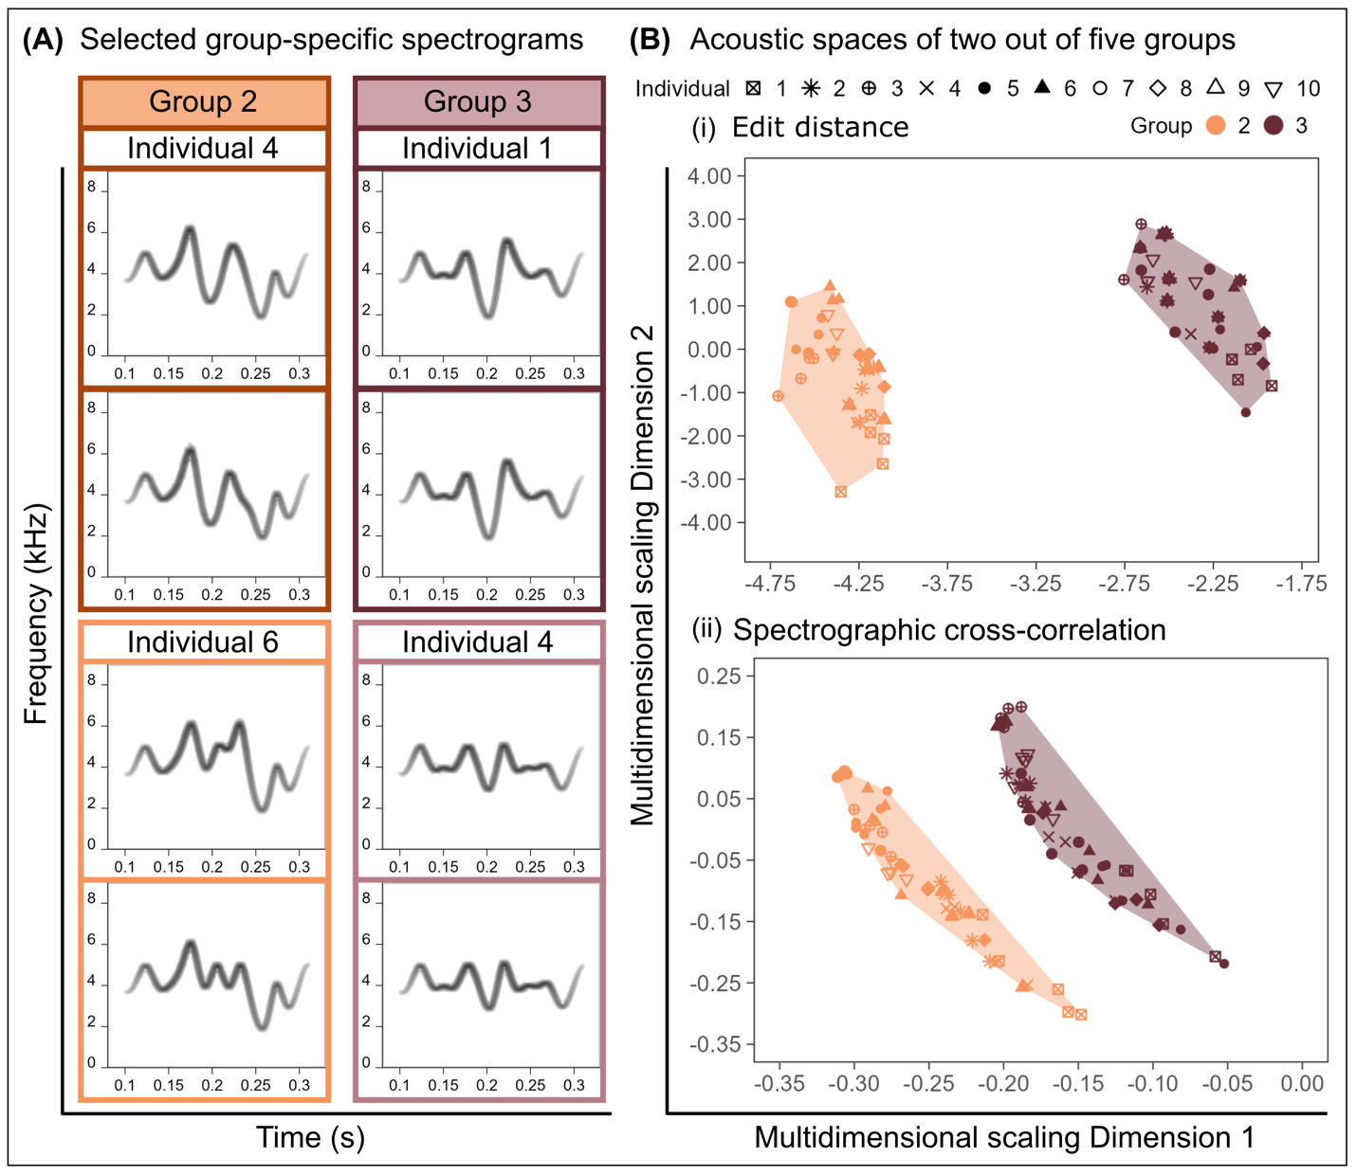
Fig 2: Here we show group-specific frequency modulation patterns and patterns of variation in acoustic space for selected synthetic vocalizations. Panel (A) displays two spectrograms per individual, with two individuals represented from each of Groups 2 and 3. Frequency modulation patterns are similar within groups and different between groups, reflecting how group information outweighed individual information in these vocalizations by a factor of two. Panel (B) displays acoustic space plots for all 10 individuals in each of Groups 2 and 3, and for each representation of the vocalizations (character strings and audio files). These plots were generated by applying multidimensional scaling to (i) edit distance (strings) or (ii) spectrographic cross-correlation (audio) matrices. In each acoustic space plot, individual identities are encoded by shapes per group, and group identities are highlighted in color, to match Group 2 in orange and Group 3 in brown in Panel A.

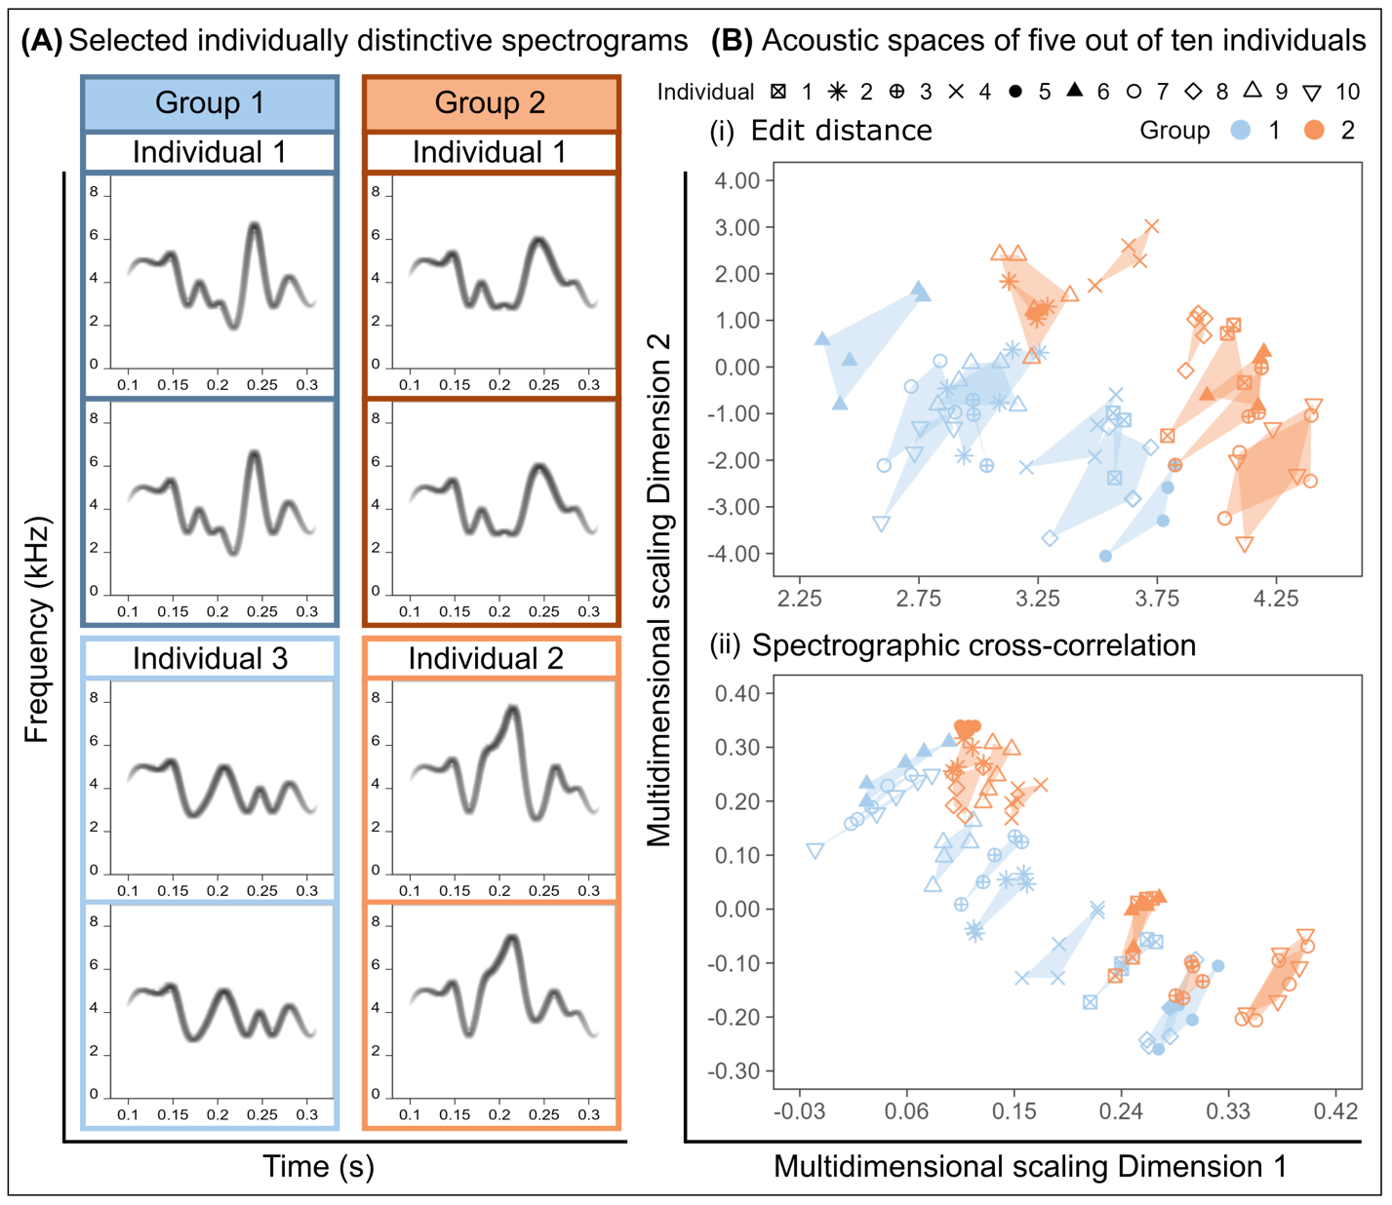
Fig 3: We show visualizations of individually distinctive frequency modulation patterns and patterns of variation in acoustic space for selected synthetic vocalizations. Panel (A) displays two spectrograms per individual, with two individuals represented from each of Groups 1 and 2. Frequency modulation patterns are similar when comparing vocalizations produced by the same individual, but these patterns differ when comparing vocalizations between individuals in the same group. Such structural variation reflects our encoding of twice as much individual to group information in these vocalizations. Panel (B) displays acoustic space plots for all 10 individuals in each of Groups 1 and 2, and for each representation of the vocalizations (character strings and audio files). These plots were generated by applying multidimensional scaling to (i) edit distance (strings) or (ii) spectrographic cross-correlation (audio) matrices. In each acoustic space plot, individual identities are encoded by shapes per group, and group identities are highlighted in color, to match Group 1 in blue and Group 2 in orange in Panel A. Note that Group 2 here is not the same as Group 2 in Fig 2, as these vocalizations represent a different dataset.

For each example dataset, we also visualized patterns of variation in low-dimensional trait spaces, hereafter “acoustic space”, by performing multidimensional scaling on the Levenshtein edit distance and spectrographic cross-correlation (SPCC) distance measurements. In these low-dimensional trait spaces, vocalizations that were structurally similar should be located closer together (shorter distances between two points) than vocalizations that were structurally different (longer distances between two points). We used these trait spaces representing structural variation amongst vocalizations represented as character strings (edit distance trait space) or audio files (SPCC) to facilitate our assessment of how the patterns of structural variation detected by an unsupervised machine learning tool recapitulated patterns of variation visible to the human eye.
For the group-specific dataset, we found that frequency modulation patterns were generally more visibly similar within groups compared to amongst groups. In addition, the convex hull polygons that encompassed the total area in acoustic space for each group did not fully overlap amongst all groups, indicating that many groups had group-specific signatures (Fig 2B). Indeed, the stochastic overlap that we identified amongst groups in the group-specific dataset was lower than what we observed in the individually distinctive dataset, in which group-level polygons overlapped nearly completely with one another, indicating very little distinctiveness amongst groups compared to the group-specific dataset (Figs S1A and S1C, and Figs S2A and S2C). We did identify evidence of stochastic similarity amongst groups, such that the convex hull polygons for some groups did overlap in each trait spaces (Figs S1 and S2). Overall, we identified similar patterns of similarity within groups and differentiation amongst groups in both the edit distance and SPCC acoustic space plots, suggesting that patterns of structural variation were similar between the character string and acoustic representations of the synthetic vocalizations.
When visualizing patterns of structural variation in the individually distinctive dataset, we found greater similarity of frequency modulation patterns within individuals compared to amongst individuals, even for individuals in the same group. Moreover, convex hull polygons outlining the area in acoustic space per individual were dispersed, rather than overlapping, and this pattern held in both the edit distance and SPCC acoustic space plots (Figs 3B and C). Such overlap amongst individual-level polygons matched our expectations that our generative process would yield stochastic similarity amongst individuals in the same and different groups (see Methods, Figs S1 and S2). The stochastic similarity that arose amongst individuals in the individually distinctive dataset was different than what we observed in the group-specific dataset, in which individual-level polygons overlapped nearly completely with one another within groups, indicating very little distinctiveness amongst individuals in the same group (Figs S1B and S1D, Figs S2B and S2D). Indeed, convex hull polygons for individuals’ acoustic spaces in the individually distinctive dataset were over-dispersed within groups (Figs S1D and S2D) compared to the group-specific dataset (Figs S1B and S2B).

Successful detection of identity information in synthetic vocalizations
We performed simulation experiments to assess how well we could detect identity information in synthetic vocalizations. These experiments were designed to manipulate parameters that we anticipated would influence the accuracy of identity information detection. We focused on manipulating the proportion of group and individual identity information encoded in vocalizations, or the complexity of identity information encoding, and the number of classes at each social level, or the density of the simulated signaling environment. We generated synthetic vocalizations over 4 treatments per manipulation, discussed in more detail in the Methods section, and ran 10 iterations per treatment combination. In each iteration, we measured the accuracy of information detection at either social level using unsupervised clustering. To summarize, we used the Levenshtein edit distance and spectrographic cross-correlation to measure distances amongst character strings or vocalizations, respectively. We then performed k-means clustering on multidimensional scaling features derived from these distance measurements and used a bipartite matching approach to compute the accuracies of how well predicted labels from clustering matched the original labels of classes at each social level. We used this analytical approach to calculate the accuracy of clustering synthetic vocalizations back to their original class labels (either group or individual identity) using edit distance or SPCC distance measurements. Overall, the accuracies of clustering back to original classes at the group and individual levels increased in concert with the amount of information encoded at the given social level (Fig 4). For example, when vocalizations contained all individual identity information and no group identity information, accuracy values at the individual level were higher compared to accuracies at the group level (Fig 4). Finally, patterns of variation in accuracy calculations were generally similar when detecting information in the audio files (SPCC) compared to the character strings (edit distance), indicating that our analytical pipelines were capable of accurately detecting identity information even after the sonification process.

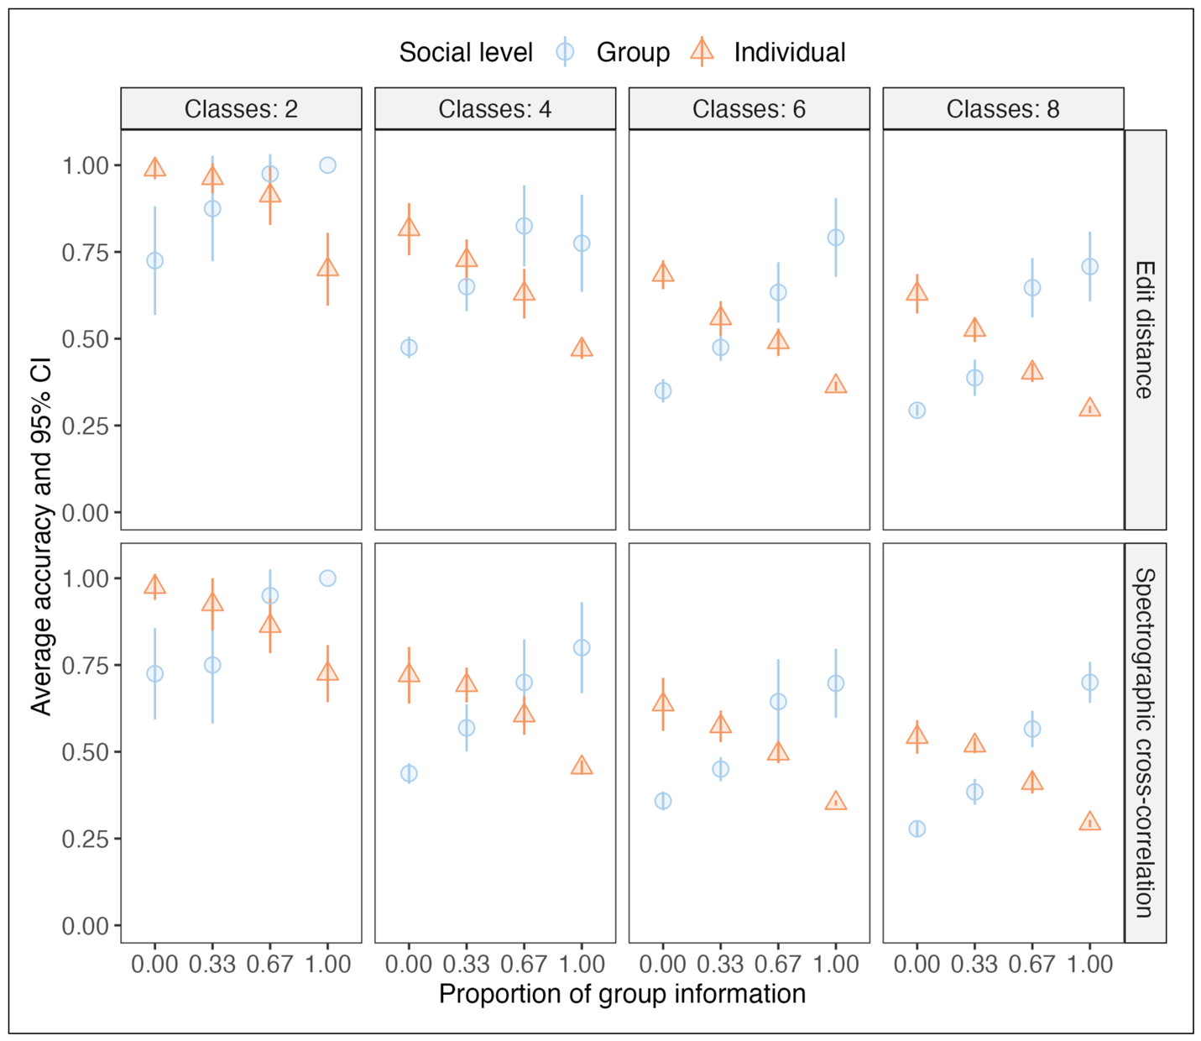
Fig 4: We identified the highest identity information detection accuracy when more information was encoded for the given social level, and when the number of classes at the given social level was low. Here we show accuracy values computed for the detection of identity information at two social levels (group and individual) over 16 combinations of two experimental treatments: (i) the complexity of identity information encoding, shown here as the proportion of group information (in which 0 indicates all individual and no group information), and (ii) varying density of the simulated signaling environment, shown here as the number of classes at each social level. We also show accuracy values computed for the character string (edit distance) and audio file (spectrographic cross-correlation, SPCC) representations of the synthetic vocalizations. Social levels are encoded in colors and shapes, such that the group-level results are shown in blue circles and individual-level results are shown in orange triangles. For group-level accuracy values, the symbol per treatment combination represents the maximum accuracy value obtained from bipartite matching. For individual-level accuracy values, the symbol for each treatment combination represents the mean of the maximum accuracy values obtained across groups. The bars around each symbol are the 95% confidence intervals.

Next, we assessed the statistical significance of information detection across social levels in both representations of the synthetic vocalizations. We calculated Cliff’s delta as the effect size between clustering accuracies at each social level. We used effect sizes to quantify comparisons because accuracy values alone, even when compared between social levels, should only be used for qualitative comparisons within a given set of experimental parameters. In addition, accuracy values are only meaningful with respect to random chance levels for a given dataset and therefore should be used to gain insights into the statistical significance of identity information detection across experimental treatments. We expected statistically significant detection of information at either social level (e.g. larger absolute effect sizes with 95% CIs that did not include zero) when information encoding was higher for one social level than the other. We also expected to identify high significance of information detection when signals were compared amongst fewer individuals or groups, as we expected that the uniqueness of identity information at either social level would decrease as the number of classes increased at either social level (see Methods). As we knew which social level contained more information than the other, effect size calculations allowed us to directly address whether we significantly detected the social level at which we had originally encoded more identity information. We calculated effect sizes between group-level and individual-level accuracies for each combination of the four information encoding treatments and four signaling environment treatments (Fig 5, Table S1). We used the group-level accuracy scores as our comparison group, such that a positive effect size value indicated that group-level information was detected with higher accuracy than individual-level information.

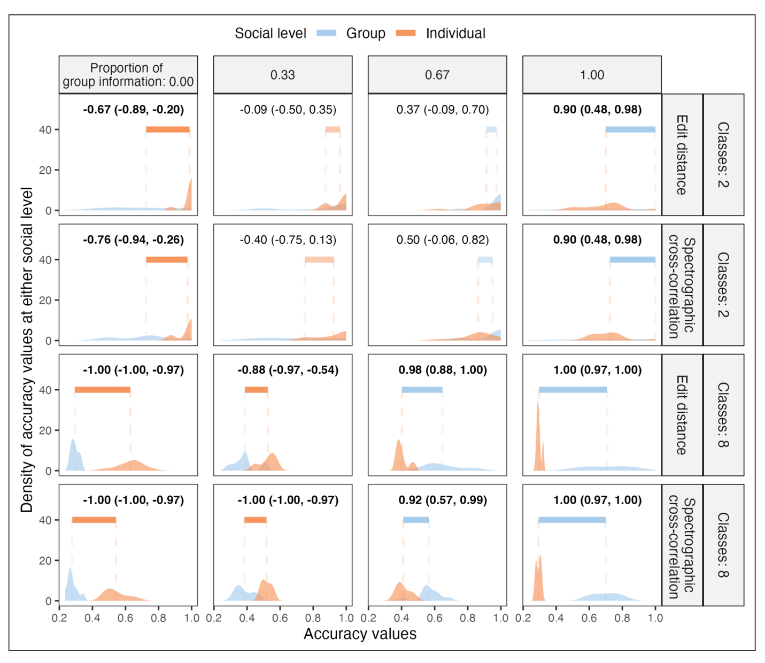
Fig 5: We identified the largest and statistically significant effect sizes when identity information encoding was higher at one social level than another, even as the number of classes increased at each social level. Here we show density curves that represent the distribution of accuracy values computed at the group level (blue) and the individual level (orange). These density curves are plotted across all 4 treatments of the proportion of group information encoded in vocalizations, as well as analyses with the character string (edit distance) and audio file (spectrographic cross-correlation, SPCC) representations of vocalizations. We show results only for the smallest (2) and largest (8) number of classes per social level. See Table S1 for all effect size results across experimental treatments. In each panel, the dashed vertical lines represent the mean accuracy value per distribution. The horizontal bars between the dashed lines of each pair of distributions represent the difference in means between distributions. The width of these horizontal bars reflects the magnitude of the effect size calculations, such that wider bars represent larger effect sizes. Effect size calculations and 95% confidence intervals are shown in text per panel. Large effect sizes are highlighted in bold, with darker horizontal bars. Across panels, the color of each bar represents the direction of the effect size, such that blue bars represent cases when we identified significantly higher accuracy values at the group than the individual level.

For the character string representations of vocalizations (edit distance measurements), we found large effect sizes between the detection accuracy of group- and individual-level information when information was encoded at one social level only (the respective extremes of the information proportion treatments, Fig 5 and Table 1). These results were generally recapitulated when analyzing the synthetic vocalizations as audio files with SPCC (Fig 5, Table 1). For both representations of the vocalizations, we identified smaller effect sizes and wider confidence intervals associated with information detection when synthetic vocalizations contained identity information at both social levels (Fig 5, Table 1). For some experimental treatment combinations, the 95% confidence intervals of the effect sizes included zero, indicating a lack of statistical significance of greater accuracy of information detection at one social level compared to the other.

Discussion
The social learning of identity information encoding in vocal signals may help animals navigate complex social environments. However, when applying computational tools to detect patterns of identity information encoding in empirical datasets of animal vocalizations, our ability to evaluate the robustness of our inferences is limited by a lack of a priori knowledge about the true types and amounts of identity information that animals are transmitting through their vocalizations. This challenge is compounded when identity information is encoded across social levels, which may be a common outcome of social learning of vocalizations in multi-level societies (10,26). To address these challenges, we built a pipeline to generate synthetic vocal identity signals through the sonification of character strings, then performed simulation experiments to test how well a computational bioacoustics tool could detect the identity information that we originally encoded. We found that we could significantly detect the social level at which we had originally encoded the greatest amount of identity information. This result held across our analyses of both the character string and audio representations of the synthetic vocal identity signals, as well as increasing density of the simulated signaling environment, although information detection was more difficult when identity information was encoded over both social levels. Below we discuss how our pipeline can be used more broadly to generate synthetic vocalizations that represent vocal identity signals, in which identity information is encoded in frequency modulation patterns, which are biologically relevant acoustic structures that animals can use for social recognition (5,27). Our simulation experiments show that a computational tool widely used in bioacoustics can successfully detect which social level contains the greatest amount of identity information in synthetic vocal datasets.
The new pipeline we present here yields synthetic vocalizations in which we can control the amount of identity information encoded across two social levels through the sonification of character strings. Our software for generating synthetic vocal identity signals is available as an R package (paRsynth) on GitHub (https://github.com/gsvidaurre/paRsynth), and relies on the existing R package soundgen (25). This sonification pipeline begins with the random generation of character strings composed of sections that are shared or different between classes at the group and individual levels. We can also control how much information is encoded at one social level relative to another. For instance, to generate individually distinctive vocalizations, we can randomly create string sections that are the same for all calls produced by the same individual, but which vary between individuals within a group, and which are also longer than string sections produced at the group level. Next, to transform character strings representing vocal identity signals into audio files, we use a musical notation called Parsons code to map unique characters across strings onto directional changes. Parsons code has been used to decode individual identity information in dolphin whistles (23), and our approach represents a new application of Parsons code to encode identity information in frequency modulation patterns. Upon converting Parsons code to a vector of frequency values, we supply the frequency timeseries to the soundgen package (25) to generate synthetic vocalizations with identity information encoded over social levels in frequency modulation patterns. A second version of our pipeline is in development and will include the flexibility to vary the positions of group and individual information along the length of the resulting character strings, as well as random variation. Further, the second version of this package, currently in development, extends the complexity of Parsons base encoding and the resulting frequency modulation patterns.
The character string sonification pipeline we present here is a new tool for studying information encoding in animal vocalizations, and a practical solution for producing biologically relevant datasets of synthetic vocal identity signals to overcome limitations posed by naturalistic data collection. Synthetic vocalizations have been successfully leveraged to disseminate new computational bioacoustics pipelines (28), and to validate biological inferences returned by such pipelines, including testing which analytical tools best quantify complexity in animal vocal sequences (29) and validating new methods for calculating and quantifying acoustic structure (28,30). In addition, several existing tools allow researchers to create synthetic vocalizations and vocal sequences, including the seewave, warbleR, and soundgen R packages (25,31,32). An underused function of these tools in animal communication research is that they provide researchers with the ability to manipulate information in synthetic vocalizations to specifically study the types of information encoded in a signal, how much information is encoded, and where such information is encoded, and how well such patterns of information encoding can be detected with different analytical tools. For instance, the soundgen package facilitates diverse types of information encoding that have been used to understand dynamic information encoding in formant structures produced during human speech (33). Our tool complements these existing tools by providing a solution for encoding identity information across social levels in frequency modulation patterns, which are one acoustic feature widely considered to be modified by vocal production learning in ways that can facilitate identity information encoding (22). In addition, by controlling information encoding in frequency modulation patterns, the synthetic vocal identity signals resulting from our package can be used in empirical experiments addressing questions about animal social recognition. Indeed, synthetic vocalizations and manipulations of acoustic structures in such synthetic signals have been used to make discoveries about the identity information in vocal signals that receivers use for social recognition (27,34).
Following the development of our new tool, we applied it in simulation experiments to test how well a widely used computational method in bioacoustics, SPCC, could detect the identity information encoded in datasets of synthetic vocalizations. Applications of information theory to animal communication systems have shown that in social environments with more classes at each social level, signal distinctiveness is harder to maintain, since the number of unique possible signals is bounded (24,35,36). Our simulation experiments revealed that it was difficult to significantly detect identity information when signal sets were large, which represented crowded signaling environments at each social level. We had originally anticipated that information detection accuracy would be lower with increasing sizes of signal datasets across social levels. As we had expected, we identified significantly higher accuracy of identity information detection when we analyzed character strings using the edit distance and audio files using SPCC in signal sets with fewer classes at each social level. When generating larger signal sets, we anticipated that we would be more likely to generate vocalizations that would be stochastically similar (less distinctive) at either social level. In particular, our generative process for creating character strings at the beginning of our pipeline is a random sampling process, which alone cannot address the evolution or creation of sets of completely unique identity information, since there is no process selecting for the distinctiveness of information amongst classes at a given social level. In other words, we expected stochastic similarity in identity information amongst classes, but especially with increasing class sizes at the group and individual levels. This is evidenced in acoustic space plots of our example datasets, which showed stochastic overlap amongst groups for the group-specific dataset, and stochastic overlap amongst individuals within groups for the individually distinctive dataset (Figs S1 and S2). Such stochasticity in the uniqueness of identity information simulates sampling animal vocalizations in the wild. We do not always have complete information about what information is important to communicate, nor about animals’ social connections, which makes it challenging to know a priori which types of information are encoded in greater amounts and whether information is encoded across more than one social level, but also which groups or individuals interact directly, and therefore experience pressure to sound similar to or distinctive from one another.
Our simulation experiments also revealed that it was more difficult to significantly detect identity information under complex information encoding conditions, when both group and individual identity information were encoded in the same signal. When analyzing such vocalizations, we found that the direction of effect sizes followed the social level at which we had originally encoded the most information, and this result held when analyzing both the character string and audio representations of vocalizations. However, these results were not always significant, as the 95% CIs for effect sizes sometimes crossed zero. Moreover, our analytical approach only allowed us to infer which social level displayed the greatest accuracy of identity information detection. Future work could use different inferential statistical tools to detect the magnitude of identity information encoding across social levels. Finally, we also identified lower information detection accuracy at the group level when analyzing synthetic audio files (post-sonification) compared to the original character strings (pre-sonification), which may arise from our approach to encode random variation at the individual level to simulate within-individual variation, as well as our approach to divide group information into two positions in each character string. We are currently developing a second version of the paRsynth package that will facilitate more flexibility in the placement of random variation and identity information in the original character strings.
In summary, here we highlighted a new pipeline to generate synthetic vocal identity signals through the sonification of character strings with controlled identity information encoding over two social levels in frequency modulation patterns, an acoustic structure that animals use for encoding identity information and social recognition (5,27). We demonstrated a simulation-focused application of how our pipeline facilitates testing the robustness of biological inferences about vocal identity information encoding. Overall, our package facilitates generating synthetic vocal identity signals that can be represented as character strings for the computational efficiency that is necessary for simulation-based research, while also producing audio files that can be analyzed with bioacoustics tools or used as stimuli in empirical experiments with animals. Our new sonification pipeline is available as an R package (paRsynth, 36) and can benefit future research that requires controlling the types and amounts of identity information encoded in synthetic vocalizations.

Materials and Methods:
A new character string sonification pipeline to generate vocal identity signals
We developed a new pipeline to encode varying amounts of group and individual-level information in frequency modulation patterns of synthetic vocalizations. Our pipeline encompassed 4 main steps: (1) generating character strings with information encoded at different social levels, (2) converting character strings to directional changes with Parsons code, (3) creating a timeseries of frequency values from these directional changes, and (4) generating audio files of frequency-modulated vocalizations. We developed functions for each of these steps in R (38), and organized these functions into an R package called paRsynth that is available on GitHub: https://github.com/gsvidaurre/paRsynth. Our package relies on the existing R package soundgen (25) for generating audio files of synthetic frequency-modulated vocalizations. Below we describe each of the steps in our pipeline available through the paRsynth package.
First, we generated character strings to represent synthetic vocal identity signals. Each character string was composed of 6 randomly generated sections with a fixed order (Fig 1): a global head, the first half of group identity information, individual identity information, random variation, the second half of group identity information, and a global tail. Across strings, we used the first three letters of the English alphabet (A, B, and C), such that each position along each string contained a randomly selected letter. The global strings were randomly selected by dataset, such that each string in a dataset shared the same global head and tail. These global strings facilitated bounding the structural variation in our synthetic datasets, such that we could generate datasets representing variation within a vocalization type in a vocal repertoire, rather than the broader structural variation that can be more commonly observed amongst vocalization types in a species repertoire (28). We randomly selected group identity information strings amongst groups in a dataset, and individual identity information strings amongst individuals within each group. We added random variation to simulate variation within an individual, such that repeated vocalization exemplars assigned to the same individual could be considered unique rather than duplicated vocal structures. In the first version of our pipeline, it is possible to vary the length of strings, including the overall string length and the length of each composite string, as well as the size of the vocal datasets (number of groups, individuals per group, and vocalizations per individual).
The second step of our pipeline was to use Parsons code, a musical notation used to summarize variation in directional changes that could then be transformed into frequency modulation patterns in an acoustic signal (23). Here we used 1-Parsons encoding, which represents relative changes in frequency at specific positions as an information “trit” by noting the direction of frequency change (up, down, or constant) from the previous position. This process is repeated at regularly spaced intervals along the duration of the original signal. Parsons code is often used in the study of music (39), however researchers have used Parsons code to decode individual identity information in frequency-modulated dolphin whistles, including more complex Parsons base encoding beyond 1-Parsons (23). Here, we used 1-Parsons encoding to encode information, such that each unique character per string mapped onto a directional change in frequency. We converted instances of “A” to “up”, “B” to “down”, and C to “constant”.
Once we converted character strings to Parsons code, our third step was to use the Parsons code sequence to generate a timeseries of frequency values. We selected a fixed value of 4 kHz to serve as the starting frequency value, then we created a timeseries of frequency values in which subsequent values shifted up or down in frequency by 1 kHz or remained constant with respect to the value that came before. For example, when a synthetic vocalization started at 4 kHz and the first Parson’s code value was “up”, then the next frequency value in the timeseries would be 5 kHz. However, if the first Parson’s code was “constant”, then the second frequency value would be 4 kHz. In this step of our pipeline, it is possible to vary the starting frequency value as well as the frequency shift parameter. Our package also includes two options for generating frequency timeseries. The first and default option generates frequency values as a continuous trajectory, and this approach can yield less bounded structural variation of signals in the same dataset that is more similar to the high degree of structural variation that can observed across types of vocalizations in a species’ repertoire (see above). The second option resets frequency values back to the starting frequency at the start of each section of the original string, such that the direction of the frequency shift will be calculated relative to the starting frequency rather than the frequency value at the last position of the previous section. We chose this second option because in preliminary work, we found that creating strings as continuous trajectories created more unbounded structural variation that washed out visible evidence of group and individual-level signatures in acoustic space. These high levels of variation did not match the more bounded structural variation associated with the encoding of identity information within the same vocalization type that we wanted to simulate. Therefore, we used the starting frequency option to generate all example and simulated datasets with levels of structural variation that were more representative of identity information encoding within the same type of vocalization across individuals and groups.
The fourth and final step in our pipeline was to use the frequency timeseries as “anchors” to guide the generation of frequency modulation patterns in synthetic vocalizations with the soundgen R package version 2.7.1 (25). Here, we developed a function that relies on the soundgen() function from the soundgen package to generate synthetic audio files with customized names. We also focused on a particular subset of arguments to control sound generation in ways that helped us create frequency-modulated vocal identity signals with soundgen. First, we used the frequency timeseries as the input to the pitch argument so that soundgen would use these values as anchors to guide frequency modulation. In this version of our pipeline, we do not specify timestamps for each frequency value in the timeseries. By default, soundgen version 2.7.1 considered frequency values to be evenly split across the duration of each audio file, which we specified using the argument sylLen (200 ms). We controlled the pitch and audio file sampling rates using the arguments pitchSamplingRate and samplingRate (both set to 44,100 Hz), respectively. We also specified the lowest and highest frequency values with pitchFloor (1 Hz, the default value in soundgen) and pitchCeiling (one half of the sampling rate, following the Nyquist rule). To generate smoother frequency modulation patterns that better approximated animal vocalizations, we used Loess or local polynomial regression interpolation with a “strong” amount of smoothing (span of 1). We turned off options for transitions between frequency anchors that were too close together (discontThresh and jumpThresh), since we were using evenly spaced anchors. We also allowed for up to 5 harmonics in synthetic vocalizations by setting 5 default amplitude values to the argument rolloffExact. For our purposes in the current work, we wanted to encode identity information in frequency modulation patterns only, so we turned off formant generation specific to different vocal tract lengths by specifying a single amplitude value (0.25) to rolloffExact, to produce a fundamental frequency contour without any harmonics, and using the default values of NA for the formants and vocalTract arguments. We also used the default value of 0.025 for soundgen’s hyperparameter for varying stochasticity in sound generation. In preliminary analyses, we found that retaining this stochasticity in sound generation was important to avoid creating duplicated audio files for different vocalizations, which can occur when the same random variation string is sampled within an individual. In other words, using soundgen’s stochasticity in sound generation facilitates generating different audio files for different vocalizations attributed to the same individual, even when the character string is exactly the same. We used 300 ms, the default value in soundgen, to specify the minimum signal epoch duration for formant locking or static subharmonics, in the case that formants were turned on. We set the vibrato frequency in Hz to 1, which was lower than the default of 5, to minimize the amount of regular pitch modulation across each vocalization. We wrote our function so that these arguments can be updated with the range of possible values specified by soundgen. With minimal code development by others, it is possible to add other soundgen arguments for greater flexibility. The synthetic vocalizations produced using these original arguments from the soundgen package were written out as audio files in .wav format that could then be used in downstream bioacoustics analyses. Our choices of default starting frequency and frequency steps generated synthetic vocalizations below the ultrasonic range and within the frequency range of human hearing, similar to the frequency ranges of avian vocalizations.

Example datasets with identity information encoded over two social levels
We created two example datasets to highlight the pipeline described above: (1) more group membership information than individual identity information (the group-specific dataset), and (2) more individual identity than group membership information (the individually distinctive dataset). Across both datasets, we used an overall string length of 16 characters, in which we allocated 4 characters each to the global head and tail sections, and 2 characters to random variation to simulate variation within an individual. Over the remaining 6 characters, we assigned 4 characters to group information and 2 to individual information to create the group-specific dataset and then reversed these numbers to create the individually distinctive dataset (2 characters for group information, and 4 for individual information). We controlled the size of the resulting signal datasets such that each dataset contained 5 groups, 10 individuals per group, and 5 calls per individual, for a total of 250 strings per dataset.
Although our pipeline facilitated controlling the amount of information encoded at both the group and individual levels, we expected that the uniqueness of identity information would be influenced by the generative process that we used to create group and individual information. As we randomly selected character strings to represent information at either social level, we did not expect that group or individual information would be fully unique amongst groups or individuals, respectively, across a given dataset. Instead, identity information could be stochastically similar amongst classes at either social level and the likelihood of such stochastic similarity would increase with the number of classes at the given social level. For instance, as the number of groups increased in a dataset, so should the likelihood that group information was shared or very similar amongst one or more groups, leading to lower distinctiveness amongst groups even when we encoded large amounts of group information. For example, in the group-specific dataset, unique strings comprised 63% of the dataset.
To sonify the 500 strings across both datasets, we used 1-Parsons encoding, a starting frequency value of 4 kHz, and frequency shifts of 1 kHz to create timeseries of frequency values for each original string. When creating these trajectories, we used the option to restart frequency values at the starting frequency value at the start of each section of the string. To create synthetic vocalizations, we used the soundgen to create an audio file for each original string, with 200 ms duration, audio file and pitch sampling rates of 44.1 kHz, a single frequency contour, the default soundgen stochasticity in sound generation (temperature of 0.025), and all other default settings used in this step of our pipeline (see above). The resulting synthetic datasets were tonal, frequency-modulated vocalizations that simulated non-harmonic avian vocalizations. We then used an analytical pipeline described below to assess patterns of variation across the group and individual levels of both example datasets.
To highlight how we used our pipeline to encode identity information over two social levels in frequency-modulated vocalizations, we generated spectrograms from audio files, as well as low-dimensional trait spaces, or acoustic space plots, for the string and audio representations of the example datasets. We used the warbleR package version 1.1.29 (32) to generate spectrograms for initial visual checks, and then we used the seewave package version 2.2.3 (31) to build final spectrograms for visual interpretation with a window length of 512 samples, an overlap between consecutive windows of 90%, and a Hanning window. We also used functions from the tuneR package version 1.4.7 (40) to facilitate creating spectrograms and extracting metadata from audio files. We also used the R package magick version 2.8.6 to add colored borders around the final versions of spectrograms (41).
We generated low-dimensional trait spaces, or acoustic space plots, to visualize patterns of variation over the group and individual levels in each example dataset and each representation of the vocalizations. We performed these analyses in R version 4.4.1 or 4.4.2 (38) and relied on tools from the tidyverse version 2.0.0 (42) for data manipulation and visualization. Unless otherwise specified, we used these same tools for all downstream data manipulation and visualization as well. We computed the Levenshtein edit distance (with a penalty of 1 each for deletion, insertion, and substitution, but ignoring penalties for transpositions) amongst all strings across datasets using the stringdist package version 0.9.12 or 0.9.15 (43). We also measured acoustic similarity with spectrographic cross-correlation (SPCC) amongst all audio files across datasets with the warbleR package (32,44), using a window length of 512 samples, an overlap between consecutive windows of 90%, a Hanning window, a bandpass filter of 0 to 7.5 kHz (0.5 kHz above the maximum frequency value across all of the frequency timeseries), and Pearson’s correlation statistic. We checked the similarity values produced by SPCC for negative values that can occur when comparing very structurally different or less stereotyped vocalizations (as we found in preliminary work, see above), as well as values of 1 off of the diagonal that can arise when synthetic vocalizations represent the exact same acoustic structures (this can occur when turning off the parameter controlling stochasticity in sound generation through soundgen). We did not identify negative SPCC values or values of 1 off of the diagonal for our example datasets. However, the edit distance calculations sometimes yielded values of zero off of the diagonal, as we expected, given the string duplications that arose from our random generation process. To treat duplicated strings produced within or amongst individuals as unique string structures for our downstream analyses, we replaced these values of zero with 1/10th of the minimum non-zero value in the edit distance matrix, or 0.1, as the minimum non-zero value produced by the edit distance was always 1 (see information on validation below).
By calculating the edit distance and SPCC similarity on all vocalizations across our two example datasets, we could interpret our subsequent analyses and visualizations of variation in a universal trait space per measurement method. In other words, all acoustic space plots produced for each distance measurement method can be interpreted as a single universal space, such that these plots represent one universal space for character strings with the edit distance, and another universal space for synthetic vocalizations with SPCC. We produced acoustic spaces from the edit distance and SPCC matrices by performing multidimensional scaling with the MASS package version (45) 7.3-58.4 with 1000 maximum iterations to yield an optimal low-dimensional solution with 15 dimensions. We used 15 dimensions to reduce the stress of the resulting optimal solution to 5% or less (46). We performed multidimensional scaling on both the edit distance and SPCC matrices to visualize patterns of variation for each representation of the synthetic vocalizations (character strings and audio files, respectively). To perform multidimensional scaling with the SPCC matrix, we first subtracted this matrix from 1 to yield distance values. We used the first two dimensions of each “optimal” multidimensional scaling solution to generate acoustic space visualizations. In each of these acoustic space plots, vocalizations that are structurally similar are closer together or concentrated in space, while those that are structurally different are farther apart, or over-dispersed. Finally, we generated acoustic space plots for character strings and vocalizations with convex hull polygons outlining the area encompassed in acoustic space by the social level at which we had originally encoded the most information (Figs 2 and 3), as well as both social levels (Supplementary Figs 1 and 2), to facilitate ease of comparisons of the patterns of concentration of points (or overlap amongst polygons), as well as overdispersion amongst points and polygons, given our original expectations. We expected to identify patterns of concentrated points within groups and overdispersion amongst groups for the group-specific dataset. For the individually distinctive dataset, we expected to find overdispersion within groups, but not amongst groups, when individuals displayed more distinctive information.

Simulation experiments to assess the accuracy of information detection
To assess how well we could detect identity information in the synthetic vocal identity signals, we performed simulation experiments over varying proportions of identity information encoded at the individual and group levels, as well as over varying sizes of signal datasets, or the number of classes at each social level. We designed our simulation experiments to manipulate the relative proportions of information encoding and signal dataset sizes because we expected both parameters to impact our detection of identity information in the synthetic vocalizations using a traditional computational tool in bioacoustics. We expected the highest accuracies of information detection at the social level at which we had originally encoded more information, and we also expected it would be more difficult to detect information with high accuracy when we had originally encoded information at both the group and individual levels. In our experiments, we varied the relative proportions of group to individual information encoded in each string over four treatments: (1) 0 (representing all individual information and no group information), (2) 1/3 (more individual than group information), (3) 2/3 (more group than individual information), and (4) 1 (all group and no individual information). We used a total length of 6 characters in the overall character string for encoding information at one or both social levels, for the following 4 treatments: (1) 6 characters devoted to individual information (no group information), (2) 4 characters for individual and 2 characters for group information, (3) 2 characters for individual and 4 characters for group information, or (4) 6 characters devoted to group information (no individual information).
We also expected that the sizes of the signal datasets that we generated would impact our information detection accuracy, as the likelihood of generating stochastically similar vocalizations should increase with the size of a given dataset. In other words, we anticipated that it would be more difficult to randomly generate completely unique group-level or individual-level vocal signatures with increasing numbers of classes at each social level. Indeed, given our information encoding approach with information trits in character strings, the greatest number of unique signatures we could create at one social level with identity information encoding was 3⁶ or 729 unique signatures, and 3⁴ or 81 unique signatures when encoding both group and individual-level information (24). Our manipulation of the number of classes at either social level, or the size of the resulting signal datasets, was therefore a proxy for the crowdedness of the signaling environment, such that it should be harder to create distinctive identity signatures when interacting with increasing numbers of individuals (24). We varied the number of classes and vocalizations produced per class at each social level over four experimental treatments: 2, 4, 6 or 8 classes. Within a treatment, we used a constant number of classes and vocalizations assigned to each social level. For instance, in the 8-class treatment, the resulting signal datasets were composed of 8 groups, 8 individuals per group, and 8 vocalizations per individual. In downstream analyses, we used all exemplars of vocalizations per individual, but for group-level analyses, we randomly selected 1 vocalization per individual in each group to use the same number of vocalizations across analyses at each social level.
We ran our simulation experiments over 16 total treatment combinations and 10 iterations per treatment. We analyzed each of the resulting 160 datasets of synthetic vocalizations to test how well we could detect the information that we had originally encoded in character strings at one or both social levels. We used the same pipeline described above to generate datasets of synthetic vocalizations under each treatment combination. Then we analyzed both the character string and audio representations of the vocalizations per treatment combination. Our results generated using the character strings served as a baseline or internal validation for our ability to detect identity information in the audio files of the synthetic vocalizations using a traditional bioacoustics tool (SPCC).
We used a similar computational approach for analyzing synthetic datasets produced during our simulation experiments as for the example datasets described above. We measured distances amongst the datasets of strings and audio files with the edit distance or SPCC, respectively, and then performed multidimensional scaling to generate features. We checked values of the SPCC matrices for negative values or values of 1 off of the diagonal. We did not find either issue in any of the SPCC matrices across iterations of our treatment combinations. Unlike our analyses of the example datasets, we did not generate acoustic space visualizations after performing multidimensional scaling but rather proceeded with a quantitative pipeline that relied on unsupervised clustering and inferential statistical tools to test our accuracy and statistical significance of information detection.
As described above for our analysis of the example datasets, edit distance calculations sometimes yielded values of zero off of the diagonal, as we had anticipated. We replaced these values of zero with 0.1 and performed validation of this decision against replacement with a value of 1 using the same analytical pipeline described below. Overall, we found that using a value of 0.1 to replace values of zero off of the diagonal of the edit distance matrix led to higher accuracy of identity information detection compared to replacement with a value of 1. Also, in preliminary analyses we sometimes produced SPCC matrices with negative values that represented comparisons of vocalizations that were very structurally different (using the option to generate frequency timeseries as a continuous trajectory). We included code in our simulation experiments to replace these negative values with the minimum positive non-zero value in the SPCC matrix, as multidimensional scaling requires positive sign values. We also added code to change values of 1 off of the diagonal to the second largest similarity value in the given SPCC matrix, although later we found that changing the hyperparameter for stochasticity in soundgen audio file generation fixed these issues. The final version of our simulation experiment code tracks all of these modifications in the results of our simulation experiments, so there is a record of the number of cells in each matrix that were found to be problematic, and the values we used to modify these cells. However, in our final experimental results, we did not find any of the issues listed above across our SPCC matrices.
In each iteration of our experiment, we applied multidimensional scaling to the edit and SPCC distance matrices as described above for the example datasets, although with minor changes. We used 2 total dimensions when the number of classes was 2, and 10 dimensions for all other classes (4, 6, 8). We chose this number of dimensions given constraints posed by the size of the dataset, but also to increase computational efficiency with increasing numbers of classes. Following multidimensional scaling, we performed k-means clustering on the edit distance or SPCC features. We used the k-means implementation from the stats package version 4.3.0 (38) with the Hartigan and Wong algorithm (47) with 10 iterations maximum, and we set the number of centers to the number of true classes at the given social level (e.g. 4 centers for 4 original groups). We performed k-means clustering at each social level to yield predicted cluster labels that we could compare to original class labels and compute the accuracy of information detection at each social level. At the group level, we randomly selected 1 vocalization per individual within a group to maintain symmetry in sample sizes used in clustering between social levels. At the individual level, we performed clustering of individuals’ vocalizations within a group for each group in the given dataset. We then used a bipartite matching approach to calculate the accuracy with which predicted labels matched original class labels. This bipartite matching approach entailed computing the accuracy values across all possible mappings between unique cluster labels (the predicted labels) and class labels (the original labels). We then obtained the maximum accuracy score across all possible accuracy values at each social level. For individual-level calculations, we averaged these accuracy calculations across groups. We generally expected to find higher clustering accuracy back to original class labels at the social level that we used to originally encode the most identity information in the synthetic vocalizations. We also expected to identify clustering accuracies that were generally lower for spectrographic cross-correlation than the edit distance, since spectrographic cross-correlation was performed on strings transformed into synthetic audio files, which may have led to losses of the original information or added noise.
Finally, we calculated the effect sizes of clustering accuracies between social levels for each measurement method (edit distance or SPCC) and experimental treatment combination (information encoding and the number of classes at each social level). We used effect sizes as an approach to quantify the statistical significance of our accuracy of information detection for the social level at which we had encoded the most information. Effect size calculations were a more direct way of addressing our ability to accurately detect the social level for which we had originally encoded more identity information. Direct comparisons of accuracy values between social levels, amongst experimental treatments, and between measurement methods were useful for qualitative interpretations of our ability to accurately detect identity information. However, direct comparisons of the accuracy values for statistical inference can be misleading, because they only hold meaning with respect to random chance levels given the size of each dataset, which changed across our experimental treatments. We used Cliff’s delta for our effect size calculations with the effsize package version 0.8.1 (48) because our accuracy values were not normally distributed. For each measurement method and treatment combination, we calculated Cliff’s delta and a 95% CI across experimental iterations. We used the group-level accuracy scores as our baseline group. Positive effect sizes indicated that we detected group-level information with more accuracy than individual-level information. Some Cliff’s delta calculations have 95% CIs were very small because the distributions of the accuracy scores were highly or fully disjointed (e.g. displayed little or no overlap) between social levels. We labeled effect size values as large, medium, or small using established rules-of-thumb for effect size interpretations (49).

References
1. Carouso-Peck S, Goldstein MH, Fitch WT. The many functions of vocal learning. Philos Trans R Soc B Biol Sci. 2021;376(1836):20200235.
2. Nowicki S, Searcy WA. The evolution of vocal learning. Curr Opin Neurobiol. 2014;28:48–53.
3. Sewall KB, Young AM, Wright TF. Social calls provide novel insights into the evolution of vocal learning. Anim Behav. 2016;120:163–72.
4. Wright TF, Derryberry EP. Defining the multidimensional phenotype: New opportunities to integrate the behavioral ecology and behavioral neuroscience of vocal learning. Neurosci Biobehav Rev. 2021;125:328–38.
5. Berg KS, Delgado S, Okawa R, Beissinger SR, Bradbury JW. Contact calls are used for individual mate recognition in free-ranging green-rumped parrotlets, Forpus passerinus. Anim Behav. 2011;81(1):241–8.
6. Janik VM, Sayigh LS, Wells RS. Signature whistle shape conveys identity information to bottlenose dolphins. PNAS. 2006;103(21):8293–7.
7. Janik VM, Sayigh LS. Communication in bottlenose dolphins: 50 years of signature whistle research. J Comp Physiol A. 2013;199(6):479–89.
8. Wright TF. Regional dialects in the contact call of a parrot. Proc R Soc Lond B Biol Sci. 1996;263(1372):867–72.
9. Bruck JN, Walmsley SF, Janik VM. Cross-modal perception of identity by sound and taste in bottlenose dolphins. Sci Adv. 2022;8(20).
10. Bradbury JW, Vehrencamp SL. Principles of animal communication. 1st ed. Sunderland, MA, USA: Sinauer Associates, Inc; 1998.
11. Deecke VB, Barrett-Lennard LG, Spong P, Ford JKB. The structure of stereotyped calls reflects kinship and social affiliation in resident killer whales (Orcinus orca). Naturwissenschaften. 2010;97(5):513–8.
12. Ford JKB. Vocal traditions among resident killer whales (Orcinus orca) in coastal waters of British Columbia. Can J Zool. 1991;69(6):1454–83.
13. Nousek AE, Slater PJB, Wang C, Miller PJO. The influence of social affiliation on individual vocal signatures of northern resident killer whales (Orcinus orca). Biol Lett. 2006;2(4):481–4.
14. Strager H. Pod-specific call repertoires and compound calls of killer whales, Orcinus orca Linnaeus, 1758, in the waters of northern Norway. Can J Zool. 1995;73(6):1037–47.
15. Yurk H, Barrett-Lennard L, Ford JKB, Matkin CO. Cultural transmission within maternal lineages: Vocal clans in resident killer whales in southern Alaska. Anim Behav. 2002;63(6):1103–19.
16. Smith-Vidaurre G, Araya-Salas M, Wright TF. Individual signatures outweigh social group identity in contact calls of a communally nesting parrot. Behav Ecol. 2020;31(2):448–58.
17. Smith-Vidaurre G, Pérez-Marrufo V, Hobson EA, Salinas-Melgoza A, Wright TF. Individual identity information persists in learned calls of introduced parrot populations. PLOS Comput Biol. 2023;19(7):e1011231.
18. Buhrman-Deever SC, Rappaport AR, Bradbury JW. Geographic variation in contact calls of feral North American populations of the monk parakeet. The Condor. 2007;109(2):389–98.
19. Smeele SQ, Senar JC, Aplin LM, McElreath MB. Evidence for vocal signatures and voice-prints in a wild parrot. R Soc Open Sci. 2023 Oct;10(10):230835.
20. Mammen DL, Nowicki S. Individual differences and within-flock convergence in chickadee calls. Behav Ecol Sociobiol. 1981;9(3):179–86.
21. Nowicki S. Vocal plasticity in captive black-capped chickadees: The acoustic basis and rate of call convergence. Anim Behav. 1989;37:64–73.
22. Janik VM, Slater PJB. The different roles of social learning in vocal communication. Anim Behav. 2000;60(1):1–11.
23. Kershenbaum A, Sayigh LS, Janik VM. The encoding of individual identity in dolphin signature whistles: How much information Is needed? PLOS ONE. 2013;8(10):e77671.
24. Beecher MD. Signalling systems for individual recognition: An information theory approach. Anim Behav. 1989;38(2):248–61.
25. Anikin A. Soundgen: An open-source tool for synthesizing nonverbal vocalizations. Behav Res Methods. 2019;51(2):778–92.
26. Cantor M, Shoemaker LG, Cabral RB, Flores CO, Varga M, Whitehead H. Multilevel animal societies can emerge from cultural transmission. Nat Commun. 2015;6(1):8091.
27. King SL, Janik VM. Bottlenose dolphins can use learned vocal labels to address each other. Proc Natl Acad Sci. 2013;110(32):13216–21.
28. Keen SC, Odom KJ, Webster MS, Kohn GM, Wright TF, Araya-Salas M. A machine learning approach for classifying and quantifying acoustic diversity. Methods Ecol Evol. 2021;12(7):1213–25.
29. Kershenbaum A, Garland EC. Quantifying similarity in animal vocal sequences: Which metric performs best? Methods Ecol Evol. 2015;6(12):1452–61.
30. Sawant S, Arvind C, Joshi V, Robin VV. Spectrogram cross-correlation can be used to measure the complexity of bird vocalizations. Methods Ecol Evol. 2022;13(2):459–72.
31. Sueur J, Aubin T, Simonis C. Seewave, a free modular tool for sound analysis and synthesis. Bioacoustics. 2008;18(2):213–26.
32. Araya-Salas M, Smith-Vidaurre G. warbleR: An r package to streamline analysis of animal acoustic signals. Methods Ecol Evol. 2017;8(2):184–91.
33. Anikin A, Pisanski K, Reby D. Static and dynamic formant scaling conveys body size and aggression. R Soc Open Sci. 2022;9(1):211496.
34. Jouventin P, Aubin T. Acoustic systems are adapted to breeding ecologies: Individual recognition in nesting penguins. Anim Behav. 2002;64(5):747–57.
35. Carter GG, Logsdon R, Arnold BD, Menchaca A, Medellin RA. Adult vampire bats produce contact calls when isolated: Acoustic variation by species, population, colony, and individual. PLoS ONE. 2012;7(6).
36. Wilkinson GS. Social and vocal complexity in bats. In: de Waal FBM, Tyack PL, editors. Animal social complexity: Intelligence, culture and individualized societies. Harvard University Press; 2003. p. 322–41.
37. Cross A, Ferdinand V, Samman R, Juárez GA, Smith-Vidaurre G. paRsynth: Sonify character strings to create synthetic frequency modulated vocalizations [Internet]. 2024. Available from: https://github.com/gsvidaurre/paRsynth
38. R Core Team. R: A Language and Environment for Statistical Computing [Internet]. Vienna, Austria: R Foundation for Statistical Computing; 2025. Available from: https://www.r-project.org/
39. Downie JS. Music information retrieval (Chapter 7). In: Annual Review of Information Science and Technology. 37th ed. Medford, NJ: Blaise Cronin; 2003. p. 295–340.
40. Ligges U, Krey S, Mersmann O, Schnackenberg S. tuneR: Analysis of Music and Speech [Internet]. 2018. Available from: https://cran.r-project.org/package=tuneR
41. Ooms J. magick: Advanced graphics and image-processing in R [Internet]. 2025. Available from: https://CRAN.R-project.org/package=magick
42. Wickham H, Averick M, Bryan J, Chang W, McGowan LD, François R, et al. Welcome to the Tidyverse. J Open Source Softw. 2019;4(43):1686.
43. van der Loo M. The stringdist package for approximate string matching. R J [Internet]. 2014; Available from: https://digitalcommons.unl.edu/r-journal/415
44. Clark CW, Marler P, Beeman K. Quantitative analysis of animal vocal phonology: An application to swamp sparrow song. Ethology. 1987;76(2):101–15.
45. Venables WN, Ripley BD. Modern applied statistics with S. Fourth. New York: Springer; 2002.
46. Kruskal JB. Nonmetric multidimensional scaling: A numerical method. Psychometrika. 1964;29(2):115–29.
47. Hartigan JA, Wong MA. Algorithm AS 136: A K-means clustering algorithm. J R Stat Soc Ser C Appl Stat. 1979;28(1):100–8.
48. Torchiano M. effsize: efficient effect size computation [Internet]. 2018. Available from: https://cran.r-project.org/package=effsize
49. Romano J, Kromrey JD, Coraggio J, Skowronek J, Devine L. Exploring methods for evaluating group differences on the NSSE and other surveys: Are the t-test and Cohen’s d indices the most appropriate choices? In: Annual meeting of the Southern Association for Institutional Research. 2006. p. 14–7.

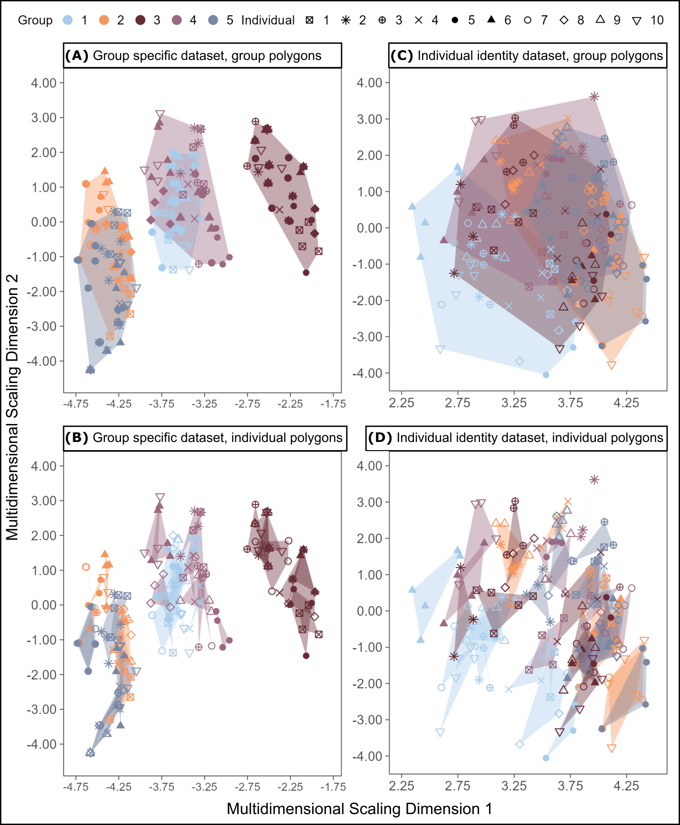

S1 Fig: Acoustic space plots for the character string representations of the group-specific example dataset (panels A and B), and the individually distinctive example dataset (panels C and D). These acoustic space plots can be interpreted in a universal acoustic space obtained by applying multidimensional scaling to the edit distance matrix for all vocalizations across both example datasets. Across panels, groups are represented by colors and individuals within groups are represented with shapes. Panel A shows patterns of variation in acoustic space with convex hull polygons drawn by group identity, while Panel B shows the same dataset with polygons drawn by individual identity. Panels C and D are organized similarly, with polygons drawn by group or individual identity, respectively. Note that panels A and D are the plots with polygons drawn by classes at the social level at which we had originally encoded the most information per dataset, respectively.

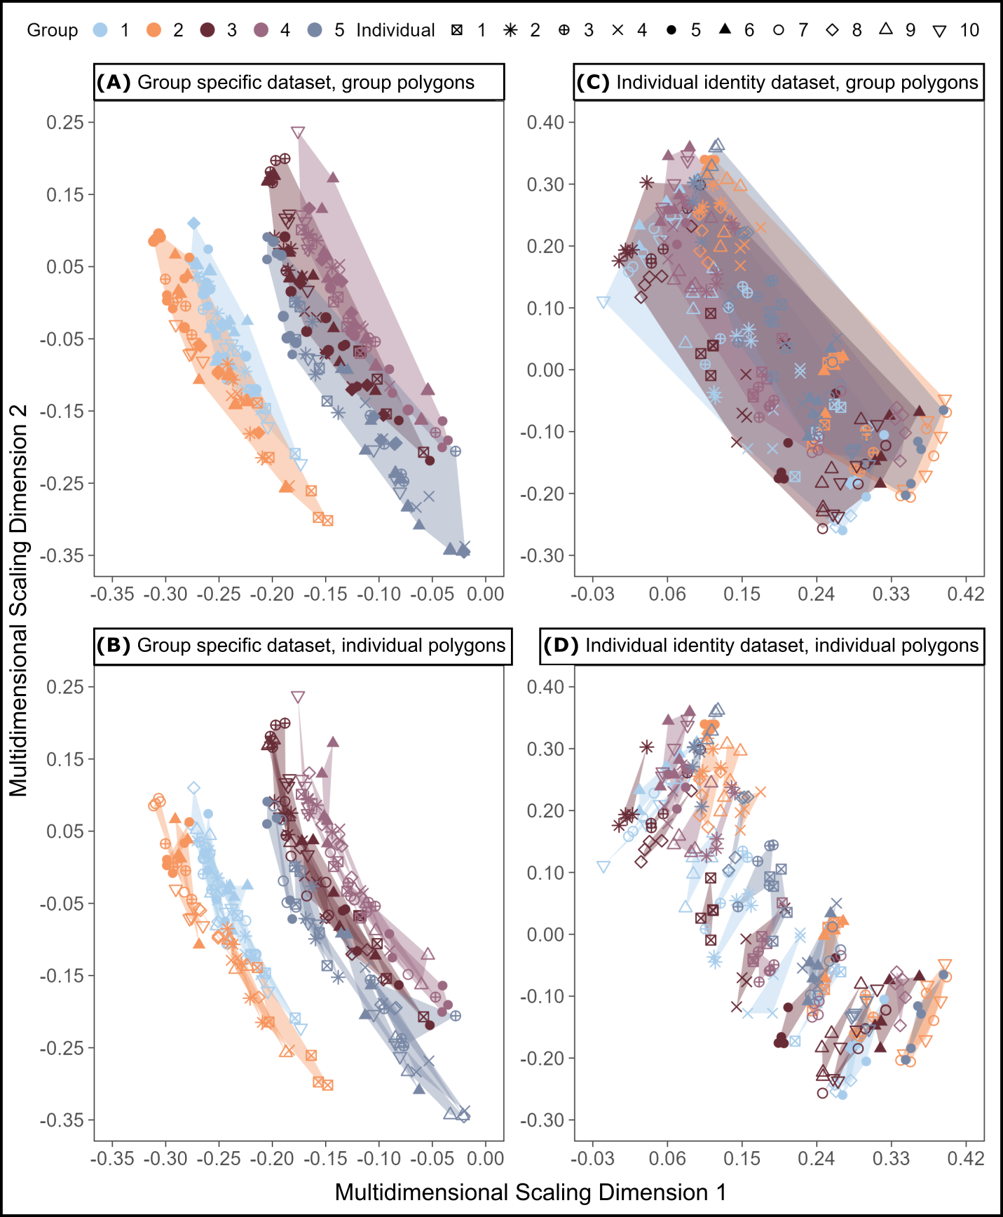

S2 Fig: Acoustic space plots for the audio file representations of the group-specific example dataset (panels A and B), and the individually distinctive example dataset (panels C and D). These acoustic space plots can be interpreted in a universal acoustic space obtained by applying multidimensional scaling to the spectrographic cross-correlation matrix for all vocalizations across both example datasets. Across panels, we have represented groups in colors and individuals within groups through shapes. Panel A shows patterns of variation in acoustic space with convex hull polygons outlining the area in acoustic space per group, while Panel B shows the same dataset with polygons outlining acoustic spaces by individual. Panels C and D are organized in the same way, with polygons highlighting the acoustic spaces of each group or individual, respectively. Panels A and D show polygons drawn at the social level where we originally encoded the most identity information per dataset.

S1 Table: Effect size calculations to detect the social level with the greatest amount of identity information encoding.
Number of Groups | Method of Information Detection | Cliff's Delta | Upper 95% CI | Lower 95% CI | Magnitude
Group Information Proportion: 0
2 | SPCC | -0.76 | -0.26 | -0.94 | Large
2 | Edit | -0.67 | -0.20 | -0.89 | Large
4 | SPCC | -1.00 | -0.97 | -1.00 | Large
4 | Edit | -1.00 | -0.97 | -1.00 | Large
6 | SPCC | -1.00 | -0.97 | -1.00 | Large
6 | Edit | -1.00 | -0.97 | -1.00 | Large
8 | SPCC | -1.00 | -0.97 | -1.00 | Large
8 | Edit | -1.00 | -0.97 | -1.00 | Large
Group Information Proportion: .33
2 | SPCC | -0.40 | 0.13 | -0.75 | Medium
2 | Edit | -0.09 | 0.35 | -0.50 | Negligible
4 | SPCC | -0.74 | -0.27 | -0.92 | Large
4 | Edit | -0.52 | 0.03 | -0.83 | Large
6 | SPCC | -0.88 | -0.54 | -0.97 | Large
6 | Edit | -0.68 | -0.11 | -0.91 | Large
8 | SPCC | -1.00 | -0.97 | -1.00 | Large
8 | Edit | -0.88 | -0.54 | -0.97 | Large
Group Information Proportion: .67
2 | SPCC | 0.50 | 0.82 | -0.06 | Large
2 | Edit | 0.37 | 0.70 | -0.09 | Medium
4 | SPCC | 0.38 | 0.75 | -0.17 | Medium
4 | Edit | 0.64 | 0.90 | 0.06 | Large
6 | SPCC | 0.69 | 0.92 | 0.10 | Large
6 | Edit | 0.76 | 0.94 | 0.21 | Large
8 | SPCC | 0.92 | 0.99 | 0.57 | Large
8 | Edit | 0.98 | 1.00 | 0.88 | Large
Group Information Proportion: 1
2 | SPCC | 0.90 | 0.98 | 0.48 | Large
2 | Edit | 0.90 | 0.98 | 0.48 | Large
4 | SPCC | 0.99 | 1.00 | 0.94 | Large
4 | Edit | 1.00 | 1.00 | 0.97 | Large
6 | SPCC | 1.00 | 1.00 | 0.97 | Large
6 | Edit | 1.00 | 1.00 | 0.97 | Large
8 | SPCC | 1.00 | 1.00 | 0.97 | Large
8 | Edit | 1.00 | 1.00 | 0.97 | Large

